Step 1 在虚拟环境中创建一个flask项目文件夹

(python36) tonykidkiddeMacBook-Air:~ tonykidkid$ source activate python36

(python36) tonykidkiddeMacBook-Air:programs tonykidkid$ mkdir -p flask_test_project

(python36) tonykidkiddeMacBook-Air:programs tonykidkid$ cd flask_test_project

(python36) tonykidkiddeMacBook-Air:get_pp_data tonykidkid$ pwd

/Users/tonykidkid/programs/flask_test_project

(python36) tonykidkiddeMacBook-Air: flask_test_project tonykidkid$ which python3.6

/Users/tonykidkid/anaconda2/envs/python36/bin/python3.6

确保已通过pip安装Flask（用python3.6解释器执行命令pip install Flask即可安装）

(base) [root@cdh-test-1-3 appdaily]# pip freeze | grep -iE --color "Werkzeug|MarkupSafe|Jinja|ItsDangerous|Click"

Click==7.0

itsdangerous==1.1.0

Jinja2==2.10

MarkupSafe==1.1.1

Werkzeug==0.14.1

(python36) tonykidkiddeMacBook-Air:flask_test_project tonykidkid$ **which flask**

/Users/tonykidkid/anaconda2/envs/python36/bin/flask

在运行应用之前，需要在终端里导出 FLASK_APP 环境变量

(python36) tonykidkiddeMacBook-Air:flask_test_project tonykidkid$ **export FLASK_APP=hello_flask.py**

(python36) tonykidkiddeMacBook-Air:flask_test_project tonykidkid$ pwd

/Users/tonykidkid/programs/flask_test_project

(python36) tonykidkiddeMacBook-Air:flask_test_project tonykidkid$ ls -alh

total 8

drwxr-xr-x 4 tonykidkid admin 136B 6 24 19:22 .

drwxr-xr-x 36 tonykidkid admin 1.2K 6 24 19:07 ..

drwxr-xr-x 9 tonykidkid admin 306B 6 24 19:16 .idea

-rw-r--r-- 1 tonykidkid admin 190B 6 24 19:22 hello_flask.py

(python36) tonykidkiddeMacBook-Air:flask_test_project tonykidkid$ flask run

* Serving Flask app "hello_flask.py"

* Environment: production

WARNING: This is a development server. Do not use it in a production deployment.

Use a production WSGI server instead.

* Debug mode: off

* Running on http://127.0.0.1:5000/ (Press CTRL+C to quit)

# 到另一终端查看进程是否启动

tonykidkiddeMacBook-Air:flask_test_project tonykidkid$ ps aux| grep -v grep | grep -i --color flask

tonykidkid 16738 0.0 0.3 2440476 27284 s000 S+ 7:23下午 0:00.55 /Users/tonykidkid/anaconda2/envs/python36/bin/python /Users/tonykidkid/anaconda2/envs/python36/bin/flask run

# 按照提示，访问http://127.0.0.1:5000

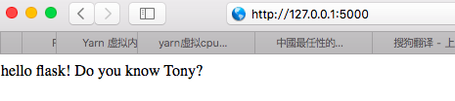

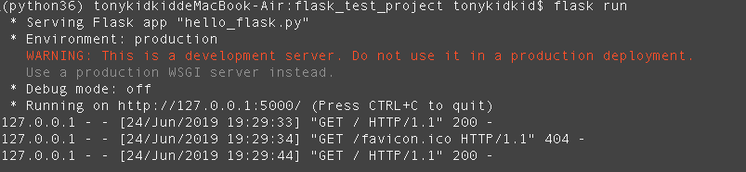

成功启动一个非常简单的内建web服务器。

**# 另一种方式启动flask的内键web服务(自定义socket)**

(python36) tonykidkiddeMacBook-Air:flask_test_project tonykidkid$ python -V

Python 3.6.8 :: Anaconda, Inc.

(python36) tonykidkiddeMacBook-Air:flask_test_project tonykidkid$ **python -m flask run --host=0.0.0.0 --port=8080**

* Serving Flask app "hello_flask.py"

**\* Environment: production**

WARNING: This is a development server. Do not use it in a production deployment.

Use a production WSGI server instead.

* Debug mode: off

* Running on http://0.0.0.0:8080/ (Press CTRL+C to quit)

127.0.0.1 - - [24/Jun/2019 19:35:15] "GET / HTTP/1.1" 200 -

127.0.0.1 - - [24/Jun/2019 19:35:15] "GET /favicon.ico HTTP/1.1" 404 -

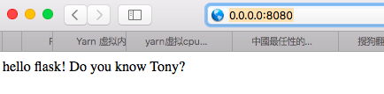

**# 打开开发功能(激活调试模式&自动重载文件)后，启动web服务**

(python36) tonykidkiddeMacBook-Air:flask_test_project tonykidkid$ **export FLASK_ENV=development**

(python36) tonykidkiddeMacBook-Air:flask_test_project tonykidkid$ **flask run**

* Serving Flask app "hello_flask.py" (lazy loading)

**\* Environment: development**

* Debug mode: on

* Running on http://127.0.0.1:5000/ (Press CTRL+C to quit)

* Restarting with stat

**\* Debugger is active!**

* Debugger PIN: 294-592-664

tonykidkiddeMacBook-Air:flask_test_project tonykidkid$ ps aux| grep -v grep | grep -i --color flask

tonykidkid 16924 0.1 0.3 2445884 27748 s000 S+ 7:48下午 0:00.87 /Users/tonykidkid/anaconda2/envs/python36/bin/python -m flask run --host=0.0.0.0 --port=8080

tonykidkid 16923 0.0 0.3 2440752 27820 s000 S+ 7:48下午 0:00.53 python -m flask run --host=0.0.0.0 --port=8080

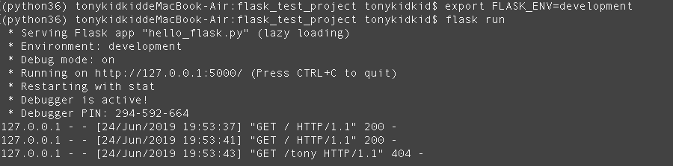

**# 注意**

上面这种交互调试器不能在分布环境下工作（也就是无法用于生产环境），但是它允许执行任意代码，这个有重大风险。因此**绝对不要在生产环境中使用调试器。**

部署到生成环境后，如何启动服务：

(base) [root@cdh-test-1-3 ~]# cd /usr/appdaily/

(base) [root@cdh-test-1-3 appdaily]# ll

total 24

-rw-r--r-- 1 root root 4921 6月 27 11:37 hello_flask.py

drwxr-xr-x 2 root root 4096 6月 27 11:39 __pycache__

drwxr-xr-x 2 root root 4096 6月 26 17:46 runningLog

-rw-r--r-- 1 root root 6427 6月 26 17:38 TestPinpointDaily.py

(base) [root@cdh-test-1-3 appdaily]# export FLASK_APP=hello_flask.py && nohup flask run --host=10.39.33.35 --port=8080 > /usr/appdaily/runningLog/all_access.log 2>&1 &

【其他】代码解析摘要

从请求对象中获取URL信息

# 访问index_page(4)：http://10.4.94.129:8080/getSingleAppDetails?app_name=devops_monitor_service&from=2019-06-20%2021:05:30&to=2019-06-22%2021:05:30  
u = request.url # 访问index_page(4)时返回：http://10.4.94.129:8080/getSingleAppDetails?app_name=devops_monitor_service&from=2019-06-20%2021:05:30&to=2019-06-22%2021:05:30  
ur = request.url_root # 访问index_page(4)时返回：http://10.4.94.129:8080/  
bu = request.base_url # 访问index_page(4)时返回：http://10.4.94.129:8080/getSingleAppDetails  
hu = request.host_url # 访问index_page(4)时返回：http://10.4.94.129:8080/