Chapter 2 "Javascript for React" Part I - Jan 5th 7pm
-----
Q1. What is the difference between function declaration and function expression?
Function Declaration is hosted and it's possible to call it from anywhere in the program (before or after its declaration).
Function Expression is NOT hoisted and the function will be "stored" in a binder.

Q2. What does destructuring an object mean? How does it work when passing an object as a function argument? And how can you destructure an object nested in another object?
Destructuring allows to extract one variable from an object which contains that variable as its property.
For instance, when passing an object to a function as parameter and that object has "a: 1" and "b: 2" properties, it is possible in the function declaration has "({a})" as argument, so the function will receive only "a".
In order to destructure a nested object, one needs to specify it in the function declaration, opening the object up to the desiraded one. For instance the passed object is
{
a: {number: 1},
b: 2
}
the function declaration has to have "function x({a: {number}}")
The same is applied for arrays.

Q3. What is object literal enhancement?
It does the opposite of destructuring.
It is possible to join different variables into one place by defining an object binder which receives those different variables to be the object's properties.
Also, using back quote (`) is possible to do the joining by `{binder-name}`.

Q4. What can you use the spread operator for?
Some of its use:
- to get an array's content, exemplo: newArray = [...oldArray, newItem]
- same above to objects
- REST parameters, which enables to receive a dynamic number of parameters setting them in an array. The function's definition has to be as parameter something like "(...params)".

function x(a = 1, ...others) {
// x a is gonna be 10, and others = [20, 30]
}
x(10, 20, 30)

BONUS 1: Why can you omit "return" in arrow functions?
When there is only one line inside an arrow function, the curly braces can be omitted. In this case, that line will be returned, so the "return" word is omitted too.

BONUS 2: How regular function declarations and arrow functions treat the scope (this) differently?
In a Function declaration "this" recalls for the global object, whereas in an arrow function it is related to the its local scope.

Chapter 2 "Javascript for React" Part II - Jan 12th 7pm
------
Q1. What is the difference between promises and async/await?
Promises is a way to execute tasks with different responses times in order. In other words, asynchronous tasks being treated synchronously.
The initial/usual way to handle Promises uses “.then” and “.catch”, where .then runs after receiving a response, in order, and .catch catchs any error within the chain (if using more than one .then). The problem with this approach is the callback hell when there are chains of thens one inside other, which turns the code very hard to read because too many identation.
Async/await is a new way to do the same thing as above, but do not need to be enchained (one inside other). It basically runs one line of code after other when the first one already received its answer. The function that handles this approach needs to have “async” before its parameters. The await keyword is only valid inside async functions.
In case to catch errors, it is a good practice to use the try/catch.
* JS is not asynchronous:
“...browsers allow us to run certain operations asynchronously. Features like Promises allow you to set an operation running (e.g. the fetching of an image from the server), and then wait until the result has returned before running another operation.”
https://developer.mozilla.org/en-US/docs/Learn/JavaScript/Asynchronous/Concepts#JavaScript_is_single_threaded

https://developer.mozilla.org/en-US/docs/Learn/JavaScript/Asynchronous/Async_await

Q2. Why do we need to include the word “default” when exporting JS modules?
“export default can be used in place of export when you wish to export only one type. Both export and export default can be used on any JavaScript type: primitives, objects, arrays, and functions” from the book.

Q3. How does a module with a single and multiple exports differ when being imported in another module?
When a multiple export are imported, the programmer needs to specify which resource is gonna be used.

Q4. What two possible locally scoped changes using the term “as” when importing a module are presented in this chapter?
1- using “import <original-name> as <new-name> from ‘file.js’” the imported resource will be referenced by new-name in that scope;
2- using “import * as <new-name> from ‘file.js’” brings all the resources from that modules into a unique variable called new-name.

Q5. How is using modules different in ES6 vs CommonJS?
CommonJS is the module pattern that’s supported by all versions of Node (see the Node.js documentation on modules). You can still use these modules with Babel and webpack. With CommonJS, JavaScript objects are exported using module.exports.
It exports by using
module.exports = <one-resource> or
module.exports = {
<resouce-one>,
<resource-two>,
...
}
It imports by using const binder = require(“<js-file>”)

ES6:
- export <resource>
- export default <resource> exports a single main variable
- import {resource-name, other-resource-name} from file.js
- import {resource-name as otherStuff} from file.js

ES6 uses export and import
CommonJS exports by using module.exports and import by require

BONUS (Interview Questions)
B1. How do you define a class in JavaScript? How do you a public and a private variable in this class?
Basically two ways:
1- Using prototypical inheritance technique:
function Vacation(destination, length) {
this.destination = destination;
this.length = length;
}

Vacation.prototype.print = function() {
console.log(this.destination + " | " + this.length + " days");
};
2- ES2015 introduce a class declaration that works similar to OOP languages
class Vacation {
constructor(destination, length) {
this.destination = destination;
this.length = length;
}

print() {
console.log(`${this.destination} will take ${this.length} days.`);
}
}
From MDN:
“Class properties are public by default and can be examined or modified outside the class. There is however a “stage 3 proposal” to allow defining private class fields using a hash # prefix.”
“Private instance fields are declared with # names (pronounced "hash names"), which are identifiers prefixed with #. The # is a part of the name itself. It is used for declaration and accessing as well.”
Before the use of #, the _ char was used simply to flag that that variable was “private”, but it access there was no restrictions. Only a flag.

* The static keyword defines a static method for a class. Static methods aren't called on instances of the class. Instead, they're called on the class itself.
Static variables are called by static methods

Another way to do it it is by creating a variable inside a function, which do not return that.
i.e.
function asd(num) {
v = 1;
return v * num;
}

B2. What is a JavaScript promise?
It is an object that will return something in a future time.
It allows running asynchronous tasks in order (synchronously).
It holds 3 possible status: Pending, Resolved and Rejected.
It can be used to execute asynchronous tasks in a synchronous way.

Chapter 3 "Functional Programming with JavaScript" Part I - Jan 19th 7pm.
Topics: What it means to be Functional, Imperative vs Declarative, Functional Concepts - Immutability, Pure Functions, Data Transformations.
-----
Q1. What does the fact of functions being variables in Javascript allow us to do with those functions?
It will handle that function (stored in a variable) to be used as it was a normal variable. For instance, a function can be passed as argument for another function or returned from another function.
Functions are data.

Q2. What is declarative programming?
It is a way to use other functions and abstract what they are doing behind the scenes.
In short: imperative is how you do, while declarative is what you do.
* metaphor when someone invite someone else over to their place:
– declarative: 3500 Price St.
– imperative: Coming from North Boundary, take right at Price St, two blocks after ...

Q3. Which of the following array methods mutate the object and which don’t?
* object and array may be mutate, even using const.
It can be reached by using freeze or seal.

Array.push = MUTATES
array.concat = DOES NOT MUTATE
array.splice = MUTATES
array.pop = MUTATES
array.filter = DOES NOT MUTATE
array.map = DOES NOT MUTATE
array.reduce = DOES NOT MUTATE
array.reduceright = DOES NOT MUTATE
.push() // => adds a new item as the last item of the array
.push() // => adds a new item as the last item of the array
.pop() // => removes the last item of the array

.unshift() // => adds a new item as the first item of the array
.shift() // => removes the first item of the array

.reverse() // => reverses the order of the array

.splice() // => removes/replaces item(s) in the array

.sort() // => re-orders the items in the array based on their Unicode code points

.copyWithin() // => copies one part of the array and put it on another part of the same array

.fill() // => changes some or all items in the array into the value being passed in
– article with the 9 array methods that change arrays:
https://dev.to/liaowow/to-mutate-or-not-to-mutate-javascript-array-methods-cheat-sheet-5092
– cheat sheet with all array methods description:
https://doesitmutate.xyz/

Q4. What defines a pure function? Why is a pure function easier to test?
They are functions that will behave the same way when receiving the same data (deterministic), on the same circumstances, without produce side effects. It means, it receives arguments and return a value without changing the environment.
Their arguments are treated as immutable data.

*** When passing an object as argument to a function, what is passed is a reference to that original object. Any changes in that will reflect in the original object. In order get a pure function, one needs to create a new object with Object.assign({}, parm1, param2,..)
https://medium.com/javascript-scene/master-the-javascript-interview-what-is-a-pure-function-d1c076bec976

Q5. What are the three rules we should follow when writing functions?
From the book:
1- The function should take in at least one argument.
2- The function should return a value or another function.
3- The function should not change or mutate any of its arguments.

Discussion after the meeting about testings
https://www.freecodecamp.org/news/how-to-start-unit-testing-javascript/
search “design patterns in javascript”

Chapter 3 "Functional Programming with JavaScript" Part II - Jan 26th 7pm
Topics: Functional Concepts - Higher-Order Functions, Recursion, Composition, Putting it all together.

Q1. What is a higher-order function?
It is a function that either takes or returns another function.
It also can be treated as data.
Arguments vs parameters?
Argument is the value(s) passed to a function when calling them.
Parameter is the variable(s) received by a function in its definition.

“A parameter is a variable in a method definition. When a method is called, the arguments are the data you pass into the method's parameters.”
https://stackoverflow.com/questions/156767/whats-the-difference-between-an-argument-and-a-parameter#:~:text=A%20parameter%20is%20a%20variable,pass%20into%20the%20method's%20parameters.&text=Parameter%20is%20variable%20in%20the,that%20gets%20passed%20to%20function.

From the book:
“A function is considered a first-class member when it can be declared as a variable and sent to functions as an argument. These functions can even be returned from functions.”

“If you see more than one arrow used during a function declaration, this means that you’re using a higher-order function.
We can say that JavaScript supports functional programming because its functions are first-class citizens. This means that functions are data. They can be saved, retrieved, or flow through your applications just like variables.”

Q2. What is a recursive function? In what scenarios can recursive functions be a better solution than loops?

From the book:
“Recursion is a technique that involves creating functions that recall themselves. Often, when faced with a challenge that involves a loop, a recursive function can be used instead.”

“Recursion is a pattern that works particularly well with asynchronous processes. Functions can recall themselves when they’re ready, like when the data is available or when a timer has finished.”

“Recursion is a good technique for searching data structures. You can use recursion to iterate through subfolders until a folder that contains only files is identified. You can also use recursion to iterate though the HTML DOM until you find an element that does not contain any children.”

Q3. What is function chaining?
When a function receives the output of another function using dot notation.

From the book:
“In JavaScript, functions can be chained together using dot notation to act on the return value of the previous function.”

Q4. What is function composition?
It is a technique used in Functional Programming paradigm which combines small methods among each other to attain a larger task. The small details will be handled by tiny methods and combined in the end.

From the book:
“Functional programs break up their logic into small, pure functions that are focused on specific tasks. Eventually, you’ll need to put these smaller functions together. Specifically, you may need to combine them, call them in series or parallel, or compose them into larger functions until you eventually have an application.”

BONUS: What are the pros and cons of functional programming vs object-oriented programming? (Not clear in the chapter).
OOP focus on object, which contains data and methods (behaviour) regarding that particular object. Imperative programming.
FP is based on the functions and variables. It separes data from behaviour. Declarative programming.

https://www.educba.com/functional-programming-vs-oop/
“In functional programming, the main focus of programming is what are we doing. In object-oriented programming, the main focus of programming is how are we doing.”

https://www.codenewbie.org/blogs/object-oriented-programming-vs-functional-programming

FP uses immutability while OOP changes the object.

In my opinion, FP is more evolutive because one can uses functions as they need.
I think OOP will need the foundation, the classes. It can lead to an overhead.

FP pros:
–
–
FP cons:
–
–

OOP pros:
–
–
OOP cons:
–
–

Chapter 4 "How React Works" - Feb 2nd 7pm

Q1. Why do we need to import React and ReactDOM libraries instead of importing just React?
React and ReactDOM are both React libraries.
React library manipulates DOM elements – the UI. In other words, instead of using document.createElements, document.appendChild, etc for instance, we can use React.createElement(“div”, {id: “root”}, React.createElement(“h1”, {id: title}, “Title”)
(it gives a div with a children H1)
ReactDOM renders react elements in the browser, in other words, ReactDOM presents that UI, and for that, it runs the Diffing Algorithm, which checks whether there are changes to be updated.

Q2. What does AJAX stand for and how did it change the way pages were loaded in the browser?
AJAX stands for Asynchronous Javascript And XML. It is a technique for accessing web servers from a web page – send and receive data without a page refresh.
It brought the Single Page Application concept, which allows an entire web application be loaded in a single page and has Javascript to update the interface, instead of having multiple HTML pages linking to themselves.

“AJAX just uses a combination of:
– A browser built-in XMLHttpRequest object (to request data from a web server)
– JavaScript and HTML DOM (to display or use the data)”
https://www.w3schools.com/xml/ajax_intro.asp

It can transport XML, JSON and pure Text.
It is available in most browser by the object XMLHttpRequest.

1- “let connection = new XMLHttpRequest” // creates a new AJAX object
2- connection.open(“GET”, “file.txt”, true); // method, target, and whether async or not
3- connection.send() // it will fire the line above
4- connection.onload = (param) => callback // executes a function as soon it is load
https://www.youtube.com/watch?v=82hnvUYY6QA

Q3. What are class components? What are the lifecycle methods of class components?
It is one way of creating React components which extends React.Component class. Actually it is an old way to create components and is on the path to deprecation.

There are 3 stages of lifecycle, each has a set of possible lifecycle methods (the main ones follow below):
– Mounting: constructor(), render(), and componenetDidMount()
– Updating: componentDidUpdate()
– Unmonting: componentWillUnmount()
* render() method is the only required method in a class component.
* render() will not be invoked if shouldComponentUpdate() returns false.

* https://reactjs.org/docs/react-component.html

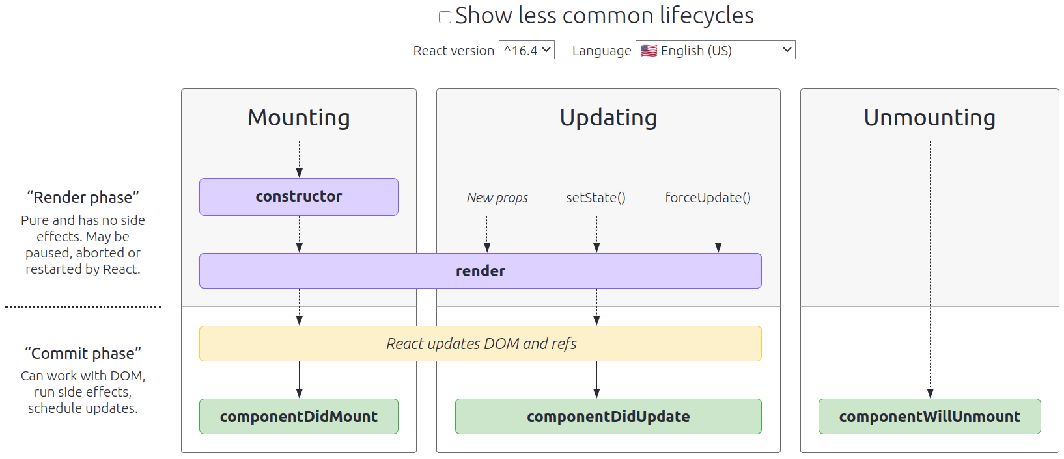
* https://projects.wojtekmaj.pl/react-lifecycle-methods-diagram/

Q4. What is JSX?
From the book:
“JSX is a tag-based JavaScript syntax that looks a lot like HTML.”

“JSX is a JavaScript Extension Syntax used in React to easily write HTML and JavaScript together.”
https://www.freecodecamp.org/news/jsx-in-react-introduction/

It stands for Javascript XML.
It allows to handle HTML while writing JS code.

In another words, it is a JS code that can deal with tags like it was HTML tags.

Comparison:
https://www.w3schools.com/react/react_jsx.asp

– With JSX
const myelement = <h1>I Love JSX!</h1>;
ReactDOM.render(myelement, document.getElementById('root'));

– Without JSX
const myelement = React.createElement('h1', {}, 'I do not use JSX!');
ReactDOM.render(myelement, document.getElementById('root'));

The browser does not understand JSX. Babel (or other JS transpiler) translates the code to the browser.

Interview Question:
1– How React works?
React is a JavaScript Library used to handle User Interface.
It works by handling HTML elements using React library, and renders its components to the UI with ReactDOM.
In other words, it manages the HTML elements tree - also known as DOM.

React Core
React handles all the DOM API transparently. Do not need document.getElementByID, document.createElement, document.createTextNode, document.appendChild, etc.
It will uses React.createElement, for instance.
JSX easier that work by enabling the use of the tags. Example: Instead of
const x = createElement(“h1”, {id: “title”}, “Site’s Title”);
we can do
const x = <h1 id = “title”>Ste’s title</h1>;
So, in essence, React handles with DOM elements in a transparent way, without needing to write in the HTML API.
React keeps a copy of the DOM (virtual DOM object). Each time there is a change in the UI, it will change the virtual DOM and compare it against the real DOM using an algorithm called Diffing Algorithm. Thus, It will re-render only the elements that have been changed.

https://www.geeksforgeeks.org/how-react-and-reactdom-works/
www.freecodecamp.org/news/react-under-the-hood/amp/
https://youtu.be/TjnyFNxQ67Y
https://youtu.be/mLMfx8BEt8g
https://youtu.be/gApwC9Ek9yo

JSX is the tool which allows writing HTML and Javascript together, being a shortcut to React library functions, such as React.createElements. In short, it easies up the way to write plain Javascript objects (React elements) which will turn to HTML elements.

Elements vs Components
The smallest unit in React is called element. It resembles an HTML element such as button, h1, div and so on. Under the hood, a React element is a Javascript object that contains data necessary to create an HTML element, which will be an DOM element.
An element also may contain other elements.
A React Elements is created by React.createElement(type, [props], [...children]) method.
When an element or a set of them are exported, they will become a React component.

Initially, React dealt with components by using React.createClass method. After that, the components were created either by extending the class React.Component (when there were state variables to manage) or by functional components when it was only an output view. The current fashion used nowadays is React Hooks which are a functional component that enables manage state variables, as well.

https://ui.dev/react-elements-vs-react-components/

Why should I use React
– It handles data (Javascript), allowing dynamic pages.
– It optimizes the rendering process, which avoids changing the whole page each time there is a change.
– JSX simplifies the way to combine HTML and Javascript.
– SPA (Single Page Application) loads one HTML file, instead of querying a new file at each clicking or API request.
To summarize, it handles the complexity of handling the UI (HTML, Javascript, CSS, variables, rendering process).

React itself also utilizes the MVC pattern:

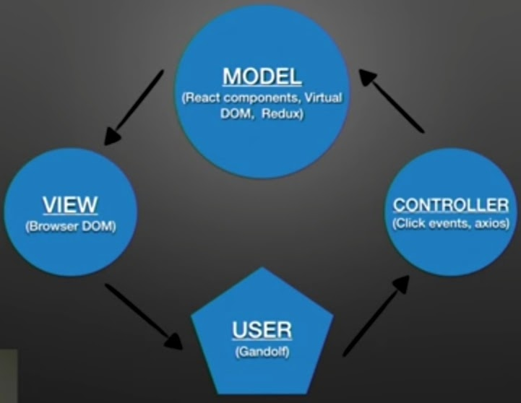

– How Virtual-DOM works in React?
React keeps a copy of the DOM. This copy is a tree of Javascript objects. The user’s UI will change the virtual DOM and compares with the real one using an algorithm called Diffing Algorithm, modifying only the actual changes.

Chapter 5 - React with JSX (React Elements as JSX, Babel, Recipes as JSX, React Fragments).

Using the cdns* and the script type=“text/babel”, recreate the Delicious Recipes code using another fake - or real - dataset (array) and share your code with the group. i.e. School Names, Addresses and Programs; Cars names, prices and available colours; etc.
We’ll notice that the process of looping through data - or consuming data from an API - and rendering UI is basically the same despite of the industry of the app (Food, Cars, Educational, Hotels, BnB, Movies, etc).
*Feel free to start a new app and run node if you prefer that.

From the book:

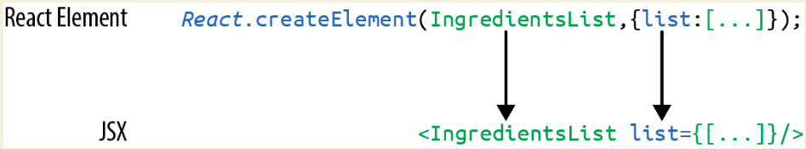
“JSX looks clean and readable, but it can’t be interpreted with a browser. All JSX must be converted into createElement calls. Luckily, there’s an excellent tool for this task: Babel.”

“...not all browsers support the latest JavaScript syntax, and no browser supports JSX syntax. Since we want to use the latest features of JavaScript along with JSX, we’re going to need a way to convert our fancy source code into something that the browser can interpret. This process is called compiling, and it’s what Babel is designed to do.”

Babel started in September/2014 being called as 6to5 due to be aimed to solve the current problem: the browsers supported more ES5 than ES6. In February/2015 it was renamed to Babel. Lately, it also supported the conversion of JSX into pure Javascript.

React Fragments are used to wrapper more than one React Element without a whole element such as div. It is a way to avoid the whole set of properties of a normal wrapper. On the other hand, it is NOT possible to have settings (properties such as borders, CSS position, CSS behaviours...)
Its usage:
<React.Fragment>
</React.Fragment>
or, its shorthand:
<>
</>

Chapter 5 - Part II - React with JSX (Intro to webpack, Creating the Project, Source Mapping, Create React App).
Q1. What tools do you use for code compilation? I.E. Webpack, parcel, babel.
The default in create-react-app, which are webpack (bundle) and babel (transpile).

Webpack allows spliting the system as a project and modularize the files and directories – it is good to organize and get the code easier to understand. Also, it gives a better network perfomance due to bundle the whole system in an unique file, avoiding multiple network requests.

Q2. Aside from code compilation, what else can webpack - or other bundlers – handle?
“– Code splitting: Splits up your code into different chunks that can be loaded when you need them. Sometimes these are called rollups or layers; the aim is to break up code as needed for different pages or devices.

– Minification: Removes whitespace, line breaks, lengthy variable names, and unnecessary code to reduce the file size.

– Feature Flagging: Sends code to one or more—but not all—environments when testing out features.

– Hot Module Replacement (HMR): Watches for changes in source code. Changes only the updated modules immediately.”

Q3. What benefits do we developers gain by using a tool like webpack?
“
– Modularity: Using the module pattern to export modules that will later be imported or required by another part of the application makes source code more approachable. It allows development teams to work together, by allowing them to create and work with separate files that will be statically combined into a single file before sending to production.

– Composition: With modules, we can build small, simple, reusable React components that we can compose efficiently into applications. Smaller components are easier to comprehend, test, and reuse. They’re also easier to replace down the line when enhancing applications.

– Speed: Packaging all the application’s modules and dependencies into a single client bundle will reduce the load time of an application because there’s latency associated with each HTTP request. Packaging everything together in a single file means that the client will only need to make a single request. Minifying the code in the bundle will improve load time as well.

– Consistency: Since webpack will compile JSX and JavaScript, we can start using tomorrow’s JavaScript syntax today. Babel supports a wide range of ESNext syntax, which means we don’t have to worry about whether the browser supports our code. It allows developers to consistently use cutting-edge JavaScript syntax.
“

Q4. What is the benefit of splitting code in multiple files or modules?
It gives a better organization, turning the code easier to read/understand, and also allows team-work due to the responsibilities may be split (even in different files) among the team members.
Q5. What is the benefit of adding “source-map” to the webpack configuration?
“Bundling our code into a single file can cause some setbacks when it comes time to debug the application in the browser. We can eliminate this problem by providing a source map. A source map is a file that maps a bundle to the original source files.”

Chapter 6 - Part I - React State Management (Building a Star Rating Component, The useState Hook, Refactoring for Advanced Reusability, State in Component Trees)

Q1. What are React Hooks?
“React Hooks is a React feature that contains reusable code logic that is separate from the component tree. They allow us to hook up functionality to our components. React ships with several built-in hooks we can use out of the box. In order to use them, one needs to import the necessary hook, for instance “import { useState } from ‘react’”.”

“When data within the hook changes, they have the power to rerender the component they’re hooked into with new data.”

Q2. What is the useState hook used for and how does it work? And how does useState make it easier to manage state in functional components compared to class components?
From reactjs.org: “What is a Hook? A Hook is a special function that lets you “hook into” React features. For example, useState is a Hook that lets you add React state to function components.”
The useState hook is a function used to manage state in the component that returns an array. The first item of that array is the state variable itself. The second item of the array is the function to change the first item – in order to use the better result of React, only this function can change the state of that first item.
useState provides a variable and a function to modify it, instead of this.state.myVariable and this.setState({myVariable: “text”}) in class components. Also, the constructor class method is avoided when using function components.

Q3. Why is it not a best practice to store state in components?
“It’s not a great idea to use state in every single component. Having state data distributed throughout too many of your components will make it harder to track down bugs and make changes within your application. This occurs because it’s hard to keep track of where the state values live within your component tree. It’s easier to understand your application’s state, or state for a specific feature, if you manage it from one location.”
Q4. What is a pure component?
“A pure component is a function component that does not contain state and will render the same user interface given the same props.”

Q5. How can we pass data up the component tree?
The parent component has to pass a method to its child, and it call this method to pass data up.
In other words, the parent component has a function property that is passed to its child, which in turn will execute the function in order to pass data up to its parent.
Another way to express it, by the book:
“We’ll need to collect interactions from child components and send them back up the tree to the root component where we can change the state”. In this case, the interactions are methods passed by the parent component to its child.

Chapter 6 - Part II - React State Management (Building Forms, React Context)
Q1. What is a ref?
“When it’s time to build a form component in React, there are several patterns available to you. One of these patterns involves accessing the DOM node directly using a React feature called refs. In React, a ref is an object that stores values for the lifetime of a component. There are several use cases that involve using refs.”

Q2. Why is using controlled components a better approach compared to using refs when building forms?
Uncontrolled component uses the DOM to save the form values. Sometimes using uncontrolled component can get you out of problems. For instance, you may want to share access to a form and its values with code outside of React. However, a controlled component is a better approach.
“In a controlled component, the form values are managed by React and not the DOM. They do not require us to use refs. They do not require us to write imperative code. Adding features like robust form validation is much easier when working with a controlled component.”

Q3. What’s the benefit of using React Context instead of passing data down the component tree using props?
When passing data down using props, the data needs to travel all the way for each component in the tree, even though they are not be used for some middle way components. Using React Context enables for only the component that needs the data to call the Context.Consumer and use it.

Q4. Why is it a best practice to add functions to context for the operations that can change the state?
Creating a custom hooks that handles all methods that perform data changing. In this way, only allowed functions will be exported and able to be used in the app.

Q5. What is the benefit of using custom hooks instead of exposing context to consumer components?
It will separate concerns, which is a good practice to avoid mistakes and also keep the code clean and organized.
One point about custom hooks is that instead of repeating code, we can abstract and centralize one function which works for more than one component/element in one place. It will avoid more code lines, it is easier of reading and maintaining.

https://dev.to/loujaybee/using-create-react-app-with-express
Build a tutorial with all the steps to build and deploy, passing through db
1- write a react FE app
2- write BE api
3- access mongo locally and mongoatlas
locally - mongo, use db, ... port 27001 (like this)
atlas – all clusters (top right side) ...
4 – on BE set models and configure the connection
5- integrate BE and FE
first using proxy, instead of long address
after, building a prod version of FE, copying to /public and setting express to get it
6- set heroku
Procfile, vars, git push heroku master...

