Kung Wai Kit, Tony

Setup Manual and Documentation of Memory Game

Development/Test/Setup Environment
OS: Windows Server 2012 R2
Browsers: Chrome 43, Firefox 38, IE 11
Editor: Brackets
Technology stack: Node.js v0.12.4, Express 4, MongoDB v3.0.3, Ext JS 4.2.1

Minimal Steps to set up the server side of Memory Game
- Install required software packages:
- Download Node.js v0.12.4 from the official site and install it
- Download MongoDB v3.0.3 from the official site and install it
- Ensure paths of the executables are included in the Path environment variable of Windows
- For Node.js, the executables are by default installed to C:\Program Files\nodejs
- For MongoDB, the executables are probably installed to C:\Program Files\MongoDB\Server\3.0\bin
- Open windows Command Prompt (run as Admin), change directory to the folder tony_memory_game
- Start the mongo server by: mongod -f mongod.conf
- Open another windows Command Prompt (run as Admin), change directory to the folder tony_memory_game
- Start the nodejs service by: node server.js
- See the nodejs is listening to port 8080 of localhost from the log shown on the command prompt
- Open Chrome/Firefox/IE, then go to http://localhost:8080/index.html
- You should see the UI similar to the following screenshot

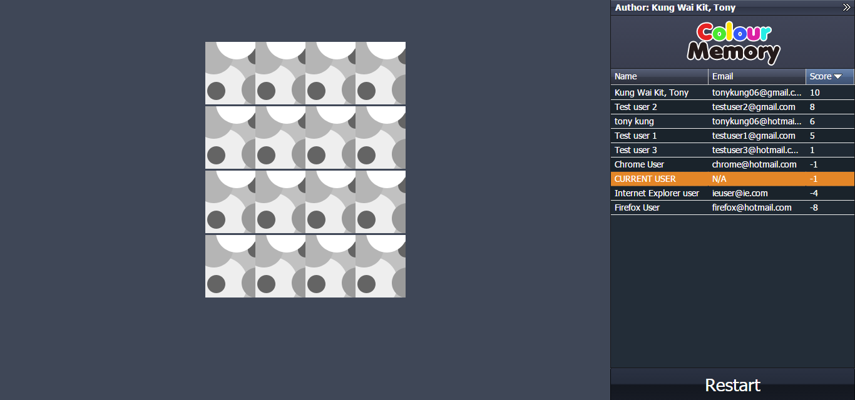
Code Architecture

The code folder tony_memory_game is shown below.

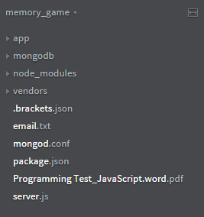
Files
mongod.conf - a configure file for starting up the mongo daemon easily
package.json - declares node package dependencies
server.js - this is the app entry point for node.js

Sub-folders
node_modules - contains all nodejs modules that have been installed
vendors - contains all third-party software, like node.js, mongodb and ext js
mongodb - this is the database folder of mongodb that is being used by the app
app - the meaty part of the app, it contains the application code

Go one level down the app folder, we see three sub-folders, i.e. models, routes and ui
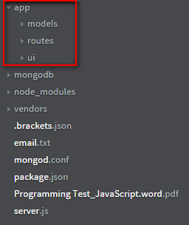
models - contains mongoose model modules that acts like ORM objects, for this app, we have HighScore.js that defines name, email and score for the schema
routes - contains router modules for routing in Express, in this app, we have one router to manage rest CRUD requests accessing /api/highscores
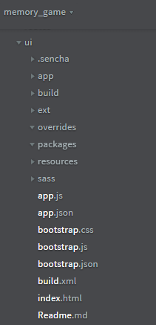
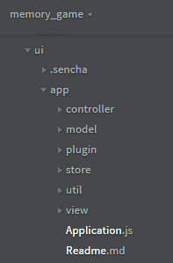
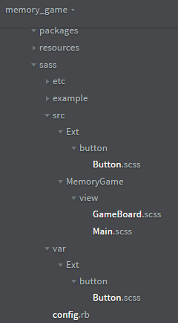
ui - contains all UI code, in this app, Ext JS is used for the UI. Inside this folder, it is structured to allow client-side MVC development. The stuff in app folder under this folder is divided into model, view, store and controller. There is also a sass folder to contain all app-specific sass source code.
Workflow of the game

The first time access the game, you will see
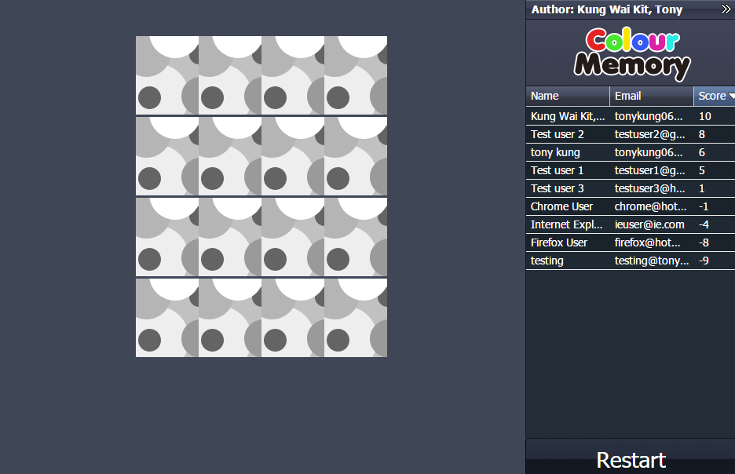
You may then click through the cards to find pairs of cards with matched colors. Keyboard navigation is also allowed on the cards and “Restart” button. You may Tab through the cards and Restart button. While you are navigating among the cards, UP, DOWN, RIGHT and LEFT arrow keys could fasciliate the navigation. ENTER key could toggole the cards by flipping them upward or downward.

When the first score update comes, a new data record for the CURRENT USER is created and shown on the ranking table on the right.
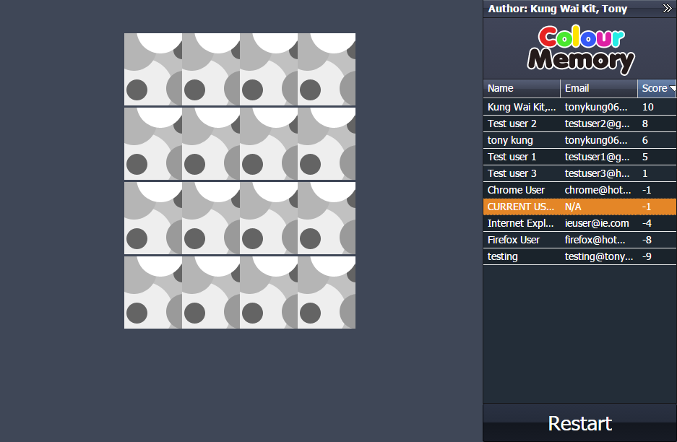

When the card is on focus, it is slightly grayed out.
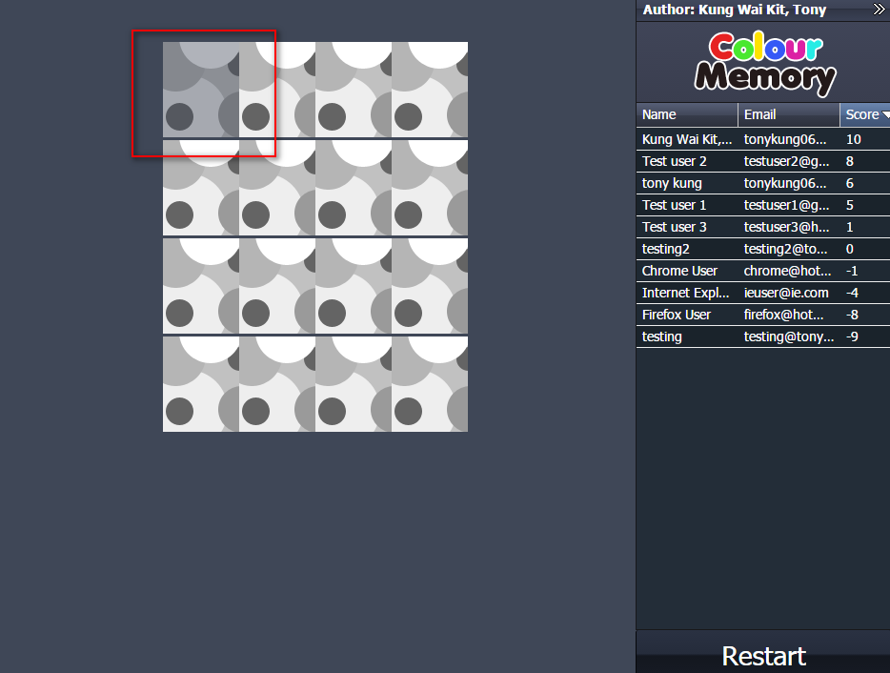

When the score is updated when you flip over unmatched cards or flip over two matched cards. There is a animated block showing the updates. The ranking table on the right will highlight the data record of the current user and ranking will be updated lively. So the highlighted data row will move up and down with the increase and decrease of the current user’s score.
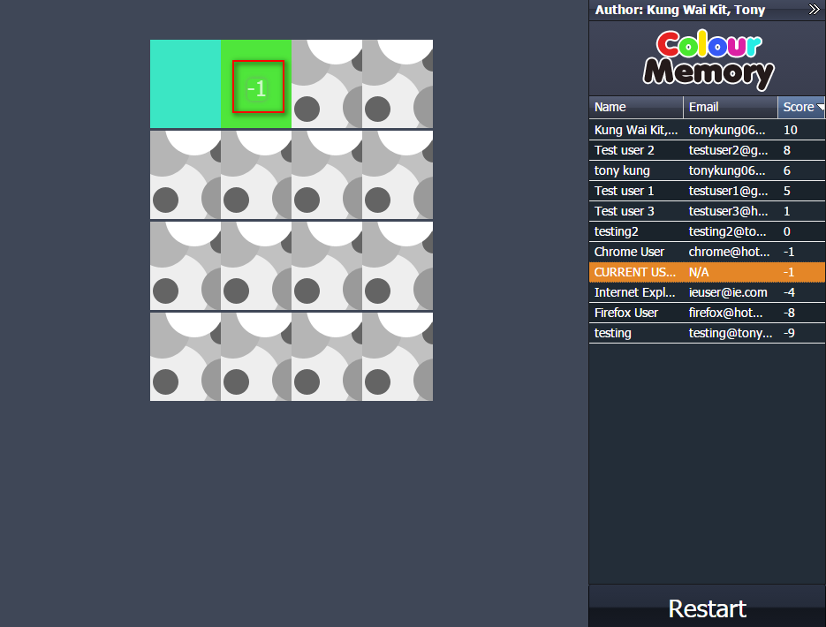
When the game is finished, you could choose to submit the score to the server or just restart the game.
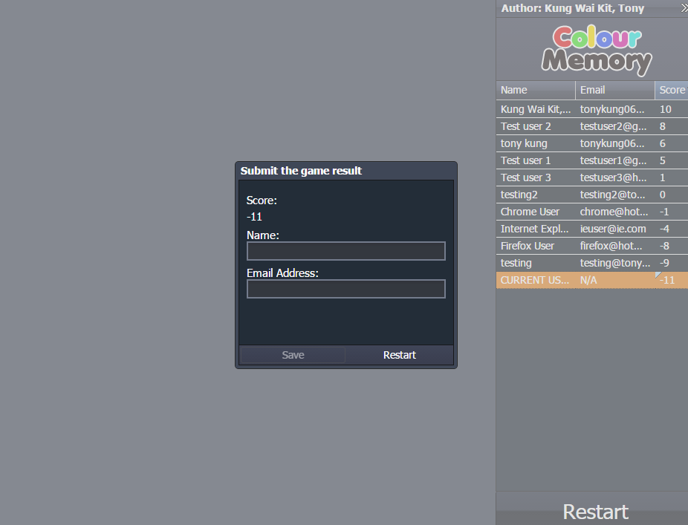

The submit form has field validations on the Name and Email fields. They must not be blank and the email value must be of correct email format. When the form is submitted to the server, the corresponding data row in the ranking table will be synced up with the name, email and score. If the game is “Restart”, the following screen will be shown.
