a) the Reinsurer shall be liable to pay the Reassured even though the Reassured is unable - AJA GROUP - New AI Claim

ULA reference: ULA-2026-0006 - 1v1
Applicant's Name: a) the Reinsurer shall be liable to pay the Reassured even though the Reassured is unable
Assured's Name: AJA GROUP
Policy No.: MC2727
01 September 2026


It’s about time you receive the quality of service and expertise your firm deserves.
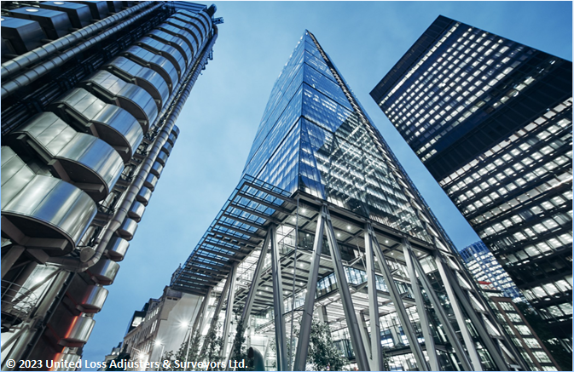

Document Control Page
Written by: | Reviewed by: | Approved by:
ULA Administrator | To be assigned | To be assigned
Designation: | Designation: | Designation:
Claims Handler | Claims Director / Technical Reviewer | Director / Chartered Adjuster
Signature (Approver)

This survey and its issued report were completed without prejudice to all rights of parties concerned.
Date of approval
01 September 2026

Version History | Date of issue | Reason for Revision
1 | 01 September 2026 | Locally generated controlled draft; professional review required
The contents of this report are for the confidential information of the client
This survey and its issued report were completed without prejudice to all rights of parties concerned and its concluded adjustment is in accordance with the terms and conditions of the relevant insurance policy.
Report Summary
At the request of a) the Reinsurer shall be liable to pay the Reassured even though the Reassured is unable (the Applicant), ULA was requested to investigate a Marine Cargo (Reefer/GFS) claim for AJA GROUP (the Assured), establish the evidence-supported circumstances and extent of loss, and validate the claim presented under the policy. The insured interest is Not established from the reviewed evidence. Table 1 summarises the salient claim details.
Assured's / Shipper's Name | AJA GROUP
Consignee's Name | Not established from the reviewed evidence
Insurance Policy | No. MC2727  Insured Value / Limit: USD 3,000,000.00  All Terms, Clauses, Conditions & Settlements as Original & to follow — Warranted Shipped under a clean Original Bill of Lading &/or — Heating, sweating, condensation, spontaneous combustion  Basis of Valuation: CIF + justified additional fees  Deductible / Excess: USD 30,000 annual aggregate
The following was concluded:
- 02 Apr 2026: Cargo discharged. (Source: 260410 - Documents.pdf, page 32)
- 14 Apr 2026: Cargo delivered. (Source: 260410 - Documents.pdf, page 32)
- 2026-03-03: Packing list issued.
- 2026-03-06: Commercial invoice issued. (Source: 260410 - Documents.pdf, page 29)
- 2024-12-20: Policy inception. (Source: 260410 - Documents.pdf, page 1)
- 2026-04-11: Cargo arrived.
- Shipment is 5x40' REEF 9'6 containers of Frozen Chicken Leg Quarters (KOCH, USA origin) loaded at Charleston on MAERSK CHICAGO voyage 610E on 2026-03-07, transhipping via Tanger Med 2, and discharged at Banjul on 2026-04-02; empty return 14 Apr 2026 (container MNBU9161036). (Source: 260410 - Documents.pdf, page 32)
- Containers declared: MNBU4110289, MNBU0581948, MNBU3911088, MNBU4419600, and MCAU6043540 (per Maersk B/L) versus MNBU9161036 listed on the commercial invoice and packing list trailer number — a possible container-list discrepancy between B/L and commercial documents requires confirmation. (Source: 260410 - Documents.pdf, page 29)
- Shipper seals recorded on B/L: UL8135594, UL8135584, UL8135597, UL5954482 (one per container); packing list for MNBU9161036 shows seal UL-8135592 — discrepancy to be reconciled (B/L vs packing list seal for the same container). (Source: 260410 - Documents.pdf, page 30)
- Master B/L does not match the packing list on quantity of packages and seal for the same container (B/L total 4 + 1 = 5 containers = 13,600 cases; packing list row totals 2,720 cases/55,976 kg/62,968 lb only for one container/trailer MNBU9161036). The packing list appears to cover only one container rather than the full 5-container shipment — discrepancy flagged. (Source: 260410 - Documents.pdf, page 30)
- Invoice arithmetic verification: 136,000 kg x USD 1.405 = USD 191,080.00 (matches stated total and the written total 'One Hundred Ninety One Thousand Eighty And 0/100 USD'). FOB 170,499 + Freight 20,000 + Insurance 581 + Charges 0 = 191,080 (CIF) — internally consistent. (Source: 260410 - Documents.pdf, page 29)
- Policy deductible is annual aggregate USD 30,000 (per 'Deductible' field, p.6). Warranty No.6 requires 'Temperature Flow Chart to be maintained and presented when required by Underwriters if it exists'; warranty No.10 specifies that shortage/loss of entire packages claims shall not be invalidated by intact seals (FCL). Exclusions include 'Mysterious &/or Unexplained Disappearance' and certain storage/warehousing stays. (Source: 260410 - Documents.pdf, page 6; 260410 - Documents.pdf, page 4)
- Shipment routing is consistent with policy permitted zones (no excluded countries, no War-Prone areas flagged); insured cargo interest (frozen chicken leg quarters in reefer containers) is within covered scope under Frozen/Chilled Food Clauses (A) CL.430.
- No claim form, surveyor report, temperature chart, photographs, shortage certificate, or notice of claim is present in the evidence set; therefore cause, scope of loss, and quantum cannot be determined from this evidence and require professional survey and claim submission.
- FOB, freight, and insurance total USD 191080.00, matching the commercial invoice total. (Source: 260410 - Documents.pdf, page 29)
- The 5 evidence-supported adjusted line item(s) total USD 382160.00. (Source: 260410 - Documents.pdf, page 29)

In our opinion,
- The supported arithmetic produces a provisional amount of USD 352,160.00 after the evidenced valuation uplift and deductions. This is not a concluded indemnity; remaining adjustment inputs and coverage require professional confirmation.
- The evidence records condition and possible causal indicators but does not establish a definitive proximate cause. (Source: 260410 - Documents.pdf, page 27; 260410 - Documents.pdf, page 29; 260410 - Documents.pdf, page 30; 260410 - Documents.pdf, page 6; 260410 - Documents.pdf, page 4)
- 1 relevant policy topic(s) were identified and linked to the evidence; their legal effect, compliance, and coverage response remain subject to professional review.
- Human review required: Conflicting evidence values were found for policy period: 12 months period w.e.f 20/12/2024 / 2024-12-20 to 2025-12-19. The highest-supported value (12 months period w.e.f 20/12/2024) was retained and all alternatives remain in the field trace.
- Human review required: Stored claim metadata for policy period differs from the uploaded evidence. The evidence-supported value (12 months period w.e.f 20/12/2024) was retained.
- Human review required: Stored claim metadata for deductible differs from the uploaded evidence. The evidence-supported value (USD 30,000 annual aggregate) was retained.
- Human review required: Stored claim metadata for container numbers differs from the uploaded evidence. The evidence-supported value (MNBU4110289, MNBU0581948) was retained.
- Human review required: Conflicting evidence values were found for conveyance mode: By Sea, Land and Air / Sea. The highest-supported value (By Sea, Land and Air) was retained and all alternatives remain in the field trace.
- Human review required: Stored claim metadata for conveyance mode differs from the uploaded evidence. The evidence-supported value (By Sea, Land and Air) was retained.
We confirm review of the 1 uploaded document(s) listed in "Enclosure to this report". Receipt of a file is not treated as proof that every substantive document requirement is complete.
Report and adjustment note
At the request of a) the Reinsurer shall be liable to pay the Reassured even though the Reassured is unable (the Applicant), ULA was requested to investigate a Marine Cargo (Reefer/GFS) claim for AJA GROUP (the Assured), establish the evidence-supported circumstances and extent of loss, and validate the claim presented under the policy. The insured interest is Not established from the reviewed evidence. Table 1 summarises the salient claim details. The following report and adjustment note is based on all uploaded evidence listed in the enclosure section. No historical template fact has been used as claim evidence.
Table 1 - Summary and salient details
Applicant's Name | a) the Reinsurer shall be liable to pay the Reassured even though the Reassured is unable
Assured's Name | AJA GROUP
Insurance Policy | No. MC2727  Insured Value / Limit: USD 3,000,000.00  All Terms, Clauses, Conditions & Settlements as Original & to follow — Warranted Shipped under a clean Original Bill of Lading &/or — Heating, sweating, condensation, spontaneous combustion  Basis of Valuation: CIF + justified additional fees  Deductible / Excess: USD 30,000 annual aggregate
Incoterm / Terms of sale | CIF (Source: 260410 - Documents.pdf, page 29)
Transport Document | Air Waybill: Not established from the reviewed evidence
Shipper's Name | Not established from the reviewed evidence
Consignee's Name | Not established from the reviewed evidence
Cargo / Commodities | MNBU4110289, MNBU0581948, MNBU3911088, MNBU4419600, MNBU9161036; 141,440 kg
Origin / Destination | USA / Place of Del iv ery . Appl icable only when document used as Mul timodal T r ansport B/L. (see clause 1)
Carrying Vessel / Carrier | Not established from the reviewed evidence
Cargo Arrival / Delivery Date | Discharged 02 Apr 2026; Arrived 2026-04-11; Delivered 14 Apr 2026

INTEREST INSURED & RELEVANT CONDITIONS OF INSURANCE POLICY
Not established from the reviewed evidence was documented for transit from USA to Place of Del iv ery . Appl icable only when document used as Mul timodal T r ansport B/L. (see clause 1) under Policy No. MC2727. (Source: 260410 - Documents.pdf, page 1)

SURVEYOR NOTES
- 02 Apr 2026: Cargo discharged. (Source: 260410 - Documents.pdf, page 32)
- 14 Apr 2026: Cargo delivered. (Source: 260410 - Documents.pdf, page 32)
- 2026-03-03: Packing list issued.
- 2026-03-06: Commercial invoice issued. (Source: 260410 - Documents.pdf, page 29)
- 2024-12-20: Policy inception. (Source: 260410 - Documents.pdf, page 1)
- 2026-04-11: Cargo arrived.
- Shipment is 5x40' REEF 9'6 containers of Frozen Chicken Leg Quarters (KOCH, USA origin) loaded at Charleston on MAERSK CHICAGO voyage 610E on 2026-03-07, transhipping via Tanger Med 2, and discharged at Banjul on 2026-04-02; empty return 14 Apr 2026 (container MNBU9161036). (Source: 260410 - Documents.pdf, page 32)
- Containers declared: MNBU4110289, MNBU0581948, MNBU3911088, MNBU4419600, and MCAU6043540 (per Maersk B/L) versus MNBU9161036 listed on the commercial invoice and packing list trailer number — a possible container-list discrepancy between B/L and commercial documents requires confirmation. (Source: 260410 - Documents.pdf, page 29)
- Shipper seals recorded on B/L: UL8135594, UL8135584, UL8135597, UL5954482 (one per container); packing list for MNBU9161036 shows seal UL-8135592 — discrepancy to be reconciled (B/L vs packing list seal for the same container). (Source: 260410 - Documents.pdf, page 30)
- Master B/L does not match the packing list on quantity of packages and seal for the same container (B/L total 4 + 1 = 5 containers = 13,600 cases; packing list row totals 2,720 cases/55,976 kg/62,968 lb only for one container/trailer MNBU9161036). The packing list appears to cover only one container rather than the full 5-container shipment — discrepancy flagged. (Source: 260410 - Documents.pdf, page 30)
- Invoice arithmetic verification: 136,000 kg x USD 1.405 = USD 191,080.00 (matches stated total and the written total 'One Hundred Ninety One Thousand Eighty And 0/100 USD'). FOB 170,499 + Freight 20,000 + Insurance 581 + Charges 0 = 191,080 (CIF) — internally consistent. (Source: 260410 - Documents.pdf, page 29)
- Policy deductible is annual aggregate USD 30,000 (per 'Deductible' field, p.6). Warranty No.6 requires 'Temperature Flow Chart to be maintained and presented when required by Underwriters if it exists'; warranty No.10 specifies that shortage/loss of entire packages claims shall not be invalidated by intact seals (FCL). Exclusions include 'Mysterious &/or Unexplained Disappearance' and certain storage/warehousing stays. (Source: 260410 - Documents.pdf, page 6; 260410 - Documents.pdf, page 4)
- Shipment routing is consistent with policy permitted zones (no excluded countries, no War-Prone areas flagged); insured cargo interest (frozen chicken leg quarters in reefer containers) is within covered scope under Frozen/Chilled Food Clauses (A) CL.430.
- No claim form, surveyor report, temperature chart, photographs, shortage certificate, or notice of claim is present in the evidence set; therefore cause, scope of loss, and quantum cannot be determined from this evidence and require professional survey and claim submission.
- FOB, freight, and insurance total USD 191080.00, matching the commercial invoice total. (Source: 260410 - Documents.pdf, page 29)
- The 5 evidence-supported adjusted line item(s) total USD 382160.00. (Source: 260410 - Documents.pdf, page 29)
Description | Boxes / Quantity | Packing
Not established from the reviewed evidence | Not established from the reviewed evidence | Not established from the reviewed evidence

CAUSE OF LOSS
The evidence records condition and possible causal indicators but does not establish a definitive proximate cause. (Source: 260410 - Documents.pdf, page 27; 260410 - Documents.pdf, page 29; 260410 - Documents.pdf, page 30; 260410 - Documents.pdf, page 6; 260410 - Documents.pdf, page 4)

RELEVANT POLICY WARRANTIES & CONDITIONS
The policy evidence records the following relevant terms and conditions: All Terms, Clauses, Conditions & Settlements as Original & to follow — Warranted Shipped under a clean Original Bill of Lading &/or — Heating, sweating, condensation, spontaneous combustion (Source: 260410 - Documents.pdf, page 3; 260410 - Documents.pdf, page 5; 260410 - Documents.pdf, page 8)
Exclusions: The condition is present in the policy wording, but the normalized evidence does not independently establish compliance or breach. (Source: 260410 - Documents.pdf, page 3; 260410 - Documents.pdf, page 5; 260410 - Documents.pdf, page 8)
No breach, exclusion, coverage, or liability conclusion is made unless it is directly supported by the cited policy wording and claim evidence.

ADEQUACY OF THE INSURED VALUE
The documented insured value / limit is USD 3,000,000.00 and the documented invoice value is USD 191,080.00. The difference is USD 2,808,920.00; the invoice represents 6.37% of the insured value / limit. The applicable valuation basis remains subject to policy review.

APPOINTMENT OF ASSESSORS
The available evidence does not identify an assessor appointed on behalf of the Assured.

CLAIM PRESENTED ON THE POLICY & ADJUSTMENT
The evidence presents a gross claim of USD 382,160.00 (Source: 260410 - Documents.pdf, page 29). Source valuations are not substituted for an absent claim quantum, and unknown deductions are not treated as zero.
Commercial invoice US2600139-2 records FOB USD 170,499.00, freight USD 20,000.00, insurance USD 581.00, and a total value of USD 191,080.00. These source valuations are not substituted for an absent presented claim.
Table 2 - Claim presented by the Assured & Adjustment
Description | Quantity damaged | Unit Price in USD | Adjusted Claim Value in USD
Frozen Chicken Leg Quarters, KOCH, USA origin (line 1) | 136,000.000 kg | USD 1.41 | USD 191,080.00
FOB value (sub-line per invoice) | Not established from the reviewed evidence | Not established from the reviewed evidence | USD 170,499.00
Freight (sub-line per invoice) | Not established from the reviewed evidence | Not established from the reviewed evidence | USD 20,000.00
Insurance (sub-line per invoice) | Not established from the reviewed evidence | Not established from the reviewed evidence | USD 581.00
Charges (sub-line per invoice) | Not established from the reviewed evidence | Not established from the reviewed evidence | USD 0.00
Adjusted Claim Amount ------------------------------------------------------- USD 382,160.00
Less, Deductible / Excess ---------------------------------------- (USD 30,000.00)
Provisional Amount after Supported Adjustments ---------------------- USD 352,160.00
Concluded Indemnity ------------------------------------------------------ Not established from the reviewed evidence
A concluded indemnity cannot be calculated without unsupported assumptions.

CONCLUSION
In our opinion,
- The supported arithmetic produces a provisional amount of USD 352,160.00 after the evidenced valuation uplift and deductions. This is not a concluded indemnity; remaining adjustment inputs and coverage require professional confirmation.
- The evidence records condition and possible causal indicators but does not establish a definitive proximate cause. (Source: 260410 - Documents.pdf, page 27; 260410 - Documents.pdf, page 29; 260410 - Documents.pdf, page 30; 260410 - Documents.pdf, page 6; 260410 - Documents.pdf, page 4)
- 1 relevant policy topic(s) were identified and linked to the evidence; their legal effect, compliance, and coverage response remain subject to professional review.
- Human review required: Conflicting evidence values were found for policy period: 12 months period w.e.f 20/12/2024 / 2024-12-20 to 2025-12-19. The highest-supported value (12 months period w.e.f 20/12/2024) was retained and all alternatives remain in the field trace.
- Human review required: Stored claim metadata for policy period differs from the uploaded evidence. The evidence-supported value (12 months period w.e.f 20/12/2024) was retained.
- Human review required: Stored claim metadata for deductible differs from the uploaded evidence. The evidence-supported value (USD 30,000 annual aggregate) was retained.
- Human review required: Stored claim metadata for container numbers differs from the uploaded evidence. The evidence-supported value (MNBU4110289, MNBU0581948) was retained.
- Human review required: Conflicting evidence values were found for conveyance mode: By Sea, Land and Air / Sea. The highest-supported value (By Sea, Land and Air) was retained and all alternatives remain in the field trace.
- Human review required: Stored claim metadata for conveyance mode differs from the uploaded evidence. The evidence-supported value (By Sea, Land and Air) was retained.
End of adjustment note.

Enclosure to this report

- 260410 - Documents.pdf - Policy, Bill of Lading, Commercial Invoice, Packing List, Supporting Evidence, Air Waybill

Outstanding/ Not Available Documents

- Claim Form
- Temperature Records
- Survey Evidence

Appendix A - Supporting Evidence
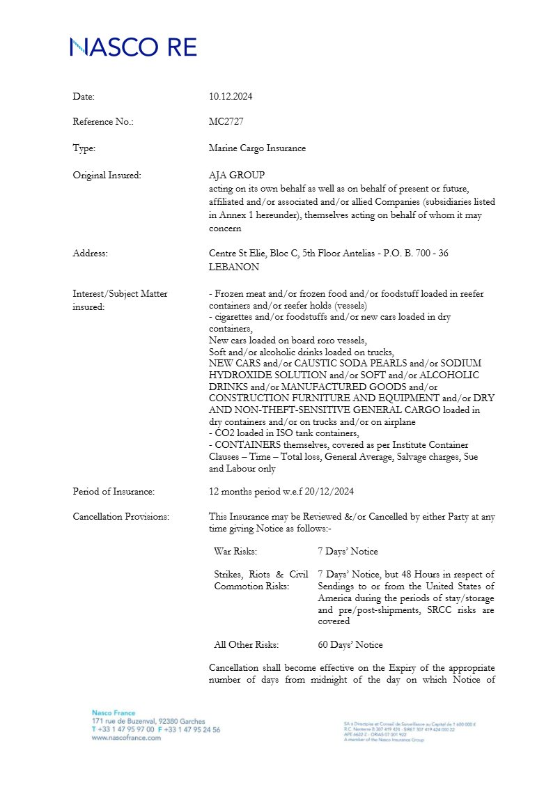
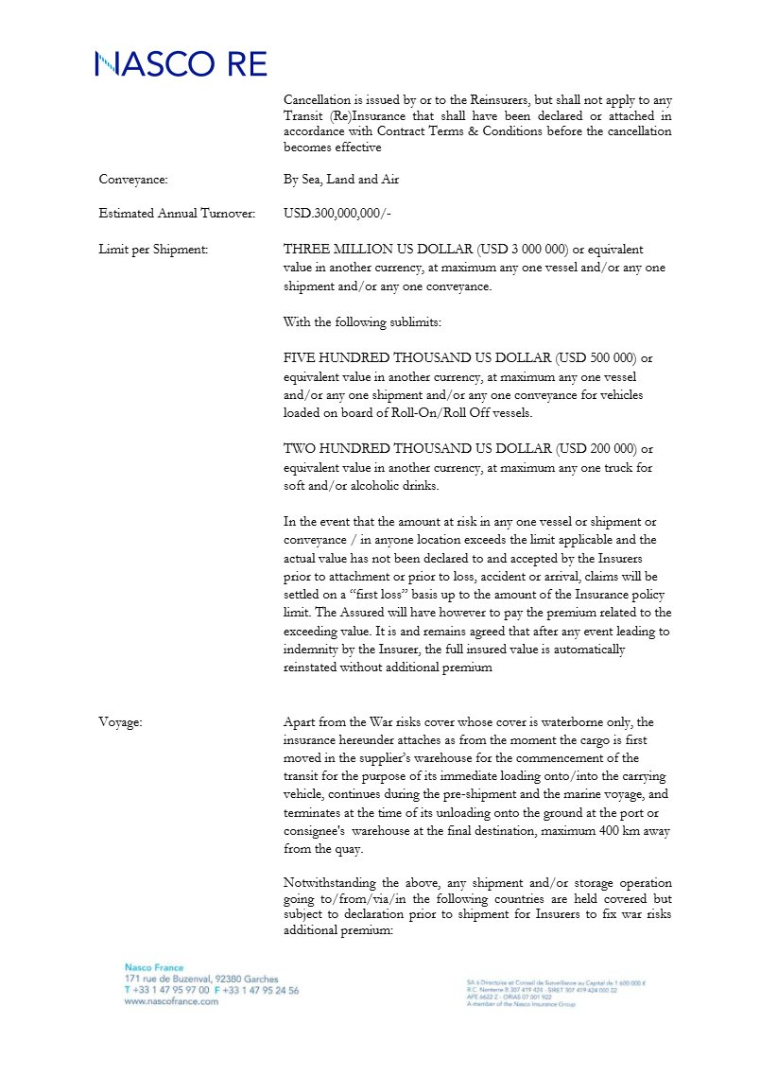
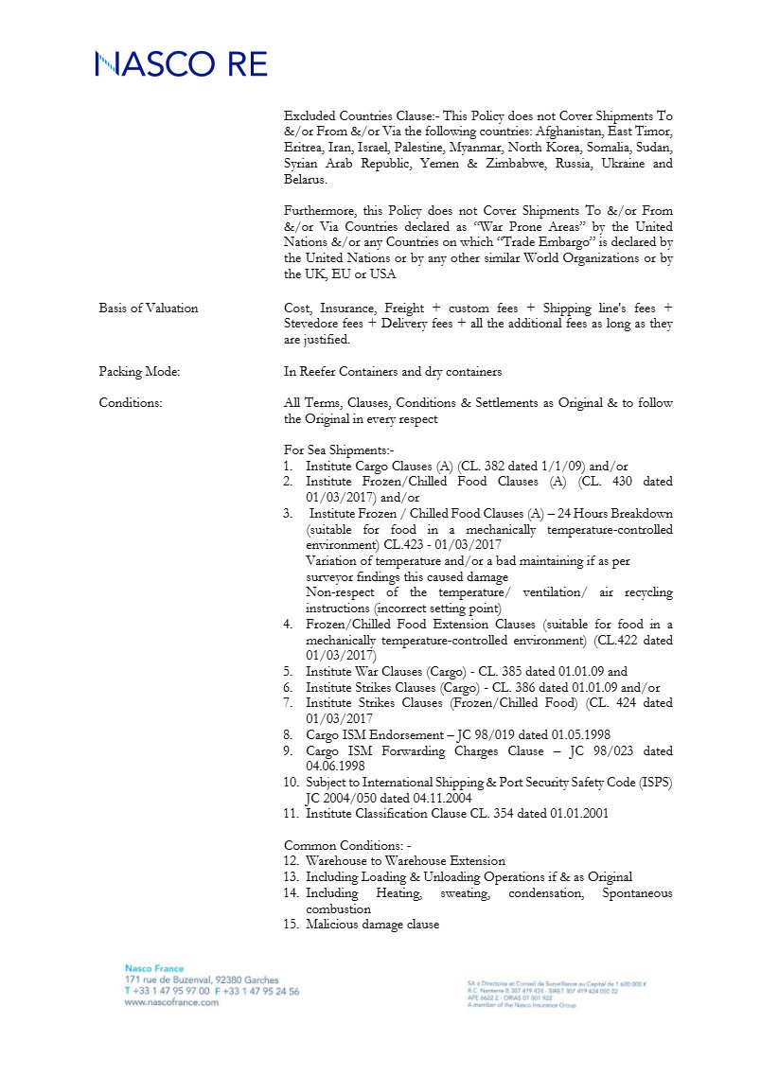
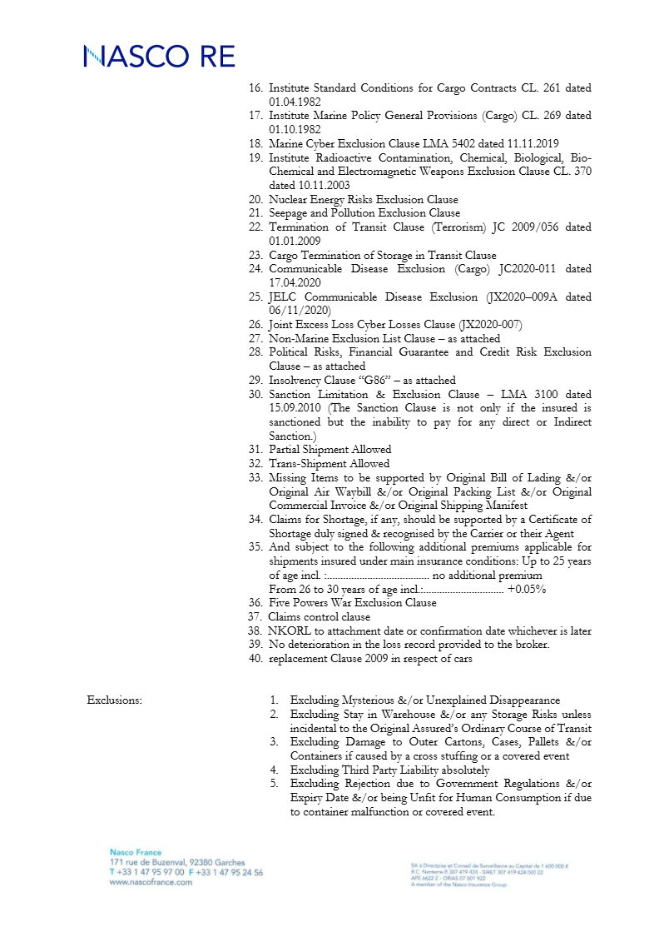
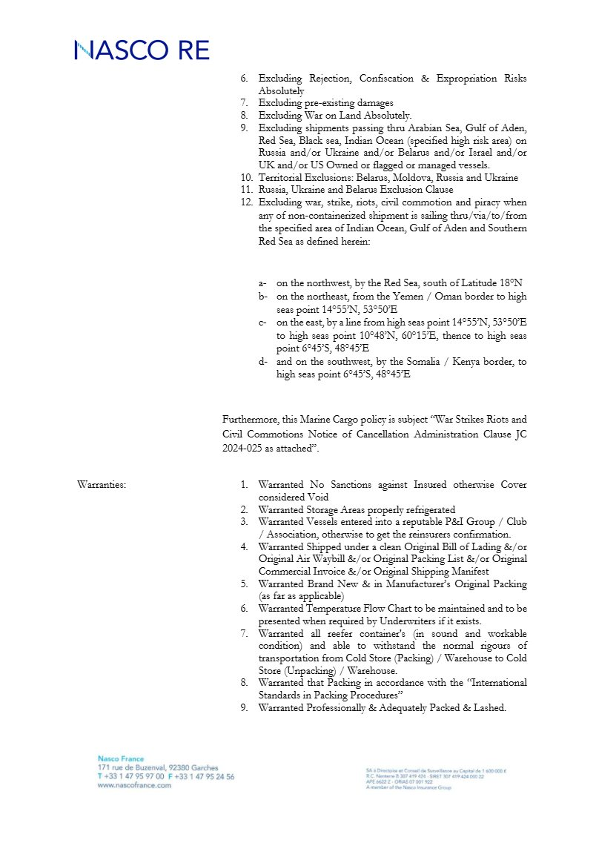
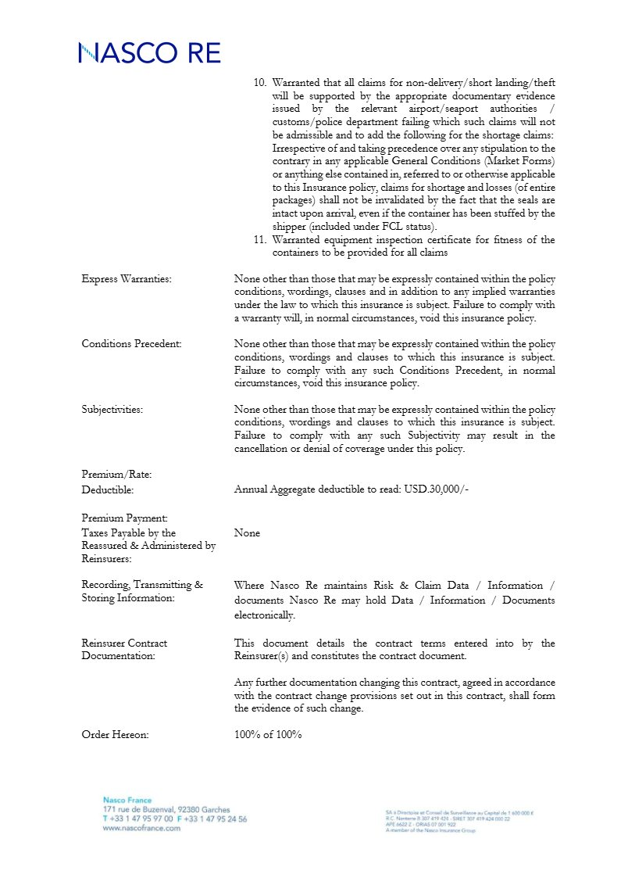
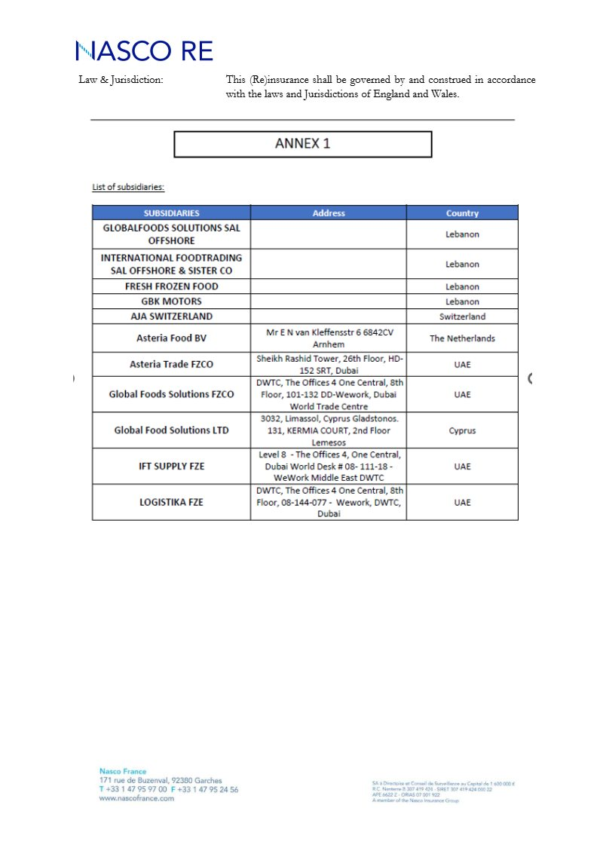
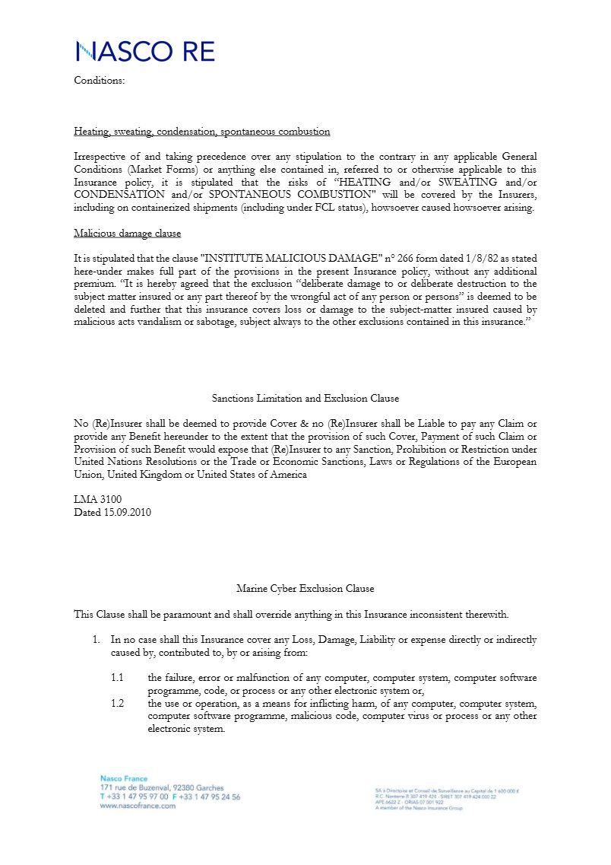
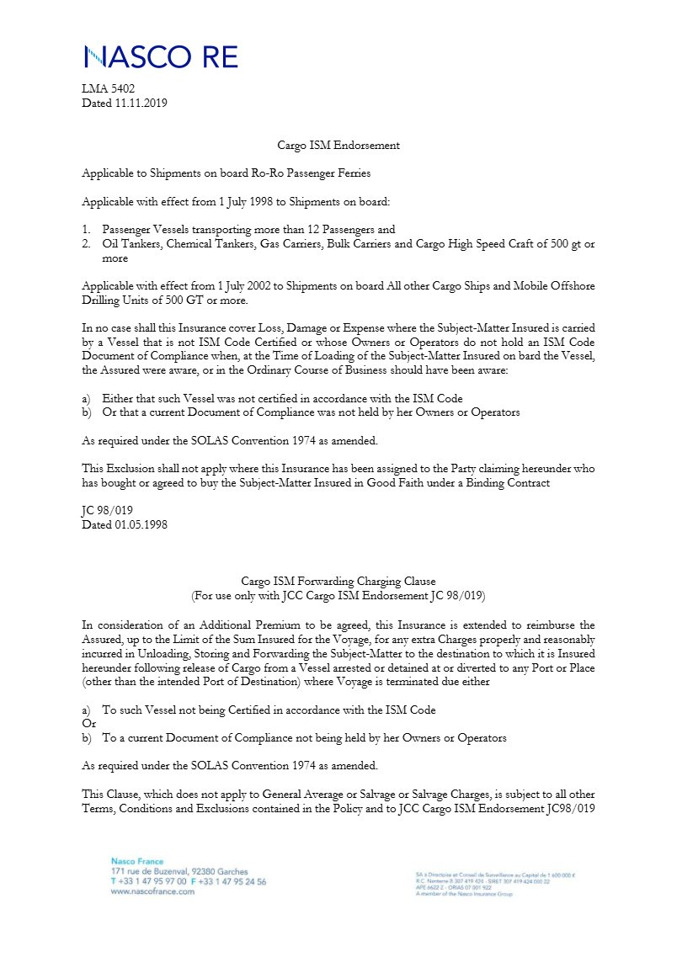
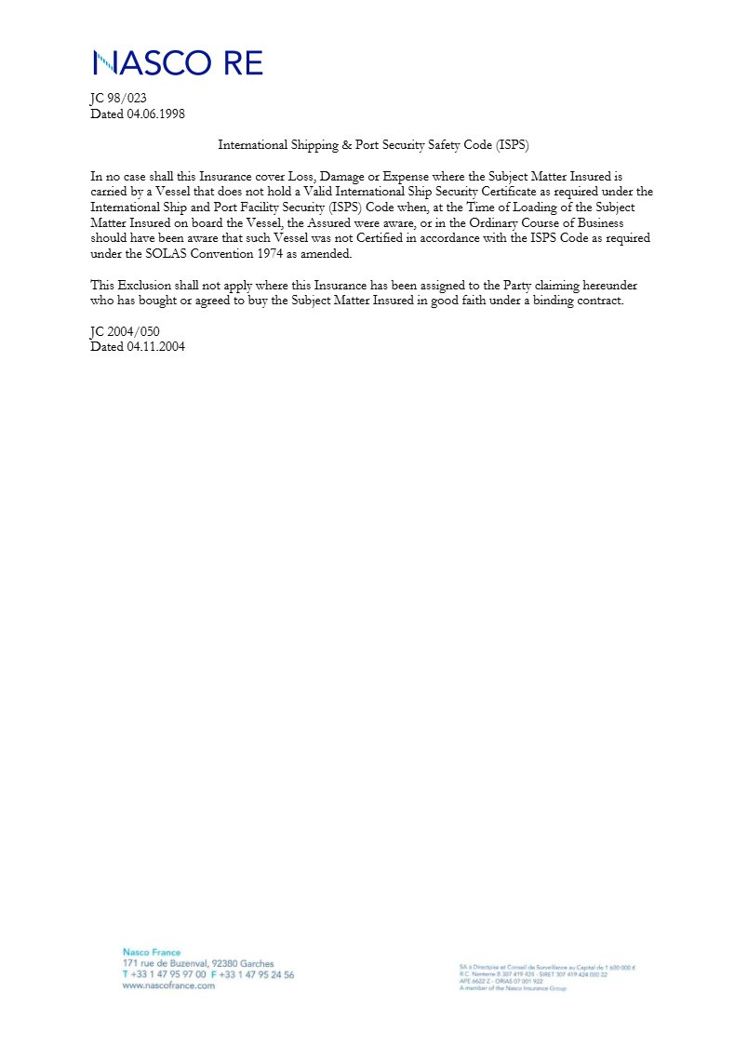
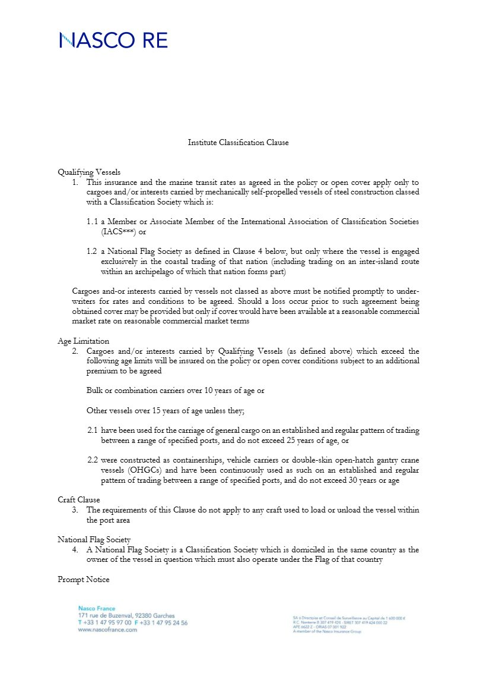
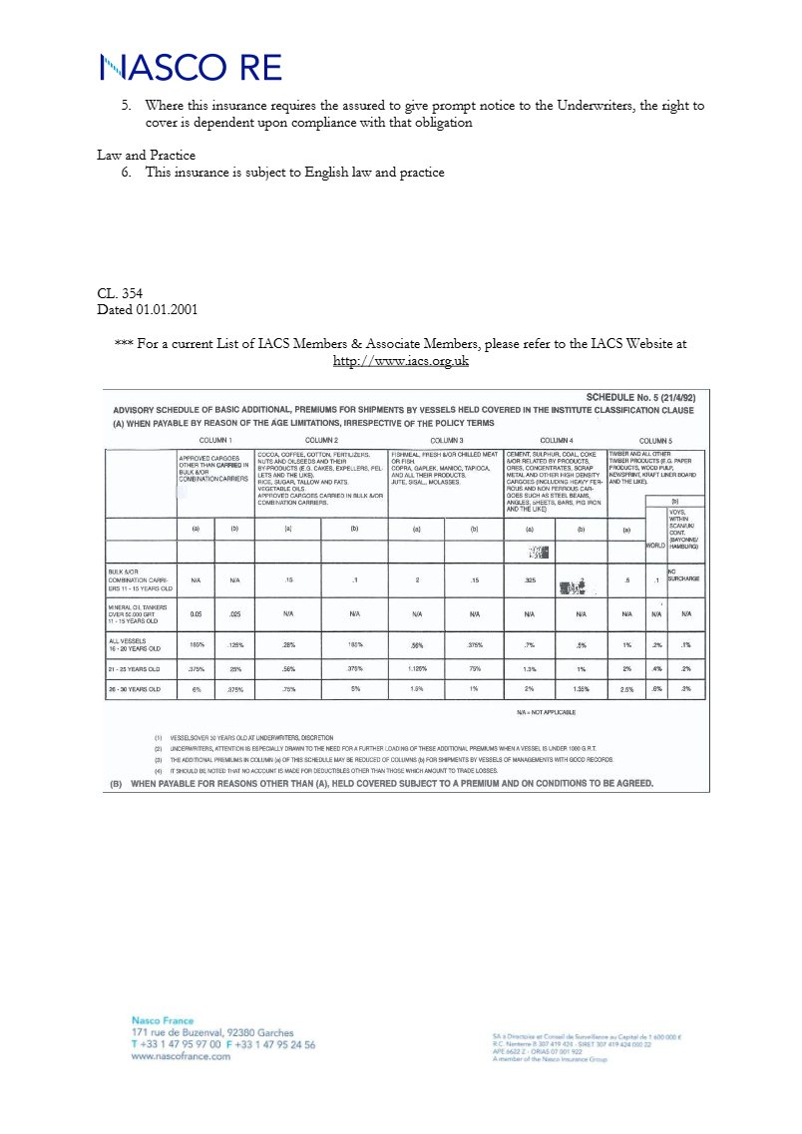
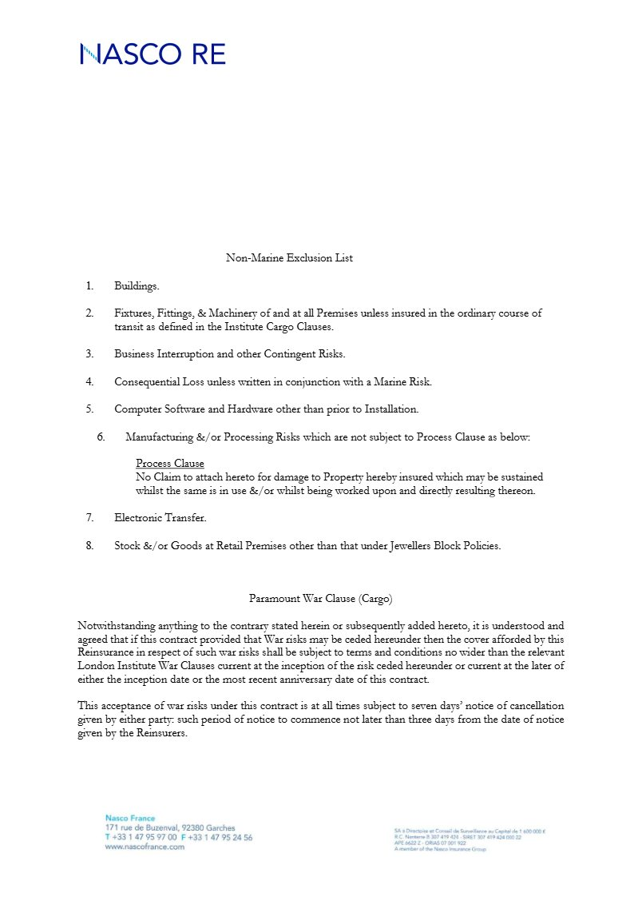
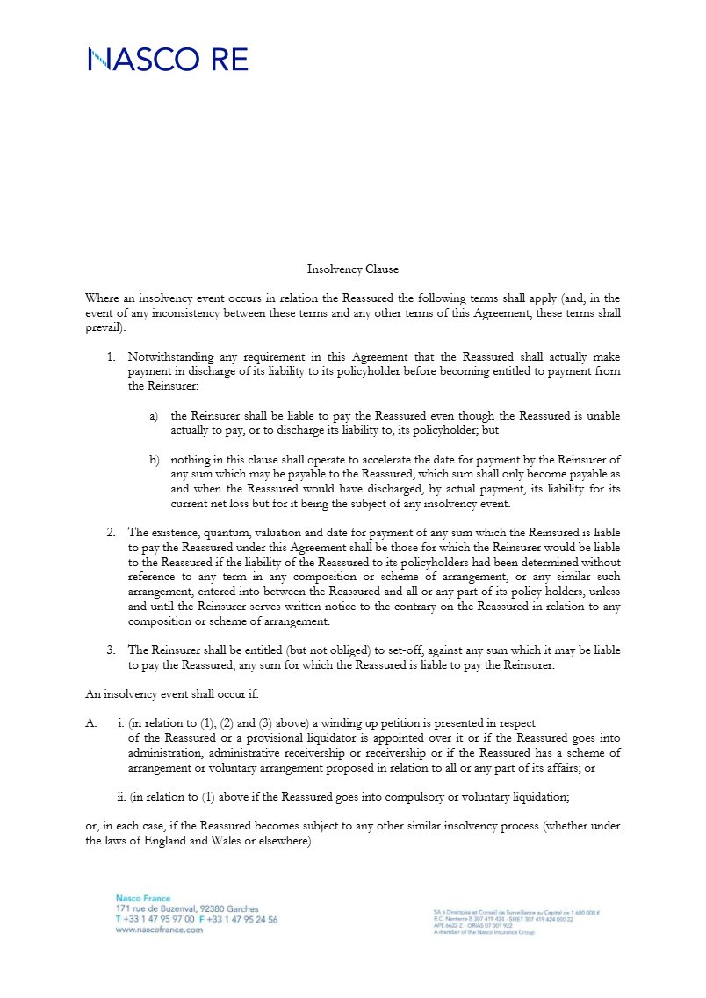
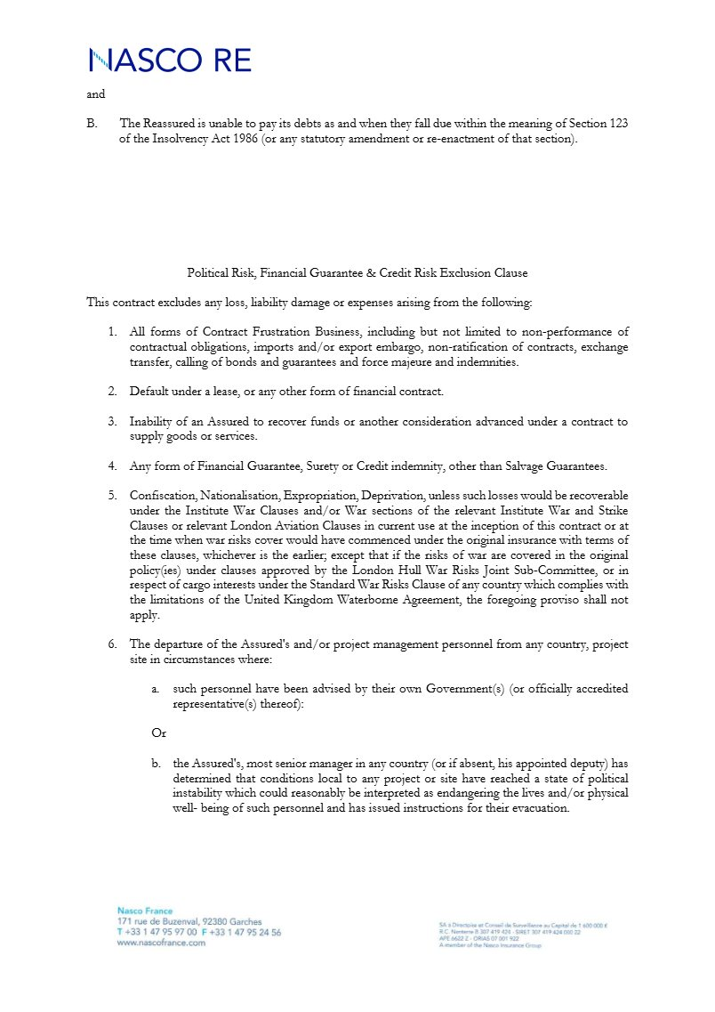
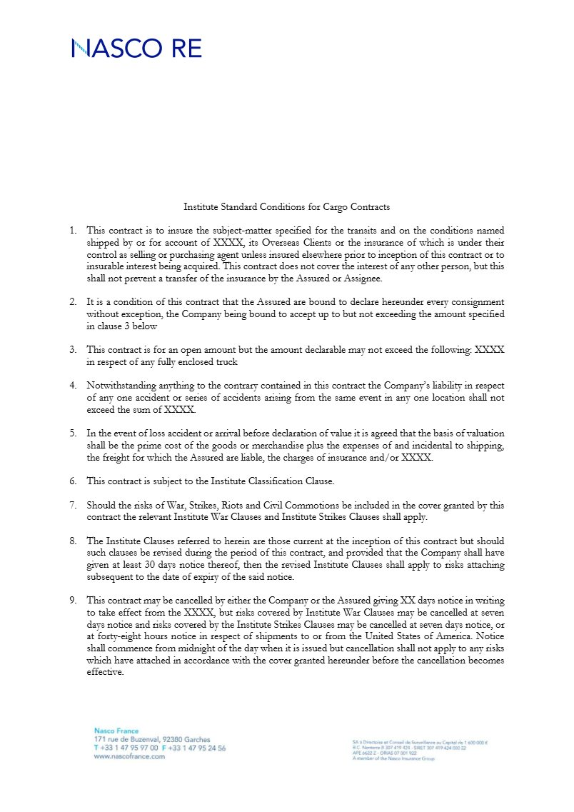
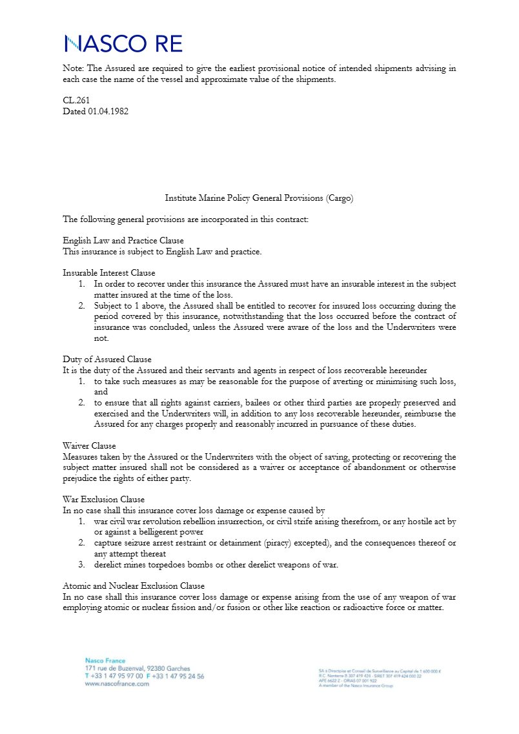
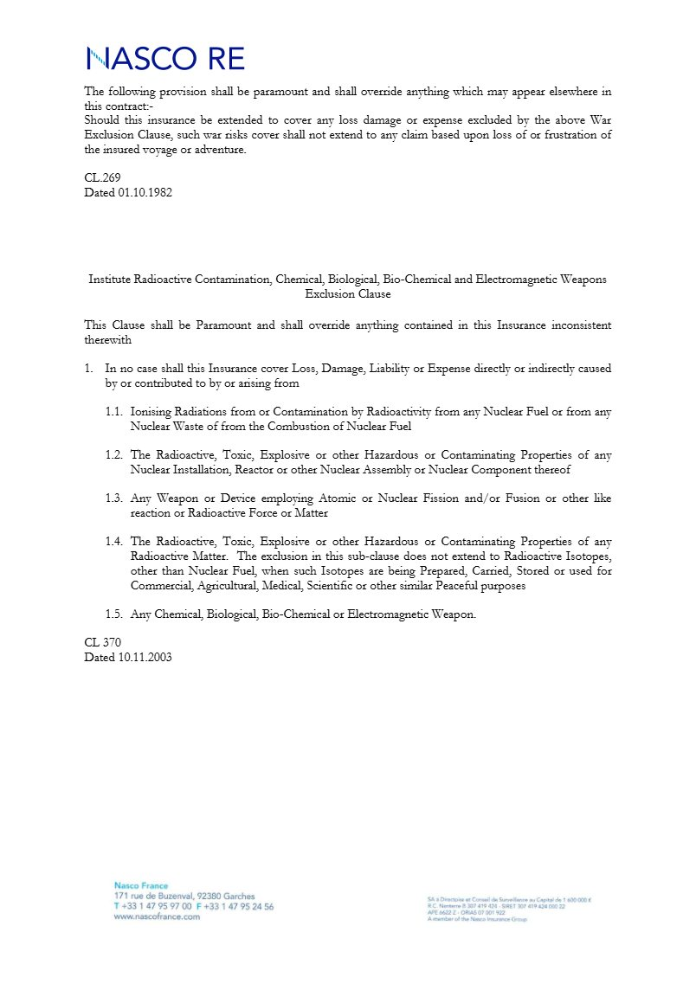
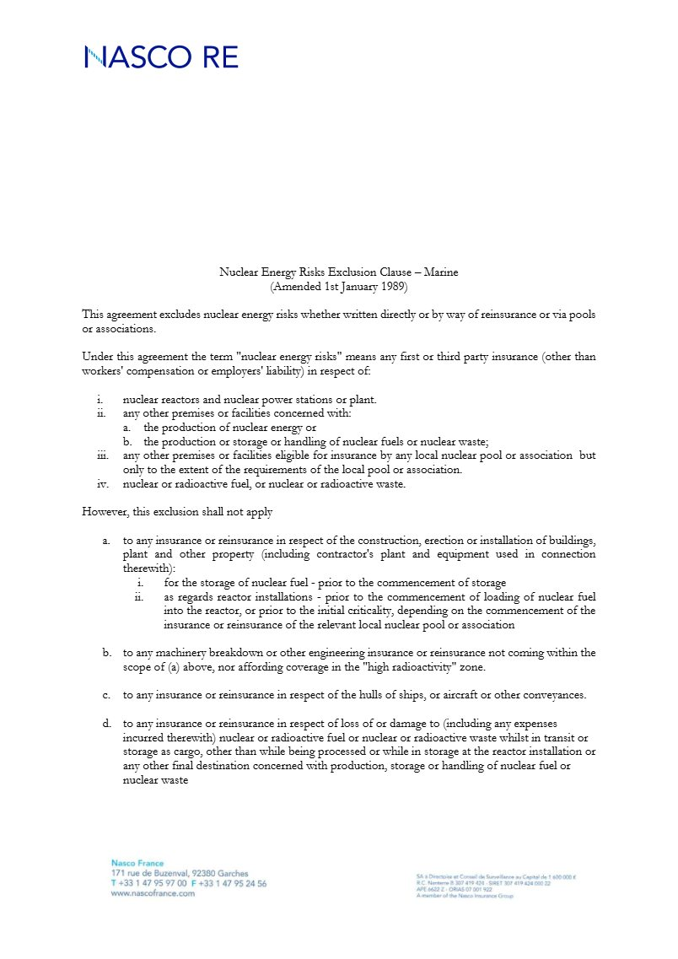
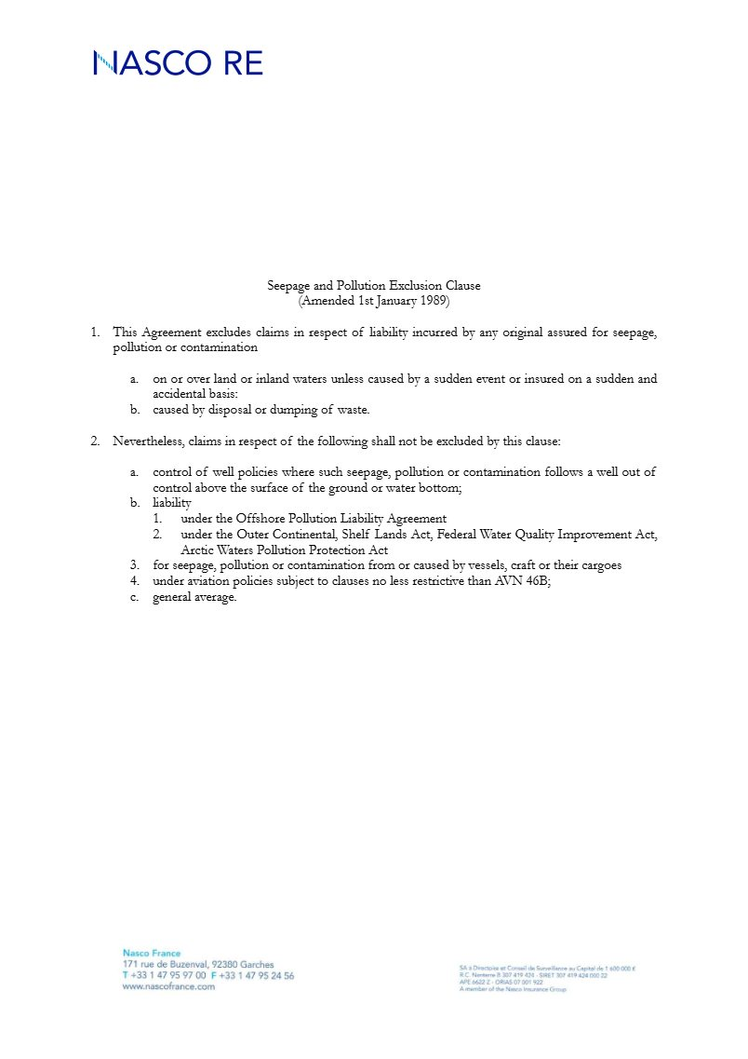
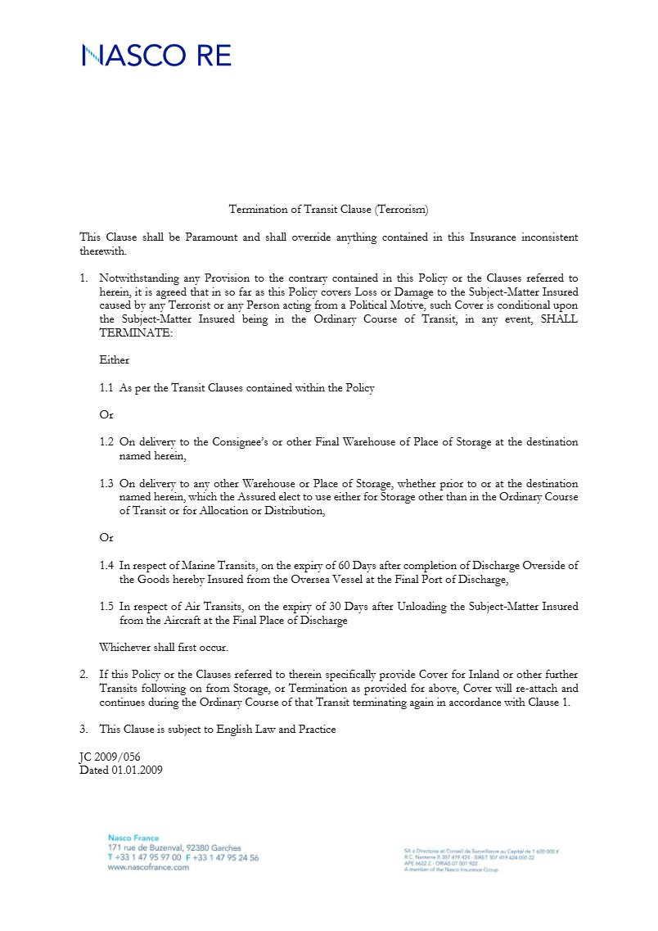
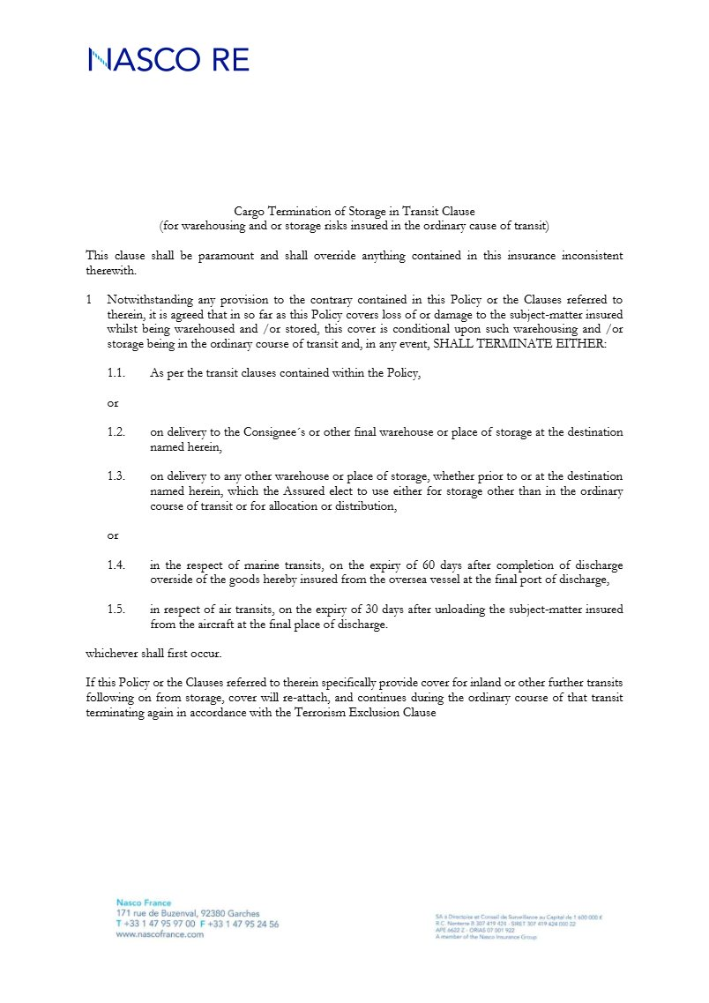
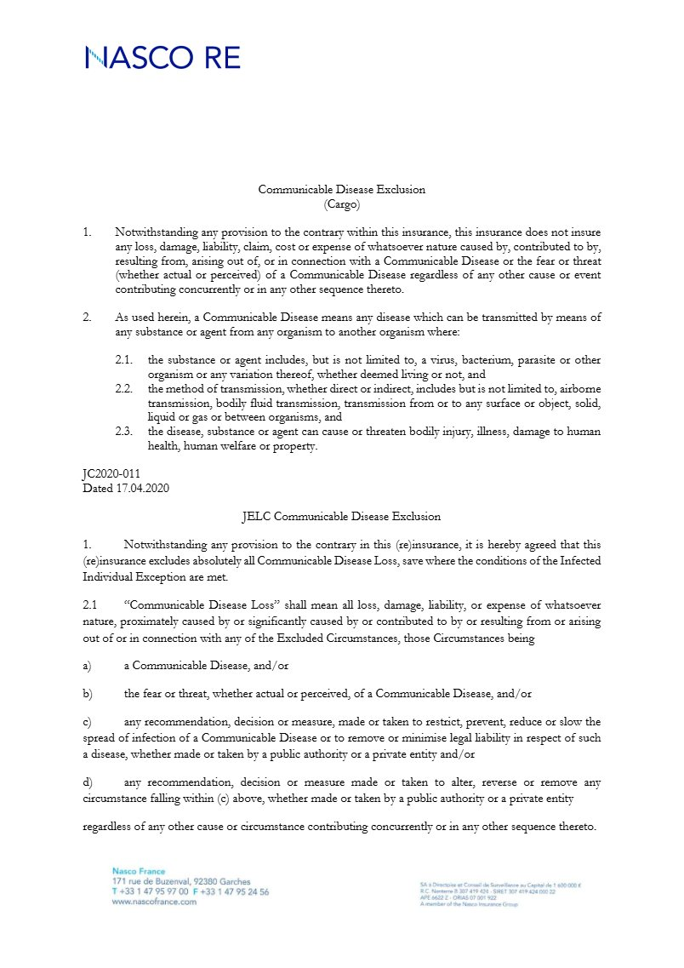
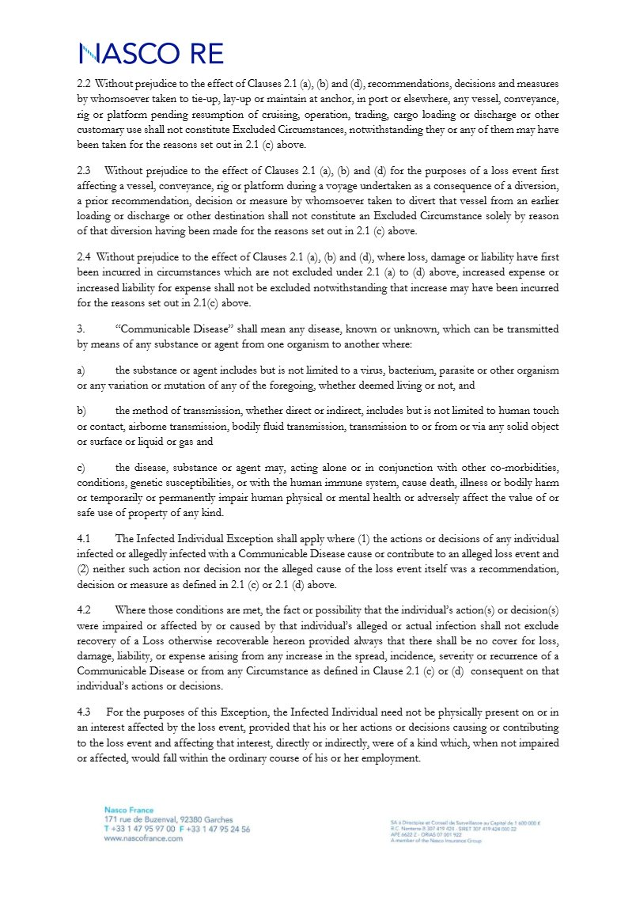
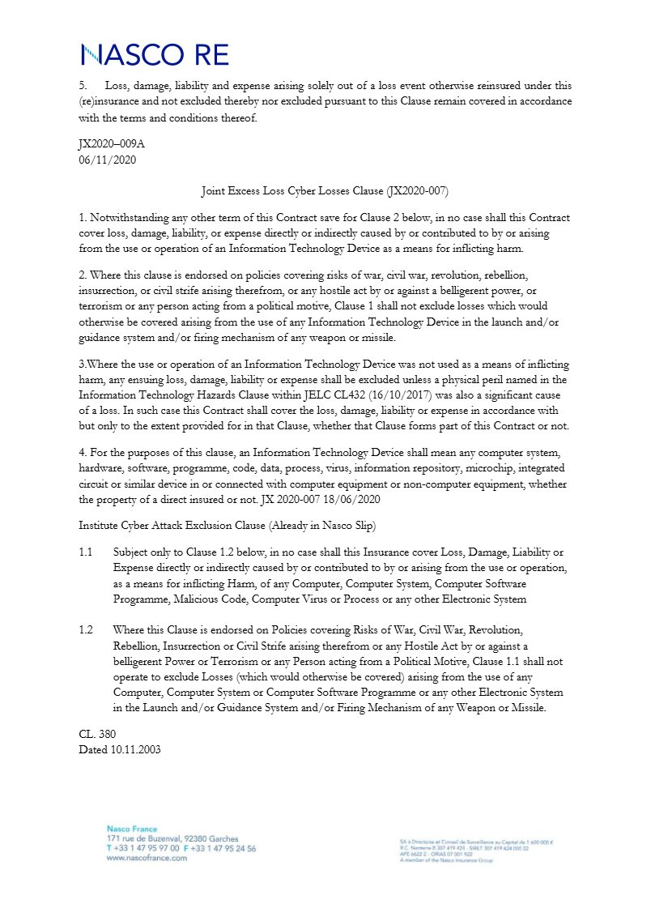
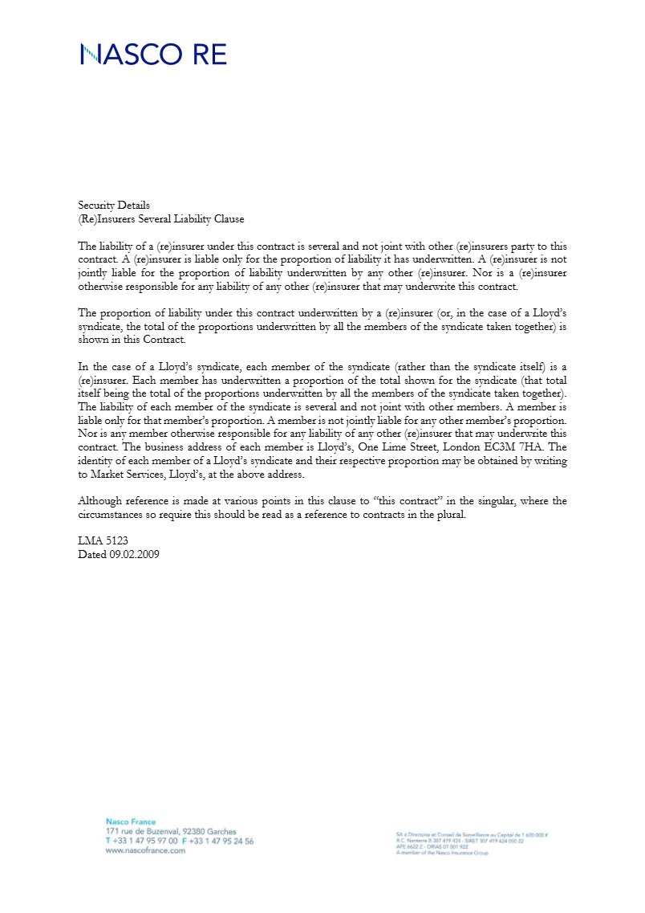
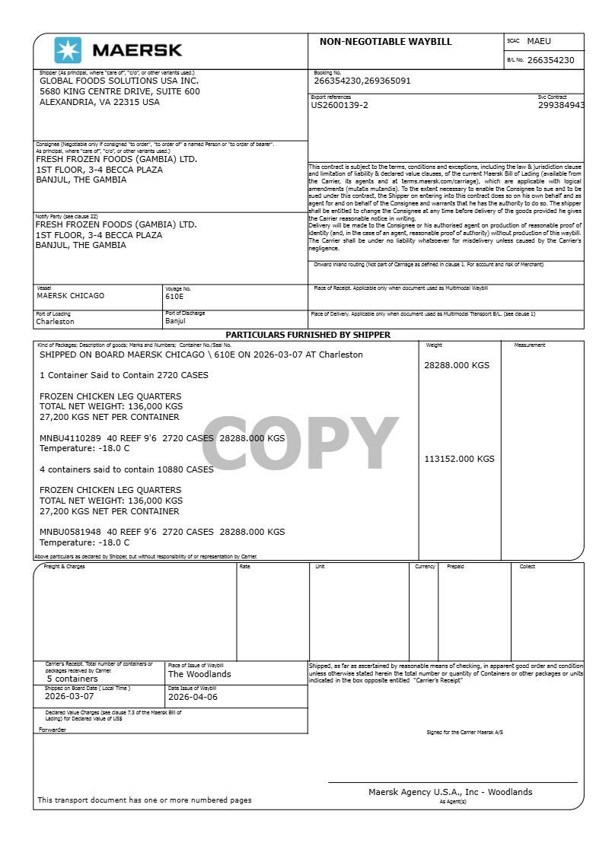
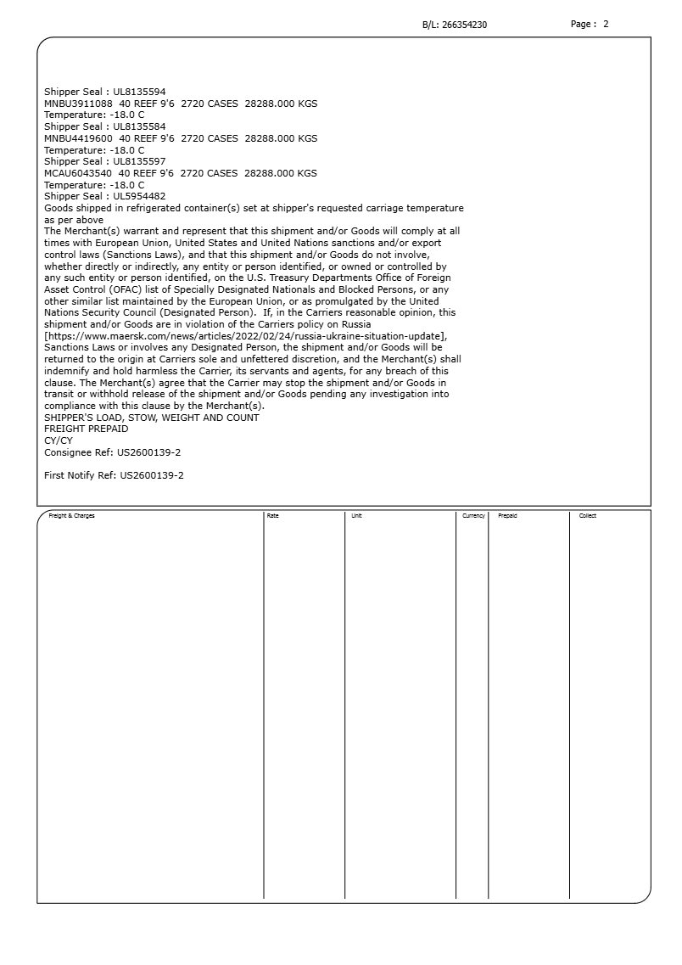
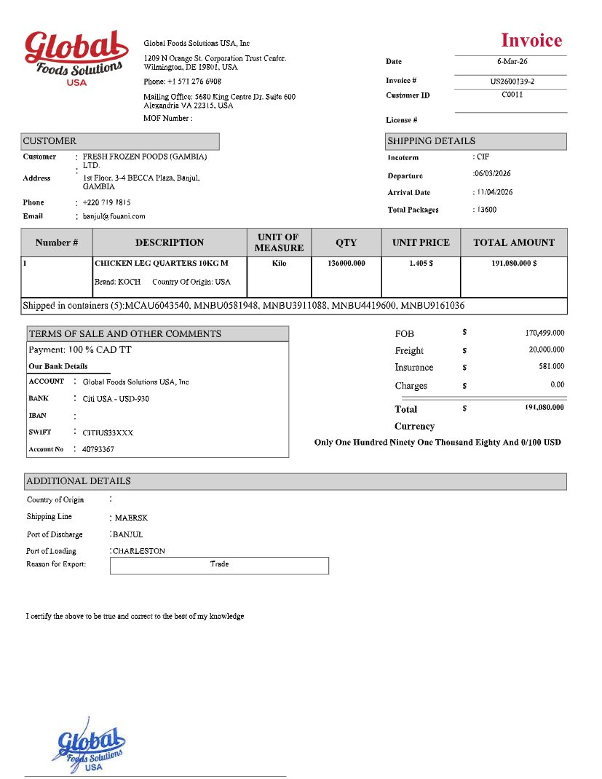
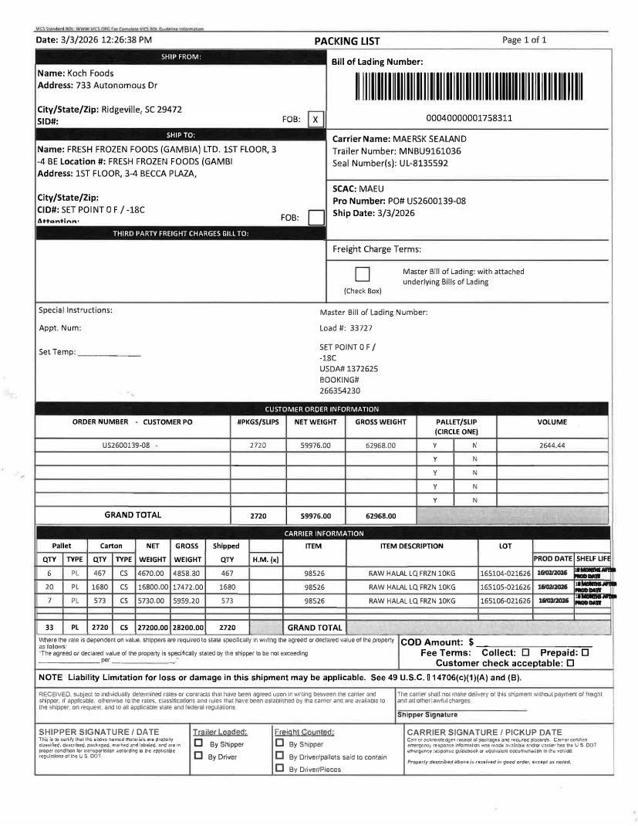
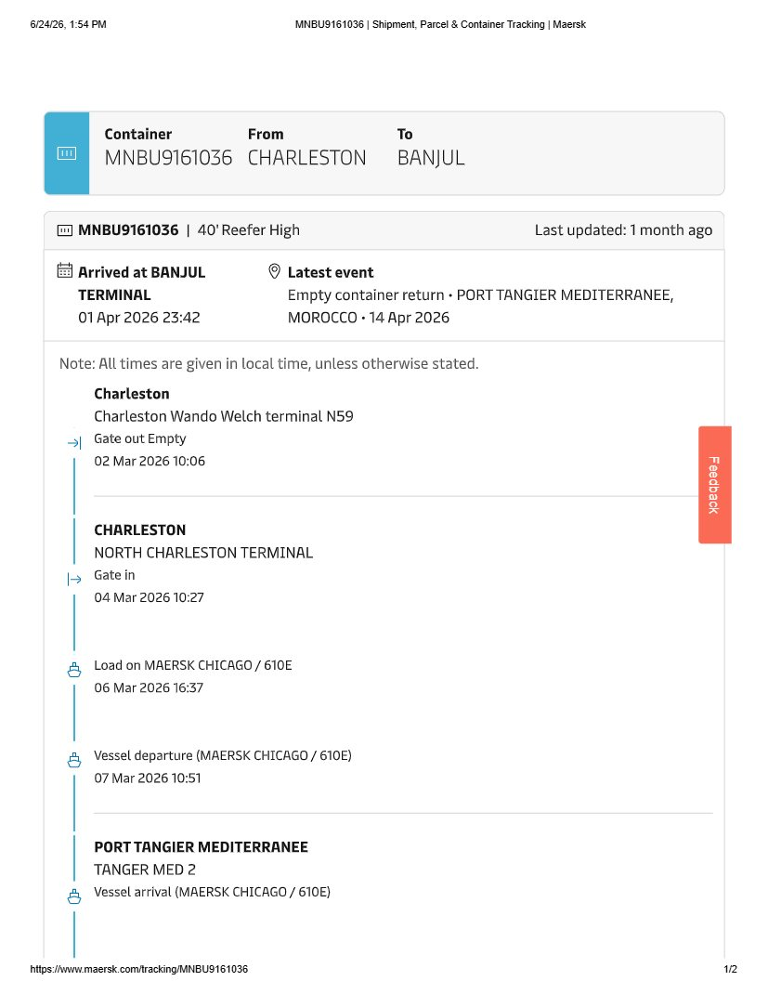
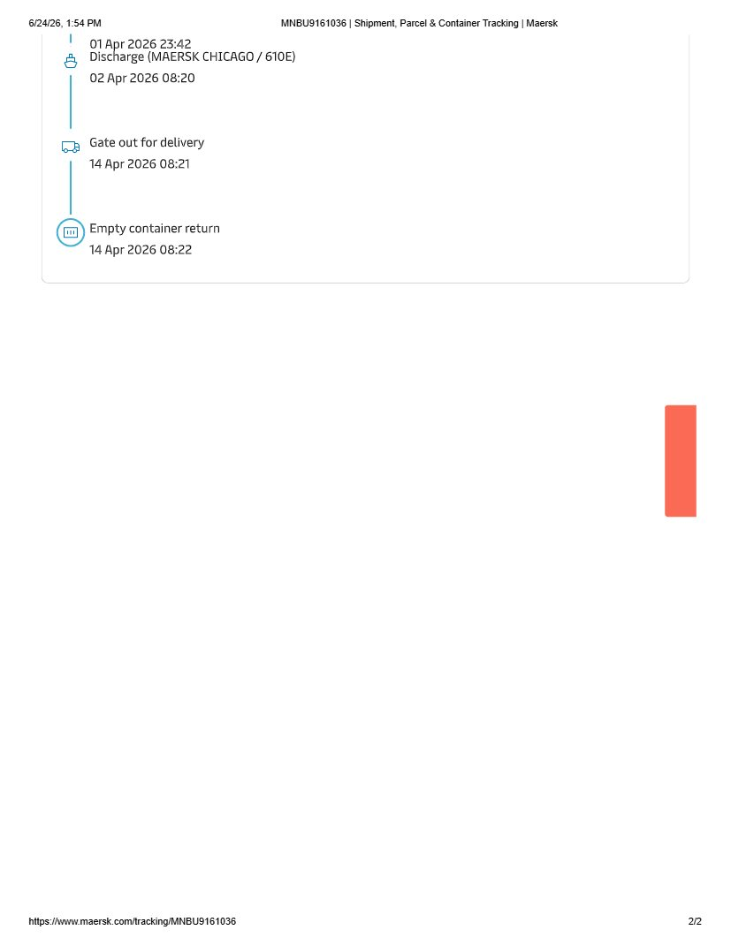
About ULA
United Loss Adjusters and Surveyors (ULA) is a leading international provider of Adjusters, Surveyors, Solicitors and Consultants, offering unrivalled technical and legal solutions with exclusive access to the London Market's leading specialists.
Founded in 2002, with strategic head offices in the Middle East and the United Kingdom, today ULA is the strategic ally of a world-leading legal firm (with offices in over 60 major countries) and the correspondent for a number of global technical service providers (with offices in 140+ countries), with principals including but not limited to Insurers, Reinsurers, Brokers, P&I clubs, Ship Owners, Shipyards and Agencies.
Lines of business:
- Insurance & Re-insurance
- Claims solutions and loss adjusting across all major lines: aviation, cargo, marine, property, fine arts and special risks claims
- Cargo & Containers
- Marine & Offshore
- Global Claim Recoveries & Legal Support
Our team:
Our team of qualified professionals experienced in the fields of Marine, Insurance, Finance, Engineering and Law known and respected for their integrity and credibility. Supported by a highly mobile team strategically positioned where our services are needed, we are always available on short notice to deal promptly with your queries. ULA is independent to the core and can be trusted to express unbiased views, and is not influenced by stakeholders.
ULA’s team members are recognised:
- Chartered Engineers
- Consultants
- Inspectors & Auditors
- Insurance & Re-Insurance Underwriters
- Loss & Average Adjusters
- Master Mariners & Chief Engineers
- Naval Architects, Marine & Offshore Engineers
- Solicitors
- Sworn Surveyors
ULA’s team members are also recognised members of the following international institutions:
- The Association of Average Adjusters (AAA)
- The Bar Council of England and Wales
- The Chartered Insurance Institute (CII)
- The Chartered Institute of Loss Adjusters (CILA)
- The European Federation of Loss Adjusting Experts (FUEDI)
- The Institute of Fire Engineers (IFE)
- The Institute of Marine Engineering, Science and Technology (IMarEST)
- The UK Engineering Council
- The Royal Institute of Naval Architects (RINA)
- The International Institute of Marine Surveying (IIMS)
- The Royal Institute of Chartered Surveyors (RICS)

Contact person
United Kingdom: 71-75 Shelton Street, Covent Garden | London, England - WC2H 9JQ
Middle East: Mina Tower, Ain Warda Street | Beirut, Lebanon - WG2G+5CX

Registered name United Loss Adjusters and Surveyors Ltd.

24/7 Contacts & Claim Support – T: +44 (0) 20 3287 3326 | M/WhatsApp: +44 (0) 7 375 110 573
Office E: mailto:claims@unitedlossadjusters.com
W: https://www.unitedlossadjusters.com/



