Elite Insurance - AFRI-FOOD SARLU - Marine Cargo Claim

ULA reference: ULA-2026-0007 - 1v1
Applicant's Name: Elite Insurance
Assured's Name: AFRI-FOOD SARLU
Policy No.: CPRLBN-2025-0760-QAT-MAR
01 September 2026

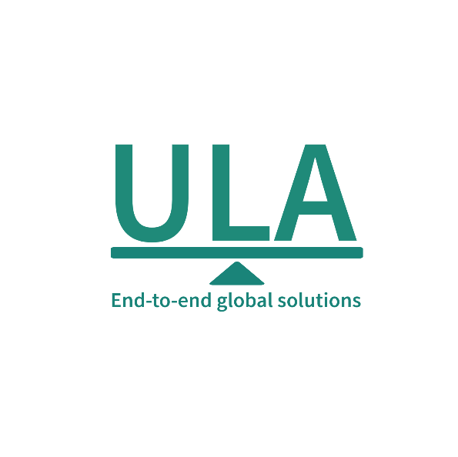
It’s about time you receive the quality of service and expertise your firm deserves.
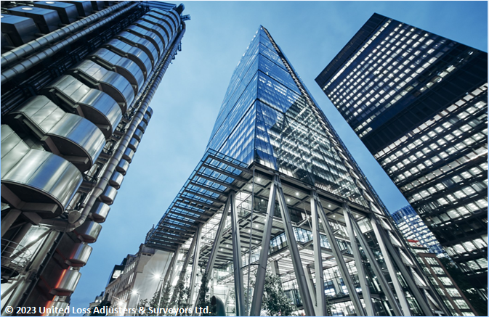

Document Control Page
Written by: | Reviewed by: | Approved by:
Tony Lahoud | To be assigned | To be assigned
Designation: | Designation: | Designation:
Claims Handler | Claims Director / Technical Reviewer | Director / Chartered Adjuster
Signature (Approver)
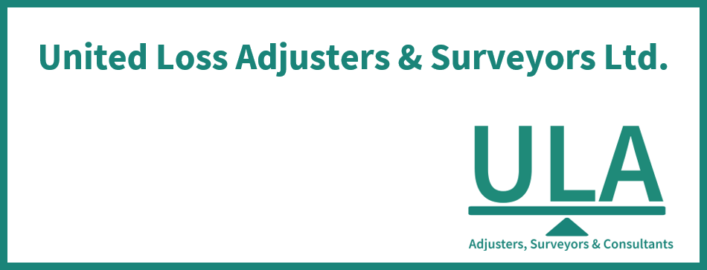
This survey and its issued report were completed without prejudice to all rights of parties concerned.
Date of approval
Pending professional approval

Version History | Date of issue | Reason for Revision
1 | 01 September 2026 | Locally generated controlled draft; professional review required
The contents of this report are for the confidential information of the client
This survey and its issued report were completed without prejudice to all rights of parties concerned and its concluded adjustment is in accordance with the terms and conditions of the relevant insurance policy.
Report Summary
At the request of Elite Insurance (the Applicant), ULA was requested to investigate a Marine Cargo (Non-Reefer) claim for AFRI-FOOD SARLU (the Assured), establish the circumstances and extent of loss, and adjust the claim presented under the policy. The insured interest is Ceramic sanitary ware.
In brief, Table 1 records AFRI-FOOD SARLU as the Assured, Ceramic sanitary ware as the insured interest, movement from CN to Democratic Republic of Congo, Policy No. CPRLBN-2025-0760-QAT-MAR.
Assured's / Shipper's Name | AFRI-FOOD SARLU (Assured)
Consignee's Name | STE IMMOBILIERE CONGOLAISE DE REFERENCE SARL (SICOREF)
Insurance Policy | No. CPRLBN-2025-0760-QAT-MAR  Insured Period: 12 months  Insured Value / Limit: USD 52,967.67  Basis of Valuation: Invoice Value + 10%  Deductible / Excess: USD 250.00

In our opinion,
- The above adjusted claim amount in USD cannot be stated as fair & reasonable because a fully supported and reconciled adjusted amount is not established from the reviewed evidence.
- The proximate cause of loss is not expressly established as a source fact; on the available evidence, the observed breakage and collapsed cartons are consistent with impact or crush damage, but the precise damaging event and custody stage are not established.
- Cover advice: The identified policy warranties, exclusions, valuation provisions, and other operative terms must be applied to the established facts before cover is confirmed; final cover remains subject to professional review and approval.
- Liable-party position: No liable party is established from the reviewed evidence; no recovery allegation is made, and any potential rights remain subject to further evidence and professional review.
- We confirm having sighted the originals of all documents customarily submitted in support of a claim of this nature and remain at Insurers disposal for further instructions.
Report and adjustment note
At the request of Elite Insurance (the Applicant), ULA was requested to investigate a Marine Cargo (Non-Reefer) claim for AFRI-FOOD SARLU (the Assured), establish the circumstances and extent of loss, and adjust the claim presented under the policy. The insured interest is Ceramic sanitary ware. This report and adjustment note sets out our findings, causal assessment and adjustment position; supporting documents are retained and transmitted separately.
Table 1 - Summary and salient details
Applicant's Name | Elite Insurance
Assured's Name | AFRI-FOOD SARLU
Insurance Policy | No. CPRLBN-2025-0760-QAT-MAR  Insured Period: 12 months  Insured Value / Limit: USD 52,967.67  Conveyance / Shipment Limits: Maximum Limit per shipment: USD 14,000,000.00  Transit Scope: Warehouse to Warehouse  Basis of Valuation: Invoice Value + 10%  Clauses / Basis of Cover: Institute Cargo Clauses “A” CL. 382 dated 01.01.2009  Extensions / Inclusions: Including Loading and Unloading Operations  Conditions: Institute Cargo Clauses “A” CL. 382 dated 01.01.2009  Deductible / Excess: USD 250.00
Incoterm / Terms of sale | FOB
Transport Document | Bill of Lading: Not established from the reviewed evidence
Shipper's Name | Not established from the reviewed evidence
Consignee's Name | STE IMMOBILIERE CONGOLAISE DE REFERENCE SARL (SICOREF)
Cargo / Commodities | MRKU2460930, SUDU8739613; 1,045 cartons / 915 pcs; Ceramic sanitary ware
Origin / Destination | CN / Democratic Republic of Congo
Carrying Vessel / Carrier | X-PRES PISCES / 621S; Feeder GFS LYSA / 2628
Cargo Arrival / Delivery Date | Discharged 2026-07-10; Delivered 2026-07-15

INTEREST INSURED & RELEVANT CONDITIONS OF INSURANCE POLICY
Ceramic sanitary ware was documented for transit from CN to Democratic Republic of Congo under Policy No. CPRLBN-2025-0760-QAT-MAR.

SHIPMENT ROUTING
Supplier factory/warehouse (Chaozhou/Fuqing, China) → Xiamen port (loaded X-PRES PISCES voy 621S, 2026-05-20) → transshipment (feeder GFS LYSA voy 2628, arriving Matadi) → Matadi Gateway Terminal EIR gate-out 2026-07-10 → land transport → consignee's warehouse Limite 12eme Rue, Kinshasa (delivered 2026-07-15)

SURVEYOR NOTES
- Material chronology. 2025-11-03: Policy inception. 2026-03-06: Packing list issued. 2026-03-06: Commercial invoice issued. 2026-05-20: Cargo departed. 2026-05-20: Cargo shipped on board.
- Shipment and transit. The delivery tally (Fiche de Pointage, 15 July 2026) records 29 broken cartons and 1 missing H-477, broadly consistent with the SOF count of 30 but differing in specifics. The remaining cargo was accepted by the consignee as sound, establishing 30 as the maximum surveyed loss scope; the full shipment value must not be used as the loss base.
- Survey observations and extent of loss. The ULA SOF records 30 broken items in MRKU2460930: 19x model 7002 washbasin, 4x model 7003 washbasin, and 7x model 7003 pedestal stand, all rejected as broken and unfit. The claim schedule records only 26 units (19x7002 + 6x7003 + 1xH-477) with no pedestal stand line and a different 7003 count, creating a material quantity conflict.
- Packing and protection. The available photographs visually confirm multiple broken ceramic pieces, including washbasins and pedestals, removed from collapsed cartons and are consistent with impact or crush damage.
- Carrier, recovery and adjustment considerations. The discrepancy between SOF (30 items, including 7 pedestal stands) and claim schedule (26 items, no stands, 1 H-477 missing) must be reconciled before quantum is finalised.
Description | Boxes / Quantity | Packing
Affected cargo identified in the survey evidence | 30 (surveyed); 26+1 (claim schedule) units | As recorded in the cited survey evidence

CAUSE OF LOSS
The proximate cause of loss is not expressly established as a source fact; on the available evidence, the observed breakage and collapsed cartons are consistent with impact or crush damage, but the precise damaging event and custody stage are not established.
The material physical and survey circumstances are as follows: The ULA SOF records 30 broken items in MRKU2460930: 19x model 7002 washbasin, 4x model 7003 washbasin, and 7x model 7003 pedestal stand, all rejected as broken and unfit. The claim schedule records only 26 units (19x7002 + 6x7003 + 1xH-477) with no pedestal stand line and a different 7003 count, creating a material quantity conflict.
Handling impact, compression, cargo movement, and pre-delivery breakage remain open pending contemporaneous handling and delivery evidence capable of distinguishing the material alternatives.
The causal assessment and quantum remain limited by the discrepancy between the SOF and claim schedule, including the different treatment of model 7003, pedestal stands, and the reported missing H-477 item; this must be reconciled before the adjustment is finalised.

RELEVANT POLICY WARRANTIES & CONDITIONS
Representatives / attendance: ULA (Mr Boussana Destin and team) as Cargo Insurers Surveyor; Mr Mohamad as Consignee's representative; Carrier representative abstained.
Mysterious / unexplained disappearance exclusion: evidenced wording: Excluding Mysterious and/or Unexplained Disappearance. The policy wording and related factual evidence are both present; compliance and legal effect remain for professional determination.
Additional evidenced policy terms requiring factual compliance review: Transit attachment / duration; Conveyance / shipment limits; Loading / unloading extension; Exclusions. No compliance, breach, or legal effect is inferred merely from their presence.
No breach, exclusion, coverage, or liability conclusion is made unless it is directly supported by the cited policy wording and claim evidence.

ADEQUACY OF THE INSURED VALUE
The documented invoice value is USD 48,152.43 and the evidenced valuation basis requires a 10% uplift, producing a value at risk of USD 52,967.67. The documented insured value is USD 52,967.67. Accordingly, the invoice values are adequately insured and there is no underinsurance on the evidenced valuation basis.

APPOINTMENT OF ASSESSORS
To date, it is understood that the Assured had not appointed a loss assessor to act on their behalf.

CLAIM PRESENTED ON THE POLICY & ADJUSTMENT
The gross claim of USD 471.40 was presented. Source valuations are not substituted for an absent claim quantum, and unknown deductions are not treated as zero.
The evidenced valuation basis adds 10%, equal to USD 47.14, producing USD 518.54 before deductible and other supported deductions.
Commercial invoice 20260306 records FOB USD 48,152.43, and a total value of USD 48,152.43. These source valuations are not substituted for an absent presented claim.
The available evidence does not contain every component needed to reconcile the commercial invoice total.
The invoice value plus the evidenced 10% valuation uplift equals USD 52967.67, matching the documented insured value.
Table 2 - Claim presented by the Assured & Adjustment
Description | Quantity damaged | Unit Price in USD | Adjusted Claim Value in USD
19x Model 7002 ceramic washbasin broken – claimed value | 19 | USD 18.20 | USD 345.80
6x Model 7003 ceramic washbasin broken – claimed value per claim schedule (discrepancy with SOF: SOF shows 4 basins + 7 stands = 11 units; claim schedule shows 6 units) | 6 | USD 17.10 | USD 102.60
1x Model H-477 ceramic washbasin missing – claimed value | 1 | USD 23.00 | USD 23.00
Itemized Presented Loss ------------------------------------------------------ USD 471.40
Add, Policy Valuation Uplift (10%) ------------------------------- USD 47.14
Claim after Valuation Uplift --------------------------------------------- USD 518.54
Less, Deductible / Excess ---------------------------------------- (USD 250.00)
Provisional Amount after Supported Adjustments ---------------------- USD 268.54
Concluded Indemnity ------------------------------------------------------ Not established from the reviewed evidence
A concluded indemnity cannot be calculated without unsupported assumptions.

CONCLUSION
In our opinion,
- The above adjusted claim amount in USD cannot be stated as fair & reasonable because a fully supported and reconciled adjusted amount is not established from the reviewed evidence.
- The proximate cause of loss is not expressly established as a source fact; on the available evidence, the observed breakage and collapsed cartons are consistent with impact or crush damage, but the precise damaging event and custody stage are not established.
- Cover advice: The identified policy warranties, exclusions, valuation provisions, and other operative terms must be applied to the established facts before cover is confirmed; final cover remains subject to professional review and approval.
- Liable-party position: No liable party is established from the reviewed evidence; no recovery allegation is made, and any potential rights remain subject to further evidence and professional review.
- We confirm having sighted the originals of all documents customarily submitted in support of a claim of this nature and remain at Insurers disposal for further instructions.

Enclosure to this report

Outstanding Documents

Appendix A - Photographs
Photographs reproduce material views available in the current claim file, including the insured interest, packaging, identification markings, and observed condition where shown.
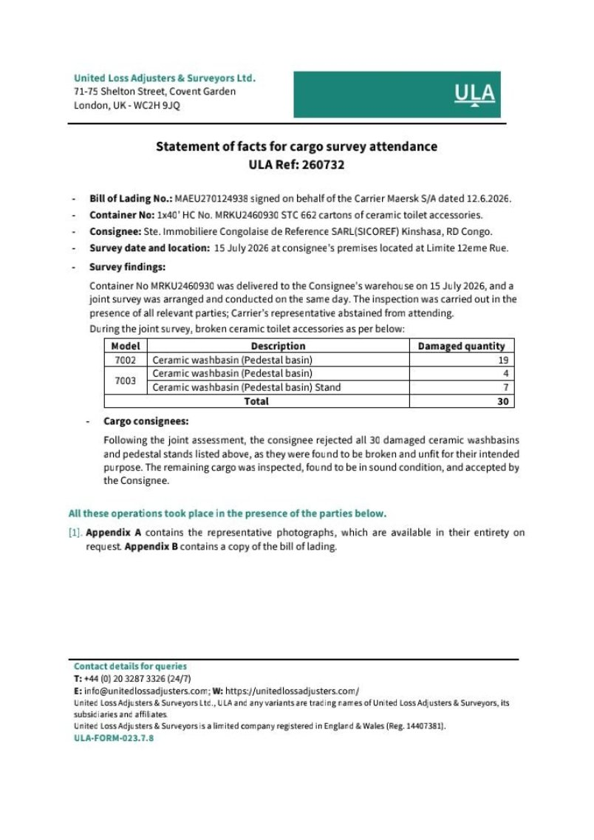 | 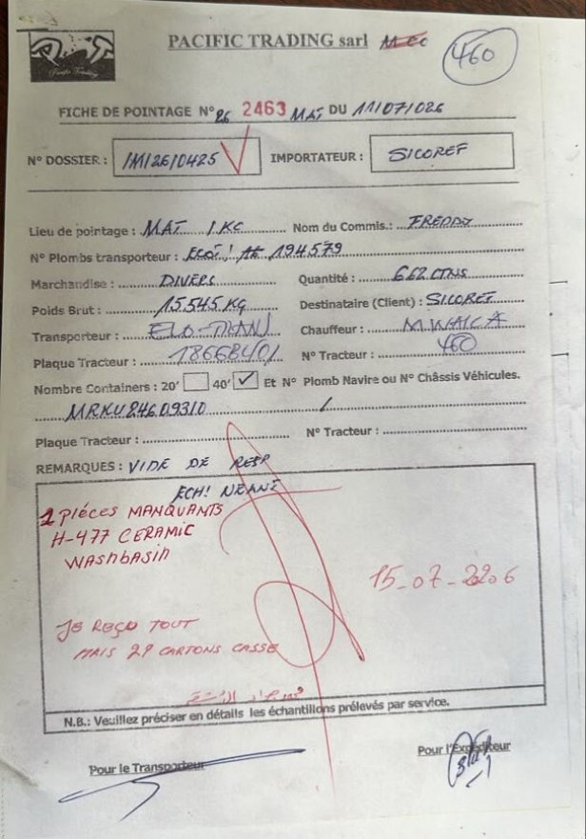
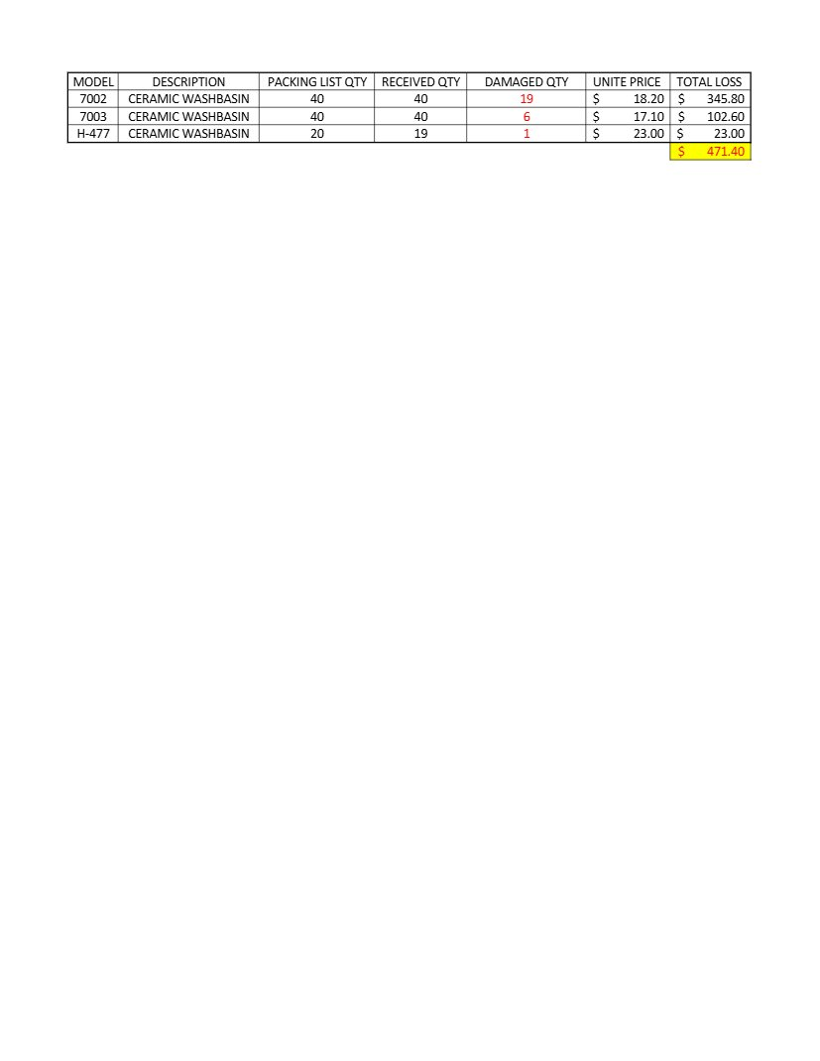 | 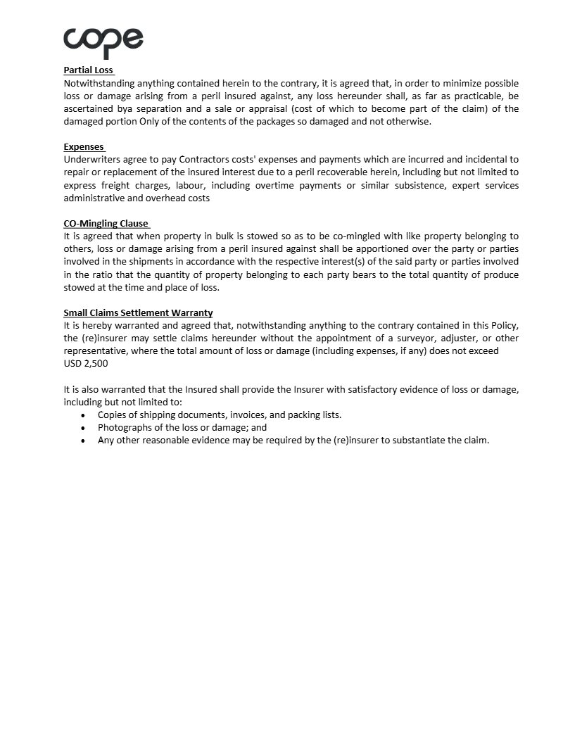
About ULA
United Loss Adjusters and Surveyors (ULA) is a leading international provider of Adjusters, Surveyors, Solicitors and Consultants, offering unrivalled technical and legal solutions with exclusive access to the London Market's leading specialists.
Founded in 2002, with strategic head offices in the Middle East and the United Kingdom, today ULA is the strategic ally of a world-leading legal firm (with offices in over 60 major countries) and the correspondent for a number of global technical service providers (with offices in 140+ countries), with principals including but not limited to Insurers, Reinsurers, Brokers, P&I clubs, Ship Owners, Shipyards and Agencies.
Lines of business:
- Insurance & Re-insurance
- Claims solutions and loss adjusting across all major lines: aviation, cargo, marine, property, fine arts and special risks claims
- Cargo & Containers
- Marine & Offshore
- Global Claim Recoveries & Legal Support
Our team:
Our team of qualified professionals experienced in the fields of Marine, Insurance, Finance, Engineering and Law known and respected for their integrity and credibility. Supported by a highly mobile team strategically positioned where our services are needed, we are always available on short notice to deal promptly with your queries. ULA is independent to the core and can be trusted to express unbiased views, and is not influenced by stakeholders.
ULA’s team members are recognised:
- Chartered Engineers
- Consultants
- Inspectors & Auditors
- Insurance & Re-Insurance Underwriters
- Loss & Average Adjusters
- Master Mariners & Chief Engineers
- Naval Architects, Marine & Offshore Engineers
- Solicitors
- Sworn Surveyors
ULA’s team members are also recognised members of the following international institutions:
- The Association of Average Adjusters (AAA)
- The Bar Council of England and Wales
- The Chartered Insurance Institute (CII)
- The Chartered Institute of Loss Adjusters (CILA)
- The European Federation of Loss Adjusting Experts (FUEDI)
- The Institute of Fire Engineers (IFE)
- The Institute of Marine Engineering, Science and Technology (IMarEST)
- The UK Engineering Council
- The Royal Institute of Naval Architects (RINA)
- The International Institute of Marine Surveying (IIMS)
- The Royal Institute of Chartered Surveyors (RICS)

Contact person
United Kingdom: 71-75 Shelton Street, Covent Garden | London, England - WC2H 9JQ
Middle East: Mina Tower, Ain Warda Street | Beirut, Lebanon - WG2G+5CX

Registered name United Loss Adjusters and Surveyors Ltd.

24/7 Contacts & Claim Support – T: +44 (0) 20 3287 3326 | M/WhatsApp: +44 (0) 7 375 110 573
Office E: mailto:claims@unitedlossadjusters.com
W: https://www.unitedlossadjusters.com/



