1. What is [hash table](https://en.wikipedia.org/wiki/Hash_table#Separate_chaining)?

Hash table is a data structure used to implement an associate array, a structure can map keys to value. And a hash table uses a hash function to compute an index into an array of slots, from which the correct value can be found.

How to deal with the conflicts?

[open addressing](https://en.wikipedia.org/wiki/Open_addressing), separate chainning

option1: By having each bucket contain a linked list of elements that are hashed to the bucket. This is why a bad hash function can make lookups in hash tables very slow.

option2: If the hash table entries are all full then the hash table can increase the number of buckets that it has and then redistribute all the elements in the table. The hash function returns an integer and the hash table has to take the result of the hash function and mod it against the size of the table that way it can be sure it will get to bucket. So by increasing the size it will rehash and run the modulo calculations which if you are lucky might send the objects to different buckets.

[Linear probing](https://en.wikipedia.org/wiki/Linear_probing):

A schema in computer programming for solving hash collision of values of hash functions by sequentially searching the hash table for a free location.

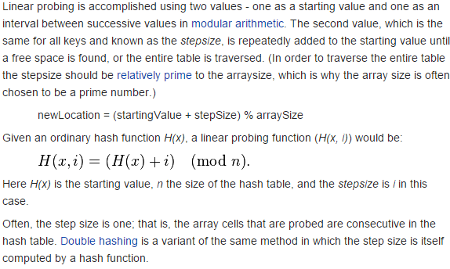

[Double hashing](https://en.wikipedia.org/wiki/Double_hashing):

1. What is OOP?

Java is a computer programming language that is concurrent, class-based and object-oriented. The advantages of object oriented software development are shown below:

* Modular development of code, which leads to easy maintenance and modification.
* Reusability of code.
* Improved reliability and flexibility of code.
* Increased understanding of code.

Object-oriented programming contains many significant features, such as encapsulation, inheritance, polymorphism and abstraction.

Inheritance:

Inheritance provides an object with the ability to acquire the fields and methods of another class, called base class. Inheritance provides re-usability of code and can be used to add additional features to an existing class, without modifying it.

Polymorphism:

Polymorphism is the ability of programming languages to present the same interface for differing underlying data types. A polymorphic type is a type whose operations can also be applied to values of some other type.

Encapsulation:

Encapsulation provides objects with the ability to hide their internal characteristics and behavior. Each object provides a number of methods, which can be accessed by other objects and change its internal data. In Java, there are three access modifiers: public, private and protected. Each modifier imposes different access rights to other classes, either in the same or in external packages. Some of the advantages of using encapsulation are listed below:

* The internal state of every objected is protected by hiding its attributes.
* It increases usability and maintenance of code, because the behavior of an object can be independently changed or extended.
* It improves modularity by preventing objects to interact with each other, in an undesired way.

1. What is different between object and class?

An object is an instance of a class. Every object must belong to a class. Objects are created and eventually destroyed – so they only live in the program for a limited time. While objects are ‘living’ their properties may also be changed signficantly.

1. What is the different between abstract class and interface?