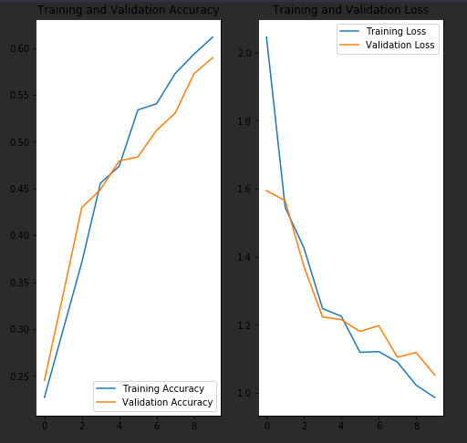

model = Sequential()  
model.add(Conv2D(32, 3, strides = 1, padding = "same", activation = "relu", input_shape = (IMG_HEIGHT, IMG_WIDTH, 3)))  
model.add(Conv2D(32, 3, strides = 1, padding = "same", activation = "relu"))  
model.add(MaxPooling2D((2, 2)))  
  
model.add(Conv2D(64, 3, strides = 1, padding = "same", activation = "relu"))  
model.add(Conv2D(64, 3, strides = 1, padding = "same", activation = "relu"))  
model.add(MaxPooling2D((2, 2)))  
  
model.add(Conv2D(128, 3, strides = 1, padding = "same", activation = "relu"))  
model.add(Conv2D(128, 3, strides = 1, padding = "same", activation = "relu"))  
model.add(MaxPooling2D((2, 2)))  
  
model.add(Flatten())  
model.add(Dense(4096, activation = "relu"))  
model.add(Dense(4096, activation = "relu"))  
model.add(Dense(1000, activation = "relu"))  
model.add(Dense(5, activation = "softmax"))

model.compile(optimizer = 'adam',  
 loss = 'categorical_crossentropy',  
 metrics = ['accuracy'])

total params: 348,854,421

savefile size: 4088226 kb

json savefile size: 6kb + 1362750kb

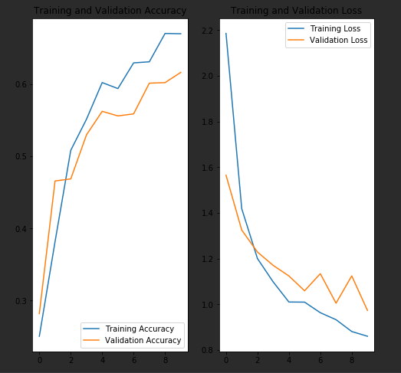

model = Sequential()  
model.add(Conv2D(32, 3, strides = 1, padding = "same", activation = "relu", input_shape = (IMG_HEIGHT, IMG_WIDTH, 3)))  
model.add(Conv2D(32, 3, strides = 1, padding = "same", activation = "relu"))  
model.add(MaxPooling2D((2, 2)))  
  
model.add(Conv2D(64, 3, strides = 1, padding = "same", activation = "relu"))  
model.add(Conv2D(64, 3, strides = 1, padding = "same", activation = "relu"))  
model.add(MaxPooling2D((2, 2)))  
  
model.add(Conv2D(128, 3, strides = 1, padding = "same", activation = "relu"))  
model.add(Conv2D(128, 3, strides = 1, padding = "same", activation = "relu"))  
model.add(MaxPooling2D((2, 2)))  
  
model.add(Flatten())  
model.add(Dense(4096, activation = "relu"))  
model.add(Dense(1000, activation = "relu"))  
model.add(Dense(5, activation = "softmax"))

model.compile(optimizer = 'adam',  
 loss = 'categorical_crossentropy',  
 metrics = ['accuracy'])

total params: 332073109

savefile size: 3891563 kb

json savefile size: 6kb + 1297196kb

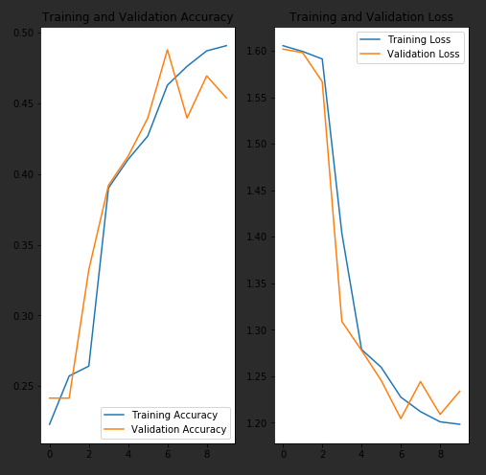

model = Sequential()  
model.add(Conv2D(32, 3, strides = 1, padding = "same", activation = "relu", input_shape = (IMG_HEIGHT, IMG_WIDTH, 3)))  
model.add(Conv2D(32, 3, strides = 1, padding = "same", activation = "relu"))  
model.add(MaxPooling2D((4, 4)))  
  
model.add(Conv2D(64, 3, strides = 1, padding = "same", activation = "relu"))  
model.add(Conv2D(64, 3, strides = 1, padding = "same", activation = "relu"))  
model.add(MaxPooling2D((4, 4)))  
  
model.add(Conv2D(128, 3, strides = 1, padding = "same", activation = "relu"))  
model.add(Conv2D(128, 3, strides = 1, padding = "same", activation = "relu"))  
model.add(MaxPooling2D((4, 4)))  
  
model.add(Conv2D(256, 3, strides = 1, padding = "same", activation = "relu"))  
model.add(Conv2D(256, 3, strides = 1, padding = "same", activation = "relu"))  
model.add(MaxPooling2D((2, 2)))  
  
model.add(Flatten())  
model.add(Dense(4096, activation = "relu"))  
model.add(Dense(4096, activation = "relu"))  
model.add(Dense(1000, activation = "relu"))  
model.add(Dense(5, activation = "softmax"))

same compile

270mb

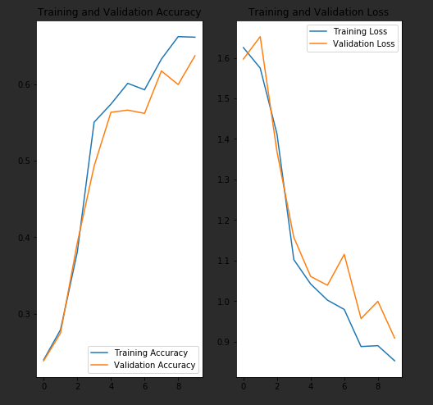

model = Sequential()  
model.add(Conv2D(32, 3, strides = 1, padding = "same", activation = "relu", input_shape = (IMG_HEIGHT, IMG_WIDTH, 3)))  
model.add(Conv2D(32, 3, strides = 1, padding = "same", activation = "relu"))  
model.add(MaxPooling2D((4, 4)))  
  
model.add(Conv2D(64, 3, strides = 1, padding = "same", activation = "relu"))  
model.add(Conv2D(64, 3, strides = 1, padding = "same", activation = "relu"))  
model.add(MaxPooling2D((4, 4)))  
  
model.add(Conv2D(128, 3, strides = 1, padding = "same", activation = "relu"))  
model.add(Conv2D(128, 3, strides = 1, padding = "same", activation = "relu"))  
model.add(MaxPooling2D((4, 4)))  
  
model.add(Flatten())  
model.add(Dense(4096, activation = "relu"))  
model.add(Dense(4096, activation = "relu"))  
model.add(Dense(1000, activation = "relu"))  
model.add(Dense(5, activation = "softmax"))

same compile

total params: 25893013

savefile size: 303522 kb

json savefile size: 6kb + 101183kb

150s/epoch

^^ all sizes above are h5

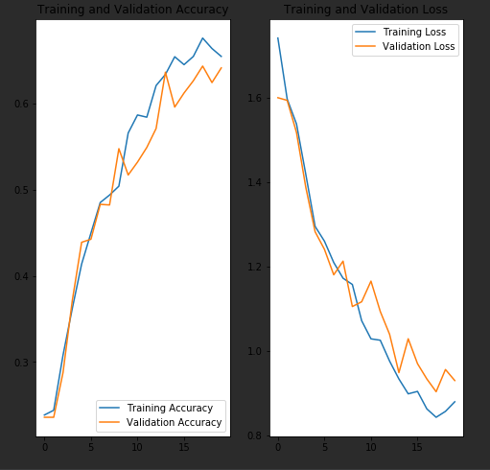

model = Sequential()  
model.add(Conv2D(32, 3, strides = 1, padding = "same", activation = "relu", input_shape = (IMG_HEIGHT, IMG_WIDTH, 3)))  
model.add(Conv2D(32, 3, strides = 1, padding = "same", activation = "relu"))  
  
model.add(MaxPooling2D(4))  
model.add(Dropout(0.2))  
  
model.add(Conv2D(64, 3, strides = 1, padding = "same", activation = "relu"))  
model.add(Conv2D(64, 3, strides = 1, padding = "same", activation = "relu"))  
  
model.add(MaxPooling2D(4))  
model.add(Dropout(0.2))  
  
model.add(Conv2D(128, 3, strides = 1, padding = "same", activation = "relu"))  
model.add(Conv2D(128, 3, strides = 1, padding = "same", activation = "relu"))  
  
model.add(MaxPooling2D(2))  
model.add(Dropout(0.2))  
  
model.add(Flatten())  
model.add(Dense(4096, activation = "relu"))  
model.add(Dense(4096, activation = "relu"))  
model.add(Dense(1000, activation = "relu"))  
model.add(Dense(5, activation = "softmax"))

same compile

470mb 100sec/step

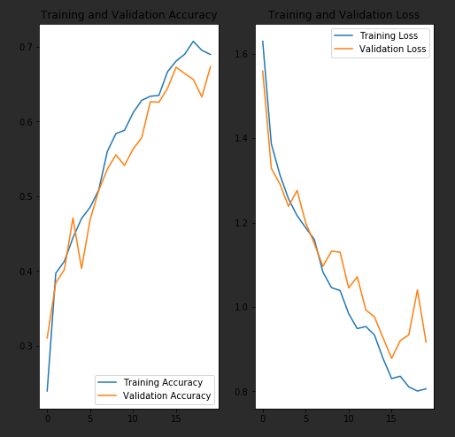

model = Sequential()  
model.add(Conv2D(32, 3, strides = 1, padding = "same", activation = "relu", input_shape = (IMG_HEIGHT, IMG_WIDTH, 3)))  
model.add(Conv2D(32, 3, strides = 1, padding = "same", activation = "relu"))  
  
model.add(MaxPooling2D(4))  
model.add(Dropout(0.1))  
  
model.add(Conv2D(64, 3, strides = 1, padding = "same", activation = "relu"))  
model.add(Conv2D(64, 3, strides = 1, padding = "same", activation = "relu"))  
  
model.add(MaxPooling2D(4))  
model.add(Dropout(0.1))  
  
model.add(Conv2D(128, 3, strides = 1, padding = "same", activation = "relu"))  
model.add(Conv2D(128, 3, strides = 1, padding = "same", activation = "relu"))  
  
model.add(MaxPooling2D(2))  
model.add(Dropout(0.1))  
  
model.add(Flatten())  
model.add(Dense(4096, activation = "relu"))  
  
model.add(Dropout(0.4))  
  
model.add(Dense(4096, activation = "relu"))  
  
model.add(Dropout(0.4))  
  
model.add(Dense(1000, activation = "relu"))  
model.add(Dense(5, activation = "softmax"))

same compile

470mb 100sec/step

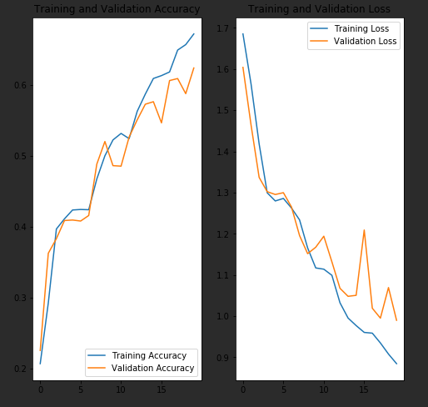

model = Sequential()  
model.add(Conv2D(32, 3, strides = 1, padding = "same", activation = "relu", input_shape = (IMG_HEIGHT, IMG_WIDTH, 3)))  
model.add(Conv2D(32, 3, strides = 1, padding = "same", activation = "relu"))  
  
model.add(MaxPooling2D(4))  
model.add(Dropout(0.2))  
  
model.add(Conv2D(64, 3, strides = 1, padding = "same", activation = "relu"))  
model.add(Conv2D(64, 3, strides = 1, padding = "same", activation = "relu"))  
  
model.add(MaxPooling2D(4))  
model.add(Dropout(0.2))  
  
model.add(Conv2D(128, 3, strides = 1, padding = "same", activation = "relu"))  
model.add(Conv2D(128, 3, strides = 1, padding = "same", activation = "relu"))  
  
model.add(MaxPooling2D(2))  
model.add(Dropout(0.2))  
  
model.add(Flatten())  
model.add(Dense(4096, activation = "relu"))  
  
model.add(Dropout(0.4))  
  
model.add(Dense(4096, activation = "relu"))  
  
model.add(Dropout(0.4))  
  
model.add(Dense(1000, activation = "relu"))  
model.add(Dense(5, activation = "softmax"))

same compile

470mb 100sec/step

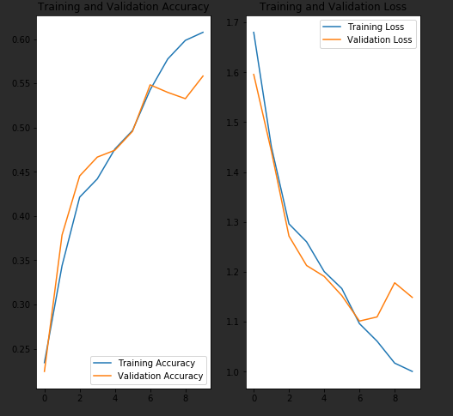

model = Sequential()  
model.add(Conv2D(32, 3, strides = 1, padding = "same", activation = "relu", input_shape = (IMG_HEIGHT, IMG_WIDTH, 3)))  
model.add(Conv2D(32, 3, strides = 1, padding = "same", activation = "relu"))  
  
model.add(MaxPooling2D(2))  
  
model.add(Conv2D(64, 3, strides = 1, padding = "same", activation = "relu"))  
model.add(Conv2D(64, 3, strides = 1, padding = "same", activation = "relu"))  
  
model.add(MaxPooling2D(2))  
  
model.add(Conv2D(128, 3, strides = 1, padding = "same", activation = "relu"))  
model.add(Conv2D(128, 3, strides = 1, padding = "same", activation = "relu"))  
  
model.add(MaxPooling2D(2))  
  
model.add(Conv2D(256, 3, strides = 1, padding = "same", activation = "relu"))  
model.add(Conv2D(256, 3, strides = 1, padding = "same", activation = "relu"))  
  
model.add(MaxPooling2D(2))  
  
model.add(Flatten())  
model.add(Dense(4096, activation = "relu"))  
model.add(Dense(4096, activation = "relu"))  
  
model.add(Dense(1000, activation = "relu"))  
model.add(Dense(5, activation = "softmax"))

total params: 174054613

savefile size: 2028088 kb

json savefile size: 6kb + 676039