IMS CONNECT DOCUMENTATION

Introduction

 Project Overview  Key Features

Installation Instructions  Troubleshooting

Configuration

 Example settings.py snippet API Endpoints

 User Endpoints

 Example views.py snippet for UserViewSet  Idea Endpoints

 Example models.py snippet for Idea model  Vote Endpoints

 Example serializers.py snippet for VoteSerializer  Team Endpoints

 Document Endpoints  Comment Endpoints

 Notification Endpoints  Milestone Endpoints

 Category Endpoints  Audit Log Endpoints

View Logic Models Authentication Testing

User Interfaces

 Dashboard Pages

 Idea Submission Page  My Ideas Page

 Profile Page

 Notifications Page  Settings Page

 Audit Logs Page

 Idea Review Page  Reports Page

 Team Collaboration Page  Milestones Page

# Introduction

It is a very specialized project that aims to give users a space to collaborate and manage ideas within a software called ims-connect-django-bootstrap-html-css-js-jquery . This idea sharing application with a Django backend and a bootstrap-html-css-js-jquery frontend helps the users to create, vote and discuss ideas from one single platform. The first purpose is to increase efficiency among workers by improving means of communication and decision-making among the groups.

It will act as a record for developers and users of the application as it maps out how to install and set it up as well as features on how to use it. It contains information about a few important components and API interfaces, and gives an overview of the internals, making it simpler for new contributors to study and contribute to the project. This document covers all aspects required in order to configure, use, or deploy the application whether that is in a local environment or as part of a wider system.

# Project Overview

The ims-connect-django-bootstrap is a web application built on the top of Django web framework with bootstrap as a frontend. It is designed for sharing and idea implementation and growth giving users rights to post, vote and comment on ideas. The idea behind the application is to improve efficiency and the overall performance of the teams by having a tool where these ideas may be created and then assessed.

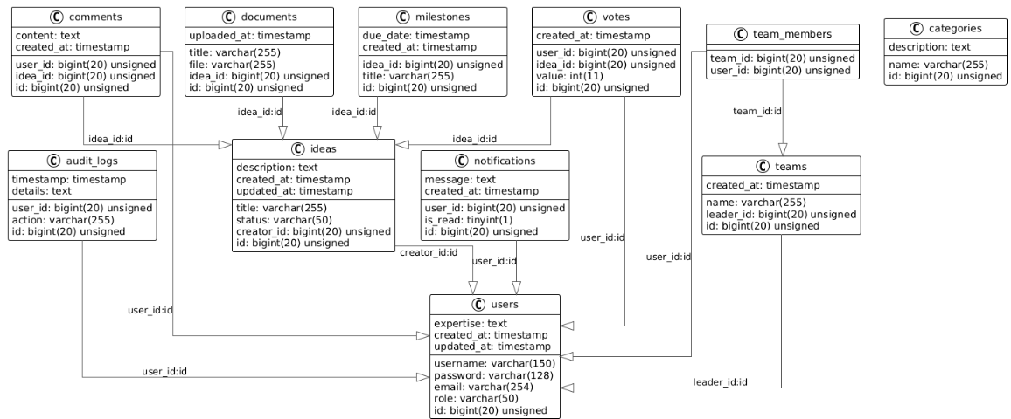

# Key Features

* Multifactor authentication and authorization by using JWT.
* Functions related to the creation, reading, updating and deleting, on ideas, votes, comments, documents, and teams notifications, new milestones, and categories, as well as, usage of audits logs.
* Real-time messages for the users’ activity. Facilities for searching as well as the idea and for users.
* There is also ensured the concept of role-based working access control for different types of users.

# Installation Instructions

To set up the backend locally, follow these steps:

1. **Clone the repository**:

git clone https://github.com/yourusername/ims-connect-django-bootstrap-html-css-js-jquery .git cd ims-connect-django-bootstrap/backend

1. **Create a virtual environment and activate it**:

python3 -m venv venv source venv/bin/activate

1. **Install the required packages**:

pip install -r requirements.txt

1. **Set up the database** (make sure MySQL is running):

python manage.py migrate

1. **Create a superuser** to access the admin panel:

python manage.py createsuperuser

1. **Run the development server**:

python manage.py runserver

# Troubleshooting

If you encounter issues with database connections, ensure that your MySQL server is running and that the credentials in your .env file are correct.

 If you face any package installation errors, ensure that you have the correct version of Python and pip installed.

# Configuration

Key settings from settings.py:

 **SECRET_KEY**: Managed through environment variables for security. This key is used for cryptographic signing and should be kept secret in production.

 **DEBUG**: Set to True for development. In production, this should be set to False

to prevent sensitive information from being exposed.

 **ALLOWED_HOSTS**: Currently set to allow all hosts ('*'). This should be updated to include specific domains in production.

 **CORS_ALLOWED_ORIGINS**: Configured to allow requests from specific local development addresses. This is important for enabling cross-origin requests from the frontend.

 **DATABASES**: Uses MySQL as the database backend. Ensure that the database is created and the credentials are correct.

INSTALLED_APPS = [

'django.contrib.admin', 'django.contrib.auth', 'django.contrib.contenttypes', 'django.contrib.sessions', 'django.contrib.messages', 'django.contrib.staticfiles', 'rest_framework', 'rest_framework_simplejwt', 'corsheaders',

'users',

'ideas',

'votes',

'teams', 'documents', 'comments', 'notifications', 'milestones', 'categories', 'audit_logs',

]

## Example settings.py snippet

MIDDLEWARE = [

'corsheaders.middleware.CorsMiddleware', 'django.middleware.security.SecurityMiddleware', 'django.contrib.sessions.middleware.SessionMiddleware', 'django.middleware.common.CommonMiddleware', 'django.middleware.csrf.CsrfViewMiddleware', 'django.contrib.auth.middleware.AuthenticationMiddleware', 'django.contrib.messages.middleware.MessageMiddleware', 'django.middleware.clickjacking.XFrameOptionsMiddleware',

]

ROOT_URLCONF = 'backend.urls' TEMPLATES = [

{

'BACKEND': 'django.template.backends.django.DjangoTemplates', 'DIRS': [],

'APP_DIRS': True, 'OPTIONS': {

'context_processors': [ 'django.template.context_processors.debug', 'django.template.context_processors.request', 'django.contrib.auth.context_processors.auth', 'django.contrib.messages.context_processors.messages',

],

},

},

]

WSGI_APPLICATION = 'backend.wsgi.application' # Database

# https://docs.djangoproject.com/en/3.2/ref/settings/#databases

DATABASES = {

'default': {

'ENGINE': 'django.db.backends.mysql', 'NAME': os.environ.get('DB_NAME'),

'USER': os.environ.get('DB_USER'), 'PASSWORD': os.environ.get('DB_PASSWORD'), 'HOST': os.environ.get('DB_HOST'),

'PORT': os.environ.get('DB_PORT'),

}

}

# API Endpoints User Endpoints

GET /users/: List all users.

**Response** : A JSON array of user objects. It mostly helps the admin to manage the system users as all the registered users can be retrieved through this endpoint.

Example:

[

{"id": 1, "username": "john_doe", "email": ["john@example.com"](mailto:john@example.com)},

{"id": 2, "username": "jane_doe", "email": ["jane@example.com"](mailto:jane@example.com)}

]

POST /users/: Create a new user.

**Responce** : JSON object with user details (username, password, etc.). This endpoint allows for the registration of new users into the system, facilitating user growth and engagement.

Example:

{"username": "new_user", "password": "securepassword"}

**Response**: The created user object, confirming successful registration.

**Example views.py snippet for UserViewSet**

class **UserViewSet**(viewsets.ModelViewSet): queryset = User.objects.all() serializer_class = UserSerializer

def **create**(self, request):

serializer = self.serializer_class(data=request.data) if serializer.is_valid():

serializer.save()

return Response(serializer.data, status=status.HTTP_201_CREATED) return Response(serializer.errors,

status=status.HTTP_400_BAD_REQUEST)

# Idea Endpoints

GET /ideas/: List all ideas.

**Response**: A JSON array of idea objects. This specifically focused endpoint involves a complete collection of ideas submitted by users for easy tracking and assessment.

Example:

[

{"id": 1, "title": "Idea 1", "description": "Description of Idea 1"},

{"id": 2, "title": "Idea 2", "description": "Description of Idea

2"}

]

POST /ideas/: Create a new idea.

**Request Body**: An object of JSON containing the details of the idea such as the title and description and so on. It is a post endpoint that enables users to post new ideas in the platform that will enhance innovation.

Example:

{"title": "New Idea", "description": "This is a new idea."}

 **Response**: The created idea object, confirming successful submission.

**Example models.py snippet for Idea model**

from django.db import models class **Idea**(models.Model):

title = models.CharField(max_length=255) description = models.TextField()

status = models.CharField(max_length=50, choices=[('draft', 'Draft'), ('submitted', 'Submitted'), ('approved', 'Approved')])

creator = models.ForeignKey(User, on_delete=models.CASCADE) created_at = models.DateTimeField(auto_now_add=True) updated_at = models.DateTimeField(auto_now=True)

# Vote Endpoints

GET /votes/: List all votes.

**Response**: A JSON array of vote objects. This particular endpoint serves to enable users view all the voting that takes place on ideas which increases transparency.

Example:

[

{"id": 1, "user_id": 1, "idea_id": 1, "value": 1},

{"id": 2, "user_id": 2, "idea_id": 1, "value": -1}

]

POST /votes/: Create a new vote.

**Request Body**: JSON object that contains the additional information regarding the vote (user ID, idea ID and so on). This end point for example will enable users to vote on the ideas thus being able to proactively participate in the decision making process.

Example:

{"user_id": 1, "idea_id": 1, "value": 1}

 **Response**: The created vote object, confirming successful voting.

**Example serializers.py snippet for VoteSerializer**

class **VoteSerializer**(serializers.ModelSerializer): class **Meta**:

model = Vote

fields = ['id', 'user_id', 'idea_id', 'value']

# Team Endpoints

GET /teams/: List all teams.

**Response**: A JSON array of team objects. This endpoint helps with the management of all teams across the application and offers numerous relavant details.

and collaboration.

### Example:

[

{"id": 1, "name": "Team Alpha"},

{"id": 2, "name": "Team Beta"}

]

POST /teams/: Create a new team.

**Request Body**: JSON object with team details (name, leader ID, etc.). This endpoint allows users to form new teams, promoting collaboration on ideas.

**Example**:

{"name": "New Team", "leader_id": 1}

 **Response**: The created team object, confirming successful team formation.

# Document Endpoints

GET /documents/: List all documents.

**Response**: A JSON array of document objects. This endpoint allows users to view all documents related to ideas, facilitating document management.

### Example:

[

{"id": 1, "title": "Document 1", "file": "url_to_file"},

{"id": 2, "title": "Document 2", "file": "url_to_file"}

]

POST /documents/: Create a new document.

**Request Body**: JSON object with document details (title, file, etc.). This endpoint allows users to upload new documents associated with their ideas. **Example**:

{"title": "New Document", "file": "url_to_file"}

 **Response**: The created document object, confirming successful upload.

# Comment Endpoints

GET /comments/: List all comments.

**Response**: A JSON array of comment objects. This endpoint allows users to view all comments made on ideas, fostering discussion and feedback.

### Example:

[

{"id": 1, "user_id": 1, "idea_id": 1, "content": "Great idea!"},

{"id": 2, "user_id": 2, "idea_id": 1, "content": "I agree!"}

]

POST /comments/: Create a new comment.

**Request Body**: JSON object with comment details (user ID, idea ID, content, etc.). This endpoint allows users to provide feedback on ideas through comments.

### Example:

{"user_id": 1, "idea_id": 1, "content": "This is a comment."}

 **Response**: The created comment object, confirming successful posting.

# Notification Endpoints

GET /notifications/: List all notifications.

**Response**: A JSON array of notification objects. This endpoint allows users to view all notifications related to their activities within the application.

### Example:

[

{"id": 1, "user_id": 1, "message": "You have a new comment.", "created_at": "2024-12-21T22:02:00Z"},

{"id": 2, "user_id": 2, "message": "Your idea was approved.", "created_at": "2024-12-21T22:03:00Z"}

]

POST /notifications/: Create a new notification.

**Request Body**: JSON object with notification details (user ID, message, etc.). This endpoint allows the system to send notifications to users about various activities.

### Example:

{"user_id": 1, "message": "New vote on your idea."}

 **Response**: The created notification object, confirming successful notification.

# Milestone Endpoints

GET /milestones/: List all milestones.

**Response**: A JSON array of milestone objects. This endpoint allows users to view all milestones associated with ideas, providing transparency in project timelines.

### Example:

[

{"id": 1, "idea_id": 1, "title": "Milestone 1", "due_date": "2024- 12-31T00:00:00Z"},

{"id": 2, "idea_id": 2, "title": "Milestone 2", "due_date": "2024- 12-31T00:00:00Z"}

]

POST /milestones/: Create a new milestone.

**Request Body**: JSON object with milestone details (idea ID, title, due date, etc.). This endpoint allows users to set milestones for their ideas, helping to track progress.

### Example:

{"idea_id": 1, "title": "New Milestone", "due_date": "2024-12- 31T00:00:00Z"}

 **Response**: The created milestone object, confirming successful milestone creation.

# Category Endpoints

GET /categories/: List all categories.

**Response**: A JSON array of category objects. This endpoint allows users to view all categories available for organizing ideas.

### Example:

[

{"id": 1, "name": "Category 1"},

{"id": 2, "name": "Category 2"}

]

POST /categories/: Create a new category.

**Request Body**: JSON object with category details (name, description, etc.). This endpoint allows users to define new categories for better organization of ideas.

### Example:

{"name": "New Category", "description": "Description of new category."}

 **Response**: The created category object, confirming successful category creation.

# Audit Log Endpoints

GET /audit-logs/: List all audit logs.

**Response**: A JSON array of audit log objects. This endpoint provides a record of all significant actions taken within the application, ensuring accountability and traceability.

class **UserViewSet**(viewsets.ModelViewSet): queryset = User.objects.all() serializer_class = UserSerializer

@action(detail=False, methods=['get']) def **profile**(self, request):

### Example:

[

{"id": 1, "user_id": 1, "action": "created idea", "timestamp": "2024-12-21T22:00:00Z"},

{"id": 2, "user_id": 2, "action": "voted", "timestamp": "2024-12- 21T22:01:00Z"}

]

POST /audit-logs/: Create a new audit log.

**Request Body**: JSON object with log details (user ID, action, etc.). This endpoint allows the system to record significant actions taken by users, enhancing transparency and accountability.

### Example:

{"user_id": 1, "action": "created idea", "details": "New idea created."}

 **Response**: The created audit log object, confirming successful logging of the action.

# View Logic

Overview of viewsets and their methods:

**UserViewSet**: Handles user-related actions such as profile retrieval and statistics.

 **profile**: Retrieve user profile information.

 **statistics**: Get user statistics.

 **sync_offline_data**: Synchronize offline data.

user = request.user

serializer = self.serializer_class(user) return Response(serializer.data)

@action(detail=False, methods=['get']) def **statistics**(self, request):

# Logic to retrieve user statistics pass

@action(detail=True, methods=['post'])

def **sync_offline_data**(self, request, pk=None): # Logic to synchronize offline data

pass

 **IdeaViewSet**: Manages ideas, including creation, retrieval, and voting.

 **my_ideas**: Retrieve ideas created by the user.

 **vote**: Vote on an idea.

 **similar_ideas**: Retrieve similar ideas.

 **recommended_collaborators**: Suggest collaborators for an idea.

 **trending**: Get trending ideas.

class **IdeaViewSet**(viewsets.ModelViewSet): queryset = Idea.objects.all() serializer_class = IdeaSerializer

@action(detail=False, methods=['get']) def **my_ideas**(self, request):

user = request.user

ideas = self.queryset.filter(creator=user) serializer = self.serializer_class(ideas, many=True) return Response(serializer.data)

@action(detail=True, methods=['post']) def **vote**(self, request, pk=None):

# Logic to handle voting on an idea pass

@action(detail=True, methods=['get'])

def **similar_ideas**(self, request, pk=None): # Logic to retrieve similar ideas

pass

@action(detail=True, methods=['get'])

def **recommended_collaborators**(self, request, pk=None): # Logic to suggest collaborators

pass

@action(detail=False, methods=['get']) def **trending**(self, request):

# Logic to get trending ideas pass

class **NotificationViewSet**(viewsets.ModelViewSet): queryset = Notification.objects.all()

**VoteViewSet**: Handles voting actions.

class **VoteViewSet**(viewsets.ModelViewSet): queryset = Vote.objects.all() serializer_class = VoteSerializer

**TeamViewSet**: Manages teams and their members.

 **add_member**: Add a member to the team.

 **remove_member**: Remove a member from the team.

class **TeamViewSet**(viewsets.ModelViewSet): queryset = Team.objects.all() serializer_class = TeamSerializer

@action(detail=True, methods=['post']) def **add_member**(self, request, pk=None):

# Logic to add a member to the team pass

@action(detail=True, methods=['post'])

def **remove_member**(self, request, pk=None): # Logic to remove a member from the team pass

**DocumentViewSet**: Handles document uploads related to ideas.

class **DocumentViewSet**(viewsets.ModelViewSet): queryset = Document.objects.all() serializer_class = DocumentSerializer

**CommentViewSet**: Manages comments on ideas.

class **CommentViewSet**(viewsets.ModelViewSet): queryset = Comment.objects.all() serializer_class = CommentSerializer

**NotificationViewSet**: Handles notifications for users.

from django.db import models class **Idea**(models.Model):

serializer_class = NotificationSerializer

**MilestoneViewSet**: Manages milestones related to ideas.

class **MilestoneViewSet**(viewsets.ModelViewSet): queryset = Milestone.objects.all() serializer_class = MilestoneSerializer

**CategoryViewSet**: Handles categories for organizing ideas.

class **CategoryViewSet**(viewsets.ModelViewSet): queryset = Category.objects.all() serializer_class = CategorySerializer

**AuditLogViewSet**: Manages audit logs for tracking actions.

class **AuditLogViewSet**(viewsets.ModelViewSet): queryset = AuditLog.objects.all() serializer_class = AuditLogSerializer

# Models

Overview of models:

**User**: Represents application users with roles and expertise.

from django.contrib.auth.models import AbstractUser class **User**(**AbstractUser**):

role = models.CharField(max_length=50) expertise = models.TextField()

**Idea**: Represents ideas submitted by users, including fields for title, description, and status.

title = models.CharField(max_length=255) description = models.TextField()

status = models.CharField(max_length=50, choices=[('draft', 'Draft'), ('submitted', 'Submitted'), ('approved', 'Approved')])

creator = models.ForeignKey(User, on_delete=models.CASCADE) created_at = models.DateTimeField(auto_now_add=True) updated_at = models.DateTimeField(auto_now=True)

**Vote**: Represents votes cast by users on ideas, linking users and ideas.

class **Vote**(models.Model):

user = models.ForeignKey(User, on_delete=models.CASCADE) idea = models.ForeignKey(Idea, on_delete=models.CASCADE)

value = models.IntegerField(choices=[(1, 'Upvote'), (-1, 'Downvote')]) created_at = models.DateTimeField(auto_now_add=True)

**Team**: Represents teams working on ideas, including team members and leaders.

class **Team**(models.Model):

name = models.CharField(max_length=255)

leader = models.ForeignKey(User, related_name='teams_lead', on_delete=models.CASCADE)

members = models.ManyToManyField(User, related_name='teams')

**Document**: Represents documents related to ideas, including file uploads.

class **Document**(models.Model):

title = models.CharField(max_length=255)

file = models.FileField(upload_to='documents/')

idea = models.ForeignKey(Idea, on_delete=models.CASCADE) uploaded_at = models.DateTimeField(auto_now_add=True)

**Comment**: Represents comments on ideas, allowing for discussions.

**Notification**: Represents notifications sent to users for various actions.

class **Comment**(models.Model):

user = models.ForeignKey(User, on_delete=models.CASCADE) idea = models.ForeignKey(Idea, on_delete=models.CASCADE) content = models.TextField()

created_at = models.DateTimeField(auto_now_add=True)

class **Notification**(models.Model):

user = models.ForeignKey(User, on_delete=models.CASCADE) message = models.TextField()

created_at = models.DateTimeField(auto_now_add=True) is_read = models.BooleanField(default=False)

**Milestone**: Represents milestones associated with ideas, tracking progress.

class **Milestone**(models.Model):

idea = models.ForeignKey(Idea, on_delete=models.CASCADE) title = models.CharField(max_length=255)

due_date = models.DateTimeField()

created_at = models.DateTimeField(auto_now_add=True)

**Category**: Represents categories for organizing ideas, allowing for better categorization.

class **Category**(models.Model):

name = models.CharField(max_length=255) description = models.TextField()

**AuditLog**: Represents logs of user actions for accountability and tracking.

class **AuditLog**(models.Model):

user = models.ForeignKey(User, on_delete=models.CASCADE) action = models.CharField(max_length=255)

timestamp = models.DateTimeField(auto_now_add=True) details = models.TextField()

# Authentication

JWT authentication is implemented using rest_framework_simplejwt. Tokens are issued upon user login and can be refreshed using the refresh endpoint. This ensures secure access to the API.

# Testing

To run tests, use the following command:

python manage.py test

This will execute all test cases defined in the application, ensuring that all functionalities work as expected.

# User Interfaces

**File:** frontend/pages/admin/user-management.html

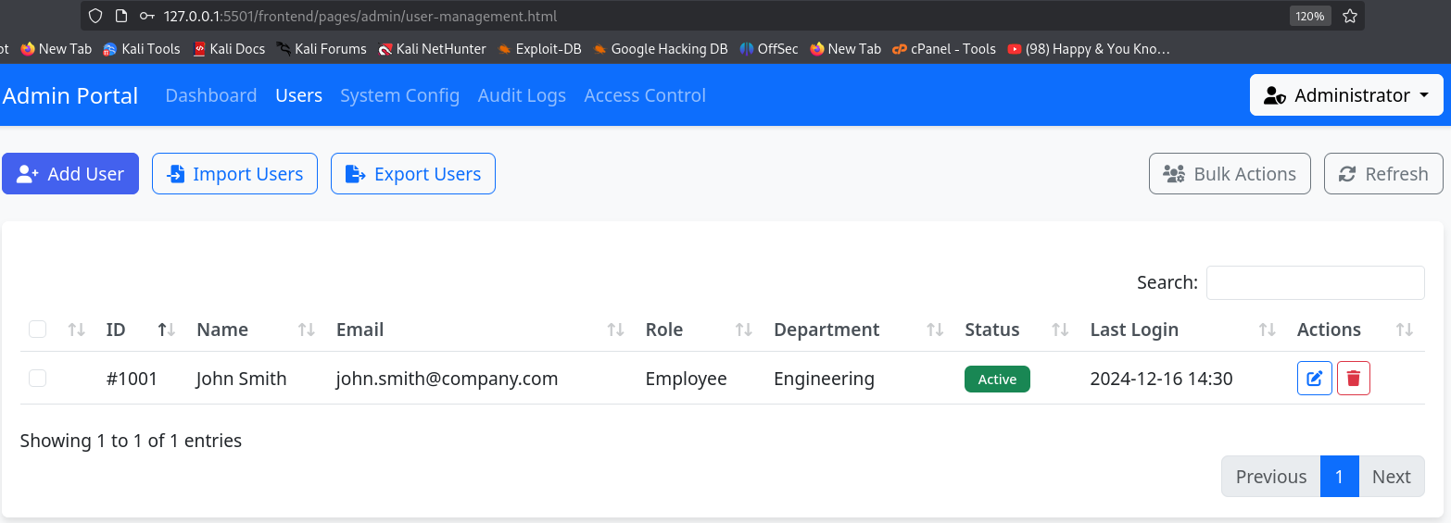

**Explanation:** This page is likely where administrators can manage user accounts, including adding, editing, or removing users. Screenshots here could show the user management interface, including forms for adding users or lists of existing users.

## Dashboard Pages

### Files:

frontend/pages/admin/dashboard.html

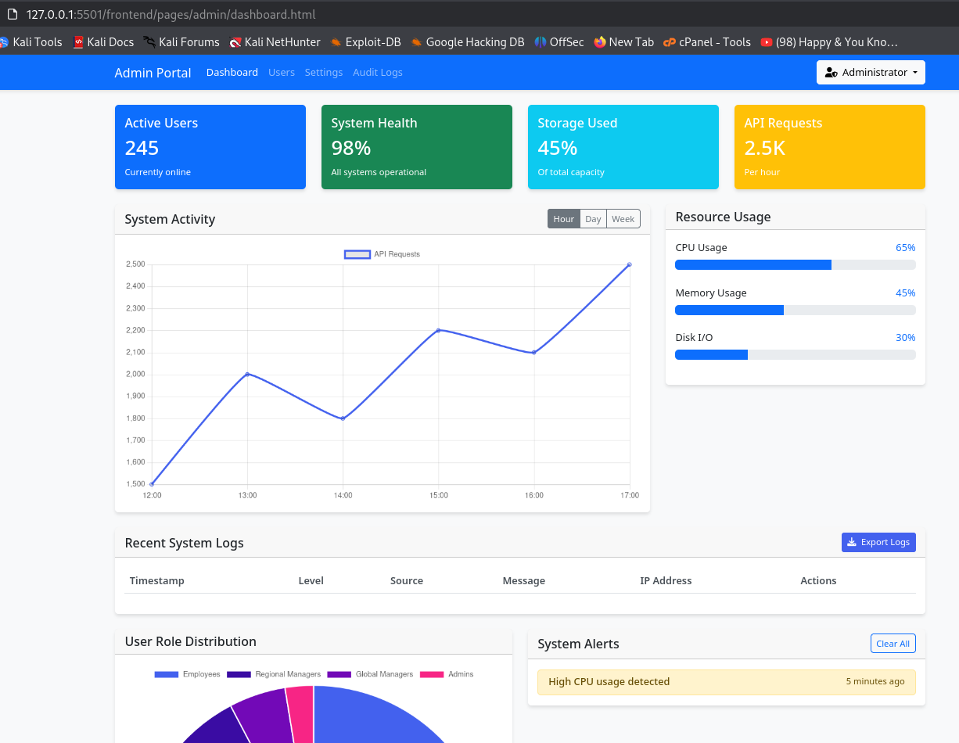

frontend/pages/employee/dashboard.html

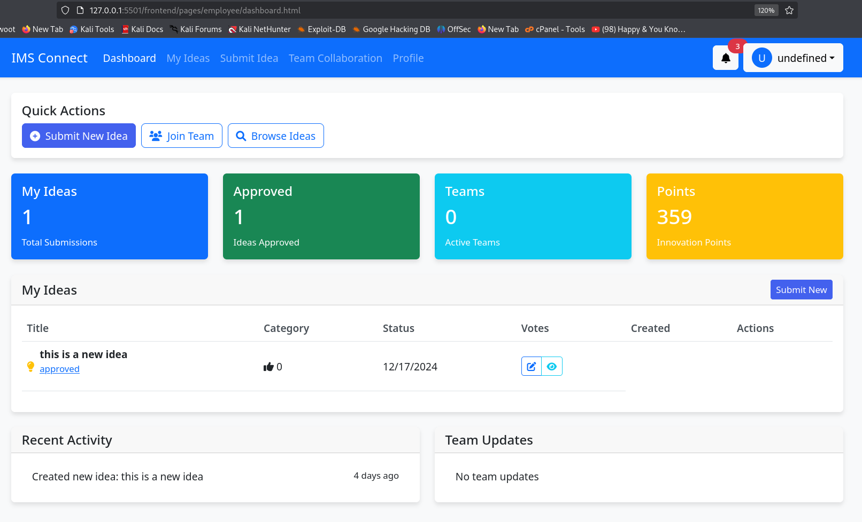

frontend/pages/global-manager/dashboard.html

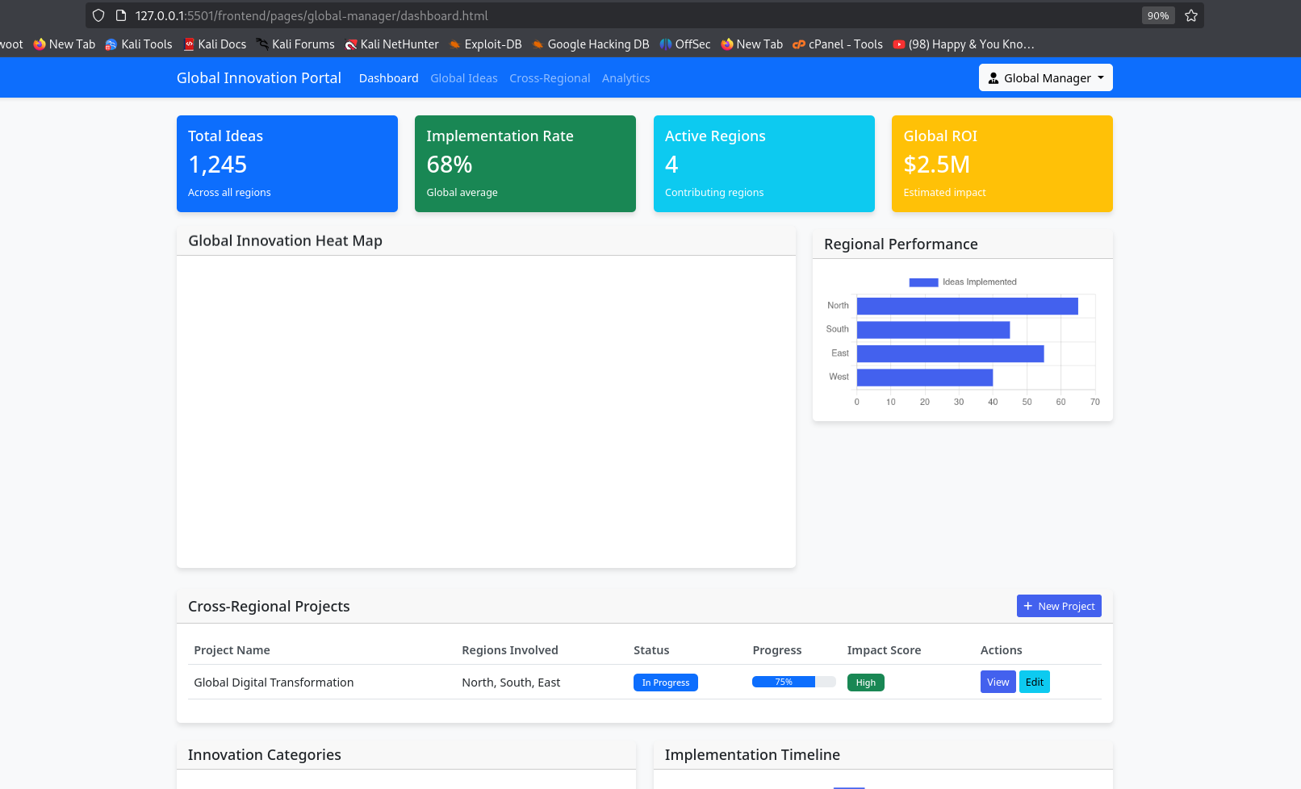

 frontend/pages/regional-manager/dashboard.html

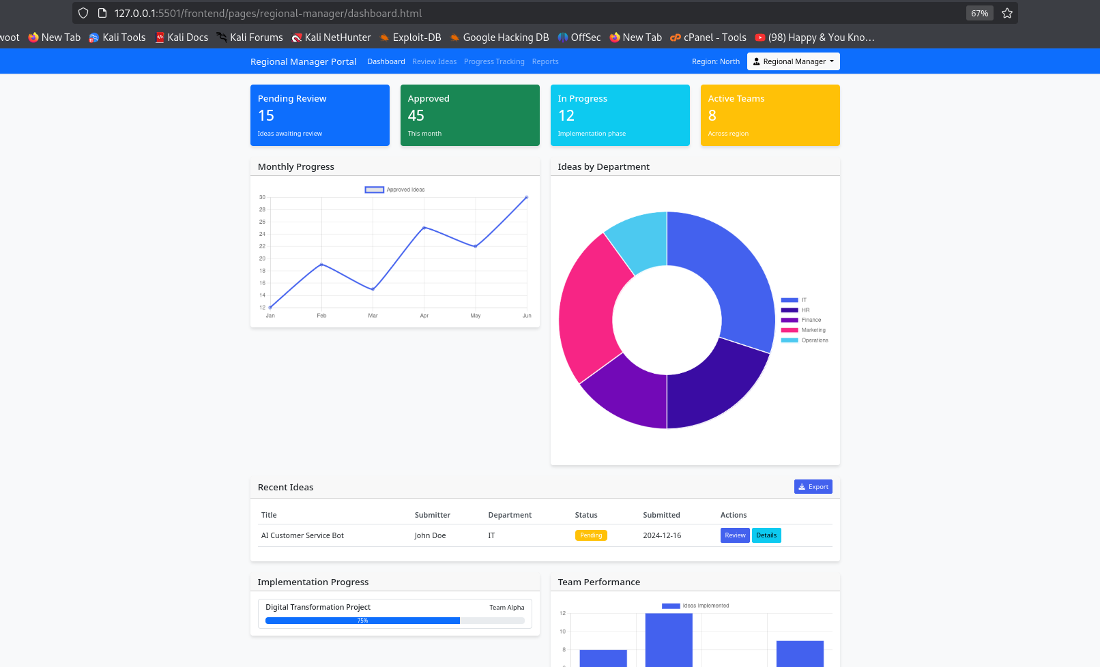

**Explanation:** These dashboard pages provide an overview of key metrics and information relevant to different user roles. Screenshots could illustrate the dashboard layout, key performance indicators, and any interactive elements.

## Idea Submission Page

**File:** frontend/pages/ideas/submit.html

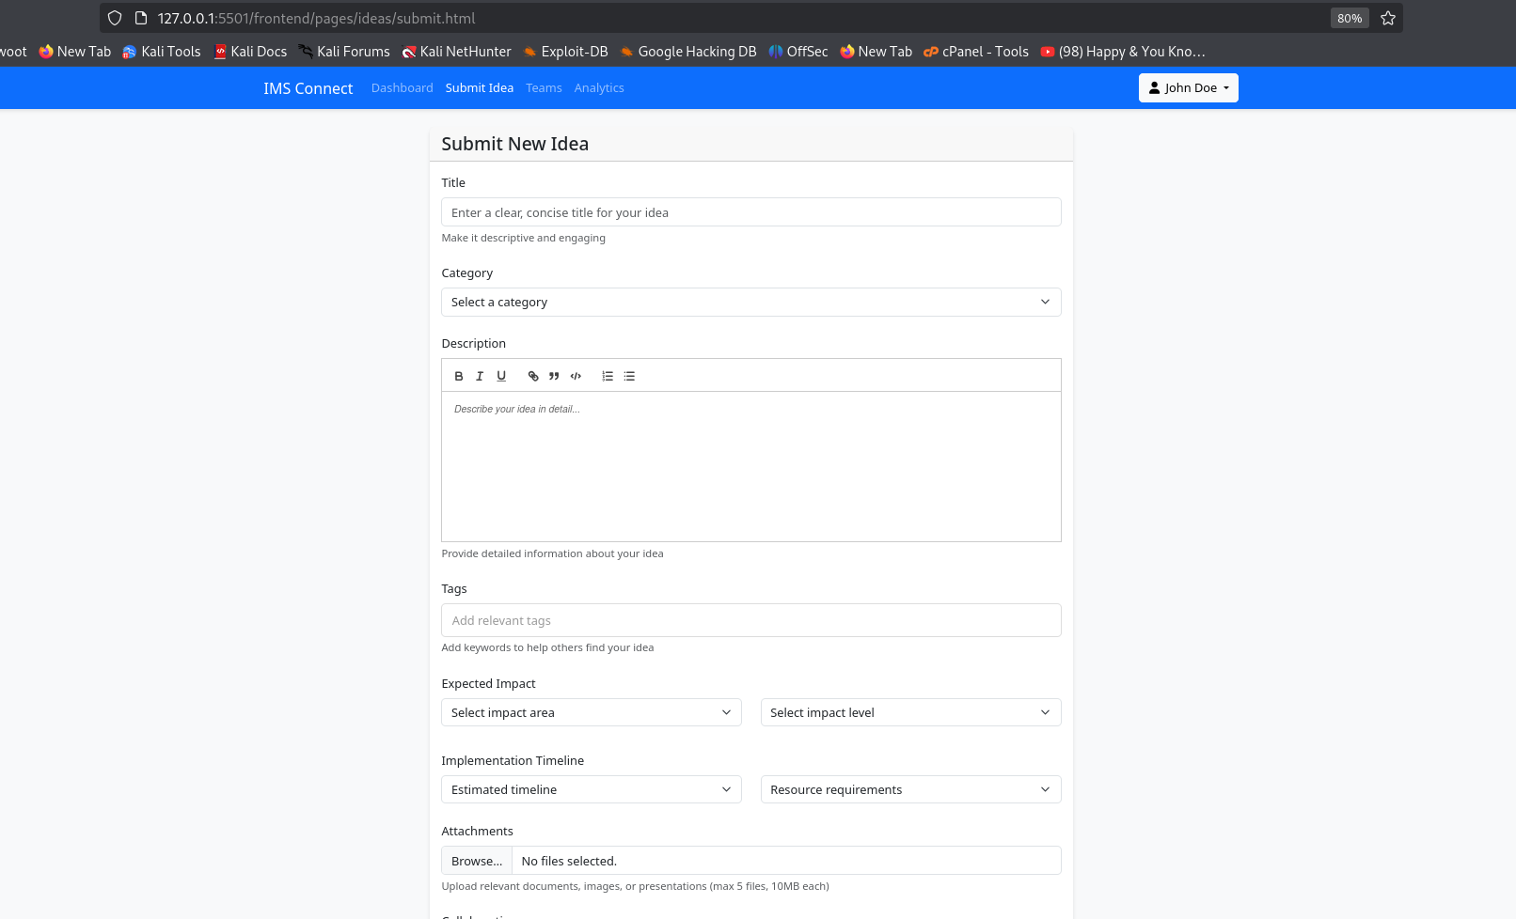

**Explanation:** This page is where users can submit new ideas. Screenshots could show the submission form, including fields for title, description, and any other relevant inputs.

## My Ideas Page

**File:** frontend/pages/employee/my-ideas.html

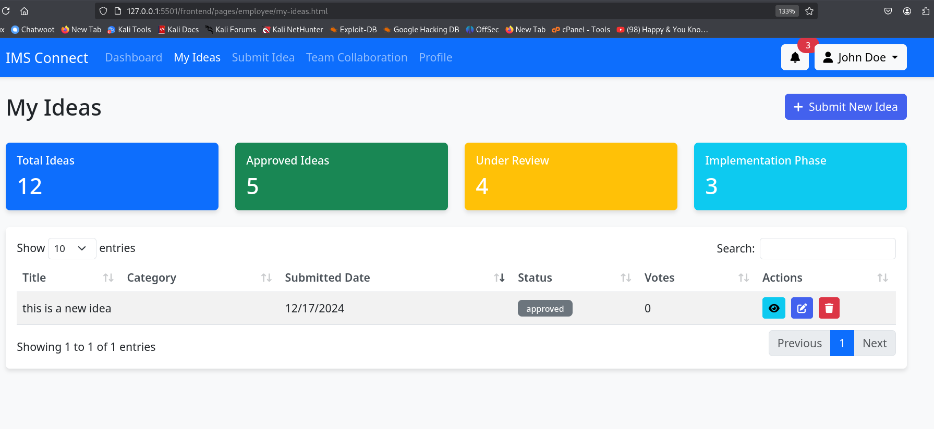

**Explanation:** This page likely displays the ideas submitted by the logged-in user. Screenshots could show the list of ideas, their statuses, and options to edit or delete them.

## Profile Page

### Files:

frontend/pages/employee/profile.html

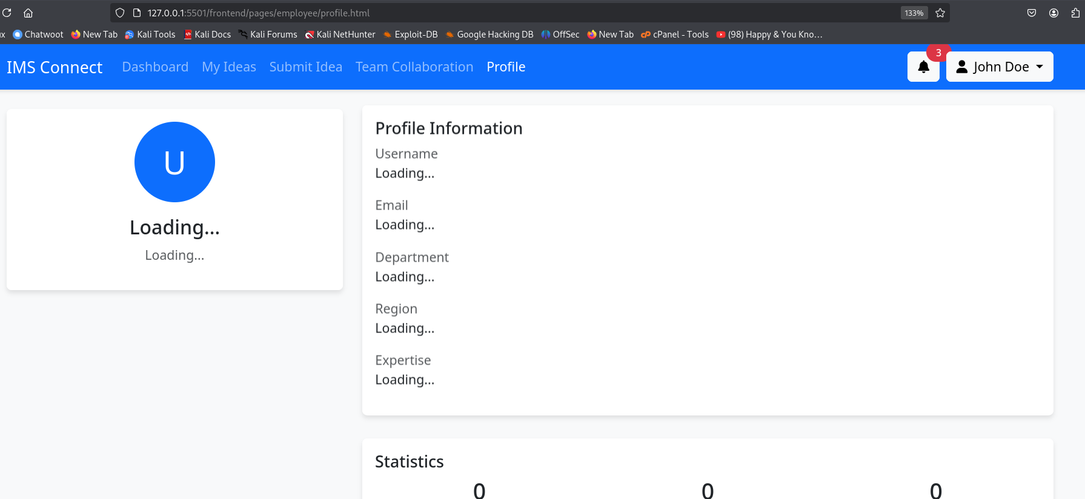

frontend/pages/global-manager/profile.html

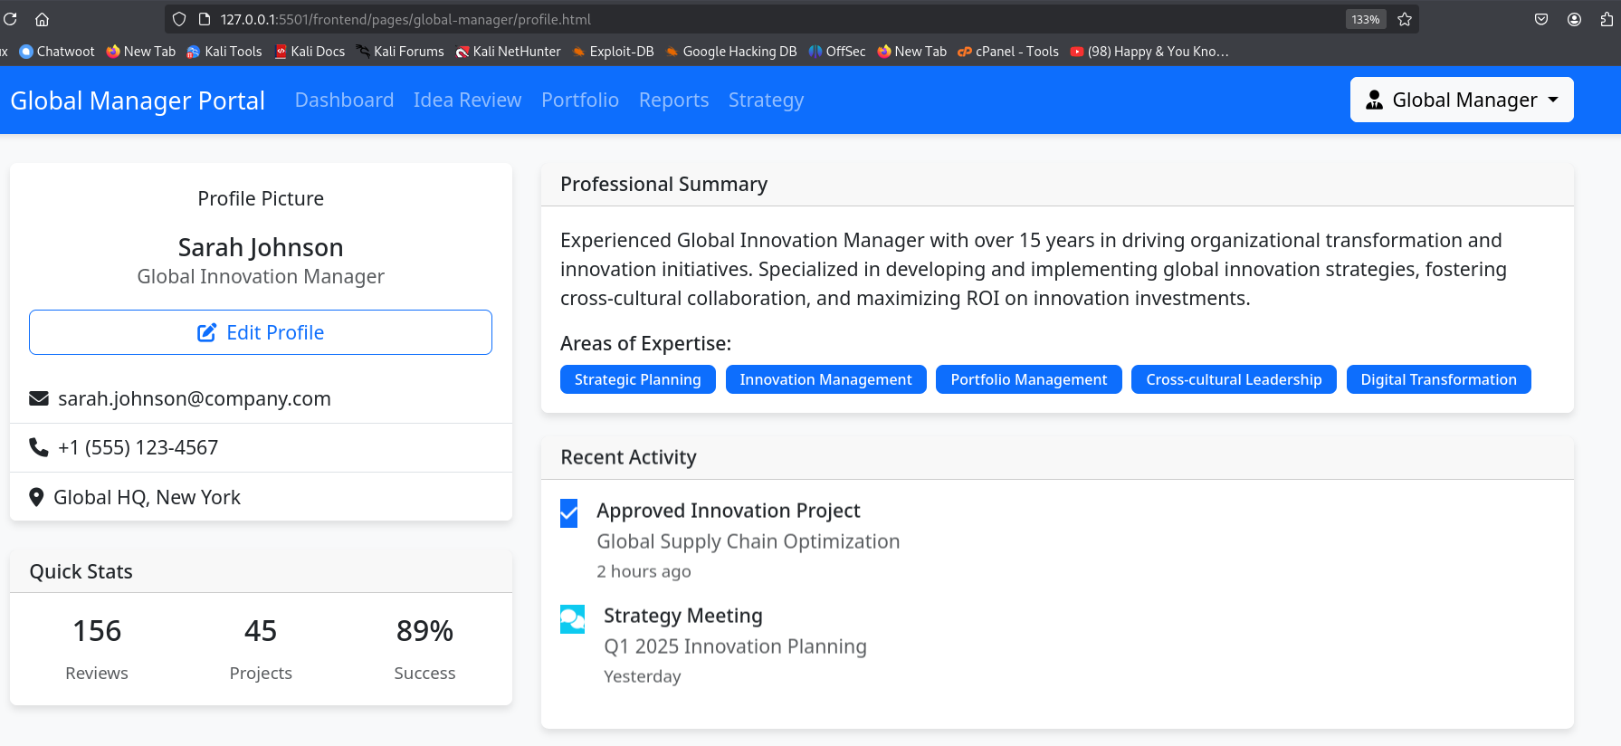

 frontend/pages/regional-manager/profile.html

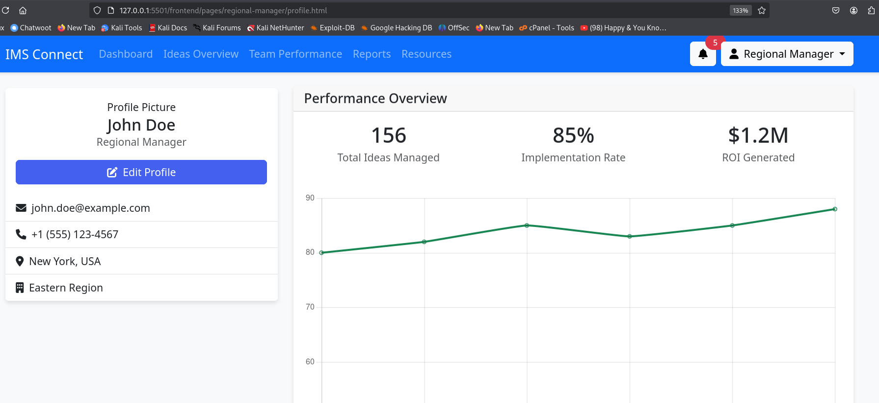

**Explanation:** These pages allow users to view and edit their profile information. Screenshots could show the profile details, including user roles and expertise.

## Notifications Page

### Files:

frontend/pages/employee/notifications.html

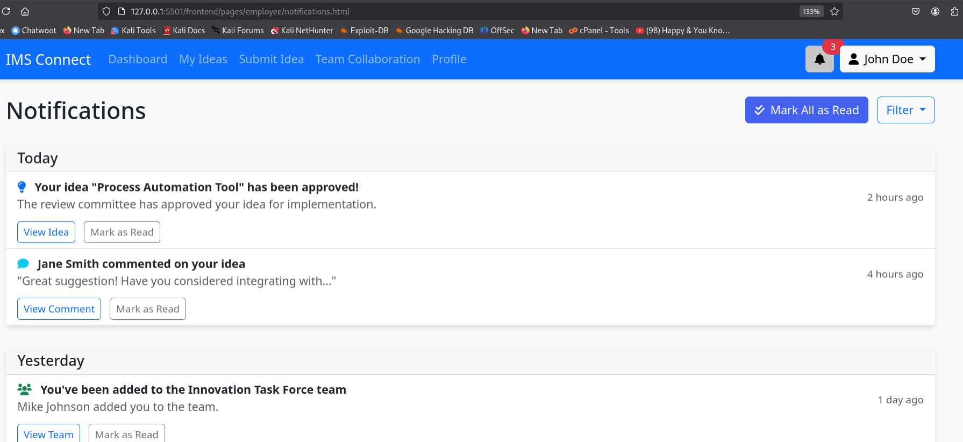

 frontend/pages/regional-manager/notifications.html

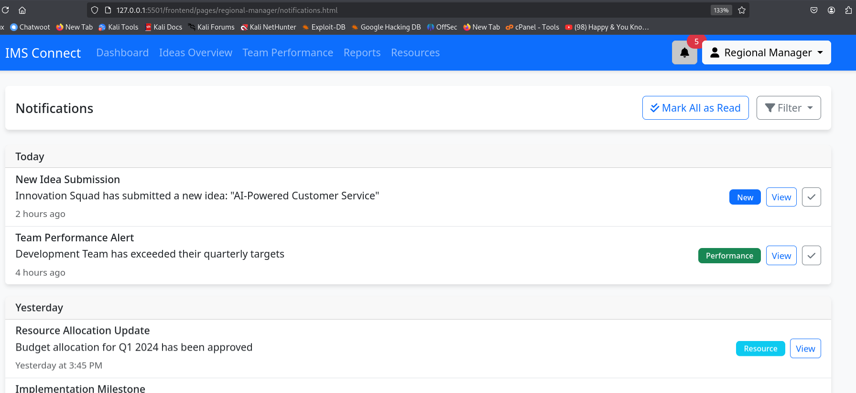

**Explanation:** These pages display notifications related to user activities. Screenshots could illustrate how notifications are presented and any actions users can take (e.g., marking as read).

## Settings Page

**File:** frontend/pages/employee/settings.html

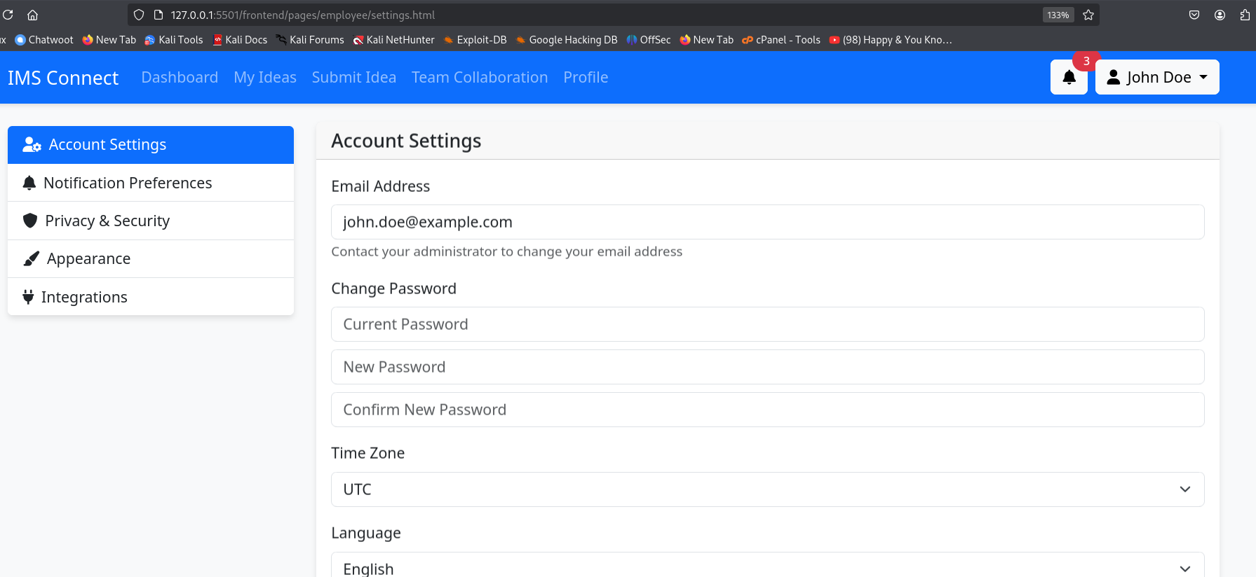**Explanation:** This page is where users can adjust their account settings. Screenshots could show the available settings options and any relevant forms.

## Audit Logs Page

**File:** frontend/pages/admin/audit-logs.html

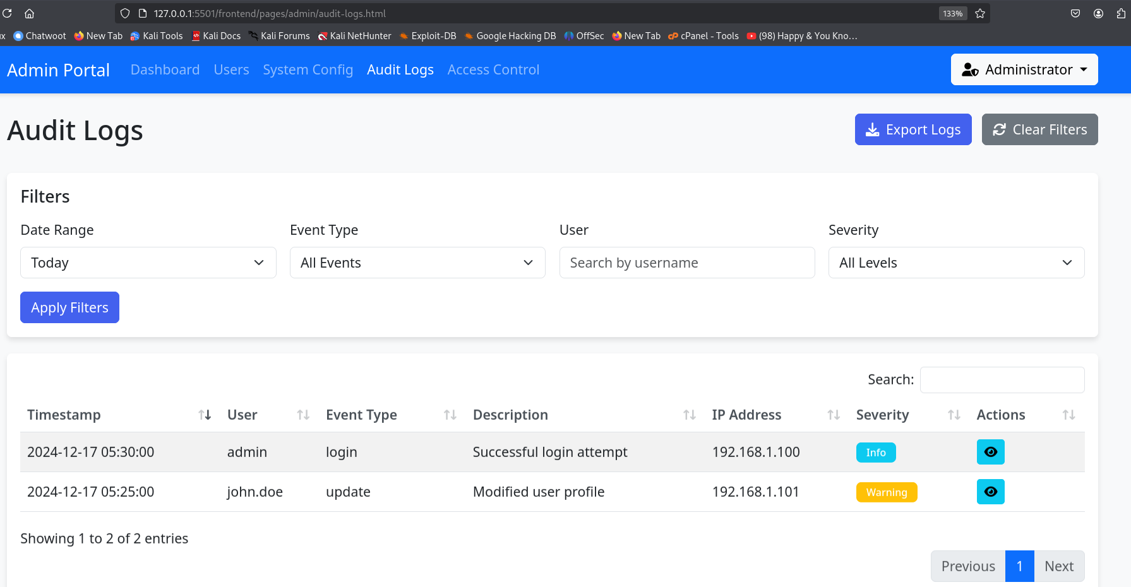

**Explanation:** This page likely displays logs of user actions for accountability. Screenshots could show the log entries and any filtering or searching capabilities.

## Idea Review Page

**File:** frontend/pages/global-manager/idea-review.html

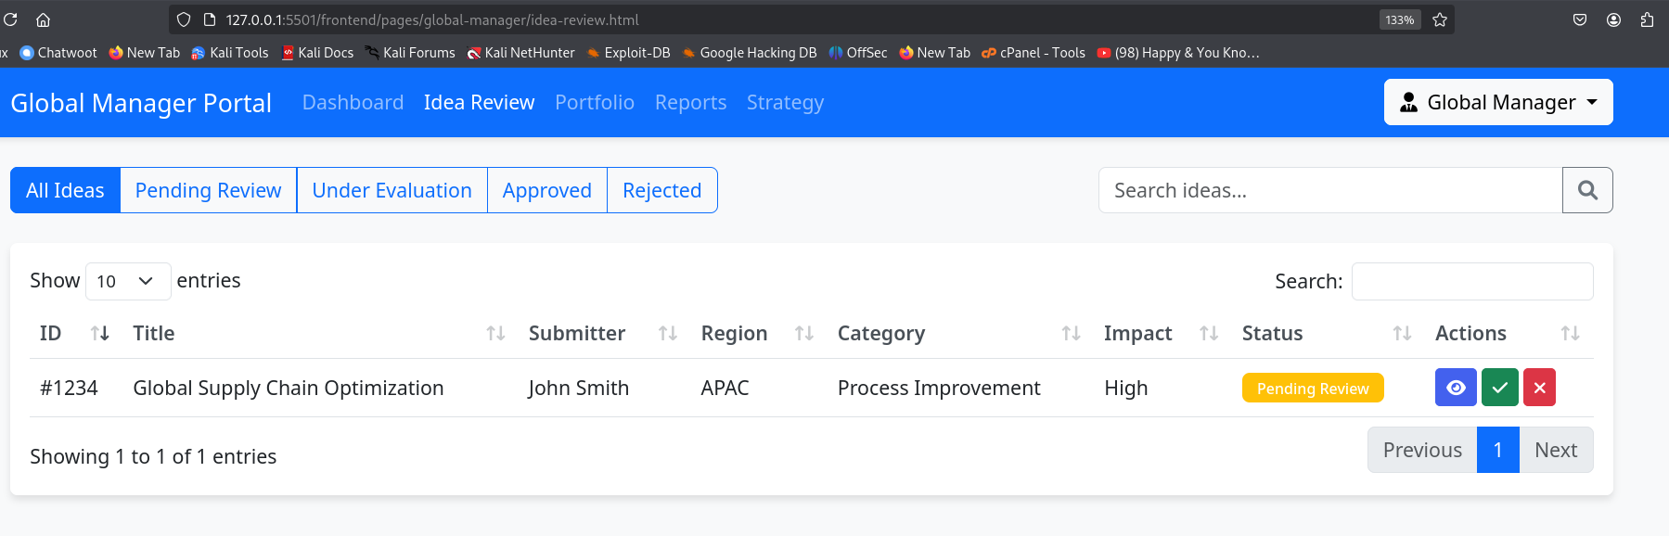**Explanation:** This page is likely for reviewing submitted ideas. Screenshots could show the review interface, including options for approval or feedback.

## Reports Page

### Files:

frontend/pages/global-manager/reports.html

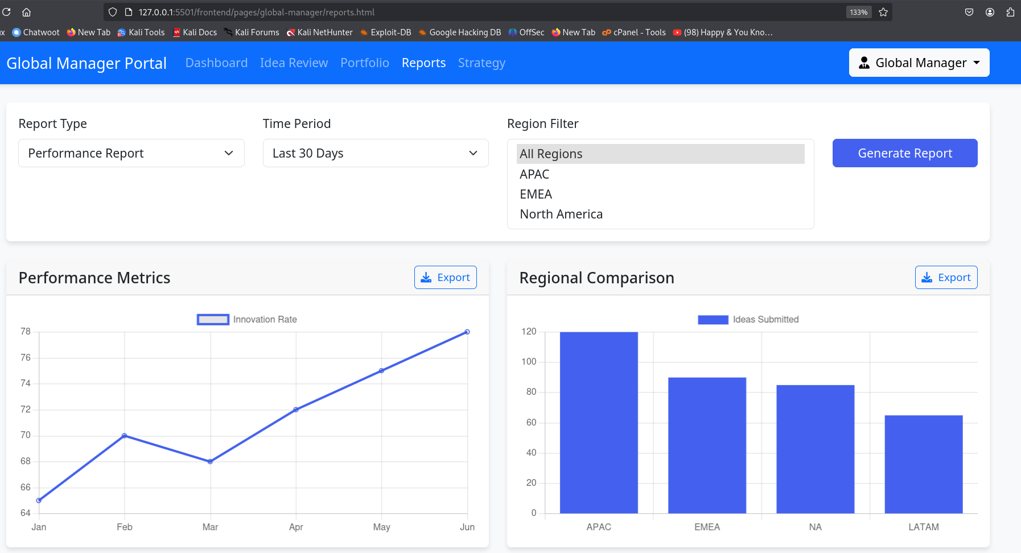

 frontend/pages/regional-manager/reports.html

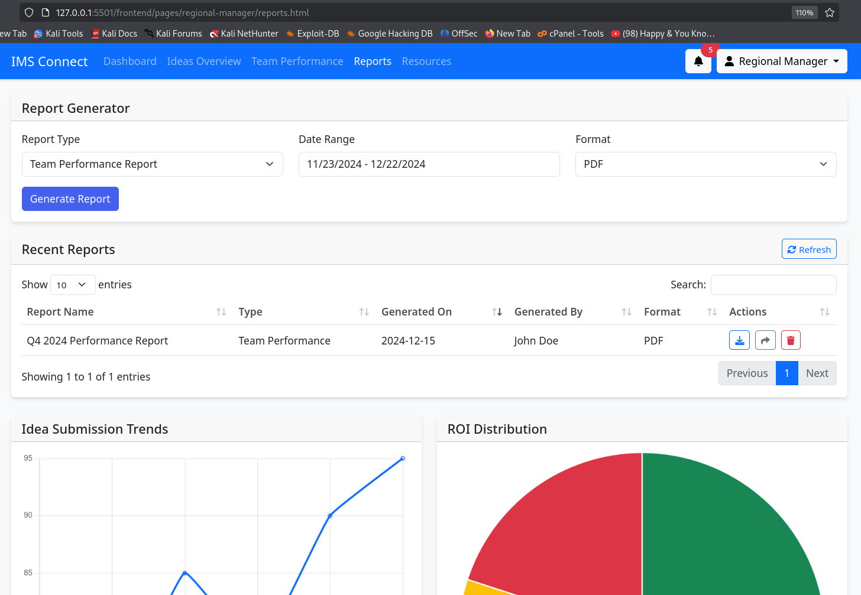

**Explanation:** These pages likely provide detailed reports on various metrics. Screenshots could illustrate the types of reports available and how to access them.

## Team Collaboration Page

**File:** frontend/pages/employee/team-collaboration.html

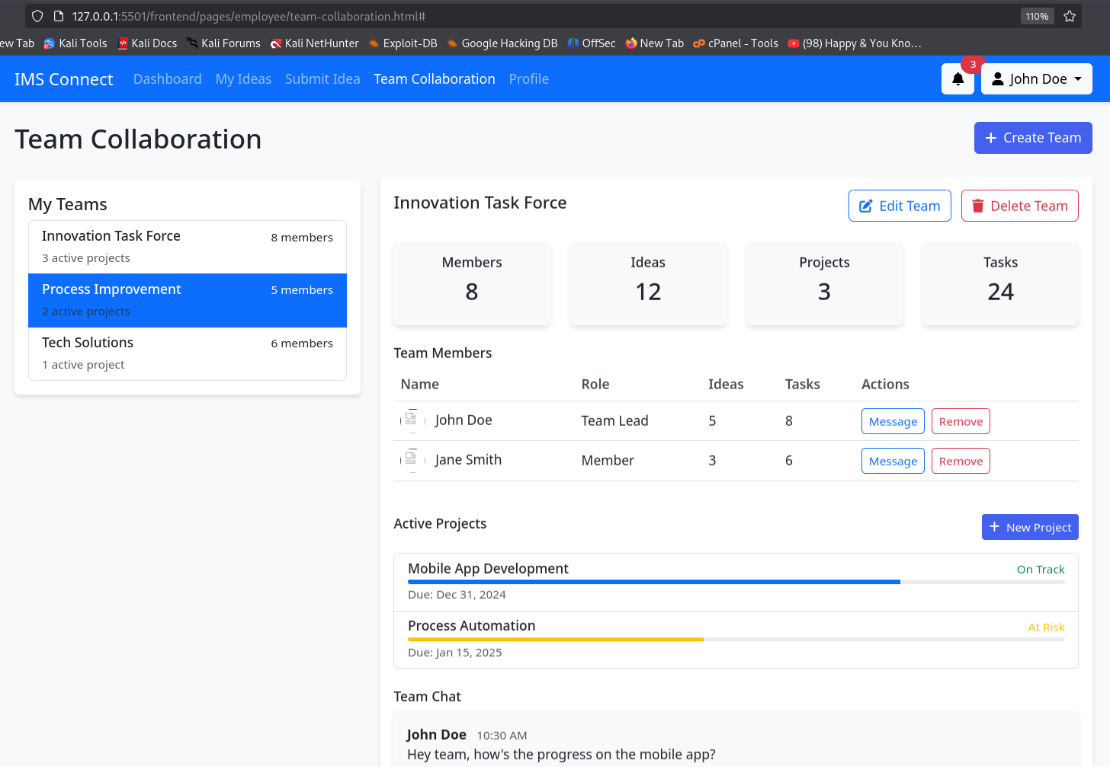

**Explanation:** This page is where team members can collaborate on ideas. Screenshots could show collaboration tools, team member lists, and any shared documents.

## Home Page

## 

This page is the entry point containg the login and registration forms fo all the users and there respctive redirects

## login page

## 

## Registration page

## 

## Role redirect section

## 