Homework 2

Anthony Adkins ([anadkins@uw.edu](mailto:anadkins@uw.edu))

## Problem 1 Results

Real rho = [0.2763549 0.2158966 0.03822885 0.06552442 0.40399523]

Estimated rho = [0.27817568 0.19989501 0.03950012 0.07982432 0.40260487]

Final SSE = 0.000467

**SSE over EM iterations**

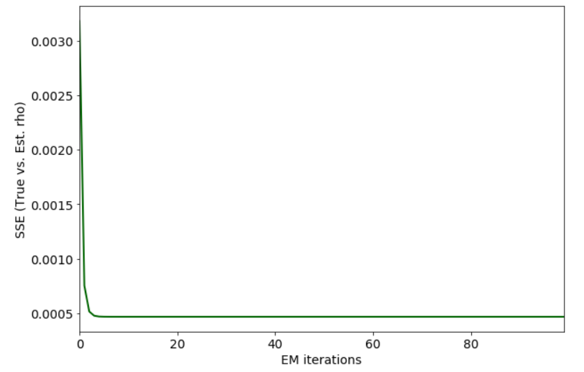

## Problem 2

2.1.a. There are 3,005 cells and 19,972 genes.

2.1.b. Average count: 0.699, maximum count: 10,738

2.1.c. Histogram of log of average counts

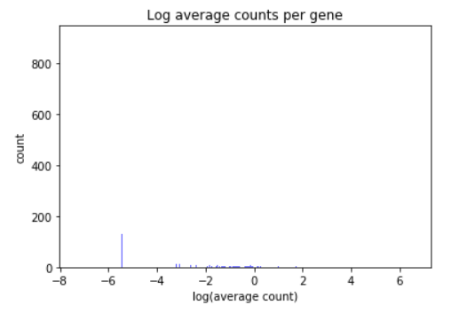

2.2 TSNE scatter plot colored with original labeling

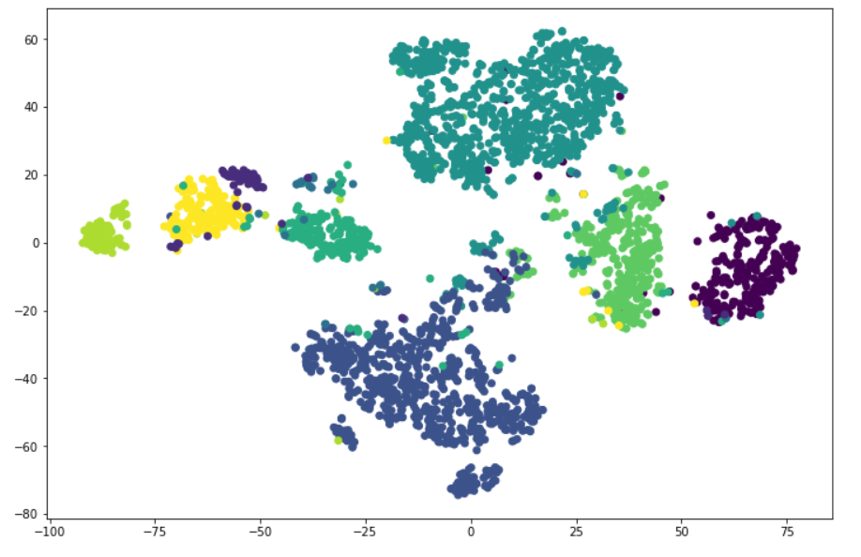

2.3

Error rate over iterations

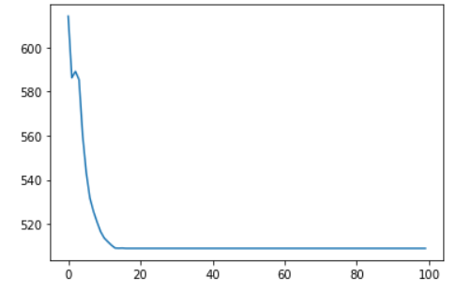

TSNE scatter plot colored with k-means cluster classification

