CSE520 Homework 4

Tony Adkins ([anadkins@uw.edu](mailto:anadkins@uw.edu))

# Genomics

## Sorted log odds ratios of 6mers

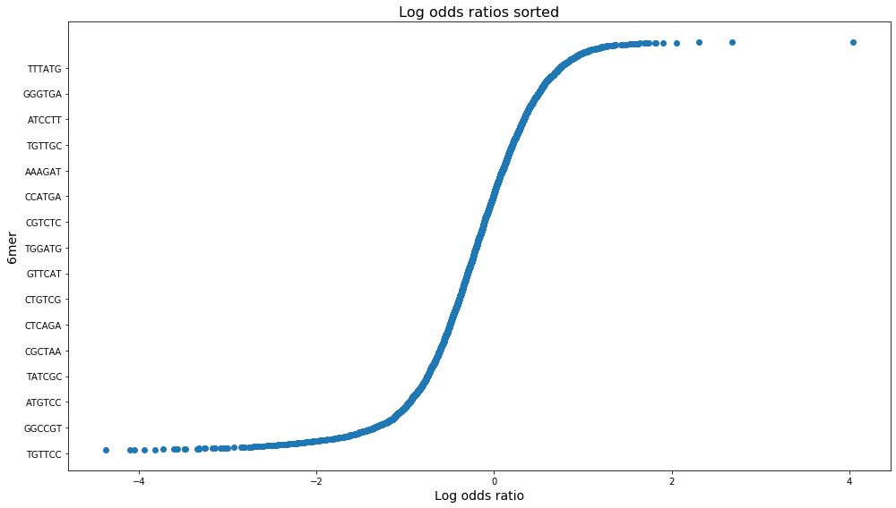

* Maximum log odds ratio: TCTTTC, 4.03856
* Minimum log odds ratio: CGACCT, -4.37356

The minimum above was calculated excluding the numerous 6mers which had zero probability, resulting in a negative infinity log odds ratio. The minimum of around -4 means the 6mer CGACCT has less than a 2:100 odds of splice usage. The maximum 6mer TCTTTC’s log odds ratio of around 4 means something closer to 55:1, a nearly 3000-fold increase in odds likelihood.

## KL-divergence Gradient Descent

### ∂L/∂wk derivation

Where yi is a constant from the data and is defined as

So, we can take the derivative as the sum of the derivatives of the two parts of the sum, starting with the first half:

Which can be further split into two, allowing us to find the derivatives of each separately because

So, now to find

We must apply the chain rule F’(w) = f’(g(w))g’(w) where g(w) =

Which requires us to find the derivative of g(w) = :

-

Then, to find f’, we find

So, we combine these results to find

Similarly, we can find the derivative for

by applying the chain rule F(w) = f’(g(w))*g’(w), where g(w) = , which we can rewrite for simplicity as

So,

Then,

Which we then bring back to our original equation to solve

This just leaves us the last part of the original equation to derive, which is simple

Now, to put that all together, we say

So, finally:

### ∂L/∂w0 derivation

With the loss function below, we will now similarly find the derivative with regards to

Again, we will start by taking the derivative as the sum of the derivatives of the two parts of the sum, starting with the first half:

Which can be further split into two, allowing us to find the derivatives of each separately because

So, now to find

We must apply the chain rule F’(w) = f’(g(w))g’(w) where g(w) =

Which requires us to find the derivative of g(w) = :

-

Then, to find f’, we find

So, we combine these results to find

Similarly, we can find the derivative for

by applying the chain rule F(w) = f’(g(w))*g’(w), where g(w) = , which we can rewrite for simplicity as

So,

Then,

Which we then bring back to our original equation to solve

This just leaves us the last part of the original equation to derive, which is even simpler this time

Now, to put that all together, we say

So, finally:

## Gradient Descent Implementation

Results from the gradient descent implementation

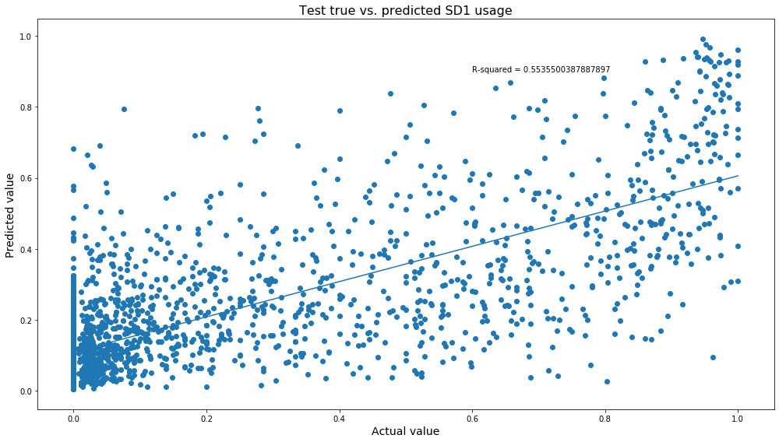

**Pearson R2 value = 0.55355**

The resulting error does not ever grow between iterations before reaching convergence within the λ = 0.0001 limitation, it is always converging.

### 10 most enhancing 6mers, with weights

1. GGGGGG = 0.7516851861509208
2. GGGAGG = 0.5557615127030084
3. GGAGGG = 0.4674845457590094
4. GGGTGG = 0.4607843124294966
5. GGTGGG = 0.443739283141239
6. GGGGGT = 0.43239217172185856
7. AGGGGG = 0.42510180949145804
8. GGGGAG = 0.40557013223742644
9. TGGGGG = 0.39704483654690115
10. GGGGGA = 0.3964454601591616

### 10 most repressive 6mers, with weights

1. GGTAAG = -0.4905625206301185
2. CGGTCG = -0.4526635880113442
3. CTTGGA = -0.37691215597236133
4. AGGTAA = -0.3247229520695178
5. CTTGGT = -0.3177554807667483
6. AGAAGA = -0.29436415586639525
7. AAGGTA = -0.28605283456665076
8. GAAGAT = -0.2829213533360671
9. CTTGGC = -0.2752746813347673
10. AAGAAG = -0.2711098799819469

Here we can see a pattern that the top 6mers to increase the odds ratio, or most enhancing motifs, are those with the most guanine (G), with a secondary preference for adenine (A). All are 4 or more G mixed with 1 or 2 A or T. A 6mer with lots of guanine appears to make a very good splice donor.

On the other hand, for most repressive 6mers, there is a pattern that they contain a 2mer of GG often paired with a 2mer of AA or TT. These 2mer pairs