Tony Majestro

Problem Set 1

1. Read the following cryptogram; give details of your decryption process.

BPKKPM GUMGU EM WM YMBPKKPM IUCZUU EG RTWA ATU RPZSI

BWSSG REGIPK.

To begin decrypting the message, I tried to print out all possible plaintexts for a shift cipher with $m=26$. This did not produce a readable message, so I assumed the message was encrypted with a substitution cipher.

I tried to take advantage of the fact that an encrypted character will always be the same throughout the encrypted message, so I could search through a dictionary for words that had similar formats to certain English words.

The first word is **BPKKPM**, and the fifth word is **YMBPKKPM**, which means that the fifth word is the same as the first word with a two letter prefix. Searching through all of the words in a dictionary of 1000 common English words

(<http://www.giwersworld.org/computers/linux/common-words.phtml>) for this particular pattern gives the following matches:

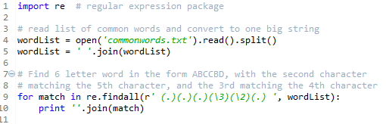

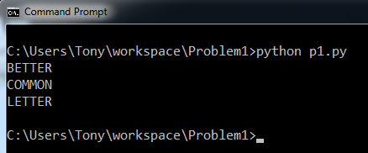0

The first word is probablyCOMMON, because it is the only word that could have a prefix (*UNCOMMON*). So the first word is COMMON and the fifth word is UNCOMMON. This gives us the following key:

|  |  |  |  |  |  |  |  |  |  |  |  |  |  |  |  |  |  |  |  |  |  |  |  |  |  |
| --- | --- | --- | --- | --- | --- | --- | --- | --- | --- | --- | --- | --- | --- | --- | --- | --- | --- | --- | --- | --- | --- | --- | --- | --- | --- |
|  |  | B |  |  |  |  |  |  |  |  |  | K | M | P |  |  |  |  |  | Y |  |  |  |  |  |
| a | b | c | d | e | f | g | h | i | j | k | l | m | n | o | p | q | r | s | t | u | v | w | x | y | z |

After partially decrypting the message, we are left with:

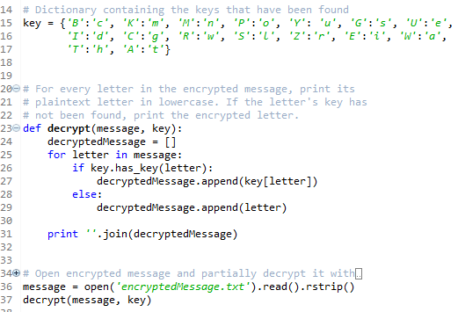

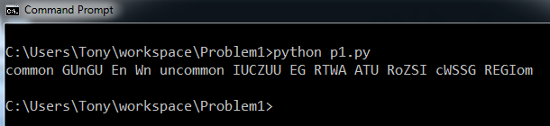

Next, we can attempt to find the second word, because it only has two missing characters in a very specific format. Searching for the possible words in this format gives only one match: SENSE.

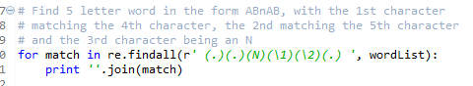

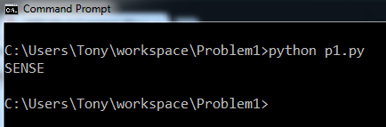

Now we have updated our key and have decrypted more of the message:

|  |  |  |  |  |  |  |  |  |  |  |  |  |  |  |  |  |  |  |  |  |  |  |  |  |  |
| --- | --- | --- | --- | --- | --- | --- | --- | --- | --- | --- | --- | --- | --- | --- | --- | --- | --- | --- | --- | --- | --- | --- | --- | --- | --- |
|  |  | B |  | U |  |  |  |  |  |  |  | K | M | P |  |  | Z | G |  | Y |  |  |  |  |  |
| a | b | c | d | e | f | g | h | i | j | k | l | m | n | o | p | q | r | s | t | u | v | w | x | y | z |

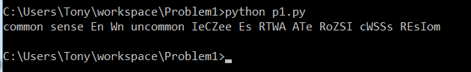

Searching for the sixth word gives us DEGREE:



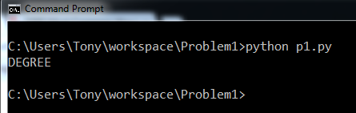

After updating the key again, we have the partially decrypted message:

|  |  |  |  |  |  |  |  |  |  |  |  |  |  |  |  |  |  |  |  |  |  |  |  |  |  |
| --- | --- | --- | --- | --- | --- | --- | --- | --- | --- | --- | --- | --- | --- | --- | --- | --- | --- | --- | --- | --- | --- | --- | --- | --- | --- |
|  |  | B | I | U |  | C |  |  |  |  |  | K | M | P |  |  | Z | G |  | Y |  |  |  |  |  |
| a | b | c | d | e | f | g | h | i | j | k | l | m | n | o | p | q | r | s | t | u | v | w | x | y | z |

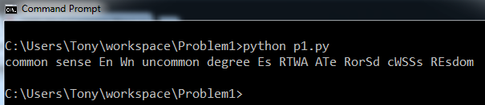

RosSd looks easy enough to decrypt:



This gives the output:



We can update our key again and partially decrypt the message:

|  |  |  |  |  |  |  |  |  |  |  |  |  |  |  |  |  |  |  |  |  |  |  |  |  |  |
| --- | --- | --- | --- | --- | --- | --- | --- | --- | --- | --- | --- | --- | --- | --- | --- | --- | --- | --- | --- | --- | --- | --- | --- | --- | --- |
|  |  | B | I | U |  | C |  |  |  |  | S | K | M | P |  |  | Z | G |  | Y |  | R |  |  |  |
| a | b | c | d | e | f | g | h | i | j | k | l | m | n | o | p | q | r | s | t | u | v | w | x | y | z |

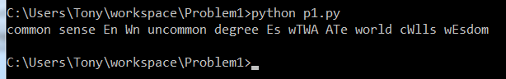

The last word is most likely WISDOM, so I’m not even going to run the script to verify it. We can update the key and partially decrypt again:

|  |  |  |  |  |  |  |  |  |  |  |  |  |  |  |  |  |  |  |  |  |  |  |  |  |  |
| --- | --- | --- | --- | --- | --- | --- | --- | --- | --- | --- | --- | --- | --- | --- | --- | --- | --- | --- | --- | --- | --- | --- | --- | --- | --- |
|  |  | B | I | U |  | C |  | E |  |  | S | K | M | P |  |  | Z | G |  | Y |  | R |  |  |  |
| a | b | c | d | e | f | g | h | i | j | k | l | m | n | o | p | q | r | s | t | u | v | w | x | y | z |

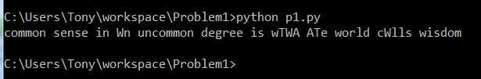

For the fourth word, there are only three 2 letter words ending in an ‘n’. It cannot be ‘in’ or ‘on’ because we have already found out that $e\left( E \right)=i$ and $e\left( P \right)=o$. So the fourth word is AN and the second to last word is CALLS:

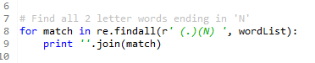

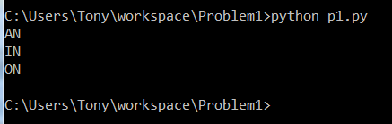

This gives us the new key and new decryption:

|  |  |  |  |  |  |  |  |  |  |  |  |  |  |  |  |  |  |  |  |  |  |  |  |  |  |
| --- | --- | --- | --- | --- | --- | --- | --- | --- | --- | --- | --- | --- | --- | --- | --- | --- | --- | --- | --- | --- | --- | --- | --- | --- | --- |
| W |  | B | I | U |  | C |  | E |  |  | S | K | M | P |  |  | Z | G |  | Y |  | R |  |  |  |
| a | b | c | d | e | f | g | h | i | j | k | l | m | n | o | p | q | r | s | t | u | v | w | x | y | z |

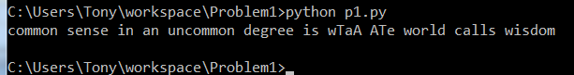

The only characters that have not been decrypted are ‘T’ and ‘A’. The eight word is probably WHAT and the ninth word is probably THE. A quick search proves this:



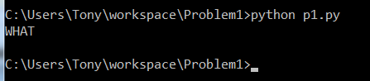

So we have the final key and the final decrypted message:

|  |  |  |  |  |  |  |  |  |  |  |  |  |  |  |  |  |  |  |  |  |  |  |  |  |  |
| --- | --- | --- | --- | --- | --- | --- | --- | --- | --- | --- | --- | --- | --- | --- | --- | --- | --- | --- | --- | --- | --- | --- | --- | --- | --- |
| W |  | B | I | U |  | C | T | E |  |  | S | K | M | P |  |  | Z | G | A | Y |  | R |  |  |  |
| a | b | c | d | e | f | g | h | i | j | k | l | m | n | o | p | q | r | s | t | u | v | w | x | y | z |

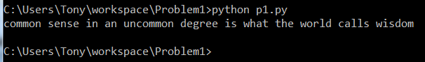

1. Read the following message, which was encrypted with an affine cipher. The

five-character groups are not an indication of word breaks. There is no special

character for the delimiter (space). Do not use an exhaustive search; rely on

letter frequencies and guesses at plaintext letter pairs (digraphs). Give the

multiplier and shift used for encryption. (Use A=1, B=2, ..., Z=26.)

GYOMX NOGNG QUGNE TNMXM PLMZO MXYMK TMMJO XAXEN TKZZM

QEBMF TZEQK JKZQE XYEXN MQLJK NOXAN HMTJE EFETX MICXE

IJMFA MIHOY HMKYH WMKZR ZOXAG IONHO N

The second problem involved decrypting a message that was encrypted with an affine cipher. The approach I took was to find the most common digraphs in the encrypted message and compare them to the most common digraphs in the English language.

I used a python script to find the most common digraphs in the encrypted message:

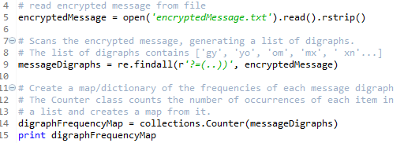

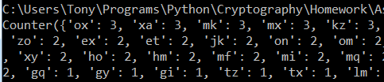

So OX, XA, MK, MX, KZ, … were the most frequently occurring digraphs in the message. Now that I know this, I can start with common digraphs in the encrypted message and use common digraphs in the English language to generate values for $a$ and $b$ for the Affine cipher. I can begin by guessing that O encrypts to T and X encrypts to H, since TH is the most frequently used digraph in the English language. This gives the equations:

$$19a+b ≡14 mod 26$$

$$7a+b ≡17 mod 26$$

Solving for a gives us the equations:

$$12a≡7 mod 26$$

$$a≡{(12}^{-1}* 7) mod 26$$

However, the multiplicative inverse of 12 mod 26 does not exist because 12 and 26 are not relatively prime. Therefore, O cannot encrypt to T while X encrypts to H. But we can continue trying pairs of digraphs until we reach a valid value for $a$. Once we’ve gotten a valid value for $a$, we can solve for our $b$ and then decrypt the message. If the decrypted message is readable, then we know that we have valid values for $a$ and $b$.

If the message is not readable, then there were incorrect values for a and b. I wrote a script to automate this process of finding the values of a and b that decrypt to the correct text. I have several helper functions for doing the algebra:

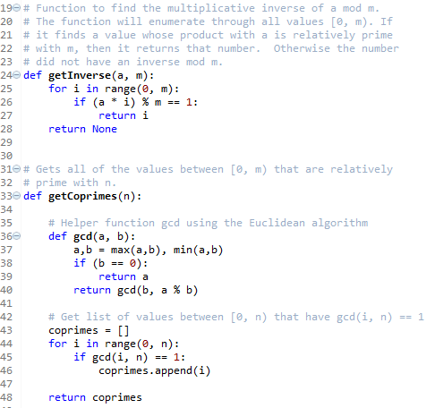

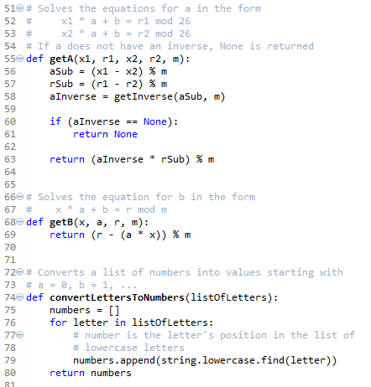

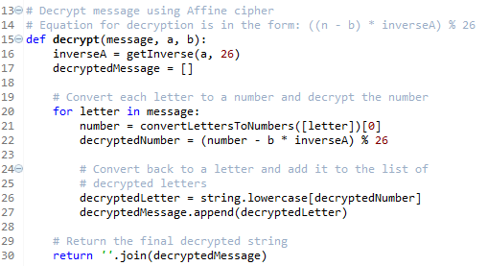

The main program goes through each pair of digraphs, searching for a valid pair of a and b. If the decryption looks like English, it gets printed out:



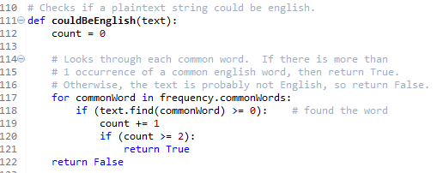

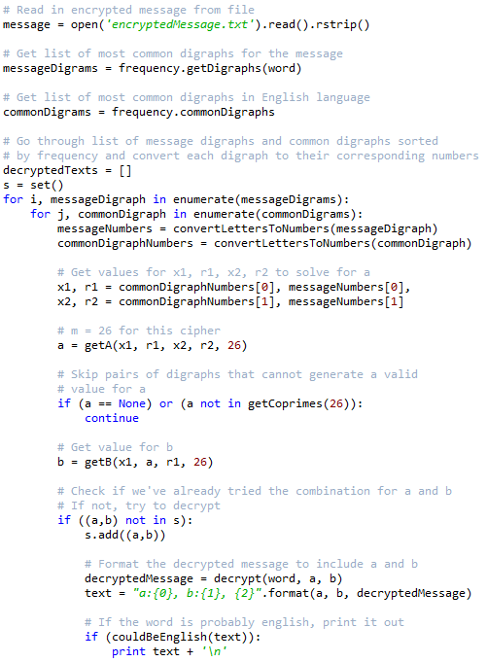

Only two of the pairs of a and b gave possible English values. The first is clearly English, decrypting to “Scientists must often experience a feeling not far removed from alarm on contemplating the flood of new knowledge which each year brings with it”, with values a = 7 and b = 10

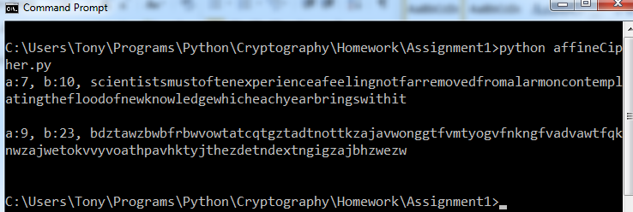

1. Calculate the number of keys for the following Affine Ciphers with values m = 30, 100, 1225

The formula for the number of keys for an affine cipher is equal to the number of possible values for $a$ times the number of possible values for b.

The number of values for $a$ given $m$ is equal to the euler-phi function of m. That is, the number of values between [0, m) that are relatively prime to $m$. The number of values for b given m is equal to $m$, since the shift may be any value in [0, m). Therefore, the number of total keys is equal to the equation:

$$m*φ\left(m\right)$$

$m=30$

$30=2^{1}*3^{1}*5^{1}$

$φ\left(30\right)= {(2}^{1}-2^{0})*{(3}^{1}-3^{0})*{(5}^{1}-5^{0})$

$φ\left(30\right)=1*2*4$

$φ\left(30\right)=8$

* Total keys = 30 * 8 = 240
$m=100$

$100=2^{2}*5^{2}$

$φ\left(100\right)= {(2}^{2}-2^{1})*{(5}^{2}-5^{1})$

$φ\left(100\right)=2*20$

$φ\left(100\right)=40$

* Total keys = 100 * 40 = 4000
$m=1225$

$1225=5^{2}*7^{2}$

$φ\left(1225\right)= {(5}^{2}-5^{1})*{(7}^{2}-7^{1})$

$φ\left(1225\right)=20*42$

$φ\left(1225\right)=840$

* Total keys = 1225 * 840 = 1,029,000

1. Write out all of the steps in the gcd (greatest common divisor) algorithm to

calculate gcd(5847,1410).

gcd(5847, 1410) =

gcd(1410, 5847 % 1410) =

gcd(1410, 207) =

gcd(207, 1410 % 207) =

gcd(168, 207 % 168) =

gcd(168, 39) =

gcd(39, 168 % 39) =

gcd(39, 12) =

gcd(12, 3) =

gcd(3, 12 % 3) =

gcd(3, 0) = 3

gcd(5847, 1410) = 3

1. Read the following message – the plaintext is English. You may work alone or

in groups. Carefully explain how you read the message. If you were unable to

read the message, describe your method in detail.

NPVGP GIZGH LGZKP LKKLF EQZUN

PGEHZ RKZOJ ZGZXZ MZQKA

Because I did not know where words began or ended, I could not approach this problem like the first problem. Instead, I began this problem by looking at frequencies of letters, digraphs, and monographs:

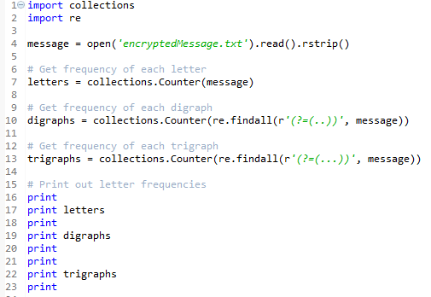

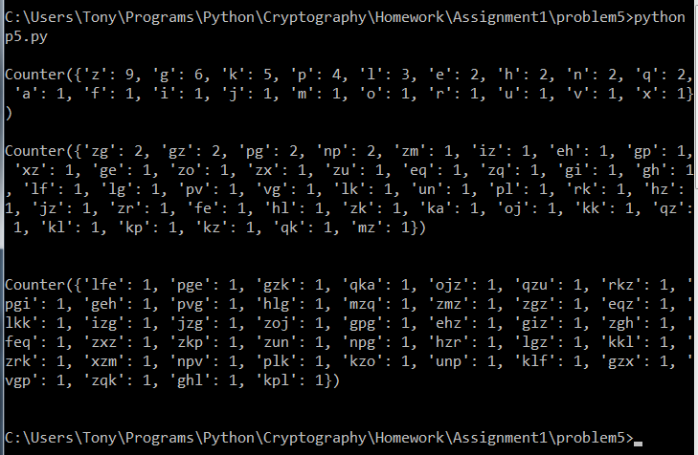

From here, I noticed several things.

* Z was by far the most popular letter, followed by G, Z, and P
* No digraph appeared more than twice
* GZ and ZG both appear twice, and look exactly like the two of the most frequent digraphs in the English language, ER and RE
* No trigraph appeared more than one time

I began by trying the digraph GZ and ZG. It appears that it could be RE and ER.

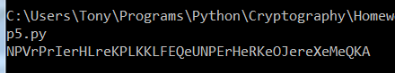

I noticed OJere, which would be some form of where. After attempting to try that key, I get the following partial decryption:

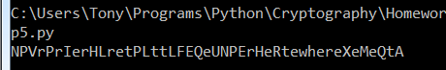

The work that I hand in is my own.

-Anthony Majestro