4.1 Chapter Overview
This chapter presents the benchmark results and evaluates them across the three dimensions of measurement. In doing so, it assesses the overall aim of the dissertation. The chapter also evaluates the benchmarking system and its outputs against the stated functional and non-functional requirements, assesses the extent to which the project objectives were achieved, and identifies the main limitations of the work.
4.2 Cryptographic Performance
This section presents the cryptographic performance results, covering signing time, verification time, total cryptographic time, and throughput for all five configurations.
4.2.1 Signing Time

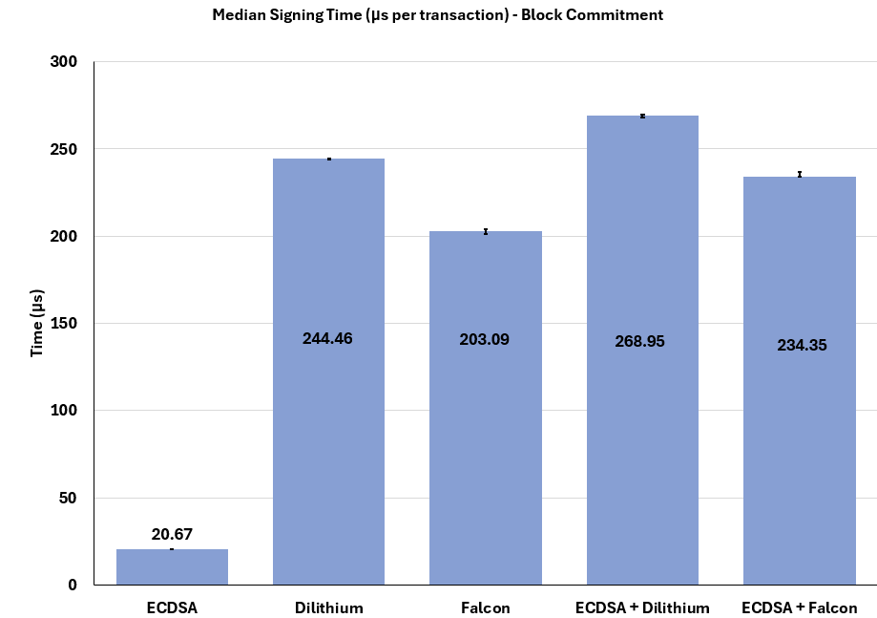
Fig A
Signature Scheme | Median (μs/tx) | Mean (μs/tx) | Standard Deviation(μs/tx)
ECDSA | 20.67 | 20.65 | 0.16
Dilithium | 244.46 | 244.42 | 2.29
Falcon | 203.09 | 203.24 | 1.38
ECDSA + Dilithium | 268.95 | 269.62 | 2.21
ECDSA + Falcon | 234.34 | 233.82 | 3.18

Figure A presents the median signing times for block commitment verification flow across all five configurations. Block commitment verification flow metrics are identical to the ones of scheme level verification, and the flow provides no difference in signing as that happens at the start excluded from any other operation. ECDSA records the lowest signing time at 20.67μs of all signature schemes when it comes to singning, followed by Falcon at 203.09 µs, ECDSA + Falcon hybrid at 234.35 µs, Dilithium at 244.46 µs, and ECDSA + Dilithium hybrid at 268.95 µs, proving to be the slowest of them all.
ECDSA’s quick signing time is expected given its classical elliptic curve foundation, that is based on lighter mathematical hardness. The gap between ECDSA and all post-quantum configurations is substantial at over 10x slower speed to its nearest counterpart. This simply shows the difference in underlying cryptographic structure of lattice-based schemes of which is consistent with the general literature on post-quantum signing timing. This
This shows why ECDSA is so popular [XX]
Notably, Falcon signs faster than Dilithium despite both being lattice-based schemes. This result is attributable to two foundational factors. Its lower NIST security level (category 1) compared to Dilithium (category 2) allows it to be a lighter scheme, performing less work per signature. Additionally, Falcon is built on NTRU lattices, a structure fundamentally more compact than Dilithium's, contributing further to its lower signing cost. This is consistent with benchmarks reported by [XX] who reports similar differences in signing cost between the post quantum only schemes.

Comparing the hybrid configurations against their parts, ECDSA + Dilithium at 268.95 µs costs more than Dilithium alone at 244.46 µs, and ECDSA+Falcon at 234.35 µs costs more than Falcon alone at 203.09 µs. In both cases the hybrid signing time is largely dictated by the post-quantum component, with the additional ECDSA signing step contributing a relatively small but measurable operation cost. This displays the process of signing twice per transaction and shows the fundamental cost of hybrid approaches. The additional ECDSA cost does not contribute significantly, adding around 30μs in both cases, nearly proportional to adding the two signature signing times to produce the hybrids signing times.
Standard deviation values across all configurations are minimal, ranging from 0.16 µs for ECDSA to 3.18 µs for ECDSA+Dilithium, indicating highly stable and consistent measurements across the 20 runs. Showing accurate results.

• Compare configurations against each other — rank them, identify which is fastest and slowest
• Explain the reasons behind notable findings — like Falcon being faster than ECDSA, which is counterintuitive and needs explanation
• Compare hybrids against their component schemes — ECDSA+Dilithium vs ECDSA alone and Dilithium alone separately
• Cross-reference literature values for Dilithium and Falcon to validate your implementation
• Note what the findings mean for the research question — faster signing means lower transaction processing cost which matters for transition suitability

Figure A presents the median signing times across all five configurations reported by the commit verification mode. ECDSA records the lowest signing time at 20.67 µs, followed by Falcon at 203.09 µs, ECDSA+Falcon at 234.35 µs, Dilithium at 244.46 µs, and ECDSA+Dilithium at 268.95 µs, the slowest configuration overall.
ECDSA's signing speed is expected given its classical elliptic curve foundation, which is designed on comparatively lighter mathematical hardness than post-quantum schemes. The gap between ECDSA and all post-quantum configurations is substantial, with the nearest scheme being over 10x slower. This reflects the fundamental computational difference between classical and lattice-based cryptographic structures, a finding consistent with the wider literature on post-quantum signing performance [XX]. Both post-quantum schemes and their hybrids run AVX2-optimised implementations, meaning these results reflect realistic deployment conditions rather than reference implementation baselines.
Notably, Falcon signs faster than Dilithium despite both being lattice-based schemes. This result is attributable to two foundational factors. Its lower NIST security level (category 1) compared to Dilithium (category 2) allows it to be a lighter scheme, performing less work per signature. Additionally, Falcon is built on NTRU lattices, a structure fundamentally more compact than Dilithium's, contributing further to its lower signing cost. This is not consistent with benchmarks of these two, as reported by [XX], showing the difference of environments,
This is consistent with benchmarks reported by [XX], who reports the same general speed of one being faster than the other.
Comparing the hybrid configurations against their individual components, ECDSA+Dilithium at 268.95 µs costs more than Dilithium alone at 244.46 µs, and ECDSA+Falcon at 234.35 µs costs more than Falcon alone at 203.09 µs. In both cases the hybrid signing time is largely dictated by the post-quantum component, with the additional ECDSA signing step contributing a relatively small but measurable cost. This reflects the fundamental overhead of signing twice per transaction inherent to the hybrid approach. The additional ECDSA contribution adds roughly 30 µs in both cases, nearly proportional to the sum of the two individual signing times.
As presented in Table X, standard deviation values across all configurations are minimal, ranging from 0.16 µs for ECDSA to 3.18 µs for ECDSA+Dilithium, indicating highly stable and consistent measurements across the 20 runs.

4.2.2 Verification time
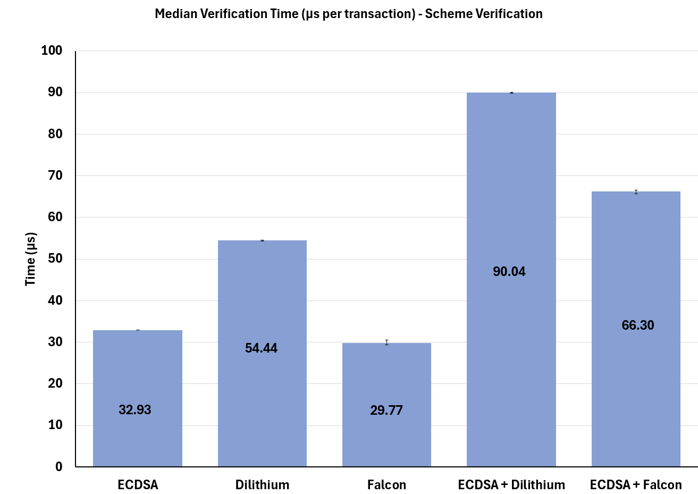
Signature Scheme | Median (μs/tx) | Mean (μs/tx) | Standard Deviation(μs/tx)
ECDSA | 32.93 | 32.91 | 0.19
Dilithium | 54.44 | 54.57 | 0.68
Falcon | 29.77 | 29.73 | 0.14
ECDSA + Dilithium | 90.04 | 90.00 | 0.63
ECDSA + Falcon | 6630 | 66.27 | 0.48

Figure B presents median verification times at the scheme level across all five configurations. Falcon records the lowest verification time at 29.77 µs, narrowly ahead of ECDSA at 32.93 µs, followed by Dilithium at 54.44 µs, ECDSA+Falcon at 66.30 µs, and ECDSA+Dilithium at 90.04 µs, the slowest overall.
Falcon outperforming ECDSA at verification is a notable result. This is explained by the fact that verification in Falcon is a considerably simpler operation than signing, as it only requires checking the signature against the public key rather than performing the expensive lattice computations involved in signing. ECDSA's verification is relatively expensive compared to its own signing process as it requires recomputing elliptic curve point multiplications to validate the signature. ECDSA verification by contrast requires a full elliptic curve point multiplication, which is comparatively more expensive. This asymmetry explains the ranking shift between signing and verification, consistent with [XX]. Given that verification occurs at every node for every transaction, Falcon's advantage here is arguably more meaningful than any signing result.

Falcon outperforming ECDSA at verification is a notable result. This is explained by the fact that verification in Falcon is a considerably simpler operation than signing, as it only requires checking the signature against the public key rather than performing the expensive lattice computations involved in signing. ECDSA's verification is relatively expensive compared to its own signing process as it requires recomputing elliptic curve point multiplications to validate the signature. This asymmetry explains the ranking shift between signing and verification, consistent with [XX]. Given that verification occurs at every node for every transaction, Falcon's advantage here is arguably more meaningful than any signing result.

Dilithium remains the slowest standalone scheme at 54.44 µs, consistent with its heavier structure and higher security level observed in signing.
As with signing, hybrid verification costs are close to fully additive, with ECDSA+Dilithium at 90.04 µs and ECDSA+Falcon at 66.30 µs both approaching the sum of their individual components, reflecting the cost of verifying two signatures per transaction.
As presented in Table X, standard deviation values are minimal across all configurations, ranging from 0.14 µs for Falcon to 0.68 µs for Dilithium, indicating stable and consistent measurements across the 20 runs.

4.2.3 Crypto Only Throughput
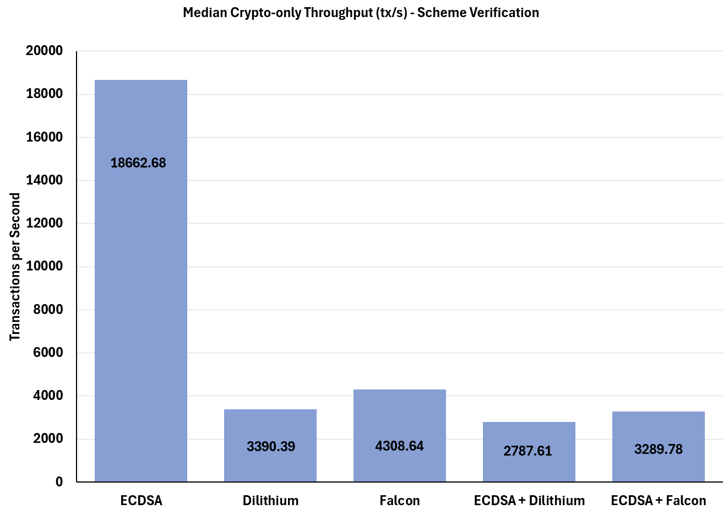
Signature Scheme | Median (μs/tx) | Mean (μs/tx) | Standard Deviation(μs/tx)
ECDSA | 18662.68 | 18675.10 | 107.47
Dilithium | 3390.39 | 3380.31 | 45.84
Falcon | 4308.64 | 4308.33 | 29.47
ECDSA + Dilithium | 2787.61 | 2790.82 | 17.29
ECDSA + Falcon | 3289.78 | 3292.55 | 25.80
Figure C presents median crypto-only throughput at the scheme level across all five configurations. ECDSA records the highest throughput at 18,662.68 tx/s, followed by Falcon at 4,308.64 tx/s, Dilithium at 3,390.39 tx/s, ECDSA+Falcon at 3,289.78 tx/s, and ECDSA+Dilithium at 2,787.61 tx/s, the slowest overall.
ECDSA's throughput is in a different category entirely, processing over four times more transactions per second than the next best configuration. This is a direct consequence of its combined signing and verification cost of 53.60 µs, far lower than any post-quantum configuration, and is fully consistent with the signing and verification results presented above. Falcon again outperforms Dilithium, consistent with its lower signing and verification costs established in the preceding sections.
A particularly notable finding is that ECDSA+Falcon at 3,289.78 tx/s performs almost identically to pure Dilithium at 3,390.39 tx/s. This is not coincidental. The total crypto time for ECDSA+Falcon (234.35 + 66.30 = 300.65 µs) is nearly identical to that of Dilithium alone (244.46 + 54.44 = 298.90 µs), meaning adding ECDSA to Falcon produces a hybrid that is cryptographically no faster than running Dilithium on its own.
Standard deviations are larger in absolute terms than in previous metrics, with ECDSA recording 107.47 tx/s, though relative to its throughput value this represents less than 1%, remaining consistent with the stable measurements observed throughout.

4.3.1 End-to-end Throughput
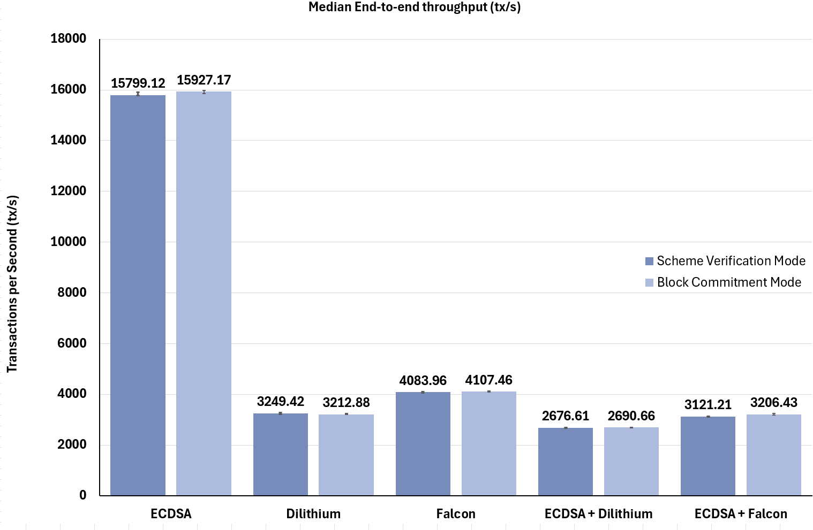

Figure D presents median end-to-end throughput across all five configurations under both scheme verification and block commitment modes, with both presented to provide a fuller picture of system behaviour across the two verification flows. Rankings remain unchanged from the crypto-only results, with ECDSA leading at 15,799.12 and 15,927.17 tx/s, followed by Falcon, Dilithium, ECDSA+Falcon, and ECDSA+Dilithium as the slowest overall.
End-to-end throughput is marginally lower than crypto-only throughput across all configurations, which is expected as it captures the full pipeline including serialisation and other system overhead beyond cryptographic operations alone. The reduction is small, confirming that cryptographic operations remain the dominant cost in the pipeline regardless of verification mode.
The two modes produce near-identical results across every configuration, with differences of less than 2% in all cases. This indicates that the block commitment flow introduces negligible additional throughput cost relative to scheme verification. The ECDSA+Falcon and pure Dilithium throughputs remain closely matched as observed in crypto-only results, further reinforcing that finding.
Standard deviations remain small relative to their respective throughput values across both modes, consistent with the stable measurements observed throughout.

4.1 Chapter Overview Short orienting paragraph recapping the five configurations, three metric dimensions, two verification modes, and how results are summarised — median over 20 runs, split 10 scheme-level and 10 commit-level.
4.2 Cryptographic Performance Present and discuss signing time, verification time, total cryptographic time, and crypto-only throughput across all five configurations. Compare scheme-level and commit-level where figures differ meaningfully. Cross-reference against literature values to validate implementation.
4.3 System-Level Performance Present and discuss end-to-end throughput, block commitment time, CPU usage, and memory usage. Discuss hybrid compounded overhead explicitly. Note where scheme-level and commit-level figures differ.
4.4 Storage Impact Present and discuss signature sizes, public key sizes, transaction sizes, and ledger growth. Include both adjusted and unadjusted figures and explain the difference. Note Falcon variable signature size and its implications.
4.5 Synthesis: Transition Suitability Bring the three metric dimensions together and answer the research question — are hybrid signatures a suitable and efficient transition approach, and does the choice of post-quantum component meaningfully affect the trade-offs? Assess each configuration in turn.
4.6 Limitations Single-machine environment, timing noise, hardware-specific results, JSON chain size as proxy, public key storage memory caveat, results reflecting a simulated rather than production environment.
4.7 Requirements and Output Evaluation Assess the benchmarking system as a project output by evaluating it against the functional and non-functional requirements from section 3.2. For each requirement, state whether it was fully met, partially met, or not met, and explain any deviations. This establishes the quality of the system as an output and its fitness for supporting a valid evaluation.
4.8 Objectives and Aims Evaluation Address each project objective one by one and assess the extent to which it was achieved. Return to the overall aim and state whether it was met based on the evidence presented in the chapter.

