Lab - Week 2: Containers

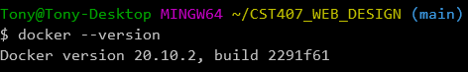

**Exercise 1 - Hello World (10 points)**

1. Run hello-world. (**screenshot**)

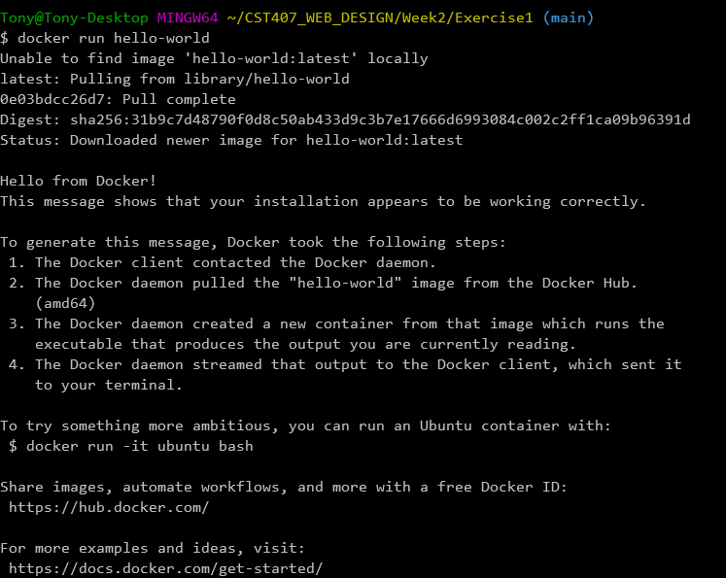

1. Run the following command to list the local images (**screenshot**):  
     
   **docker images**

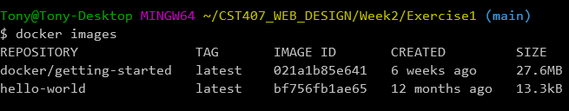

1. Run the following command to list the containers (**screenshot**):  
     
   **docker ps -a**

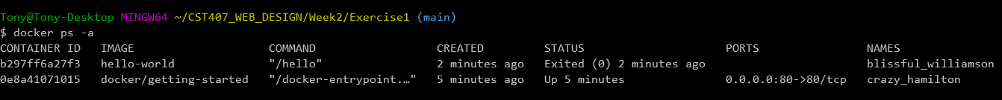

**Exercise 2 - Running a Container (20 points)**

Read and work through [1.0 Running your first container (Links to an external site.)](https://github.com/docker/labs/blob/master/beginner/chapters/alpine.md).  T**ake a screenshot after each "docker" CLI command you run.**

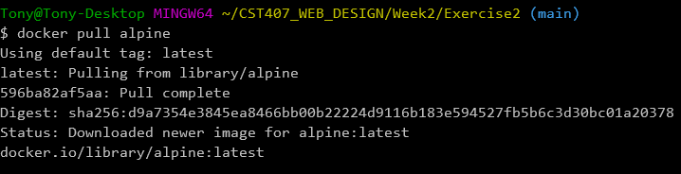

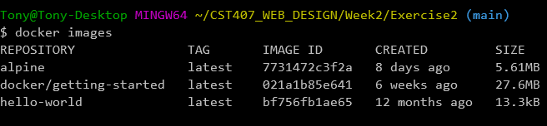

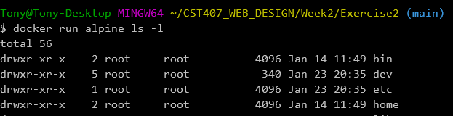

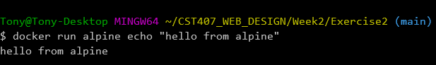

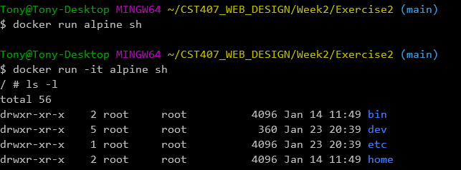

**Exercise 3 - Sample Web Application in a Container (30 points)**

1. Create an "Exercise3" folder and include the code for this exercise there.

2. Read and work through [2.0 Webapps with Docker (Links to an external site.)](https://github.com/docker/labs/blob/master/beginner/chapters/webapps.md).

3. Run each of the Docker CLI commands shown in that section.  Take a screenshot after each command you run with its results.

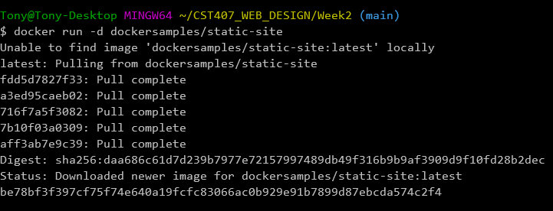

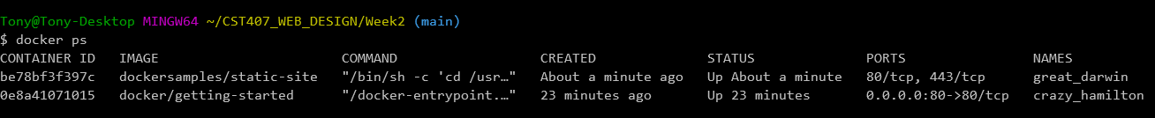

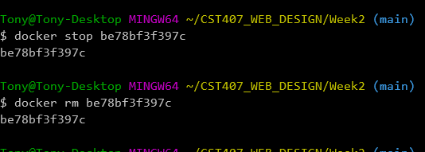

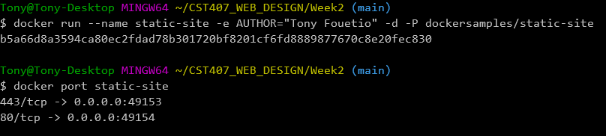

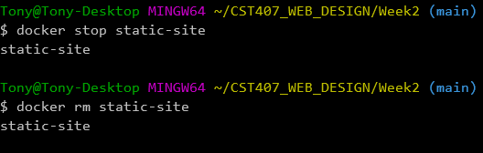

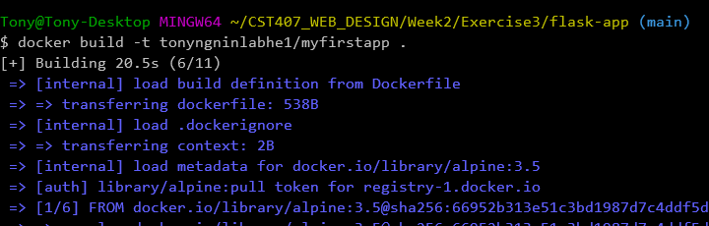

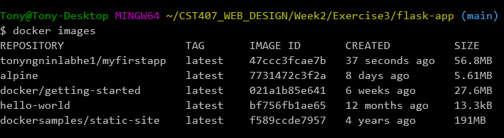

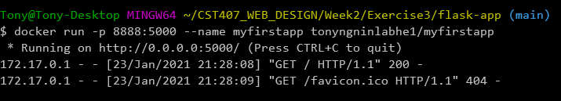

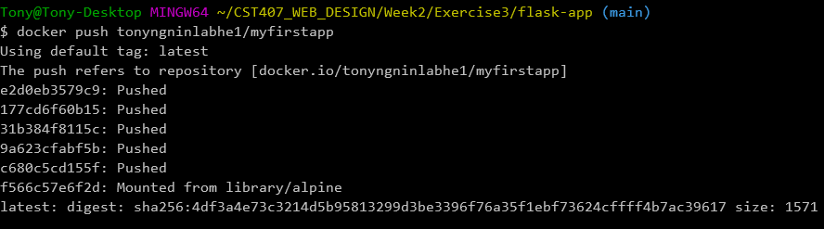

4. Include a screenshot of a browser displaying the output of the sample Web application.

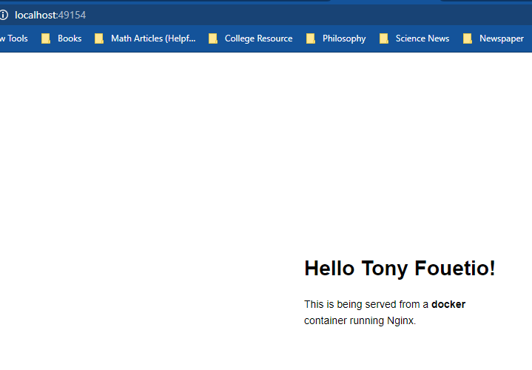

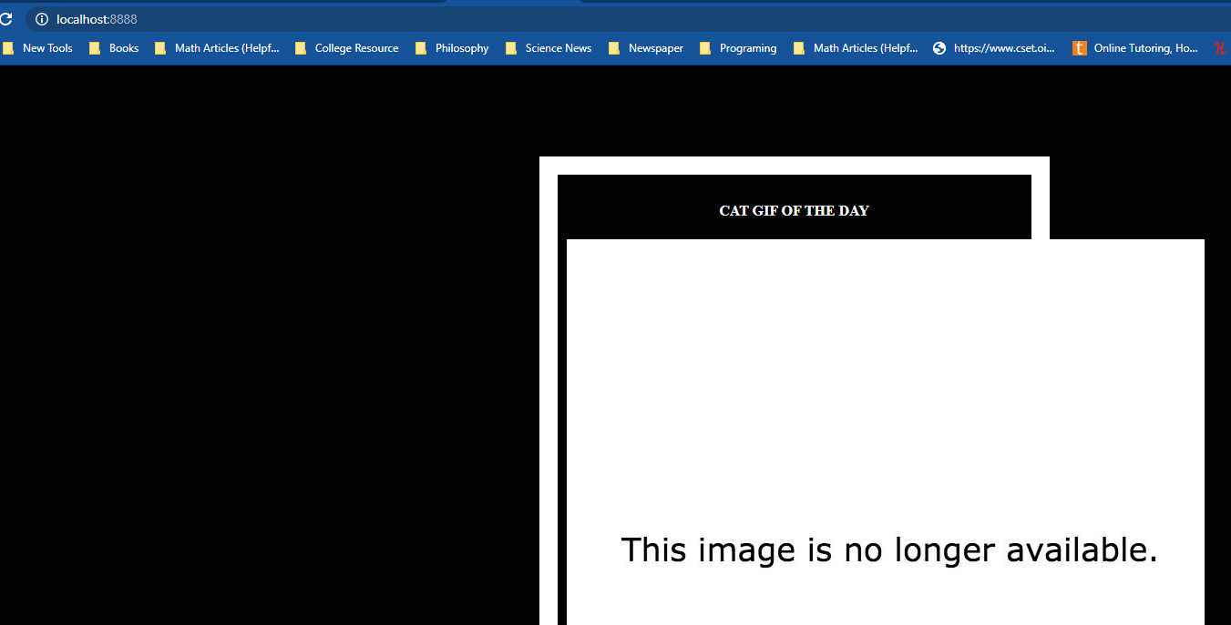

**Exercise 4 - Your Web Application in a Container (40 points)**

1. Create an "Exercise4" folder and include the code for this exercise there.

2. Repeat section 2.3 from [2.0 Webapps with Docker (Links to an external site.)](https://github.com/docker/labs/blob/master/beginner/chapters/webapps.md) with the following exceptions:

     - Replace the steps in 2.3.1 with the following: copy the folders/files from your week1 folder to your week2/Exercise4 folder.

     - Replace the steps in 2.3.2 with the following: copy the nginx folder and the Dockerfile from the Week2/app1 folder in [my GitHub repo (Links to an external site.)](https://github.com/oitgaden/Web-Development) to your week2/Exercise4 folder.  
  
3. For 2.3.3 through 2.3.4:

     - Give your Docker images a different name than what you used in Exercise 3 above.  
  
     - Use port 80 instead of port 5000 in the docker run command since NGINX configuration is configured to listen on port 80 inside the container.

     - Use port 8080 instead of 8888 in the run command and in the browser to distinguish it from the application in Exercise 3.

1. Take a screenshot after each Docker CLI command you run with its results.

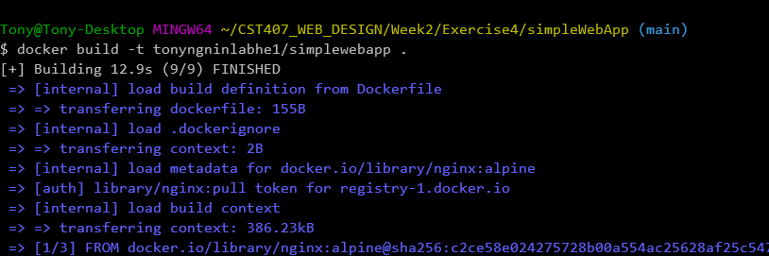

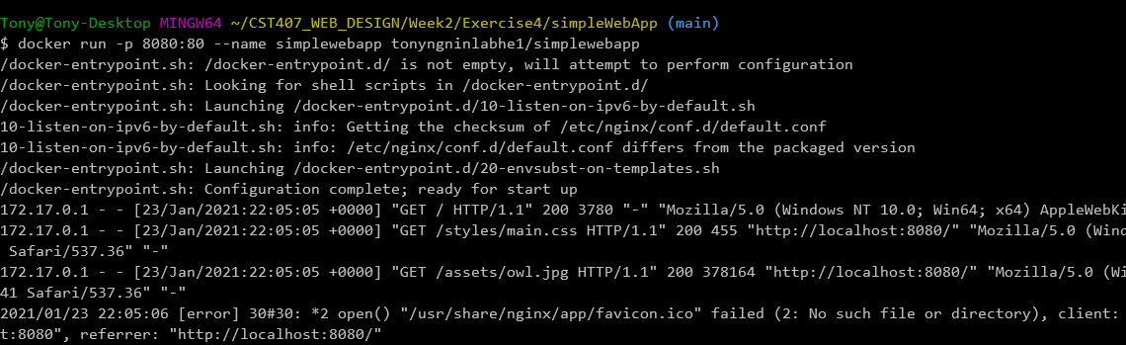

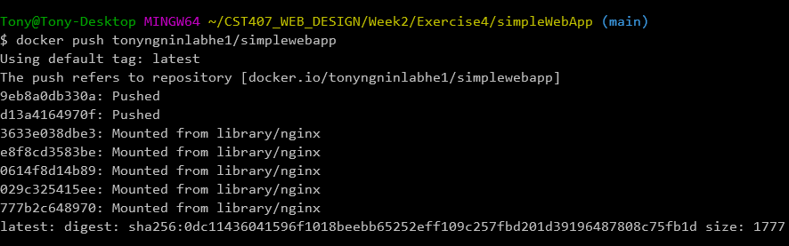

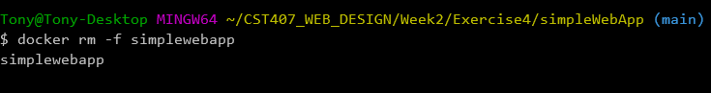

1. Include a screenshot of a browser displaying the output of your Web application.

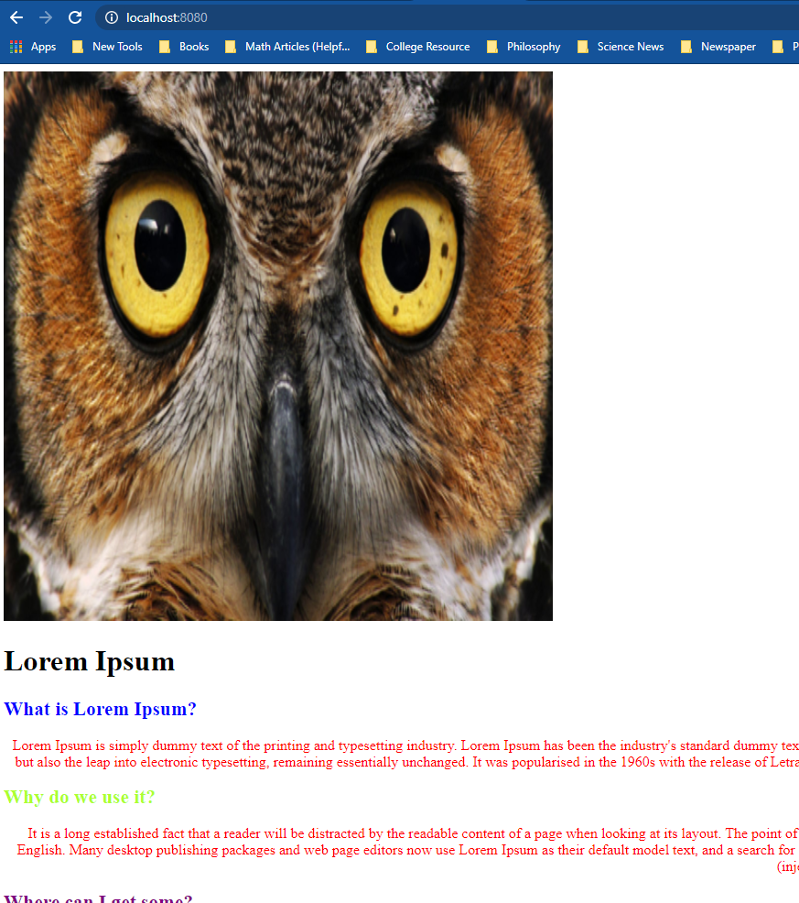  
**Include a URL to your Docker Hub registry account in the Word screenshot document.**

https://hub.docker.com/r/tonyngninlabhe1/simplewebapp