**Lab - Week 7: Database and Service Integration**

**Exercise 1 - Create the database with data**

7. Run the command (include screenshot):

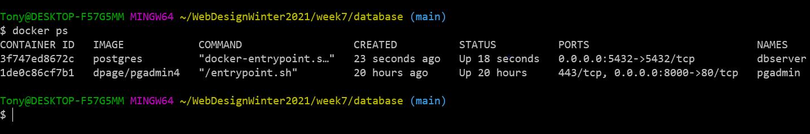

8. Run the command (include screenshot):

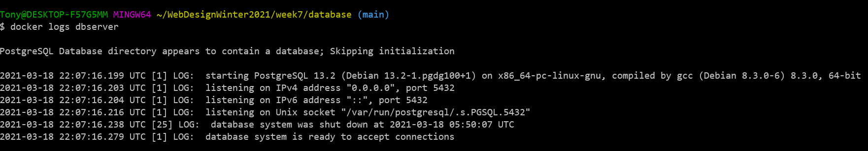

10. Open pgAdmin by accessing it through a browser with the address:

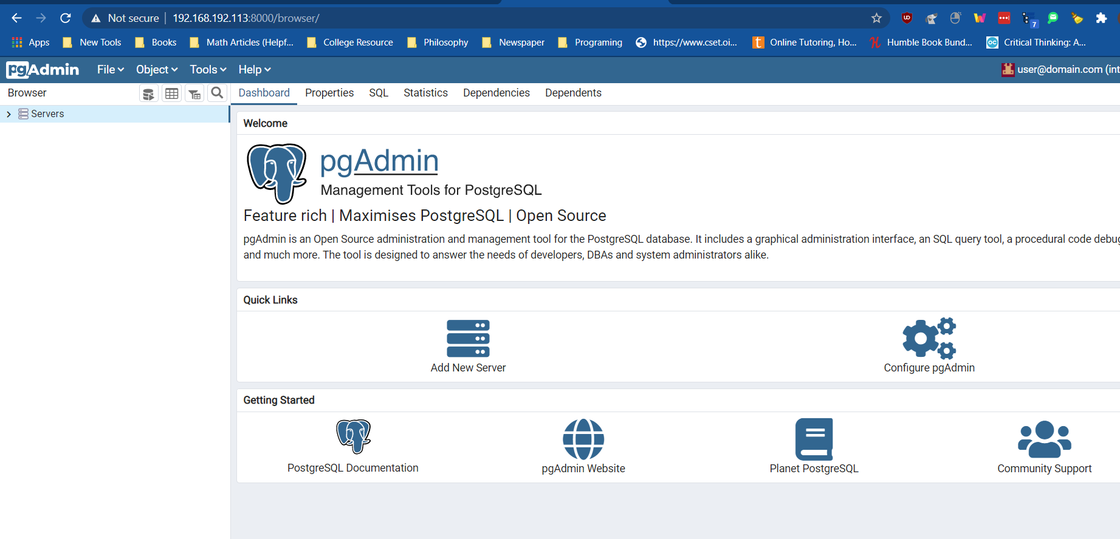

**Exercise 2 - Modify your REST service to now access the database**

Make sure your Postgres container is still running. Start your webapi by going to the Debug menu in VSCode and selecting "Run without debugging".

Use Postman to attempt to retrieve your students by using the URL (include a screenshot):

http://localhost:5000/api/student

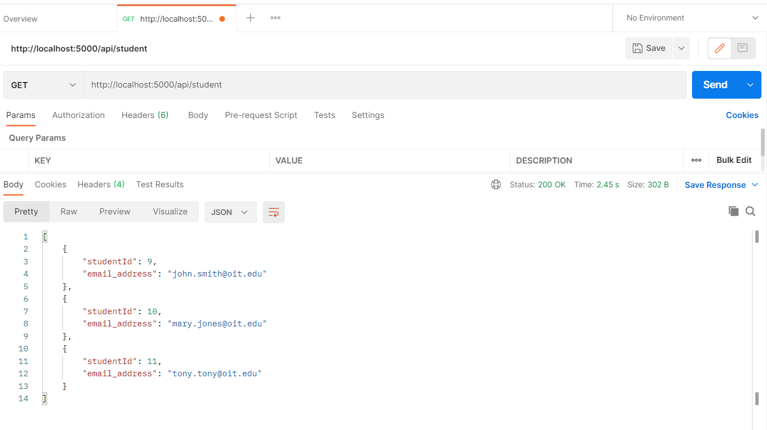

**Exercise 4 - Build and run your Web app in a Docker container**

7.Run the command (include sceenshot):

docker-compose up -d --build

from your lab folder. You should see the images being built and the containers started. After the command completes run the command (include screenshot):

docker ps

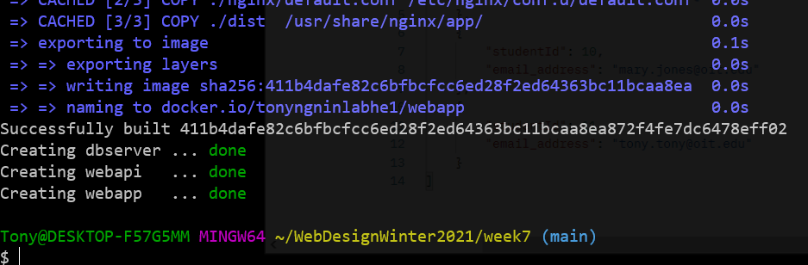

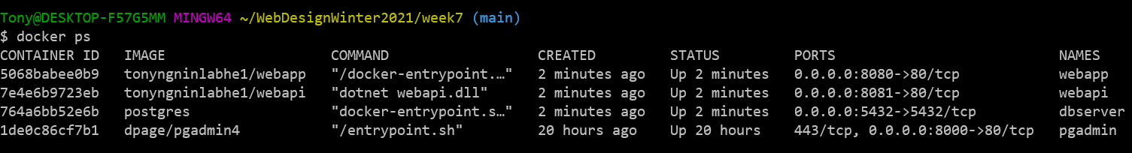

8.Try accessing your webapp at http://localhost:8080/ You should be able to go to the student page and see the table populated with data coming from your API.

