**Lab - Week 9: Security**

**Exercise 2 - Secure your backend webapi**

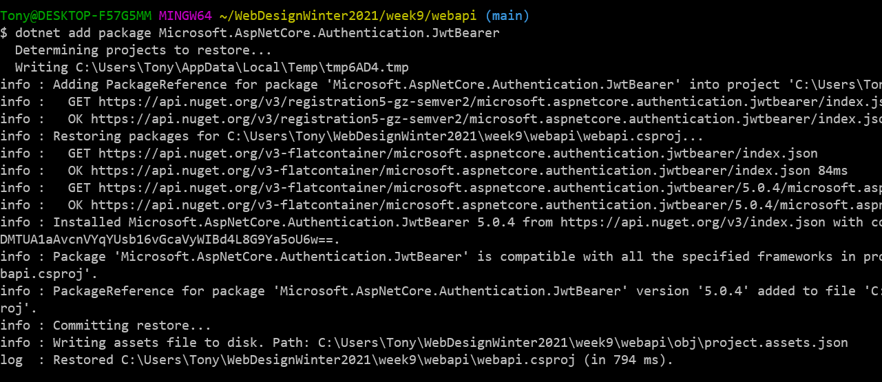

8.Use Postman instead of curl to test the secured GET all students API endpoint. You should get a HTTP status code of 401.

Include a screenshot of Postman with the URL you used and the resulting status code returned.

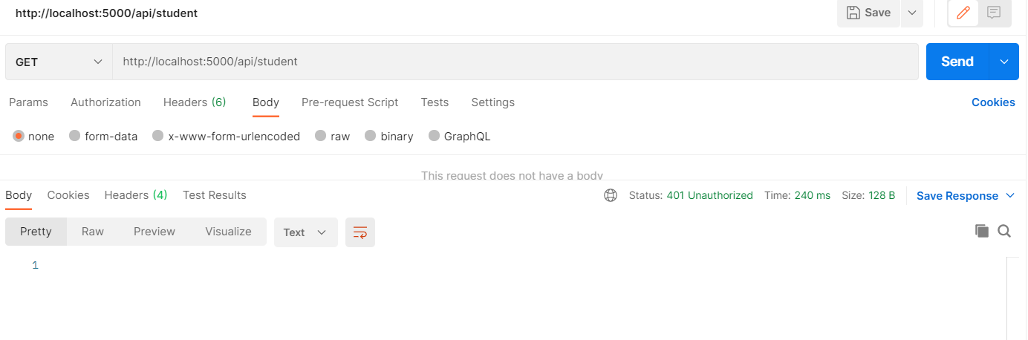

Once you get a JWT token from the auth0 dashboard test page, as described in the tutorial, you can test your API again with the token using Postman to make sure it authorizes correctly. Select the "Authorization" tab under the method and URL entry. Select "Bearer Token" under the "Type" dropdown menu. Enter the token from the auth0 dashboard in the token field to the right of the type selection.

Include a screenshot of Postman with the URL you used, the token entry and the resulting status code returned.

