# EPIC: Authentication & Session

**Goal:** Let users securely log in and persist sessions during an exam.

## Story: Email/Username + Password Login

**Type:** Story | **Priority:** Must | **Labels:** auth, web  
**Summary:** As a user, I can log in using my credentials to access the practice tests.  
**Acceptance Criteria**

* **Given** I am on /login  
  **When** I enter a valid username and password and click **Log in**  
  **Then** I am taken to **Home** and my display name appears in the top-right.
* **Given** I enter invalid credentials  
  **When** I click **Log in**  
  **Then** I see an inline error and remain on the login page.
* **Given** I am logged in  
  **When** I refresh the browser  
  **Then** I remain logged in (session persisted per security policy).

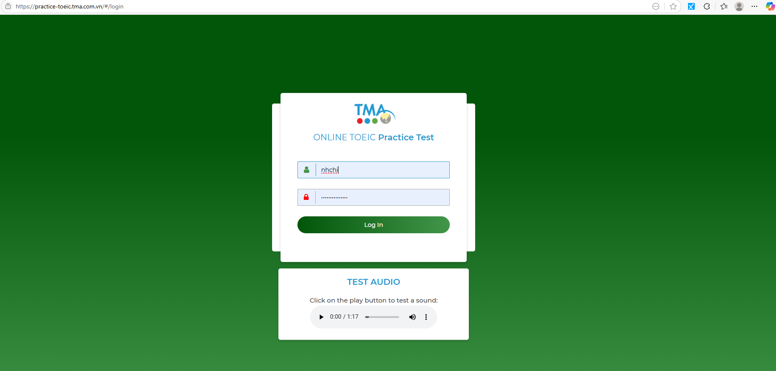

**Notes/Assumptions:** Basic rate limiting; form has visible/hidden password toggle.

# EPIC: Exam Rules & Consent

**Goal:** Ensure candidates acknowledge rules before starting.

## Story: Rules Modal Before First Start

**Type:** Story | **Priority:** Must | **Labels:** exam, compliance  
**Summary:** As a user, I must read and acknowledge exam rules before starting a new exam.  
**Acceptance Criteria**

* **Given** I’m on **Home**  
  **When** I click **Start New Exam**  
  **Then** a modal titled **QUI ĐỊNH PHÒNG THI** appears with rules, test time and test method.
* **Given** rules modal is visible  
  **When** I click **Close** without starting  
  **Then** the modal closes and I remain on **Home**.
* **Given** rules modal is visible  
  **When** I click **Start** (or equivalent confirm)  
  **Then** the exam player opens at **Part I** and the master timer starts.
* **Given** time expires during the exam  
  **When** the master timer reaches 0  
  **Then** the system auto-submits and records my score to my account.

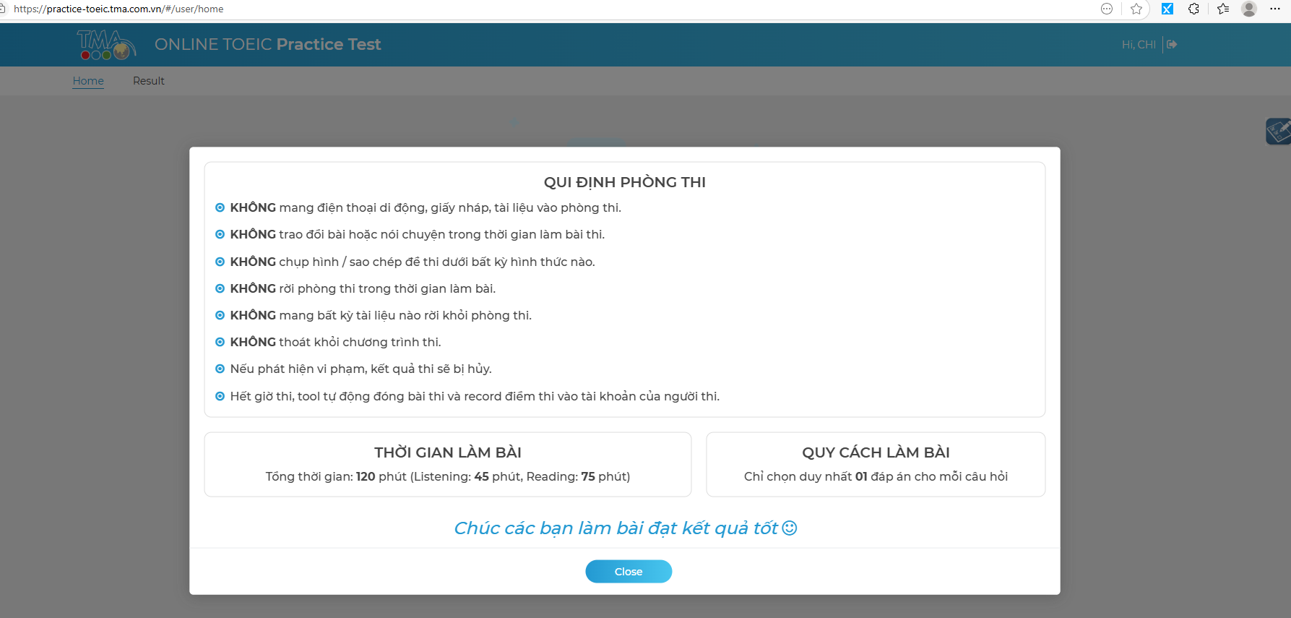

**Notes:** Keep copy editable via CMS or config; support bilingual (VN/EN).

# EPIC: Home & Exam Lifecycle

**Goal:** Provide home screen, start flow, and exam history.

## Story: Home Screen – Start and Resume

**Type:** Story | **Priority:** Must | **Labels:** home, lifecycle  
**Acceptance Criteria**

* **Given** I’m logged in  
  **When** I land on **/user/home**  
  **Then** I see the banner **ONLINE TOEIC Practice Test**, total time **120 minutes**, and a **Start New Exam** button.
* **Given** I have an in-progress attempt (network drop / tab close)  
  **When** I return to Home  
  **Then** I see a **Resume Exam** action that returns me to the exact question and restores timer.

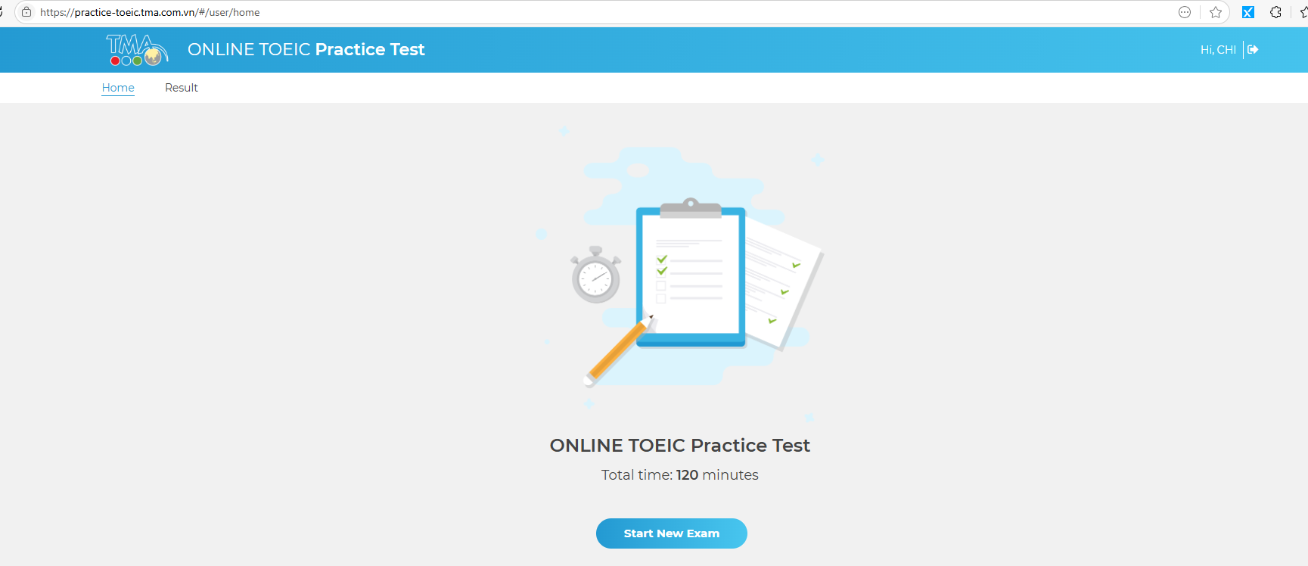

## Story: Results Tab – Attempt History

**Type:** Story | **Priority:** Should | **Labels:** results  
**Acceptance Criteria**

* **Given** I completed at least one exam  
  **When** I click **Result** in the top nav  
  **Then** I see a list of attempts with date, overall score, Listening score, Reading score, status (Complete/Auto-submitted).
* **Given** the results list is visible  
  **When** I select an attempt  
  **Then** I can view a breakdown and (if enabled) review answers & explanations.

# EPIC: Exam Player Shell

**Goal:** Deliver the 7 TOEIC parts with timer, navigation, and answer capture.

## Story: Master Timer & Progress

**Type:** Story | **Priority:** Must | **Labels:** player, timer  
**Acceptance Criteria**

* **Given** the player is open  
  **When** the exam loads  
  **Then** a master timer shows **02:00:00** counting down and a progress indicator shows **0/200** and **0%**.
* **Given** I answer questions  
  **When** the answer state changes  
  **Then** the progress counter updates (e.g., **30/200 – 15%**).
* **Given** the timer reaches 00:00  
  **When** time expires  
  **Then** the system auto-submits and navigates to submission state (no further changes allowed).

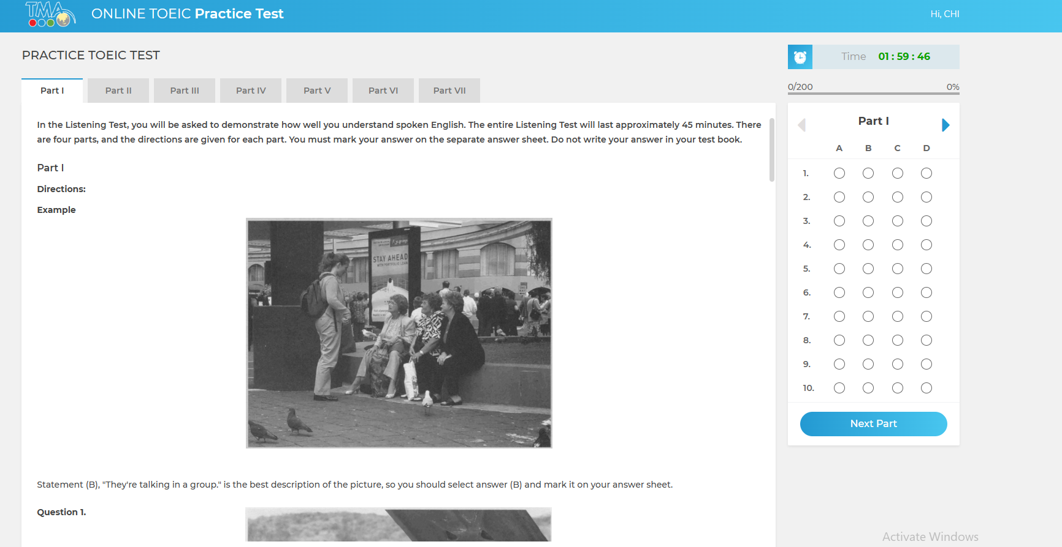

## Story: Part Tabs & In-Part Paging

**Type:** Story | **Priority:** Must | **Labels:** navigation  
**Acceptance Criteria**

* **Given** the player is open  
  **When** I click part tabs **Part I** … **Part VII**  
  **Then** the content area shows that part’s directions/questions.
* **Given** the right-side question navigator is visible  
  **When** I click a question number  
  **Then** the viewport scrolls/jumps to that question, highlighting it.
* **Given** I’m in any part  
  **When** I click **Next Part**  
  **Then** the next part becomes active and the question navigator updates.

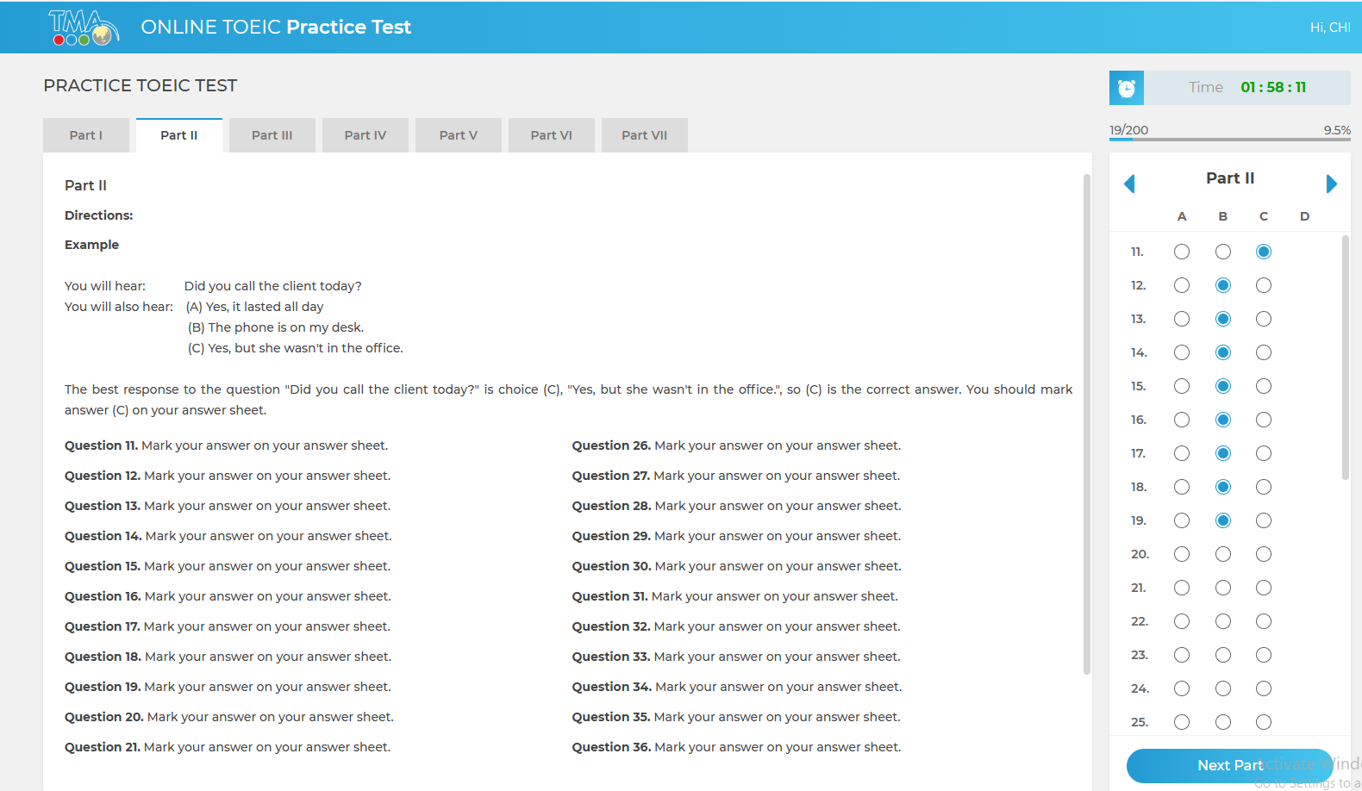

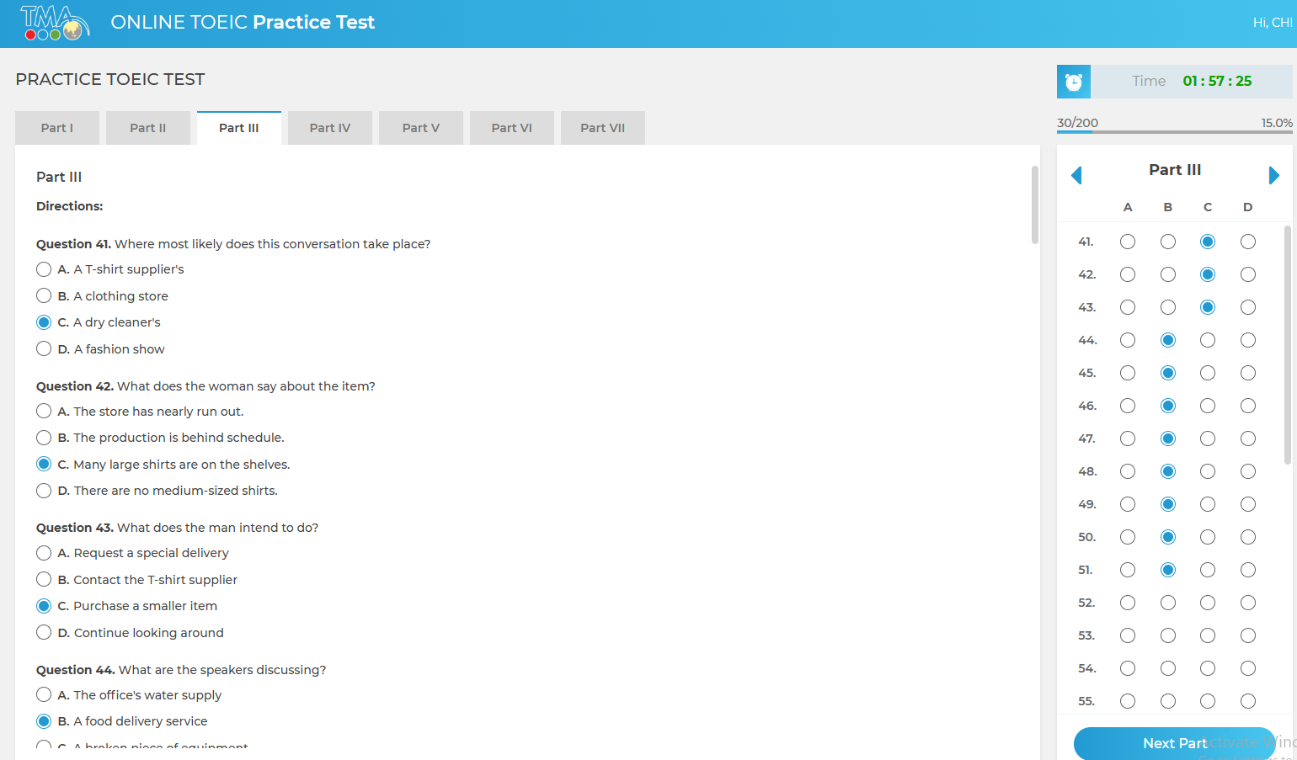

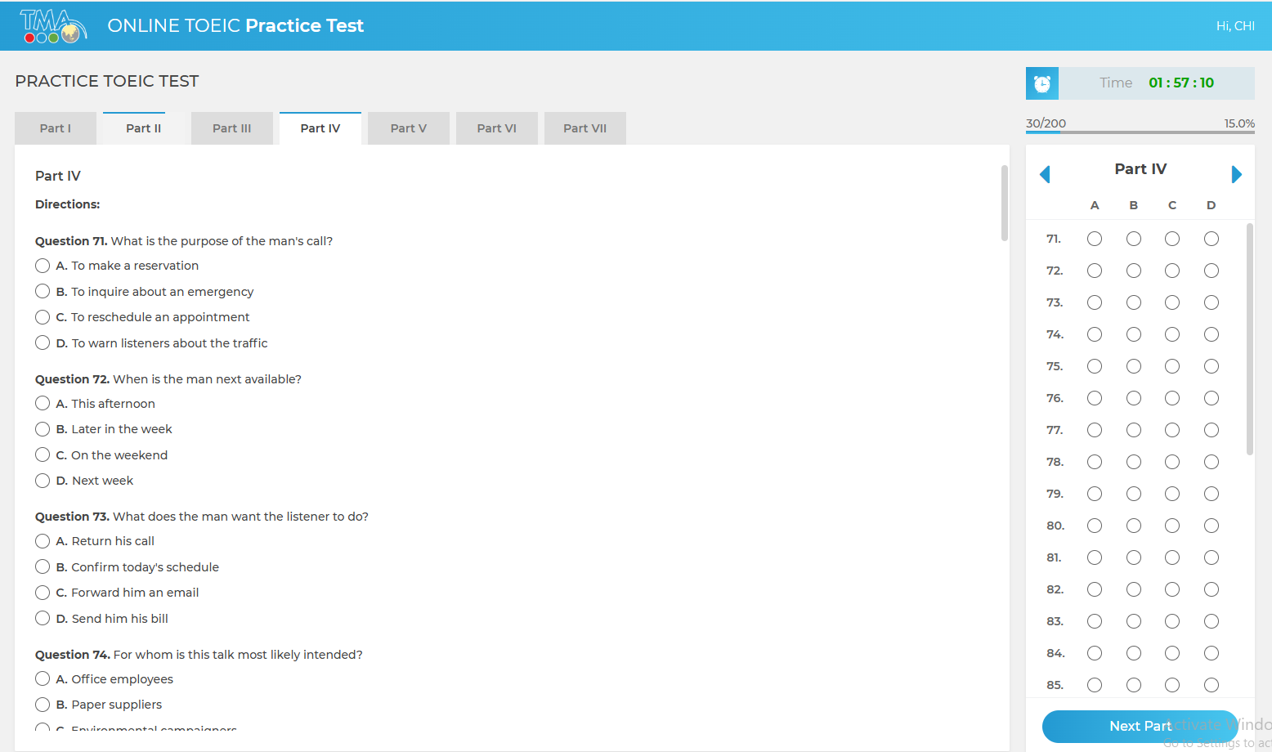

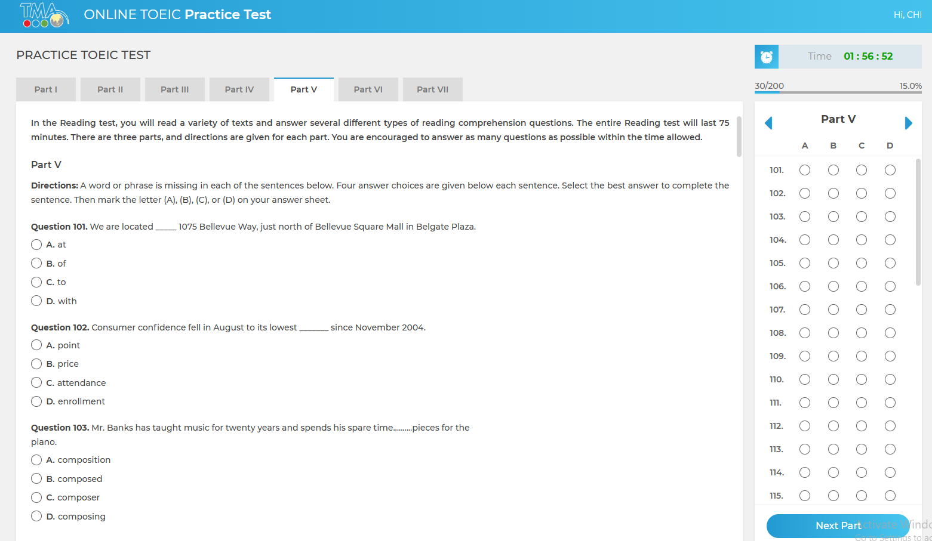

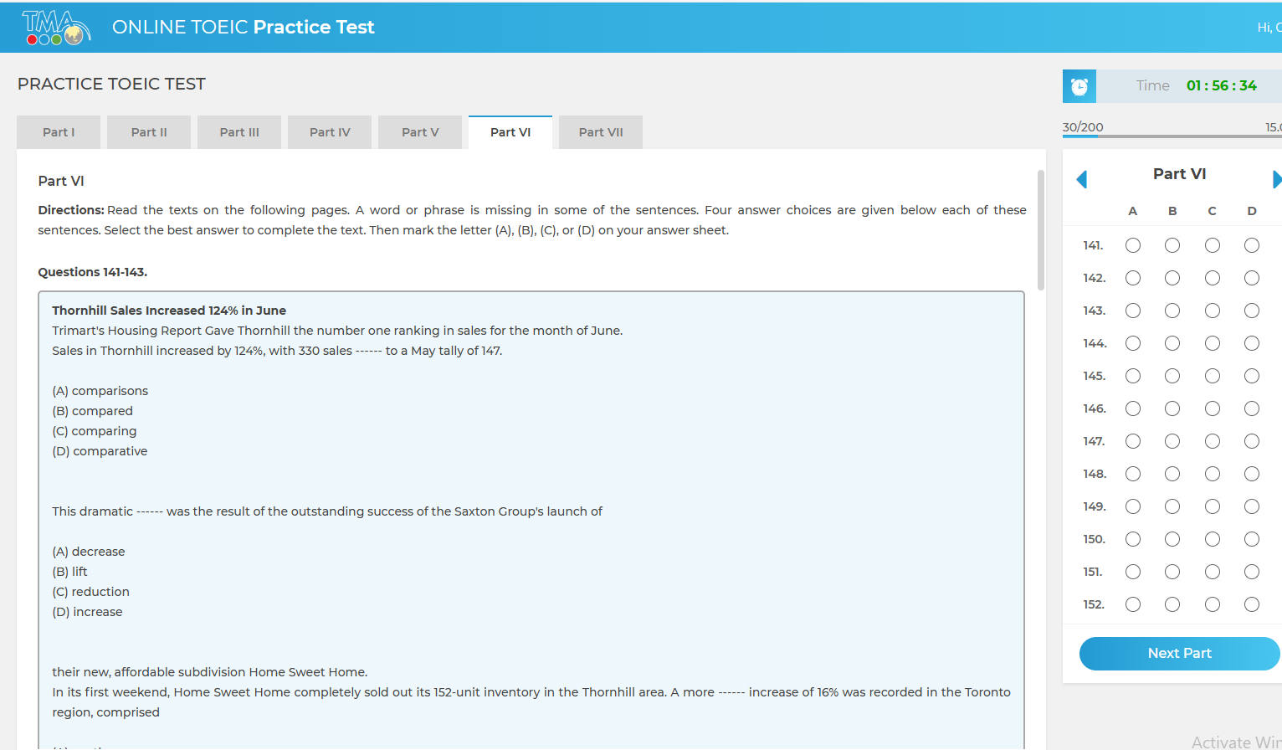

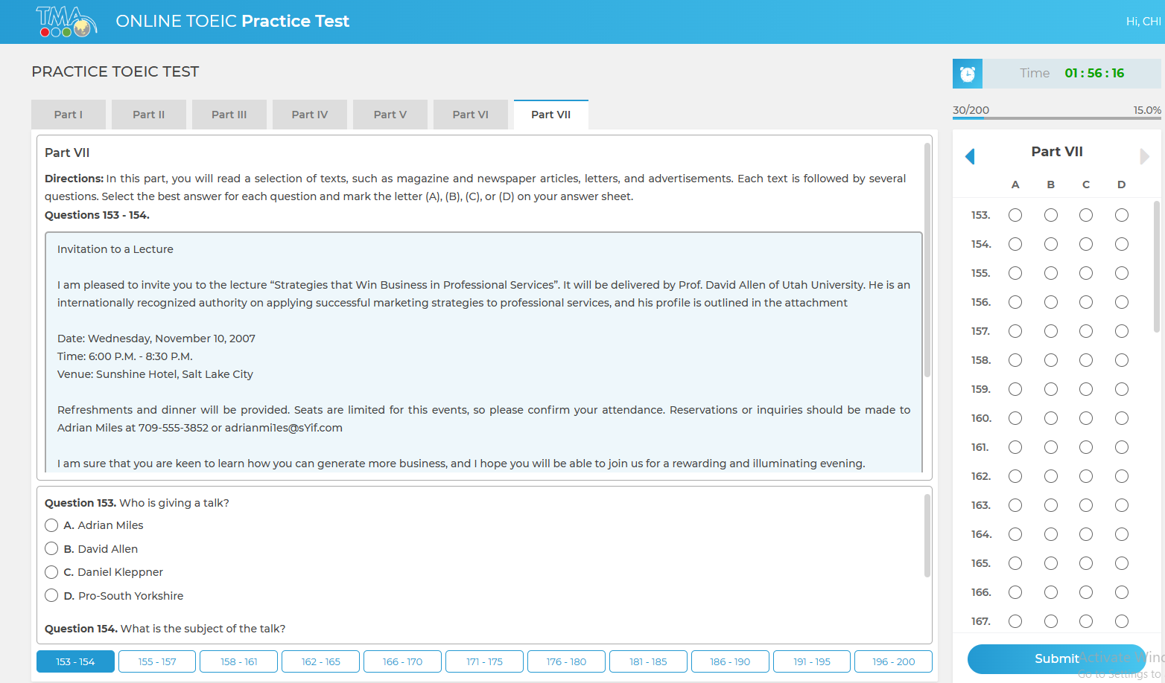

## Story: Answer Options (Single-choice A–D)

**Type:** Story | **Priority:** Must | **Labels:** answers  
**Acceptance Criteria**

* **Given** a question is visible  
  **When** I select an option (A/B/C/D)  
  **Then** only one option is selected and the selection persists on navigation/refresh.
* **Given** an answer is selected  
  **When** I click the same option again  
  **Then** it remains selected (no deselect to null).
* **Given** I move between parts  
  **When** I return  
  **Then** previously selected answers are restored.
* 

## Story: Submit Exam

**Type:** Story | **Priority:** Must | **Labels:** submission  
**Acceptance Criteria**

* **Given** I’m in **Part VII**  
  **When** I click **Submit**  
  **Then** I see a confirmation dialog with count of unanswered questions.
* **Given** I confirm submit  
  **When** submission succeeds  
  **Then** I’m shown a **Submission Successful** state and results (or results are accessible under **Result**).

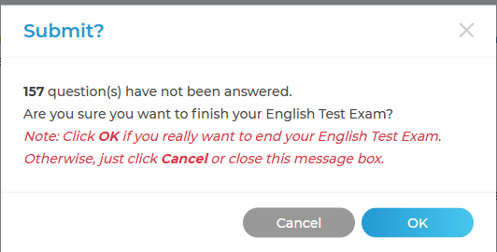

**Notes:** Prevent submit if no questions loaded; handle server failure with retry.

## Story: Submit Exam Confirmation

**Type:** Story | **Priority:** Must | **Labels:** submission, UX  
**Summary:** As a user, I must confirm submission when unanswered questions remain.  
**Acceptance Criteria**

* **Given** I click **Submit**  
  **When** unanswered questions > 0  
  **Then** a confirmation dialog appears showing the exact count of unanswered (e.g., 157 unanswered).
* **Given** the dialog is visible  
  **When** I click **OK**  
  **Then** the exam ends and answers are submitted.
* **Given** the dialog is visible  
  **When** I click **Cancel** or close the modal  
  **Then** submission is aborted and I return to the exam.
* **Given** all 200 questions are answered  
  **When** I click **Submit**  
  **Then** the confirmation still appears but with “0 unanswered”.

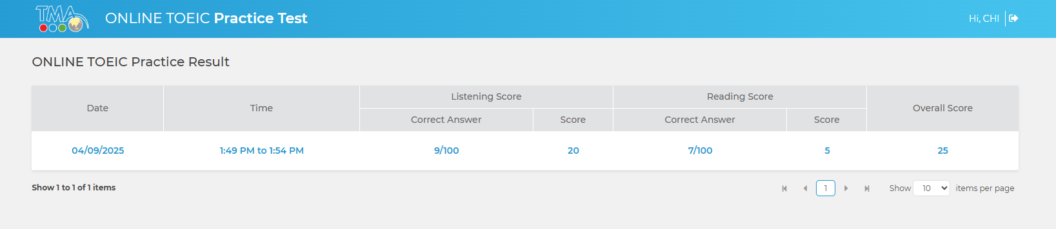

# EPIC: Listening – Audio Controls (Parts I–IV)

**Goal:** Provide audio playback per TOEIC Listening format.

## Story: Global Sample Audio Test (Home)

**Type:** Story | **Priority:** Should | **Labels:** audio  
**Acceptance Criteria**

* **Given** I’m on **Home**  
  **When** I press **Play** in **TEST AUDIO**  
  **Then** I hear the sample and the scrubber shows elapsed time (e.g., **0:00 / 1:17**).

## Story: Part-Scoped Audio Playback

**Type:** Story | **Priority:** Must | **Labels:** audio, player  
**Acceptance Criteria**

* **Given** I’m in **Listening** parts (I–IV)  
  **When** I start the part  
  **Then** audio for that part is available and plays according to TOEIC rules.
* **Given** playback is active  
  **When** I pause/play  
  **Then** the control updates accordingly (respect exam policy configured for practice mode).
* **Given** audio completes  
  **When** it finishes  
  **Then** I can continue answering and navigate.

**Assumptions:** For practice mode, allow replay per configuration flag; for strict mode, one-time play. Audio preloaded to avoid stutter.

# EPIC: Reading – Content Rendering (Parts V–VII)

**Goal:** Render sentences and long passages cleanly and accessibly.

## Story: Part V (Incomplete Sentences)

**Type:** Story | **Priority:** Must | **Labels:** reading  
**Acceptance Criteria**

* Questions render one per block with four options underneath.
* Typography supports ellipses and blanks; no layout shifts while answering.



## Story: Part VI (Text Completion)

**Type:** Story | **Priority:** Must | **Labels:** reading  
**Acceptance Criteria**

* Multi-question passages render in a shaded box (like screenshot) with Q-IDs (141–143…) aligned to the right-nav.
* Scrolling keeps the passage visible while navigating its questions.



## Story: Part VII (Reading Comprehension)

**Type:** Story | **Priority:** Must | **Labels:** reading  
**Acceptance Criteria**

* Long passages (letters, ads, multi-passage sets) render with stable line height.
* A mini-pagination strip (e.g., **153–154 | 155–157 | …**) appears and jumps to the first question of the selected range.



# EPIC: Persistence & Autosave

**Goal:** Never lose answers.

## Story: Autosave on Interaction

**Type:** Story | **Priority:** Must | **Labels:** reliability  
**Acceptance Criteria**

* **Given** I change an answer  
  **When** I select an option  
  **Then** the system saves within 300 ms (debounced) and shows a discreet “Saved” state.
* **Given** I lose connectivity  
  **When** the network returns  
  **Then** unsynced answers are retried automatically.

## Story: Resume After Interruption

**Type:** Story | **Priority:** Must  
**Acceptance Criteria**

* **Given** my tab or browser closes mid-exam  
  **When** I log back in within the allowed window  
  **Then** I can resume with remaining time and saved answers.

# EPIC: Scoring & Results

**Goal:** Score, store, and present results.

## Story: Score Calculation

**Type:** Story | **Priority:** Must | **Labels:** scoring  
**Acceptance Criteria**

* **Given** an exam is submitted  
  **When** scoring runs  
  **Then** raw correct counts per part are calculated and converted to TOEIC Listening/Reading scaled scores and total score.
* **Given** scoring completes  
  **When** I open the attempt view  
  **Then** I see overall score, Listening score, Reading score, and per-part correct counts.

## Story: Answer Review (Practice Mode)

**Type:** Story | **Priority:** Should | **Labels:** review  
**Acceptance Criteria**

* **Given** review is enabled  
  **When** I open an attempt  
  **Then** each question shows my answer, the correct answer, and an optional explanation (if available).
* **Given** review is disabled by policy  
  **When** I open an attempt  
  **Then** I only see scores, not item-level answers.

## Story: Results Page – Attempt Summary Table

**Type:** Story | **Priority:** Must | **Labels:** results, scoring  
**Summary:** As a user, I want to see my attempt history in a results table with details.  
**Acceptance Criteria**

* **Given** I finished an exam  
  **When** I go to **Result** tab  
  **Then** I see a row showing:
  + Date
  + Time (start → finish)
  + Listening Correct Answers and Score
  + Reading Correct Answers and Score
  + Overall Score
* **Given** I have multiple attempts  
  **When** the table is rendered  
  **Then** it shows pagination with options to change items per page.
* **Given** an attempt exists  
  **When** I click it (row or link)  
  **Then** I can view a detailed breakdown (future story: review mode).



# EPIC: Question Navigator (Right Panel)

**Goal:** Fast jump and visual state of answers.

## Story: Bubble Navigator with States

**Type:** Story | **Priority:** Must | **Labels:** navigation, UX  
**Acceptance Criteria**

* Bubbles show **Unanswered**, **Answered**, and **Current** states with distinct visual indicators.
* Clicking a bubble scrolls to the question and focuses it.
* The panel’s header shows the active part label (e.g., **Part III**) and arrows for prev/next section.



# EPIC: Non-Functional Requirements (NFR)

**Goal:** Performance, accessibility, security.

## Task: Performance

**Type:** Task | **Priority:** Must  
**Acceptance Criteria**

* First meaningful paint < 2.5s on 3G Fast.
* Audio starts within 300 ms of play click (preload).
* No answer loss on slow networks (tested with 400 ms RTT, 2% packet loss).

## Task: Accessibility

**Type:** Task | **Priority:** Should  
**Acceptance Criteria**

* Keyboard-navigable answers and part tabs.
* ARIA roles for radio groups and progress.
* Color contrast AA; focus indicators visible.

## Task: Security

**Type:** Task | **Priority:** Must  
**Acceptance Criteria**

* HTTPS enforced; cookies HttpOnly, Secure, SameSite=Lax/Strict per policy.
* CSRF protection for submission endpoints.
* Authentication locked after 5 failed attempts for 15 minutes.

# EPIC: Admin/Content Management (Lightweight)

**Goal:** Keep content maintainable (optional if you already have a CMS).

## Story: Manage Rules Text

**Type:** Story | **Priority:** Should | **Labels:** admin  
**Acceptance Criteria**

* Admin can update Rules modal copy and localized versions without code deploy.

## Story: Upload Audio & Passages

**Type:** Story | **Priority:** Should  
**Acceptance Criteria**

* Admin can attach audio to Listening parts, link questions to passages, and preview.

# EPIC: Analytics & Audit

**Goal:** Understand usage and protect integrity.

## Story: Attempt Audit Trail

**Type:** Story | **Priority:** Should | **Labels:** audit  
**Acceptance Criteria**

* Store start/end timestamps, auto-submit flag, device info, and reconnect events for each attempt.

## Story: Usage Analytics

**Type:** Story | **Priority:** Could | **Labels:** analytics  
**Acceptance Criteria**

* Track drop-off by part and avg time per part, exportable as CSV.

## “Ready for Dev” Definition (applies to all Stories)

* UX mocks for any new UI states attached.
* API contracts documented (start attempt, save answer, submit, get results).
* Test data for all 7 parts available.
* Localization strings defined (EN/VN).

## Example Jira Card (copy pattern)

**Issue Type:** Story  
**Epic Link:** Exam Player Shell  
**Summary:** Master Timer & Progress  
**Description:**  
As a candidate, I want a clear countdown and progress so that I can pace myself during the test.  
**Acceptance Criteria:**

1. **Given** the exam loads **When** it renders **Then** show 02:00:00 countdown and 0/200 (0%).
2. **Given** I select answers **When** any answer changes **Then** progress updates (answered count & percent).
3. **Given** timer hits 00:00 **When** time expires **Then** auto-submit and lock changes.  
   **Notes/Assumptions:** Timer state persists on refresh; server is source of truth for remaining time.  
   **Dependencies:** Start Attempt API; Autosave service.  
   **Story Points:** ☐  
   **Attachments:** Timer mock, state diagram.

If you’d like, I can drop these into a downloadable CSV for Jira bulk create or a .XLSX backlog template—and once you share the two extra screenshots, I’ll add/adjust any missing flows (e.g., final Results UI) in the same format.