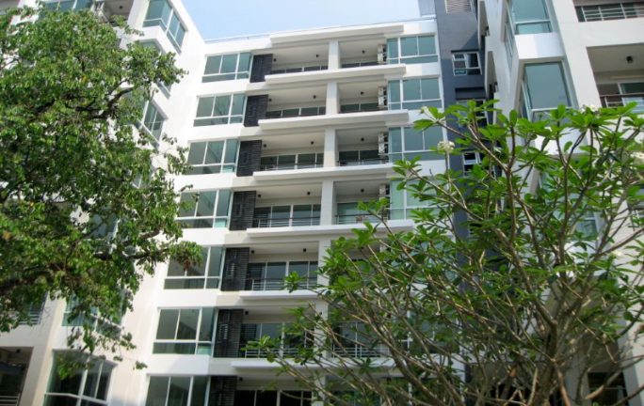**Condominium Oneplus Jed Yod**

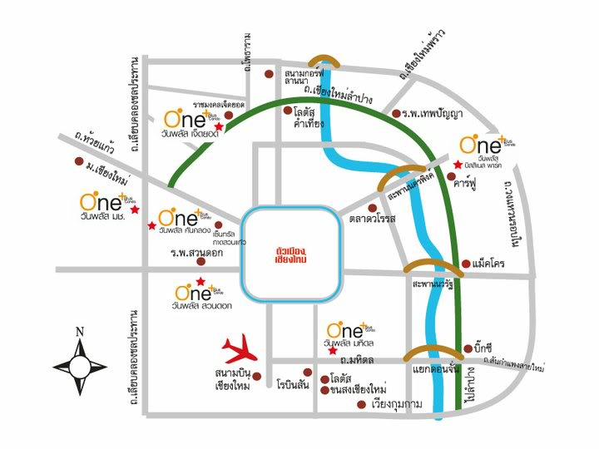

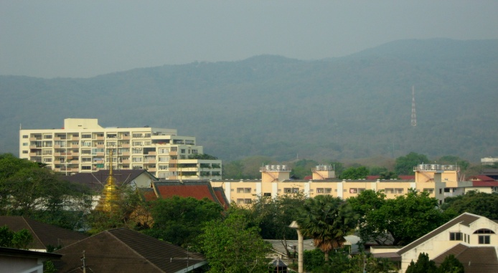

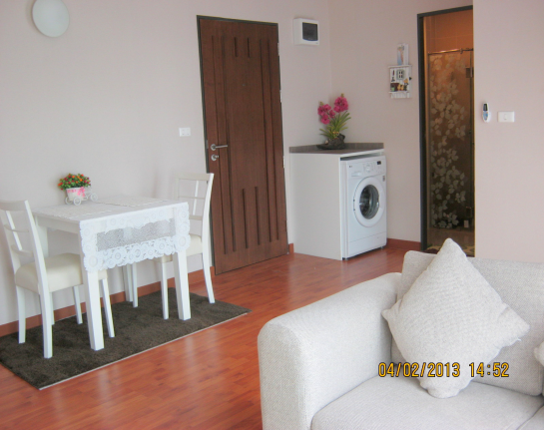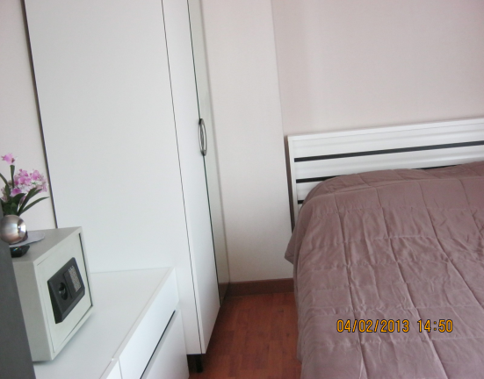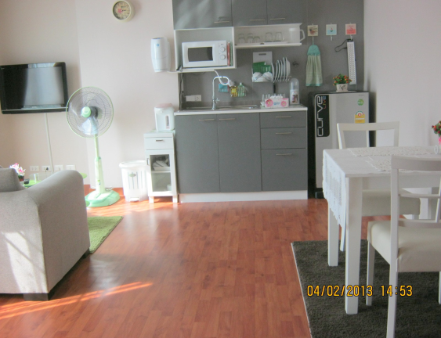

|  |  |  |
| --- | --- | --- |
| **Rent Price (THB) : 12,000**  **Property Type : Condo**  **Village : Jed Yod**  **Province : Chiagmai**  **Condo size (sq. m) : 42**  **Floor(s) : 7**  **Bedroom(s) : 1**  **Bathroom(s) : 1**  **Kitchen(s) : 1** | **Living Room(s) : 1**  **Car Park : Yes**  **Air Conditioner(s) : 2**  **Hot Shower(s) : 1**  **Refrigerator(s) : 1**  **Television(s) : 1**  **Microwave : 1**  **Cable TV : Yes** | **WiFi : Yes**  **ADSL Internet : Yes**  **Furnishings : Yes**  **Property Facility :**   * **Fitness** * **Swimming** * **Sauna** * **Security** |