LA MIA RECIPE & MEAL PLANNER PLATFORM
Cloud Firestore Database Architecture & Entity-Relationship Specification
Document Version 1.0 • Database Engine: Google Cloud Firestore (NoSQL) • Status: Production Verified

1. Architecture & Data Storage Paradigm
La Mia is a cross-platform culinary platform built on Flutter and Google Firebase. The persistence layer utilizes Google Cloud Firestore, a scalable, real-time, document-oriented NoSQL database. Firestore organizes data into Documents which reside inside Collections and Subcollections.
- Read-Optimized Document Design: Denormalized counter fields (likeCount, favoriteCount, commentCount, ratingAvg) are embedded directly in recipe and user documents. This eliminates expensive aggregation queries and enables sub-second read performance.
- User-Scoped Subcollections: Private or user-specific datasets (meal plans, personal grocery checklists, bookmarks, and notification logs) reside inside user subcollections (/users/{userId}/*), enforcing clean data isolation and rule-level privacy.
- Global Inverted Indices: Bidirectional relationship collections (/followers, /following, /likes, /favorites) allow efficient membership checks (e.g. checking whether user X follows user Y or likes recipe Z) in O(1) document reads without querying massive nested arrays.
- Server-Authoritative Guardrails: Sensitive business metrics (trendingScore, approval status, rating averages, atomic counters) can only be manipulated by Cloud Functions and strict Firestore Security Rules, guaranteeing zero client-side spoofing.

2. Global Entity-Relationship (ER) Topology Diagram
The visual diagram below follows the dbdiagram / entity-relationship card format, illustrating all collections, subcollections, fields, data types, and primary-to-foreign key relationships across Cloud Firestore:
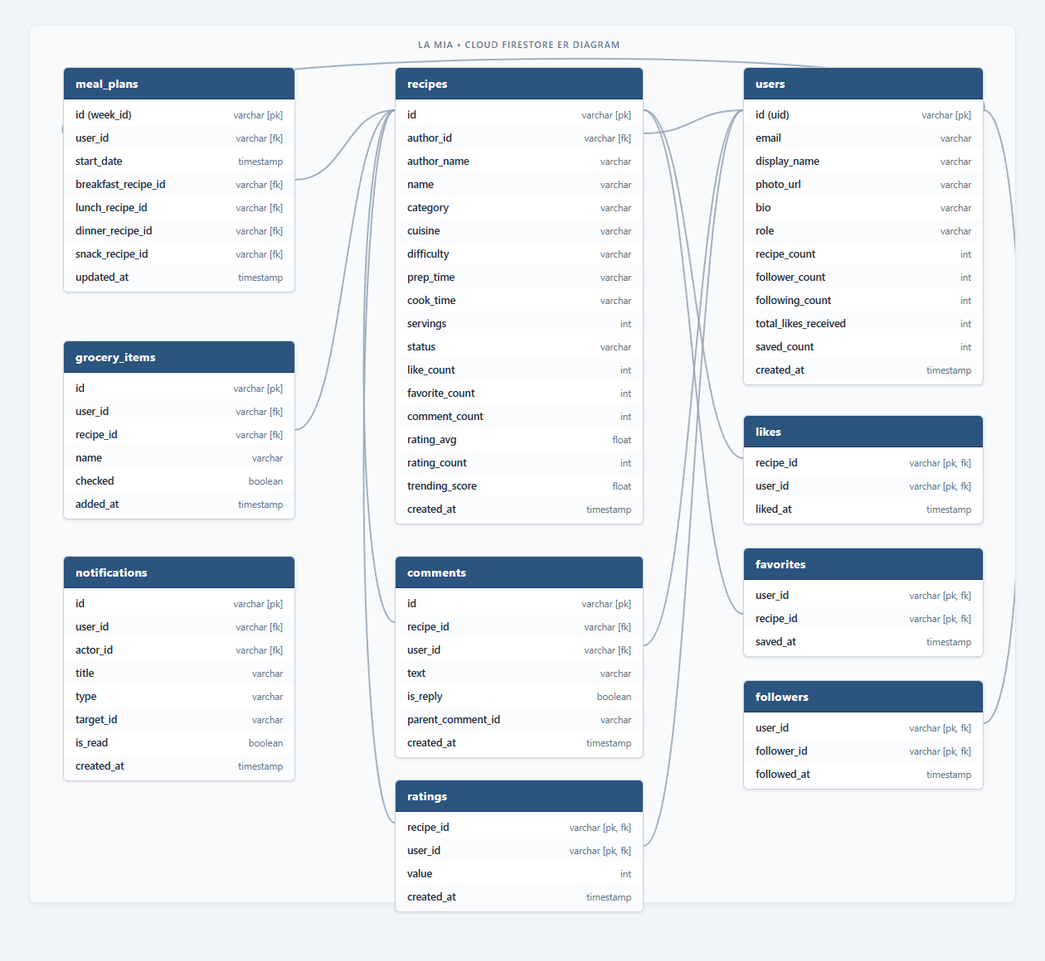
Interactive DBML file provided: A complete la_mia_schema.dbml file is saved in your project root. You can import or copy-paste it directly into https://dbdiagram.io to interactively view, rearrange, and export this diagram.

3. Collection & Subcollection Field Specifications

3.1 Root Collection: users
Path: /users/{userId} • Document ID: Firebase Auth UID
Field Name | Type | Null? | Description / Rules
uid | String | No | Unique user identifier corresponding to Firebase Auth UID.
email | String | No | Registered email address of the account.
displayName | String | No | Public display name / username shown on recipes and profile.
photoUrl | String | Yes | Public avatar photo URL hosted on Cloud Storage or Google OAuth.
bio | String | Yes | Cook bio or culinary tagline (max 250 characters).
role | String | No | Access level: "user", "trusted", or "admin". Server enforced.
recipeCount | Integer | No | Denormalized count of published recipes. Incremented on approval.
followerCount | Integer | No | Total users following this cook. Atomic +/-1 updates only.
followingCount | Integer | No | Total accounts this user follows. Atomic +/-1 updates only.
totalLikesReceived | Integer | No | Aggregate likes received across all published recipes.
savedCount | Integer | No | Count of recipes saved to private cookbook.
createdAt | Timestamp | No | Server-generated account creation timestamp.

3.2 Subcollection: users/{userId}/mealPlans (Weekly Planner)
Path: /users/{userId}/mealPlans/{weekId} • Document ID: week_YYYY_MM_DD (e.g. week_2026_08_31)
Field Name | Type | Null? | Description / Rules
weekId | String | No | Standardized week identifier format: week_YYYY_MM_DD.
startDate | Timestamp | No | Calendar Monday timestamp initiating the 7-day planning window.
updatedAt | Timestamp | No | Timestamp of last modification (serverTimestamp).
days | Map<String, Day> | No | Map of 7 calendar days keyed by YYYY-MM-DD containing meal slots.
days.{date}.dateKey | String | No | Date string identifier matching key (e.g. "2026-08-31").
days.{date}.dayOfWeek | String | No | Display day label ("Monday", "Tuesday", etc.).
days.{date}.breakfast | Map (Item) | Yes | Assigned breakfast dish (Almusal) or null if vacant.
days.{date}.lunch | Map (Item) | Yes | Assigned lunch dish (Tanghalian) or null if vacant.
days.{date}.dinner | Map (Item) | Yes | Assigned dinner dish (Hapunan) or null if vacant.
days.{date}.snack | Map (Item) | Yes | Assigned afternoon snack (Meryenda) or null if vacant.
days.{date}.*.recipeId | String | No | Referenced recipe ID from /recipes.
days.{date}.*.recipeName | String | No | Denormalized dish title for instant offline rendering.
days.{date}.*.coverPhotoUrl | String | No | Thumbnail photo URL.
days.{date}.*.category | String | No | Culinary category (Almusal, Ulam, Sabaw, etc.).
days.{date}.*.ingredients | Array<String> | No | Ingredient strings used for consolidated grocery generation.

3.3 Subcollection: users/{userId}/grocery_items (Pantry Checklist)
Path: /users/{userId}/grocery_items/{itemId} • Document ID: Auto-generated UUID
Field Name | Type | Null? | Description / Rules
name | String | No | Ingredient / item name (e.g. "Garlic", "Soy Sauce", "Pork Belly").
recipeId | String | Yes | Optional reference to recipe that generated this ingredient.
recipeName | String | Yes | Optional human-readable recipe name for contextual grouping.
checked | Boolean | No | Checklist status: true if acquired/purchased, false if pending.
addedAt | Timestamp | No | Server timestamp when item was appended to checklist.

3.4 Subcollection: users/{userId}/notifications
Path: /users/{userId}/notifications/{notifId} • Document ID: Auto-generated UUID
Field Name | Type | Null? | Description / Rules
title | String | No | Notification header (e.g. "New Comment", "Recipe Approved").
body | String | No | Notification body text with details.
type | String | No | Category: "comment", "reply", "like", "rating", "follow", "recipe_status".
targetId | String | Yes | Associated entity ID (recipeId, commentId, or userId).
targetType | String | Yes | Type indicator ("recipe", "comment", "profile").
actorId | String | Yes | UID of the user triggering the notification.
actorName | String | Yes | Display name of the actor.
actorPhotoUrl | String | Yes | Avatar URL of the actor.
isRead | Boolean | No | Read status. Defaults to false upon generation.
createdAt | Timestamp | No | Timestamp of notification delivery.

3.5 Root Collection: recipes
Path: /recipes/{recipeId} • Document ID: Auto-generated or seeded UUID
Field Name | Type | Null? | Description / Rules
authorId | String | No | UID of author. Must match request.auth.uid upon creation.
authorName | String | No | Denormalized author display name for single-query display.
authorPhotoUrl | String | Yes | Denormalized author profile picture URL.
name | String | No | Recipe title (min 3 chars, max 150 chars).
description | String | No | Culinary summary and backstory.
category | String | No | Allowed: Almusal, Ulam, Sabaw, Merienda, Panghimagas, Gulay, Inihaw, Lamang Dagat, Pulutan.
cuisine | String | No | Regional provenance: Luzon, Visayas, Mindanao, or National.
difficulty | String | No | Complexity rating: "Easy", "Medium", or "Hard".
prepTime | String | No | Preparation duration (e.g. "15 mins").
cookTime | String | No | Active cooking duration (e.g. "45 mins").
servings | Integer | No | Serving yield (positive integer, e.g. 4).
ingredients | Array<String> | No | Full list of required ingredients with quantities (min 2 items).
instructions | Array<String> | No | Sequential preparation and cooking steps (min 2 steps).
coverPhotoUrl | String | No | High-resolution photo URL hosted in Cloud Storage.
tags | Array<String> | No | Search keywords and dietary tags (e.g. ["pork", "adobo", "ulam"]).
status | String | No | Moderation state: "pending", "approved", "rejected", "hidden".
likeCount | Integer | No | Total likes. Atomic increment/decrement guarded.
favoriteCount | Integer | No | Total bookmarks. Atomic increment/decrement guarded.
commentCount | Integer | No | Total discussion replies. Maintained by Cloud Functions.
ratingAvg | Double | No | Average community star rating (0.0 to 5.0). Server-calculated.
ratingCount | Integer | No | Total rating submissions. Server-calculated.
trendingScore | Double | No | Algorithmic popularity score updated hourly by Cloud Function.
createdAt | Timestamp | No | Creation timestamp.
updatedAt | Timestamp | No | Last edit timestamp.
approvedAt | Timestamp | Yes | Timestamp when admin or automated moderation approved publication.

3.6 Subcollections: recipes/{recipeId}/ratings and comments
Ratings Path: /recipes/{recipeId}/ratings/{userId} (1 rating per user)
Field Name | Type | Null? | Description / Rules
value | Number | No | Star rating score between 1.0 and 5.0.
createdAt | Timestamp | No | Timestamp when rating was submitted.

Comments Path: /recipes/{recipeId}/comments/{commentId} (Discussion Thread)
Field Name | Type | Null? | Description / Rules
userId | String | No | UID of commenting user (must match request.auth.uid).
authorName | String | No | Display name of commenting author.
authorPhotoUrl | String | Yes | Profile avatar of commenter.
text | String | No | Comment text (1 to 1,000 characters).
isReply | Boolean | No | True if replying to another comment; false if top-level.
parentCommentId | String | Yes | ID of parent comment if isReply is true.
createdAt | Timestamp | No | Timestamp when comment was published.

3.7 Social Graph & Index Collections
Bi-directional relationship collections for O(1) existence lookups:
Collection Path | Document ID | Key Fields | Cardinality & Purpose
/followers/{userId}/users/{followerUid} | {followerUid} | followedAt (Timestamp) | Users following {userId}. Allows instant follower feed queries.
/following/{userId}/users/{targetUid} | {targetUid} | followedAt (Timestamp) | Users followed by {userId}. Allows instant following feed queries.
/likes/{recipeId}/users/{userId} | {userId} | likedAt (Timestamp) | Tracks whether user liked recipe. Prevents duplicate likes.
/favorites/{userId}/items/{recipeId} | {recipeId} | savedAt (Timestamp) | Cookbook bookmarks for offline synchronization.
/moderationLogs/{logId} | Auto-UUID | recipeId, reviewerId, decision, reason, timestamp | Audit logs for admin approval and AI content filtering.

4. Firestore Security Rules & Access Guardrails
Firestore Security Rules enforce strict authorization, immutability, and boundary protections across the database:
Collection / Resource | Read Permission | Write Permission | Special Guardrails
/users/{uid} | Public (All) | Owner (isUser(uid)) | Users cannot modify role or recipeCount directly.
/users/{uid}/mealPlans/{weekId} | Owner only | Owner only | Full CRUD restricted strictly to authenticated account owner.
/users/{uid}/grocery_items/{id} | Owner only | Owner only | Private checklist items inaccessible to any other user.
/users/{uid}/notifications/{id} | Owner only | Owner (update/del), Signed-in (create) | Users cannot read or delete others’ notifications.
/recipes/{recipeId} | Public if approved; Author or Admin if pending | Owner on create (pending only); Owner on edit; Admin on approve | Clients cannot set approvedAt, likeCount, commentCount, ratingAvg.
/recipes/{id}/ratings/{uid} | Signed-in users | Owner only (uid == auth.uid) | Values restricted to 1 <= value <= 5.
/recipes/{id}/comments/{id} | Public (All) | Signed-in users (own comment) | Comments capped at 1,000 chars. Only author or admin can delete.
/followers and /following | Public (All) | Owner of action | Ensures accurate mutual following graph.
/moderationLogs/{id} | Admin only | Deny client writes (Cloud Functions Admin SDK only) | Audit logs are completely tamper-proof.

5. Composite Indexes & Query Access Patterns
- Recipe Categorization Index: recipes where status == "approved" AND category == {category} order by createdAt DESC
- Trending Recipes Index: recipes where status == "approved" order by trendingScore DESC, likeCount DESC
- Highest Rated Viands Index: recipes where status == "approved" AND category == "Ulam" order by ratingAvg DESC
- Author Published Recipes Index: recipes where authorId == {uid} AND status == "approved" order by createdAt DESC
- User Weekly Meal Plan Realtime Stream: users/{uid}/mealPlans/{weekId} (direct document lookup and snapshot stream)
- User Grocery Checklist Realtime Stream: users/{uid}/grocery_items order by addedAt ASC
End of Document • La Mia Database Architecture Specification v1.0

