Advance notice of a Brainstrust evening

_____________________________

Tales from Africa
_____________________________

Host: Barry Curnow, Visiting Professor of Management Consulting at Cass Business School, City University, London and at Durham University Business School

Presenters: | 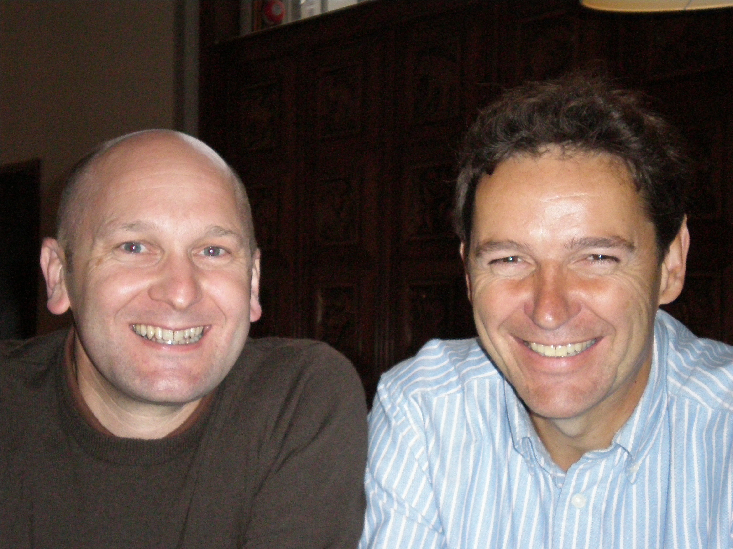 | Dr Philip Goodwin (Director, East and West Africa Region, British Council)  and  Tony Page (C.Psych, facilitator and coach)

Date/time: Tuesday 16th October 2007, 6-9pm

Venue: CASS, City University Business School, London
____________________________

Summary

Philip and Tony will tell the story of a three year leader-facilitator collaboration following a business merger of two regions of the British Council in sub-Saharan Africa.

They will describe the challenging context of Africa, the ups and downs of engaging a leadership team of 30 through a series of meetings in Kenya, Cameroon, Ethiopia, Nigeria, Tanzania and London.

The 30 leaders were in turn to engage 500 staff (spread across 11 different countries) in facing up to their challenge of scaling up their offerings to achieve higher impact and relevance while funding is being reduced.

Weathering storms and suffering a serious drop in morale this region has subsequently achieved the highest levels of leadership confidence as measured by MORI across all 13 of the British Council regions worldwide.

The presenters will share their insights into how the client-consultant relationship adds value, and will offer their views as to how an experience that is quintessentially African is relevant to all of us who are leading change in organisations today.
_____________________________

Tickets: For full details of programme, venue and price and to reserve your place please email Barry Curnow (Barry_Curnow@compuserve.com)

