E-Commerce SQL JOINS Mini Project
Advanced SQL JOIN Operations with Real-World Business Use Cases
Corporate Training Guide for Fresh CS/IT Engineering Graduates
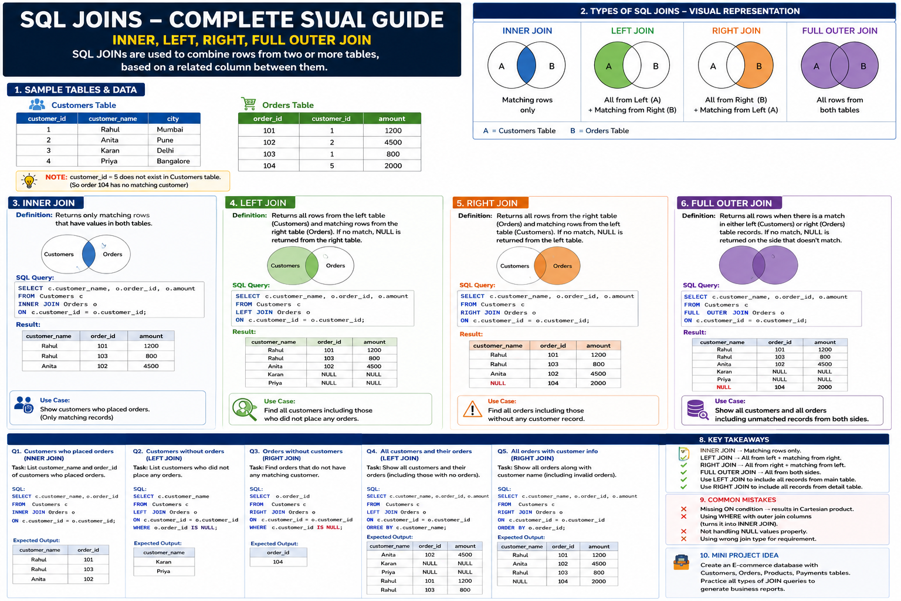

Step 1: Create Database
CREATE DATABASE ecommerce_db;
USE ecommerce_db;

Step 2: Create Customers Table
CREATE TABLE Customers (
customer_id INT PRIMARY KEY,
customer_name VARCHAR(100),
city VARCHAR(50),
email VARCHAR(100)
);

Create Products Table
CREATE TABLE Products (
product_id INT PRIMARY KEY,
product_name VARCHAR(100),
category VARCHAR(50),
price DECIMAL(10,2)
);

Create Orders Table
CREATE TABLE Orders (
order_id INT PRIMARY KEY,
customer_id INT,
order_date DATE,
total_amount DECIMAL(10,2)
);

Create Payments Table
CREATE TABLE Payments (
payment_id INT PRIMARY KEY,
order_id INT,
payment_method VARCHAR(50),
payment_status VARCHAR(20)
);

Insert Customers Data
INSERT INTO Customers VALUES
(1,'Rahul Sharma','Mumbai','rahul@gmail.com'),
(2,'Anita Verma','Pune','anita@gmail.com'),
(3,'Karan Singh','Delhi','karan@gmail.com'),
(4,'Priya Mehta','Bangalore','priya@gmail.com'),
(5,'Amit Joshi','Hyderabad','amit@gmail.com');

Insert Products Data
INSERT INTO Products VALUES
(101,'Laptop','Electronics',65000),
(102,'Mobile Phone','Electronics',25000),
(103,'Headphones','Accessories',3000),
(104,'Office Chair','Furniture',7000),
(105,'Smart Watch','Electronics',12000);

Insert Orders Data
INSERT INTO Orders VALUES
(1001,1,'2026-05-01',65000),
(1002,2,'2026-05-03',25000),
(1003,1,'2026-05-05',3000),
(1004,6,'2026-05-06',12000);

Insert Payments Data
INSERT INTO Payments VALUES
(1,1001,'UPI','Completed'),
(2,1002,'Credit Card','Pending'),
(3,1003,'Net Banking','Completed');

INNER JOIN
Business Requirement:
Display customers who placed orders.
SELECT c.customer_name,
o.order_id,
o.total_amount
FROM Customers c
INNER JOIN Orders o
ON c.customer_id = o.customer_id;
Explanation:
- Returns only matching records
- Excludes customers without orders

LEFT JOIN
Business Requirement:
Display all customers including those without orders.
SELECT c.customer_name,
o.order_id,
o.total_amount
FROM Customers c
LEFT JOIN Orders o
ON c.customer_id = o.customer_id;
Explanation:
- Shows all customers
- NULL appears for customers without orders

RIGHT JOIN
Business Requirement:
Display all orders including invalid orders.
SELECT c.customer_name,
o.order_id,
o.total_amount
FROM Customers c
RIGHT JOIN Orders o
ON c.customer_id = o.customer_id;
Explanation:
- Displays all orders
- Invalid customer mapping appears as NULL

FULL OUTER JOIN
Business Requirement:
Display all customers and all orders.
SELECT c.customer_name,
o.order_id,
o.total_amount
FROM Customers c
FULL OUTER JOIN Orders o
ON c.customer_id = o.customer_id;
Explanation:
- Shows all matching and non-matching rows
- Useful for audit reports

Business Reports
Report 1: Total Sales by Customer
SELECT c.customer_name,
SUM(o.total_amount) AS total_sales
FROM Customers c
INNER JOIN Orders o
ON c.customer_id = o.customer_id
GROUP BY c.customer_name;
Report 2: Orders with Payment Status
SELECT o.order_id,
c.customer_name,
p.payment_status
FROM Orders o
LEFT JOIN Customers c
ON o.customer_id = c.customer_id
LEFT JOIN Payments p
ON o.order_id = p.order_id;

Audit Report for Invalid Orders
SELECT o.order_id,
o.customer_id,
o.total_amount
FROM Customers c
RIGHT JOIN Orders o
ON c.customer_id = o.customer_id
WHERE c.customer_id IS NULL;
Purpose:
- Detect invalid orders
- Identify missing customer records
- Used in Banking and ERP audit systems

Hands-On Practice Exercises
- Find customers without orders
- Find completed payments
- Find top purchasing customers
- Generate monthly sales report
- Find pending payments

Interview Questions
- Difference between INNER JOIN and LEFT JOIN?
- What is Cartesian Product?
- Why NULL values appear in joins?
- What is audit reporting?
- Which JOIN is used most in companies?

Performance Tips and Common Mistakes
- Use indexes on JOIN columns
- Avoid SELECT * in production
- Always use proper ON conditions
- Use aliases for readability
- Avoid joining huge tables unnecessarily

