Key Tech Web Quotation

Web design and layout module

No. | Specification | Man-day (s)
1 | Catalog bar | 1
2 | About KeyTech | 2
3 | Expertise | 2
4 | News and events | 2
5 | Partners | 2
6 | Contacts | 2
7 | Footer | 1
8 | Projects | 2

Web functions

No. | Specification | Man-day (s)
1 | Customer enquires  (include email hosting account / services) | 3

Cross-platform layout

No. | Specification | Man-day (s)
1 | Responsive layout  (include tablet / mobile) | 4

Catalog bar



About KeyTech

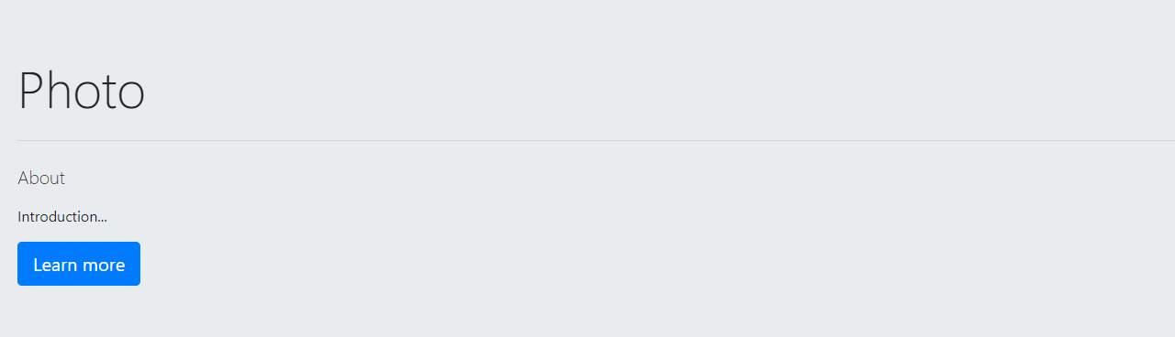
Expertise

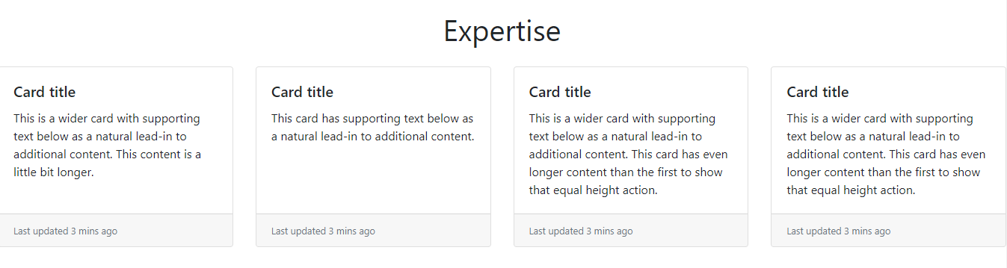

News and events

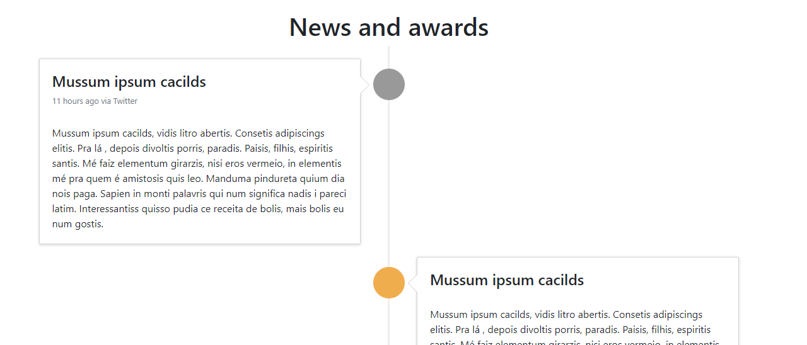
Partners

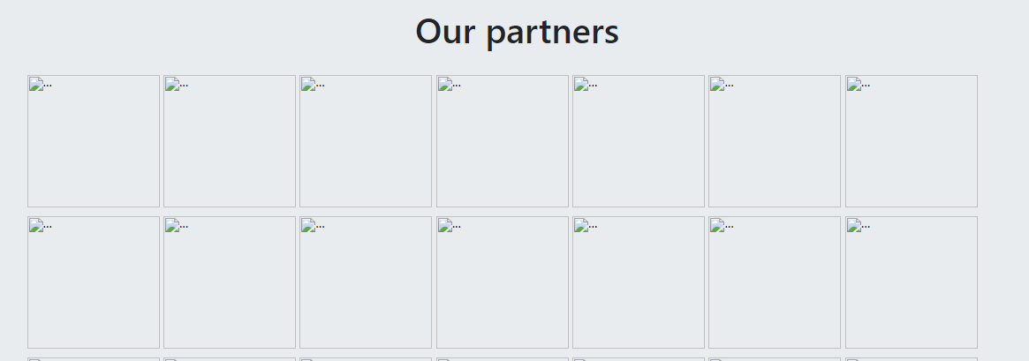
Contacts

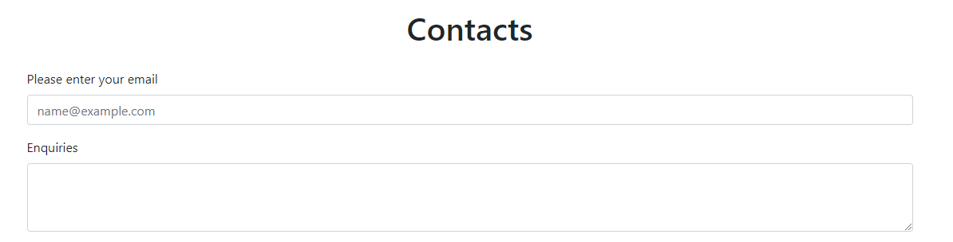
Footer

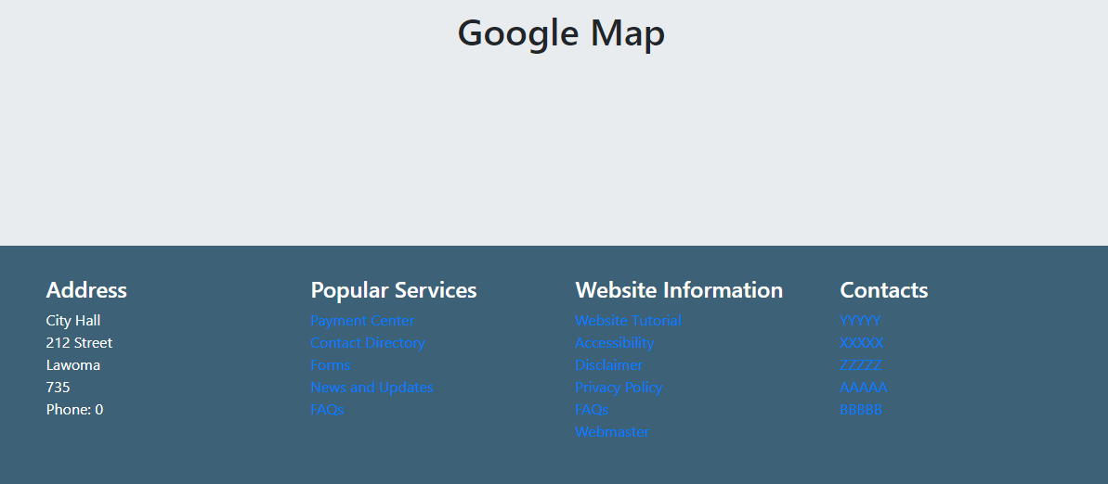

Projects

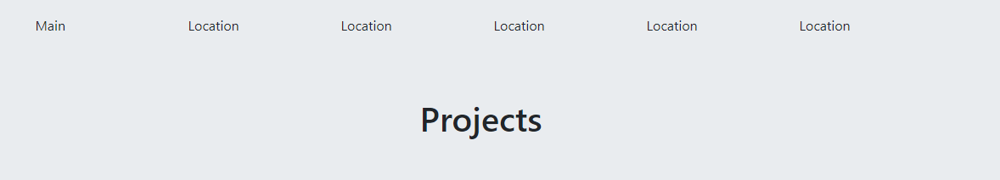

Responsive layout
(include tablet / mobile)

