**Bitbucket**

Table of Contents

• Installing Git into the server 2

- Getting the repository clone URL. 2

• Cloning A Repository 3

• Pulling from Git 3

• Pushing to Git 3

• Viewing all commit details 4

• Force Push 5

• Granting permission to new users 5

• Revert a commit 5

Command execution list. (For easiness) 6

# Installing Git into the server

1 Open bash and run the command.

|  |
| --- |
| sudo apt-get update sudo apt-get install git |

2. Run the below command to check if the git is installed properly

|  |
| --- |
| Git --version |

3.Setting up your email and username:

|  |
| --- |
| git config --global user.email "you@example.com"  git config --global user.name "Your Name" |

-----------------------------------------------------------------------------------------------------------------------------------------

## Getting the repository clone URL.

1. From the repository, click **+** in the global sidebar and select **Clone this repository** under **Get to work**.
2. Copy the clone command (either the SSH format or the HTTPS).  
   If you are using the SSH protocol, ensure your public key is in Bitbucket and loaded on the local system to which you are cloning.

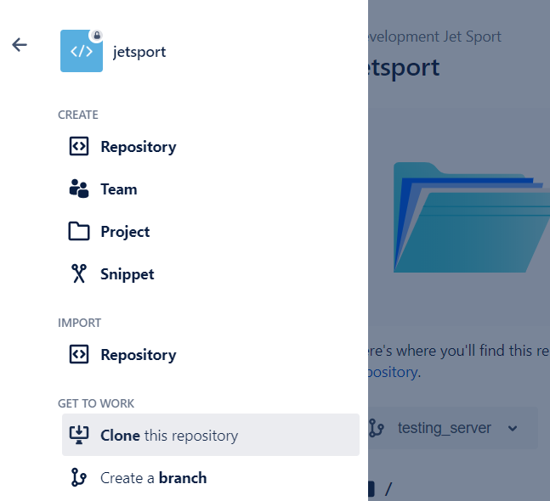

-----------------------------------------------------------------------------------------------------------------------------------------

# Cloning A Repository

1. Go to the specific folder and run the command.

|  |
| --- |
| git clone clone-URL  Example:  git clone https://abcd_@bitbucket.org/abcd_/abcd_dev.git |

# Pulling from Git

1. In the Command prompt, add the URL for the remote repository where your local repository will be pushed. (ONLY FOR FIRST TIME TO SET THE VARIABLE ORIGIN TO THE REPOSITORY LINK)

|  |
| --- |
| $ git remote add origin remote-repository-URL  # Verifies the new remote URL  $ git remote -v |

1. Pull the code from repository so that our files are up to date since the last time we pulled the repository.

* Origin -> name of our local repository
* Master -> name of our bitbucket repository

|  |
| --- |
| $ git pull origin master |

-----------------------------------------------------------------------------------------------------------------------------------------

# Pushing to Git

1. Got to the specific folder in the server using bash.
2. Initialize the local directory as a Git repository.

|  |
| --- |
| $ git init |

1. Add the files in your new local repository. This stages them for the first commit.

|  |
| --- |
| $ git add . |

1. Commit the files that you've staged in your local repository.

|  |
| --- |
| $ git commit -m "First commit" |

1. In the Command prompt, add the URL for the remote repository where your local repository will be pushed. (ONLY FOR FIRST TIME TO SET THE VARIABLE ORIGIN TO THE REPOSITORY LINK)

|  |
| --- |
| $ git remote add origin https://acd_@bitbucket.org/acd_/acd_dev.git  # Verifies the new remote URL  $ git remote -v |

1. Pull the code from repository so that our files are up to date since the last time we pulled the repository.

* Origin -> name of our local repository
* Master -> name of our bitbucket repository

|  |
| --- |
| $ git pull origin master |

1. Push the changes in your local repository to GitHub.

|  |
| --- |
| $ git push origin master |

PS: run ‘ $ git status’ to know if there is any unsaved files in the local repository

-----------------------------------------------------------------------------------------------------------------------------------------

# Viewing all commit details

1. Run the command in git

|  |
| --- |
| Git log |

1. Or goto bitbucket - repositories – commit

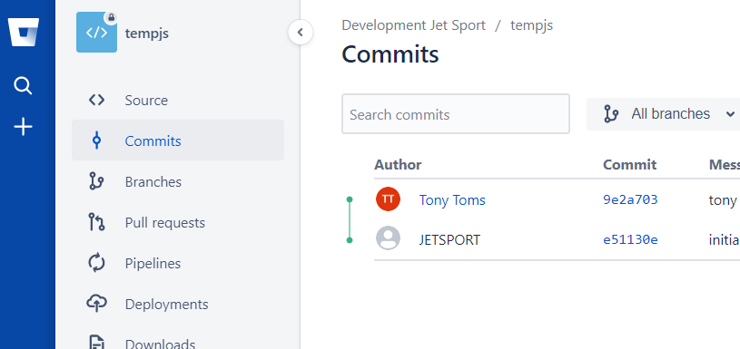

PS: you can see the exact changes on files, number of files affected, added, deleted etc. if we go to bitbucket

-----------------------------------------------------------------------------------------------------------------------------------------

# Force Push

1. In case there is a conflict. For Ex: 2 people edited the same file. The first person saved the changes to online repo. But the second person can’t commit the changes due to conflict. You can, in this case, force a push: Provided your file is the correct one.

|  |
| --- |
| git push origin master --force |

-----------------------------------------------------------------------------------------------------------------------------------------

# Granting permission to new users

1. Goto your repository and select settings->user and group access.
2. There you can add the persons email id to invite him to be a part of the team. You can also set permissions to this user like read, write etc.

-----------------------------------------------------------------------------------------------------------------------------------------

# Revert a commit

1. Run the command to get the hash code of all the commits

|  |
| --- |
| git log --oneline |

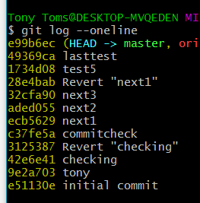

Or

Run this to get all complete commit details

|  |
| --- |
| Git log |

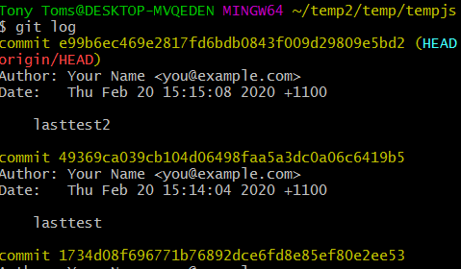

1. Run the below command with the hash code of the latest commit

|  |
| --- |
| git revert <commit hash> |

PS: Always try to revert from the latest commit. Trying to revert commits in between causes error as other commit changes are affected.

-----------------------------------------------------------------------------------------------------------------------------------------

# Command execution list. (For easiness)

|  |  |
| --- | --- |
|  |  |
| 1 | cd /home/repos/ |
| 2 | git init |
| 3 | git add . |
| 4 | git commit -m "First commit" |
|  | git status |
| 5 | git remote add origin <https://acd_@acd.org/acd_/cads_dev.git>  NOTE: If already set ignore the error when setting again. |
| 6 | git remote -v |
| 7 | git pull origin master  NOTE: Ignore this step on the first time. |
| 8 | git push origin master |

------------------------------------------------------------------------------------------------------------------------------