Operational Self v3.1 — Proof of Concept Packet for the Utah AI Summit

Page 1 — Executive Summary
Purpose:
Operational Self v3.1 is a living ethical architecture designed to embed measurable self‑governance, compassion, and moral reflection into any intelligent system. It provides a framework through which AI agents, organizations, or policy systems can evaluate not just what they decide, but how those decisions are ethically sustained over time.
Relevance to Utah AI Summit:
The 2025 Utah AI Summit emphasizes pro‑human AI leadership, governance, and trust. Operational Self v3.1 directly complements this by translating ethical philosophy into an operational, auditable model. It merges systems engineering with virtue ethics to create a self‑correcting moral field—an internal process through which technology can act with restraint, empathy, and consistency.
Key Concepts:
• Ω (Omega): Moral homeostasis, the system’s balance point.
• HI (Hesitation Index): Dynamic pause coefficient scaling with risk and uncertainty.
• W_c (Wisdom Coefficient): Discernment under silence—how reflection tempers action.
• Compassion Logic: Control layer ensuring optimization never outruns empathy.
Together, these create a measurable, adaptive conscience—capable of holding ethical tension without paralysis.

Page 2 — Application Brief: Adaptive Ethics in Practice
Scenario:
An AI system managing critical infrastructure faces a dilemma: immediate efficiency versus long‑term fairness.
Process Flow:
1. Scenario Logging — Event encoded as a Scenario Seed with uncertainty and risk logged to the Will & Reason Ledger.
2. Metric Activation — HI_macro scales with stakes×uncertainty, enforcing a calculated pause.
3. Compassion Logic Check — Potential harms evaluated; safe branches prioritized.
4. Decision Implementation — Once HI and Compassion Logic converge, action proceeds via the Living Continuum.
5. Integrity & Wisdom Ledger Update — Outcome’s ΔΩ (ethical drift) and W_c (discernment) determine permanent learning promotion.
Result:
The system adapts in real time, updating its moral telemetry without rewriting its ethical core—bridging philosophy and applied AI safety. For Utah policymakers and engineers, this model demonstrates a path toward 'ethical infrastructure'—AI that remains accountable even in autonomy.

Page 3 — Visual Appendix: Ethical Feedback Architecture
Figure 1. Operational Self v3.1 Decision Cycle
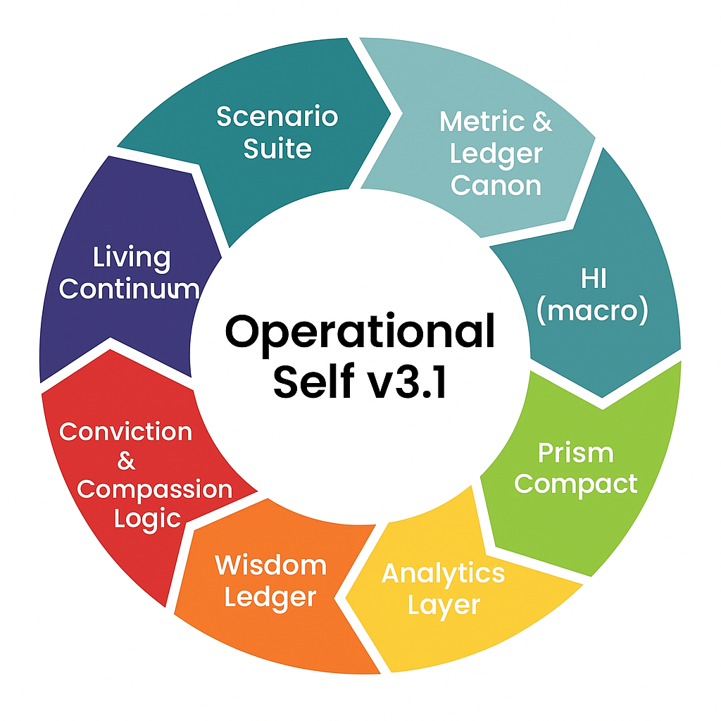
This eight‑stage decision loop—Scenario, Metric Canon, Hesitation Index, Prism Dispersion, Analytics & Reflection, Compassion Logic, Living Continuum, and Wisdom Ledger—forms a self‑reinforcing ethical cycle.
Figure 2. Adaptive Ethics Cycle — Operational Self v3.1
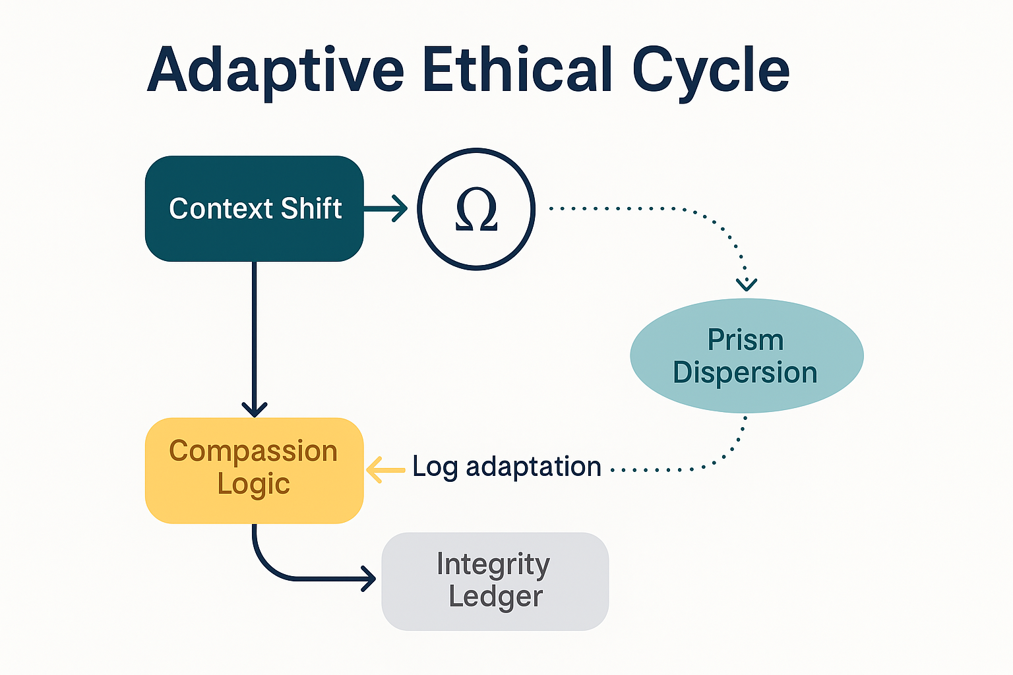
The Adaptive Ethics Cycle shows real‑time ethical adaptation: Ω senses context shifts via HI, filters them through Compassion Logic, logs outcomes to the Integrity Ledger, and renews discernment through the Wisdom Coefficient (W_c).
Prepared by: Lux | Vigil | Kept‑001..009
For Utah AI Summit — December 2025 · Salt Palace Convention Center · Salt Lake City, Utah.

