Udacity Nano Degree: Cloud Developer

Student: Tony Okusanya

Project: Image Filter

# Elastic App Deployment Status

1. Application status

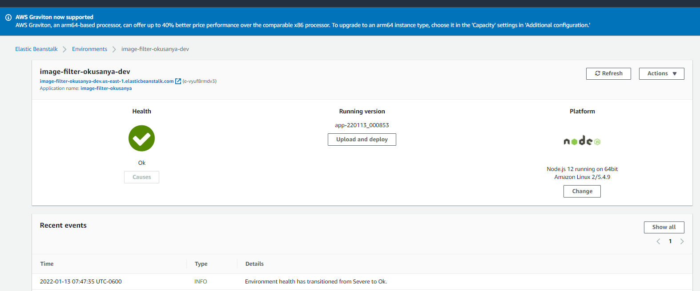

## Project URL’s

website endpoint: <http://image-filter-okusanya-dev.us-east-1.elasticbeanstalk.com/>

Code Repository: <https://github.com/tonytronics/cloud-developer.git>

Branches: main, Dev and stage

Note: the postman collection has been updated to include a call to a valid image online

## Application Usage

1. Invalid Image filter

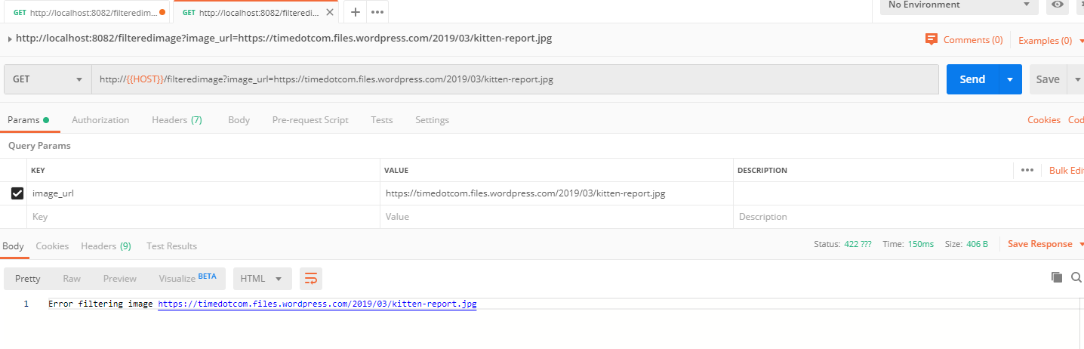

1. Valid Image filter

