# Market Overview

* Market shares

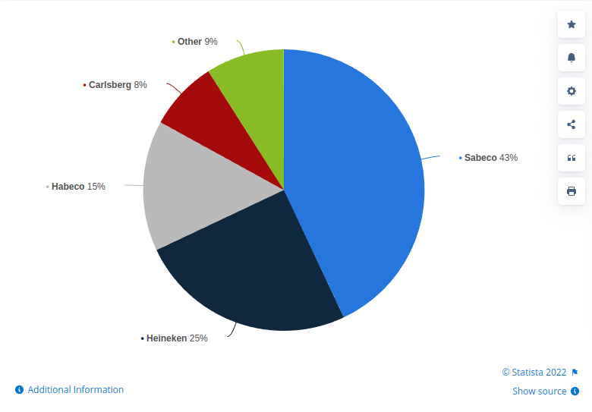

* Vietnam is Asia’s top beer consumer. The market was worth US$5.18 billion in 2015 and is expected to be worth US$10.1 billion in 2025. However, the pace of growth is slowing. Annual growth between 2020-2025 is forecast to be 5.57 percent per annum versus 8.75 percent per year registered in 2015-2019.
* Growing working-age population with an increasing income
* drinking alcoholic products is to well observe social etiquette, exhibit a proper manner at work, and build and maintain social networking and business relationships. This mindset has existed in Vietnamese society for ages. In addition, Vietnamese people are able to consume alcoholic products for any celebrations
* 77.3 percent of the male population consume alcoholic products, which is twice the average and the highest figure in the world. Furthermore, Vietnam’s middle class will double in size by 2020, reaching 33 million – the fastest growth rate in South East Asia

# Critical Success Factor for Vietnam Food and Beverage

* Tourism is another sizeable contributor to Vietnam’s food and beverage industry. Tourists spend an average of (23.7% percent of their budget on food and drink while in Vietnam)
* One of the most noticeable trends is the shift toward the consumption of low and no-alcohol beers, such as the Heineken 0.0 (zero alcohol) or Sabeco’s Sagota – the first Vietnamese brewery to introduce non-alcoholic beer as well as craft beers with common brand names, such as Belgo or BiaCraft Artisan Ales.
* Marketing and advertising, local taste for different region in Vietnam
  + San Miguel and Carlsberg, which are distributed around the world, do not achieve much in Vietnam, because their products apparently do not suit the Vietnamese specific taste. Other reasons can be their ill-designed advertising campaigns, or the color, the foam and the alcohol content of their beers do not match the consumers’ desires and preferences as will be described later.
  + Northern Vietnam based consumers tend to be trend followers, pay strong attention to packaging, especially for products that are gifted and have considerable knowledge of different brands Central Vietnam based consumers tend to be reserved, less willing to try new brands, and prefer local brands. The absence of a variety of brands can be a key reason for this trend. By contrast, people living in Southern Vietnam are classified as easy-going consumers who are willing to try new brands and are knowledgeable about different brands.
  + As a usual practice, foreign companies often spend a large sum of money in advertising and promotion (A & P) to get the consumers’ awareness for their products. The most typical A & P activities used by them 5are erecting billboards at crowded crossroads, commissioning foreign ads agency to develop attractive clips to be shown on prime time TV, putting large ads in leading newspapers, sponsoring key sportive and social events, providing free-of-charge name boards to groceries with their logos, and using promotion girls in restaurants and wedding parties. As a typical case, Tiger and Heineken brands had made quick and large impacts on the Vietnamese market by a large scale A & P campaign in their attempt to conquer the market quickly
* Government policy
  + According to the Law on Special Excise Duty No.70/2014/QH13, from 2018 onwards, special consumption tax rates imposed on alcoholic products with ABV < 20o, ≥ 20o, and beer, will be 35 percent, 65 percent, and 65 percent respectively.
  + In addition, pursuant to Decree No.181/2013/ND-CP following the Law of Advertising, Vietnamese enterprises are required to work with Vietnam-based licensed advertising services providers. This prohibition will prevent Vietnamese enterprises to employ other useful and low-cost tools to advertise products such as Facebook.
* Effective management
  + SABECO possess very good management skills. They have a good grip on advanced management such as environmental management, or latest management methods.
* Product quality and premiumnisation
  + Vietnamese people have seen vast improvements in their standard of living and consumer spending power, along with a strong obsession with foreign products, believing them to be of higher quality.
  + product quality standards (how to ensure standards when you have an unstable supply of raw materials and increasing quality demands for export products as a result of the various Free Trade Agreements?) guaranteeing traceability and clean sources for raw materials used small scale production facilities in many cases weak branding combined with poor packaging (brands like prestige in consumer perceptions)
* wide distribution system
  + omnichannel approach with increasing digitalisation convenience
  + Sabecco has already started untangling this sub-optimal supply and production network through a digitalisation project to reduce its reliance on third-party producers.
  + Businesses have also diversified the sales format with an aggressive shift to online transactions.

# Risk Factor

* One of the most important trends on the beer market is the shift in consumer preference towards low and non-alcohol beers, as well as craft beers
* difficulties due to the chronic shortage of input materials, while foreign goods – particularly Chinese items – overwhelmed the domestic market
* According to VIRAC, Vietnam’s beer industry still faces many challenges such as communication, risks of changing consumer tastes, M&A,… requiring continuous efforts and improvement to enhance the position in the international market.
* Production license: This can be considered as a major obstacle for new businesses. To open a beer factory in Vietnam, enterprises must be licensed by the Ministry of Industry and Trade. While the regulations are quite clear, implementation can be difficult. Even if all provinces were willing to facilitate new breweries to collect taxes, the licensing would depend on the beer and beverage planning of the Ministry of Industry and Trade, which may have been registered many years in advance.

References

<https://www.vietnam-briefing.com/news/vietnams-alcoholic-beverage-industry.html/>

<https://vir.com.vn/competition-heating-up-in-alcoholic-beverages-sector-82588.html>

<https://viracresearch.com/vietnams-beer-market-and-opportunities-in-2020/>

<https://www.vietnam-briefing.com/news/vietnams-food-and-beverage-industry-market-trends-demographics-consumer-preferences.html/>