
Acme Manufacturing
Mechanical Design

How to Extrude a Boss in Fusion
Standard operating procedure for the base flange
Author: Jordan Lee Date: 2026-06-24 Revision: 1.0 Department: Mechanical Design

In Autodesk Fusion
1. Click at the highlighted location in Autodesk Fusion.

2. Click at the highlighted location in Autodesk Fusion.
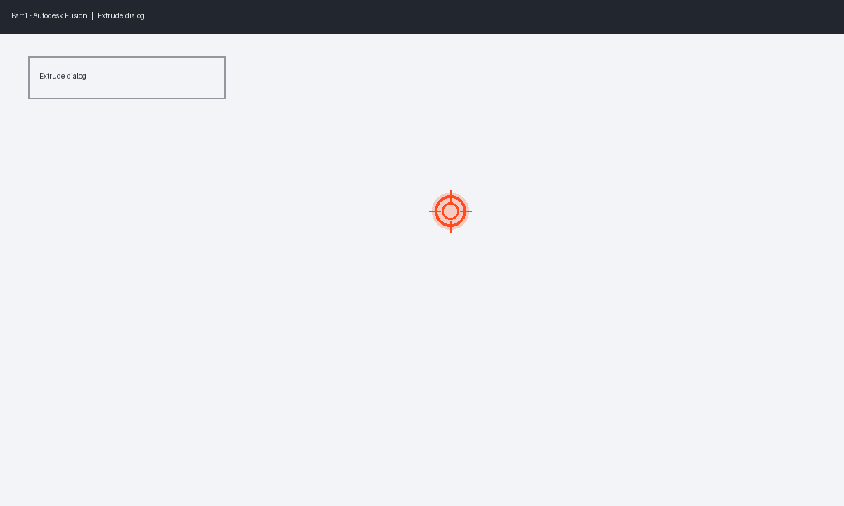
3. Type 25 mm.
4. Press Enter.
5. Verify the body shows in the timeline.

