
O-RAN.WG2.TS.Use-Case-Requirements-R005-v11.00
Technical Specification

Non-RT RIC & A1/R1 interface: Use Cases and Requirements

Copyright © 2026 by the O-RAN ALLIANCE e.V.
The copying or incorporation into any other work of part or all of the material available in this specification in any form without the prior written permission of O-RAN ALLIANCE e.V. is prohibited, save that you may print or download extracts of the material of this specification for your personal use, or copy the material of this specification for the purpose of sending to individual third parties for their information provided that you acknowledge O-RAN ALLIANCE as the source of the material and that you inform the third party that these conditions apply to them and that they must comply with them.

O-RAN ALLIANCE e.V., Buschkauler Weg 27, 53347 Alfter, Germany
Register of Associations, Bonn VR 11238, VAT ID DE321720189

Contents
Foreword 4
Modal verbs terminology 4
Introduction 4
1 Scope 5
2 References 5
2.1 Normative references 5
2.2 Informative references 6
3 Definition of terms, symbols and abbreviations 7
3.1 Terms 7
3.2 Symbols 8
3.3 Abbreviations 8
4 Use cases 9
4.1 Traffic steering 9
4.1.1 Background and goal of the use case 9
4.1.2 Entities/resources involved in the use case 10
4.1.3 Solutions 10
4.1.4 Required data 17
4.1.5 A1 usage example 18
4.1.6 Enrichment information example 20
4.1.7 A1 usage example in multi-access environment 21
4.2 QoE optimization 24
4.2.1 Background and goal of the use case 24
4.2.2 Entities/resources involved in the use case 25
4.2.3 Solutions 25
4.2.4 Required data 31
4.2.5 A1 usage example 32
4.3 QoS based resource optimization 33
4.3.1 Background and goal of the use case 33
4.3.2 Entities/resources involved in the use case 34
4.3.3 Solutions 34
4.3.4 Required data 38
4.3.5 A1 usage example 38
4.4 Context-based dynamic HO management for V2X 41
4.4.1 Background and goal of the use case 41
4.4.2 Entities/resources involved in the use case 41
4.4.3 Solutions 42
4.4.4 Required data 45
4.4.5 Proposed solution(s) 45
4.4.6 A1 enrichment interface aspects 46
4.4.7 A1 usage example 47
4.5 RAN slice SLA assurance 48
4.5.1 Background and goal of the use case 48
4.5.2 Entities/resources involved in the use case 48
4.5.3 Solutions 49
4.5.4 Required data 57
4.5.5 A1 usage example 58
4.5.6 O1 usage example 61
4.6 NSSI resource allocation optimization 62
4.6.1 Background and goal of the use case 62
4.6.2 Entities/resources involved in the use case 63
4.6.3 Solutions 63
4.6.4 Required data 69
4.6.5 O1 usage example 70
4.7 Massive MIMO optimization 71
4.7.1 Massive MIMO Grid-of-Beams Beamforming (GoB BF) optimization 71
4.7.2 Massive MIMO Non-GoB Beamforming (Non-GoB BF) optimization 77
4.7.3 MIMO optimization via MIMO DL Tx power optimization, MU-MIMO pairing, and MIMO mode selection 86
4.7.4 AI/ML-based initial access (SS Burst Set) configuration optimization 91
4.8 Network energy saving 96
4.8.1 Carrier and cell switch off/on 96
4.8.2 RF channel reconfiguration 112
4.8.3 Advanced sleep mode 126
4.8.4 Time domain cell DTX/DRX optimization (3GPP Rel-18) 135
4.8.5 Spatial and power domain optimization (3GPP Rel-18) 142
4.8.6 SSB-less SCell optimization for inter-band CA (3GPP Rel-18) 149
4.8.7 PA power optimization for O-RU energy saving 156
4.8.8 External power source coordination-based energy saving 163
4.9 O-Cloud resource optimization 170
4.9.1 Use case: O-Cloud node draining use case 170
5 Requirements 184
5.1 Functional requirements 184
5.1.1 Non-RT RIC functional requirements 184
5.1.2 A1 interface functional requirements 185
5.1.3 R1 interface functional requirements 185
5.2 Non-functional requirements 186
5.2.1 Non-RT RIC non-functional requirements 186
5.2.2 A1 interface non-functional requirements 186
5.2.3 R1 interface non-functional requirements 187
Annex (informative): Change history/Change request (history) 188

Foreword
This Technical Specification (TS) has been produced by WG2 of the O-RAN ALLIANCE.
The content of the present document is subject to continuing work within O-RAN and may change following formal O-RAN approval. Should the O-RAN ALLIANCE modify the contents of the present document, it will be re-released by O-RAN with an identifying change of version date and an increase in version number as follows:
version xx.yy.zz
where:
xx: the first digit-group is incremented for all changes of substance, i.e. technical enhancements, corrections, updates, etc. (the initial approved document will have xx=01). Always 2 digits with leading zero if needed.
yy: the second digit-group is incremented when editorial only changes have been incorporated in the document. Always 2 digits with leading zero if needed.
zz: the third digit-group included only in working versions of the document indicating incremental changes during the editing process. External versions never include the third digit-group. Always 2 digits with leading zero if needed.

Modal verbs terminology
In the present document "shall", "shall not", "should", "should not", "may", "need not", "will", "will not", "can" and "cannot" are to be interpreted as described in clause 3.2 of the O-RAN Drafting Rules (Verbal forms for the expression of provisions).
"must" and "must not" are NOT allowed in O-RAN deliverables except when used in direct citation.

Introduction
This document provides O-RAN WG2 Non-RT RIC Use Cases and Requirements, including A1 and R1 interfaces.

1 Scope
The present document specifies the RAN optimization and control related use cases that have been approved within O-RAN WG2. The purpose of the use cases is to help identify requirements for O-RAN defined interfaces and functions, specifically Non-RT RIC function and A1 and R1 interfaces, eventually leading to formal drafting of interface specifications. For each use case, the document describes the motivation, resources, steps involved, and data requirements. Finally, the requirements clause details the functional and non-functional requirements derived from these use cases.

2 References

2.1 Normative references
References are either specific (identified by date of publication and/or edition number or version number) or non-specific. For specific references, only the cited version applies. For non-specific references, the latest version of the referenced document (including any amendments) applies. In the case of a reference to a 3GPP document, a non-specific reference implicitly refers to the latest version of that document in Release 18, or the latest 3GPP release prior to Release 18 that includes that document.
NOTE: While any hyperlinks included in this clause were valid at the time of publication, O-RAN cannot guarantee their long-term validity.
The following referenced documents are necessary for the application of the present document.
- 3GPP TS 22.261: “3rd Generation Partnership Project; Technical Specification Group Services and System Aspects; Service requirements for the 5G system; Stage 1”
- 3GPP TS 23.501: “3rd Generation Partnership Project; Technical Specification Group Services and System Aspects; System architecture for the 5G System (5GS); Stage 2”
- 3GPP TS 28.530: “3rd Generation Partnership Project; Technical Specification Group Services and System Aspects; Management and orchestration; Concepts, use cases and requirements”
- 3GPP TS 28.541: “3rd Generation Partnership Project; Technical Specification Group Services and System Aspects; Management and orchestration; 5G Network Resource Model (NRM); Stage 2 and stage 3”
- 3GPP TS 28.552: “3rd Generation Partnership Project; Technical Specification Group Services and System Aspects; Management and orchestration; 5G performance measurements”
- 3GPP TS 36.314: “3rd Generation Partnership Project; Technical Specification Group Radio Access Network; Evolved Universal Terrestrial Radio Access (E-UTRA); Layer 2 - Measurements”
- 3GPP TS 38.314: “3rd Generation Partnership Project; Technical Specification Group Radio Access Network; NR; Layer 2 Measurements”
- 3GPP TS 37.340: “3rd Generation Partnership Project; Technical Specification Group Radio Access Network; Evolved Universal Terrestrial Radio Access (E-UTRA) and NR; Multi-connectivity; Overall Description; Stage 2”
- GSMA: “Generic Network Slice Template Version 4.0”, November 2020
- O-RAN TS: “Management Plane Specification” (“MP”)
- 3GPP TS 32.423: “3rd Generation Partnership Project; Technical Specification Group Services and System Aspects; Telecommunication management; Subscriber and equipment trace; Trace data definition and management”
- O-RAN TS: “Control, User and Synchronization Plane Specification” (“CUS”)
- O-RAN TS: “O2 Interface General Aspects and Principles” (“O2-GA&P”)
- O-RAN TS: “Cloudification and Orchestration Use Cases and Requirements for O-RAN Virtualized RAN” (“ORCH-USE-CASES”)
- O-RAN TS: “Slicing Architecture”
- O-RAN TS: “Near-Real-time RAN Intelligent Controller E2 Service Model (E2SM) KPM” (“E2SM-KPM”)
- 3GPP TS 28.554: “3rd Generation Partnership Project; Technical Specification Group Services and System Aspects; Management and orchestration; 5G end to end Key Performance Indicators (KPI)”
- 3GPP TS 32.422: “3rd Generation Partnership Project; Technical Specification Group Services and System Aspects; Telecommunication management; Subscriber and equipment trace; Trace control and configuration management”
- 3GPP TS 37.320: “3rd Generation Partnership Project; Technical Specification Group Radio Access Network; Radio measurement collection for Minimization of Drive Tests (MDT); Overall description; Stage 2”
- 3GPP TS 38.331: “3rd Generation Partnership Project; Technical Specification Group Radio Access Network; NR; Radio Resource Control (RRC) protocol specification”
- 3GPP TS 38.300: “NR; NR and NG-RAN Overall Description; Stage 2”
- 3GPP TS 38.306: “NR; User Equipment (UE) radio access capabilities”
- 3GPP TS 28.558: “3rd Generation Partnership Project; Technical Specification Group Services and System Aspects; Management and orchestration; UE level measurements for 5G system”
- O-RAN TS: “A1 interface: Type Definitions” (“A1TD”)
- 3GPP TS 28.310: “Management and orchestration; Energy efficiency of 5G”, V19.1.0 (2025-06)

2.2 Informative references
References are either specific (identified by date of publication and/or edition number or version number) or non-specific. For specific references, only the cited version applies. For non-specific references, the latest version of the referenced document (including any amendments) applies. In the case of a reference to a 3GPP document, a non-specific reference implicitly refers to the latest version of that document in Release 18, or the latest 3GPP release prior to Release 18 that includes that document.
NOTE: While any hyperlinks included in this clause were valid at the time of publication, O-RAN cannot guarantee their long-term validity.
The following referenced documents are not necessary for the application of the present document, but they assist the user with regard to a particular subject area.
[i.1] 3GPP TR 21.905: “Vocabulary for 3GPP Specifications”
[i.2] ETSI EN 302 637-2: “Intelligent Transport Systems (ITS); Vehicular Communications; Basic Set of Applications; Part 2: Specification of Cooperative Awareness Basic Service”, Release 1, November 2010
[i.3] O-RAN.WG1.MMIMO-USE-CASES-TR-v01.00: “O-RAN Working Group 1, Massive MIMO Use Cases”, Technical Report, March 2022
[i.4] ETSI ES 203 228, Environmental Engineering (EE); Assessment of mobile network energy efficiency
[i.5] ETSI ES 202 706-1, Metrics and measurement method for energy efficiency of wireless access network equipment; Part 1: Power consumption - static measurement method

3 Definition of terms, symbols and abbreviations

3.1 Terms
For the purposes of the present document, the terms and definitions [given in 3GPP TR 21.905 [i.1] and the following] apply. A term defined in the present document takes precedence over the definition of the same term, if any, in 3GPP TR 21.905 [i.1].
A1: Interface between orchestration/NMS layer containing Non-RT RIC and eNB/gNB containing Near-RT RIC.
A1 policy: Type of declarative policies expressed using formal statements that enable the Non-RT RIC function in the SMO to guide the Near-RT RIC function, and hence the RAN, towards better fulfilment of the RAN intent.
A1 enrichment information: Information utilized by Near-RT RIC that is collected or derived at SMO/Non-RT RIC either from non-network data sources or from network functions themselves.
E2: Interface between Near-RT RIC and the Multi-RAT CU protocol stack and the underlying RAN DU.
E2 node: O-CU-CP, O-CU-UP, O-DU, O-gNB, O-eNB.
Energy consumption: Integral of power consumption over time [i.5].
Energy efficiency: Relation between the useful output and energy/power consumption [i.4].
FCAPS: Fault, Configuration, Accounting, Performance, Security.
Intents: A declarative policy to steer or guide the behavior of RAN functions, allowing the RAN function to calculate the optimal result to achieve stated objective.
Near-RT RIC: O-RAN Near-Real-Time RAN Intelligent Controller: A logical function that enables near-real-time control and optimization of RAN elements and resources via fine-grained data collection and actions over E2 interface.
Non-RT RIC: O-RAN Non-Real-Time RAN Intelligent Controller: A logical function in the SMO framework that enables non-real-time control and optimization of RAN elements and resources, AI/ML workflow including model training and updates, and policy-based guidance of applications/features in Near-RT RIC. The Non-RT RIC is comprised of the Non-RT RIC framework and Non-RT RIC applications (rApps).
Non-RT RIC framework: Functionality internal to the SMO framework that logically terminates the A1 interface and provides the R1services to rApps through the R1 interface.
NMS: A Network Management System.
O-CU: O-RAN Central Unit: A logical node hosting O-CU-CP and O-CU-UP.
O-CU-CP: O-RAN Central Unit – Control Plane: A logical node hosting the RRC and the control plane part of the PDCP protocol.
O-CU-UP: O-RAN Central Unit – User Plane: A logical node hosting the user plane part of the PDCP protocol and the SDAP protocol.
O-DU: O-RAN Distributed Unit: A logical node hosting RLC/MAC/High-PHY layers based on a lower layer functional split.
O-RU: O-RAN Radio Unit: A logical node hosting Low-PHY layer and RF processing based on a lower layer functional split. This is similar to 3GPP’s “TRP” or “RRH” but more specific in including the Low-PHY layer (e.g., FFT/iFFT, PRACH extraction).
O1: Interface between management entities (NMS/EMS/MANO) and O-RAN managed elements, for operation and management, by which FCAPS management, software management, file management can be achieved.
RAN: Generally referred as Radio Access Network. In terms of this document, any component below Near-RT RIC per O-RAN architecture, including O-CU/O-DU/O-RU.
rApp: Non-RT RIC application: An application designed to consume and /or produce R1 Services.
NOTE: rApps can leverage the functionality provided by the SMO and Non-RT RIC framework to deliver value added services related to intelligent RAN optimization and operation.
R1 interface: Interface between rApps and Non-RT RIC framework via which R1 Services can be produced and consumed.
R1 services: A collection of services including, but not limited to, service registration and discovery services, authentication and authorization services, AI/ML workflow services, and A1, O1 and O2 interface related services.

3.2 Symbols
Void

3.3 Abbreviations
For the purposes of the present document, the abbreviations [given in 3GPP TR 21.905 [i.1] and the following] apply. An abbreviation defined in the present document takes precedence over the definition of the same abbreviation, if any, in 3GPP TR 21.905 [i.1].

5QI 5G Quality of Service Identifier
ASM Advanced Sleep Mode
CAM Cooperative Awareness Message
EC Energy Consumption
EE Energy Efficiency
eNB eNodeB (applies to LTE)
ES Energy Saving
gNB gNodeB (applies to NR)
KPI Key Performance Indicator
KQI Key Quality Indicator
m-MIMO Massive Multiple Input, Multiple Output
MBB Mobile BroadBand
QoE Quality of Experience
RIC O-RAN RAN Intelligent Controller
SINR Signal-to-Interference-plus-Noise Ratio
SMO Service Management and Orchestration
SSB Synchronization Signal Block

4 Use cases

4.1 Traffic steering
This use case provides the motivation, description, and requirements for traffic steering use case, allowing operators to specify different objectives for traffic management such as optimizing the network/UE performance, or achieving balanced cell load.

4.1.1 Background and goal of the use case
5G systems will support many different combinations of access technologies namely; LTE (licensed band), NR (licensed band), NR-U (unlicensed band), Wi-Fi (unlicensed band). Several different multi-access deployment scenarios are possible with 5GC to support wide variety of applications and satisfy the spectrum requirements of different service providers;
- Carrier aggregation between licensed band NR (primary cell) and NR-U (secondary cell)
- Dual connectivity between licensed band NR (primary cell) and NR-U (secondary cell)
- Dual connectivity between licensed band LTE (primary cell) and NR-U (secondary cell)

The rapid traffic growth and multiple frequency bands utilized in a commercial network make it challenging to steer the traffic in a balanced distribution. Further in a multi-access system there is need to switch the traffic across access technologies based on changes in radio environment and application requirements and even split the traffic across multiple access technologies to satisfy performance requirements. The different types of traffic and frequency bands in a commercial network make it challenging to handle the complex QoS aspects, bearer selection (Master Cell Group (MCG) bearer, Secondary Cell Group (SCG) bearer, split bearer), bearer type change for load balancing, achieving low latency and best in class throughput in a multi-access scenario with 5GC networks (as specified in 3GPP TS 37.340 [8]). Typical controls are limited to adjusting the cell reselection and handover parameters; modifying load calculations and cell priorities; and are largely static in nature when selecting the type of bearers and QoS attributes.
Further, the RRM (Radio Resource Management) features in the existing cellular network are either cell-centric or UE-centric. Even in different areas within a cell, there are variations in radio environment, such as neighboring cell coverage, signal strength, interference status, etc. However, base stations based on traditional control strategies treat all UEs in a similar way and both cell- and UE-centric algorithms do exist.
Such current solutions suffer from following limitations:
1) It is hard to adapt the RRM control to diversified scenarios and optimization objectives.
2) The traffic management strategy is usually passive, rarely taking advantage of capabilities to predict network and UE performance. The strategy needs to consider aspects of steering, switching and splitting traffic across different access technologies in a multi-access scenario.
3) Non-optimal traffic management, with slow response time, due to various factors such as inability to select the right set of UEs for control action. This further results in non-optimal system and UE performance, such as suboptimal spectrum utilization, reduced throughput and increased handover failures.
Based on the above reasons, the main objective of this use case is to allow operators to flexibly configure the desired optimization policies, utilize the right performance criteria, and leverage machine learning to enable intelligent and proactive traffic management.

4.1.2 Entities/resources involved in the use case
- SMO (including Non-RT RIC):
  - Retrieve necessary performance, configuration, and other data for defining and updating policies to guide the behavior of traffic management function in Near-RT RIC. For example, the policy could relate to specifying different optimization objectives to guide the carrier/band preferences at per-UE or group of UE granularity.
  - Retrieve necessary performance, configuration, and other data for performing data statistical analysis that will provide enrichment information for Near-RT RIC to assist in the traffic steering function. For example, this could be an analysis method to construct radio fingerprint based on UE measurement report with RSRP/RSRQ/CQI information for serving and neighbouring cells.
  - Support communication of policies to Near-RT RIC.
  - Support communication of measurement configuration parameters to RAN nodes.
  - Support communication of enrichment information to Near-RT RIC, e.g., radio fingerprint information, etc.
- Near-RT RIC:
  - Support interpretation and enforcement of policies from Non-RT RIC.
  - Support using enrichment information to optimize control function, e.g., Near-RT RIC can use radio finger print to directly predict the inter-frequency cell measurement based on the intra-frequency cell measurement result to speed up the traffic steering with much reduced signaling overhead.
- E2 nodes:
  - Support data collection with required granularity to SMO over O1 interface.

4.1.3 Solutions

4.1.3.1 Traffic steering – policy part
The context of traffic steering – policy part is captured in table 4.1.3.1-1.
Table 4.1.3.1-1: Traffic steering – policy part
Use Case Stage | Evolution / Specification | <<Uses>>  Related use
Goal | Drive traffic management in RAN in accordance with defined intents, policies, and configuration.
Actors and Roles | Non-RT RIC: RAN policy control function.  Near-RT RIC: RAN policy enforcement function.  E2 nodes: Control plane and user plane functions.  SMO/Collection & Control: Termination point for O1 interface.
Assumptions | - All relevant functions and components are instantiated.  - A1 and interface connectivity is established with Non-RT RIC.  - O1 interface connectivity is established with SMO/Collection & Control.
Pre-conditions | - Network is operational.  - SMO/Collection & Control has established the data collection and sharing process, and Non-RT RIC has access to this data.  - Non-RT RIC monitors the performance by collecting the relevant performance events and counters from E2 nodes via SMO/Collection & Control.
Begins when | Operator specified trigger condition or event is detected.
Step 1 (O) | If required, Non-RT RIC can request via SMO additional, more specific, performance measurement data to be collected from E2 nodes to assess the performance.
Step 2 (M) | Non-RT RIC decides an action and communicates relevant policies to Near-RT RIC over A1. The example policies can include:  - QoS targets  - Preferences on which cells to allocate control plane and user plane  - Preferences on user traffic distribution over primary cells and secondary cells  - Preferences on on which carriers to be used for primary component carriers and secondary component carriers in multiple frequency coordination to optimize user traffic distribution
Step 3 (M) | The Near-RT RIC receives relevant information from Non-RT RIC over A1 interface, interprets the policies and enforces them.
Step 4 (M) | Non-RT RIC decides that conditions to continue the policy are no longer valid.
Ends when | Non-RT RIC deletes the policy.
Exceptions | None identified.
Post Conditions | Non-RT RIC monitors the performance by collecting the relevant performance events and counters from E2 nodes via SMO.
Traceability | - REQ-Non-RT-RIC-FUN1, REQ-Non-RT-RIC-FUN2, REQ-Non-RT-RIC-FUN3, REQ-Non-RT-RIC-FUN4, REQ-Non-RT-RIC-FUN5  - REQ-A1-FUN1  - REQ-Non-RT-RIC-NonFUN1, REQ-Non-RT-RIC-NonFUN2

@startuml
skinparam ParticipantPadding 5
skinparam BoxPadding 10
Autonumber

Box “Service Management and Orchestration” #gold
participant “Collection & Control” as smo
participant “non-RT RIC” as non
end box

Box “O-RAN” #lightpink
participant “near-RT RIC” as near
participant “E2 Nodes” as ran
end box

ran -> smo : <<O1>> Data collection
smo -> non : Data retrieval

non -> non : Performance monitoring and evaluation
non -> non : Performance trigger for traffic steering

group O1 Data collection
non -> smo: Request additional measurements
smo -> ran: <<O1>> PM measurement configuration
ran -> smo : <<O1>> Data collection
smo -> non : Data retrieval
end

non -> non : Decision of optimization action

group A1 Policies
non -> near : <<A1>> Traffic steering policy create message
near -> ran : <<E2>> Traffic steering enforcement
end

ran -> smo : <<O1>> Data collection
smo -> non : Data retrieval of RAN and non-RAN data
non -> non : Performance monitoring and evaluation
non -> non : Decision to remove policy
group A1 Policies
non -> near : <<A1>> Traffic steering policy delete message
end
@enduml
Traffic steering use case flow diagram given in figure 4.1.3.1-1 illustrates the overall procedure for the traffic steering use case.

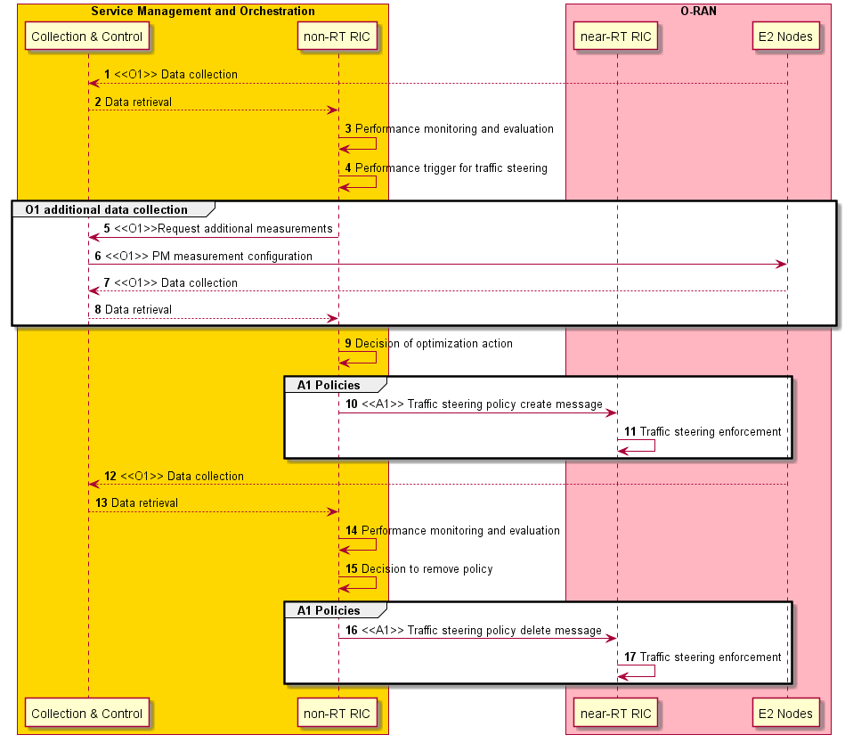
Figure 4.1.3.1-1: Traffic steering use case flow diagram

4.1.3.2 Traffic steering – EI part
The context of traffic steering – EI part is captured in table 4.1.3.2-1.

Table 4.1.3.2-1: Traffic steering - EI part
Use Case Stage | Evolution / Specification | <<Uses>>  Related use
Goal | Assist in traffic optimization in RAN in accordance with produced enrichment information.
Actors and Roles | Non-RT RIC: Enrichment information generation function.  Near-RT RIC: Enrichment information consumption function.  E2 nodes: Control plane and user plane functions.  SMO/Collection & Control: Termination point for O1 interface.
Assumptions | - All relevant functions and components are instantiated.  - A1 and interface connectivity is established with Non-RT RIC.  - O1 interface connectivity is established with SMO/Collection & Control.
Pre-conditions | - Network is operational.  - SMO/Collection & Control has established the data collection and sharing process, and Non-RT RIC has access to this data.  - Non-RT RIC monitors the performance by collecting the relevant performance events and counters from E2 nodes via SMO/Collection & Control.  - Non-RT RIC performs data analytics to generate/update the enrichment information.
Begins when | Operator specified trigger condition or event is detected.
Step 1 (O) | If required, Non-RT RIC can request via SMO additional, more specific, performance measurement data to be collected from E2 nodes to assess the performance.
Step 2 (M) | When receiving EI request/subscription message from Near-RT RIC, Non-RT RIC responds/notifies relevant enrichment information to Near-RT RIC over A1. The example enrichment information can include:  - Radio fingerprint
Step 3 (M) | The Near-RT RIC uses the enrichment information to optimize control function.
Step 4 (M) | In the EI subscription-notification mode, if there is an update on enrichment information. Non-RT RIC notifies the updated enrichment information to Near-RT RIC over A1 for optimizing control function.
Stop When | In the EI subscription-notification mode, EI notification continues until Non-RT RIC receives unsubscription message from Near-RT RIC.
Exceptions | None identified.
Post Conditions | Non-RT RIC monitors the performance by collecting the relevant performance events and counters from E2 nodes via SMO.
Traceability | - REQ-Non-RT-RIC-FUN1, REQ-Non-RT-RIC-FUN2, REQ-Non-RT-RIC-FUN3, REQ-Non-RT-RIC-FUN5, REQ-Non-RT-RIC-FUN7  - REQ-A1-FUN2  - REQ-Non-RT-RIC-NonFUN1, REQ-Non-RT-RIC-NonFUN2

@startuml
skinparam ParticipantPadding 5
skinparam BoxPadding 10
Autonumber

Box “Service Management and Orchestration” #gold
participant “Collection & Control” as smo
participant “non-RT RIC” as non
end box

Box “O-RAN” #lightpink
participant “near-RT RIC” as near
participant “E2 Nodes” as ran
end box

ran -> smo : <<O1>> Data collection
smo -> non : Data retrieval

non -> non : Performance monitoring and evaluation
non -> non : Performance trigger for traffic steering

group O1 Data collection
non -> smo: Request additional measurements
smo -> ran: <<O1>> PM measurement configuration
ran -> smo : <<O1>> Data collection
smo -> non : Data retrieval
end

non -> non : Decision of optimization action

group A1 Policies
non -> near : <<A1>> Traffic steering policy create message
near -> ran : <<E2>> Traffic steering enforcement
end
non -> non : Performance monitoring and evaluation
non -> non : Decision to remove policy
group A1 Policies
non -> near : <<A1>> Traffic steering policy delete message
end

ran -> smo : <<O1>> Data collection
smo -> non : Data retrieval of RAN and non-RAN data

group ALt 1:A1 Enrichment Information
near -> non : <<A1>> Traffic steering enrichment information request message
non -> near: <<A1>> Traffic steering enrichment information response message
near -> ran: <<E2>> Use the enrichment information to optimize control function
end
group Alt 2:A1 Enrichment Information
near -> non : <<A1>> Traffic steering enrichment information subscription message
non -> near: <<A1>> Traffic steering enrichment information notification message
near -> ran: <<E2>> Use the enrichment information to optimize control function
non -> non : Update the enrichment information
non -> near: <<A1>> Traffic steering enrichment information notification message
near -> ran: <<E2>> Use the enrichment information to optimize control function
near -> non: <<A1>> Traffic steering enrichment information unsubscription message
non -> near: <<A1>> Traffic steering enrichment information unsubscription confirmation message
end
@enduml
Traffic steering use case flow diagram (with EI part) is given in figure 4.1.3.2-1.

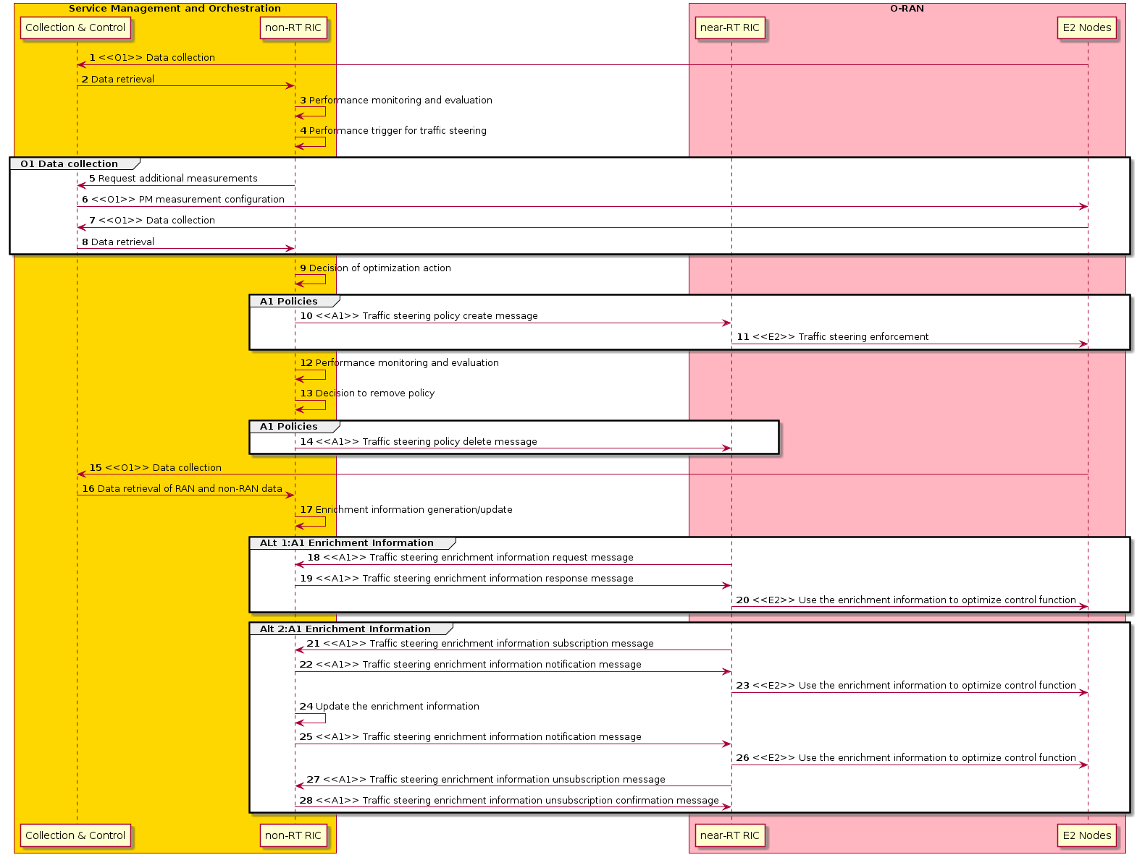
Figure 4.1.3.2-1: Traffic steering use case flow diagram (with EI part)

4.1.4 Required data
The measurement counters and KPIs (as defined by 3GPP and will be extended for O-RAN use cases) should be appropriately aggregated by cell, QoS type, slice, etc.
- Measurement reports with RSRP/RSRQ/CQI information for serving and neighboring cells. In multi-access scenarios this will also include intra-RAT and inter-RAT measurement reports, cell quality thresholds, CGI reports and measurement gaps on per-UE or per-frequency.
- UE connection and mobility/handover statistics with indication of successful and failed handovers, other metrics including threshold of number of UEs to trigger traffic management at O-DU, O-CU-CP, etc.
- Cell load statistics such as information in the form of number of active users or connections, number of scheduled active users per TTI, PRB utilization, and CCE utilization, bearer metrics such as number of bearers to trigger traffic management at O-DU, O-CU-CP, etc.
- Per user performance statistics such as PDCP throughput, RLC or MAC layer latency, DL throughput thresholds to trigger traffic management at O-DU, O-CU-CP, etc.

4.1.5 A1 usage example
An example scenario is here used to describe the use of A1 for traffic management, implying the Non-RT RIC sending policies for allocation of the control plane (RRC) and the user plane for different services, identified by their 5QI.
In the scenario a UE with UEid=1, belonging to a subnet slice identified by S-NSSAI=1, having a voice (5QI=1) and an MBB (5QI=9) connection established, enters an area covered by four frequency bands. The Non-RT RIC understands the requirements and characteristics of the services and decides to let the voice and RRC connection reside on the low band (here covered by a macro cell B becoming the PCell), while the MBB connection should preferably use the higher band (here provided by a smaller cell C and D becoming the SCells) and avoid the low band if possible. Cell A is used for MBB if required for coverage reasons.
Policies are sent to any cell of concern, e.g., where the UE resides and can move.
The desired use of the cells is shown in figure 4.1.5-1.
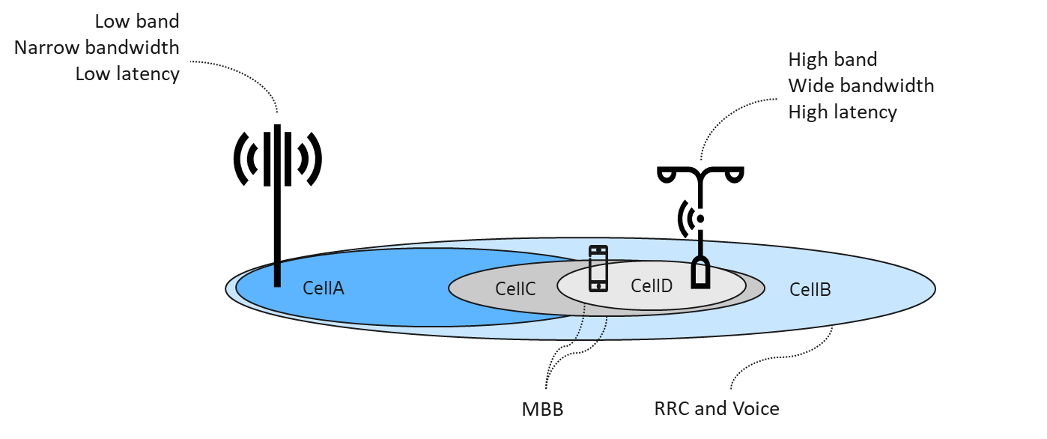
Figure 4.1.5-1: Desired use of the cells
Two policies over A1 are needed to accomplish the desired behavior, described in JSON format below. Note that as part of the scope, the cell_id is optional, and if omitted it is up to the Near-RT RIC to locate the UE and there enforce the policy.
{
"policy_id": "1",
"scope": {
"ue_id": "1",
"slice_id": "1",
"qos_id": "1",
“cell_id”: ”X” // Policy for Cell X, where X is one of A, B, C or D
},
"statement": {
"cell_id_list": "B",
"preference": "Shall",
"primary": true // Control plane and voice on Cell B (becoming PCell)
}
}

{
"policy_id": "2",
"scope": {
"ue_id": "1",
"slice_id": "1",
"qos_id": "9",
“cell_id”: ”X” // Policy for Cell X, where X is one of A, B, C or D
},
"statement": {
"cell_id_list ": {"B", “A”},
"preference": "Avoid",
"primary": false // Avoid MBB on Cell A and Cell B
},
"statement": {
"cell_id_list": {“C”, “D”},
"preference": "Prefer",
"primary": false // Prefer MBB on Cell C and Cell D
}
}

Besides the cell level preference policy, there are also carrier level preference policy for the traffic steering use case. Taking the above scenario as an example, the UE with UEid=1, belonging to a subnet slice identified by S-NSSAI=1, having a voice (5QI=1) and an MBB (5QI=9) connection established, enters the area covered by four cells identified by cell A, cell B, cell C and cell D, respectively.
Assuming that cell A and cell B work on the same frequency carrier which can be identified by Arfcn_1, cell C and cell D work on the same frequency carrier which can be identified by Arfcn_2. Carrier Arfcn_1 is in low frequency and have narrow bandwidth and adapt to voice (5QI=1) connection. Carrier Arfcn_2 is in high frequency and have wide bandwidth and adapt to MBB (5QI=9) connection, meanwhile, avoid connection to the low frequency bands.
The following policies are needed to accomplish this as described in JSON format below.
{
"policy_id": "1",
"scope": {
"ue_id": "1",
"slice_id": "1",
"qos_id": "1",
“cell_id”: ”X” // Policy for Cell X, where X is one of A, B, C or D
},
"statement": {
"carrier_id_list": "Arfcn_1",
"preference": "Prefer",
"primary": true // Control plane on Carrier Arfcn_1 (becoming Primary Component Carrier)
},
}

{
"policy_id": "2",
"scope": {
"ue_id": "1",
"slice_id": "1",
"qos_id": "9",
“cell_id”: ”X” // Policy for Cell X, where X is one of A, B, C or D
},
"statement": {
"carrier_id_list ": "Arfcn_1",
"preference": "Avoid",
"primary": false // Avoid MBB on Carrier Arfcn_1, and no carrier in the carrier_id_list is to be used as secondary component carrier. That is said, Arfcn_1 is not used as secondary component carrier, because it is already used for primary component carrier as the policy 1 stated.
},
"statement": {
"carrier_id_list": “Arfcn_2”,
"preference": "Prefer",
"primary": false // Prefer MBB on Carrier Arfcn_2, and Arfcn_2 is used as secondary component carrier
}
}

4.1.6 Enrichment information example
Radio fingerprint is composed of multiple virtual grids. The virtual grids are constructed based on the historical report of intra-frequency and inter-frequency measurement results of UEs from both the serving cell and the neighbor cell. The serving cell is divided into multiple grids according to the signaling measurement difference. It can be seen as a kind of different space partition method which is different with the traditional space partition method based on geographical location. To construct the radio fingerprint, the grid index and the grid attributes need to be defined. The grid index is to identify a specific virtual grid and this index consists of cell ID and corresponding coverage quality, e.g., RSRP segment ID, of at least three intra-frequency cells. The grid attributes are used to describe the wireless characteristics of the grid, such as coverage of inter-frequency neighbor cells, including RSRP, Reference Signal Receiving Quality (RSRQ), Received Signal Strength Indication (RSSI), Channel Quality Indicator (CQI), Modulation and Coding Scheme (MCS), beam ID, etc., handover performance indicators, and so on. The virtual grids of the radio fingerprint are shown in figure 4.1.6-1.
Figure 4.1.6-1: Illustration of the virtual grid of radio fingerprint

4.1.7 A1 usage example in multi-access environment
The Non-RT RIC can send policies for traffic distribution in a multi-access environment based on UE characteristics and traffic patterns for different services that can be identified by their 5QI. The following example scenario illustrates this, in which there are three UEs with the following characteristics.

UE Identifier | UE Id=1, S-NSSAI =1 | UE Id=2, S-NSSAI =2 | UE Id=3, S-NSSAI =3
User Traffic | 5QI=1: Voice  5QI=8: FTP, Email | 5QI=1: Voice  5QI=8: Email  5QI=83: Advanced driving | 5QI=1: Voice  5QI=8: Progressive video  5QI=8: File sharing
Mobility Pattern | Stationary | High mobility | Low mobility

The UEs are in an area covered by three frequency bands identified by cell A, cell B and cell C respectively. Cell A is the macro licensed cell with the best coverage. Cell B is the unlicensed cell with limited coverage and cell C is a licensed cell with narrow bandwidth but provides greater coverage area than cell B.
The cell layout for multi-access use case is shown in figure 4.1.7-1.
Figure 4.1.7-1: Cell layout for multi-access use case

From a traffic distribution perspective, since UE with UE Id=1 is a stationary UE the FTP and email traffic with (5QI=8) should preferably be routed over secondary unlicensed cell B and should avoid licensed cells, cell A and cell C. The voice traffic should be routed over cell A.
For UE with UE Id=2, since it is a highly mobile UE, all the traffic should be routed over licensed cells, preferably cell A to avoid disruption in connections. However, if there is a shortage of bandwidth in cell A, the email traffic (5QI=8) can be routed over unlicensed band (cell B). Given that this is a high mobility UE, there can be a policy that a minimum of 50% and maximum of 70% of all traffic from this UE should be routed over cell A which should be the primary cell and remaining can be routed over secondary cell.
For UE with UE Id=3, since it is a low mobility UE both the progressive video (5QI=8) and file sharing (5QI=8) should be routed over unlicensed band (cell B). The voice traffic should be routed over cell A.
The following policies are needed to accomplish this as described in JSON format below.
- Policy Id 1: For group of UEs with UE Id, 1, 2 and 3. It sets the preference for voice traffic (5QI=1) on cell A for all the UEs. Further, dual connectivity should be enabled for all these UEs whenever possible.
- Policy Id 2: For group of UEs with UE Id, 1 and 3. It sets the preference for all traffic with (5QI=8) on cell B for both the UEs and also avoids cell A and cell C for routing this traffic.
- Policy Id 3: For UE with UE Id=2. It sets the preference for advanced driving traffic with (5QI=83) on cell A and C and also avoids cell B for routing this traffic.
- Policy Id 4: For UE with UE Id=2. It sets the preference for email traffic with (5QI=8) on cell A and C for the high mobility UE. However, it does not avoid use of cell B for routing this traffic in case of bandwidth limitation.
- Policy Id 5: For UE with UE Id=2. It sets the preference that minimum of 50% and a maximum of 70% of all traffic from this UE should be routed through cell A for this UE.
{
"group_id": "1",
"ue_id_list": {"1","2","3"} // Define group_1 list of UEs, 1, 2 and 3

"policy_id": "1",
"scope": {
"group_id": "1",
"qos_id": "1",
"cell_id": ”X” // Policy for Cell X, where X is one of A, B, or C for this group of UEs
},
"statement": {
"cell_id_list": "A",
"preference": "Prefer",
"dual connectivity": true, // dual connectivity is preferred for UEs in group 1
"primary": true // Cell A is preferred primary cell for 5QI=1 (Voice), for UEs in group 1
}
}

{
"group_id": "2",
"ue_id_list": {"1","3"} // Define group_1 list of UEs, 1 and 3

"policy_id": "2",
"scope": {
"group_id": "2",
"qos_id": "8",
"cell_id": ”X” // Policy for Cell X, where X is one of A, B, or C
},
"statement": {
"cell_id_list": {"A", "C"},
"preference": "Avoid",
"primary": false // Avoid 5QI=8 traffic on Cell A and C
},
"statement": {
"cell_id_list": {"B"},
"preference": "Prefer",
"primary": false // Prefer 5QI=8 traffic on Cell B for stationary and low mobility UEs
}
}

{
"policy_id": "3",
"scope": {
"ue_id": "2",
"slice_id": "2",
"qos_id": "83",
"cell_id": ”X” // Policy for Cell X, where X is one of A, B, or C
},
"statement": {
"cell_id_list ": {"B"},
"preference": "Avoid",
"primary": false // Avoid 5QI=83 traffic on Cell B
},
"statement": {
"cell_id_list": {"A", "C"},
"preference": "Prefer",
"primary": true // Prefer 5QI=83 traffic on Cell A or C for high mobility UE
}
}

{
"policy_id": "4",
"scope": {
"ue_id": "2",
"slice_id": "2",
"qos_id": "8",
"cell_id": ”X” // Policy for Cell X, where X is one of A, B, or C
},
"statement": {
"cell_id_list": {"A", "C"},
"preference": "Prefer",
"primary": true // Prefer 5QI=8 traffic on Cell A or C and don’t avoid cell B
}
}

{
"policy_id": "5",
"scope": {
"ue_id": "2",
"slice_id": "2",
"traffic distribution": "X" // Policy for traffic distribution
},
"statement": {
"cell_id_list": {"A"},
"preference": "Prefer",
"minimum": "50%",
"maximum": "70%", // Prefer 50-70% of traffic distribution on cell A for this UE
}
}

4.2 QoE optimization
This use case provides the background and motivation for the O-RAN architecture to support real-time QoE optimization. Moreover, some high-level description and requirements over Non-RT RIC, A1 and E2 interfaces are introduced.

4.2.1 Background and goal of the use case
The highly demanding 5G native applications such as cloud VR are both bandwidth consuming and latency sensitive. However, for such traffic-intensive and highly interactive applications, current semi-static QoS framework cannot efficiently satisfy diversified QoE requirements especially taking into account potentially significant fluctuation of radio transmission capability. It is expected that QoE estimation/prediction from application level can help deal with such uncertainty and improve the efficiency of radio resources, and eventually improve user experience.
The main objective is to ensure QoE optimization be supported within the O-RAN architecture and its open interfaces. Multi-dimensional data, e.g., user traffic data, QoE measurements, network measurement report, can be acquired and processed via ML algorithms to support traffic recognition, QoE prediction, and QoS enforcement decisions. ML models can be trained offline and model inference will be executed in a real-time manner. Focus should be on a general solution that would support any specific QoE use case (e.g., cloud VR, video, etc.).

4.2.2 Entities/resources involved in the use case
- Non-RT RIC:
  - Retrieve necessary QoE related measurement metrics from network level measurement report and SMO (can acquire data from application) for constructing/training relevant AI/ML model that will be deployed in Near-RT RIC to assist in the QoE optimization function. For example, this could be application classification, QoE prediction, and available bandwidth prediction.
  - Training of potential ML models for predictive QoE optimization, which can respectively autonomously recognize traffic types, predict quality of experience, or predict available radio bandwidth.
  - Send policies/intents to Near-RT RIC to drive the QoE optimization at RAN level in terms of expected behavior.
- Near-RT RIC:
  - Support update of AI/ML models from Non-RT RIC.
  - Support execution of the AI/ML models from Non-RT RIC, e.g., application classification, QoE prediction, and available bandwidth prediction.
  - Support interpretation and execution of intents and policies from Non-RT RIC to derive the QoE optimization at RAN level in terms of expected behavior.
  - Sending QoE performance report to Non-RT RIC for evaluation and optimization.
- E2 nodes:
  - Support network state and UE performance report with required granularity to SMO over O1 interface.
  - Support QoS enforcement based on messages from A1/E2, which are expected to influence RRM behavior.

4.2.3 Solutions

4.2.3.1 Model training and distribution
The context of model training and distribution is captured in table 4.2.3.1-1.

Table 4.2.3.1-1: Model training and distribution
Use Case Stage | Evolution / Specification | <<Uses>>  Related use
Goal | Model training and distribution.
Actors and Roles | Non-RT RIC, Near-RT RIC, SMO, application server
Assumptions | - All relevant functions and components are instantiated.  - A1/O1 interface connectivity is established with Non-RT RIC.
Pre-conditions | Near-RT RIC and Non-RT RIC are instantiated with A1 interface connectivity being established between them.
Begins when | Operator specified trigger condition or event is detected.
Step 1 (M) | QoE related measurement metrics from SMO (can acquire data from application) and network level measurement report either for instantiating training of a new ML model or modifying existing ML model.
Step 2 (M) | Non-RT RIC does the model training, obtains QoE related models, and can deploy QoE policy model internally. An example of QoE-related models that can be used at the Near-RT RIC is provided as follows:  - Application classification model (optional and can refer to 3rd party’s existing functionality)  - QoE prediction model  - QoE policy model  - Available BW prediction model
Step 3 (M) | Non-RT RIC deploys/updates the AI/ML model in the Near-RT RIC via O1.
Step 4 (M) | Near-RT RIC stores the received QoE related ML models in the ML model inference platform and based on requirements of ML models.
Step 5(O) | If required, Non-RT RIC can configure specific performance measurement data to be collected from RAN to assess the performance of AI/ML models and update the AI/ML model in Near-RT RIC based on the performance evaluation and model retraining.
Ends when | Operator specified trigger condition or event is satisfied.
Exceptions | None.
Post Conditions | Near-RT RIC stores the received QoE related ML models in the ML Model inference platform and execute the model for QoE optimization function in Near-RT RIC.
Traceability | - REQ-Non-RT-RIC-FUN1, REQ-Non-RT-RIC-FUN3, REQ-Non-RT-RIC-FUN4, REQ-Non-RT-RIC-FUN5  - REQ-A1-FUN1, REQ-A1-FUN2, REQ-A1-FUN4

@startuml
skinparam ParticipantPadding 5
skinparam BoxPadding 10
skinparam defaultFontSize 12

Box “Service Management and Orchestration” #gold
Participant “Collection & Control” as smo
Participant “non-RT RIC” as non
End box

Box “O-RAN” #lightpink
Participant near as “near-RT RIC”
Participant ran as “E2 Nodes”
End box

ran --> smo : <<O1>> Data collection
app --> smo: Data retrieval of application data
smo --> non : Data retrieval

group ML workflow
non -> non : Training of ML models
non -> non : Deploy internal ML models
non -> near : <<O1>> Deploy AI/ML models
end

group Performance evaluation and optimization
smo -> non : Data retrieval of RAN and application
non -> non : Performance monitoring & evaluation
non -> non : Model re-training/update
non -> near: <<O1>> Update AI/ML models
end
@enduml
The QoE use case flow diagram – model training and distribution/update is given in figure 4.2.3.1-1.

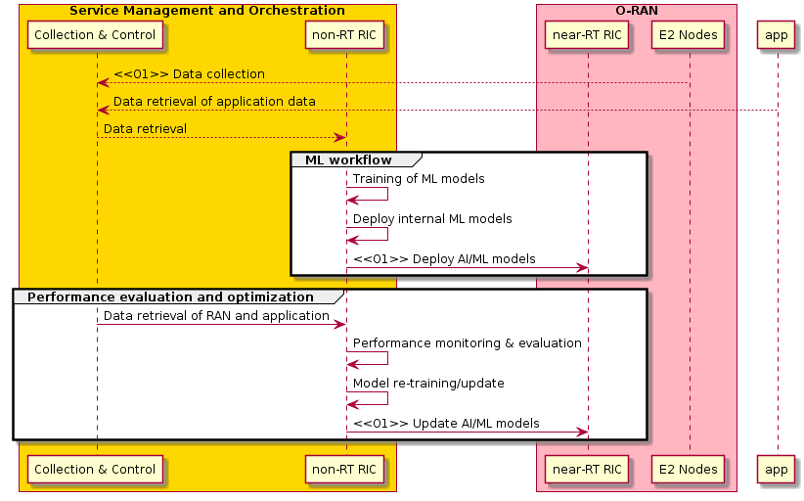
Figure 4.2.3.1-1: QoE use case flow diagram - model training and distribution/update

4.2.3.2 Policy generation and performance evaluation
The context of policy generation and performance evaluation is captured in table 4.2.3.2-1.
Table 4.2.3.2-1: Policy generation and performance evaluation
Use Case Stage | Evolution / Specification | <<Uses>>  Related use
Goal | Policy generation and performance evaluation.
Actors and Roles | Non-RT RIC, Near-RT RIC, SMO
Assumptions | - All relevant functions and components are instantiated.  - A1/O1 interface connectivity is established with Non-RT RIC.
Pre-conditions | QoE related models have been deployed in Non-RT RIC and Near-RT RIC respectively.
Begins when | The network operator/manager want to generate QoE policy or optimize QoE related AI/ML models.
Step 1 (M) | Non-RT RIC evaluates the collected data and generates the appropriate QoE optimization policy.
Step 2 (M) | Non-RT RIC sends the QoE optimization policy to Near-RT RIC via A1 interface.
Step 3 (M) | Near-RT RIC receives the policy from the Non-RT RIC over the A1 interface. And the Near-RT RIC inferences the QoE related AI/ML models and converts policy to specific E2 control or policy commands.
Step 4 (M) | Near-RT RIC sends the E2 control or policy commands towards RAN for QoE optimization.
Step 5 (M) | RAN enforces the received control or policy from the Near-RT RIC over the E2 interface.
Step 6 (O) | If required, Non-RT RIC can receive policy feedback from Near-RT RIC and performance measurement data collected from SMO to assess the performance of the QoE optimization function in Near-RT RIC, or to assess the outcome of the applied A1 policies. And then update A1 policy and E2 control or policy.
Ends when | Operator specified trigger condition or event is satisfied.
Exceptions | None.
Post Conditions | Non-RT RIC monitors the performance of the QoE optimization related function in Near-RT RIC by collecting and monitoring the relevant performance KPIs and counters from RAN.
Traceability | - REQ-Non-RT-RIC-FUN1, REQ-Non-RT-RIC-FUN3, REQ-Non-RT-RIC-FUN4, REQ-Non-RT-RIC-FUN5  - REQ-A1-FUN1, REQ-A1-FUN2, REQ-A1-FUN4

@startuml
skinparam ParticipantPadding 5
skinparam BoxPadding 10
skinparam defaultFontSize 12

Box “Service Management and Orchestration” #gold
Participant “Collection & Control” as smo
Participant “non-RT RIC” as non
End box

Box “O-RAN” #lightpink
Participant ran as “E2 Nodes”
Participant near as “near-RT RIC”
End box

ran --> smo : <<O1>> Data collection
smo --> non : Data retrieval

group A1 policies
non -> non : performance monitoring
non -> non : QoE optimization policy generation
non -> near : <<A1>> QoE optimization policy create message
end

group E2 control & Policy
ran -> near: <<E2>> Data collection
near -> near : ML model inference
near -> near : E2 control or policy generation
near -> ran: <<E2>> QoE optimization enforcement message
end

group Performance evaluation and optimization
near ->non: <<A1>> QoE optimization policy feedback message
smo -> non: Data retrieval
non -> non: performance monitoring
non -> non: update A1 policy
non -> near : <<A1>> QoE optimization policy update message
near -> near: Update E2 control or policy
ran -> near : <<E2>> Data collection
near -> ran: <<E2>> QoE optimization enforcement message
end
@enduml
The QoE use case flow diagram – policy generation and performance evaluation is given in figure 4.2.3.2-1.

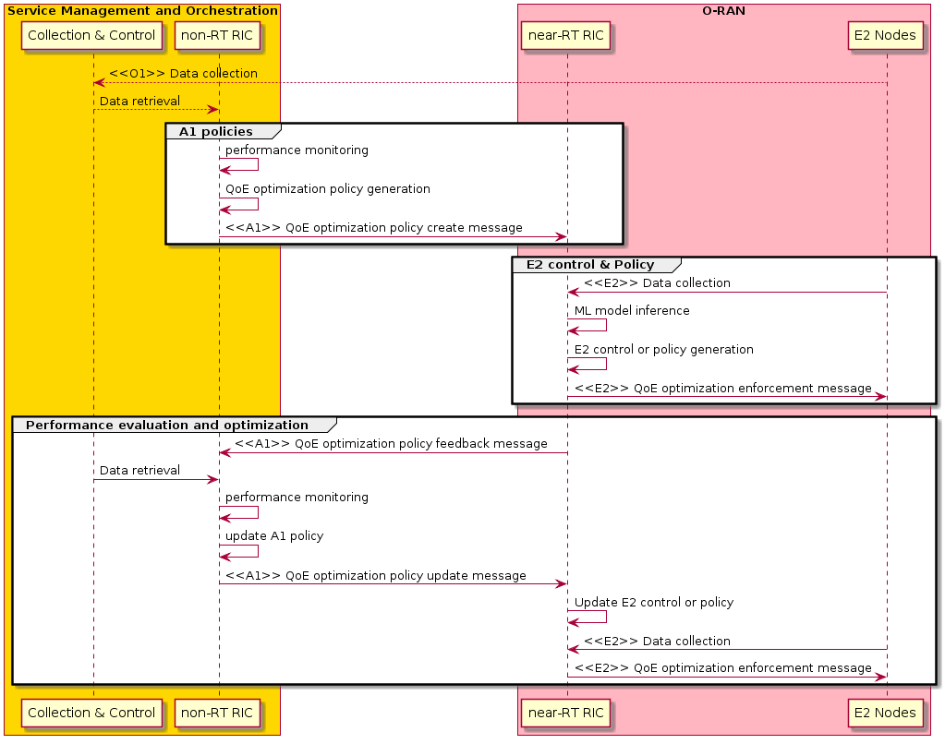
Figure 4.2.3.2-1: QoE use case flow diagram - policy generation and performance evaluation

4.2.4 Required data
Multi-dimensional data are expected to be retrieved by Non-RT RIC for AI/ML model training and policies/intents generation.
- Network level measurement report, including:
  - UE level radio channel information, mobility related metrics
  - L2 measurement report related to traffic pattern, e.g., throughput, latency, packets per-second, inter frame arrival time
  - RAN protocol stack status: e.g., PDCP buffer status
  - Cell level information: e.g., DL/UL PRB occupation rate
- QoE related measurement metrics collected from SMO (can acquire data from application or network).
- User traffic data, which can be obtained via a proprietary interface from existing data collection equipment and is currently out of the scope of A1 or E2.

4.2.5 A1 usage example
There are 3 examples to explain how A1 policy woks for QoE optimization.
One is for ue_id (100), slice_id (1) and qos_id (5QI =50), the target QoE score (for example video MOS 80) should be satisfied.

{
"policy_id": "1",
"scope": {
"ue_id": "100",
"slice_id": "1",
"qos_id": "50"
},
"statement": {
"qoe_score": "80"
}
}

The second example is to regulate specific QoE targets, for example, initial buffering time for video streaming is required within 2 seconds, rebuffering frequency is 2 times and stalling ratio is 5% for a customized time window (e.g., 30 seconds).
{
"policy_id": "2",
"scope": {
"ue_id": "101",
"slice_id": "1",
"qos_id ": "51"
},
"statement": {
"initial_buffering": “2”,
"reBuffFreq":“2”,
"stallRatio": “5”
}
}

The specific user id need not be required, and only slice_id and flow_id are required for specific QoE targets.
{
"policy_id": "3",
"scope": {
"slice_id": "1",
"flow_id": "51"
},
"statement": {
"initial_buffering":”2”,
"reBuffFreq":“2”,
"stallRatio": “5”
}
}

4.3 QoS based resource optimization
This use case provides the background and motivation for the O-RAN architecture to support RAN QoS based resource optimization. Moreover, some high-level description and requirements over Non-RT RIC and A1 interfaces are introduced.

4.3.1 Background and goal of the use case
QoS based resource optimization can be used when the network has been configured to provide some kind of preferential QoS for certain users. One such scenario can be related to when the network has been configured to support e2e slices. In this case, the network has functionality that ensures resource isolation between slices as well as functionality to monitor that slice Service Level Specifications (SLS) are fulfilled.
In RAN, it is the scheduler that ensures that Physical Resource Block (PRB) resources are isolated between slices in the best possible way and also that the PRB resources are used in an optimal way to best fulfill the SLS for different slices. The desired default RAN behavior for slices is configured over O1. For example, the ratio of physical resources (PRBs) reserved for a slice is configured at slice creation (instantiation) over O1. Also, QoS can be configured to guide the RAN scheduler how to (in real-time) allocate PRB resources to different users to best fulfill the SLS of a specific slice. In the NR NRM this is described by the resource partition attribute.
Instantiation of a RAN sub-slice will be prepared by rigorous planning to understand to what extent deployed RAN resources will be able to support RAN sub-slice SLS. Part of this procedure is to configure RAN functionality according to above. With this, a default behavior of RAN is obtained that will be able to fulfill slice SLSs for most situations. However, even through rigorous planning, there will be times and places where the RAN resources are not enough to fulfill SLS given the default configuration. To understand how often (and where) this happens, the performance of a RAN slice will continuously be monitored by SMO. When SMO detects a situation when RAN SLS cannot be fulfilled, Non-RT RIC can use A1 policies to improve the situation. To understand how to utilize A1 policies and how to resolve the situation, the Non RT-RIC will use additional information available in SMO.
Take an emergency service as an example of a slice tenant. For this example, it is understood (at slice instantiation) that 50% of the PRBs in an area can be enough to support the emergency traffic under normal circumstances. Therefore, the ratio of PRBs for the emergency users is configured to 50% as default behavior for the pre-defined group of users belonging to the emergency slice. Also, QoS is also configured in core network and RAN so that video cameras of emergency users get a minimum bitrate of 500 kbps.
Now, suppose a large fire is ongoing and emergency users are on duty. Some of the personnel capture the fire on video on site. The video streams are available to the emergency control command. Because of the high traffic demand in the area from several emergency users (belonging to the same slice), the resources available for the emergency slice is not enough to support all the traffic. In this situation, the operator has several possibilities to mitigate the situation. Depending on SLAs towards the emergency slice compared to SLAs for other slices, the operator could reconfigure the amount of PRB reserved to emergency slice at the expense of other slices. However, there is always a risk that emergency video quality is not good enough irrespective if all resources are used for emergency users. It might be that no video shows sufficient resolution due to resource limitations around the emergency site.
In this situation, the emergency control command decides, based on the video content, to focus on a selected video stream to improve the resolution. The emergency control system gives the information about which users to up- and down-prioritize to the E2E slice assurance function (through e.g., an edge API) of the mobile network to increase bandwidth for selected video stream(s). Given this additional information, the Non-RT RIC can influence how RAN resources are allocated to different users through a QoS target statement in an A1 policy. By good usage of the A1 policy, the emergency control command can ensure that dynamically defined group of UEs provides the video resolution that is needed.
The use case can be summarized as per below:
- A fire draws a lot of emergency personnel to an area.
- Because of this, RAN resources becomes congested which affects the video quality for all video feeds in the area.
- The emergency control command have 5 active video feeds and selects one video feed which is of specific interest.
- The emergency control command requests higher resolution of a selected feed, while demoting the other.
- With this information, the Non-RT RIC will evaluate how to ensure higher bandwidth for the feed selected by emergency control command (and lower for other feeds).
- The Non-RT RIC updates the policy for the associated UEs in the associated Near-RT RIC over the A1 interface.
- Near-RT RIC enforce the modified QoS target for the associated UEs over the E2 interface to fulfil the request.
- The emergency control command experiences a higher resolution of the selected video feed.

4.3.2 Entities/resources involved in the use case
- Non-RT RIC:
  - Monitor necessary QoS related metrics from network function and other SMO functions.
  - Send policies to Near-RT RIC to drive QoS based resource optimization at RAN level in terms of expected behavior.
- Near-RT RIC:
  - Support interpretation and execution of A1 policies for QoS based resource optimization.
- E2 nodes:
  - Support network state and UE performance report with required granularity to SMO over O1 interface.
  - Support QoS enforcement based on messages from E2, which are expected to influence RRM behavior.

4.3.3 Solutions

4.3.3.1 QoS based resource optimization
The context of QoS based resource optimization is captured in table 4.3.3.1-1.

Table 4.3.3.1-1: QoS based resource optimization
Use Case Stage | Evolution / Specification | <<Uses>>  Related use
Goal | Drive QoS based resource optimization in RAN in accordance with defined policies and configuration.
Actors and Roles | Non-RT RIC: Creates A1 policies.  Near-RT RIC: Enforces A1 policies.  RAN: Policy enforcement.  SMO: Termination point for O1 interface.
Assumptions | All relevant functions and components are instantiated and configured according wanted default behavior.  A1 interface connectivity is established with Non-RT RIC.  O1 interface connectivity is established with SMO.  The default configuration will handle most situations.
Pre-conditions | Network is operational with default configuration.  SMO has established the data collection and sharing process, and Non-RT RIC has access to this data.  Non-RT RIC analyzes the data from RAN to understand the current resource consumption.
Begins when | Non-RT RIC observes that resources are close to congestion in a certain area.
Step 1 (O) | If needed, Non-RT RIC orders additional RAN observability, SMO configures additional observability over O1.
Step 2 | Non-RT RIC evaluates RAN resource utilization for all users in a slice in specific area.
Step 3 | Non-RT RIC asks for additional information from additional SMO functionality, e.g., E2E slice assurance function.
Step 4 | Non-RT RIC determines dynamic group of users for which QoS target shall be changed.
Step 5 | Non-RT issues A1 policy/policies with QoS target based on information from other SMO functionality.
Ends when | Non-RT RIC (through O1 observability) understands that situation of resource constraints within the slice is resolved, and the deployed policies are deleted over A1.
Exceptions | None identified.
Post Conditions | Non-RT RIC monitors the performance by collecting the relevant performance events and counters from E2 nodes via SMO.
Traceability | - REQ-Non-RT-RIC-FUN1, REQ-Non-RT-RIC-FUN2, REQ-Non-RT-RIC-FUN3, REQ-Non-RT-RIC-FUN4, REQ-Non-RT-RIC-FUN5  - REQ-A1-FUN1

@startuml
skinparam ParticipantPadding 5
skinparam BoxPadding 10
Autonumber

Box “External enrichment server” #lightblue
Entity sliceuserdata as “Slice user data”
End box

Box “Service Management and Orchestration” #gold
participant “Collection & Control” as smo
participant “non-RT RIC” as non

end box

Box “O-RAN” #lightpink
participant “near-RT RIC” as near
participant “E2 Nodes” as ran
end box

ran -> smo : <<O1>> Data collection
non-> non: Evaluation of resource consumption
non-> non: Indication of approaching congestion in certain area
group O1 configuration
non -> smo: Request additional measurements
smo -> ran: <<O1>> PM measurement configuration
ran -> smo : <<O1>> Data collection
smo -> non : Additional data retrieval
end

non -> non: Detailed evaluation of situation
non -> smo: Request additional info on priorities
smo -> sliceuserdata: Request Non-RAN info on priorities
sliceuserdata –> smo: Non-RAN information on priorities
smo–> non: Additional information on priorities

group A1 Policies
non -> near : <<A1>> QoS based resource optimization policy create message
near -> ran : <<E2>> QoS based resource optimization enforcement
end

ran -> smo: <<O1>> Data collection (incl specific data)
smo -> non: Data retrieval of RAN and non-RAN data
non -> non: Detailed evaluation of congestion situation to understand the effect of policy
non -> non: Evaulation of congestion situation to understandwhen gone
group A1 policies
non -> near: <<A1>> QoS target policy delete message
end
@enduml
The flow diagram of the QoS based resource optimization use case is given in figure 4.3.3.1-1.

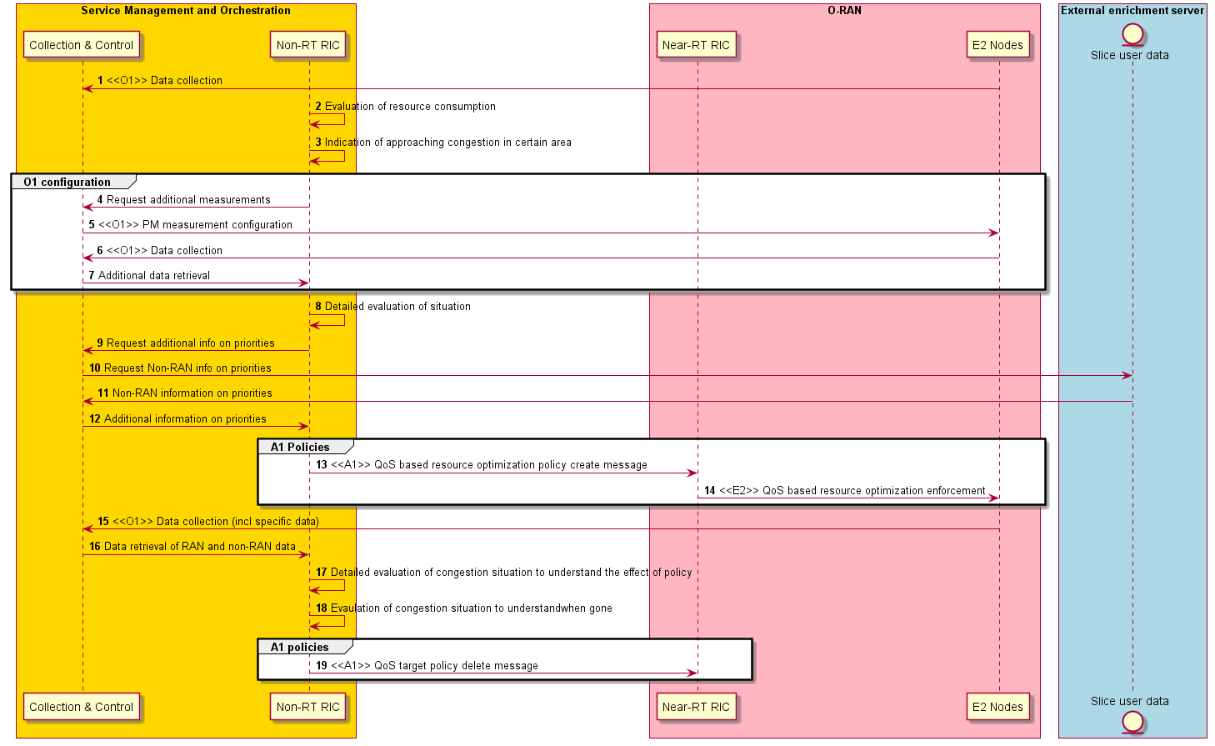
Figure 4.3.3.1-1: Flow diagram of QoS based resource optimization use case

4.3.4 Required data
For this use case, different kind of observability need to be reported to Non-RT RIC. First Non-RT RIC shall monitor resource consumption in the area. As long as resource consumption is low, the RAN scheduler will be able to give all users in an area the needed resources. When resource consumption in an area increases above a threshold, there is risk of that the default configuration of RAN will not be enough to fulfil the requirements. At this point, the Non-RT RIC need to be able to configure more detailed reporting for individual UEs that the Non-RT RIC is interested in. This detailed observability should provide the Non RT RIC better insight in performance for specific users and therefore includes observability of e.g., user throughput and delay. With this more detailed observability, the Non-RT RIC can understand when pre-configured priorities are not enough for the scheduler to solve the problem and when additional (non-RAN) information to solve the prioritization is needed.

4.3.5 A1 usage example
Example scenario
- One emergency RAN sub-slice defined (S-NSSAI=1) with a ratio of 50% configured. 5QI=74 configured for a minimum bitrate of 500 kbps.
- 4 UEs (UeId=10, 11, 12, 13) in the area which belongs to S-NSSAI = 1 and with active flows of 5QI = 74.
- Resource shortage means that minimum bitrate 500 kbps cannot be fulfilled for all users.
- E2E Slice assurance function indicates to Non-RT RIC that UeId=10 and 12 needs to be prioritized.
- Because of resource shortage, increasing minimum bitrate for UeId=10 and 12 will not improve, instead minimum bitrate for other users in slice needs to be lowered.

{
{
"policy_id": "1",
"scope": {
"ue_id": "11",
"slice_id": "1",
"flow_id": "74"
},
"statement": {
"gfbr": "0"
}
}
{
"policy_id": "2",
"scope": {
"ue_id": "13",
"slice_id": "1",
"flow_id": "74"
},
"statement": {
"gfbr": "0"
}
}

- An alternative way to temporarily change RAN behavior for S-NSSAI=1 users is to change the relative priority in the scheduler. This would change the relative resource assignment to different users with different priority.

- {
- {
- "policy_id": "1",
- "scope": {
- "ue_id": "10",
- "slice_id": "1",
- "flow_id": "74"
- },
- "statement": {
- "priority_level": "10"
- }
- }

- {
- "policy_id": "2",
- "scope": {
- "ue_id": "12",
- "slice_id": "1",
- "flow_id": "74"
- },
- "statement": {
- "priority_level": "10"
- }
- }

- {
- "policy_id": "3",
- "scope": {
- "ue_id": "11",
- "slice_id": "1",
- "flow_id": "74"
- },
- "statement": {
- "priority_level": "1"
- }
- }

- {
- "policy_id": "4",
- "scope": {
- "ue_id": "13",
- "slice_id": "1",
- "flow_id": "74"
- },
- "statement": {
- "priority_level": "1"
- }
- }

4.4 Context-based dynamic HO management for V2X
This use case provides the background, motivation, and requirements for the context-based dynamic HO management for V2X use case, allowing operators to adjust radio resource allocation policies through the O-RAN architecture, reducing latency and improving radio resource utilization.

4.4.1 Background and goal of the use case
V2X communication allows for numerous potential benefits such as increasing the overall road safety, reducing emissions, and saving time. Part of the V2X architecture is the V2X UE (SIM + device attached to vehicle) which communicates with the V2X Application Server (V2X AS). The exchanged information comprises Cooperative Awareness Messages (CAMs) (from UE to V2X AS) [i.2], radio cell IDs, connection IDs, and basic radio measurements (RSRP, RSPQ, etc.)
As vehicles traverse along a highway, due to their high speed and the heterogeneous natural environment V2X UEs are handed over frequently, at times in a suboptimal way, which can cause handover (HO) anomalies: e.g., short stay, ping-pong, and remote cell. Such suboptimal HO sequences substantially impair the functionality of V2X applications. Since HO sequences are mainly determined by the Neighbor Relation Tables (NRTs), maintained by the xNBs, there is hardly room for UE-level customization.
This UC aims to present a method to avoid and/or resolve problematic HO scenarios by using past navigation and radio statistics in order to customize HO sequences on a UE level. To this end, the AI/ML functionality that is enabled by the Near-RT RIC is employed.

4.4.2 Entities/resources involved in the use case
- Non-RT RIC:
  - Retrieve necessary performance, configuration, and other data for constructing/training relevant AI/ML models that will be deployed in Near-RT RIC to assist in the V2X HO management function. For example, this could be a clustering algorithm that classifies traffic situations and radio conditions that (probably) do or do not lead to HO anomalies.
  - Support deployment and update of AI/ML models into Near-RT RIC xApp.
  - Support communication of intents and policies (system-level and UE-level) from Non-RT RIC to Near-RT RIC.
  - Support communication of non-RAN data to enrich control functions in Near-RT RIC (enrichment data).
- Near-RT RIC:
  - Support update of AI/ML models retrieved from Non-RT RIC.
  - Support interpretation and execution of intents and policies from Non-RT RIC.
  - Support necessary performance, configuration, and other data for defining and updating intents and policies for tuning relevant AI/ML models.
  - Support communication of configuration parameters to RAN.
- E2 nodes:
  - Support data collection with required granularity to SMO over O1 interface.
  - Support near-real-time configuration-based optimization of HO parameters over E2 interface.
  - Report necessary performance, configuration, and other data for performing real-time V2X HO optimization in the Near-RT RIC over E2 interface.
- V2X application server:
  - Support data collection with required granularity from V2X UE over V1 interface.
  - Support communication of real-time traffic related data about V2X UE to Non-RT RIC as enrichment data.

4.4.3 Solutions

4.4.3.1 Context-based dynamic handover management for V2X
The context of the context-based dynamic handover management for V2X is captured in table 4.4.3.1-1.

Table 4.4.3.1-1: Context-based dynamic handover management for V2X
Use Case Stage | Evolution / Specification | <<Uses>>  Related use
Goal | Drive V2X UE HOs in RAN according to defined intents, policies, and configuration while enabling AI/ML-based solutions.
Actors and Roles | Non-RT RIC: RAN policy control function.  Near-RT RIC: RAN policy enforcement function.  RAN: Policy enforcement for configuration updates.  SMO: Termination point for O1 interface.  V2X AS: Termination point for V1 interface and enrichment data provider.
Assumptions | All relevant functions and components are instantiated.  A1, O1, E2 interface connectivity is established.
Pre-conditions | Network is operational.  SMO has established the data collection and sharing process, and Non-RT RIC has access to this data.  Non-RT RIC analyzes the historical data from RAN and V2X AS for training the relevant AI/ML models to be deployed or updated in the Near-RT RIC, as well as AI/ML models required for real-time optimization of configuration and policies.
Begins when | Operator specified trigger condition or event is detected.
Step 1 (M) | Non-RT RIC deploys/updates the AI/ML model in the Near-RT RIC via O1 or Non-RT RIC assigns/update the AI/ML model for the Near-RT RIC xApp via A1.
Step 2 (M) | Non-RT RIC communicates relevant policies/intents and enrichment data to the Near-RT RIC over the A1 interface. The enrichment data from the non-RAN data can include V2X UE location, trajectory, navigation information, GPS data, CAMs.
Step 3 (M) | The Near-RT RIC receives the relevant info from the Non-RT RIC over the A1 interface and from the RAN over the E2 interface, interprets the policies and updates the AI/ML models.
Step 4 (M) | The Near-RT RIC infers optimal RAN configuration (UE-specific NRTs) according to the trained AI/ML models and communicates the result to the RAN over E2 interface.
Step 5 (M) | RAN deploys the configuration received from the Near-RT RIC over the E2 interface.
Step 6 | If required, Non-RT RIC can configure specific performance measurement data to be collected from RAN to assess the performance of the V2X HO management function in Near-RT RIC, or to assess the outcome of the applied policies and configuration.
Ends when | Operator specified trigger condition or event is satisfied.
Exceptions | None identified.
Post Conditions | Non-RT RIC monitors the performance of the V2X HO related function in Near-RT RIC by collecting and monitoring the relevant performance KPIs and counters from the RAN and the V2X AS.
Traceability | - REQ-Non-RT-RIC-FUN1, REQ-Non-RT-RIC-FUN2, REQ-Non-RT-RIC-FUN3, REQ-Non-RT-RIC-FUN4, REQ-Non-RT-RIC-FUN7  - REQ-A1-FUN1, REQ-A1-FUN2, REQ-A1-FUN3, REQ-A1-FUN5

@startuml
skinparam ParticipantPadding 5
skinparam BoxPadding 10
skinparam defaultFontSize 12
Autonumber

Box “Service Management and Orchestration” #gold
Participant SMO as “Orchestration”
Boundary Collector
Control CTRL as “Resource Controller”
Database DL as “Data Lake”
Participant NON as “non-RT RIC”
Collections MLTH as “ML Training Host(s)”
end box

Box “O-RAN” #lightpink
Participant RIC as “near-RT RIC + E2 Node”
End box

Box “External” #lightcyan
Participant V2X as “V2X Application Server”
End box

RIC -> Collector : <<O1 Perf./trace management >> SMO data collection

Hnote over NON
Assume trained models are available in SMO
Endhnote

SMO -> NON : <<SMO internal>> Deploy NonRT_Model1
NON -> NON : Execute NonRT_Model1
NON -> RIC : <<A1>> Traffic Steering Policy (create/update/delete)

SMO -> RIC : <<O1 Software management>> Deploy NearRT_Model1
SMO -> RIC : <<O1 Software management>> Deploy NearRT_Model2

group "Data Collection Subscribtion, for Inference"
RIC -> RIC : <<E2>> Subscription request: UE E2 data collection
RIC -> NON : <<A1-EI>> Subscription request: UE EI data collection
NON -> V2X : <<SMO-EXT>> Subscription request: UE EI data collection
V2X -> NON : <<SMO-EXT>> Subscription Ack: UE EI data collection
NON -> RIC : <<A1-EI>> Subscription Ack: UE EI data collection
end

group "Measurement Data Collection for Inference"
RIC -> RIC : <<E2>> Subscription Request:{UE E2 measurement report}
RIC -> NON : <<A1-EI>> Subscription Request:{UE EI measurement report}
NON -> V2X : <<SMO-EXT>> Subscription Request:{UE EI measurement report}
V2X -> NON : <<SMO-EXT>> Report:{UE EI measurement report}
NON -> RIC : <<A1-EI>> Report:{UE EI measurement report}
end
RIC -> RIC : V2X HO Optimization

RIC -> Collector : <<O1 Perf./trace management >> SMO data collection

SMO -> SMO: Update NearRT_model2
SMO -> RIC : <<O1 Software management>> Deploy NearRT_Model2
@enduml
@enduml
The flow diagram of the V2X HO management use case is given in figure 4.4.3.1-1.

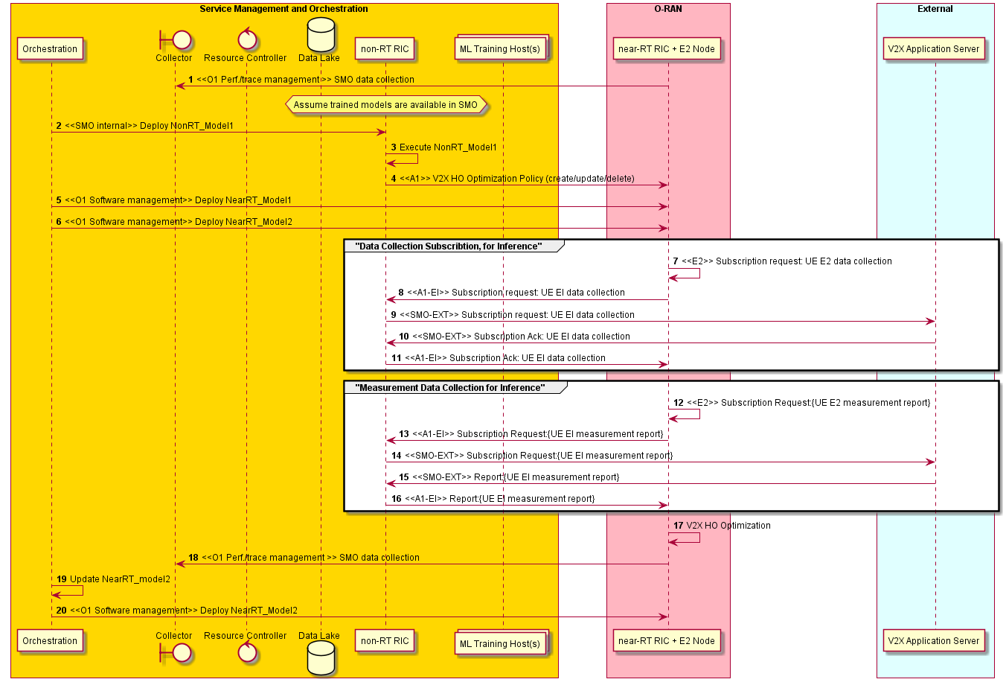
Figure 4.4.3.1-1: V2X HO management use case flow diagram

4.4.4 Required data
The measurement counters and KPIs (as defined by 3GPP) should be appropriately aggregated by cell, QoS type, slice, etc.
- Measurement reports with RSRP/RSRQ/CQI information for serving and neighboring cells.
- UE connection and mobility/handover statistics with indication of successful and failed handovers and error codes, etc.
- V2X related data: position, velocity, direction, navigation data, CAMs.

4.4.5 Proposed solution(s)

4.4.5.1 Workflow overview
The use case workflow consists of these main components:
1. Data collection & maintenance: This is required at Non-RT RIC (over O1 and Enrichment Interface (EI)). Required radio measurements and V2X related metrics are collected over a longer period of time (sufficient to facilitate model training). The O1/EI data collection is used for offline training of models, as well as for generating A1 policies for V2X HO optimization. The E2 (and EI) data collection is used for model execution in the Near-RT RIC. Details of the models are described below.
2. Long-term HO analytics & model maintenance: The Non-RT RIC long-term analytics is responsible for providing the relevant models for V2X HO optimization over A1 interface. Based on O-RAN A1 interface specs v1, these policies can be defined at per-UE level, UE group level, cell or xNB level etc. This will provide the optimization scope/objective for the Near-RT RIC V2X HO xApp. The xApp hosts two AI/ML-assisted functions: 1. HO anomaly detection & prediction, 2. HO anomaly avoidance. The 1. trained model's input is [E2: HO sequences, UE radio measurements; EI: position, velocity, direction, (O) navigation data, (O) cell load data of cells in the area] of a given time window, while the output is [anomaly likelihoods for possible future HO sequences]. The 2. trained model's input is [E2 report, EI report, output of 1. model, (O) navigation data, (O) cell load data of cells in the area] and its output is [UE-customized NRT sequence for cells that the UE is about to touch, with lower anomaly likelihood, (O) with validity time]. The two models are regularly retrained/updated based on new radio/V2X data.
4. HO anomaly prediction & detection: The navigation information and HO sequence and predicted HO sequence of V2X UEs in scope are evaluated and HO anomalies are detected or predicted. If any, it is delegated for further consideration for HO sequence optimization.
5. HO sequence optimization: Based on the E2 and enrichment reports and the prediction/detection output, the trained AI/ML model outputs UE-customized NRTs for the cells that I. are in scope, II. the UE is about to come in touch with.
6. V2X HO optimization execution: The new NRTs are deployed at xNBs through E2 policies.

4.4.5.2 Overview of ML models
While many combinations and deployments are possible, this proposal outlines one specific set of models and analytics that can be useful to drive such a use case.
NonRT_Model1: The Non-RT RIC ML-assisted solution uses the O1-based and EI-based data collection to monitor the V2X UE HO performance metrics and the navigation indicators (position, direction, speed, (O) traffic indicators). Based on the performance monitoring, the model aims to represent navigation and radio environments/conditions and maintain a data base in order to classify HO situations. Input: historical radio, HO, and location, direction, velocity data. Output: maintained database with locations, directions, velocities and cells, HO situations, HO anomalies, and/or sequences of all these, together with prevalence rates (=estimated probabilities).
NearRT_Model1: The first ML-assisted near-RT xApp model in the Near-RT RIC aims to rate/score future/current HO situations (on a UE level) based on real-time radio (E2) and navigation conditions (EI), i.e., predict/detect anomalous HO situations. Input: per-UE current radio parameters, HO history, location, direction, velocity. Output: predicted HO sequence(s) with probabilities for anomalies at specific cell pairs.
NearRT_Model2: The second ML-assisted near-RT xApp model in the Near-RT RIC aims to choose alternative, UE specific NRTs for a set of cells and UEs so as to resolve or avoid anomalous HO situations. Input: input and output of the NearRT_Model1. Output: alternative, UE specific NRTs for some cells (e.g., with temporal validity/expiration time).

4.4.6 A1 enrichment interface aspects
1. As per ETSI EN 302 637-2 [i.2], V2X UE provides CAMs (which include its GPS coordinates) on a 0.1-1s temporal granularity to the V2X application server. The inference part of this use case depends on accurate navigation data from V2X UEs, thus we expect this data to be provided through the A1-EI without substantial processing or delay.
2. The data (in particular the GPS coordinates) received over A1-EI need to be correlated with RAN UE data. For this problem there might be different requirements for the training data collection and the inference data collection. E.g., the UE data association might be solved using the ECGI + C-RNTI identifiers at any point in time (inference), but when collecting historical data for training it is essential to save the data in such a way that later correlation is possible as well.

4.4.7 A1 usage example
As of now the A1 aspect of the use case is confined to whether the HO optimization is, within a certain scope, activated or not. Thus, some of the attributes can overlap with the policy scope, but they are proposed in order to allow for more fine-grained control (e.g., optimize for only vehicles that are faster than 100 km/h [vel_range], between 7am and 9am on workdays [time_range], within a given geographical area [pos range] or [cell_id_list].)
The proposed (optional) attributes of the statement type v2x_nrt_opt are captured in table 4.4.7-1.

Table 4.4.7-1: Definition of statement type v2x_nrt_opt/extra scope identifiers
Attribute name | Data type | P | Cardinality | Description | Applicability
cell_id_list | Array | “M” | "1..N" | list of CellIDs
time_range | Array | "O" | "1..N" | refers to the time intervals of activation
pos_range | Array | "O" | "1..N" | refers to GPS position ranges of activation
vel_range | Array | "O" | "1..N" | refers to velocity ranges of activation

{
"title": "policies",
"description": "O-RAN A1 policy",
"type": "object",
"properties": {
"policy_id": {"type": "string"},
"scope": {
…
},
"statement": {
"cell_id_list": {"type": "number"},
"time_range": {"type": "number"},
" pos_range": {"type": "number"},
" vel_range": {"type": "number"}
}
}
}

4.5 RAN slice SLA assurance
The 3GPP standards architected a sliceable 5G infrastructure which allows creation and management of customized networks to meet specific service requirements that can be demanded by future applications, services and business verticals. Such a flexible architecture needs different requirements to be specified in terms of functionality, performance and group of users which can greatly vary from one service to the other. The 5G standardization efforts have gone into defining specific slices and their Service Level Agreements (SLAs) based on application/service type as specified in 3GPP TS 23.501 [2]. Since network slicing is conceived to be an end-to-end feature that includes the core network, the transport network and the Radio Access Network (RAN), these requirements should be met at any slice subnet during the life-time of a network slice as specified in 3GPP TS 28.530 [3], especially in RAN side. Exemplary slice performance requirements are specified in terms of throughput, energy efficiency, latency and reliability at a high level in SDOs such as 3GPP TS 22.261 [1] and GSMA [9]. These requirements are defined as a reference for SLA/contractual agreements for each slice, which individually need proper handling in NG-RAN.
Although network slicing support is started to be defined with 3GPP Release 15, slice assurance mechanisms in RAN needs to be further addressed to achieve deployable network slicing in an open RAN environment. It is necessary to assure the SLAs by dynamically controlling slice configurations based on slice specific performance information. Existing RAN performance measurements as specified in 3GPP TS 28.552 [5] and information model definitions as specified in 3GPP TS 28.541 [4] are not enough to support RAN slice SLA assurance use cases. This use case is intended to clarify necessary mechanisms and parameters for RAN slice SLA assurance.

4.5.1 Background and goal of the use case
In the 5G era, network slicing is a prominent feature which provides end-to-end connectivity and data processing tailored to specific business requirements. These requirements include customizable network capabilities such as the support of very high data rates, traffic densities, service availability and very low latency. According to 5G standardization efforts, the 5G system can support the needs of the business through the specification of several service needs such as data rate, traffic capacity, user density, latency, reliability, and availability. These capabilities are always provided based on a Service Level Agreement (SLA) between the mobile operator and the business customer, which brought up interest for mechanisms to ensure slice SLAs and prevent its possible violations. O-RAN’s open interfaces and AI/ML based architecture will enable such challenging mechanisms to be implemented and help pave the way for operators to realize the opportunities of network slicing in an efficient manner.

4.5.2 Entities/resources involved in the use case
- Non-RT RIC:
  - Retrieve RAN slice SLA target from respective entities such as SMO, NSSMF.
  - Long term monitoring of RAN slice performance measurements.
  - Training of potential ML models that will be deployed in Non-RT RIC for slow loop optimization and/or Near-RT RIC for fast loop optimization.
  - Support deployment and update of AI/ML models into Near-RT RIC.
  - Receive slice control/slice SLA assurance rApps from SMO.
  - Create and update A1 policies based on RAN intent and A1 feedback.
  - Send A1 policies and enrichment information to Near-RT RIC to drive slice assurance.
  - Send O1 reconfiguration requests to SMO for slow-loop slice assurance.
- Near-RT RIC:
  - Near-real-time monitoring of slice specific RAN performance measurements.
  - Support deployment and execution of the AI/ML models from Non-RT RIC.
  - Receive slice SLA assurance xApps from SMO.
  - Support interpretation and execution of policies from Non-RT RIC.
  - Perform optimized RAN (E2) actions to achieve RAN slice requirements based on O1 configuration, A1 policy, and E2 reports.
- E2 nodes:
  - Support slice assurance actions such as slice-aware resource allocation, prioritization, etc.
  - Support slice specific performance measurements through O1.
  - Support slice specific performance reports through E2.

4.5.3 Solutions

4.5.3.1 Creation and deployment of RAN slice SLA assurance applications
The context of the creation and deployment of RAN slice SLA assurance applications is captured in table 4.5.3.1-1.
Table 4.5.3.1-1: Creation and deployment of RAN slice SLA assurance applications
Use Case Stage | Evolution / Specification | <<Uses>>  Related use
Goal | Training and distribution of the RAN slice SLA assurance applications.
Actors and Roles | Non-RT RIC, Near-RT RIC, SMO
Assumptions | All relevant functions and components are instantiated.  A1, O1 interface connectivity is established.
Pre-conditions | Near-RT RIC and Non-RT RIC are instantiated with A1 interface. A1 connectivity being established between them.  O1 interface is established between SMO and Near-RT RIC.
Begins when | A RAN slice is activated, or an operator defined trigger is detected.
Step 1 (M) | Non-RT RIC retrieves a RAN slice SLA from SMO (e.g., from NSSMF).
Step 2a (O) | Non-RT RIC starts to collect slice specific performance measurements (PMs) via O1. Examples of the PMs are CSI, PRB usage, L2 throughput, RAN latency, etc. Applicable PMs are specified in 3GPP TS 28.552 [5].
Step 2b (O) | Non-RT RIC starts to collect Enrichment Information (EIs) from external applications. Examples of the external applications are public safety application triggering slice priority during an emergency event, or location-based enrichment information, etc.
Step 3 (O) | Non-RT RIC does the model training during a certain period of time using the collected data in step 2 and generates RAN slice SLA assurance AI/ML models.
Step 4 (M) | Non-RT RIC deploys RAN slice SLA assurance rApp (which can include the newly trained AI/ML model(s)).
Step 5 (O) | Non-RT RIC deploys RAN slice SLA assurance xApp(s) to respective Near-RT RICs (which can include the newly trained AI/ML model(s)).
Step 6 (O) | Non-RT RIC continues collecting slice specific performance measurements (PMs) via O1 and receives/utilizes A1 feedback if available. Non-RT RIC can update the AI/ML models within rApp and xApp(s).
Ends when | A RAN slice is deactivated.
Exceptions | None identified.
Post Conditions | RAN slice SLA assurance applications are deployed.
Traceability | REQ-Non-RT-RIC-FUN1, REQ-Non-RT-RIC-FUN2, REQ-Non-RT-RIC-FUN3, REQ-Non-RT-RIC-FUN4, REQ-Non-RT-RIC-FUN5, REQ-Non-RT-RIC-FUN9, REQ-A1-FUN2, REQ-A1-FUN4

@startuml
skinparam ParticipantPadding 5
skinparam BoxPadding 10
skinparam defaultFontSize 12
Autonumber

Box “Service Management and Orchestration” #gold
Participant SMO as “SMO Functions”
Boundary Collector
Participant NON as “Non-RT RIC”
end box

Box “O-RAN” #lightpink
Participant RIC as “Near-RT RIC”
Participant E2NODES as “E2 Nodes”
End box

Box “External” #lightcyan
Participant APP as “App”
End box

SMO-> NON : RAN Slice SLA Retrieval
E2NODES-> Collector : <<O1>> Data Collection
RIC-> Collector : <<O1>> Data Collection

group opt
APP-> Collector : Enrichment information collection
end

Collector-> NON : Retrieval of RAN and non-RAN data

group opt
NON-> NON : Training of AI/ML models
end

NON-> NON : Deploy rApp
group opt
NON-> RIC : <<O2>> Deploy xApp
end

group opt
Collector-> NON : Retrieval of RAN and non-RAN data
NON-> NON : Performance monitoring & evaluation
NON-> NON : Model re-training
NON-> NON : Update rApp
end

group opt
NON-> RIC : <<O2>> Update xApp
end

@enduml
The flow diagram of the creation and deployment of RAN slice SLA assurance applications is given in figure 4.5.3.1-1.

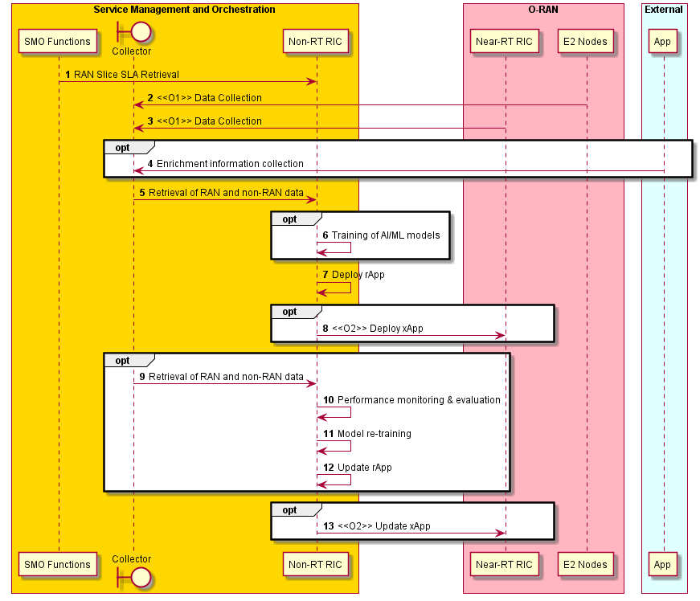
Figure 4.5.3.1-1: Creation and deployment of RAN slice SLA assurance applications

4.5.3.2 RAN slice SLA assurance
The context of RAN slice SLA assurance is captured in table 4.5.3.2-1.

Table 4.5.3.2-1: RAN slice SLA assurance
Use Case Stage | Evolution / Specification | <<Uses>>  Related use
Goal | RAN slice SLA assurance
Actors and Roles | SMO functions, Non-RT RIC framework, RAN slice SLA assurance rApp, Near-RT RIC, E2 nodes
Assumptions | All relevant functions and components are instantiated.  A1, O1, E2 interface connectivity is established.
Pre-conditions | Near-RT RIC and Non-RT RIC are instantiated with A1 interface connectivity being established between them.  O1 interfaces are established between SMO and Near-RT RIC, and SMO and E2 nodes.  RAN slice SLA assurance applications have been deployed in Non-RT RIC and Near-RT RIC respectively.
Begins when | A RAN slice is activated, or an operator defined trigger is detected.
Step 1 (M) | RAN slice SLA assurance rApp retrieves relevant information from Non-RT RIC framework via R1, such as active RAN slices (such as active S-NSSAIs, network slice subnet instances, topology), RAN slice SLA information, NF configuration, etc.
Step 2 (O) | RAN slice SLA assurance rApp retrieves relevant enrichment information from Non-RT RIC framework via R1.
Step 3a (M) | RAN slice SLA assurance rApp requests relevant slicing specific PMs.  Examples of the PMs are layer 2 throughput, PRB usage, CSI, RAN latency.
Step 3b (M) | Non-RT RIC framework triggers retrieval of requested O1 PMs by interacting with SMO.
Step 3c (M) | RAN slice SLA assurance rApp starts retrieving E2 node generated slice specific PMs from Non-RT RIC framework via R1.
Step 4 (M) | RAN slice SLA assurance rApp monitors and evaluates performance of RAN slices which can include detection of possible RAN slice SLA violation.
Step 5 (O) | RAN slice SLA assurance rApp decides to apply O1 reconfiguration on certain E2 nodes and/or Near-RT RIC. RAN slice SLA assurance rApp triggers O1 reconfiguration through Non-RT RIC framework using R1.
Step 6a (O) | RAN slice SLA assurance rApp decides to apply A1 policy based RAN slice SLA assurance considering RAN slice SLA requirements and/or operator-defined RAN intents, EI from external application servers and O1 based long term trends. In addition to these input parameters, A1 feedback from Near-RT RIC, when available, can be utilized for updating existing policies.  The policies include scope identifiers (e.g., S-NSSAI, flow ID, and cell ID) and/or policy statements (e.g., slice specific KPI targets).
Step 6b (O) | RAN slice SLA assurance rApp triggers creation/update/removal of A1 policies on respective Near-RT RICs through Non-RT RIC framework via R1.
Step 6c (O) | Non-RT RIC framework applies A1 policy creation/update/removal on respective Near-RT RICs through A1 interface.
Step 6d (O) | Near-RT RIC applies A1 policy-based RAN slice SLA assurance.
Step 6e (O) | RAN slice SLA assurance rApp retrieves A1 feedback generated from respective Near-RT RICs. Steps include Near-RT RIC sending the A1 feedback via A1 to Non-RT RIC framework, and then rApp retrieving this feedback via R1 from Non-RT RIC framework.
Ends when | RAN slice(s) is deactivated or an operator defined trigger is detected.
Exceptions | None identified.
Post Conditions | SLA assurance for RAN slice(s) over a period of time is achieved.
Traceability | REQ-Non-RT-RIC-FUN1, REQ-Non-RT-RIC-FUN5, REQ-Non-RT-RIC-FUN8, REQ-Non-RT-RIC-FUN9, REQ-A1-FUN1, REQ-A1-FUN3, REQ-A1-FUN5

@startuml
skinparam ParticipantPadding 5
skinparam BoxPadding 10
skinparam defaultFontSize 12
Autonumber

Box “Service Management and Orchestration” #gold
Participant SMO as “SMO Functions”
Participant NON as “Non-RT RIC Framework”
Participant RAPP as “SLA Assurance rApp”
end box

Box “O-RAN” #lightpink
Participant RIC as “Near-RT RIC”
Participant E2NODES as “E2 Nodes”
End box

Box “External” #lightcyan
Participant APP as “App”
End box

SMO-> NON : RAN Slice SLA assurance related data\n (e.g. RAN Slice SLA, NF configuration, topology)
RAPP-> NON : <<R1>> Request for RAN Slice SLA assurance related data
NON-> RAPP : <<R1>> RAN Slice SLA assurance related data

group Opt: Enrichment information collection
RAPP-> NON : <<R1>> Request RAN Slice SLA assurance related EI
APP-> SMO : EI collection
SMO-> NON : RAN Slice SLA assurance related EI data
NON-> RAPP : <<R1>> RAN Slice SLA assurance related EI data retrieval
end

RAPP-> NON : <<R1>> Request slice specific PMs

group Opt: Slice specific PM configuration
NON-> SMO : Request new PM
SMO-> RIC : <<O1>> PM configuration
SMO-> E2NODES : <<O1>> PM configuration
end

E2NODES-> SMO : <<O1>> Slice specific PMs
RIC-> SMO : <<O1>> Slice specific PMs
SMO-> NON : Slice specific PMs
NON-> RAPP : <<R1>> Slice specific PM retrieval

RAPP-> RAPP : Performance monitoring and evaluation
RAPP-> RAPP : Trigger for RAN slice SLA assurance \n(e.g. SLA violation detection)

group Opt: O1 Configuration update
RAPP-> RAPP : Creation of slice specific O1 configuration
RAPP-> NON : <<R1>> Request for O1 configuration update
NON-> SMO : Request for O1 configuration update
SMO-> RIC : <<O1>> Configuration update
SMO-> E2NODES : <<O1>> Configuration update
end

group Opt: A1 Policy creation / update / removal
RAPP-> RAPP : Creation / update / removal of RAN slice SLA assurance policy
RAPP-> NON : <<R1>> Request for A1 policy creation / update / removal
NON-> RIC : <<A1-P>> RAN slice SLA assurance policy creation / update / removal

group Opt: A1 Enrichment information transfer
NON-> RIC : <<A1-EI>> RAN slice SLA assurance related EI
end

group Near-RT RIC RAN slice SLA assurance
RIC<-> E2NODES : <<E2>> RAN slice SLA assurance
end

group Opt: A1 policy feedback
RIC-> NON : <<A1>> RAN slice SLA assurance policy feedback
NON-> RAPP : <<R1>> RAN slice SLA assurance policy feedback
end
end

@enduml
The flow diagram of the RAN slice SLA assurance is given in figure 4.5.3.2-1.

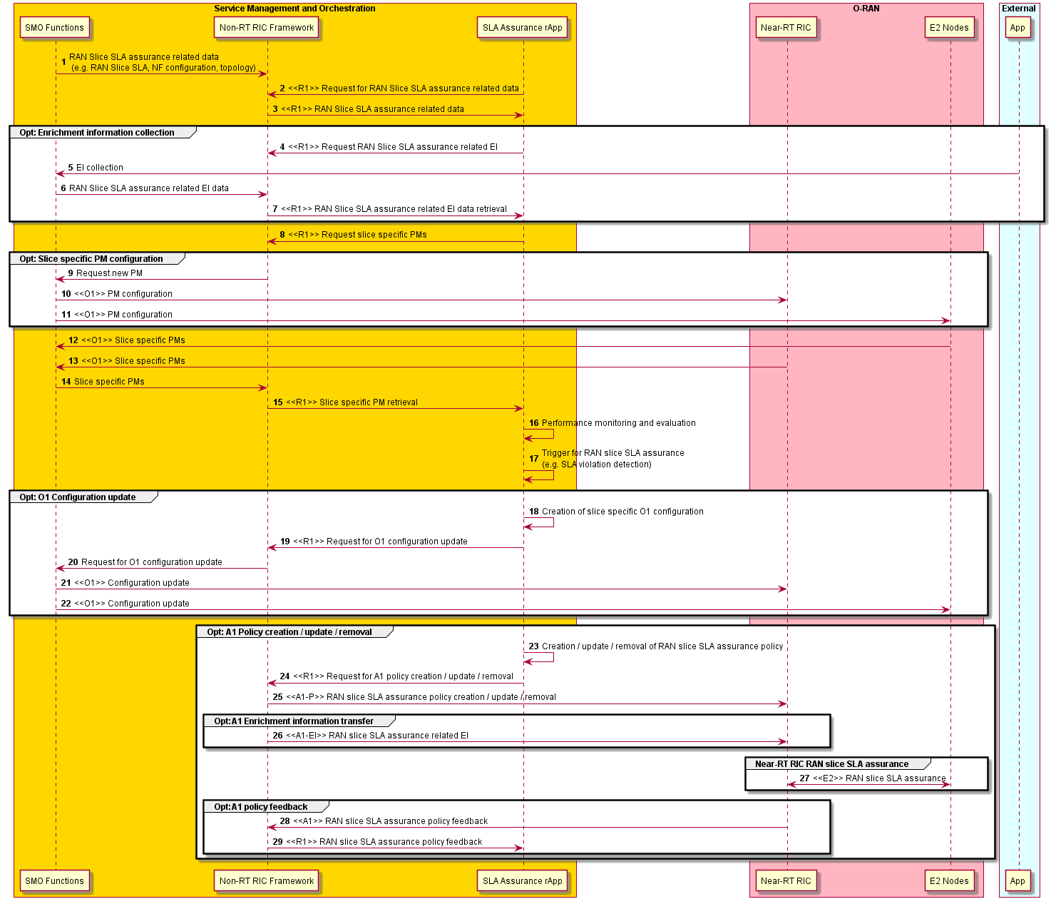
Figure 4.5.3.2-1: RAN slice SLA assurance

4.5.4 Required data
The measurement counters and KPIs (as defined by 3GPP and will be extended for O-RAN use cases) should be appropriately aggregated by cell, QoS type, slice, etc. Examples for required data for RAN slice SLA assurance use case are as follows:
- Per UE and/or per slice performance statistics as specified in 3GPP TS 28.552 [5], 3GPP TS 36.314 [6], 3GPP TS 38.314 [7], 3GPP TS 28.558 [23] such as:
  - CQI related measurements; such as wideband CQI distribution (as specified in 3GPP TS 28.552 [5], clause 5.1.1.11.1)
  - UE throughput related measurements; such as average DL / UL UE throughput in gNB (as specified in 3GPP TS 28.552 [5], clauses 5.1.1.3.1, 5.1.1.3.3), scheduled IP throughput in DL/UL (as specified in 3GPP TS 36.314 [6], clauses 4.1.6.1, 4.1.6.2)
  - RRC connection related measurements; such as mean / max number of RRC connections (as specified in 3GPP TS 28.552 [5], clauses 5.1.1.4.1, 5.1.1.4.2), attempted / successful RRC connection establishments (as specified in 3GPP TS 28.552 [5], clauses 5.1.1.15.1, 5.1.1.15.2)
  - DRB related measurements; such as number of DRBs attempted to / successfully setup (as specified in 3GPP TS 28.552 [5], clauses 5.1.1.10.1, 5.1.1.10.2)
  - PDU session management related measurements; such as number of PDU sessions requested to / successfully / failed to setup (as specified in 3GPP TS 28.552 [5], clauses 5.1.1.5.1, 5.1.1.5.2, 5.1.1.5.3)
  - Number of active UEs; such as mean number of active UEs in the UL / DL per cell (as specified in 3GPP TS 28.552 [5], clauses 5.1.1.23.1, 5.1.1.23.3)
  - Radio resource utilization related measurements; such as mean DL / UL PRB used for data traffic (as specified in 3GPP TS 28.552 [5], clauses 5.1.1.2.5, 5.1.1.2.7)
  - PDCP data volume measurements; such as DL / UL PDCP PDU data volume (as specified in 3GPP TS 28.552 [5], clauses 5.1.3.6.1.1, 5.1.3.6.1.2), data volume in DL/UL (as specified in 3GPP TS 36.314 [6], clauses 4.1.8.1, 4.1.8.2)
  - Average user plane delay; such as UL PDCP packet average delay (as specified in 3GPP TS 28.558 [23], clause 6.3.1.1.5), average delay DL air-interface (as specified in 3GPP TS 28.552 [5], clause 5.1.1.1.1), average delay UL on over-the-air interface (as specified in 3GPP TS 28.552 [5], clause 5.1.1.1.3), average delay DL in gNB-DU (as specified in 3GPP TS 28.552 [5], clause 5.1.3.3.3), average delay DL on F1-U (as specified in 3GPP TS 28.552 [5], clause 5.1.3.3.2), average delay DL in CU-UP (as specified in 3GPP TS 28.552 [5], clause 5.1.3.3.1), average over-the-air interface packet delay in the UL per DRB per UE (as specified in 3GPP TS 38.314 [7], clause 4.2.1.2.2), average delay DL air-interface (as specified in 3GPP TS 28.558 [23], clause 6.3.1.1.1)
  - Packet drop and loss rate measurements; such as DL RLC SDU packet drop rate in gNB-DU (as specified in 3GPP TS 28.552 [5], clause 5.1.3.2.2), UL / DL F1-U packet loss rate (as specified in 3GPP TS 28.552 [5], clauses 5.1.3.1.2, 5.1.3.1.3), packet Uu loss rate in the DL per DRB per UE (as specified in 3GPP TS 38.314 [7], clause 4.2.1.5.1)
- O1 configuration information for NR NRM such as NRCellCU (as specified in 3GPP TS 28.541 [4], clause 4.3.4), NRCellDU (as specified in 3GPP TS 28.541 [4], clause 4.3.5), GNBDUFunction (as specified in 3GPP TS 28.541 [4], clause 4.3.1), GNBCUCPFunction (as specified in 3GPP TS 28.541 [4], clause 4.3.2), GNBCUUPFunction (as specified in 3GPP TS 28.541 [4], clause 4.3.3), RRMPolicy_ (as specified in 3GPP TS 28.541 [4], clause 4.3.43)
- Slice SLA information; such as ServiceProfile (as specified in 3GPP TS 28.541 [4], clause 6.3.3), SliceProfile (as specified in 3GPP TS 28.541 [4], clause 6.3.4)
- Enrichment information; such as UE geo-location information (as specified in A1TD [24], clause 8.3.3.2)

4.5.5 A1 usage example
Example scenario 1
- One mobile leased line network slice for live broadcasting is defined (S-NSSAI=1).
- The SLA for the slice is defined with the total UL/DL throughput of 30 Mbps of the users in the slice provided in the coverage area (cellId=1, 2, 3).
- Non-RT RIC generates A1 policy for Near-RT RIC slice SLA assurance, which includes S-NSSAI and cellId as scope identifiers, and per-slice total PDCP layer throughput target as a policy statement.
- Near-RT RIC enforces the policy and guides RAN behavior via E2 to meet the slice SLA.

{
"PolicyId": "1",
"scope": {
"sliceId": "1",
“cellId”: ”1”, ”2”, ”3”, // Multiple cellIds need to be supported
},
"statement": {
"uLThptPerSlice": "30"
"dLThptPerSlice": "30"
}
}

Example scenario 2
Background of the scenario
- SLA violation occurs when a cell is congested, and not enough resources are allocated to slice users. To minimize this kind of SLA violation, load balancing is effective.
- Although load balancing can be performed using traffic steering preference policy type, that approach is insufficient to reduce the load to desired level, because there will be a gap between the actual load and the load recognized by Non-RT RIC due to long monitoring and control interval of Non-RT RIC. As shown in figure 4.5.5-1, the near-real-time control loop can achieve smaller reaction time than the non-real-time control loop. Therefore, it is preferable to use Near-RIC for load balancing.
- In this scenario, by using A1 policy for load balancing, the load balancing is performed in a shorter cycle, which is more effective in assuring slice SLAs.

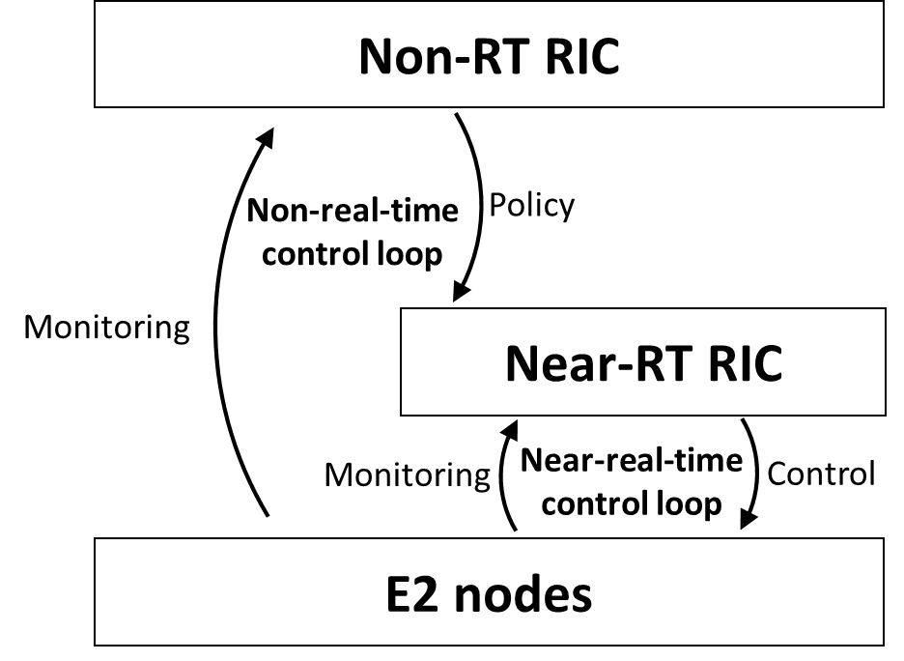
Figure 4.5.5-1: Illustration of the control loops involving Non-RT RIC, Near-RT RIC and E2 nodes

Overall flow in the scenario
- In this scenario, Non-RT RIC monitors the load and performance under the cell and decides whether the cell load should be balanced or not. Only when cell congestion is detected or predicted, A1 policy for load balancing is sent to Near-RT RIC, and Near-RT RIC performs cell load balancing to ease the cell congestion and solve SLA violation.
- The following example describes the overall steps in load balancing to assure slice SLAs defined by delay requirement. Note that the step number corresponds to the number given in figure 4.5.5-2.
- An A1 policy (PolicyId: 1) corresponding to SLA of slice #1, which includes delay requirement per UE for users of cell A~E, and slice #1, is sent from Non-RT RIC to Near-RT RIC.
- To monitor the cell load and performance of delay, Non-RT RIC collects mean DL PRB used for data traffic (as specified in 3GPP TS 28.552 [5], clause 5.1.1.2.5) from cell A~E, and distribution of delay DL air-interface (per S-NSSAI) (as specified in 3GPP TS 28.552 [5], clause 5.1.1.1.2) from cell A~E via O1.
- In Non-RT RIC, when the load of cell A is high, and the percentage of packets of slice #1 experiencing a longer delay than required, Non-RT RIC determines that the SLA violation is due to high load and decides to start load balancing. Non-RT RIC sends an A1 policy (PolicyId: 2) to transfer the load of cell A to neighboring non-congested cells (cell B, D and E) until the load of cell A becomes smaller than 80%.
- To monitor the load and radio quality, Near-RT RIC collects mean DL PRB used for data traffic (as specified in 3GPP TS 28.552 [5], clause 5.1.1.2.5) from cell A~E, and per-UE RSRP measurement and RSRQ measurement (as specified in E2SM-KPM [16], clauses 8.2.1.2.2, 8.2.1.2.3 and in 3GPP TS 28.552 [5], clauses 5.1.1.22, 5.1.1.31) via E2.
- Near-RT RIC decides the combination of UEs to be handed over and target cells based on the information collected in (4). Near-RT RIC sends E2 CONTROL for UE-level hand over control to decrease the load of cell A below 80%.
- Non-RT RIC continues to monitor the cell load and performance. When Non-RT RIC decides that the cell load becomes low enough to not cause SLA violation, it notifies deletion of the policy (PolicyId: 2) to Near-RT RIC.

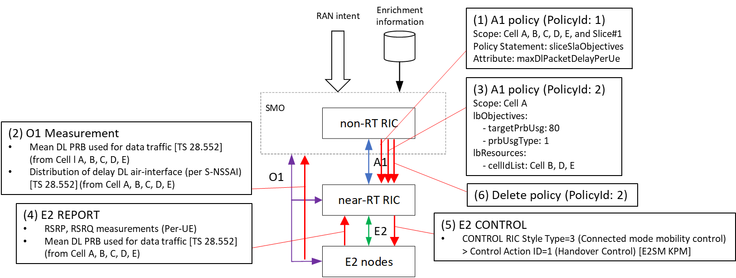
Figure 4.5.5-2: Illustration of the overall flow in the load balancing scenario

{
"PolicyId": "2",
"scope": {
“cellId”: ”A” // Designate a cell of which load is to be transferred to other cells
},
"lbObjectives": {
"targetPrbUsg": 80 // Target load of Cell A
"prbUsgType": 1 // PRB usage type used in the calculation of targetPrbUsg
},
"lbResources": {
"cellIdList": "B", "D", "E", // Designate cells to which cell load is transferred
}
}

The illustration of the cell congestion in multi-cell environment is given in figure 4.5.5-3.

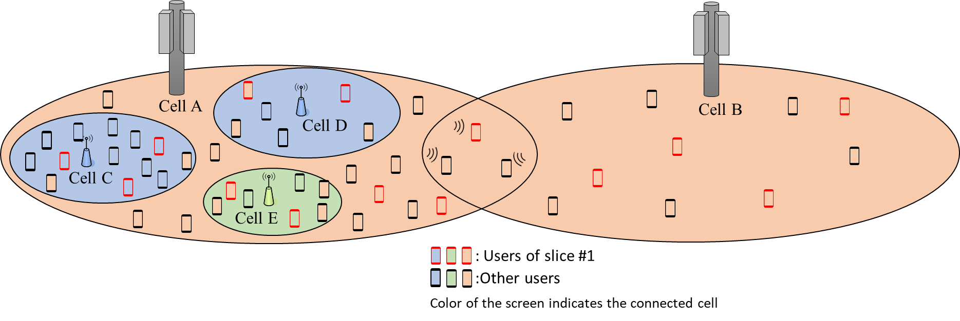
Figure 4.5.5-3: Illustration of the cell congestion in multi-cell environment

4.5.6 O1 usage example
Example scenario
- One mobile leased line network slice for live broadcasting is defined (S-NSSAI=1).
- The SLA for the slice is defined with the average total UL/DL throughput of 30 Mbps of the users in the slice provided in the coverage area (cellId=1, 2, 3).
- Note that O1 configuration is used to assure SLAs defined as long term performance values such as average throughput, which do not need frequent reconfiguration.
- In order to calculate the number of required PRBs to meet throughput requirement of the slice, Non-RT RIC collects wideband CQI distribution and data volume in UL/DL via O1. The calculated value is converted to the portion of PRB allocation to the slice i.e., rRMPolicyDedicatedRatio (as specified in 3GPP TS 28.541 [4]).
- Non-RT RIC sends rRMPolicyDedicatedRatio as O1 reconfiguration requests to E2 nodes.
- Non-RT RIC also collects UL/DL PRB used for data traffic and average UL/DL UE throughput in gNB. When the PRB usage becomes low, Non-RT RIC reconfigures rRMPolicyDedicatedRatio via O1 to decrease the allocated PRBs. When the PRB usage becomes high and throughput deterioration occurs, Non-RT RIC reconfigures rRMPolicyDedicatedRatio via O1 to increase the allocated PRBs.

The illustration of the RRMPolicy reconfiguration via O1 is given in figure 4.5.6-1.

Figure 4.5.6-1: Illustration of the RRMPolicy reconfiguration via O1

4.6 NSSI resource allocation optimization
This use case provides the background, objectives, solution, and requirements for the NSSI resource optimization, an rApp implemented in Non-RT RIC, which leverages AI/ML inference on slice performance measurement data to determine the actions to automatically optimize the resource allocation for network slice instances.

4.6.1 Background and goal of the use case
Network slicing is essential to 5G, as it enables many new services across manufacturing, autonomous driving, gaming, and many more via the provision of ultra-low latency in URLLC and huge data volume in eMBB features that require different or contrasting QoS requirements exploiting a shared RAN node. The goal of this use case is to ensure the resources are allocated dynamically and efficiently among multiple network slices sharing the RAN node.
As the new 5G services have different characteristics, the network traffic tends to be sporadic, where there can be different usage pattern in terms of time, location, UE distribution, and types of applications. For example, most IoT sensor applications can run during off-peak hours or weekends. Special events, such as sport games, concerts, can cause traffic demand to shoot up at certain time and locations. Cars with autonomous driving capability tend to require more URLLC services in the morning or afternoon rush hours in major freeways in big cities, while subscribers tend to consume eMBB services to watch video streaming at night in residential areas. Therefore, NSSI resource optimization rApp trains the AI/ML model, based on the huge volume of performance data collected over days, weeks, months from O-RAN nodes. It then performs inference function on the model with input measurements to predict the traffic demand patterns of 5G networks in different times and locations for each network slice, and automatically optimize the resource allocation for network slice instances accordingly.

4.6.2 Entities/resources involved in the use case
- Non-RT RIC:
  - Receive measurements to monitor the usage of RRM resources (e.g., PRB, RRC, DRB) identified by S-NSSAI from E2 nodes via the O1 interface.
  - Perform the model training with input measurements data received from E2 nodes to create the model.
  - Perform the inference function on the model with the input measurements data to determine if any actions shall be executed to update the resources on the E2 nodes.
  - Configure the resources at the E2 nodes via O1 interface.
  - Receive notifications from E2 nodes indicating the resource re-configuration was done.
  - Update the O-Cloud resources via the O2 interface.
  - Receive notifications from O-Cloud indicating the resource was updated.
- E2 nodes (O-CU-CP, O-CU-UP, D-DU):
  - Support the collections and reporting of measurements that are used to monitor the resource usage on per network slice basis via the O1 interface.
  - Support the re-configuration of attributes to update the resources allocated to each network slice via the O1 interface.

4.6.3 Solutions

4.6.3.1 NSSI resource optimization
The context of the NSSI resource optimization is captured in table 4.6.3.1-1.

Table 4.6.3.1-1: NSSI resource optimization
Use Case Stage | Evolution / Specification | <<Uses>>  Related use
Goal | The goal is to ensure the resources (e.g., PRB, RRC, DRB) are allocated dynamically and efficiently among multiple network slices sharing the E2 nodes.
Actors and Roles | - SMO functions.  - Non-RT RIC framework.  - rApp: NSSI resource optimization.  - E2 nodes (i.e., O-CU-CP, O-CU-UP, O-DU).
Assumptions | - All relevant functions and components are instantiated.  - O1 interface connectivity is established.
Pre-conditions | - O1 interfaces have been established to enable SMO to receive measurements from E2 nodes and configure the E2 nodes.  - R1 interface has been established to enable the rApp to receive measurements form E2 nodes and configure the E2 nodes via Non-RT RIC framework.  - E2 nodes have been configured to collect the measurements and send them to Non-RT RIC framework.
Begins when | The rApp utilizes the model to perform the inference function.
Step 1 (M) | The rApp performs the offline model training with input measurements data received from E2 nodes to create the model.
Step 2 (M) | Non-RT RIC framework receives the measurements from O-CU-CP via O1 to monitor the usage of RRM resources (e.g., RRC connected user).
Step 3 (M) | Non-RT RIC framework sends the measurements to rApp via R1 interface.
Step 4 (M) | Non-RT RIC framework receives the measurements from O-CU-UP via O1 to monitor the usage of RRM resources (e.g., the number of DRB allocated, and the number of PDU sessions).
Step 5 (M) | Non-RT RIC framework sends the measurements to rApp via R1 interface.
Step 6 (M) | Non-RT RIC framework receives the measurements from O-CU-UP via O1 to monitor the usage of RRM resources (e.g., the number of PRBs used in the downlink and uplink data traffic).
Step 7 (M) | Non-RT RIC framework sends the measurements to rApp via R1 interface.
Step 8 (M) | The rApp performs the inference function based on the model with input measurements data received to determine the actions to update the resources allocated to slices on the E2 nodes if needed.
 | If the rApp decides the RRM resources (e.g., RRC) in O-CU-CP need to be updated, then steps 9 to 12 are executed.
Step 9 (O) | rApp requests Non-RT RIC framework via R1 interface to update the RRM resources for slices in O-CU-CP.
Step 10 (O) | Non-RT RIC framework uses the modify MOI (Managed Object Instance) operation to configure the MOI(s) associated with the RRM resources at O-CU-CP via O1 interface.
Step 11 (O) | Non-RT RIC framework receives a notification from O-CU-CP via O1 interface indicating the resource re-configuration was successful.
Step 12 (O) | Non-RT RIC framework notifies rApp via R1 interface indicating the RRM resources in O-CU-CP have been successfully updated.
 | If the rApp decides the RRM resources (e.g., DRB) in O-CU-UP need to be updated, then steps 13 to 16 are executed.
Step 13 (O) | rApp requests Non-RT RIC framework via R1 interface to update the RRM resources for slices in O-CU-UP.
Step 14 (O) | Non-RT RIC framework uses the modify MOI operation to configure the MOI(s) associated with the RRM resource at O-CU-UP via O1 interface.
Step 15 (O) | Non-RT RIC framework receives a notification from O-CU-UP via O1 interface indicating the resource re-configuration was successful.
Step 16 (O) | Non-RT RIC framework notifies rApp via R1 interface indicating the RRM resources in O-CU-UP have been successfully updated.
 | If the rApp decides the RRM resources (e.g., PRB) in O-DU need to be updated, then steps 17 to 20 are executed.
Step 17 (O) | rApp requests Non-RT RIC framework via R1 interface to update the RRM resources for slices in O-DU.
Step 18 (O) | Non-RT RIC framework uses the modify MOI operation to configure the MOI(s) associated with the RRM resource at O-DU via O1 interface.
Step 19 (O) | Non-RT RIC framework receives a notification from O-DU via O1 interface indicating the resource re-configuration was successful.
Step 20 (O) | Non-RT RIC framework notifies rApp via R1 interface indicating the RRM resources in O-DU have been successfully updated.
 | If the rApp decides the O-Cloud resources need to be updated, then steps 21 to 24 are executed:
Step 21 (O) | rApp requests Non-RT RIC framework via R1 interface to update the O-Cloud resources.
Step 22 (O) | Non-RT RIC framework re-configures the O-Cloud resources via O2 interface.
Step 23 (O) | Non-RT RIC framework receives a notification via O2 interface indicating the resource re-configuration was successful.
Step 24 (O) | Non-RT RIC framework notifies rApp via R1 interface indicating the O-Cloud resources have been successfully updated.
Ends when | The resources have been optimized.
Exceptions | None identified.
Post Conditions | None.
Traceability | REQ-R1-FUN9, REQ-R1-FUN10.

NOTE: How the O-Cloud resources are to be monitored and updated is not defined in the present document.

@startuml
skinparam ParticipantPadding 5
skinparam BoxPadding 10
skinparam defaultFontSize 12
Autonumber

Box “Service Management and Orchestration” #gold
Participant NON as “Non-RT RIC Framework\n& O1/2 terminations”
Participant RAPP as “NSSI Optimization rApp”
end box

Box “O-RAN” #lightpink
Participant CUCP as “O-CU-CP”
Participant CUUP as “O-CU-UP”
Participant DU as “O-DU”
Participant OC as “O-Cloud”
End box

RAPP-> RAPP : Perform offline model training with \ninput measurement data from E2\n nodes to create the model.

group Loop: NSSI resource optimization loop
group input data collection
CUCP->NON : <<O1>> PM data to monitor the usage of RRM resources (e.g. RRC)
NON-> RAPP : <<R1>> input measurement data \nfor RRM resources
CUUP->NON : <<O1>> PM data to monitor the usage of RRM resources (e.g. DRB)
NON-> RAPP : <<R1>> input measurement data \nfor RRM resources
DU->NON : <<O1>> PM data to monitor the usage of RRM resources (e.g. PRB)
NON-> RAPP : <<R1>> input measurement data \nfor RRM resources
end

group Inference
RAPP-> RAPP : Performs inference based on the model \nwith input measurement data from E2\n nodes to decide the actions to update\n the resources in E2 nodes if needed
end

group Opt: resources in O-CU-CP need to be updated
RAPP-> NON : <<R1>> Request to update the \nRRM resources (e.g. RRC)
NON-> CUCP : <<O1>> Configure the MOI associated with the RRM resources
CUCP-> NON : <<O1>> Notify the resource re-configuration was successful
NON-> RAPP : <<R1>> Notify the RRM \nresources being updated
end

group Opt: resources in O-CU-UP need to be updated
RAPP-> NON : <<R1>> Request to update the \n RRM resources (e.g. DRB)
NON-> CUUP : <<O1>> Configure the MOI associated with the RRM resources
CUUP-> NON : <<O1>> Notify the resource re-configuration was successful
NON-> RAPP : <<R1>> Notify the RRM \nresources being updated
end

group Opt: resources in O-DU need to be updated
RAPP-> NON : <<R1>> Request to update the \nRRM resources (e.g. PRB)
NON-> DU : <<O1>> Configure the MOI associated with the RRM resources
DU-> NON : <<O1>> Notify the resource re-configuration was successful
NON-> RAPP : <<R1>> Notify the RRM \nresources being updated
End

group Opt: O-Cloud resources need to be updated
RAPP-> NON : <<R1>> Request to update the \nO-Cloud resources
NON-> OC : <<O2>> Configure the MOI associated with the O-Cloud resources
OC-> NON : <<O2>> Notify the resource re-configuration was successful
NON-> RAPP : <<R1>> Notify the O-Cloud \nresources being updated
end
end
@enduml
The flow diagram of the NSSI resource optimization is given in figure 4.6.3.1-1.

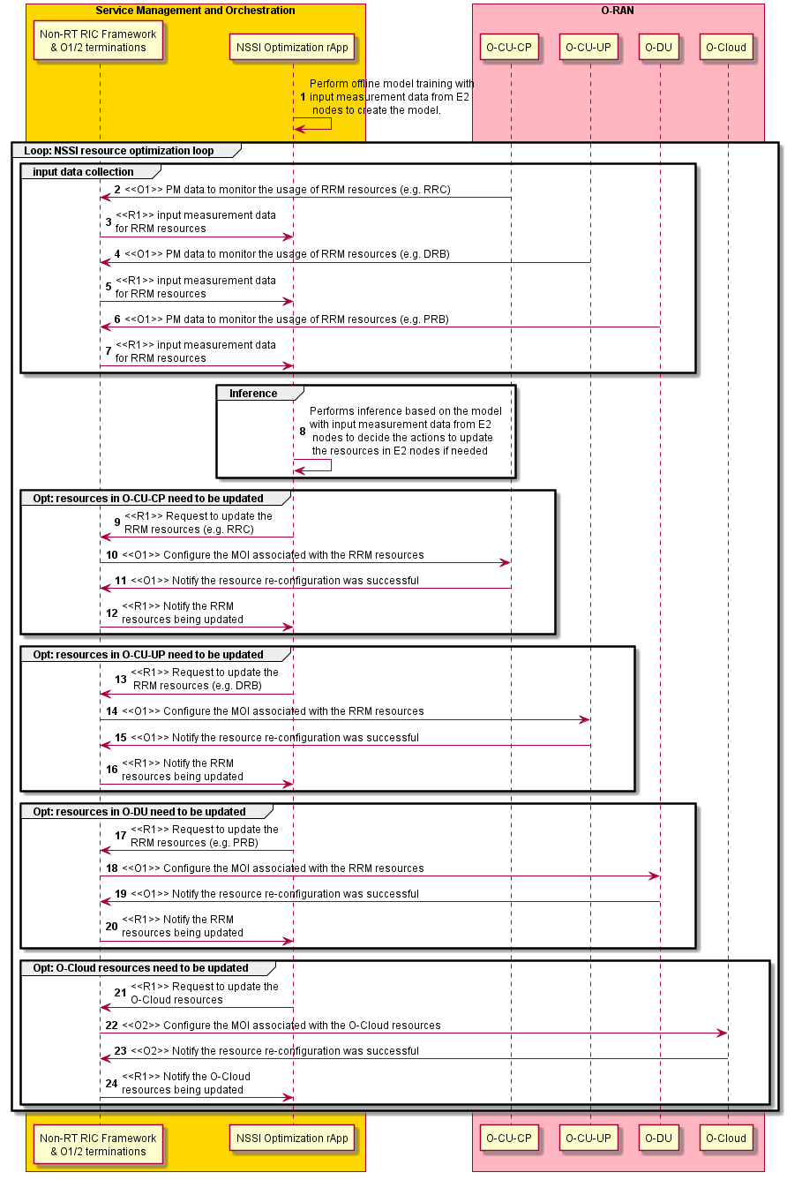
Figure 4.6.3.1-1: NSSI resource optimization flow diagram

4.6.4 Required data
This sub-clause contains the input and output data of model training and inference.

4.6.4.1 Input data
The measurement input data are used in model training and inference. They include the following measurements to monitor the resource usage for network slices in E2 nodes:
1) Measurements used to monitor the usage of RRC related resources in O-CU-CP include:
- Mean number of RRC connections – provides the mean number of RRC connections with sub-counters per S-NSSAI (as specified in 3GPP TS 28.552 [5], clause 5.1.1.4.1).
- Max number of RRC connections – provides the max number of RRC connections with sub-counters per S-NSSAI (as specified in 3GPP TS 28.552 [5], clause 5.1.1.4.2).
2) Measurements used to monitor the usage of DRB related resources in O-CU-UP include:
- Mean number of DRBs being allocated – provides the mean number of DRBs being allocated in the PDU sessions with sub-counters per S-NSSAI (as specified in 3GPP TS 28.552 [5], clause 5.1.1.10.9).
- Peak number of DRBs being allocated – provides the peak number of DRBs being allocated in the PDU sessions with sub-counters per S-NSSAI (as specified in 3GPP TS 28.552 [5], clause 5.1.1.10.10).
3) Measurements used to monitor the usage of PRB related resources in O-DU include:
- Mean DL PRB used for data traffic – provides the mean number of PRBs used in downlink for data traffic with sub-counters per S-NSSAI (as specified in 3GPP TS 28.552 [5], clause 5.1.1.2.5).
- Peak DL PRB used for data traffic – provides the peak number of PRBs used in downlink for data traffic with sub-counters per S-NSSAI (as specified in 3GPP TS 28.552 [5], clause 5.1.1.2.9).
- Mean UL PRB used for data traffic – provides the mean number of PRBs used in uplink for data traffic with sub-counters per S-NSSAI (as specified in 3GPP TS 28.552 [5], clause 5.1.1.2.7).
- Peak UL PRB used for data traffic – provides the peak number of PRBs used in uplink for data traffic with sub-counters per S-NSSAI (as specified in 3GPP TS 28.552 [5], clause 5.1.1.2.10).
- Mean number of PDU sessions being allocated – provides the mean number of PDU sessions being allocated with sub-counters per S-NSSAI (as specified in 3GPP TS 28.552 [5], clause 5.1.1.5.4).
- Peak number of PDU sessions being allocated – provides the peak number of PDU sessions being allocated with sub-counters per S-NSSAI (as specified in 3GPP TS 28.552 [5], clause 5.1.1.5.5).
- Mean number of active UEs in the DL per cell – provides the mean number of active UEs in downlink with sub-counters per S-NSSAI (as specified in 3GPP TS 28.552 [5], clause 5.1.1.23.1).
- Max number of active UEs in the DL per cell – provides the max number of active UEs in downlink with sub-counters per S-NSSAI (as specified in 3GPP TS 28.552 [5], clause 5.1.1.23.2).
- Mean number of active UEs in the UL per cell – provides the mean number of active UEs in uplink with sub-counters per S-NSSAI (as specified in 3GPP TS 28.552 [5], clause 5.1.1.23.3).
- Max number of active UEs in the UL per cell – provides the max number of active UEs in uplink with sub-counters per S-NSSAI (as specified in 3GPP TS 28.552 [5], clause 5.1.1.23.4).

4.6.4.2 Output data
The output data, including NRCellCU IOC, NRCellDU IOC, GNBDUFunction IOC, GNBCUCPFunction IOC, GNBCUUPFunction IOC and RRMPolicyRatio IOC with RRMPolicy abstract class (as specified in 3GPP TS 28.541 [4]), are needed to enable NSSI resource optimization rApp to re-configure the resources via O1 and O2 interfaces.

4.6.5 O1 usage example
An example of two NSSIs, where NSSI#1 groups E2 nodes (i.e., O-DU, O-CU-CP, and O-CU-UP), and NSSI#2 groups 5GC NFs is shown in figure 4.6.5-1. It also shows that two network slices, identified by S-NSSAI#1 supporting URLLC, and S-NSSAI#2 supporting eMBB. The goal of this use case is to optimize the resources associated with RAN network slices.

Figure 4.6.5-1: NSSI resource optimization example

NSSI resources optimization rApp runs model inference with input measurement data collected from E2 nodes for S-NSSAI#1 and S-NSSAI#2, and detects a traffic pattern for O-DU serving an area with high density of business and residential users at the time on a given day. An example of PRB resource allocation for S-NSSAI#1 and S-NSSAI#2 at the O-DU is shown in figure 4.6.5-2.

- At 15:00, the dedicated resources and prioritized resources for S-NSSAI#1 were increased to 20% and 50% respectively for as more cars demand more URLLC services at the start of rush hours.
- At 17:00, the dedicated resources, prioritized resources, and shared resources for S-NSSAI#1 were further increased as the rush hours traffic getting worse.
- At 19:00, the dedicated resources, prioritized resources, and shared resources for S-NSSAI#2 were increased to 20%, 60%, and 75% respectively as more residential users demand more eMBB services for home video streaming.
- At 20:00, the dedicated resources, prioritized resources, and shared resources for S-NSSAI#1 were decreased as the rush hours traffic coming to end.
- At 21:00, the dedicated resources, prioritized resources, and shared resources for S-NSSAI#2 were further increased as the demand for eMBB services increased.
- At 22:00, the dedicated resources, prioritized resources, and shared resources for S-NSSAI#1were decreased as the demand for URLLC services further reduced.
- At 24:00, the dedicated resources, prioritized resources, and shared resources for S-NSSAI#2 were decreased to 10%, 25%, and 60% respectively as the demand for eMBB services further reduced.

Figure 4.6.5-2: Example of network slice resource allocations for O-DU

4.7 Massive MIMO optimization
Massive MIMO optimization is one of the top priority use cases in O-RAN. Several massive MIMO sub-features have been proposed and studied during the massive MIMO pre-normative study, which is documented in the O-RAN.WG1.MMIMO-USE-CASES-TR-v01.00 [i.3], including the potential data requirements for each of the sub-use cases. The following sub-clauses provide the background, objectives, solutions, deployment options, and identified WG2 requirements for massive MIMO sub-features

4.7.1 Massive MIMO Grid-of-Beams Beamforming (GoB BF) optimization

4.7.1.1 Background and goal of the use case
Massive MIMO (mMIMO) is among the key methods to increase performance and QoS in 5G networks. Capacity enhancement is obtained by means of beamforming of the transmitted signals, and by spatially multiplexing data streams. Beamforming can increase the received signal power and simultaneously decrease the interference generated for other users, hence resulting in higher SINR and higher user throughputs. Grid-of-Beams (GoB) with the corresponding beam sweeping has been introduced to allow beamforming of the control channels used during initial access as well as for data transmission and reception, mainly for high frequency (but can be used also for the sub-6 GHz band) MIMO operation. The physical properties of the antenna array and its possible configurations characterize the span of the beams, namely the horizontal and vertical aperture in which beamforming is supported, and therefore the coverage area and the shape of the cell. mMIMO can be deployed in 5G macrocell clusters as well as in heterogeneous networks, where macrocells and small cells co-exist and complement each other for better aggregated capacity and coverage. In order to obtain optimal beamforming and cell resources (Tx power, PRB) configuration, one will have to look at a multi-cell environment instead of a single cell. Moreover, different vendors can have different implementations in terms of the number of beams, the horizontal/vertical beam widths, azimuth and elevation range, to achieve the desired coverage. In a multi-node/multi-vendor scenario, centralized monitoring and control is required to offer optimal coverage, capacity and mobility performance as well as control over electromagnetic emissions in order to comply with regulatory requirements.
The problem associated with traditional mMIMO BF is that its performance is highly dependent on the choice of the Beam Forming (BF) pattern. Manual configuration is usually based on the empirical knowledge and manual test results of the domain expert(s) and is performed in a semi-static way. That is, (near-)real time contextual, per-site information (such as cell geometry change, user/traffic distribution, mobility patterns, seasonalities etc.) is taken into account in a suboptimal and non-real-time way. This can cause one or more of the following problems:
- High inter-cell interference.
- Unbalanced traffic between neighboring cells.
- Low performance at the cell edges or throughout the cell.
- Poor handover performance.

This solution proposes a framework that allows the operator to flexibly configure the mMIMO BF parameters in a cell or in a cluster of cells by means of policies and configuration assisted by Machine Learning (ML) techniques. The configuration optimization relies on contextual information and patterns such as the user distribution, traffic demand distribution, cell geometries, and mobility.

4.7.1.2 Entities/resources involved in the use case
- SMO & Non-RT RIC Framework (FW):
  - Collect the necessary configurations, performance indicators, and measurement reports from the E2 nodes (O-DU), triggered by Non-RT RIC FW if required.
  - Transfer collected data towards rApp.
  - Provide optimized mMIMO GoB parameters via O1 (to O-DU) or open FH M-plane (to O-RU) interface.
  - Optional: Retrieve necessary enrichment information (UE location related information, e.g., GPS coordinates) for the purpose of i) training relevant rApps and ii) execution of relevant rApps.
NOTE: Exposure of enrichment information to rApps is not defined in the present document.
  - Monitor the performance of the respective cells; when the optimization objective fails, initiate fallback procedure and/or trigger the rApp model retraining and re-optimization.
  - Execute the inference/control loop periodically or event-triggered.
  - Optional: The ML model training can be done by the Non-RT RIC FW.
- rApps:
  - Retrieve the necessary configurations, performance indicators, and measurement reports from the E2 nodes and necessary enrichment information via the SMO, for the purpose of training and execution of relevant AI/ML models.
  - Infer an optimized GoB BF configuration.
- E2 nodes & O-RU:
  - Collect and provide necessary measurements and KPIs to the SMO (see Required data clause).
  - Apply mMIMO GoB configuration received from the SMO.
NOTE: Both aggregated and disaggregated gNB architecture are supported.

4.7.1.3 Solutions
The context of the creation and deployment of mMIMO GoB BF optimization applications is captured in table 4.7.1.3-1.
Table 4.7.1.3-1: Creation and deployment of mMIMO GoB BF optimization applications
Use Case Stage | Evolution / Specification | <<Uses>>  Related use
Goal | Optimized beamforming configuration with the Grid-of-Beams method.
Actors and Roles | SMO, Non-RT RIC, E2 nodes, O-RU
Assumptions | All relevant functions and components are instantiated.  O1 and OFH-MP interface connectivity is established.
Pre-conditions | Near-RT RIC and Non-RT RIC are instantiated.  O1 interface is established between SMO and Near-RT RIC and E2 nodes, OFH-MP is established between O-DU(s) and O-RU(s).
Begins when | GoB BF optimization rApp with initial ML model is deployed.
Step 1 (M) | SMO/Non-RT RIC FW collects the necessary configurations, performance indicators, and measurement reports from E2 nodes (O-DU).
Step 2 (O) | SMO/Non-RT RIC FW collects input data from external apps.
Step 3-6 (M) | Collected data is transferred to rApp from the SMO/Non-RT RIC FW and rApp trains the necessary ML model(s).
Step 7-10 (M) | A new optimization trigger is applied or re-optimization of the GoB BF is necessary due to low performance. ML model assisted rApp infers optimized GoB BF configuration and transfers it to the SMO/Non-RT RIC.
Step 11-13 (M) | SMO/Non-RT RIC FW applies the optimized GoB BF configuration via O1 or via O1 and OFH-MP.
Step 14-20 (O) | SMO/Non-RT RIC FW continuously monitors GoB BF performance in repsective cells. Optionally, it initiates fallback in case performance is unsatisfactory and requests ML model retraining/update. Then, rApp retrains/updates the respective ML model(s).
Ends when | On operator request of rApp is disabled.
Exceptions | None identified.
Post Conditions | GoB BF configuration is active.
Traceability | REQ-Non-RT-RIC-FUN1, REQ-Non-RT-RIC-FUN5, REQ-Non-RT-RIC-FUN6, REQ-Non-RT-RIC-FUN8, REQ-Non-RT-RIC-FUN9

@startuml

box "Service Management & \nOrchestration Framework" #gold
Participant "SMO & Non-RT RIC FW" as SMO
Participant "rApps" as rAPP
end box

box "E2 Nodes" #lightpink
collections "O-CUs" as OCU
collections "O-DUs" as ODU

end box

box "O-RUs" #lightpink
collections "O-RUs" as ORUs
end box

box "External" #lightseagreen
Participant APP
end box
Autonumber

activate APP
activate SMO
activate rAPP
activate ODU
|||

group Data Collection
ODU -> SMO : <<O1>> Data Collection
APP --> SMO : Data Collection
end

group ML Training
ODU -> SMO : <<O1>> Data Collection
APP --> SMO : Data Collection
SMO -> rAPP: <<R1>> Data Retrieval
rAPP --> rAPP: AI/ML model training
end

group ML Inference
alt
hnote over rAPP: Optimization Target/Trigger received
else
SMO --> SMO: Performance Degradation
end
SMO -> rAPP: <<R1>> Data Retrieval
rAPP --> rAPP: AI/ML model inference
rAPP -> SMO: <<R1>> Optimal mMIMO GoB Configuration
end
group GoB Configuration
alt via O1
SMO -> ODU: <<O1>> Provide new mMIMO GoB configuration
else via OFH-MP
SMO -> ORUs: <<OFH-MP>> Provide new mMIMO GoB configuration
SMO -> ODU: <<O1>> Information about new mMIMO GoB configuration
end
end

group ML Performance Monitoring
ODU -> SMO : <<O1>> Data Collection
APP --> SMO : Data Collection
SMO --> SMO : Performance monitoring and evaluation
opt
SMO --> SMO : Fallback (e.g. restore configuration)
SMO -> ODU: <<O1>> Default/Fallback mMIMO configuration
SMO -> rAPP : <<R1>> Model retraining and update request
rAPP --> rAPP : ML Model retraining
end
end

@enduml
The flow diagram of GoB BF optimization is given in figure 4.7.1.3-1.

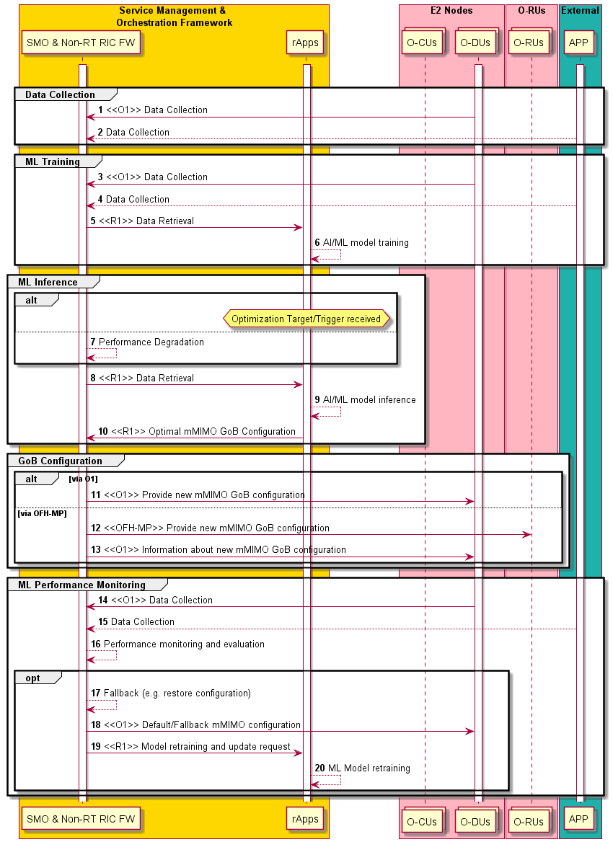
Figure 4.7.1.3-1: Flow diagram of GoB BF optimization

4.7.1.4 Required data
The specification of the data communicated over O1 is outside the scope of WG2.
There are no data that are relevant for the A1 interface.

4.7.2 Massive MIMO Non-GoB Beamforming (Non-GoB BF) optimization
This use case provides the background and motivation for the O-RAN architecture to support Non-Grid of Beams beamforming optimization. Non-RT RIC could be used to train AI/ML models for Non-GoB BF selection xApps, which intelligently recommend best Non-GoB BF modes to a O-gNB or O-DU.
Note that non-AI/ML based solutions for Non-GoB BF optimization is not precluded. The AI/ML model training, deployment, and inference described below are not applicable to non-AI/ML based solutions.

4.7.2.1 Background and goal of the use case
Non-GoB BF approaches are an important class of beamforming algorithms for 5G massive MIMO deployments, especially for implementations in sub-6 GHz frequency bands. For example, beam weights can be computed at the O-gNB or O-DU based on channel measurements of Sounding Reference Signals (SRS) without predefined beam sets, assuming uplink and downlink correspondence.
Noted that Non-GoB BF modes are not standardized, instead they are vendor-specific proprietary algorithms. Multiple Non-GoB BF modes can be implemented, as some modes perform better than others under particular wireless conditions. Non-GoB BF modes can differ in the following aspects:
- MIMO modes (i.e., SU-MIMO or MU-MIMO)
- Channel estimation algorithms
- Beam weight calculation approaches (e.g., Matched Filter (MF), Zero-Forcing (ZF), eigen-beamforming, etc.)
- Time and frequency granularity of beamforming, etc.
To select the best Non-GoB BF modes, the SMO/Non-RT RIC and the Near-RT RIC are not required to understand the details of a specific Non-GoB BF modes, e.g., how the beamforming weights are computed under a mode. They only need to know how many Non-GoB BF modes are supported in the O-DU and the performance of each mode.
The goal of this use case is therefore to provide an intelligent control over multiple supported Non-GoB BF modes in order to recommend a preferred mode to a BS as a function of wireless conditions, such as channel quality, UE location and mobility, interference condition, PHY layer configuration, etc.

4.7.2.2 Entities/resources involved in the use case
- SMO/Non-RT RIC:
  - Retrieve the number of supported Non-GoB BF modes in O-DU via the O1 interface.
  - Retrieve performance measurement data and UE context information (e.g., SRS periodicity) from O-DU via the O1 interface, for each Non-GoB BF mode.
  - Collect enrichment information from external sources such as application servers.
  - Associate enrichment information with collected measurements and configurations.
  - Perform model training.
  - Perform model deployment.
  - Perform model performance monitoring and model re-training.
  - Send enrichment information to the Near-RT RIC for inference via the A1 interface.
Note that the model can be trained in the Non-RT RIC framework or in the Non-GoB BF optimization rApp.
- Near-RT RIC:
  - Receive enrichment information via the A1 interface.
  - Support AI/ML model deployment from the SMO/Non-RT RIC.
  - Receive performance measurement data and UE context information (e.g., SRS periodicity) from O-DU via the E2 interface.
  - Associate enrichment information with collected measurements and configurations.
  - Select Non-GoB modes, e.g., by performing model inference.
  - Send Non-GoB BF control/policy message to O-DU via the E2 interface.
Note that the requirements of Near-RT RIC are under the scope of WG3.
- O-DU:
  - Send the number of supported Non-GoB BF modes to SMO/Non-RT RIC via the O1 interface.
  - Send measurement data and UE context information (e.g., SRS periodicity) to SMO/Non-RT RIC via the O1 interface.
  - Send measurement data and UE context information (e.g., SRS periodicity) to the Near-RT RIC via the E2 interface.
  - Support Non-GoB control/policy message received from the Near-RT RIC via the E2 interface.
Note that the requirements of O1 interface for O-DU are under the scope of WG5.

4.7.2.3 Solutions

4.7.2.3.1 AI/ML-assisted Non-GoB BF mode selection
Note that data collection over E2 interface and E2 control/policy procedures shown in table 4.7.2.3.1-2 and in figure 4.7.2.3.1-2 are under the scope of WG3. Note that external interface between the Non-RT RIC and the external sources (e.g., application servers) is not specified by O-RAN.
The context of the AI/ML-assisted Non-GoB BF mode selection – model training, deployment, and update is captured in table 4.7.2.3.1-1.

Table 4.7.2.3.1-1: AI/ML-assisted Non-GoB BF mode selection – model training, deployment, and update
Use Case Stage | Evolution / Specification | <<Uses>>  Related use
Goal | To train an AI/ML model to select the best Non-GoB BF modes given wireless conditions and per-UE configurations.
Actors and Roles | SMO, Non-RT RIC, Near-RT RIC, O-DU, external sources, e.g., application server
Assumptions | - All relevant functions and components are instantiated.
Pre-conditions | - O1 interface is established between SMO and O-DU to enable SMO/Non-RT RIC to obtain the number of supported Non-GoB BF modes and to collect performance measurement data and associated per-UE configuration.  - A1 interface is established between Non-RT RIC and Near-RT RIC to enable enrichment information transfer.  - O-DU supports Non-GoB BF.
Begins when | Operator specified trigger condition or event is satisfied.
Step 1 (M) | SMO requests the number of supported Non-GoB BF modes in O-DU via the O1 interface.
Step 2 (M) | SMO collects the number of supported Non-GoB BF modes in O-DU via the O1 interface.
Step 3 (M) | Non-RT RIC retrieves collected information.
Step 4 (M) | For each Non-GoB BF mode, SMO requests performance measurement data and associated UE context information (e.g., SRS periodicity) from O-DU for model training via the O1 interface.
Step 5 (M) | SMO collects required performance measurement data and UE context information (e.g., SRS periodicity) from O-DU via the O1 interface.
Step 6 (O) | SMO collects enrichment information (e.g., UE mobility and location info) from external sources, e.g., application server.
Step 7 (O) | Non-RT RIC retrieves collected data and enrichment information.
Step 8 (O) | For each Non-GoB BF mode, Non-RT RIC associates received enrichment information with measurement data and UE context information.
Step 9 (M) | Non-RT RIC performs model training.
Step 10 (M) | Non-RT RIC requests to deploy the trained AI/ML model.
Step 11 (M) | SMO/Non-RT RIC deploys trained model to the Near-RT RIC via O1 or O2 interface.
Step 12 (M) | SMO requests performance measurement data, including the active Non-GoB BF mode index, from O-DU for performance monitoring via the O1 interface.
Step 13 (M) | SMO collects performance measurement data, including the active Non-GoB BF mode index, from O-DU for performance monitoring via the O1 interface.
Step 14 (O) | SMO collects enrichment information (e.g., UE mobility and location info) from external sources, e.g., application server.
Step 15 (O) | Non-RT RIC retrieves collected performance monitoring data and enrichment information.
Step 16 (M) | Non-RT RIC evaluates the performance of deployed AI/ML model.
Step 17 (M) | Non-RT RIC re-trains the model.
Step 18 (M) | Non-RT RIC requests to deploy the updated AI/ML model.
Step 19 (M) | SMO/Non-RT RIC updates model in the Near-RT RIC via O1 or O2 interface.
Ends when | Operator specified trigger condition or event is satisfied.
Exceptions | None identified.
Post Conditions | Near-RT RIC executes the deployed model for AI/ML-assisted Non-GoB BF.
Traceability | REQ-Non-RT-RIC-FUN1, REQ-Non-RT-RIC-FUN4, REQ-Non-RT-RIC-FUN5, REQ-Non-RT-RIC-FUN9,  REQ-A1-FUN2

@startuml
skinparam ParticipantPadding 5
skinparam BoxPadding 10
skinparam defaultFontSize 12
autonumber

Box “Service Management and Orchestration” #gold
Participant “SMO functions” as smo
Participant “Non-RT RIC” as non
End box

Box “O-RAN” #lightpink
Participant near as “Near-RT RIC”
Participant ran as “O-DU”
End box

Box “External” #lightcyan
Participant “Application Server” as app
End box

group Data Collection
smo -> ran : <<O1>> Request the number of supported Non-GoB BF modes
ran -> smo : <<O1>> Collect the number of supported Non-GoB BF modes
smo -> non : Retrieve collected information

smo -> ran : <<O1>> Request measurement data and UE context information for each Non-GoB BF mode
ran -> smo : <<O1>> Collect measurement data and UE context information for each Non-GoB BF mode
app -> smo : Collect enrichment information (e.g., UE location/mobility, etc.)
smo -> non : Retrieve collected data
end

group AI/ML workflow
non -> non : Associate enrichment information with \n measurements and configurations
non -> non : Train AI/ML models to select \n the best Non-GoB mode
non -> smo : Request to deploy trained AI/ML models
smo -> near: <<O1>> or <<O2>> \n Deploy AI/ML models
end

group Performance evaluation and optimization
smo -> ran : <<O1>> Request measurement data and UE context information
ran -> smo : <<O1>> Collect measurement data and UE context information
app -> smo : Collect enrichment information (e.g., UE location/mobility, etc.)
smo -> non : Retrieve collected data
non -> non : Performance monitoring & evaluation
non -> non : Re-train AI/ML models
non -> smo : Request to deploy updated AI/ML models
smo -> near: <<O1>> or <<O2>> \n Update AI/ML models
end
@enduml
The flow diagram of the AI/ML-assisted Non-GoB BF mode selection - model training, deployment, and performance monitoring is given in figure 4.7.2.3.1-1.

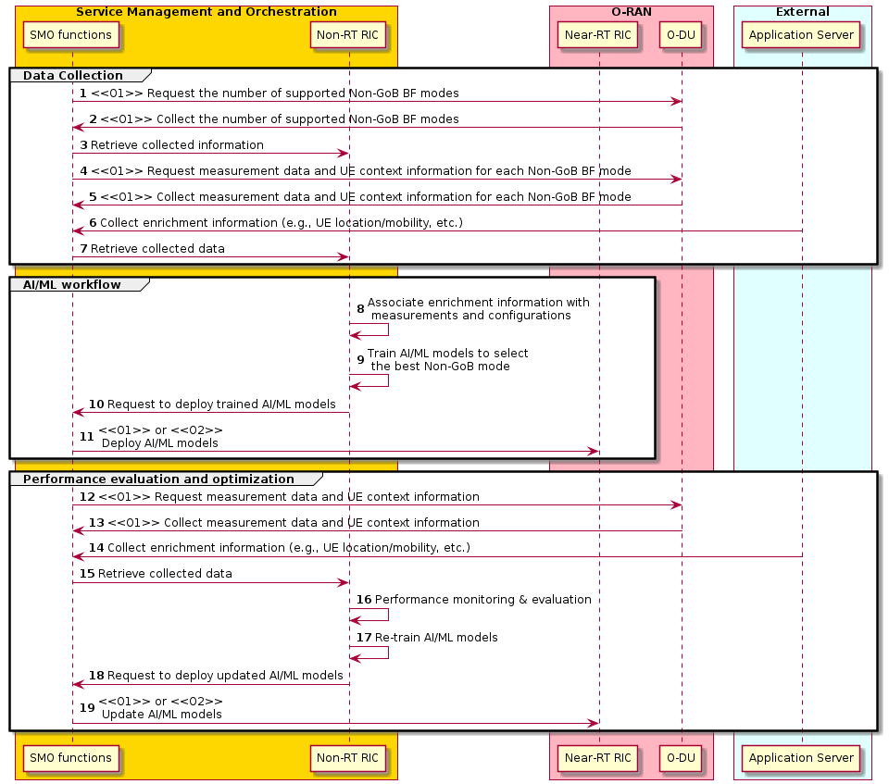
Figure 4.7.2.3.1-1: AI/ML-assisted Non-GoB BF mode selection - model training, deployment, and performance monitoring

The context of the AI/ML-assisted Non-GoB BF mode selection – model inference is captured in table 4.7.2.3.1-2.

Table 4.7.2.3.1-2: AI/ML-assisted Non-GoB BF mode selection – model inference
Use Case Stage | Evolution / Specification | <<Uses>>  Related use
Goal | To generate Non-GoB control/policy message.
Actors and Roles | SMO, Non-RT RIC, Near-RT RIC, O-DU, external sources, e.g., application server
Assumptions | - All relevant functions and components are instantiated.
Pre-conditions | - A1 interface is established between Non-RT RIC and Near-RT RIC to enable enrichment information transfer.  - E2 interface is established between Near-RT RIC and O-DU to enable Non-GoB BF mode selection via E2 control/policy message  - O-DU supports Non-GoB BF.
Begins when | Operator specified trigger condition or event is satisfied.
Step 1 (O) | The Near-RT RIC queries available EI type identifiers.
Step 2 (O) | The Non-RT RIC responds an array of identifiers of all available EI types.
Step 3 (O) | The Near-RT RIC queries the EI type to support Non-GoB BF inference (e.g., UE mobility/location info).
Step 4 (O) | The Non-RT RIC responds detailed information related to the queried EI type.
Step 5 (O) | The Near-RT RIC creates an EI job.
Step 6 (O) | The Non-RT RIC responds to the EI job creation request.
Step 7 (O) | SMO collects enrichment information (e.g., UE mobility/location info) from external sources, e.g., application server.
Step 8 (O) | Non-RT RIC retrieves collected enrichment information.
Step 9 (O) | Non-RT RIC delivers collected enrichment information as EI job results to the Near-RT RIC via the A1 interface.
Step 9 (M) | Near-RT RIC requests measurement data and UE context information (e.g., SRS periodicity) from O-DU via the E2 interface.
Step 9 (M) | Near-RT RIC collects measurement data and UE context information (e.g., SRS periodicity) from O-DU via the E2 interface.
Step 9 (M) | Near-RT RIC associates received enrichment information with collected measurement data and UE context information.
Step 9 (M) | Near-RT RIC selects the best Non-GoB BF mode, e.g., by performing model inference.
Step 9 (M) | Near-RT RIC generates Non-GoB control/policy message based on inferred Non-GoB BF mode selection.
Step 9 (M) | Near-RT RIC sends Non-GoB control/policy message to O-DU via the E2 interface.
Ends when | Operator specified trigger condition or event is satisfied.
Exceptions | None identified.
Post Conditions | Non-RT RIC monitors the performance of AI/ML-assisted Non-GoB BF mode selection in the Near-RT RIC.
Traceability | REQ-Non-RT-RIC-FUN9,  REQ-A1-FUN3

@startuml
skinparam ParticipantPadding 5
skinparam BoxPadding 10
skinparam defaultFontSize 12
autonumber

Box “Service Management and Orchestration” #gold
Participant “SMO Functions” as smo
Participant “Non-RT RIC” as non
End box

Box “O-RAN” #lightpink
Participant near as “Near-RT RIC”
Participant ran as “O-DU”
End box

Box “External” #lightcyan
Participant “Application Server” as app
End box

group Query EI identiers
non <- near : <<A1>> Query EI type identifiers
non -> near : <<A1>> List of EI type identifers
end
group Query EI type
non <- near : <<A1>> Query EI type
non -> near : <<A1>> Information for the EI type
end
group Create EI job
non <- near : <<A1>> Create EI job
non -> near : <<A1>> EI job creation response
end
app -> smo : Collect enrichment information (e.g., UE location/mobility, etc.)
smo -> non : Retrieve collected data
group Deliver EI job results
non -> near : <<A1>> Deliver EI job results
end

group E2 control & Policy
near -> ran : <<E2>> Request measurement data \n and UE context information
ran -> near : <<E2>> Collect measurement data \n and UE context information
near -> near: Associate enrichment information with \n collected measurements and configurations
near -> near : Perform AI/ML model inference
near -> near : Generate Non-GoB control/policy message
near -> ran : <<E2>> Non-GoB control/policy message
end

@enduml
The flow diagram of the AI/ML-assisted Non-GoB BF mode selection – inference is given in figure 4.7.2.3.1-2.

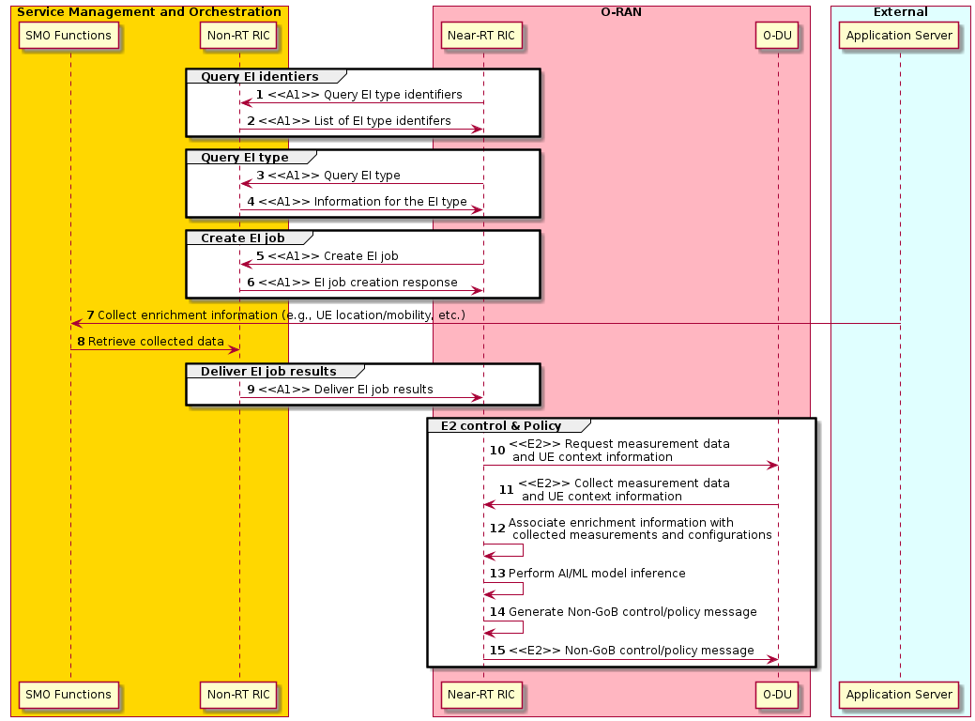
Figure 4.7.2.3.1-2: AI/ML-assisted Non-GoB BF mode selection - inference

4.7.2.4 Required data
The specification of the data communicated over O1 is outside the scope of WG2.
The following enrichment information from external sources (e.g., application server) are used in model training and inference:
- UE location
- UE mobility
- Time granularity of the enrichment information reports (e.g., integer multiple of a second)
Note that for model inference, above EI is sent from Non-RT RIC to Near-RT RIC via the A1 interface.

4.7.2.5 A1 enrichment information example
In training phase, the retrieved enrichment information (e.g., UE mobility and location information) needs to be associated with collected per-UE L1/L2 measurement reporting (e.g., L1-RSRP and/or L1-SINR, etc.) and UE context information (e.g., UE-specific SRS periodicity) by the Non-RT RIC. In the inference phase, such data association is performed by the Near-RT RIC. Therefore, the EI delivered over the A1 interface should contain necessary UE identification to facilitate the data association at the Near-RT RIC. The Near-RT RIC shall be able to recognize the UE identification and be able to map it to the UE identification used over the E2 interface.
For example, the A1 enrichment information contains the following information elements:
- UE identifier
- Position of the UE
- Height of the UE
- Time stamp when the position and height was recorded

4.7.3 MIMO optimization via MIMO DL Tx power optimization, MU-MIMO pairing, and MIMO mode selection
This use case will provide the objective, solutions, and data requirements related to MIMO optimization based on three key sub-features involving downlink transmit power, MIMO pairing enhancement (user separability), and user MIMO mode selection (MU-MIMO or SU-MIMO) that are described in detail in the O-RAN.WG1.MMIMO-USE-CASES-TR-v01.00 [i.3]. The use-case leverages Non-RT RIC to train and host the relevant models and applications that rely on O1 interface services to intelligently optimize MIMO capacity and user experience.

4.7.3.1 Background and goal of the use case

4.7.3.1.1 MIMO downlink transmit power optimization
For general downlink precoding, the downlink transmit power is usually evenly distributed across the UEs. However, depending on the UE separability and path loss deltas, this can result in good cell capacity at the expense of individual UE quality. This can be due to several issues such as cell edge UEs having general downlink SINR issues (even without MU-MIMO), poor UE separability between cell edge UEs, and poor uplink SINR resulting in degraded SRS which are a few example issues. The result of these issues can be manifested by observations of very poor individual UE SINRs (either downlink, uplink, or both) when running in a MU-MIMO mode. Therefore, although the capacity of the cell has been significantly increased, certain customer experiences can become unacceptable in this MU-MIMO mode.
The solution to the problem described above is to simply provide observations of UE performance in the form of periodic histograms of UE channel quality as well as the overall cell capacity in order to compute an optimal solution via AI/ML with control of the downlink minimum required SINR threshold to achieve a minimal UE quality requirement that is set by the operator. The minimum required SINR is a threshold recommendation and thus doesn’t require real time AI/ML adjustment of transmit power directly but rather leaves this to the scheduler to adjust and optimize consistent with its numerous other priorities and requirements.
The value of this observability and adjustability allows the operator to optimize the trade-off between cell capacity and individual user/customer quality which is essential to provide the best customer experience. The trade-off, for example, can reduce a very high cell centre data rate (which would likely be unnoticeable for the user) to allow more power to be allocated to the cell edge user (who is noticing low tput and large latencies) to improve the cell edge data rate situation.

4.7.3.1.2 MU-MIMO pairing enhancement (user separability)
Existing channel orthogonality between multiple users is critical to create user separability and allow for the opportunity to share radio frequency resources simultaneously. Failing this, residual interference will be too high to maintain adequate post pairing radio link signal quality levels required to sustain MU-MIMO mode assignments. With mobility there is an added demand to adjust beamforming weight assignments to not only maintain signal power levels at the user end (beam quality), but also to continuously limit the inter user interference experienced between users assigned with the same radio resource allocations. If these challenges are left unaddressed, a 5G massive MIMO deployment will fail to utilize the full capability of large antenna arrays powered by transceivers designed to transmit data channel signals towards a spatially confined direction. Further, the network will also fail to realize potential multiplexing gains as fewer radio resource blocks are shared between users within the same cell, reducing spectral efficiency.
Another important aspect is the need to efficiently identify users with low demand for radio resources - sources of bursty traffic. An intelligent assessment of how best such users can be effectively paired, if at all, with other users, needs to be pre-determined by the RIC. In summary, this use case suggests various measurement objects that are recommended as input into the AI/ML analytics Apps to optimally determine the outputs required to optimize the MU-MIMO feature operation.
The AI/ML assisted modelling and training output, along with the Non-RT RIC based enhancement/inference, will strive to deliver end goal solution selections and system configuration options that upon adoption within the respective domains where they reside, realize an optimization framework that maximizes the potential of a MU-MIMO feature. Capacity augmentation will be realized by successfully assigning MU-MIMO layers to a greater number of users simultaneously, more often, and more uniformly across the serving area of each gNB.

4.7.3.1.3 MIMO mode selection optimization (MU-MIMO vs SU-MIMO selection)
A successful MU-MIMO operation involves the realization of as many orthogonal radio frequency channel links between multiple spatially separated users as possibly as supported by the implementation software at the digital domain. Key to such realization is the successful beamforming weight determination that enables not only the phase addition of multipath signals at the user receiver, but also the choice of precoding algorithms which limit the residual interference between the paired users. It can make sense for the scheduler to prioritize the assignment of radio resources to a MU-MIMO mode of operation during periods of congestion or when high latency requiring applications are supported (to free up other resources that can be assigned sooner). However, doing so at the expense of undesirably lower spectral efficiency on these assigned radio resources will reduce overall sector throughput levels and create poor user experience. It is important to find a means through the AI/ML agent to distinguish users and identify sectors where optimal operation means a greater assignment of SU-MIMO modes independently to users, especially those requiring higher throughput, using devices that are capable of supporting higher layer SU-MIMO count, and operating in an environment that sustains a greater channel rank.
With increased loading massive MIMO systems will incur rising levels of interference on the uplink from connected users and on the downlink from the gNB. In addition to normal SINR measurements, the diagnosis of interference from all spatial directions uniformly (white spatial noise) versus specific directions (spatially correlated noise) will be of interest and will require MIMO modes (SU-MIMO vs MU-MIMO) to be properly selected for assignment on a user basis. Such implementation will optimize the per user and per cell throughputs, taking into consideration channel orthogonality conditions rank realizable, and per user effective bandwidth requirement.

4.7.3.2 Entities/resources involved in the use case
- SMO/Non-RT RIC:
  - Retrieve relevant performance measurement data and RAN configurations from O-DU via the O1 interface.
  - Perform model training and model deployment based on identified measurement data.
  - Perform model performance monitoring and model re-training as required.
  - Provide RAN configuration recommendations based on identified parameters to O-DU over O1 interface.
  - Allow rApps to access the measurement data and to provide configuration recommendations via relevant R1 interface services.

- O-DU:
  - Send measurement data and RAN configurations to SMO/Non-RT RIC via the O1 interface.
  - Support implementation of MIMO configuration parameters received from the SMO/Non-RT RIC via the O1 interface.

4.7.3.3 Solutions

4.7.3.3.1 MIMO optimization via DL SINR threshold, MU-MIMO pairing, and MIMO mode selection
The context of the MIMO optimization via DL Tx power, pairing enhancement, and mode selection is captured in table 4.7.3.3.1-1.

Table 4.7.3.3.1-1: MIMO optimization via DL Tx power, pairing enhancement, and mode selection
Use Case Stage | Evolution / Specification | <<Uses>>  Related use
Goal | To train and deploy AI/ML models for MIMO optimization that given wireless conditions and RAN configuration information as input will generate configuration recommendations for DL SINR threshold, MU-MIMO user pairing, and MIMO mode selection.
Actors and Roles | SMO, Non-RT RIC, O-DU
Assumptions | - All relevant functions and components are instantiated.  - O1 interface connectivity is established.
Pre-conditions | - O1 interface is established between SMO and O-DU to enable SMO/Non-RT RIC to collect performance measurement data and associated RAN configurations.  - O-DU supports the implementation of identified configuration parameters when configuration recommendation is received via O1 interface.
Begins when | Operator specified trigger condition or event is satisfied.
Step 1 (M) | SMO requests performance measurement data and associated RAN configurations from O-DU for model training via the O1 interface.
Step 2 (M) | SMO collects required performance measurement data and RAN configurations from O-DU via the O1 interface.
Step 3 (M) | Non-RT RIC FW retrieves collected information.
Step 4 (O) | Non-RT RIC performs model training/update.
Step 5 (O) | Non-RT RIC deploys trained model for inference.
Step 6 (M) | SMO requests performance measurement data from O-DU for performance monitoring via the O1 interface for rApp execution and optionally model inference.
Step 7 (M) | SMO collects performance measurement data from O-DU for performance monitoring via the O1 interface for rApp execution and optionally model inference.
Step 8 (M) | Non-RT RIC FW retrieves the collected data.
Step 9 (M) | rApp accesses the collected data via R1 interface services.
Step 10 (M) | rApp performance monitoring and evaluation and optional model inference.
Step 11 (M) | rApp generates configuration recommendation.
Step 12 (M) | Non-RT RIC FW retrieves the configuration recommendation via R1 interface services.
Step 13 (M) | Non-RT RIC provides configuration output to SMO O1 termination.
Step 14 (M) | SMO communicates MIMO configuration recommednation to O-DU via O1 interface.
Ends when | Operator specified trigger condition or event is satisfied.
Exceptions | None identified.
Post Conditions | O-DU implements the configuration recommendations provided by MIMO optimization App.
Traceability | REQ-Non-RT-RIC-FUN1, REQ-Non-RT-RIC-FUN2, REQ-Non-RT-RIC-FUN5, REQ-Non-RT-RIC-FUN8  REQ-R1-FUN9

@startuml
skinparam ParticipantPadding 5
skinparam BoxPadding 10
skinparam defaultFontSize 12
autonumber

Box “Service Management and Orchestration” #gold
Participant “Collection & Control” as smo
Participant “Non-RT RIC” as non
Participant “rApps” as rapp
End box

Box “O-RAN” #lightpink
Participant ran as “O-DU”
End box

group Data Collection
smo -> ran : <<O1>> Request measurement data and RAN configurations
ran -> smo : <<O1>> Collect measurement data and RAN configurations
smo -> non : Retrieve collected data and configuration

end

group AI/ML workflow (O)
non --> non : Train/update AI/ML models for MIMO optimization
non --> non: Deploy AI/ML models
end

group Performance evaluation and optimization
smo -> ran : <<O1>> Request measurement data and RAN configurations
ran -> smo : <<O1>> Collect measurement data and RAN configurations
smo -> non : Retrieve collected data and configuration
non -> rapp : <<R1>> Access collected data and configuration
rapp -> rapp : Performance monitoring & evaluation, \n optional model inference
rapp -> rapp : Generate MIMO configuration recommendation
rapp -> non : <<R1>> Provide MIMO configuration recommendation
non -> smo : Provide MIMO configuration recommendation
smo -> ran : <<O1>> MIMO configuration recommendation message
end
@enduml
The call flow for MIMO optimization use case is given in figure 4.7.3.3.1-1.
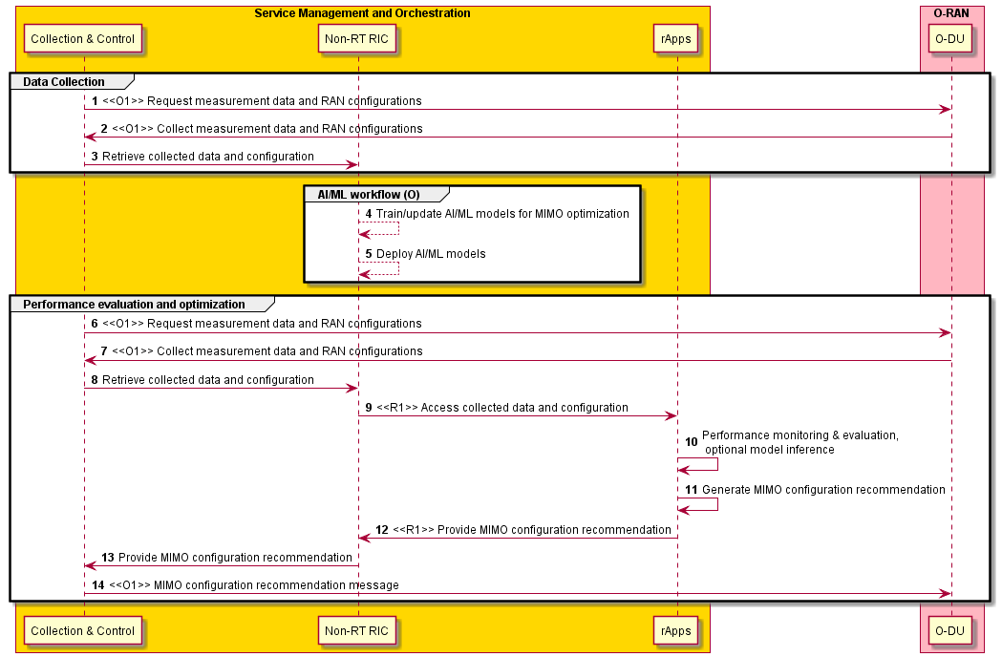
Figure 4.7.3.3.1-1: Call flow for MIMO optimization use case

4.7.3.4 Required data
The specification of the data communicated over O1 is outside the scope of WG2.
There are no data that are relevant for the A1 interface.

4.7.4 AI/ML-based initial access (SS Burst Set) configuration optimization

4.7.4.1 Background and goal of the use case
3GPP NR based wireless cellular networks promises to provide leaner system design compared to its predecessors in a bid to improve spectral efficiency, power consumption performance and reduce interferences. Ultra-lean design aims to minimize “always on” reference signal transmissions in the downlink. Synchronization Signals Burst (SSB) sets are one of the high-overhead “always on” reference signals. In large scale NR networks with thousands of gNB/Transmission-Reception Points (TRPs) deployed, system configurations derived statically/manually aiming to accommodate worst case scenario which may arise only for a small window of time can impact on the followings:
- Increased overhead i.e., degraded utilization of time-frequency resources affecting Spectral Efficiency (SE).
- Increased interferences among the cells.
- Increased power consumptions in both network and UEs leading increased network CAPEX and reduced UE battery life respectively.
In this context, this sub-use case proposes an AI/ML assisted optimization framework wherein AI/ML agent/engine running at Non-RT RIC can infer optimal SSB set configuration (i.e., number of SS blocks, SS beam directions and SS burst periodicity) based on Configuration (CM) parameters, Performance Measurements (PM), Key Performance Indicators (KPI), and measurement report traces obtained from the E2 nodes (O-CU-CP, O-CU-UP, O-DU, O-eNB) and O-RU. At high-level, the goal of the optimization problem is to minimize SS signal transmissions overhead i.e., determine the minimum number of SSB beams required, their directions and periodicity subject to KPI (integrity, mobility, etc.) targets.
The overall scheme can be summarized as follows. Based on the history/trace/distribution of UE-specific beams (e.g., P2 beams), the AI/ML engine determines the minimum number of SSB beams, their directions and the maximum periodicity of the SS burst required to achieve KPI targets as per history/trace/distribution of UE-specific beams. Furthermore, in order to handle the lower probability occurrences in the statistical models e.g., UEs appearing in a completely new direction that has not been considered in the training data, the AI/ML engine (if required) updates the optimal set (e.g., adds beam directions that compliments the optimal directions, updates the SS burst periodicity etc.). Finally, the AI/ML engine shares the optimized SSB set configuration with gNB.

4.7.4.2 Entities/resources involved in the use case
- SMO & Non-RT RIC framework:
  - Collect the necessary Configuration (CM) parameters, Performance Measurements (PM), Key Performance Indicators (KPI), and measurement report traces from the E2 nodes (O-CU-CP, O-CU-UP, O-DU, O-eNB) and O-RU.
  - Allow the rApp to receive the CMs, PMs, KPIs measurement data (collected via O1) to perform the AI/ML model training and provide inference on the SSB set configuration parameters (number of SS blocks, SS beam directions and SS burst periodicity).
  - Write/update the optimized SSB set configuration via O1 (to O-DU) interface.

- rApps:
  - Retrieve the necessary Configuration (CM) parameters, Performance Measurements (PM), Key Performance Indicators (KPI), and measurement report traces pertaining to the E2 nodes and O-RU from the SMO/Non-RT RIC framework via R1 for the purpose of optimizing SSB set configuration.
  - Train AI/ML model to optimize the SSB set configurations.
  - Modify/update the SSB set configurations, optimized by the inference engine of the rApp, and write the configuration output to the SMO/Non-RT RIC framework via R1.
  - Monitor the performance of the respective cells. Upon KPI degradation, initiate rollback to the previous version of the AI/ML model, if any, and/or trigger the AI/ML model retraining.
  - Execute the inference/control loop periodically or on an event-triggered based.

- E2 nodes and O-RU:
  - Report the desired performance measurements and KPIs, configuration parameters and CM changes, trace reports and measurements to the SMO via O1.
  - Receive the optimized SSB set configurations from the SMO via O1 and apply the configuration on the O-DU which may further exercise the configuration update on the O-RU.
NOTE: Both aggregated and disaggregated gNB architectures are supported.

4.7.4.3 Solutions
The context of the creation and deployment of mMIMO SSB set optimization applications is captured in table 4.7.4.3-1.

Table 4.7.4.3-1: Creation and deployment of mMIMO SSB set optimization applications
Use Case Stage | Evolution / Specification | <<Uses>>  Related use
Goal | SSB set optimization
Actors and Roles | SMO/Non-RT RIC framework, SS burst set optimization rApp, E2 nodes, O-RU
Assumptions | All relevant functions and components are instantiated.  O1 interface connectivity is established.
Pre-conditions | SMO/Non-RT RIC framework is instantiated.  O1 interface is established between SMO and E2 nodes.
Begins when | SSB optimization rApp with initial ML model is deployed.
Step 1-3(M) | SMO/Non-RT RIC framework collects the necessary configurations, performance indicators, and measurement reports from E2 nodes.
Step 4-5 (M) | rApp retrieves the necessary configurations, performance indicators, and measurement data from SMO/Non-RT RIC framework via R1 and trains AI/ML model for the purpose of optimizing SSB set configuration.
Step 6 (M) | SMO/Non-RT RIC framework collects observation data from E2 nodes.
Step 7-9 (M) | rApp retrieves the observation data from SMO/Non-RT RIC framework via R1, infers SSB set configuration, and shares the configuration to SMO/Non-RT RIC framework.
Step 10-11 (M) | SMO/Non-RT RIC framework writes/updates SSB set configuration at E2 nodes.
Step 12-18(M) | rApp continuously monitors KPIs in respective cells. In case of unsatisfactory performance, it initiates fallback and retrains/updates the respective AI/ML model(s).
Ends when | On operator request for rApp to be disabled.
Exceptions | None identified.
Post Conditions | SSB set configuration is active.
Traceability | REQ-Non-RT-RIC-FUN1, REQ-Non-RT-RIC-FUN2, REQ-Non-RT-RIC-FUN5, REQ-Non-RT-RIC-FUN6

The flow diagram of SSB set optimization is given in figure 4.7.4.3-1.

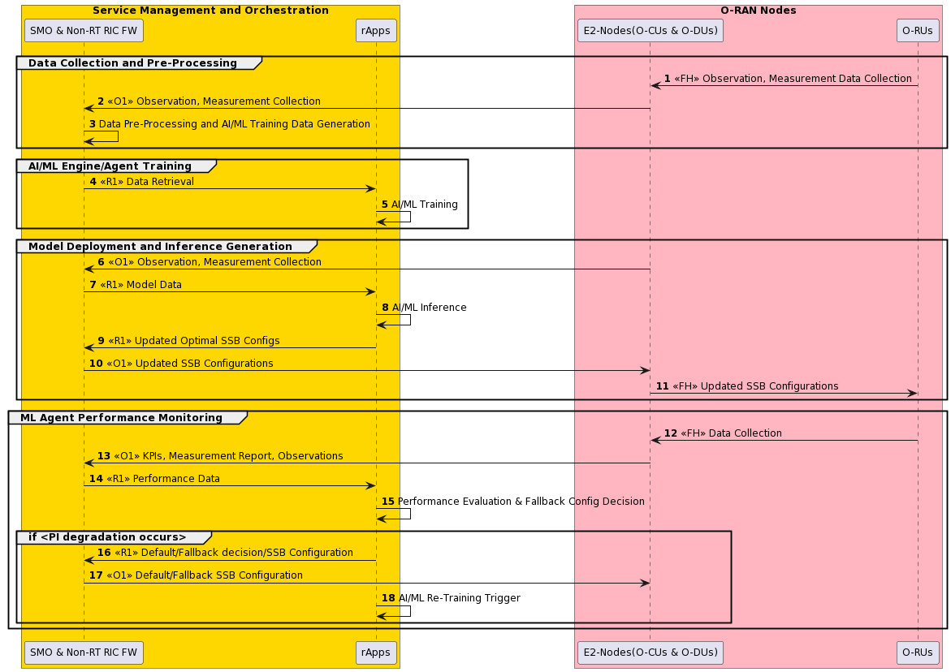
Figure 4.7.4.3-1: Flow diagram of SSB set optimization
@startuml
skinparam defaultFontSize 12

Box "Service Management and Orchestration" #gold
Participant "SMO & Non-RT RIC FW" as SMO
Participant "rApps" as NRTRIC
End box

Box "O-RAN Nodes" #lightpink
Participant "E2-Nodes(O-CUs & O-DUs)" as E2NODES
Participant "O-RUs" as ORUs
End box

Autonumber

group Data Collection and Pre-Processing
ORUs -> E2NODES : <<FH>> Observation, Measurement Data Collection
E2NODES -> SMO : <<O1>> Observation, Measurement Collection
SMO -> SMO : Data Pre-Processing and AI/ML Training Data Generation

end

group AI/ML Engine/Agent Training
SMO -> NRTRIC : <<R1>> Data Retrieval
NRTRIC -> NRTRIC: AI/ML Training
end

group Model Deployment and Inference Generation
E2NODES -> SMO : <<O1>> Observation, Measurement Collection
SMO -> NRTRIC : <<R1>> Model Data
NRTRIC -> NRTRIC: AI/ML Inference
NRTRIC -> SMO : <<R1>> Updated Optimal SSB Configs
SMO -> E2NODES : <<O1>> Updated SSB Configurations
E2NODES -> ORUs : <<FH>> Updated SSB Configurations

end

group ML Agent Performance Monitoring
ORUs -> E2NODES : <<FH>> Data Collection
E2NODES -> SMO : <<O1>> KPIs, Measurement Report, Observations
SMO -> NRTRIC : <<R1>> Performance Data
NRTRIC -> NRTRIC: Performance Evaluation & Fallback Config Decision
group if <PI degradation occurs>
NRTRIC -> SMO : <<R1>> Default/Fallback decision/SSB Configuration
SMO -> E2NODES : <<O1>> Default/Fallback SSB Configuration
SMO -> NRTRIC : <<R1>> Model retraining and update request
NRTRIC -> NRTRIC: AI/ML Re-Training Trigger
end
end
@enduml

4.7.4.4 Required data

4.7.4.4.1 Input data
              - Supported SSB configurations per cell (as specified in 3GPP TS 38.331 [20], clause 6.3.2 and in 3GPP TS 28.541 [4], clause 4.3.5).
              - Key Performance Indicator (KPIs) such as integrity and cell/beam mobility KPIs, etc., for service level assurance (as specified in 3GPP TS 28.552 [5] and in 3GPP TS 28.554 [17]).
              - CSI-RS beam configuration and CSI-RS beam-specific UE measurement reporting from tracing of RRC messages (as specified in 3GPP TS 38.331 [20], clause 5.5.5.2).
              - PMs, such as the distribution of SS-RSRP, SS-RSRQ across of UEs measured per cell, number of RRC connected UEs (mean, max) measured per cell, intra-NRCell SSB beam switch measurement and received random access preambles on a per SSB/per cell basis (as specified in 3GPP TS 28.552 [5], clauses 5.1.1.22, 5.1.1.31, 5.1.1.4, 5.1.1.20 and 5.1.1.21).
              - Radio Link Failure (RLF) tracing across UEs across SSBs per cell (as specified in 3GPP TS 37.320 [19], clause 5.4.1.2, 3GPP TS 32.422 [18], clause 4.3 and in 3GPP TS 38.331 [20], clause 5.3.10).
              - DL/UL throughput per cell (as specified in 3GPP TS 28.552 [5], clause 5.1.1.3).

4.7.4.4.2 Output data
- Inferred SSB set (number of SS blocks, SS beam directions and SS burst periodicity) configuration per cell (as specified in 3GPP TS 28.541 [4], clauses 4.3.39 and 4.3.40).

4.8 Network energy saving
This clause contains the set of energy saving use cases.

4.8.1 Carrier and cell switch off/on

4.8.1.1 Background and goal of the use case
Mobile networks often utilize multiple frequency layers (carriers) to cover the same service area. At low load, i.e., when the expected traffic volume is lower than a fixed threshold, ES can be achieved by switching off one or more carriers or entire cells without impairing the user experience. UEs previously served by the carrier or cell will be offloaded by the E2 node(s) to a new target carrier or cell prior to the switch off.
However, the switch off/on decisions are not a trivial task. There are conflicting targets between system performance and energy savings. Other carriers / cells will have to serve the additional traffic and traffic is changing over time. E2 node(s) and O-RU(s) support several techniques effecting energy consumption which might also be load dependent. While energy savings for the switched off carrier/cell is maximized, the overall energy consumption of the network might even increase.
Carrier and cell switch off/on control by the Non-RT or Near-RT RIC can consider overall network energy efficiency instead of local optimization. The switch off/on decision can optionally be made by an AI/ML model within the inference host, deployed at the Non-RT RIC to further improve decision making. Among others, the AI/ML models' functionality can include prediction of future traffic, user mobility, and resource usage and can also predict expected energy efficiency enhancements, resource usage, and network performance for different ES optimization states. Also, with addition of per-UE geographical location information such as trace record for immediate MDT measurement (as specified in 3GPP TS 32.423 [11], clause 4.34.1) and trace record for UE location information (as specified in 3GPP TS 32.423 [11], clause 4.34.2) as input data, the increased accuracy for UE location/trajectory prediction could be expected for more efficient solution so that it could prevent switched off cell(s) from being switched on even though meaningful number of UEs generating/receiving traffic do not exist in that cell(s). In that sense these collections could be conditionally activated during some cells being switched off and be deactivated once all cells switched on in terms of UE energy saving. Possible differences among collected types of geographical location information such as between MDT and LMF are expected to be absorbed and exposed to rApp(s) based on R1 data type definition.
Before switching off/on carrier(s) or cell(s), there is a possibility the E2 node(s) and O-RU(s) of performing some preparation actions for off switching (e.g. check ongoing emergency calls and warning messages, to enable, disable, modify carrier aggregation and/or dual connectivity, to trigger HO traffic and UEs from cells/carriers to other cells or carriers, informing neighbour nodes via X2/Xn interface, etc.) as well as for on switching (e.g., cell probing, informing neighbour nodes via X2/Xn interface, etc.).This solution proposes a framework that allows the operator to flexibly configure carrier and cell switch off/on parameters in a cell or in a cluster of cells through O1 configuration formulated by rApp towards E2 node(s) and O-RU(s) or A1 policies formulated by rApp towards Near-RT RIC through SMO/Non-RT RIC framework assisted by machine learning (ML) techniques.

4.8.1.2 Entities/resources involved in the use case
- SMO/Non-RT RIC framework function:
- Collect the configurations, performance indicators and measurement reports (e.g., cell load related information and traffic information, EE/EC measurement reports) from E2 node(s) and trace records (e.g., per-UE measurement metrics and location information) through O1 Interface, for the purpose of decision making, optionally using training and inference of AI/ML models that assist such EE/ES functions. It is assumed that configurations, performance indicators and measurement reports collected from the O-DU contain the related information for the corresponding O-RU(s).
- Transfer collected data towards rApp.
- Signal updated configurations for EE/ES optimization towards E2 node(s) (O-CU) through O1 Interface.
- (Optionally) Retrain, update, configure EE/ES AI/ML models in Non-RT RIC.
- Provide A1 policies to Near-RT RIC via A1 interface based on the request from energy saving rApp in the case of A1 policy-based solution.
- Send enrichment information to the Near-RT RIC for calculation of coverage overlap via the A1 interface in the case of A1 policy-based solution..n the case of A1 policy-based solution.
- rApps:
  - Energy saving rApp
- Collect the necessary configurations, performance indicators, and measurement reports from SMO/Non-RT RIC framework, for the purpose of training and execution of relevant AI/ML models.
- (Optionally) Retrain, update, configure EE/ES AI/ML model.
- Infer an optimized O1 configuration for EE/ES based on the data collected using R1 interface.
- Infer an optimized A1 policy for EE/ES based on the data collected using R1 interface in the case of A1 policy-based solution.
  - EI producer rApp ( For A1-EI solution)
              - Support to produce enrichment information data requested by Near-RT RIC to ascertain overlapping carriers/cells and the coverage of those carriers/cells (e.g., geo location information of carriers/cells , coverage samples mapped geo location, etc.)
              - Send enrichment information to the Near-RT RIC through SMO/Non-RT RIC framework functions for calculation of coverage overlap via the A1 interface.
- E2 nodes:
- Report cell configuration, performance indicators and measurement reports (e.g., cell load related information and traffic information, EE/EC measurement reports, trace records such as per-UE measurement metrics and location information) to SMO via O1 interface.
- Report measurement reports (e.g., cell load related information and traffic information, EE/EC measurement reports) to Near-RT RIC via E2 interface in the case of A1 policy-based solution.
- Perform actions required for EE/ES optimization.
  - e.g. check ongoing emergency calls and warning messages, perform some preparation actions for off switching (e.g., to enable, disable, modify carrier aggregation and/or dual connectivity, to trigger HO traffic and UEs from cells/carriers to other cells or carriers, informing neighbour nodes via X2/Xn interface etc.) as well as for on switching (e.g., cell probing, informing neighbour nodes via X2/Xn interface etc.) and make final decision on switch off/on and notify SMO via O1 interface about performed actions in case of O1 based solution or notify Near-RT RIC via E2 interface about performed actions in case of A1 policy-based solution.
- O-RU:
- Report EC and EE related information via open FH M-plane interface to O-DU.
- Support actions required to perform EE/ES optimization.
  - Updated carrier configuration (i.e., activation, deactivation or sleep).
- Near-RT RIC (For A1 policy-based solution):
- Collect measurement reports (e.g., cell load related information and traffic information, EE/EC measurement reports) from E2 nodes.
- (Optionally) Receive EE/ES AI/ML model for deployment via O1 or O2 interface.
- Receive EE/ES related policies via A1 interface for consideration during optimization.
- Analyse the received data from E2 nodes and perform AI/ML model inference to determine EE/ES. Optimization (i.e., if carriers or cells are recommended to be switched off/on) considering the optimization targets/policies.
- Provide policies or required information to E2 node (O-CU) via E2 to trigger actions for EE/ES optimization.
- Receive enrichment information via the A1 interface.
- Associate enrichment information with collected measurements.

4.8.1.3 Solution

4.8.1.3.1 O1 interface based carrier and cell switch off/on optimization for energy saving
In this solution, decision making, potentially including AI/ML model training and inference, is done at the Non-RT RIC.
The context of the O1 interface based carrier and cell switch off/on optimization for energy saving is captured in table 4.8.1.3.1-1.

Table 4.8.1.3.1-1: O1 interface based carrier and cell switch off/on optimization for energy saving
Use Case Stage | Evolution / Specification | <<Uses>>  Related use
Goal | Enable carrier and cell switch off/on energy saving functions in the network by means of configuration parameter change and actions controlled by Non-RT RIC and allow for AI/ML-based solutions.
Actors and Roles | SMO/Non-RT RIC framework function: O1 termination.  rApp: Carrier and cell switch off/on optimization.  E2 node(s), O-RU: Enforces carrier and cell switch off/on optimization configurations.
Assumptions | O1 interface connectivity is established.  Open FH M-plane interface is established between E2 node(s) and O-RU.  Network is operational.  Non-RT RIC has knowledge about overlapping carriers/cells and the coverage of those carriers/cells (e.g., which carrier/cell is a coverage layer, and which is a capacity layer).
Pre-conditions | Operator has set the targets for energy saving functions in the Non-RT RIC.
Begins when | Operator enables the optimization rApp along with initial ML model for carrier and cell switch off/on energy saving functions and E2 node(s) and O-RU(s) become operational.
Step 1 (M) | rApp requests to collect necessary configurations, performance indicators, and measurement data (e.g., cell load related information and traffic information, EE/EC measurement reports, cell level configurations, per-UE measurement metrics and location information) towards SMO/Non-RT RIC framework function over R1 interface.
Step 2 (M) | SMO/Non-RT RIC framework function requests data collection towards E2 node(s) and O-RU(s) (via E2 node(s)) over O1 Interface.
Step 3 (M) | E2 node(s) upon receiving request from SMO/Non-RT RIC framework function requests and collect necessary data form O-RU(s) over open FH M-plane interface.
Step 4 (M) | E2 node(s) sends the configuration data, configured measurement data to SMO/Non-RT RIC framework function periodically or event based.
Step 5 (M) | rApp collects the configuration data, collected measurement data for processing.
Step 6 (O) | AI/ML models can be retrained either on Non-RT RIC framework or on rApp. If Non-RT RIC framework is hosting retraining, then rApp to select AI/ML model and initiate retraining on Non-RT RIC framework.  See NOTE 1.
Step 7 (O) | Upon receiving retraining request from rApp. Non-RT RIC framework initiates AI/ML model retraining.
Step 8 (O) | rApp monitors retrained AI/ML model and retrieves retrained AI/ML model.  See NOTE 2.
Step 9 (O) | Upon receiving retrieval request from rApp, Non-RT RIC framework to transfer AI/ML model to rApp.  See NOTE 3.
Step 10 (O) | If AI/ML model retraining is hosted by rApp then AI/ML model to be retrained on rApp itself.
Step 11 (O) | Once AI/ML model retraining is performed, AI/ML models are deployed and activated for inferencing for which rApp constantly monitors,  - performance and energy consumption of the E2 node(s)  - energy consumption of O-RU(s).  rApp monitors performance and energy consumption for evaluation of necessary O1 configurations required to perform cell and carrier shutdown.
Step 12 (M) | rApp generates O1 configurations to prepare and execute cell(s) and carrier(s) off/on SMO/Non-RT RIC framework function.
Step 13 (M) | SMO/Non-RT RIC framework function instructs E2 node(s) via O1 interface to perform the received request(s) from the rApp.
Step 14 (M) | O-RU(s) is informed about the updated O-RU(s) configuration via open FH M-plane interface by E2 node. O-RU(s) to notify E2 node(s) once O-RU(s) configuration is implemented.
Step 15 (M) | E2 node(s) will inform SMO/Non-RT RIC framework function once cell or carrier switch off/on is completed.
Step 16 (M) | SMO/Non-RT RIC framework inform rApp about completion of cell or carrier switch off/on over R1 interface.
Step 17 (M) | rApp monitors energy saving objectives and if energy saving objectives are not achieved, it can decide to initiate fallback mechanism for example, reverting changes over O1 interface for carrier and cell switch off/on optimization, and/or AI/ML model update or retraining.
Ends when | E2 node(s) becomes non-operational or when the operator disables the optimization functions or ML model for energy saving.
Exceptions | TBD
Post Conditions | rApp continues monitoring of energy saving function at E2 node(s) and O-RU.  E2 node(s) and O-RU(s) operate using the newly deployed parameters/models and state (off/on).
NOTE 1: AI/ML procedures mentioned here can be subject to change based on future work on AI/ML workflow in WG2.
NOTE 2: AI/ML model retrieval procedure over R1 interface is for illustration purpose, can be subject to change based on future work on AI/ML workflow in WG2.
NOTE 3: AI/ML model transfer procedure over R1 interface is for illustration purpose, can be subject to change based on future work on AI/ML workflow in WG2.

@startuml
'https://plantuml.com/sequence-diagram
!pragma teoz true
Skin rose
skinparam ParticipantPadding 5
skinparam BoxPadding 10
skinparam defaultFontSize 12
skinparam lifelineStrategy solid
autonumber
Box "Service Management and Orchestration Framework" #gold
Box #lightgrey
Participant "Energy Saving\nrApp" as rAPP
End Box
Participant "SMO / Non-RT RIC\nFWK Function" as NRTF
End box
Box " RAN Nodes" #lightpink
Participant "E2-Node(s)" as E2NODES
Participant "O-RU(s) " as ORUs
End box
group Data Collection
rAPP-> NRTF : <<R1>> Data collection request
NRTF -> E2NODES : <<O1>> Data collection request
E2NODES <-> ORUs : <<FH>> Data collection request
E2NODES -> NRTF : <<O1>> Data Collection
NRTF -> rAPP : <<R1>> Data Collection
End
group Data Analysis /AIML Training and Inference
alt trainig on Non-RT RIC Fwk
rAPP -> NRTF : <<R1>> Select AI/ML Model and Inintiate re-training
NRTF -> NRTF : AI/ML Model re-training
rAPP -> NRTF : <<R1>> Retrive Re-trained AIML Model
Note right
rApp monitors re-trained
model parameters and decides
to retieve AIML model
End note
NRTF -> rAPP : <<R1>> Transfer Re-trained AI/ML Model
Else trainig on rApp
rAPP -> rAPP : AI/ML Model re-training
end
rAPP -> rAPP : Deploy and activate re-trained\nAI/ML Model for inferencing
Note right
Performance and Energy
Consumption Monitoring
(E2 Node(s) and O-RU(s))
and O1 configuration evaluation.
End note
end
group Actor Decision Making
rAPP -> NRTF : <<R1>> Configuration to prepare and execute \nfor carrier(s) and cell(s) switch off/on
NRTF -> E2NODES : <<O1>> E2-Node(s) configurations for\ncarrier(s) and cell(s) switch off/on
E2NODES <-> ORUs : <<FH>> Update O-RU(s) Configurations \nand notification of update
E2NODES -> NRTF :<<O1>> Inform Completion of\ncarrier(s) and cell(s) switch off/on
NRTF -> rAPP : <<R1>> Inform Completion of\ncarrier(s) and cell(s) switch off/on
rAPP -> rAPP : Performance monitoring and\nevluation of AI/ML model \n(with possible actions,\ne.g. fallback, re-training)
end

@enduml

@startuml
'https://plantuml.com/sequence-diagram
!pragma teoz true
Skin rose
skinparam ParticipantPadding 5
skinparam BoxPadding 10
skinparam defaultFontSize 12
skinparam lifelineStrategy solid
autonumber
Box "Service Management and Orchestration Framework" #gold
Box #lightgrey
Participant "Energy Saving\nrApp" as rAPP
End Box
Participant "SMO / Non-RT RIC\nFWK Function" as NRTF
End box
Box " RAN Nodes" #lightpink
Participant "E2-Node(s)" as E2NODES
Participant "O-RU(s) " as ORUs
End box
group Data Collection
rAPP-> NRTF : <<R1>> Data collection request
NRTF -> E2NODES : <<O1>> Data collection request
E2NODES <-> ORUs : <<FH>> Data collection request
E2NODES -> NRTF : <<O1>> Data Collection
NRTF -> rAPP : <<R1>> Data Collection
End
group Data Analysis /AIML Training and Inference
alt trainig on Non-RT RIC Fwk
rAPP -> NRTF : <<R1>> Select AI/ML Model and Inintiate re-training
NRTF -> NRTF : AI/ML Model re-training
rAPP -> NRTF : <<R1>> Retrive Re-trained AIML Model
Note right
rApp monitors re-trained
model parameters and decides
to retieve AIML model
End note
NRTF -> rAPP : <<R1>> Transfer Re-trained AI/ML Model
Else trainig on rApp
rAPP -> rAPP : AI/ML Model re-training
end
rAPP -> rAPP : Deploy and activate re-trained\nAI/ML Model for inferencing
Note right
Performance and Energy
Consumption Monitoring
(E2 Node(s) and O-RU(s))
and O1 configuration evaluation.
End note
end
group Actor Decision Making
rAPP -> NRTF : <<R1>> Configuration to prepare and execute \nfor carrier(s) and cell(s) switch off/on
NRTF -> E2NODES : <<O1>> E2-Node(s) configurations for\ncarrier(s) and cell(s) switch off/on
E2NODES <-> ORUs : <<FH>> Update O-RU(s) Configurations \nand notification of update
E2NODES -> NRTF :<<O1>> Inform Completion of\ncarrier(s) and cell(s) switch off/on
NRTF -> rAPP : <<R1>> Inform Completion of\ncarrier(s) and cell(s) switch off/on
rAPP -> rAPP : Performance monitoring and\nevluation of AI/ML model \n(with possible actions,\ne.g. fallback, re-training)
end

@enduml
The flow diagram of O1 interface based carrier and cell switch off/on optimization for energy saving is given in figure 4.8.1.3.1-1.

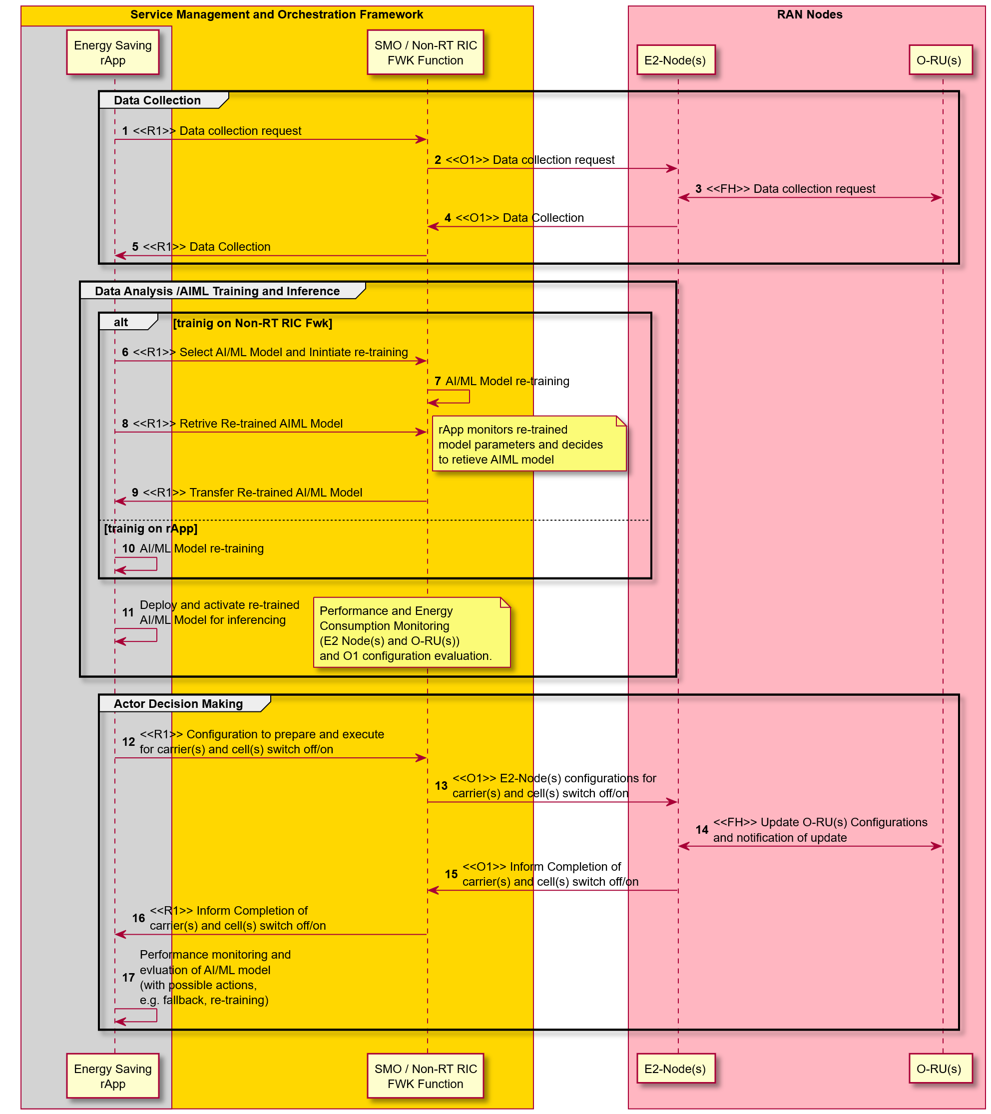
Figure 4.8.1.3.1-1: Flow diagram of O1 interface based carrier and cell switch off/on optimization for energy saving

4.8.1.3.2 A1 policy based carrier and cell switch off/on optimization for energy saving
In this solution, decision making, potentially using AI/ML model inference, is done at Near-RT RIC. While AI/ML model training might be hosted in Non-RT or Near-RT RIC, the description below is based on AI/ML model training in the Non-RT RIC.
The context of the A1 policy based carrier and cell switch off/on optimization for energy saving is captured in table 4.8.1.3.2-1

Table 4.8.1.3.2-1: A1 policy based carrier and cell switch off/on optimization for energy saving
Use Case Stage | Evolution / Specification | <<Uses>>  Related use
Goal | Enable A1 policy based carrier and cell switch off/on energy saving functions in the network by means of configuration parameter change and actions controlled by Near-RT RIC and allow for AI/ML-based solutions.
Actors and Roles | SMO/Non-RT RIC framework function: A1 & O1 termination.  rApp: Carrier and cell switch off/on optimization.  E2 node(s), O-RU: Enforces carrier and cell switch off/on optimization configurations.  Near -RT RIC: Energy savings decision making function.
Assumptions | O1 interface connectivity is established between SMO and E2 nodes.  R1 interface connectivity is established.  Open FH M-plane interface is established between E2 node(s) and O-RU.  E2 interface connectivity is established between E2 node and Near-RT RIC.  A1 interface is established between Non-RT RIC and Near-RT RIC.  Network is operational.
Pre-conditions | Operator has set the targets for energy saving functions in the Non-RT RIC.
Begins when | Operator enables the optimization rApp along with initial ML model for carrier and cell switch off/on energy saving functions and E2 node(s) and O-RU(s) become operational.  See NOTE 1.
Step 1 (M) | rApp requests to collect necessary configurations, performance indicators, and measurement data (e.g., cell load related information and traffic information, EE/EC measurement reports, cell level configurations) towards SMO/Non-RT RIC framework function over R1 interface.
Step 2 (M) | SMO/Non-RT RIC framework function requests data collection towards E2 node(s) and O-RU(s) (via E2 node(s)) over O1 Interface.
Step 3 (M) | E2 node(s) upon receiving request from SMO/Non-RT RIC framework function requests and collect necessary data form O-RU(s) over open FH M-plane interface.
Step 4 (M) | E2 node(s) sends the configuration data, configured measurement data to SMO/Non-RT RIC framework function periodically or event based.
Step 5 (M) | rApp collects the configuration data, collected measurement data for processing.
Step 6 (O) | AI/ML models can be retrained either on SMO/Non-RT RIC framework or on rApp. If SMO/Non-RT RIC framework is hosting retraining, then rApp to select AI/ML model and initiate retraining on Non-RT RIC framework.  See NOTE 2.
Step 7 (O) | Upon receiving retraining request from rApp. SMO/Non-RT RIC framework initiates AI/ML model retraining.
Step 8 (O) | rApp monitors retrained AI/ML model before requesting to deploy towards Near-RT RIC.
Step 9 (O) | rApp request SMO/Non-RT RIC framework to deploy AI/ML model in Near-RT RIC over R1 Interface.  See NOTE 3.
Step 10 (O) | If AI/ML model retraining is hosted by rApp then AI/ML model to be retrained on rApp itself.
Step 11 (O) | Once AI/ML model retraining is performed rApp to transfer AI/ML model to Non-RT RIC framework for deployment to Near-RT RIC.
Step 12 (O) | Upon receiving request to deploy AI/ML model, Non-RT RIC framework to deploy AI/ML model in Near-RT RIC.
Step 13 (M) | rApp to trigger EE/ES optimization through A1 policy to prepare and execute cell(s) and carrier(s) off/on.
Step 14 (M) | Non-RT RIC framework receives policy from rApp and forwards it towards Near-RT RIC via A1 Interface.
Step 15 (M) | Near-RT RIC provides A1 policy response to SMO/Non-RT RIC framework.
Step 16 (M) | Non-RT RIC framework informs rApp about A1 policy feedback.
Step 17 (M) | rApp monitors energy saving objectives as per A1 policy.
Step 18 (M) | Near-RT RIC receives the policy from the Non-RT RIC over the A1 interface and inferences the EE/ES related AI/ML models and converts policy to specific E2 control or policy commands.
Step 19 (O) | The Near-RT RIC creates an EI job to ascertain overlapping carriers/cells and the coverage of those carriers/cells (e.g., geo location information of carriers/cells, coverage samples mapped geo location, etc.).
Step 20 (O) | SMO/Non-RT RIC framework functions requests EI rApp to deliver EI data as per details mentioned by Near-RT RIC.
Step 21 (O) | EI rApp delivers requested EI data to SMO/Non-RT RIC framework functions.
Step 22 (O) | Non-RT RIC delivers collected enrichment information as EI job results to the Near-RT RIC via the A1 interface.
Step 23 (M) | Near-RT RIC requests data collection from E2 node(s) and O-RU(s) via E2 interface.
Step 24 (M) | Upon receiving data collection request E2 nodes requests and collect measurement data.
Step 25 (M) | Near-RT RIC collects measurement data from E2 node(s) and O-RU(s) via E2 interface.
Step 26 (M) | Inferencing AI/ML model to evaluate & generate E2 control or policies for cell and carrier switch off/on.
Step 27 (M) | Near-RT RIC generates and sends cell and carrier switch off/on control/policy message based on inferred AI/ML model to E2 nodes and O-RU(s) via E2 interface.
Step 28 (M) | O-RU(s) node to update configurations to execute cell or carrier switch off/on.
Step 29 (M) | E2 nodes feedbacks E2 control/policy to Near-RT RIC.
Step 30 (M) | Near-RT RIC to notify Non-RT RIC if any change in the state of policy.
Step 31 (M) | SMO/Non-RT RIC framework forwards notification received from Near-RT RIC to rApp.
Step 32 (O) | If energy saving objectives are not achieved rApp can decide to initiate fallback mechanism for example, updating or deleting A1 policy for carrier and cell switch off/on optimization.
Step 33 (O) | SMO/Non-RT RIC framework send update or delete A1 policies to Near-RT RIC.
Step 34 (O) | rApp can update or retrain AI/ML model based on evaluation of energy saving objectives.
Step 35 (O) | SMO/Non-RT RIC framework send update or retrain AI/ML model to Near-RT RIC.
Ends when | E2 node(s) becomes non-operational or when the operator disables the rApp or ML model for energy saving.
Exceptions | N/A
Post Conditions | rApp continues monitoring of energy saving function at E2 node(s) and O-RU.  E2 node(s) and O-RU(s) operate using the newly deployed parameters/models and state (off/on).
NOTE 1: Operator can set policies through rApp or allow AI/ML model in rApp to infer policies.
NOTE 2: AI/ML procedures mentioned here can be subject to change based on future work on AI/ML workflow in WG2.
NOTE 3: AI/ML model deployment procedure over R1 interface is for illustration purpose, can be subject to change based on future work on AI/ML workflow in WG2.

@startuml
'https://plantuml.com/sequence-diagram
!pragma teoz true
Skin rose
skinparam ParticipantPadding 5
skinparam BoxPadding 10
skinparam defaultFontSize 12
skinparam lifelineStrategy solid
autonumber
Box "Service Management and Orchestration Framework" #gold
Box #lightgrey
Participant "Energy Saving\nrApp" as ESrAPP
Participant "Enrichment Information\nrApp" as EIrApp

End Box
Participant "SMO / Non-RT RIC\nFWK Function" as NRTF
End box
Box " O-RAN Nodes" #lightpink
Participant "Near-RT RIC" as NeRT
Participant "E2-Node(s)" as E2NODES
Participant "O-RU(s) " as ORUs
End box
group Data Collection
ESrAPP -> NRTF : <<R1>> Data collection request
NRTF -> E2NODES : <<O1>> Data collection request
E2NODES <-> ORUs : <<FH>> Data collection request
E2NODES -> NRTF : <<O1>> Data Collection
NRTF -> ESrAPP : <<R1>> Data Collection
End
group Data Analysis /AI/ML Training and Inference
alt trainig on Non-RT RIC Fwk
ESrAPP -> NRTF : <<R1>> Select AI/ML Model and Inintiate re-training
NRTF -> NRTF : AI/ML Model re-training
ESrAPP <-> NRTF : <<R1>> Monitoring AI/ML Model
Note over ESrAPP ,NRTF
ES rApp monitors re-trained model parameters and decides to deploy AI/ML model
End note
ESrAPP -> NRTF : <<R1>> Request to Deploy AI/ML Model in Near-RT RIC
Else trainig on rApp
ESrAPP -> ESrAPP : AI/ML Model re-training
ESrAPP -> NRTF : <<R1>> Transfer AI/ML Model to deploy in Near-RT RIC
end
NRTF -> NeRT : Deploy re-trained AI/ML Model
end
group Actor Decision Making
ESrAPP -> NRTF : <<R1>> Create A1 Policy
NRTF -> NeRT : <<A1>> Policy to prepare and execute \nfor carrier(s) and cell(s) switch off/on
NeRT -> NRTF : <<A1>> A1 Policy create Response
NRTF -> ESrAPP : <<R1>> A1 Policy create Response
ESrAPP -> ESrAPP : Monitor Energy saving objectives
NeRT -> NeRT : Interpreting A1 Policy
group collect EI Data
NeRT -> NRTF: <<A1>> Create EI job
NRTF -> EIrApp : <<R1>> Request EI data
EIrApp -> NRTF : <<R1>> Deliver enrichment information
NRTF -> NeRT: <<A1>> Deliver EI job results
end
NeRT -> E2NODES : <<E2>> Measurement Data\nCollection Request
E2NODES <-> ORUs : <<FH>> Measurement Data Collection
E2NODES -> NeRT : <<E2>> Measurement Data Delivery
NeRT -> NeRT : AI/ML Model Inference\n to Evaluate E2 Control/Policy
NeRT -> E2NODES : <<E2>> E2 Control/Policy for\nCell and Carrier Switch off/on
E2NODES <-> ORUs : <<FH>> Update O-RU configurations \nand notification of update
E2NODES -> NeRT : <<E2>> E2 Control/Policy Feedback
group Opt
NeRT -> NRTF : <<A1>> Notify A1 Policy Staus
NRTF -> ESrAPP : <<R1>> Notify A1 Policy Staus
end
group Opt
ESrAPP -> NRTF : <<R1>> Update or Delete A1 Policy
NRTF -> NeRT : <<A1>> Update or Delete Policy
ESrAPP -> NRTF : <<R1>> Update or Retrain AI/ML Model
NRTF -> NeRT : Update or Retrain AI/ML Model
end
end
@enduml
The flow diagram of A1 interface based carrier and cell switch off/on optimization for energy saving is given in figure 4.8.1.3.2-1.

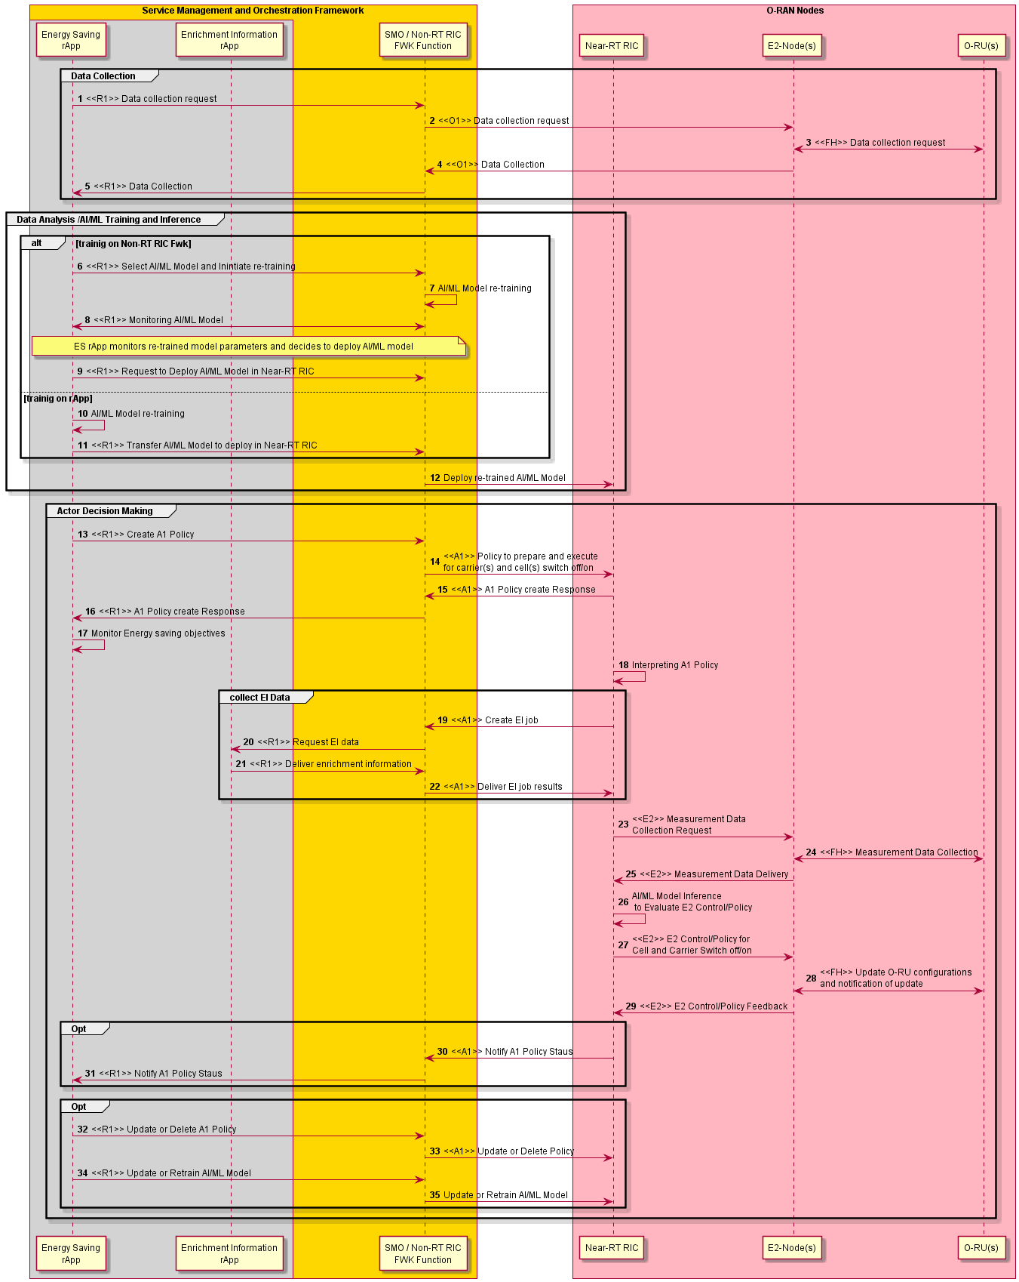
Figure 4.8.1.3.2-1: Flow diagram of A1 interface based carrier and cell switch off/on optimization for energy saving

NOTE: Above mentioned AI/ML procedures are illustration purpose and details are not defined in the present document.

4.8.1.4 Required data
This sub-clause contains the input and output data of model training and inference for energy saving cell and carrier shutdown.

4.8.1.4.1 Input data
The measurement input data are used in model training and inference. They can include the following measurements to monitor energy consumption and energy efficiency of E2 node(s) and O-RU(s):
- DL PDCP SDU data volume per interface (data volume in DL delivered from O-CU-UP to O-DU, per PLMN, per QoS level, per slice, per interface (F1-U, Xn-U, X2-U)) (as specified in 3GPP TS 28.552 [5], clause 5.1.3.6.2.3)
- UL PDCP SDU data volume per interface (data volume in UL delivered to O-CU-UP from O-DU, per PLMN, per QoS level, per slice, per interface (F1-U, Xn-U, X2-U)) (as specified in 3GPP TS 28.552 [5], clause 5.1.3.6.2.4)
- RSRQ measurement per SSB per cell (as specified in 3GPP TS 28.552 [5], clause 5.1.1.31)
- RSRP measurement per SSB per cell (as specified in 3GPP TS 28.552 [5], clause 5.1.1.22)
- SINR measurement per SSB per cell (as specified in 3GPP TS 28.552 [5], clause 5.1.1.32)
- PNF energy consumption (as specified in 3GPP TS 28.552 [5], clause 5.1.1.19.3)
- Power consumed by physical network function & its components (as specified in 3GPP TS 28.552 [5], clause 5.1.1.19.2 and in MP [10], clauses B.1, B.5)
- Transmit power (as specified in MP [10], clauses B.1, B.2.1)
- M1 MDT measurement in trace record for immediate MDT measurements (as specified in 3GPP TS 32.423 [11], clause 4.34.1)
- UE location in trace record for UE location information (as specified in 3GPP TS 32.423 [11], clause 4.34.2)

4.8.1.4.2 Output data
rApps to deliver energy saving & energy efficiency policies for cell/carrier switch off/on optimization through R1 interface.

4.8.2 RF channel reconfiguration

4.8.2.1 Background and goal of the use case
In mobile networks m-MIMO antennas are used for beamforming techniques to enhance cell capacity and throughput. To achieve beamforming, O-RU(s) need to concentrate the power amplifiers at the radome by combining radiating elements. At low load, i.e., when the expected traffic volume or number of connected users are lower than the configured threshold, ES can be achieved by reducing the power consumption of O-RU(s) by switching off certain Tx/Rx arrays. For example, 32 out of 64 Tx/Rx arrays of an O-RU(s) can be switched off in a digital m-MIMO architecture and correspondingly the number of spatial layers and SSBs can be reduced. The procedure (involvement of respective O-RAN interfaces) of the RF channel reconfiguration depends on the management architecture model (hybrid or hierarchical) and the deployment option. The switch off/on decision can be made by an AI/ML model within the inference host deployed at the Non-RT RIC. Among others the AI/ML models can include prediction of future traffic, user mobility, and resource usage and can also predict expected energy efficiency enhancements, resource usage, and network performance for different ES optimization states.
This solution proposes a framework that allows the operator to flexibly configure RF channel reconfiguration parameters in a cell or in a cluster of cells through O1 configuration formulated by rApp towards E2 node(s) and O-RU(s) through SMO/Non-RT RIC or A1 policies formulated by rApp towards Near-RT RIC through SMO/Non-RT RIC framework assisted by Machine Learning (ML) techniques.

4.8.2.2 Entities/resources involved in the use case
- SMO/Non-RT RIC framework function:
- Collect the configurations, performance indicators and measurement reports (e.g., cell load related information and traffic information, EE/EC measurement reports) from E2 node(s), for the purpose of decision making, optionally using training and inference of AI/ML models that assist such EE/ES functions.
- Transfer collected data towards rApp. It is assumed that configurations, performance indicators and measurement reports collected from the O-DU contain the related information for the corresponding O-RU(s).
- Signal updated configurations for EE/ES optimization towards E2 node(s) (O-CU) through O1 interface.
- (Optionally) Retrain, update, configure EE/ES AI/ML models in Non-RT RIC.
- Provide A1 policies to Near-RT RIC via A1 interface based on the request from energy saving rApp in the case of A1 policy-based solution.
- rApps:
- Collect the necessary configurations, performance indicators, and measurement reports from SMO/Non-RT RIC framework function, for the purpose of training and execution of relevant AI/ML models.
- (Optionally) Retrain, update, configure EE/ES AI/ML model.
- Infer an optimized RF channel configuration for EE/ES based on the data collected using R1 interface.
- Provide optimized A1 policy for EE/ES based on the data collected using R1 interface in the case of A1 policy-based solution.
- E2 nodes:
- Report cell configuration, performance indicators and measurement reports (e.g., cell load related information and traffic information, EE/EC measurement reports) to SMO via O1 interface.
- Report measurement reports to Near-RT RIC via E2 interface in the case of A1 policy-based solution.
- Perform actions required to perform RF channel reconfiguration (i.e., O-RU Tx/Rx array selection, modification of the number of SSB beams, modification of the O-RU antenna transmit power, modification of the number of SU/MU MIMO data layers or spatial streams) as part of EE/ES optimization.
- O-RU:
- Report EC and EE related information via open FH M-plane interface to O-DU.
- Perform actions required to be performed due to RF channel reconfiguration (i.e., O-RU Tx/Rx array selection, modification of the number of SSB beams, modification of the O-RU antenna transmit power, modification of the number of SU/MU MIMO spatial streams or data layers) as part of EE/ES optimization.
- Near-RT RIC (For A1 policy-based solution):
- Collect measurement reports (e.g., cell load related information and traffic information, EE/EC measurement reports) from E2 nodes.
- (Optionally) Receive EE/ES AI/ML model for deployment via O1 or O2 interface.
- Receive EE/ES related policies via A1 interface for consideration during optimization.
- Analyse the received data from E2 nodes and perform AI/ML model inference to determine EE/ES. Optimization (i.e., if carriers or cells are recommended to be switched off/on) considering the optimization targets/policies.
- Provide policies or required information to E2 node via E2 to trigger actions for EE/ES optimization.

4.8.2.3 Solution

4.8.2.3.1 O1 policy based RF channel reconfiguration optimization for energy saving
In this solution, decision making, potentially including AI/ML model training and inference, is done at the Non-RT RIC.
The context of the O1 interface based RF channel reconfiguration optimization for energy saving is captured in table 4.8.2.3.1-1.

Table 4.8.2.3.1-1: O1 interface based RF channel reconfiguration optimization for energy saving
Use Case Stage | Evolution / Specification | <<Uses>>  Related use
Goal | Enable RF channel reconfiguration energy saving functions in the network by means of configuration parameter change and actions controlled by Non-RT RIC and allow for AI/ML-based solutions.
Actors and Roles | SMO/Non-RT RIC framework function: Termination point for O1 interface.  E2 node(s), O-RU(s): Enforces optimized RF channel configuration.  rApp: RF channel reconfiguration optimization.
Assumptions | O1 interface connectivity is established.  Open FH M-plane interface is established between E2 node(s) and O-RU.  Network is operational.
Pre-conditions | Operator has set the targets for energy saving functions in the Non-RT RIC.
Begins when | Operator enables the optimization rApp along with initial ML model for RF channel reconfiguration saving functions and E2 node(s) and O-RU(s) become operational.
Step 1 (M) | rApp requests to collect necessary configurations, performance indicators, and measurement data towards SMO/Non-RT RIC framework function over R1 interface.
Step 2 (M) | SMO/Non-RT RIC framework function requests data collection towards E2 node(s) and O-RU(s) (via E2 node(s)) over O1 interface.
Step 3 (M) | E2 node(s) upon receiving request from SMO/Non-RT RIC framework function requests and collect necessary data from O-RU(s) over open FH M-plane interface.
Step 4 (M) | E2 node(s) send the configuration data, configured measurement data to SMO/Non-RT RIC framework periodically or event based.
Step 5 (M) | rApp collects the configuration data, collected measurement data for processing.
Step 6 (O) | AI/ML models can be retrained either on Non-RT RIC framework or on rApp. If Non-RT RIC framework is hosting retraining, then rApp to select AI/ML model and initiate retraining on Non-RT RIC framework.  See NOTE 1.
Step 7 (O) | Upon receiving retraining request from rApp. Non-RT RIC framework initiates AI/ML model retraining.
Step 8 (O) | rApp monitors retrained AI/ML model and retrieves retrained AI/ML model.  See NOTE 2.
Step 9 (O) | Upon receiving retrieval request from rApp, Non-RT RIC framework to transfer AI/ML model to rApp.  See NOTE 3.
Step 10 (O) | If AI/ML model retraining is hosted by rApp then AI/ML model to be retrained on rApp itself.
Step 11 (O) | Once AI/ML model retraining is performed, AI/ML models are deployed and activated for inferencing for which rApp constantly monitors performance and energy consumption to evaluate necessary O1 configurations to perform RF channel reconfiguration.
Step 12 (M) | rApp to request the SMO/Non-RT RIC framework to configure E2 node(s) to prepare and execute RF channel reconfigurations as below,  - O-RU Tx/Rx array selection.  - Modify the number of SU/MU MIMO spatial streams or data layers.  - Modify the number of SSB beams.  - Modify O-RU antenna transmit power.
Step 13 (M) | SMO/Non-RT RIC framework function to requests to configure E2 node(s) for RF channel reconfiguration through O1 interface.
Step 14 (M) | O-RU(s) is informed about the updated O-RU configuration via open FH M-plane interface by E2 node(s). O-RU(s) to inform E2 node(s) once O-RU(s) configuration is implemented.
Step 15 (M) | E2 node(s) will inform SMO/Non-RT RIC framework function once RF channel reconfiguration is completed.
Step 16 (M) | SMO/Non-RT RIC framework function to inform rApp about completion of RF channel reconfiguration over R1 interface.
Step 17 (M) | rApp monitors energy saving objectives. If energy saving objectives are not achieved, it can decide to initiate fallback mechanism for example, reverting changes over O1 interface for RF channel reconfigurations, and/or AI/ML model update or retraining.
Ends when | E2 node(s) becomes non-operational or when the operator disables the optimization functions or ML model for energy saving.
Exceptions | TBD.
Post Conditions | rApp continues monitoring of energy saving function at E2 node(s) and O-RU(s).  E2 node(s) and O-RU(s) operate using the newly deployed parameters/models and state.
NOTE 1: AI/ML procedures mentioned here can be subject to change based on future work on AI/ML workflow in WG2.
NOTE 2: AI/ML model retrieval procedure over R1 interface is for illustration purpose, can be subject to change based on future work on AI/ML workflow in WG2.
NOTE 3: AI/ML model transfer procedure over R1 interface is for illustration purpose, can be subject to change based on future work on AI/ML workflow in WG2.

@startuml
‘https://plantuml.com/sequence-diagram
!pragma teoz true
Skin rose
skinparam ParticipantPadding 5
skinparam BoxPadding 10
skinparam defaultFontSize 12
skinparam lifelineStrategy solid
autonumber
Box “Service Management and Orchestration Framework” #gold
Box #lightgrey
Participant “Energy Saving\nrApp” as rAPP
End box
Participant “ SMO / Non-RT RIC\nFWK Function “ as NRTF
End box

Box “RAN Nodes” #lightpink
Participant “E2-Node(s)” as E2NODES
Participant “O-RU(s)” as ORUs
End box

group Data Collection
rAPP-> NRTF : <<R1>> Data collection request
NRTF -> E2NODES : <<O1>> Data collection request
E2NODES <-> ORUs : <<FH>> Data collection request
E2NODES -> NRTF : <<O1>> Data Collection
NRTF -> rAPP : <<R1>> Data Collection
End

group Data Analysis /AIML Training and Inference
alt trainig on Non-RT RIC Fwk
rAPP -> NRTF : <<R1>> Select AI/ML Model and Inintiate re-training
NRTF -> NRTF : AI/ML Model re-training
rAPP -> NRTF : <<R1>> Retrive Re-trained AIML Model
Note right
rApp monitors re-trained
model parameters and decides
to retieve AIML model
End note
NRTF -> rAPP : <<R1>> Transfer Re-trained AI/ML Model
Else trainig on rApp
rAPP -> rAPP : AI/ML Model re-training
end

rAPP -> rAPP : Deploy and activate re-trained\nAI/ML Model for inferencing
Note Right
Performance and Energy
Consumption Monitoring
(E2 Node(s) and O-RU(s))
and O1 configuration evaluation.
End note
end
group Actor Decision Making
rAPP -> NRTF : <<R1>> Configuration to prepare and execute \nfor RF Channel Reconfiguration
NRTF <-> E2NODES : <<O1>> E2-Node configurations for\nRF Channel Reconfiguration
E2NODES <-> ORUs : <<FH>> Update O-RU Configurations \nand notification of update
E2NODES -> NRTF :<<O1>> Inform Completion of\nRF Channel Reconfiguration
NRTF -> rAPP : <<R1>> Inform Completion of RF Channel Reconfiguration
rAPP -> rAPP : Performance monitoring and\nevluation of AI/ML model \n(with possible actions,\ne.g. fallback, re-training)
end

@enduml
The flow diagram of O1 interface based RF channel reconfiguration optimization for energy saving is shown in figure 4.8.2.3.1-1.

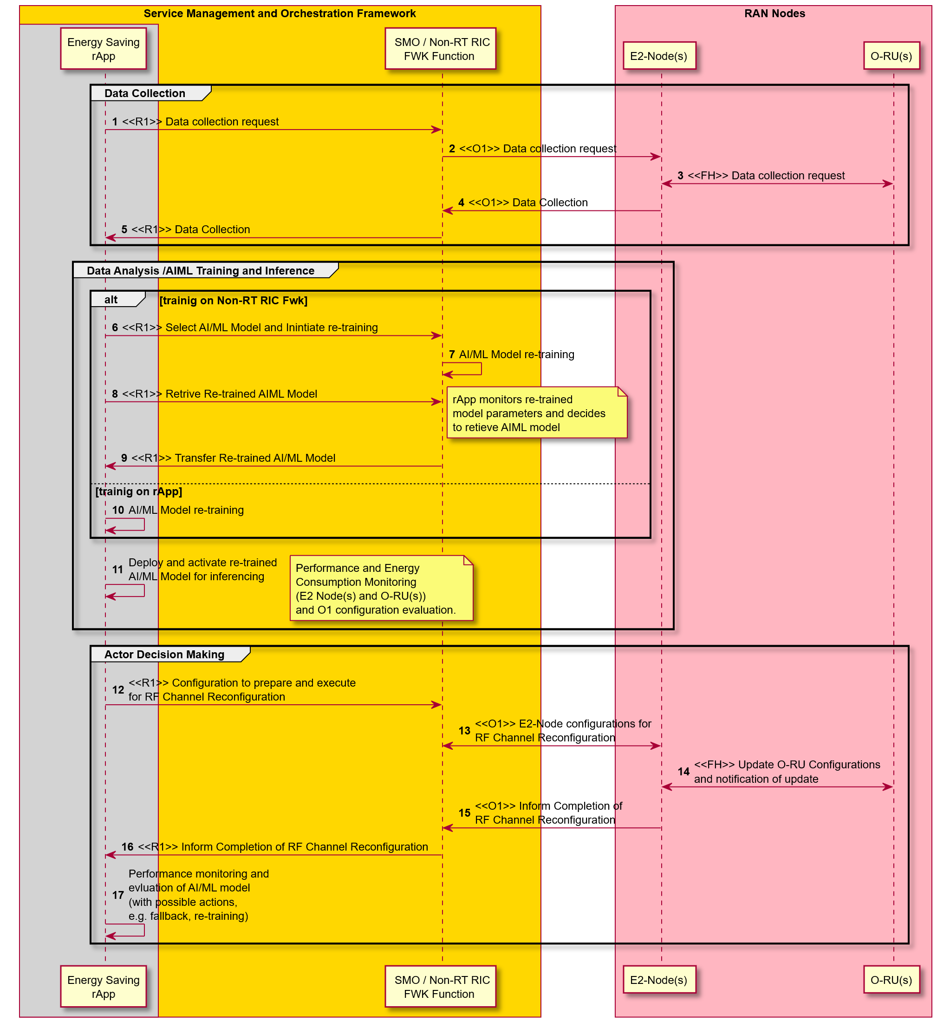
Figure 4.8.2.3.1-1: Flow diagram of O1 interface based RF channel reconfiguration optimization for energy saving

4.8.2.3.2 A1 policy based RF channel reconfiguration optimization for energy saving
In this solution, decision making, potentially using AI/ML model inference, is done at Near-RT RIC. While AI/ML model training might be hosted in Non-RT or Near-RT RIC, the description below is based on AI/ML model inferencing in the Near-RT RIC.
The context of the A1 policy based optimization for energy saving is captured in table 4.8.2.3.2-1.
Table 4.8.2.3.2-1: A1 policy based optimization for energy saving
Use Case Stage | Evolution / Specification | <<Uses>>  Related use
Goal | Enable A1 policy based RF channel reconfiguration energy saving functions in the network by means of configuration parameter change and actions controlled by Near-RT RIC and allow for AI/ML-based solutions.
Actors and Roles | SMO/Non-RT RIC framework function: A1 & O1 termination  rApp: RF channel reconfiguration optimization  E2 node(s), O-RU: Enforces RF channel reconfiguration  Near-RT RIC: RF channel reconfiguration energy savings decision making function
Assumptions | O1 interface connectivity is established between SMO and E2 nodes.  R1 interface connectivity is established.  Open FH M-plane interface is established between O-DU and O-RU.  E2 interface connectivity is established between E2 nodes and Near-RT RIC.  A1 interface is established between Non-RT RIC and Near-RT RIC.  Network is operational.
Pre-conditions | Operator has set the targets for energy saving functions in the Non-RT RIC.
Begins when | Operator enables the optimization rApp along with initial ML model for RF channel reconfiguration energy saving functions and E2 node(s) and O-RU(s) become operational.  See NOTE.
Step 1 (M) | rApp requests for necessary configurations, performance indicators, and measurement data towards SMO/Non-RT RIC framework function over R1 interface.  Configurations may contain data related to node capability such as O-RU RF channel configuration/TRx control capability information which rApp needs to know before formulating A1 policies for ASM optimization.
Step 2 (M) | SMO/Non-RT RIC framework function requests data collection towards E2 node(s) and O-RU(s) (via E2 node(s)) over O1 Interface.
Step 3 (M) | E2 node(s) upon receiving request from SMO/Non-RT RIC framework function requests and collect necessary data form O-RU(s) over open FH M-plane interface.
Step 4 (M) | E2 node(s) sends the configuration data, configured measurement data to SMO/Non-RT RIC framework function periodically or event based.
Step 5 (M) | rApp collects the configuration data, collected measurement data for processing.
Step 6 (M) | rApp to trigger EE/ES optimization through A1 policy to prepare and execute RF channel configuration/Trx control.
Step 7 (M) | Non-RT RIC framework receives policy from rApp and forwards it towards Near-RT RIC via A1 interface.
Step 8 (M) | Near-RT RIC provides A1 policy response to SMO/Non-RT RIC framework.
Step 9 (M) | Non-RT RIC framework informs rApp about A1 policy feedback.
Step 10 (M) | rApp monitors energy saving objectives as per A1 policy.
Step 11 (M) | The Near-RT RIC receives the policy from the Non-RT RIC over the A1 interface. It then interprets the policy to determine the required data collection and E2 control/policies.
Step 12 (M) | Inferencing AI/ML model to evaluate & generate E2 control or policies for RF channel configuration/Trx Control optimization.
Step 13 (M) | Near-RT RIC to notify Non-RT RIC if any change in the state of policy.
Step 14 (M) | SMO/Non-RT RIC framework forwards notification received from Near-RT RIC to rApp.
Step 15 (O) | If energy saving objectives are not achieved rApp may decide to initiate fallback mechanism for example, updating or deleting A1 policy for RF channel configuration/Trx control optimization.
Step 16 (O) | SMO/Non-RT RIC framework send update or delete A1 policies to Near-RT RIC.
Step 17 (O) | rApp can update or retrain AI/ML model based on evaluation of energy saving objectives.
Step 18 (O) | SMO/Non-RT RIC framework send update or retrained AI/ML model to Near-RT RIC.
Ends when | E2 node(s) becomes non-operational.
Exceptions | N/A
Post Conditions | rApp continues monitoring of energy saving function at E2 node(s) and O-RU.  E2 node(s) and O-RU(s) operate using the newly deployed parameters/models and state (off/on).
NOTE: Operator can set policies through rApp or allow AI/ML model in rApp to infer policies.
@startuml
‘https://plantuml.com/sequence-diagram
!pragma teoz true
Skin rose
skinparam ParticipantPadding 5
skinparam BoxPadding 10
skinparam defaultFontSize 12
skinparam lifelineStrategy solid
autonumber
Box “Service Management and Orchestration Framework” #gold
Box #lightgrey
Participant “Energy Saving\nrApp” as ESrAPP
End Box
Participant “SMO / Non-RT RIC\nFWK Function” as NRTF
End box
Box “ O-RAN Nodes” #lightpink
Participant “Near-RT RIC” as NeRT
Participant “E2-Node(s)” as E2NODES
Participant “O-RU(s) “ as ORUs
End box
group Data Collection
ESrAPP -> NRTF : <<R1>> Data collection request
NRTF -> E2NODES : <<O1>> Data collection request
E2NODES <-> ORUs : <<FH>> Data collection request
E2NODES -> NRTF : <<O1>> Data Collection
NRTF -> ESrAPP : <<R1>> Data Collection
End
group Data Analysis /AI/ML Model Selection and Training
Note over ESrAPP , NeRT
rApp/Non-RT RIC performs AIML Model Selection ,re-training and decides
to deploy Model in Near-RT RIC or provide AIML Model access details.
End note
end
group Actor Decision Making
ESrAPP -> NRTF : <<R1>> Create A1 Policy
NRTF -> NeRT : <<A1>> Policy to prepare and execute \nfor RF Channel Configuration/Trx Control
NeRT -> NRTF : <<A1>> A1 Policy create Response
NRTF -> ESrAPP : <<R1>> A1 Policy create Response
ESrAPP -> ESrAPP : Monitor Energy saving objectives
NeRT -> NeRT : Interpreting A1 Policy
group E2 Data Collection
Note over NeRT , ORUs
Near-RT RIC to trigger E2 data collection from different E2 Nodes.
In the case of O-DU, data collected is expected to include the data from the related O-RU(s)
End note
end
NeRT -> NeRT : AI/ML Model Inference\n to Evaluate E2 Control/Policy
group E2 Control /Policy
Note over NeRT , ORUs
Near-RT RIC to trigger RF Channel Configuration/Trx Control
E2 Control /Policy towards E2 Nodes and O-RU via O-DU
End note
end
group Opt
NeRT -> NRTF : <<A1>> Notify A1 Policy Staus
NRTF -> ESrAPP : <<R1>> Notify A1 Policy Staus
end
group Opt
ESrAPP -> NRTF : <<R1>> Update or Delete A1 Policy
NRTF -> NeRT : <<A1>> Update or Delete Policy
ESrAPP -> NRTF : <<R1>> Update AI/ML Model
NRTF -> NeRT : Update AI/ML Model
end
end
@enduml

@startuml
‘https://plantuml.com/sequence-diagram
!pragma teoz true
Skin rose
skinparam ParticipantPadding 5
skinparam BoxPadding 10
skinparam defaultFontSize 12
skinparam lifelineStrategy solid
autonumber
Box “Service Management and Orchestration Framework” #gold
Box #lightgrey
Participant “Energy Saving\nrApp” as ESrAPP
End Box
Participant “SMO / Non-RT RIC\nFWK Function” as NRTF
End box
Box “ O-RAN Nodes” #lightpink
Participant “Near-RT RIC” as NeRT
Participant “E2-Node(s)” as E2NODES
Participant “O-RU(s) “ as ORUs
End box
group Data Collection
ESrAPP -> NRTF : <<R1>> Data collection request
NRTF -> E2NODES : <<O1>> Data collection request
E2NODES <-> ORUs : <<FH>> Data collection request
E2NODES -> NRTF : <<O1>> Data Collection
NRTF -> ESrAPP : <<R1>> Data Collection
End
group Data Analysis /AI/ML Model Selection and Training
Note over ESrAPP , NeRT
rApp/Non-RT RIC performs AIML Model Selection ,re-training and decides
to deploy Model in Near-RT RIC or provide AIML Model access details.
End note
end
group Actor Decision Making
ESrAPP -> NRTF : <<R1>> Create A1 Policy
NRTF -> NeRT : <<A1>> Policy to prepare and execute \nfor RF Channel Configuration/Trx Control
NeRT -> NRTF : <<A1>> A1 Policy create Response
NRTF -> ESrAPP : <<R1>> A1 Policy create Response
ESrAPP -> ESrAPP : Monitor Energy saving objectives
NeRT -> NeRT : Interpreting A1 Policy
group E2 Data Collection
Note over NeRT , ORUs
Near-RT RIC to trigger E2 data collection from different E2 Nodes.
In the case of O-DU, data collected is expected to include the data from the related O-RU(s)
End note
end
NeRT -> NeRT : AI/ML Model Inference\n to Evaluate E2 Control/Policy
group E2 Control /Policy
Note over NeRT , ORUs
Near-RT RIC to trigger RF Channel Configuration/Trx Control
E2 Control /Policy towards E2 Nodes and O-RU via O-DU
End note
end
group Opt
NeRT -> NRTF : <<A1>> Notify A1 Policy Staus
NRTF -> ESrAPP : <<R1>> Notify A1 Policy Staus
end
group Opt
ESrAPP -> NRTF : <<R1>> Update or Delete A1 Policy
NRTF -> NeRT : <<A1>> Update or Delete Policy
ESrAPP -> NRTF : <<R1>> Update AI/ML Model
NRTF -> NeRT : Update AI/ML Model
end
end
@enduml
The flow diagram of A1 interface based RF channel reconfiguration optimization for energy saving is shown in figure 4.8.2.3.2-1.

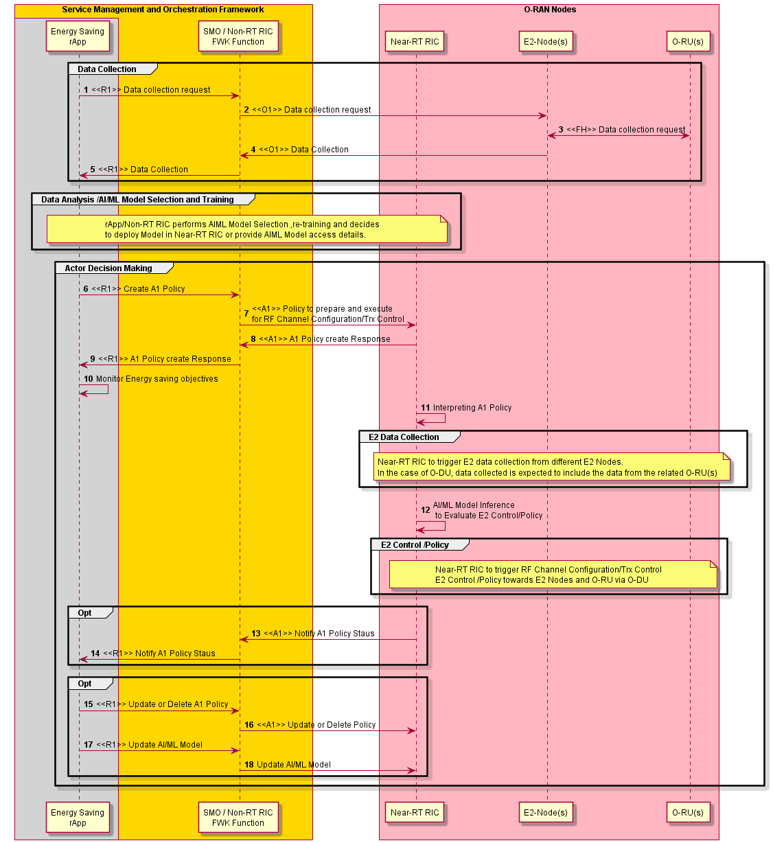
Figure 4.8.2.3.2-1: Flow diagram of A1 interface based RF channel reconfiguration optimization for energy saving

4.8.2.4 Required data
This sub-clause contains the input and output data of model training and inference for energy saving using RF channel reconfiguration.

4.8.2.4.1 Input data
The measurement input data are used in model training and inference. They can include the following measurements to monitor energy consumption and energy efficiency of E2 node(s) and O-RU(s):
- DL PDCP SDU data volume per interface (data volume in DL delivered from O-CU-UP to O-DU, per PLMN, per QoS level, per slice, per interface (F1-U, Xn-U, X2-U)) (as specified in 3GPP TS 28.552 [5], clause 5.1.3.6.2.3)
- UL PDCP SDU data volume per interface (data volume in UL delivered to O-CU-UP from O-DU, per PLMN, per QoS level, per slice, per interface (F1-U, Xn-U, X2-U)) (as specified in 3GPP TS 28.552 [5], clause 5.1.3.6.2.4)
- RSRQ measurement per SSB per cell (as specified in 3GPP TS 28.552 [5], clause 5.1.1.31)
- RSRP measurement per SSB per cell (as specified in 3GPP TS 28.552 [5], clause 5.1.1.22)
- SINR measurement per SSB per cell (as specified in 3GPP TS 28.552 [5], clause 5.1.1.32)
- PNF energy consumption (as specified in 3GPP TS 28.552 [5], clause 5.1.1.19.3)
- Power consumed by physical network function & its components (as specified in 3GPP TS 28.552 [5], clause 5.1.1.19.2 and in MP [10], clauses B.1, B.5)
- Transmit power (as specified in MP [10], clauses B.1, B.2.1)

4.8.2.4.2 Output data
rApps to deliver energy saving & energy efficiency A1 policies for RF channel reconfiguration optimization through R1 interface.

4.8.3 Advanced sleep mode
This use case describes a method to achieve intelligent energy saving by optimizing the sleep mode via Non-RT RIC-based guidance.

4.8.3.1 Background and goal of the use case
Mobile networks were often designed to provide higher data rates, better coverage, and ubiquitous connectivity. They have to be always available and well-dimensioned in order to ensure the best Quality of Service (QoS) even in peak hours and emergency or mass event scenarios. This may lead to an over-dimensioned and under-utilized network particularly when the traffic demand is low, such is the case during night hours.
The energy consumption of a network is composed of two components:
- A fixed component, which is mainly due to the system architecture and includes the power consumption of control signals, backhaul infrastructure, and load-independent consumption of baseband processors.
- A variable, load-dependent component, which depends on the transported traffic.
Over-provisioning of the network as well as low load periods translate into significant, and unnecessary, energy consumption, due to the fixed component. Sleep modes, which consist in shutting down the O-RU for a certain period of time, are an efficient way to handle this component.
It consists in a progressive deactivation of the O-RU’s components according to the time needed by each of them to shut down then reactivate again. According to this transition time, four levels of sleep modes have been specified in CUS [12], clause 16. Deeper sleep levels allow more energy saving but induce larger delays for the users who arrive to the network and who need to wait longer for the components to be reactivated. Hence, Non-RT RIC can provide policies in such cases where reactivation time may not be concern or proactively reactivates.
O-RU and E2 nodes (O-CU, O-DU) may implement various sleep modes. The sleep modes could be enabled by SMO/Non-RT RIC through A1 policy. When enabled, the Near-RT RIC selects among the sleep modes considering their capabilities, the actual traffic situation, and the network conditions. Different SM operate at different time scales (e.g., symbol, slot, frame).
This solution proposes a framework that allows the operator to flexibly select various sleep modes parameters through A1 policy formulated by rApp towards Near-RT RIC through SMO/Non-RT RIC framework assisted by Machine Learning (ML) techniques.

4.8.3.2 Entities/resources involved in the use case
- SMO/Non-RT RIC framework function:
- Collect the configurations, performance indicators and measurement reports (e.g., cell load related information and traffic information, EE/EC measurement reports) from E2 node(s) and trace records (e.g., per-UE measurement metrics and location information) through O1 interface, for the purpose of decision making, optionally using training and inference of AI/ML models that assist such EE/ES functions.
- Transfer collected data towards rApp. It is assumed that configurations, performance indicators and measurement reports collected from the O-DU contain the related information for the corresponding O-RU(s).
- Signal A1 policies for Near-RT RIC for ASM optimization A1 interface.
- (Optionally) Retrain, update, configure AI/ML models in Non-RT RIC.
- rApps:
- Collect the necessary configurations, performance indicators, and measurement reports from SMO/Non-RT RIC framework function, for the purpose of training and execution of relevant AI/ML models.
- (Optionally) Retrain, update, configure EE/ES AI/ML model.
- Infer an optimized A1 policy for ASM based on the data collected using R1 interface.
- E2 nodes:
- Report cell configuration, performance indicators and measurement reports (e.g., cell load related information and traffic information, EE/EC measurement reports, Trace records such as per-UE measurement metrics and location information) to SMO via O1 interface.
- Report measurement reports (e.g., cell load related information and traffic information, EE/EC measurement reports) to Near-RT RIC via E2 interface.
- Support actions required to perform ASM and Trx control for EE/ES optimization.
- O-RU:
- Report EC and EE related information via open FH M-plane interface to O-DU .
- Support actions required to perform ASM and Trx control for EE/ES optimization.
- Near-RT RIC (For A1 policy based solution):
- Collect measurement reports (e.g., cell load related information and traffic information, EE/EC measurement reports) from E2 nodes.
- (Optionally) Receive EE/ES AI/ML model for deployment via O1 or O2 interface.
- Receive EE/ES related policies via A1 interface for consideration during optimization.
- Analyse the received data from E2 nodes and perform AI/ML model inference to determine ASM & Trx control EE/ES. Optimization (i.e., ASM to be activated for certain time and cells) considering the optimization targets/policies.
- Provide policies or required information to E2 node (O-CU) via E2 to trigger actions for EE/ES optimization.

4.8.3.3 Solution

4.8.3.3.1 A1 policy based ASM optimization for energy saving
In this solution, decision making, potentially using AI/ML model inference, is done at Near-RT RIC. While AI/ML model training might be hosted in Non-RT or Near-RT RIC, the description below is based on AI/ML model inferencing in the Near-RT RIC.
The context of the A1 policy based ASM optimization for energy saving is captured in table 4.8.3.3.1-1.
Table 4.8.3.3.1-1: A1 policy based ASM optimization for energy saving
Use Case Stage | Evolution / Specification | <<Uses>>  Related use
Goal | Enable A1 policy based ASM energy saving functions in the network by means of configuration parameter change and actions controlled by Near-RT RIC and allow for AI/ML-based solutions.
Actors and Roles | SMO/Non-RT RIC framework function: A1 & O1 termination.  rApp: ASM optimization.  E2 node(s), O-RU: Enforces ASM E2 controls or policies.  Near-RT RIC: ASM energy savings decision making function.
Assumptions | O1 interface connectivity is established between SMO and E2 nodes.  R1 interface connectivity is established.  Open FH M-plane interface is established between E2 node(s) and O-RU.  E2 interface connectivity is established between E2 node and Near-RT RIC.  A1 interface is established between Non-RT RIC and Near-RT RIC.  Network is operational.
Pre-conditions | Operator has set the targets for energy saving functions in the Non-RT RIC.
Begins when | Operator enables the optimization rApp along with initial ML model for ASM energy saving functions and E2 node(s) and O-RU(s) become operational.  See NOTE.
Step 1 (M) | rApp requests to collect necessary configurations, performance indicators, and measurement data towards SMO/Non-RT RIC framework function over R1 interface.  Configurations may contain data related to node capability such as O-RU ASM capability information which rApp needs to know before formulating A1 policies for ASM optimization.
Step 2 (M) | SMO/Non-RT RIC framework function requests data collection towards E2 node(s) and O-RU(s) (via E2 node(s)) over O1 interface.
Step 3 (M) | E2 node(s) upon receiving request from SMO/Non-RT RIC framework function requests and collect necessary data form O-RU(s) over open FH M-plane interface.
Step 4 (M) | E2 node(s) sends the configuration data, configured measurement data to SMO/Non-RT RIC framework function periodically or event based.
Step 5 (M) | rApp collects the configuration data, collected measurement data for processing.
Step 6 (M) | rApp to trigger EE/ES optimization through A1 policy to prepare and execute ASM & Trx control.
Step 7 (M) | Non-RT RIC framework receives policy from rApp and forwards it towards Near-RT RIC via A1 interface.
Step 8 (M) | Near-RT RIC provides A1 policy response to SMO/Non-RT RIC framework.
Step 9 (M) | Non-RT RIC framework informs rApp about A1 policy feedback.
Step 10 (M) | rApp monitors energy saving objectives as per A1 policy.
Step 11 (M) | The Near-RT RIC receives the policy from the Non-RT RIC over the A1 interface. It then interprets the policy to determine the required data collection and E2 control/policies.
Step 12 (M) | Inferencing AI/ML model to evaluate & generate E2 control or policies for ASM optimization.
Step 13 (M) | Near-RT RIC to notify Non-RT RIC if any change in the state of policy.
Step 14 (M) | SMO/Non-RT RIC framework forwards notification received from Near-RT RIC to rApp.
Step 15 (O) | If energy saving objectives are not achieved rApp may decide to initiate fallback mechanism for example, updating or deleting A1 policy for ASM optimization.
Step 16 (O) | SMO/Non-RT RIC framework send update or delete A1 policies to Near-RT RIC
Step 17 (O) | rApp can update or retrain AI/ML model based on evaluation of energy saving objectives.
Step 18 (O) | SMO/Non-RT RIC framework send update or retrain AI/ML model to Near-RT RIC.
Ends when | E2 node(s) becomes non-operational or when the operator disables the rApp or ML model for energy saving.
Exceptions | N/A
Post Conditions | rApp continues monitoring of energy saving function at E2 node(s) and O-RU.  E2 node(s) and O-RU(s) operate using the newly deployed parameters/models and state (off/on).
NOTE: Operator can set policies through rApp or allow AI/ML model in rApp to infer policies.

@startuml
'https://plantuml.com/sequence-diagram
!pragma teoz true
Skin rose
skinparam ParticipantPadding 5
skinparam BoxPadding 10
skinparam defaultFontSize 12
skinparam lifelineStrategy solid
autonumber
Box "Service Management and Orchestration Framework" #gold
Box #lightgrey
Participant "Energy Saving\nrApp" as ESrAPP

End Box
Participant "SMO / Non-RT RIC\nFWK Function" as NRTF
End box
Box " O-RAN Nodes" #lightpink
Participant "Near-RT RIC" as NeRT
Participant "E2-Node(s)" as E2NODES
Participant "O-RU(s) " as ORUs
End box
group Data Collection
ESrAPP -> NRTF : <<R1>> Data collection request
NRTF -> E2NODES : <<O1>> Data collection request
E2NODES <-> ORUs : <<FH>> Data collection request
E2NODES -> NRTF : <<O1>> Data Collection
NRTF -> ESrAPP : <<R1>> Data Collection
End
group Data Analysis /AI/ML Model Selection and Training
Note over ESrAPP , NeRT
rApp/Non-RT RIC performs AIML Model Selection ,re-training and decides
to deploy Model in Near-RT RIC or provide AIML Model access details.
End note
end
group Actor Decision Making
ESrAPP -> NRTF : <<R1>> Create A1 Policy
NRTF -> NeRT : <<A1>> Policy to prepare and execute \nfor ASM
NeRT -> NRTF : <<A1>> A1 Policy create Response
NRTF -> ESrAPP : <<R1>> A1 Policy create Response
ESrAPP -> ESrAPP : Monitor Energy saving objectives
NeRT -> NeRT : Interpreting A1 Policy
group E2 Data Collection
Note over NeRT , ORUs
Near-RT RIC to trigger E2 data collection from E2 Nodes and O-RU via O-DU
End note
end
NeRT -> NeRT : AI/ML Model Inference\n to Evaluate E2 Control/Policy
group E2 Control /Policy
Note over NeRT , ORUs
Near-RT RIC to trigger E2 Control /Policy towards E2 Nodes and O-RU via O-DU
End note
end
group Opt
NeRT -> NRTF : <<A1>> Notify A1 Policy Staus
NRTF -> ESrAPP : <<R1>> Notify A1 Policy Staus
end
group Opt
ESrAPP -> NRTF : <<R1>> Update or Delete A1 Policy
NRTF -> NeRT : <<A1>> Update or Delete Policy
ESrAPP -> NRTF : <<R1>> Update AI/ML Model
NRTF -> NeRT : Update AI/ML Model
end
end
@enduml
@startuml
'https://plantuml.com/sequence-diagram
!pragma teoz true
Skin rose
skinparam ParticipantPadding 5
skinparam BoxPadding 10
skinparam defaultFontSize 12
skinparam lifelineStrategy solid
autonumber
Box "Service Management and Orchestration Framework" #gold
Box #lightgrey
Participant "Energy Saving\nrApp" as ESrAPP

End Box
Participant "SMO / Non-RT RIC\nFWK Function" as NRTF
End box
Box " O-RAN Nodes" #lightpink
Participant "Near-RT RIC" as NeRT
Participant "E2-Node(s)" as E2NODES
Participant "O-RU(s) " as ORUs
End box
group Data Collection
ESrAPP -> NRTF : <<R1>> Data collection request
NRTF -> E2NODES : <<O1>> Data collection request
E2NODES <-> ORUs : <<FH>> Data collection request
E2NODES -> NRTF : <<O1>> Data Collection
NRTF -> ESrAPP : <<R1>> Data Collection
End
group Data Analysis /AI/ML Model Selection and Training
Note over ESrAPP , NeRT
rApp/Non-RT RIC performs AIML Model Selection ,re-training and decides
to deploy Model in Near-RT RIC or provide AIML Model access details.
End note
end
group Actor Decision Making
ESrAPP -> NRTF : <<R1>> Create A1 Policy
NRTF -> NeRT : <<A1>> Policy to prepare and execute \nfor ASM
NeRT -> NRTF : <<A1>> A1 Policy create Response
NRTF -> ESrAPP : <<R1>> A1 Policy create Response
ESrAPP -> ESrAPP : Monitor Energy saving objectives
NeRT -> NeRT : Interpreting A1 Policy
group E2 Data Collection
Note over NeRT , ORUs
Near-RT RIC to trigger E2 data collection from E2 Nodes and O-RU via O-DU
End note
end
NeRT -> NeRT : AI/ML Model Inference\n to Evaluate E2 Control/Policy
group E2 Control /Policy
Note over NeRT , ORUs
Near-RT RIC to trigger E2 Control /Policy towards E2 Nodes and O-RU via O-DU
End note
end
group Opt
NeRT -> NRTF : <<A1>> Notify A1 Policy Staus
NRTF -> ESrAPP : <<R1>> Notify A1 Policy Staus
end
group Opt
ESrAPP -> NRTF : <<R1>> Update or Delete A1 Policy
NRTF -> NeRT : <<A1>> Update or Delete Policy
ESrAPP -> NRTF : <<R1>> Update AI/ML Model
NRTF -> NeRT : Update AI/ML Model
end
end
@enduml
The flow diagram of A1 interface based ASM optimization for energy saving is shown in figure 4.8.3.3.1-1.

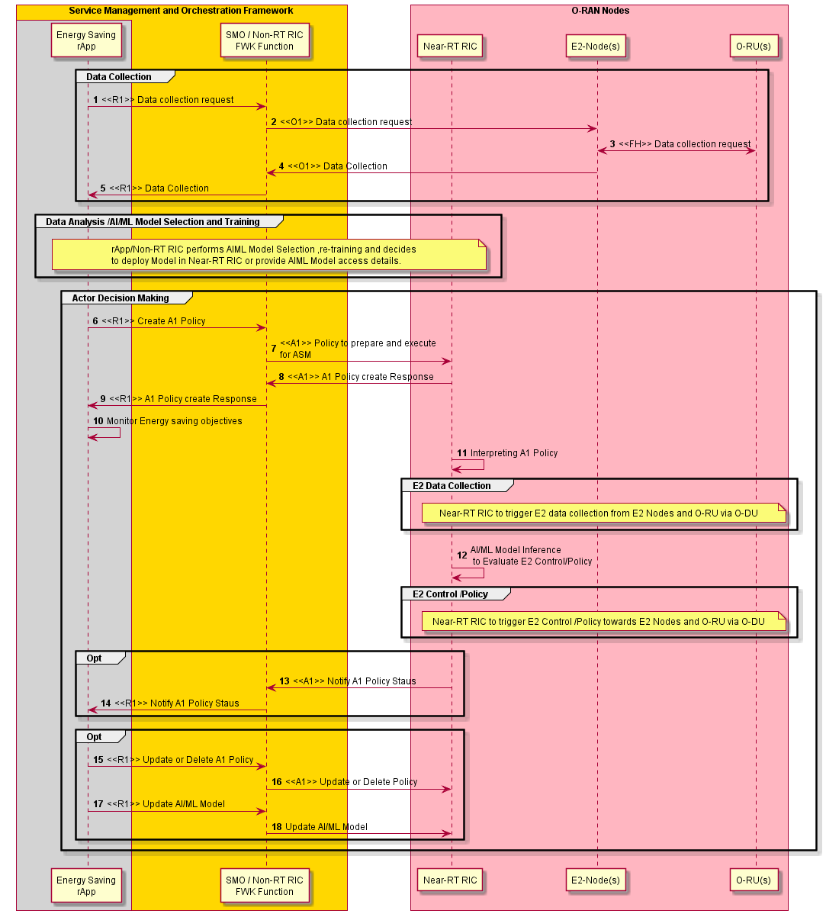
Figure 4.8.3.3.1-1: Flow diagram of A1 interface based ASM optimization for energy saving

4.8.3.4 Required data
This sub-clause contains the input and output data of model training and inference for energy saving using ASM.

4.8.3.4.1 Input data
The measurement input data are used in model training and inference. They can include the following measurements to monitor energy consumption and energy efficiency of E2 node(s) and O-RU(s):
- DL PDCP SDU data volume per interface (data volume in DL delivered per PLMN, per QoS level, per slice, per interface ((from O-CU-UP to O-DU over F1-U, to external O-CU-UP over Xn-U and to external O-eNB over X2-U)) (as specified in 3GPP TS 28.552 [5], clause 5.1.3.6.2.3)
- UL PDCP SDU data volume per interface (data volume in UL delivered per PLMN, per QoS level, per slice, per interface ((from O-DU to O-CU-UP over F1-U, to external O-CU-UP over Xn-U and to external O-eNB over X2-U)) (as specified in 3GPP TS 28.552 [5], clause 5.1.3.6.2.4)
- RSRQ measurement per SSB per cell (as specified in 3GPP TS 28.552 [5], clause 5.1.1.31)
- RSRP measurement per SSB per cell (as specified in 3GPP TS 28.552 [5], clause 5.1.1.22)
- SINR measurement per SSB per cell (as specified in 3GPP TS 28.552 [5], clause 5.1.1.32)
- PNF energy consumption (as specified in 3GPP TS 28.552 [5], clause 5.1.1.19.3)
- Power consumed by physical network function & its components (as specified in 3GPP TS 28.552 [5], clause 5.1.1.19.2 and in MP [10], clauses B.1, B.5)
- Transmit power (as specified in MP [10], clauses B.1, B.2.1)
- M1 MDT measurement in trace record for immediate MDT measurements (as specified in 3GPP TS 32.423 [11], clause 4.34.1)
- UE location in trace record for UE location information (as specified in 3GPP TS 32.423 [11], clause 4.34.2)
- O-RU ASM capability information (as specified in MP [10], clause 20.4)

4.8.3.4.2 Output data
rApps to deliver energy saving & energy efficiency policies for ASM optimization through R1 interface.

4.8.4 Time domain cell DTX/DRX optimization (3GPP Rel-18)

4.8.4.1 Background and goal of the use case
In 3GPP Release 18 [21], clause 15.4.2.3, Discontinuous Transmission (DTX) and Discontinuous Reception (DRX) mechanisms were further enhanced to improve energy efficiency for the gNB. To reduce the gNB's downlink transmission and uplink reception active time, the UE can be configured with a periodic cell DTX/DRX pattern, which defines active and non-active periods. This pattern is common for UEs configured with this feature in the cell, and the cell DTX/DRX patterns can be configured and activated separately. A maximum of two cell DTX/DRX patterns can be configured per MAC entity for different serving cells. When cell DTX is activated, the UE may not monitor PDCCH in selected cases or does not monitor SPS occasions during the non-active duration of the cell DTX. Similarly, when cell DRX is activated, the UE does not transmit on CG resources or transmit an SR during the non-active duration of the cell DRX. This feature is applicable only to UEs in the RRC_CONNECTED state and does not impact the Random Access procedure, SSB transmission, paging, or system information broadcasting. Cell DTX/DRX can be activated or deactivated via RRC signaling or L1 group common signaling.
Cell DTX/DRX is characterized by:
- Active duration: The duration during which the UE is expected to receive PDCCHs, SPS occasions, and transmit SR or CG. In this duration, the gNB's transmission/reception of PDCCH, SPS, SR, CG, and periodic/semi-persistent CSI reports are not impacted for energy-saving purposes.
- Cycle: Specifies the periodic repetition of the active duration followed by a non-active period.
The active duration and cycle parameters are common between cell DTX and DRX when both are configured. If there is an emergency call or a public safety-related service (e.g., MPS or MCS), the network ensures that these services are not impacted, possibly by releasing or deactivating the cell DTX/DRX configuration. The network should also ensure at least partial overlap between the UE’s connected mode DRX on-duration and cell DTX/DRX active duration, ensuring that the UE’s DRX periodicity is a multiple of the cell DTX/DRX periodicity, or vice versa.
The Non-RT RIC considers several factors when generating A1 policies for energy savings through cell DTX/DRX. These factors include real-time traffic patterns, the density of Rel-18-capable UEs, and the potential for energy savings in specific cells. It also evaluates QoE/QoS requirements to ensure service quality is maintained. Based on this analysis, the Non-RT RIC generates A1 policies that include, but are not limited to, the following:
Activate DTX/DRX in cells with low traffic or a high concentration of Rel-18 UEs.
Steer Rel-18 UEs toward specific cells, enabling those cells to either operate efficiently or be shut down.
Bar non-Rel-18 UEs from cells optimized for DTX/DRX to maximize energy savings.
Balance QoE/QoS by adjusting traffic steering and DTX/DRX settings, ensuring energy efficiency without service
degradation.
These A1 policies are enforced by the Near-RT RIC, which dynamically applies DTX/DRX configurations and traffic steering decisions in near-real-time.

4.8.4.2 Entities/resources involved in the use case
- SMO/Non-RT RIC framework:
- Collect the configurations, performance indicators and measurement reports (e.g., cell load related information and traffic information, EE/EC measurement reports) from E2 node(s) and trace records (e.g., per-UE measurement metrics, location information, Rel-18 and pre-Rel-18 supported UE information) through O1 interface, for the purpose of decision making.
- Transfer collected data towards rApp. It is assumed that configurations, performance indicators and measurement reports collected from the O-DU contain the related information for the corresponding O-RU(s).
- Create A1 polices for Near-RT RIC based on rApp request to optimize time domain cell DTX/DRX via the A1 interface.
- rApps:
- Collect the necessary configurations, performance indicators, and measurement reports from SMO/Non-RT RIC framework function, for the purpose of training and execution of relevant AI/ML models.
- (Optionally) Retrain, update, configure EE/ES AI/ML model.
- Infer an optimized A1 policy for time domain cell DTX/DRX optimization based on the data collected using R1 interface.
- E2 nodes:
- Report cell configuration, performance indicators and measurement reports (e.g., cell load related information and traffic information, EE/EC measurement reports, trace records such as per-UE measurement metrics, location information and Rel-18 and pre-Rel-18 supported UE information) to SMO via O1 interface.
- Report measurement reports (e.g., cell load related information and traffic information, EE/EC measurement reports) to Near-RT RIC via E2 interface.
- Support actions required to perform time domain cell DTX/DRX based optimization for EE/ES optimization.
Note that the requirements of O1 interface for E2 nodes are under the scope of WG10.
- O-RU:
- Report EC and EE related information via open FH M-plane interface to O-DU.
- Support actions required to perform time domain cell DTX/DRX based optimization for EE/ES optimization.
Note that the requirements for O-RU and open FH are under the scope of WG4.
- Near-RT RIC:
- Collect measurement reports (e.g., cell load related information and traffic information, EE/EC measurement reports, Rel-18 and pre-Rel-18 supported UE information) from E2 nodes.
- (Optionally) Receive EE/ES AI/ML model for deployment via O1 or O2 interface.
- Analyse the received data from E2 nodes and perform AI/ML model inference to determine time domain cell DTX/DRX based EE/ES optimization (i.e., time domain cell DTX/DRX to be activated for certain time and cells) considering the optimization targets/policies.
- Provide policies or required information to E2 node (O-CU) via E2 to trigger actions for EE/ES optimization.
Note that the requirements for Near-RT RIC are under the scope of WG3.

4.8.4.3 Solution

4.8.4.3.1 A1 policy based time domain cell DTX/DRX optimization for energy saving
In this solution, decision making, potentially using AI/ML model inference, is done at Near-RT RIC. While AI/ML model training might be hosted in Non-RT RIC or Near-RT RIC, the description below is based on AI/ML model inferencing in the Near-RT RIC.
The context of the A1 policy based time domain cell DTX/DRX optimization for energy saving is captured in table 4.8.4.3.1-1.
Table 4.8.4.3.1-1: A1 policy based time domain cell DTX/DRX optimization for energy saving
Use Case Stage | Evolution / Specification | <<Uses>>  Related use
Goal | A1 policy based guidance for performing time domain cell DTX/DRX energy saving in the network.
Actors and Roles | SMO/Non-RT RIC framework function: A1 & O1 termination.  rApp: Time domain cell DTX/DRX optimization.  E2 node(s): Enforces time domain cell DTX/DRX on O-RU based on E2 policy or control.  Near-RT RIC: Time domain cell DTX/DRX energy savings decision making function.
Assumptions | O1 interface connectivity is established between SMO and E2 nodes.  R1 interface connectivity is established.  Open FH M-plane interface is established between E2 node(s) and O-RU.  E2 interface connectivity is established between E2 node and Near-RT RIC.  A1 interface is established between Non-RT RIC and Near-RT RIC.  Network is operational.
Pre-conditions | Operator has set the targets for energy saving in the Non-RT RIC.
Begins when | Operator enables the rApp along with initial ML model for time domain cell DTX/DRX energy saving and E2 node(s) and O-RU(s) become operational.  See NOTE.
Step 1 (M) | rApp requests to collect necessary configurations, performance indicators, and measurement data towards SMO/Non-RT RIC framework over R1 interface.  Configurations may contain data related to UE capability to support 3GPP Rel-18, which rApp needs to know before formulating A1 policies for time domain cell DTX/DRX optimization.
Step 2 (M) | SMO/Non-RT RIC framework requests data collection towards E2 node(s) and O-RU(s) (via E2 node(s)) over O1 interface.
Step 3 (M) | E2 node(s) upon receiving request from SMO/Non-RT RIC framework requests and collect necessary data form O-RU(s) over open FH M-plane interface.
Step 4 (M) | E2 node(s) sends the configuration data, configured measurement data to SMO/Non-RT RIC framework periodically or event based.
Step 5 (M) | rApp collects the configuration data, collected measurement data for processing.
Step 6 (M) | rApp to trigger EE/ES optimization through A1 policy to prepare and execute time domain cell DTX/DRX optimization.
Step 7 (M) | SMO/Non-RT RIC framework receives policy from rApp and forwards it towards Near-RT RIC via A1 interface.
Step 8 (M) | Near-RT RIC provides A1 policy response to SMO/Non-RT RIC framework.
Step 9 (M) | SMO/Non-RT RIC framework informs rApp about A1 policy feedback.
Step 10 (M) | rApp monitors energy saving objectives as per A1 policy.
Step 11 (M) | It then interprets the policy to determine the required data collection and E2 control/policies.
Step 12 (M) | Inferencing AI/ML model to evaluate & generate E2 control or policies for time domain cell DTX/DRX optimization.
Step 13 (M) | Near-RT RIC to notify Non-RT RIC if any change in the state of policy.
Step 14 (M) | SMO/Non-RT RIC framework forwards notification received from Near-RT RIC to rApp.
Step 15 (O) | If energy saving objectives are not achieved rApp may decide to initiate fallback mechanism for example, updating or deleting A1 policy for time domain cell DTX/DRX optimization.
Step 16 (O) | SMO/Non-RT RIC framework send update or delete A1 policies to Near-RT RIC.
Ends when | E2 node(s) becomes non-operational or when the operator disables the rApp for ML model for energy saving.
Exceptions | N/A
Post Conditions | rApp continues monitoring of energy saving function at E2 node(s) and O-RU.  E2 node(s) and O-RU(s) operate using the newly deployed parameters/models and state (off/on).
NOTE: Operator can set policies through rApp or allow AI/ML model in rApp to infer policies.
@startuml
'https://plantuml.com/sequence-diagram
!pragma teoz true
Skin rose
skinparam ParticipantPadding 5
skinparam BoxPadding 10
skinparam defaultFontSize 12
skinparam lifelineStrategy solid
autonumber
Box "Service Management and Orchestration Framework" #gold
Box #lightgrey
Participant "Energy Saving\nrApp" as ESrAPP

End Box
Participant "SMO / Non-RT RIC\nFWK " as NRTF
End box
Box " O-RAN Nodes" #lightpink
Participant "Near-RT RIC" as NeRT
Participant "E2-Node(s)" as E2NODES
Participant "O-RU(s) " as ORUs
End box
group Data Collection
ESrAPP -> NRTF : <<R1>> Data collection request
NRTF -> E2NODES : <<O1>> Data collection request
E2NODES <-> ORUs : <<FH>> Data collection request
E2NODES -> NRTF : <<O1>> Data Collection
NRTF -> ESrAPP : <<R1>> Data Collection
End
group Data Analysis /AI/ML Model Selection and Training
Note over ESrAPP , NeRT
rApp/Non-RT RIC performs AI/ML model selection, retraining, and deployment decisions.
For a model deployment request, the rApp provides the rAppId, AI/ML model identifier, and target deployment location
End note
End
group Actor Decision Making
ESrAPP -> NRTF : <<R1>> Create A1 Policy
NRTF -> NeRT : <<A1>> Policy to prepare and execute \nfor Time domain Cell DTX/DRX optimization
NeRT -> NRTF : <<A1>> A1 Policy create Response
NRTF -> ESrAPP : <<R1>> A1 Policy create Response
ESrAPP -> ESrAPP : Monitor Energy saving objectives
NeRT -> NeRT : Interpreting A1 Policy
group E2 Data Collection
Note over NeRT , ORUs
Near-RT RIC to trigger E2 data collection from E2 Nodes and O-RU via O-DU
End note
end
NeRT -> NeRT : AI/ML Model Inference\n to Evaluate E2 Control/Policy
group E2 Control /Policy
Note over NeRT , ORUs
Near-RT RIC to trigger E2 Control /Policy towards E2 Nodes
End note
end
group Opt
NeRT -> NRTF : <<A1>> Notify A1 Policy Staus
NRTF -> ESrAPP : <<R1>> Notify A1 Policy Staus
end
group Opt
ESrAPP -> NRTF : <<R1>> Update or Delete A1 Policy
NRTF -> NeRT : <<A1>> Update or Delete Policy
end
end
@enduml

The flow diagram of A1 interface-based time domain cell DTX/DRX optimization for energy saving is shown in figure 4.8.4.3.1-1.
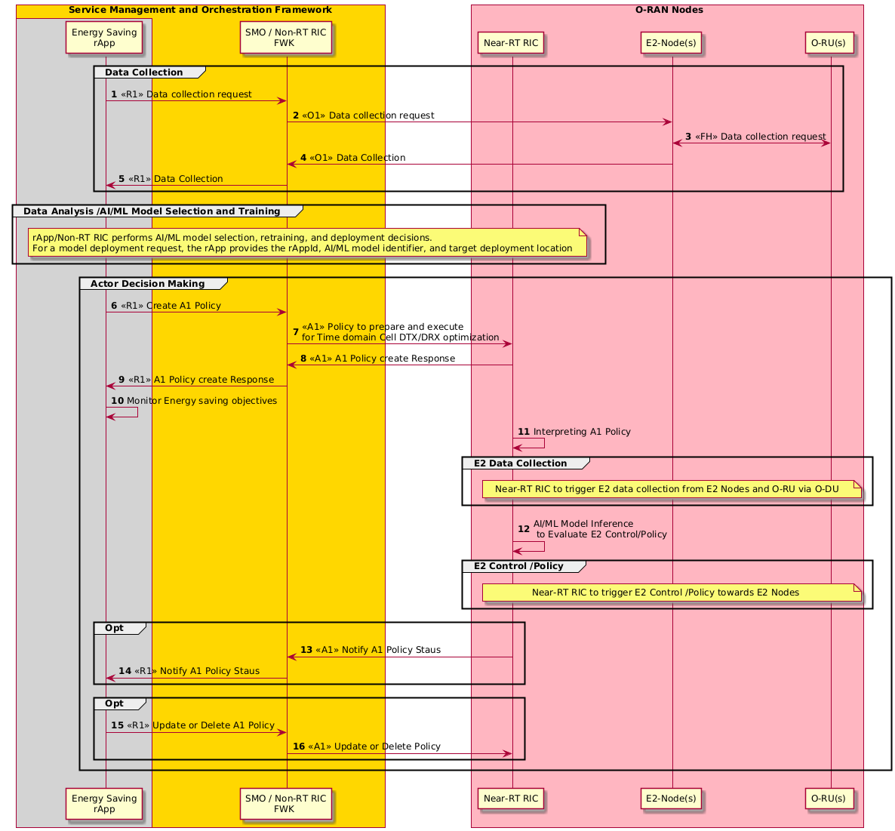

Figure 4.8.4.3.1-1: Flow diagram of A1 interface-based time domain cell DTX/DRX optimization for energy saving

4.8.4.4 Required data
This sub-clause contains the input and output data of model training and inference for energy saving using time domain cell DTX/DRX optimization.

4.8.4.4.1 Input data
The measurement input data are used in model training and inference. They can include the following measurements to monitor energy consumption and energy efficiency of E2 node(s) and O-RU(s):
- DL PDCP SDU data volume per interface (data volume in DL delivered per PLMN, per QoS level, per slice, per interface (from O-CU-UP to O-DU over F1-U, to external O-CU-UP over Xn-U and to external O-eNB over X2-U)) (as specified in 3GPP TS 28.552 [5], clause 5.1.3.6.2.3)
- UL PDCP SDU data volume per interface (data volume in UL delivered per PLMN, per QoS level, per slice, per interface (from O-DU to O-CU-UP over F1-U, to external O-CU-UP over Xn-U and to external O-eNB over X2-U)) (as specified in 3GPP TS 28.552 [5], clause 5.1.3.6.2.4)
- RSRQ measurement per SSB per cell (as specified in 3GPP TS 28.552 [5], clause 5.1.1.31)
- RSRP measurement per SSB per cell (as specified in 3GPP TS 28.552 [5], clause 5.1.1.22)
- SINR measurement per SSB per cell (as specified in 3GPP TS 28.552 [5], clause 5.1.1.32)
- PNF energy consumption (as specified in 3GPP TS 28.552 [5], clause 5.1.1.19.3)
- Power consumed by physical network function & its components (as specified in 3GPP TS 28.552 [5], clause 5.1.1.19.2 and in MP [10], clauses B.1, B.5)
- Transmit power (as specified in MP [10], clauses B.1, B.2.1)
- M1 MDT measurement in trace record for immediate MDT measurements (as specified in 3GPP TS 32.423 [11], clause 4.34.1)
- UE location in trace record for UE location information (as specified in 3GPP TS 32.423 [11], clause 4.34.2)
- UE capability information to support the time domain cell DTX/DRX inter-band CA operation (as specified in 3GPP TS 38.306 [22], clause 4.2.7.2)
- Measurement of paging success rate, helps optimize DRX cycle length to minimize paging failures and avoid unnecessary wake ups (as specified in 3GPP TS 28.552 [5], clause 5.1.1.27)
- DRX cycle parameters like on-duration timer, inactivity timer, and short/long DRX cycle lengths per UE (as specified in 3GPP TS 38.331 [20], clause 5.7)
- Battery usage patterns from UEs during active and DRX modes to optimize DRX configurations to balance energy savings for the network and battery preservation for UEs (as specified 3GPP TS 28.552 [5], clause A.122)
- Quality of Service (QoS) class identifier or 5G QoS indicator assigned to UEs to determine which UEs can enter DRX mode without compromising critical services e.g., VoIP, real-time video (as specified 3GPP TS 23.501 [2], clauses 5.7.3, 5.7.4)

4.8.4.4.2 Output data
rApps to deliver energy saving & energy efficiency A1 policies for time domain cell DTX/DRX optimization through R1 interface.

4.8.5 Spatial and power domain optimization (3GPP Rel-18)

4.8.5.1 Background and goal of the use case
In 3GPP Release-18 [21], clause 15.4.2.7 Spatial Domain (SD) and Power Domain (PD) adaptations were introduced, These features enable the gNB to dynamically adjust the number of active antenna elements and transmission power based on UE channel conditions. In the spatial domain, adaptive control allows antenna elements to be turned on or off depending on demand, while in the power domain, transmission power is adjusted according to the CSI (Channel State Information) reports provided by UEs. These adaptations optimize energy consumption of Transceiver Unit (TXRU) and Power Amplifier (PA) while maintaining service quality.

The Non-RT RIC, through A1 policies, provides high-level guidance to the Near-RT RIC on how to manage these energy-saving features. For spatial domain adaptation, A1 policies advise the Near-RT RIC to prioritize cells with the highest potential for energy savings, such as those with a lower number of active UEs or with more Rel-18-capable UEs. This allows the Near-RT RIC to adapt spatial resources more efficiently, focusing energy-saving efforts where they are most impactful.

For power domain adaptation, the Non-RT RIC provides policy-level guidance based on long-term traffic patterns and CSI reports. A1 policies direct the Near-RT RIC to target cells where transmission power reductions can be implemented without compromising service. The policies focus on balancing energy efficiency with maintaining adequate network performance by advising which cells are suitable for power reduction.

Through these A1 policies, the Non-RT RIC enables the Near-RT RIC to manage spatial and power resources dynamically, ensuring that energy-saving measures are applied where they offer the most benefit, all while maintaining service quality. This high-level guidance helps align real-time network operations with strategic energy-saving goals.

Adaptive spatial control: Non-RT RIC A1 policies enable dynamic control of antenna elements prioritizing cells with lower traffic density or higher Rel-18 UE concentration for enhanced energy efficiency.
Transmission power: Non-RT RIC A1 policies enable dynamic downlink power control of cells with lower traffic density or higher Rel-18 UE concentration for enhanced energy efficiency.
Steer Rel-18 UEs toward specific cells, enabling those cells to either operate efficiently or be shut down.
Bar non-Rel-18 UEs from cells optimized for power and spatial energy savings to maximize energy savings.

4.8.5.2 Entities/resources involved in the use case
- SMO/Non-RT RIC framework:
- Collect the configurations, performance indicators and measurement reports (e.g., cell load related information and traffic information, EE/EC measurement reports) from E2 node(s) and trace records (e.g., per-UE measurement metrics, location information, Rel-18 and pre-R-18 supported UE information) through O1 interface, for the purpose of decision making.
- Transfer collected data towards rApp. It is assumed that configurations, performance indicators and measurement reports collected from the O-DU contain the related information for the corresponding O-RU(s).
- Create A1 Polices for Near-RT RIC based on rApp request for spatial and power domain energy savings optimization via A1 Interface.
- rApps:
- Collect the necessary configurations, performance indicators, and measurement reports from SMO/Non-RT RIC framework, for the purpose of training and execution of relevant AI/ML models.
- (Optionally) Retrain, update, configure EE/ES AI/ML model.
- Infer an optimized A1 policy for spatial and power domain optimization on the data collected using R1 interface.
- E2 node:
- Report cell configuration, performance indicators and measurement reports (e.g., cell load related information and traffic information, EE/EC measurement reports, trace records such as per-UE measurement metrics, location information and Rel-18 and pre-Rel-18 supported UE information) to SMO via O1 interface.
- Report measurement reports (e.g., cell load related information and traffic information, EE/EC measurement reports) to Near-RT RIC via E2 interface.
- Support actions required to perform spatial and power domain optimization for EE/ES optimization.
Note that the requirements of O1 interface for E2 nodes are under the scope of WG10.
- O-RU:
- Report EC and EE related information via open FH M-plane interface to O-DU.
- Support actions required to perform spatial and power domain optimization for EE/ES optimization.
Note that the requirements for O-RU and open FH are under the scope of WG4.

- Near- RT RIC:
- Collect measurement reports (e.g., cell load related information and traffic information, EE/EC measurement reports, Rel-18 and pre-R-18 supported UE information) from E2 nodes.
- (Optionally) Receive EE/ES AI/ML model for deployment via O1 or O2 interface.
- Receive EE/ES related policies via A1 interface for consideration during optimization.
- Analyse the received data from E2 nodes and perform AI/ML model inference to determine spatial and power domain based EE/ES optimization.
- Provide policies or required information to E2 node (O-CU) via E2 to trigger actions for EE/ES optimization.
Note that the requirements for Near-RT RIC are under the scope of WG3.

4.8.5.3 Solution

4.8.5.3.1 A1 policy-based spatial and power domain optimization
In this solution, decision making, potentially using AI/ML model inference, is done at Near-RT RIC. While AI/ML model training might be hosted in Non-RT or Near-RT RIC.
The context of the A1 policy based spatial and power domain optimization for energy saving is captured in table 4.8.5.3.1-1.
Table 4.8.5.3.1-1: A1 policy-based spatial and power domain optimization
Use Case Stage | Evolution / Specification | <<Uses>>  Related use
Goal | A1 policy-based guidance for spatial and power domain energy saving optimization in the network.
Actors and Roles | SMO/Non-RT RIC framework: A1 & O1 termination.  rApp: Provides policy for cell power and spatial domain optimization.  E2 node(s): Enforces mechanism for spatial and power domain optimization on O-RU based on E2 controls or policies.  Near-RT RIC: Spatial and power domain optimization energy savings decision making.
Assumptions | O1 interface connectivity is established between SMO and E2 nodes.  R1 interface connectivity is established.  Open FH M-plane interface is established between O-DU and O-RU.  E2 interface connectivity is established between E2 node and Near-RT RIC.  A1 interface is established between Non-RT RIC and Near-RT RIC.  Network is operational.
Pre-conditions | Operator has set the targets for energy saving in the Non-RT RIC.
Begins when | Operator enables the optimization rApp along with initial ML model for spatial and power domain optimization energy saving and E2 node(s) and O-RU(s) become operational.  See NOTE.
Step 1 (M) | rApp requests to collect necessary configurations, performance indicators, and measurement data towards SMO/Non-RT RIC framework over R1 interface.  Configurations may contain data related to UE capability to support 3GPP Rel-18, which rApp needs to know before formulating A1 policies for spatial and power domain optimization.
Step 2 (M) | SMO/Non-RT RIC framework requests data collection towards E2 node(s) and O-RU(s) (via E2 node(s)) over O1 interface.
Step 3 (M) | O-DU upon receiving request from SMO/Non-RT RIC framework requests and collect necessary data form O-RU(s) over open FH M-plane interface.
Step 4 (M) | E2 node(s) sends the configuration data, configured measurement data to SMO/Non-RT RIC framework periodically or event based.
Step 5 (M) | rApp collects the configuration data, collected measurement data for processing.
Step 6 (M) | rApp to trigger EE/ES optimization through A1 policy to prepare and execute spatial and power domain optimization.
Step 7 (M) | SMO/Non-RT RIC framework receives policy from rApp and forwards it towards Near-RT RIC via A1 interface.
Step 8 (M) | Near-RT RIC provides A1 policy response to SMO/Non-RT RIC framework.
Step 9 (M) | SMO/Non-RT RIC framework informs rApp about A1 policy feedback.
Step 10 (M) | rApp monitors energy saving objectives as per A1 policy.
Step 11 (M) | The Near-RT RIC receives the policy from the Non-RT RIC over the A1 interface. It then interprets the policy to determine the required data collection and E2 control/policies.
Step 12 (M) | Inferencing AI/ML model to evaluate & generate E2 control or policies for spatial and power domain optimization.
Step 13 (M) | Near-RT RIC to notify Non-RT RIC if any change in the state of policy.
Step 14 (M) | SMO/Non-RT RIC framework forwards notification received from Near-RT RIC to rApp.
Step 15 (O) | If energy saving objectives are not achieved rApp may decide to initiate fallback mechanism for example, updating or deleting A1 policy for spatial and power domain optimization.
Step 16 (O) | SMO/Non-RT RIC framework send update or delete A1 policies to Near-RT RIC.
Ends when | E2 node(s) becomes non-operational or when the operator disables the rApp.
Exceptions | N/A
Post Conditions | rApp continues monitoring of energy saving at E2 node(s) and O-RU.  E2 node(s) and O-RU(s) operate using the newly deployed parameters/models and state (off/on).
NOTE: Operator can set policies through rApp or allow AI/ML model in rApp to infer policies.

@startuml
'https://plantuml.com/sequence-diagram
!pragma teoz true
Skin rose
skinparam ParticipantPadding 5
skinparam BoxPadding 10
skinparam defaultFontSize 12
skinparam lifelineStrategy solid
autonumber
Box "Service Management and Orchestration Framework" #gold
Box #lightgrey
Participant "Energy Saving\nrApp" as ESrAPP

End Box
Participant "SMO / Non-RT RIC\nFWK" as NRTF
End box
Box " O-RAN Nodes" #lightpink
Participant "Near-RT RIC" as NeRT
Participant "E2-Node(s)" as E2NODES
Participant "O-RU(s) " as ORUs
End box
group Data Collection
ESrAPP -> NRTF : <<R1>> Data collection request
NRTF -> E2NODES : <<O1>> Data collection request
E2NODES <-> ORUs : Data collection request
E2NODES -> NRTF : <<O1>> Data Collection
NRTF -> ESrAPP : <<R1>> Data Collection
End
group Data Analysis /AI/ML Model Selection and Training
Note over ESrAPP , NeRT
rApp/Non-RT RIC performs AI/ML model selection, retraining, and deployment decisions.
For a model deployment request, the rApp provides the rAppId, AI/ML model identifier, and target deployment location
End note
end
group Actor Decision Making
ESrAPP -> NRTF : <<R1>> Create A1 Policy
NRTF -> NeRT : <<A1>> Policy to prepare and execute \nfor spatial and power domain optimization
NeRT -> NRTF : <<A1>> A1 Policy create Response
NRTF -> ESrAPP : <<R1>> A1 Policy create Response
ESrAPP -> ESrAPP : Monitor Energy saving objectives
NeRT -> NeRT : Interpreting A1 Policy
group E2 Data Collection
Note over NeRT , ORUs
Near-RT RIC to trigger E2 data collection from E2 Nodes and O-RU via O-DU
End note
end
NeRT -> NeRT : AI/ML Model Inference\n to Evaluate E2 Control/Policy
group E2 Control /Policy
Note over NeRT , ORUs
Near-RT RIC to trigger E2 Control /Policy towards E2 Nodes and O-RU via O-DU
End note
end
group Opt
NeRT -> NRTF : <<A1>> Notify A1 Policy Staus
NRTF -> ESrAPP : <<R1>> Notify A1 Policy Staus
end
group Opt
ESrAPP -> NRTF : <<R1>> Update or Delete A1 Policy
NRTF -> NeRT : <<A1>> Update or Delete Policy
end
end
@enduml

The flow diagram of A1 interface-based mechanism for spatial and power domain optimization for energy saving is shown in figure 4.8.5.3.1-1.

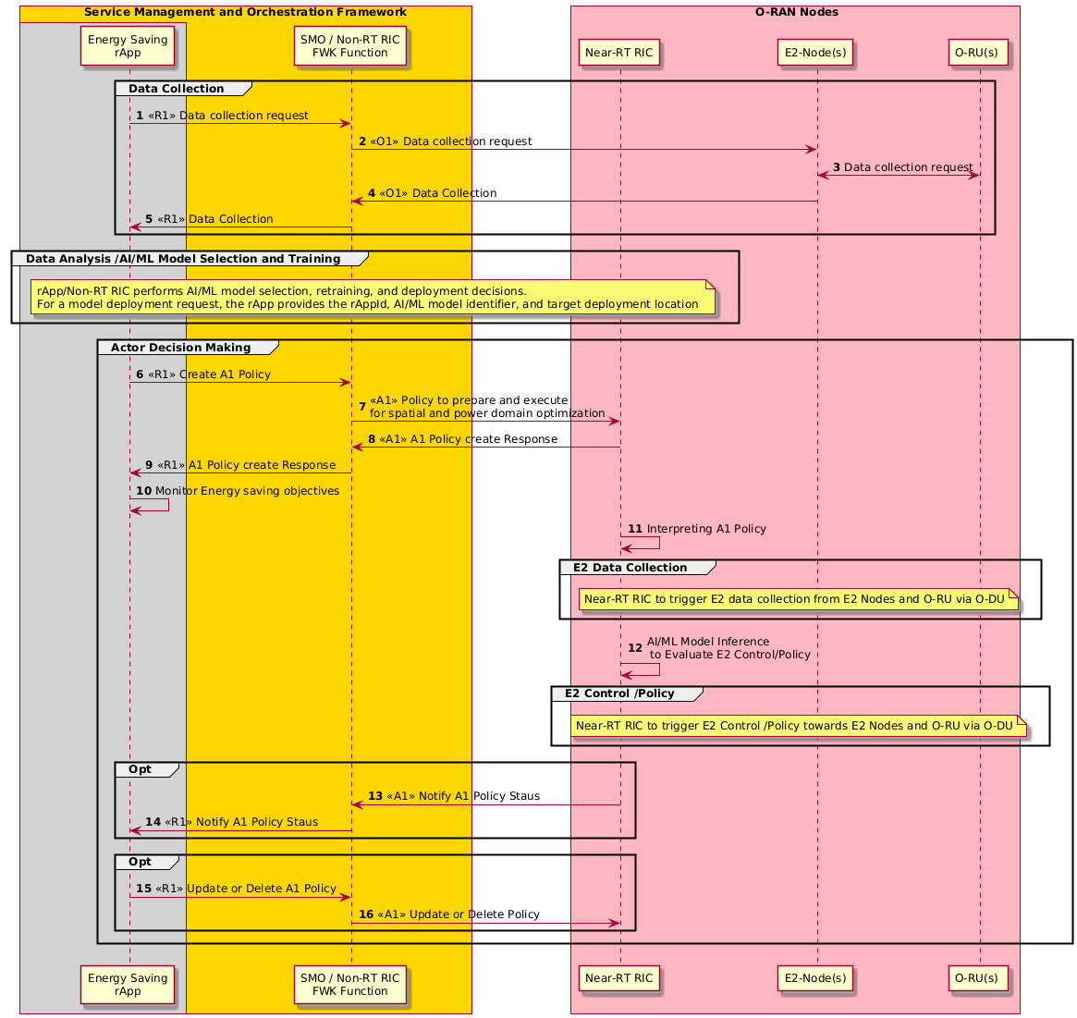
Figure 4.8.5.3.1-1: Flow diagram of A1 interface-based mechanism for spatial and power domain optimization for energy saving

4.8.5.4 Required data
This sub-clause contains the input and output data of model training and inference for energy saving using spatial and power domain optimization.

4.8.5.4.1 Input data
The measurement input data is used in model training and inference. They can include the following measurements to monitor energy consumption and energy efficiency of E2 node(s) and O-RU(s):
- DL PDCP SDU data volume per interface (data volume in DL delivered per PLMN, per QoS level, per slice, per interface ((from O-CU-UP to O-DU over F1-U, to external O-CU-UP over Xn-U and to external O-eNB over X2-U)) (as specified in 3GPP TS 28.552 [5], clause 5.1.3.6.2.3)
- UL PDCP SDU data volume per interface (data volume in UL delivered per PLMN, per QoS level, per slice, per interface ((from O-DU to O-CU-UP over F1-U, to external O-CU-UP over Xn-U and to external O-eNB over X2-U)) (as specified in 3GPP TS 28.552 [5], clause 5.1.3.6.2.4)
- RSRQ measurement per SSB per cell (as specified in 3GPP TS 28.552 [5], clause 5.1.1.31)
- RSRP measurement per SSB per cell (as specified in 3GPP TS 28.552 [5], clause 5.1.1.22)
- SINR measurement per SSB per cell (as specified in 3GPP TS 28.552 [5], clause 5.1.1.32)
- PNF Energy consumption (as specified in 3GPP TS 28.552 [5], clause 5.1.1.19.3)
- Power consumed by physical network function & its components (as specified in 3GPP TS 28.552 [5], clause 5.1.1.19.2 and in MP [10], clauses B.1, B.5)
- Transmit power (as specified in MP [10], clauses B.1, B.2.1)
- M1 MDT measurement in trace record for immediate MDT measurements (as specified in 3GPP TS 32.423 [11], clause 4.34.1)
- UE location in trace record for UE location information (as specified in 3GPP TS 32.423 [11], clause 4.34.2)
- UE capability information related to Rel-18 Spatial and Power domain energy savings, including the following capability indicators:powerAdaptation-CSI-Feedback-r18, powerAdaptation-CSI-FeedbackAperiodic-r18, powerAdaptation-CSI-FeedbackPUCCH-r18, powerAdaptation-CSI-FeedbackPUSCH-r18, spatialAdaptation-CSI-Feedback-r18, spatialAdaptation-CSI-FeedbackAperiodic-r18, spatialAdaptation-CSI-FeedbackPUCCH-r18, spatialAdaptation-CSI-FeedbackPUSCH-r18 (as specified in 3GPP TS 38.306 [22], clause 4.2.7.2)
- Handover Measurement Data (as specified 3GPP TS 28.552 [5], clauses 5.1.1.6.5, 5.1.3.7)

4.8.5.4.2 Output data
rApps to deliver energy saving & energy efficiency A1 policies for mechanism for spatial and power domain optimization through R1 interface.

4.8.6 SSB-less SCell optimization for inter-band CA (3GPP Rel-18)

4.8.6.1 Background and goal of the use case
3GPP Rel-18 [21], clause 15.4.2.6 introduces the concept of SSB-less secondary cell (SCell) activation for carrier aggregation, which allows efficient use of secondary carriers without needing constant synchronization signals. This enhances spectral efficiency and data throughput for users with high demand, without burdening the network with unnecessary signaling. The SSB-less SCell operation for inter-band CA is designed to enhance energy efficiency while maintaining data throughput in carrier aggregation scenarios. By operating without the need for continuous synchronization signal block (SSB) transmissions, the network can reduce power consumption on secondary cells, particularly in periods of lower traffic demand. The primary goal of this use case is to maximize energy savings without degrading user experience by intelligently enabling and disabling SCells based on real-time traffic demand.
The SSB-less SCell feature, as specified in [20], enables User Equipment (UE) to obtain a timing reference from a serving cell other than its primary serving cell, even when Synchronization Signal Block (SSB) or Secondary Management and Control Channel (SMTC) configurations are unavailable. Within the O-RAN framework, this capability can be enhanced through Non-RT RIC-driven predictive analytics, which anticipate optimal conditions for activating SSB-less SCells. By pre-configuring network parameters, the Non-RT RIC ensures seamless SCell switching and synchronization without relying on SSB transmissions, significantly reducing energy consumption. Meanwhile, the Near-RT RIC, leveraging its near real-time decision-making capabilities, dynamically adjusts SCell parameters based on A1 policies, ensuring efficient and adaptive network operation.
Based on this analysis, the Non-RT RIC generates A1 policies that include, but are not limited to, the following:
Activate SSB-less SCells in appropriate cells to improve spectral efficiency while minimizing unnecessary synchronization transmissions, reducing power consumption during low-traffic periods.
Steer Rel-18 UEs towards SSB-less SCells where energy savings can be maximized, ensuring that secondary cells operate efficiently without impacting service quality.
Bar non-Rel-18 UEs from SSB-less optimized SCells to maintain seamless operation and prevent unnecessary fallback to legacy synchronization mechanisms, maximizing energy efficiency.

4.8.6.2 Entities/resources involved in the use case
- SMO/Non-RT RIC framework:
- Collect the configurations, performance indicators and measurement reports (e.g., cell load related information and traffic information, EE/EC measurement reports) from E2 node(s) and trace records (e.g., per-UE measurement metrics, location information, Rel-18 and pre-Rel-18 supported UE information) through O1 Interface, for the purpose of decision making.
- Transfer collected data towards rApp. It is assumed that configurations, performance indicators and measurement reports collected from the O-DU contain the related information for the corresponding O-RU(s).
- Create A1 Policies for Near-RT RIC based on rApp request to optimize SSB-less SCell energy savings via the A1 interface.
- rApps:
- Collect the necessary configurations, performance indicators, and measurement reports from SMO/Non-RT RIC framework, for the purpose of training and execution of relevant AI/ML models.
- (Optionally) Retrain, update, configure EE/ES AI/ML model.
- Infer an optimized A1 policy for SSB-less SCell based optimization on the data collected using R1 interface.
- E2 node:
- Report cell configuration, performance indicators and measurement reports (e.g., cell load related information and traffic information, EE/EC measurement reports, trace records such as per-UE measurement metrics, location information and Rel-18 and pre-Rel-18 supported UE information) to SMO via O1 interface.
- Report measurement reports (e.g., cell load related information and traffic information, EE/EC measurement reports) to Near-RT RIC via E2 interface.
- Support actions required to perform SSB-less SCell based optimization for EE/ES optimization.
Note that the requirements of O1 interface for E2 nodes are under the scope of WG10.
- O-RU :
- Report EC and EE related information via open FH M-Plane interface to O-DU.
- Support actions required to perform SSB-less SCell based optimization for EE/ES optimization.
Note that the requirements for O-RU and open FH are under the scope of WG4.
- Near- RT RIC:
- Collect measurement reports (e.g., cell load related information and traffic information, EE/EC measurement reports, Rel-18 and pre-R-18 supported UE information) from E2 nodes.
- (Optionally) Receive EE/ES AI/ML model for deployment via O1 or O2 interface.
- Receive EE/ES related policies via A1 interface for consideration during optimization.
- Analyse the received data from E2 nodes and perform AI/ML model inference to determine SSB-less SCell based EE/ES Optimization (i.e., SSB-less SCell to be activated for certain time and cells) considering the optimization targets/policies.
- Provide policies or required information to E2 node (O-CU) via E2 to trigger actions for EE/ES optimization.
Note that the requirements for Near-RT RIC are under the scope of WG3.

4.8.6.3 Solution

4.8.6.3.1 A1 policy-based SSB-less SCell optimization for energy saving
In this solution, decision making, potentially using AI/ML model inference, is done at Near-RT RIC. While AI/ML model training might be hosted in Non-RT or Near-RT RIC.
The context of the A1 policy-based SSB-less SCell optimization for energy saving is captured in table 4.8.6.3.1-1.
Table 4.8.6.3.1-1: A1 policy-based SSB-less SCell optimization for energy saving
Use Case Stage | Evolution / Specification | <<Uses>>  Related use
Goal | A1 policy-based guidance for performing SSB-less S-Cell optimization energy saving in the network.
Actors and Roles | SMO/Non-RT RIC framework:A1 & O1 termination.  rApp: SSB-less SCell optimization.  E2 node(s): Enforces SSB-less SCell optimization on O-RU based on E2 policy or control.  Near-RT RIC: SSB-less SCell energy savings decision making function.
Assumptions | O1 interface connectivity is established between SMO and E2 nodes.  R1 interface connectivity is established.  Open FH M-plane interface is established between O-DU and O-RU.  E2 interface connectivity is established between E2 node and Near-RT RIC.  A1 interface is established between Non-RT RIC and Near-RT RIC.  Network is operational.
Pre-conditions | Operator has set the targets for energy saving in the Non-RT RIC.
Begins when | Operator enables the rApp along with initial ML model for SSB-less SCell energy saving and E2 node(s) and O-RU(s) become operational.  See NOTE.
Step 1 (M) | rApp requests to collect necessary configurations, performance indicators, and measurement data towards SMO/Non-RT RIC framework over R1 interface.  Configurations may contain data related to UE capability to support 3GPP Rel-18, which rApp needs to know before formulating A1 policies for SSB-less SCell optimization.
Step 2 (M) | SMO/Non-RT RIC framework requests data collection towards E2 node(s) and O-RU(s) (via E2 node(s)) over O1 interface.
Step 3 (M) | E2 node(s) upon receiving request from SMO/Non-RT RIC framework requests and collect necessary data form O-RU(s).
Step 4 (M) | E2 node(s) sends the configuration data, configured measurement data to SMO/Non-RT RIC framework periodically or event based.
Step 5 (M) | rApp collects the configuration data, collected measurement data for processing.
Step 6 (M) | rApp to trigger EE/ES optimization through A1 policy to prepare and execute SSB-less SCell optimization.
Step 7 (M) | Non-RT RIC framework receives policy from rApp and forwards it towards Near-RT RIC via A1 interface.
Step 8 (M) | Near-RT RIC provides A1 policy response to SMO/Non-RT RIC framework.
Step 9 (M) | SMO/Non-RT RIC framework informs rApp about A1 policy feedback.
Step 10 (M) | rApp monitors energy saving objectives as per A1 policy.
Step 11 (M) | The Near-RT RIC receives the policy from the Non-RT RIC over the A1 interface. It then interprets the policy to determine the required data collection and E2 control/policies.
Step 12 (M) | Inferencing AI/ML model to evaluate & generate E2 control or policies for SSB-less SCell optimization.
Step 13 (M) | Near-RT RIC to notify Non-RT RIC if any change in the state of policy.
Step 14 (M) | SMO/Non-RT RIC framework forwards notification received from Near-RT RIC to rApp.
Step 15 (O) | If energy saving objectives are not achieved rApp may decide to initiate fallback mechanism for example, updating or deleting A1 policy for SSB-less SCell optimization.
Step 16 (O) | SMO/Non-RT RIC framework send update or delete A1 policies to Near-RT RIC.
Ends when | E2 node(s) becomes non-operational or when the operator disables the rApp.
Exceptions | N/A
Post Conditions | rApp continues monitoring of energy saving at E2 node(s) and O-RU.  E2 node(s) and O-RU(s) operate using the newly deployed parameters and state (off/on).
NOTE: Operator can set policies through rApp or allow AI/ML model in rApp to infer policies.

@startuml
'https://plantuml.com/sequence-diagram
!pragma teoz true
Skin rose
skinparam ParticipantPadding 5
skinparam BoxPadding 10
skinparam defaultFontSize 12
skinparam lifelineStrategy solid
autonumber
Box "Service Management and Orchestration Framework" #gold
Box #lightgrey
Participant "Energy Saving\nrApp" as ESrAPP

End Box
Participant "SMO / Non-RT RIC\nFWK " as NRTF
End box
Box " O-RAN Nodes" #lightpink
Participant "Near-RT RIC" as NeRT
Participant "E2-Node(s)" as E2NODES
Participant "O-RU(s) " as ORUs
End box
group Data Collection
ESrAPP -> NRTF : <<R1>> Data collection request
NRTF -> E2NODES : <<O1>> Data collection request
E2NODES <-> ORUs : Data collection request
E2NODES -> NRTF : <<O1>> Data Collection
NRTF -> ESrAPP : <<R1>> Data Collection
End
group Data Analysis /AI/ML Model Selection and Training
Note over ESrAPP , NeRT
rApp/Non-RT RIC performs AI/ML model selection, retraining, and deployment decisions.
For a model deployment request, the rApp provides the rAppId, AI/ML model identifier, and target deployment location
End note
End
group Actor Decision Making
ESrAPP -> NRTF : <<R1>> Create A1 Policy
NRTF -> NeRT : <<A1>> Policy to prepare and execute \nfor SSB-less-S-Cell Operation
NeRT -> NRTF : <<A1>> A1 Policy create Response
NRTF -> ESrAPP : <<R1>> A1 Policy create Response
ESrAPP -> ESrAPP : Monitor Energy saving objectives
NeRT -> NeRT : Interpreting A1 Policy
group E2 Data Collection
Note over NeRT , ORUs
Near-RT RIC to trigger E2 data collection from E2 Nodes and O-RU via O-DU
End note
end
NeRT -> NeRT : AI/ML Model Inference\n to Evaluate E2 Control/Policy
group E2 Control /Policy
Note over NeRT , ORUs
Near-RT RIC to trigger E2 Control /Policy towards E2 Nodes
End note
end
group Opt
NeRT -> NRTF : <<A1>> Notify A1 Policy Staus
NRTF -> ESrAPP : <<R1>> Notify A1 Policy Staus
end
group Opt
ESrAPP -> NRTF : <<R1>> Update or Delete A1 Policy
NRTF -> NeRT : <<A1>> Update or Delete Policy
end
end
@enduml

The flow diagram of A1 interface based SSB-less SCell optimization for energy saving is shown in figure 4.8.6.3.1-1.

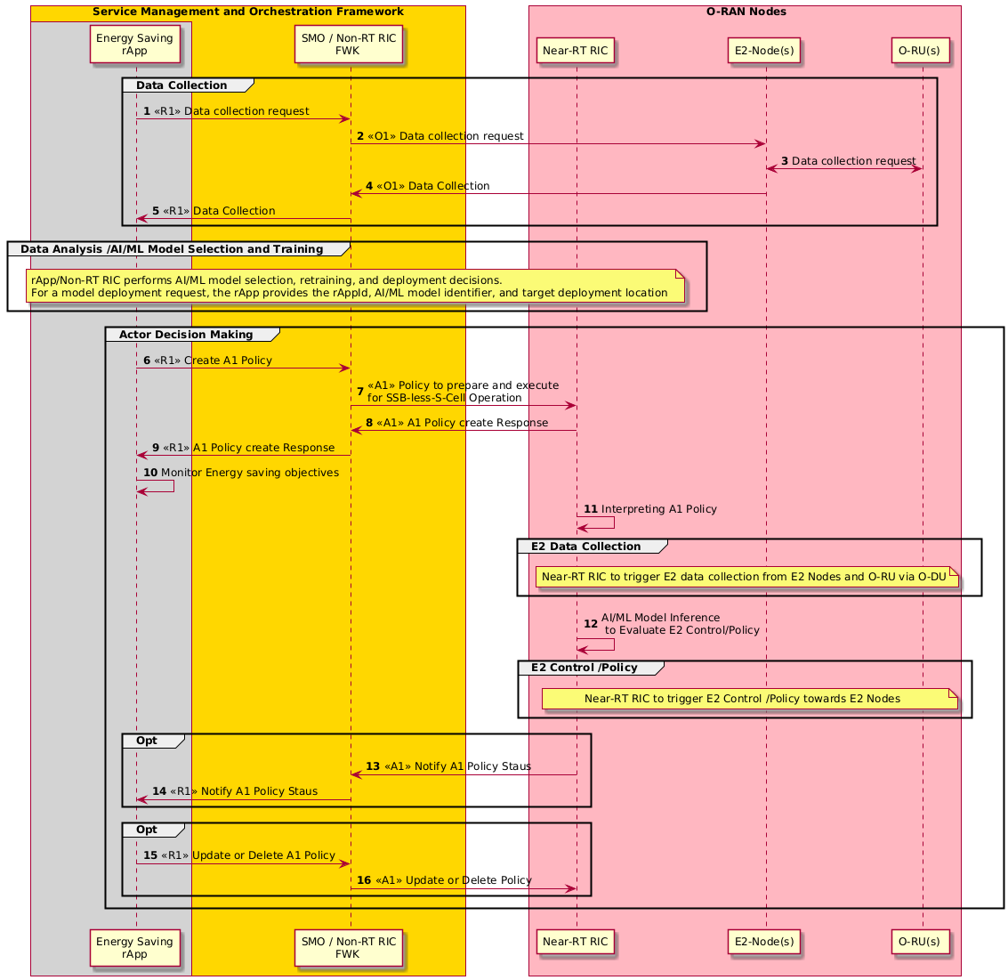
Figure 4.8.6.3.1-1: Flow diagram of A1 interface based SSB-less SCell optimization for energy saving

4.8.6.4 Required data
This sub-clause contains the input and output data of model training and inference for energy saving using SSB-less SCell optimization.

4.8.6.4.1 Input data
The measurement input data is used in model training and inference. They can include the following measurements to monitor energy consumption and energy efficiency of E2 node(s) and O-RU(s):
- DL PDCP SDU data volume per interface (data volume in DL delivered per PLMN, per QoS level, per slice, per interface ((from O-CU-UP to O-DU over F1-U, to external O-CU-UP over Xn-U and to external O-eNB over X2-U)) (as specified in 3GPP TS 28.552 [5], clause 5.1.3.6.2.3)
- UL PDCP SDU data volume per interface (data volume in UL delivered per PLMN, per QoS level, per slice, per interface ((from O-DU to O-CU-UP over F1-U, to external O-CU-UP over Xn-U and to external O-eNB over X2-U)) (as specified in 3GPP TS 28.552 [5], clause 5.1.3.6.2.4)
- RSRQ measurement per SSB per cell (as specified in 3GPP TS 28.552 [5], clause 5.1.1.31)
- RSRP measurement per SSB per cell (as specified in 3GPP TS 28.552 [5], clause 5.1.1.22)
- SINR measurement per SSB per cell (as specified in 3GPP TS 28.552 [5], clause 5.1.1.32)
- PNF Energy consumption (as specified in 3GPP TS 28.552 [5], clause 5.1.1.19.3)
- Power consumed by physical network function & its components (as specified in 3GPP TS 28.552 [5], clause 5.1.1.19.2 and in MP [10], clauses B.1, B.5)
- Transmit power (as specified in MP [10], clauses B.1, B.2.1)
- M1 MDT measurement in trace record for immediate MDT measurements including RSRP, RSRQ, SINR (as specified in 3GPP TS 32.423 [11], clause 4.34.1)
- UE location in trace record for UE location information (as specified in 3GPP TS 32.423 [11], clause 4.34.2)
- UE capability information to support the SSB-less SCell inter-band carrier aggregation operation; scellWithoutSSB, scellWithoutSSB-InterBandCA-r18 (as specified in 3GPP TS 38.306 [22], clause 4.2.7.2)
l) DL cell PDCP SDU data volume on X2 interface (as specified in 3GPP TS 28.552 [5], clause 5.1.2.1.1.2) and UL Cell PDCP SDU Data Volume on Xn Interface (as specified in 3GPP TS 28.552 [5], clause 5.1.2.1.2.3)

4.8.6.4.2 Output data
rApps to deliver energy saving & energy efficiency A1 policies for SSB-less SCell optimization through R1 interface.

4.8.7 PA power optimization for O-RU energy saving

4.8.7.1 Background and goal of the use case
The O-RU energy saving could be achieved by optimizing its Power Amplifier (PA) operating region according to the traffic scheduling requirements, to reduce the O-RU power consumption. To facilitate this, the SMO (Non-RT RIC) framework analyses various network data and KPIs to generate A1 policies and provide them to Near-RT RIC via A1 interface. The Near-RT RIC, leveraging its near-real-time decision-making capabilities, prepare E2 policies or configuration changes dynamically and deliver them to the E2 node (i.e., O-DU) via E2 interface. The O-DU analyses the E2 policies or applies the configuration changes provided by Near-RT RIC. Once the conditions mentioned in the E2 policy are satisfied or based on requested configuration changes, the O-DU configures the maximum output power of the O-RU via fronthaul M-plane or C-plane interface. The O-RU subsequently optimizes its power amplifier parameters according to the configured maximum output power. This could result in a reduction of PA power consumption, thereby achieving energy saving in O-RU and enhancing the overall energy efficiency of the O-RAN network.

4.8.7.2 Entities/resources involved in the use case
- SMO/Non-RT RIC framework:
- Collect the configurations, performance indicators and measurement reports (e.g., cell load related information and traffic information, EE/EC measurement reports) from E2 node(s) through O1 interface, for the purpose of decision making.
- Transfer collected data towards rApp. It is assumed that configurations, performance indicators and measurement reports collected from the O-DU contain the related information for the corresponding O-RU(s).
- Create A1 policies for Near-RT RIC based on rApp request to optimize O-RU power amplifier to achieve energy savings via the A1 interface.
- rApps:
- Collect the necessary configurations, performance indicators, and measurement reports from SMO/Non-RT RIC framework, for the purpose of training and execution of relevant AI/ML models.
- (Optionally) Retrain, update, configure EE/ES AI/ML model.
- Infer an optimized A1 policy for O-RU PA power optimization based on the data collected using R1 interface.
- E2 node:
- Report cell configuration, performance indicators and measurement reports (e.g., cell load related information and traffic information, EE/EC measurement reports to SMO via O1 interface.
- Report measurement reports (e.g., cell load related information and traffic information, EE/EC measurement reports) to Near-RT RIC via E2 interface.
- Support actions required to perform O-RU PA power optimization for EE/ES optimization.
Note that the requirements of O1 interface for E2 nodes are under the scope of WG10.
- O-RU:
- Report EC and EE related information via open FH M-plane interface to O-DU.
- Support actions required to perform PA power optimization for EE/ES optimization.
Note that the requirements for O-RU and open FH are under the scope of WG4.
- Near- RT RIC:
- Collect measurement reports (e.g., cell load related information and traffic information, EE/EC measurement reports from E2 nodes via E2 interface.
- (Optionally) Receive EE/ES AI/ML model for deployment via O1 or O2 interface.
- Receive EE/ES related policies via A1 interface for consideration during optimization.
- Analyse the received data from E2 nodes and perform AI/ML model inference to determine O-RU PA optimization (i.e., maximum Tx output power to be configured in a specific O-RU) considering the optimization targets/policies.
- Provide policies or required information to E2 node (O-CU) via E2 to trigger actions for EE/ES optimization.
Note that the requirements for Near-RT RIC are under the scope of WG3.

4.8.7.3 Solution

4.8.7.3.1 A1 policy-based PA power optimization for energy saving
In this solution, decision making, potentially using AI/ML model inference, is done at Near-RT RIC. While AI/ML model training might be hosted in Non-RT or Near-RT RIC.
The context of the A1 policy-based PA power optimization for energy saving is captured in table 4.8.7.3.1-1.
Table 4.8.7.3.1-1: A1 policy-based PA power optimization for energy saving
Use Case Stage | Evolution / Specification | <<Uses>>  Related use
Goal | A1 policy-based guidance for performing PA power optimization energy saving in the network.
Actors and Roles | SMO/Non-RT RIC framework: A1 & O1 termination.  rApp: PA power optimization.  E2 node(s): Enforces PA power optimization on O-RU based on E2 policy or control.  Near-RT RIC: PA power optimization-based energy savings decision making function.
Assumptions | O1 interface connectivity is established between SMO and E2 nodes.  R1 interface connectivity is established.  Open FH M-plane interface is established between O-DU and O-RU.  E2 interface connectivity is established between E2 node and Near-RT RIC.  A1 interface is established between Non-RT RIC and Near-RT RIC.  Network is operational.
Pre-conditions | Operator has set the targets for energy saving in the Non-RT RIC.
Begins when | Operator enables the rApp along with initial ML model for PA power optimization-based energy saving and E2 node(s) and O-RU(s) become operational.  See NOTE.
Step 1 (M) | rApp requests to collect necessary configurations, performance indicators, and measurement data towards SMO/Non-RT RIC framework over R1 interface.  Configurations may contain data related to maximum Tx output power, which rApp needs to know before formulating A1 policy for O-RU PA power optimization.
Step 2 (M) | SMO/Non-RT RIC framework requests data collection towards E2 node(s) and O-RU(s) (via E2 node(s)) over O1 interface.
Step 3 (M) | O-DU upon receiving request from SMO/Non-RT RIC framework requests and collect necessary data from O-RU(s).
Step 4 (M) | E2 node(s) sends the configuration data, configured measurement data to SMO/Non-RT RIC framework periodically or event based.
Step 5 (M) | rApp collects the configuration data, collected measurement data for processing.
Step 6 (M) | rApp to trigger EE/ES optimization through A1 policy to prepare and execute PA power optimization.
Step 7 (M) | Non-RT RIC framework receives policy from rApp and forwards it towards Near-RT RIC via A1 interface.
Step 8 (M) | Near-RT RIC provides A1 policy response to SMO/Non-RT RIC framework.
Step 9 (M) | SMO/Non-RT RIC framework informs rApp about A1 policy feedback.
Step 10 (M) | rApp monitors energy saving objectives as per A1 policy.
Step 11 (M) | The Near-RT RIC receives the policy from the Non-RT RIC over the A1 interface. It then interprets the policy to determine the required data collection and E2 control/policies.
Step 12 (M) | Inferencing AI/ML model to evaluate & generate E2 control or policies for PA power optimization.
Step 13 (M) | Near-RT RIC to notify Non-RT RIC if any change in the state of policy.
Step 14 (M) | SMO/Non-RT RIC framework forwards notification received from Near-RT RIC to rApp.
Step 15 (O) | If energy saving objectives are not achieved rApp may decide to initiate fallback mechanism for example, updating or deleting A1 policy for O-RU PA power optimization.
Step 16 (O) | SMO/Non-RT RIC framework send update or delete A1 policies to Near-RT RIC
Ends when | E2 node(s) becomes non-operational or when the operator disables the rApp.
Exceptions | N/A
Post Conditions | rApp continues monitoring of energy saving at E2 node(s) and O-RU.  E2 node(s) and O-RU(s) operate using the newly deployed parameters and state (off/on).
NOTE: Operator can set policies through rApp or allow AI/ML model in rApp to infer policies.

@startuml
'https://plantuml.com/sequence-diagram
!pragma teoz true
Skin rose
skinparam ParticipantPadding 5
skinparam BoxPadding 10
skinparam defaultFontSize 12
skinparam lifelineStrategy solid
autonumber
Box "Service Management and Orchestration Framework" #gold
Box #lightgrey
Participant "Energy Saving\nrApp" as ESrAPP

End Box
Participant "SMO / Non-RT RIC\nFWK " as NRTF
End box
Box " O-RAN Nodes" #lightpink
Participant "Near-RT RIC" as NeRT
Participant "E2-Node(s)" as E2NODES
Participant "O-RU(s) " as ORUs
End box
group Data Collection
ESrAPP -> NRTF : <<R1>> Data collection request
NRTF -> E2NODES : <<O1>> Data collection request
E2NODES <-> ORUs : Data collection request
E2NODES -> NRTF : <<O1>> Data Collection
NRTF -> ESrAPP : <<R1>> Data Collection
End
group Data Analysis /AI/ML Model Selection and Training
Note over ESrAPP , NeRT
rApp/Non-RT RIC performs AI/ML model selection, retraining, and deployment decisions.
For a model deployment request, the rApp provides the rAppId, AI/ML model identifier, and target deployment location
End note
End
group Actor Decision Making
ESrAPP -> NRTF : <<R1>> Create A1 Policy
NRTF -> NeRT : <<A1>> Prepare policy and execute \nfor PA power optimization
NeRT -> NRTF : <<A1>> A1 Policy create Response
NRTF -> ESrAPP : <<R1>> A1 Policy create Response
ESrAPP -> ESrAPP : Monitor Energy saving objectives
NeRT -> NeRT : Interpreting A1 Policy
group E2 Data Collection
Note over NeRT , ORUs
Near-RT RIC to trigger E2 data collection from E2 Nodes and O-RU via O-DU
End note
end
NeRT -> NeRT : AI/ML Model Inference\n to Evaluate E2 Control/Policy
group E2 Control /Policy
Note over NeRT , ORUs
Near-RT RIC to trigger E2 Control /Policy towards E2 Nodes
End note
end
group Opt
NeRT -> NRTF : <<A1>> Notify A1 Policy Staus
NRTF -> ESrAPP : <<R1>> Notify A1 Policy Staus
end
group Opt
ESrAPP -> NRTF : <<R1>> Update or Delete A1 Policy
NRTF -> NeRT : <<A1>> Update or Delete Policy
end
end
@enduml

The flow diagram of A1 interface-based O-RU PA optimization for energy saving is shown in figure 4.8.7.3.1-1.

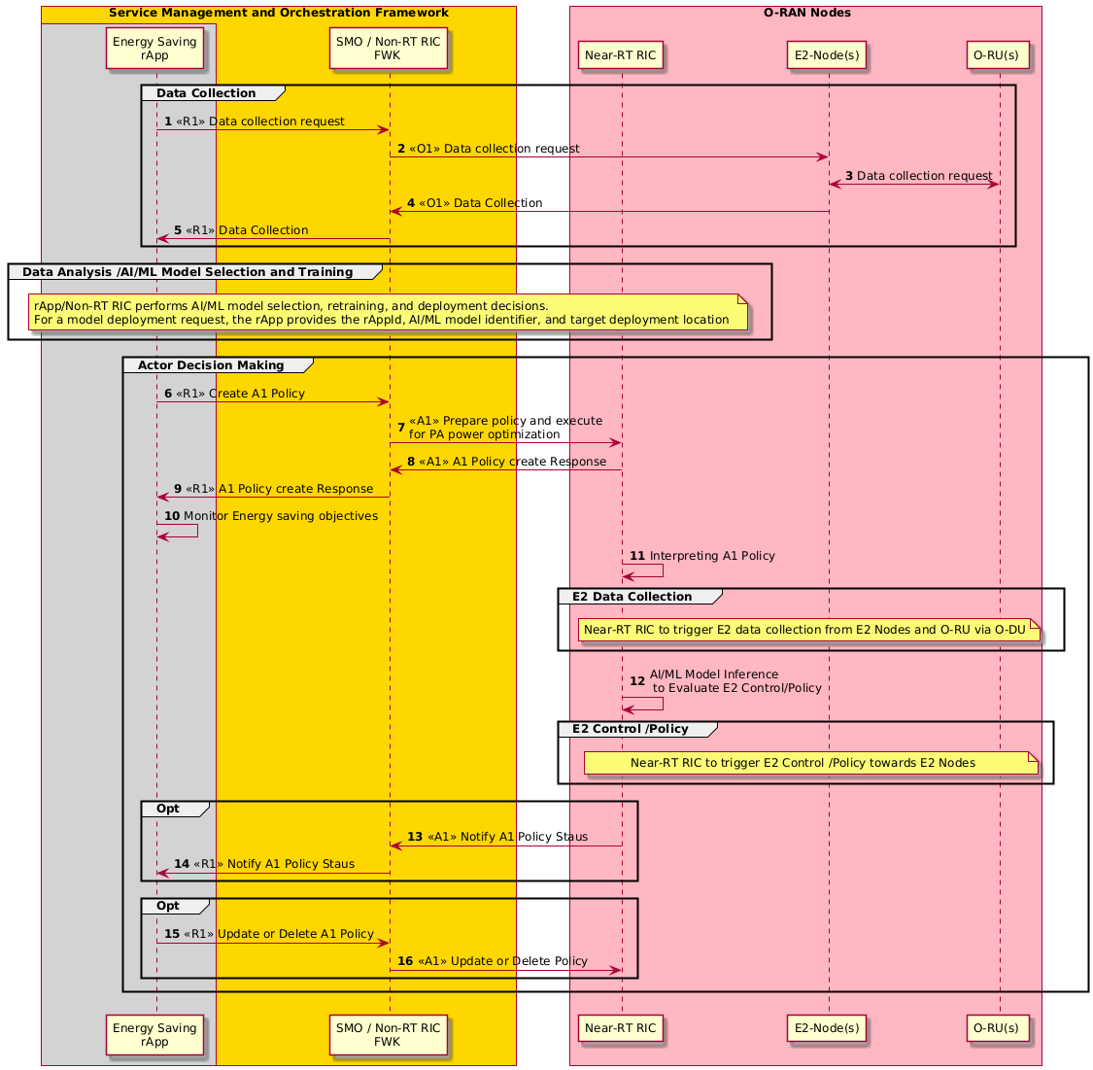
Figure 4.8.7.3.1-1: Flow diagram of A1 interface-based O-RU PA optimization for energy saving

4.8.7.4 Required data
This sub-clause contains the input and output data of model training and inference for energy saving using O-RU PA power optimization.

4.8.7.4.1 Input data
The measurement input data is used in model training and inference. They can include the following measurements to monitor energy consumption and energy efficiency of E2 node(s) and O-RU(s):
- DL PDCP SDU data volume per interface (data volume in DL delivered per PLMN, per QoS level, per slice, per interface ((from O-CU-UP to O-DU over F1-U, to external O-CU-UP over Xn-U and to external O-eNB over X2-U)) (as specified in 3GPP TS 28.552 [5], clause 5.1.3.6.2.3)
- UL PDCP SDU data volume per interface (data volume in UL delivered per PLMN, per QoS level, per slice, per interface ((from O-DU to O-CU-UP over F1-U, to external O-CU-UP over Xn-U and to external O-eNB over X2-U)) (as specified in 3GPP TS 28.552 [5], clause 5.1.3.6.2.4)
- PNF Energy consumption (as specified in 3GPP TS 28.552 [5], clause 5.1.1.19.3)
- Power consumed by physical network function & its components (as specified in 3GPP TS 28.552 [5], clause 5.1.1.19.2 and in MP [10], clauses B.1-1, B.5)
- M1 MDT measurement in trace record for immediate MDT measurements including RSRP, RSRQ, SINR (as specified in 3GPP TS 32.423 [11], clause 4.34.1)

4.8.7.4.2 Output data
rApps to deliver energy saving & energy efficiency A1 policies for PA power optimization through R1 interface.

4.8.8 External power source coordination-based energy saving

4.8.8.1 Background and goal of the use case
In 3GPP Release 19 [25], clauses 5.1.6.2, 5.2.5.1, 8.3.1, 8.3.2, and 8.3.3, and Annex C.1, the framework is described for an operator to have awareness about the external power source.
In O-RAN, energy source and supply information is obtained by the SMO via standard management paths. When the O-RU exposes such information, it shall be provided over O1 (M-plane) using WG4 YANG/NRM attributes (when available). The SMO may also ingest the information from external systems (e.g., an energy management system) using SMO integrations. The interface between an external power source and the O-RU is out of scope for O-RAN.
The SMO (Non-RT RIC) may use the energy source/supply information—together with other network data—to create or update an A1 energy saving policy for the relevant cells.
These A1 policies are enforced by the Near-RT RIC, which dynamically applies configurations or provide E2 policy to switch the external power source and configure an appropriate energy saving methods in the O-RU through E2 node in near-real-time.

4.8.8.2 Entities/resources involved in the use case
- SMO/Non-RT RIC framework:
- Energy source and supply information can be made available at SMO framework (operator configures energy source and supply information [25] or collect through E2 node using O1 interface.
- Collect the configurations, performance indicators and measurement reports (e.g., cell load related information and traffic information, EE/EC measurement reports) from E2 node(s) through O1 interface, for the purpose of decision making.
- Transfer collected data towards rApp. It is assumed that energy supply and source information and configurations, performance indicators and measurement reports collected from the O-DU contain the related information for the corresponding O-RU(s).
- Create A1 policies for Near-RT RIC based on rApp requests to optimize the O-RU energy consumption based on energy source and supply information via the A1 interface.
- rApps:
- Collect the energy source and supply information, necessary configurations, performance indicators, and measurement reports from SMO/Non-RT RIC framework the purpose of training and execution of relevant AI/ML models.
- (Optionally) Retrain, update, configure EE/ES AI/ML model.
- Infer an optimized A1 policy for energy source configuration changes and external power source coordination-based energy optimization based on the data collected using R1 interface.
- E2 node:
- Report energy source and supply information, cell configuration, performance indicators and measurement data (e.g., cell load related information and traffic information, EE/EC measurement) and reports to SMO via O1 interface.
- Report energy source and supply information and measurement data (e.g., cell load related information and traffic information, EE/EC measurement reports) to Near-RT RIC via E2 interface.
- Support actions required to forward the energy source configuration changes and to perform external power source coordination-based energy optimization for E2 node and O-RU for EE/ES optimization.
Note that the requirements of O1 interface for E2 nodes are under the scope of WG10.
- O-RU :
- Report energy source and supply information and EC/EE related information via open FH M-plane interface to O-DU.
- Support actions required to forward the energy source configuration changes and to perform energy saving for EE/ES optimization.
Note that the requirements for O-RU and open FH are under the scope of WG4.
- Near- RT RIC:
- Collect measurement reports (e.g., cell load related information and traffic information, EE/EC measurement reports, Rel-18 and pre-R-18 supported UE information) from E2 nodes.
- (Optionally) Receive EE/ES AI/ML model for deployment via O1 or O2 interface.
- Analyse the received data from E2 nodes and perform AI/ML model inference to determine external power coordination-based EE/ES. Optimization (i.e., specific energy saving method to be activated for certain time and cells) considering the energy source and supply information and optimization targets/policies.
- Provide policies or required information to E2 node (O-CU) via E2 to trigger actions for EE/ES optimization.
Note that the requirements for Near-RT RIC are under the scope of WG3.

4.8.8.3 Solution

4.8.8.3.1 A1 energy saving policy for external power source coordination
In this solution, decision making, potentially using AI/ML model inference, is done at Near-RT RIC. While AI/ML model training might be hosted in Non-RT or Near-RT RIC, the description below is based on AI/ML model inferencing in the Near-RT RIC.
The context of the A1 policy based external power source coordination-based energy optimization for energy saving is captured in table 4.8.8.3.1-1.
Table 4.8.8.3.1-1: A1 energy saving policy for external power source coordination
Use Case Stage | Evolution / Specification | <<Uses>>  Related use
Goal | A1 policy-based guidance for performing external power source coordination-based energy saving in the network.
Actors and Roles | SMO/Non-RT RIC framework A1 & O1 termination.  rApp: External power source coordination-based energy optimization.  E2 node(s): Enforces external power source coordination-based energy saving on E2 node and/or O-RU based on E2 policy or control.  Near-RT RIC: External power source coordination-based energy savings decision making function.
Assumptions | O1 interface connectivity is established between SMO and E2 nodes.  R1 interface connectivity is established.  Open FH M-plane interface is established between O-DU and O-RU.  E2 interface connectivity is established between E2 node and Near-RT RIC.  A1 interface is established between Non-RT RIC and Near-RT RIC.  Network is operational.
Pre-conditions | Operator collected the energy source and supply information from external power source control panel/energy supplier control panel.  Operator has set the targets for energy saving in the Non-RT RIC.
Begins when | Operator enables the rApp along with initial ML model for external power source coordination-based energy saving and E2 node(s) and O-RU(s) become operational.  See NOTE.
Step 1 (M) | rApp requests to collect energy source and supply information, necessary configurations, performance indicators, and measurement data towards SMO/Non-RT RIC framework over R1 interface.  Configurations may contain data related to O-RU capability to support the exposure of external power source (energy source and supply) information, which rApp needs to know before formulating A1 policies for external power source coordination-based energy optimization.
Step 2 (M) | SMO/Non-RT RIC framework requests data collection towards E2 node(s) and O-RU(s) (via E2 node(s)) over O1 interface.
Step 3 (M) | O-DU upon receiving request from SMO/Non-RT RIC framework requests and collect necessary data including external power source (energy source and supply) information from O-RU(s).
Step 4 (M) | E2 node(s) sends the energy source and supply information, configuration data, configured measurement data to SMO/Non-RT RIC framework periodically or event based.
Step 5 (M) | rApp collects the energy source and supply information (either operator configuring the information to SMO framework or exposed through E2 node(s) via O1 interface), configuration data, collected measurement data for processing.
Step 6 (M) | rApp to trigger EE/ES optimization through A1 policy to prepare and execute external power source coordination-based energy optimization.
Step 7 (M) | SMO/Non-RT RIC framework receives policy from rApp and forwards it towards Near-RT RIC via A1 interface.
Step 8 (M) | Near-RT RIC provides A1 policy response to SMO/Non-RT RIC framework.
Step 9 (M) | SMO/Non-RT RIC framework informs rApp about A1 policy feedback.
Step 10 (M) | rApp monitors energy source and supply information and energy saving objectives as per A1 policy.
Step 11 (M) | Near RT-RIC then interprets the policy to determine the required data collection and E2 control/policies.
Step 12 (M) | Near RT-RIC Inferencing AI/ML model to evaluate & generate E2 control or policies for external power source configuration and energy optimization according to the energy source and supply information.
Step 13 (M) | Near-RT RIC to notify Non-RT RIC if any change in the state of policy.
Step 14 (M) | SMO/Non-RT RIC framework forwards notification received from Near-RT RIC to rApp.
Step 15 (O) | If energy saving objectives are not achieved rApp may decide to initiate fallback mechanism for example, updating or deleting A1 policy for external power source coordination-based energy optimization.
Step 16 (O) | SMO/Non-RT RIC framework send update or delete A1 policies to Near-RT RIC.
Ends when | E2 node(s) becomes non-operational or when the operator disables the rApp for energy saving.
Exceptions | N/A
Post Conditions | rApp continues monitoring of energy saving functionality at E2 node(s) and O-RU.  E2 node(s) and O-RU(s) operate using the newly deployed parameters and state (off/on).
NOTE: Operator can set policies through rApp or allow AI/ML model in rApp to infer policies.

@startuml
'https://plantuml.com/sequence-diagram
!pragma teoz true
Skin rose
skinparam ParticipantPadding 5
skinparam BoxPadding 10
skinparam defaultFontSize 12
skinparam lifelineStrategy solid
autonumber
Box "Service Management and Orchestration Framework" #gold
Box #lightgrey
Participant "Energy Saving\nrApp" as ESrAPP

End Box
Participant "SMO / Non-RT RIC\nFWK " as NRTF
End box
Box " O-RAN Nodes" #lightpink
Participant "Near-RT RIC" as NeRT
Participant "E2-Node(s)" as E2NODES
Participant "O-RU(s) " as ORUs
End box
group Data Collection
ESrAPP -> NRTF : <<R1>> Data collection request
Note over ESrAPP, NRTF : Operator configure the energy source and supply information
NRTF -> E2NODES : <<O1>> Data collection request
E2NODES <-> ORUs : <<FH>> Data collection request
E2NODES -> NRTF : <<O1>> Data Collection
NRTF -> ESrAPP : <<R1>> Data Collection
End
group Data Analysis /AI/ML Model Selection and Training
Note over ESrAPP , NeRT
rApp/Non-RT RIC performs AI/ML model selection, retraining, and deployment decisions.
For a model deployment request, the rApp provides the rAppId, AI/ML model identifier, and target deployment location
End note
End
group Actor Decision Making
ESrAPP -> NRTF : <<R1>> Create A1 Policy
NRTF -> NeRT : <<A1>> Policy to prepare and execute for external \npower source coordination based energy optimization
NeRT -> NRTF : <<A1>> A1 Policy create Response
NRTF -> ESrAPP : <<R1>> A1 Policy create Response
ESrAPP -> ESrAPP : Monitor Energy saving objectives
NeRT -> NeRT : Interpreting A1 Policy
group E2 Data Collection
Note over NeRT , ORUs
Near-RT RIC to trigger E2 data collection from E2 Nodes and O-RU via O-DU
End note
end
NeRT -> NeRT : AI/ML Model Inference\n to Evaluate E2 Control/Policy
group E2 Control /Policy
Note over NeRT , ORUs
Near-RT RIC to trigger E2 Control /Policy towards E2 Nodes
End note
end
group Opt
NeRT -> NRTF : <<A1>> Notify A1 Policy Staus
NRTF -> ESrAPP : <<R1>> Notify A1 Policy Staus
end
group Opt
ESrAPP -> NRTF : <<R1>> Update or Delete A1 Policy
NRTF -> NeRT : <<A1>> Update or Delete Policy
end
end
@enduml

The flow diagram of A1 energy saving policy for external power source coordination is shown in figure 4.8.8.3.1-1.
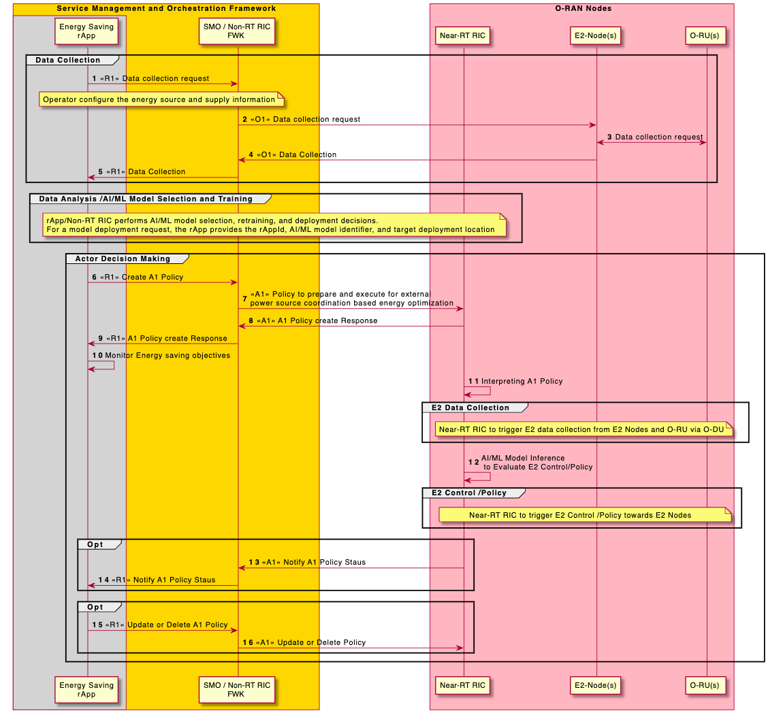
Figure 4.8.8.3.1-1: Flow diagram of A1 energy saving policy for external power source coordination

4.8.8.4 Required data
This sub-clause contains the input and output data of model training and inference for energy saving using external power source coordination-based energy optimization.

4.8.8.4.1 Input data
The measurement input data are used in model training and inference. They can include the following measurements to monitor energy consumption and energy efficiency of E2 node(s) and O-RU(s):
- Energy supply information (energySupplyMode and energySourceList) (as specified in 3GPP TS 28.310 [25], clause 8.3.1.2).
- Energy source information (energySourceType, energySourceCef, renewableEnergy, and energyCompositionPercentage) (as specified in 3GPP TS 28.310 [25], clause 8.3.2.2).
- Energy information group (energySupplyModeRefList and memberDNList) (as specified in 3GPP TS 28.310 [25], clause 8.3.3.2).
- DL PDCP SDU data volume per interface (data volume in DL delivered per PLMN, per QoS level, per slice, per interface ((from O-CU-UP to O-DU over F1-U, to external O-CU-UP over Xn-U and to external O-eNB over X2-U)) (as specified in 3GPP TS 28.552 [5], clause 5.1.3.6.2.3)
- UL PDCP SDU data volume per interface (data volume in UL delivered per PLMN, per QoS level, per slice, per interface ((from O-DU to O-CU-UP over F1-U, to external O-CU-UP over Xn-U and to external O-eNB over X2-U)) (as specified in 3GPP TS 28.552 [5], clause 5.1.3.6.2.4)
- Power consumed by physical network function & its components (as specified in 3GPP TS 28.552 [5], clause 5.1.1.19.2 and in MP [10], clauses B.1, B.5)

4.8.8.4.2 Output data
rApps to deliver energy saving & energy efficiency A1 policies for external power source coordination-based energy optimization through R1 interface.

4.9 O-Cloud resource optimization
This clause contains the set of O-Cloud resource optimization use cases

4.9.1 Use case: O-Cloud node draining use case
This use case describes the procedure for the SMO/Non-RT RIC to perform draining of specific O-Cloud node [O-Cloud node description based on O2-GA&P [13] recommendation by rApp through SMO, which can result in relocation of network functions or its components to another O-Cloud node, thereby restoring network function i.e., network healing.

4.9.1.1 Background and goal of the use case
When one or more NF(s) is (are) experiencing some performance degradation, and there is possibility that issue could not be fixed, or root cause could not be identified just by analyzing O1 (FCAPS) data. There can be a requirement of co-relating O1 and O2 (FCAPS) data optionally with the help of AI/ML, which can result in identification of root cause.
Examples for reasons to perform O-Cloud node draining:
- There is possibility of faulty or misconfiguration of underneath O-Cloud node. By co-relating RAN OAM and O2 related data rApp will help in identifying issue in O-Cloud node which is found to be the root cause of NF's performance degradation, then O-Cloud can be drained, and relocation of the NF(s) on another O-Cloud node can be performed. This example explains a scenario where an action can be invoked when NF(s) performance degradation happens due to O-Cloud node(s), which can be resolved by draining the O-Cloud node.
NOTE: The O-Cloud node(s) is set to maintenance mode (as specified in O2-GA&P [13], clause 3.10.2) by default, when this use case is called.

4.9.1.2 Entities/resources involved in the use case
- SMO/Non-RT RIC framework:
  - To collect necessary performance, configuration, and other data for rApp to define and update policies which guides the SMO for O-Cloud resource management through O2 related functions over O2 interface.
  - Non-RT RIC framework should support rApp for managing data to and from O2 related functions related to resource management.
  - Train AI/ML model with data from O1 and O2, which supports rApp to predict possible requirement of O-Cloud node draining.
- rApps:
  - Collect the necessary configurations, performance indicators, and measurement reports from SMO/Non-RT RIC framework.
  - (Optionally) Retrain, update, configure AI/ML model.
  - Infer an optimized policies/recommendations for O-Cloud node draining based on the data collected using R1 interface.
- O2 related functions (NFO/FOCOM):
  - To support discovery and delivery of O-Cloud IMS/DMS FCAPS data.
  - To support reception of policy/recommendations from rApp and enforcing these policies/ recommendations towards O-Cloud over O2 interface.
- RAN OAM functions:
  - Retrieve relevant PM, CM, FM data from E2 nodes via the O1 interface.
  - Allow rApps to access the PM, CM, FM data over R1 interface.
- O-Cloud (IMS and DMS):
  - To support delivery of O-Cloud (IMS/DMS) resource performance, configuration, and other data to O2 related functions.
  - To provide feedback post completion or non-completion of recommendations to Non-RT RIC through O2 related functions.
  - To support to relocate network function and drain O-Cloud node.
- E2 nodes:
  - Support to send fault and measurement data, RAN configurations to SMO/Non-RT RIC via the O1 interface.

4.9.1.3 Solutions
In this solution, decision making, potentially using AI/ML model inference, is done at rApp. While AI/ML model training might be hosted in Non-RT RIC, the description below is based on AI/ML model training in the Non-RT RIC.
The context of Non-RT RIC based O-Cloud node draining is captured in table 4.9.1.3-1.
Table 4.9.1.3-1: Non-RT RIC based O-Cloud node draining
Use Case Stage | Evolution / Specification
Goal | Draining O-Cloud node through O2 related functions.
Actors and Roles | SMO/Non-RT RIC framework.  rApp: O-Cloud policy/recommendations triggering function.  O2 related functions (NFO/FOCOM): Orchestration and management related functions.  RAN OAM functions: O1 FCAPS functions.  O-Cloud IMS and DMS: O-Cloud policy enforcement and resource data reporting.  E2 node: To report network function data to SMO/Non-RT RIC.
Assumptions | - All relevant functions and components are instantiated.  - O1 and O2 interface connectivity is established with SMO including RAN OAM functions /O2 related functions.  - R1 interface connectivity is established between rApp and Non-RT RIC framework.
Pre-conditions | - Network is operational.
Begins when | Operator specified trigger condition or event is detected.
Step 1 (M) | rApp sent discovery request to SMO/Non-RT RIC framework to discover O2 related services.
Step 2 (M) | Non-RT RIC framework resolves the request and sent service discovery result to rApp.
Step 3 (M) | rApp requests O2 related data from O2 related functions (NFO/FOCOM).  rApp can request data such as compute utilization, memory usage, availability of network function, performance of API responses from NF deployments, status of AAL logical processing unit, etc.
Step 4 (M) | Non-RT RIC framework processes the data request and request O2 related function (NFO and FOCOM) to collect O2ims and O2dms related data.
Step 5 (M) | O2 related function (FOCOM) performs data request and collection from O-Cloud (IMS).
Step 6 (M) | O2 related function (NFO) performs data request and collection from O-Cloud (DMS).
Step 7 (M) | SMO/Non-RT RIC framework collect and store O2ims and O2dms related data.
Step 8 (M) | SMO/Non-RT RIC framework delivers O2 related data towards rApp over R1 Interface.
Step 9 (M) | rApp requests RAN OAM related data to be collected from E2 nodes such as availability of E2 node, accessibility KPIs, UEs connected, user traffic and alarms reported on interface level, etc., to understand performance of E2 nodes.
Step 10 (M) | Non-RT RIC framework forwards request to E2 nodes through RAN OAM functions.
Step 11 (M) | RAN OAM functions request and collect data from E2 nodes.
Step 12 (M) | SMO/Non-RT RIC framework to collect and store RAN OAM related PM data.
Step 13 (M) | SMO/Non-RT RIC framework delivers RAN OAM related O1 data towards rApp.
Step 14 (O) | AI/ML models can be retrained either on Non-RT RIC framework or on rApp. If Non-RT RIC framework is hosting retraining, then rApp selects AI/ML model and initiate retraining on Non-RT RIC framework.  See NOTE 1.
Step 15 (O) | Upon receiving retraining request from rApp. Non-RT RIC framework initiates AI/ML model retraining.
Step 16 (O) | rApp monitors retrained AI/ML model and retrieves retrained AI/ML model.  See NOTE 2.
Step 17 (O) | If AI/ML model retraining is hosted by rApp then AI/ML model to be retrained on rApp itself.
Step 18 (O) | Once AI/ML model retraining is performed, AI/ML models are deployed and activated for inferencing for which rApp constantly monitors O1 and O2 related data.
Step 19 (M) | rApp identifies the requirement of fault recovery or maintenance of O-Cloud node and formulate policy/recommendations to drain, which can relocate network function to another O-Cloud node.  rApp can sent policy or recommendations to O2 related function (FOCOM) for O-Cloud node draining. rApp to include the necessary identifiers of the O-Clouds to be drained.  See NOTE 3.
Step 20 (M) | Post receiving policy/recommendations for draining of O-Cloud node, O-Cloud to perform NF relocation (optionally) and drain O-Cloud node as specified in ORCH-USE-CASES [14], clause 3.12.2, then O2 related function (FOCOM) Informs rApp about NF relocation (optionally) and drain O-Cloud node R1 Interface.
Step 21 (M) | rApp monitors O1 and O2 PM, FM data from NF for any undesirable behaviour.
Ends when | If network function/E2 node becomes non-operational or when the operator disables the rApp.
Exceptions | N/A
Post Conditions | rApp continues close loop monitoring of O-Cloud node telemetry.
NOTE 1: AI/ML procedures mentioned here can be subject to change based on future work on AI/ML workflow in WG2.
NOTE 2: AI/ML model retrieval procedure over R1 interface is for illustration purpose, can be subject to change based on future work on AI/ML workflow in WG2.
NOTE 3: Identifiers mentioned above are not specified in the present document.

@startuml
'https://plantuml.com/sequence-diagram
!pragma teoz true
Skin rose
skinparam ParticipantPadding 5
skinparam BoxPadding 10
skinparam defaultFontSize 12
skinparam lifelineStrategy solid
autonumber

Box “O-Cloud” #lightseagreen
participant “DMS” as DMS
participant “IMS” as IMS
End box

Box "Service Management and Orchestration Framework" #gold
Participant “O2 Related Function\nNFO & FOCOM” as ORF
Participant “RAN OAM Functions” as OAM
Box #lightgrey
Participant “Non-RT RIC\nFramework Function” as nRT
Participant “rApp” as rApp
End Box
End box
Box " RAN Nodes" #lightpink
Participant “E2 Node” as E2Node
End box
group O2 Related Data Collection
rApp -> nRT : <<R1>> O2 Related service Discovery
nRT -> rApp : <<R1>> O2 Related service Result
rApp -> nRT : <<R1>> O2 Related Data subscritpion request
nRT -> ORF : Data subscription request(O2ims and Odms related)

Note right
Data subscription request O2, which can include
NF compute utilization, memory usage , availability
of Network function ,API responses from NFs etc.
End note
loop #white for each data delievery
ORF <-> IMS : <<o2ims>> Data\nRequest & collection
ORF <-> DMS : <<o2dms>> Data\nRequest & collection
ORF -> nRT : Data delivery(O2ims and Odms related)
nRT -> rApp: <<R1>> O2 Related Data Delivery
End loop
End
group O1 Data Collection
rApp -> nRT : <<R1>> O1 Data subscritpion request
nRT -> OAM : Data subscription Request
Note right
Data such as Availability of E2 Node,
accessibly KPIs , UEs connected , user traffic
and alarms reported on interface level etc.
End note
loop #white foreach data delievery
OAM <-> E2Node : <<O1>> Data Request and Collection
OAM -> nRT : Data Retrieval
nRT -> rApp: <<R1>> O1 Data Delivery
End Loop
End

group Data Analysis AI/ML Training and Inference
alt trainig on Non-RT RIC Fwk
rApp -> nRT : <<R1>> Select AI/ML Model and Inintiate re-training
nRT -> nRT : AI/ML Model re-training
rApp <-> nRT : <<R1>> Request and Transfer Re-trained AI/ML Model
Note over rApp
rApp monitors re-trained
model parameters and decides
to retieve AI/ML model
End note
Else trainig on rApp
rApp -> rApp : AI/ML Model re-training
end
rApp -> rApp : Deploy and activate re-trained\nAI/ML Model for inferencing
Note left
AI/ML model inference deployed in rApp to evaluate policy/recommendations
based on O1 & O2 Related Data analyzed.
End Note
End
group Action

rApp -> ORF : <<R1>> O-Cloud Node Drain Policy /recomendation
Note over nRT,rApp
Node Identifier & other node related details to be included in request.
End Note
group O-Cloud Operation
ref over ORF ,IMS, DMS
As specified in O-RAN.WG6.ORCH-USE-CASES [14], clause 3.12.2 O-Cloud to perform NF relocation (optionally)
and draining of O-Cloud node Based
policy/recommendation from rApp.
End
end
ORF -> rApp : <<R1>> Policy or Recommedation Completion Feedback
end
rApp -> rApp : Monitor NF’s PM/FM\nPost Relocation
Note over rApp
rApp to monitor PM, FM of NF for any undesirable behaviour
End Note

@enduml
@startuml
'https://plantuml.com/sequence-diagram
!pragma teoz true
Skin rose
skinparam ParticipantPadding 5
skinparam BoxPadding 10
skinparam defaultFontSize 12
skinparam lifelineStrategy solid
autonumber

Box “O-Cloud” #lightseagreen
participant “DMS” as DMS
participant “IMS” as IMS
End box

Box "Service Management and Orchestration Framework" #gold
Participant “O2 Related Function\nNFO & FOCOM” as ORF
Participant “RAN OAM Functions” as OAM
Box #lightgrey
Participant “Non-RT RIC\nFramework Function” as nRT
Participant “rApp” as rApp
End Box
End box
Box " RAN Nodes" #lightpink
Participant “E2 Node” as E2Node
End box
group O2 Related Data Collection
rApp -> nRT : <<R1>> O2 Related service Discovery
nRT -> rApp : <<R1>> O2 Related service Result
rApp -> nRT : <<R1>> O2 Related Data subscritpion request
nRT -> ORF : Data subscription request(O2ims and Odms related)

Note right
Data subscription request O2, which may include
NF compute utilization, memory usage , availability
of Network function ,API responses from NFs etc.
End note
loop #white for each data delievery
ORF <-> IMS : <<o2ims>> Data\nRequest & collection
ORF <-> DMS : <<o2dms>> Data\nRequest & collection
ORF -> nRT : Data delivery(O2ims and Odms related)
nRT -> rApp: <<R1>> O2 Related Data Delivery
End loop
End
group O1 Data Collection
rApp -> nRT : <<R1>> O1 Data subscritpion request
nRT -> OAM : Data subscription Request
Note right
Data such as Availability of E2 Node,
accessibly KPIs , UEs connected , user traffic
and alarms reported on interface level etc.
End note
loop #white foreach data delievery
OAM <-> E2Node : <<O1>> Data Request and Collection
OAM -> nRT : Data Retrieval
nRT -> rApp: <<R1>> O1 Data Delivery
End Loop
End

group Data Analysis AI/ML Training and Inference
alt trainig on Non-RT RIC Fwk
rApp -> nRT : <<R1>> Select AI/ML Model and Inintiate re-training
nRT -> nRT : AI/ML Model re-training
rApp <-> nRT : <<R1>> Request and Transfer Re-trained AIML Model
Note over rApp
rApp monitors re-trained
model parameters and decides
to retieve AIML model
End note
Else trainig on rApp
rApp -> rApp : AI/ML Model re-training
end
rApp -> rApp : Deploy and activate re-trained\nAI/ML Model for inferencing
Note left
AIML model inference deployed in rApp to evaluate policy/recommendations
based on O1 & O2 Related Data analyzed.
End Note
End
group Action

rApp -> ORF : <<R1>> O-Cloud Node Drain Policy /recomendation
Note over nRT,rApp
Node Identifier & other node related details to be included in request.
End Note
group O-Cloud Operation
ref over ORF ,IMS, DMS
As specified in O-RAN.WG6.ORCH-USE-CASES [14], clause 3.12.2 O-Cloud to perform NF relocation (optionally)
and draining of O-Cloud node Based
policy/recommendation from rApp.
End
end
ORF -> rApp : <<R1>> Policy or Recommedation Completion Feedback
end
rApp -> rApp : Monitor NF’s PM/FM\nPost Relocation
Note over rApp
rApp to monitor PM, FM of NF for any undesirable behaviour
End Note

@enduml
@startuml
'https://plantuml.com/sequence-diagram
!pragma teoz true
Skin rose
skinparam ParticipantPadding 5
skinparam BoxPadding 10
skinparam defaultFontSize 12
skinparam lifelineStrategy solid
autonumber

Box “O-Cloud” #lightseagreen
participant “DMS” as DMS
participant “IMS” as IMS
End box

Box "Service Management and Orchestration Framework" #gold
Participant “O2 Related Function\nNFO & FOCOM” as ORF
Participant “RAN OAM Functions” as OAM
Box #lightgrey
Participant “Non-RT RIC\nFramework Function” as nRT
Participant “rApp” as rApp
End Box
End box
Box " RAN Nodes" #lightpink
Participant “E2 Node” as E2Node
End box
group O2 Related Data Collection
rApp -> nRT : <<R1>> O2 Related service Discovery
nRT -> rApp : <<R1>> O2 Related service Result
rApp -> nRT : <<R1>> O2 Related Data subscritpion request
nRT -> ORF : Data subscription request(O2ims and Odms related)

Note right
Data subscription request O2, which may include
NF compute utilization, memory usage , availability
of Network function ,API responses from NFs etc.
End note
loop #white for each data delievery
ORF <-> IMS : <<o2ims>> Data\nRequest & collection
ORF <-> DMS : <<o2dms>> Data\nRequest & collection
ORF -> nRT : Data delivery(O2ims and Odms related)
nRT -> rApp: <<R1>> O2 Related Data Delivery
End loop
End
group O1 Data Collection
rApp -> nRT : <<R1>> O1 Data subscritpion request
nRT -> OAM : Data subscription Request
Note right
Data such as Availability of E2 Node,
accessibly KPIs , UEs connected , user traffic
and alarms reported on interface level etc.
End note
loop #white foreach data delievery
OAM <-> E2Node : <<O1>> Data Request and Collection
OAM -> nRT : Data Retrieval
nRT -> rApp: <<R1>> O1 Data Delivery
End Loop
End

group Data Analysis AI/ML Training and Inference
alt trainig on Non-RT RIC Fwk
rApp -> nRT : <<R1>> Select AI/ML Model and Inintiate re-training
nRT -> nRT : AI/ML Model re-training
rApp <-> nRT : <<R1>> Request and Transfer Re-trained AIML Model
Note over rApp
rApp monitors re-trained
model parameters and decides
to retieve AIML model
End note
Else trainig on rApp
rApp -> rApp : AI/ML Model re-training
end
rApp -> rApp : Deploy and activate re-trained\nAI/ML Model for inferencing
Note left
AIML model inference deployed in rApp to evaluate policy/recommendations
based on O1 & O2 Related Data analyzed.
End Note
End
group Action

rApp -> ORF : <<R1>> O-Cloud Node Drain Policy /recomendation
Note over nRT,rApp
Node Identifier & other node related details to be included in request.
End Note
group O-Cloud Operation
ref over ORF ,IMS, DMS
As specified in O-RAN.WG6.ORCH-USE-CASES [14], clause 3.12.2 O-Cloud to perform NF relocation (optionally)
and draining of O-Cloud node Based
policy/recommendation from rApp.
End
end
ORF -> rApp : <<R1>> Policy or Recommedation Completion Feedback
end
rApp -> rApp : Monitor NF’s PM/FM\nPost Relocation
Note over rApp
rApp to monitor PM, FM of NF for any undesirable behaviour
End Note

@enduml
The workflow for Non-RT RIC based O-Cloud node draining is shown in figure 4.9.1.3-1.

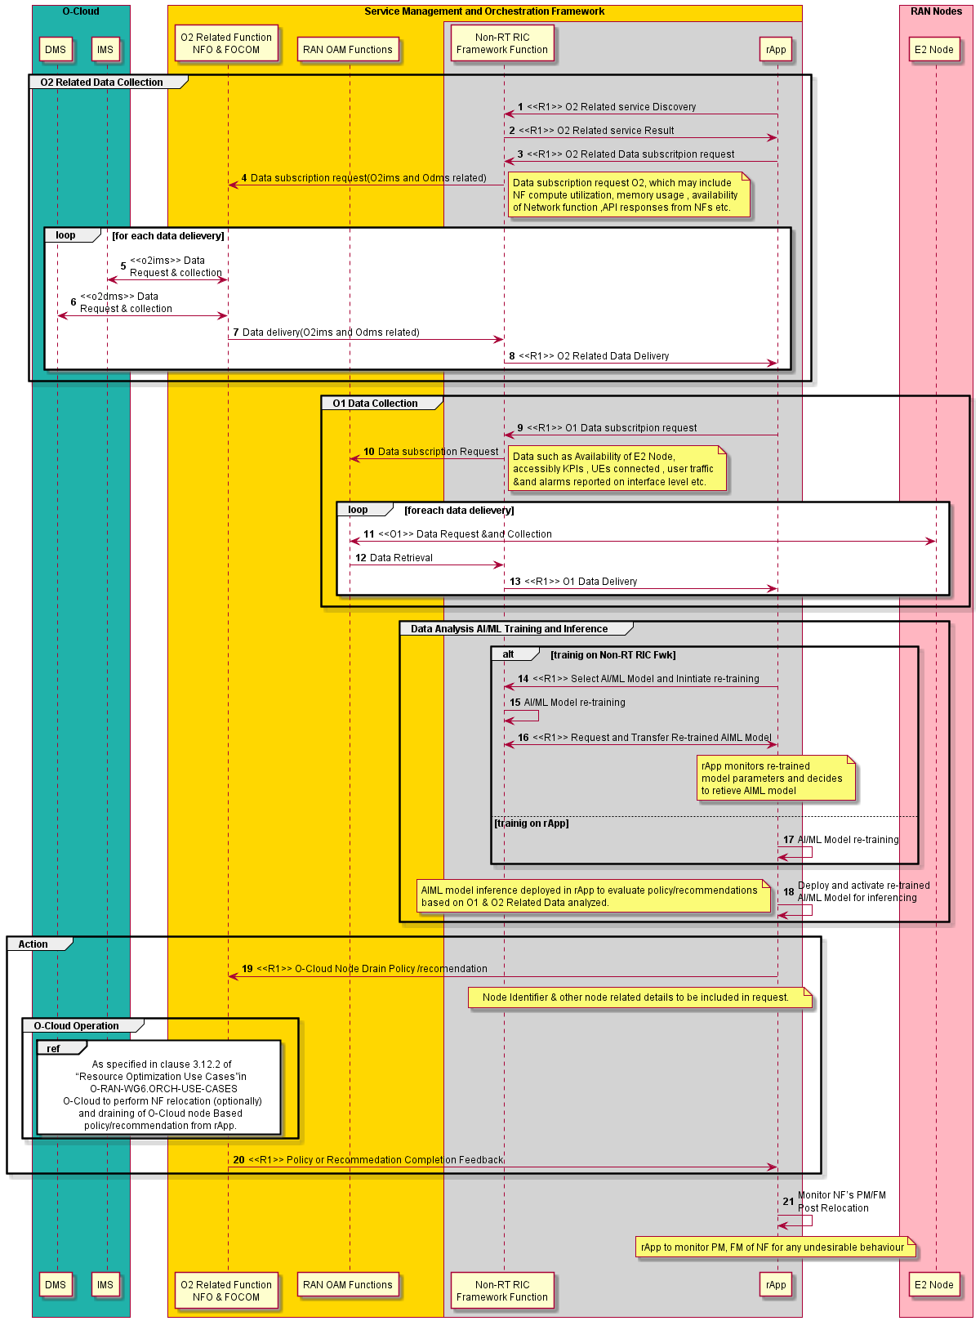
Figure 4.9.1.3-1: Workflow for Non-RT RIC based O-Cloud node draining

4.9.1.4 Required data
This sub-clause contains the input and output data required for O-Cloud node drain.

4.9.1.4.1 Input data
O2 related data (O-Cloud FCAPS data)
  - DMS telemetry data to understand state and health of network functions deployed on O-Cloud node.
  - IMS telemetry data to understand the state and health of O-Cloud nodes.
  - IMS/DMS inventory data to understand configuration of nodes and network functions deployments on O-Cloud nodes.
  - Monitoring data such as compute utilization, memory usage, availability of network function, performance of API responses from NF deployments, status of AAL logical processing unit, etc.
RAN OAM related data (E2 node and O-RU/network function data)
- The measurement counters and KPIs (as defined by 3GPP and will be extended for O-RAN use cases) should be appropriately aggregated by cell, slice, etc.
- E2 node KPIs such as availability of E2 node, accessibility KPIs, UEs connected, user traffic and alarms reported on interface level etc. to understand whether E2 nodes behaving as usual.

4.9.1.4.2 Output data
O2 related data
- rApp to provide policy based guidance or trigger recommendations to drain O-Cloud node towards O2 related function (NFO/ FOCOM).

5 Requirements

5.1 Functional requirements

5.1.1 Non-RT RIC functional requirements
The Non-RT RIC functional requirements are captured in table 5.1.1-1.

Table 5.1.1-1: Non-RT RIC functional requirements
REQ | Description | Note
REQ-Non-RT-RIC-FUN1 | Non-RT RIC shall support data retrieval and analysis; the data can include performance, configuration or other data related to the application (recommended data shown in required data clause for different use cases).
REQ-Non-RT-RIC-FUN2 | Non-RT RIC shall support relevant AI/ML model training based on the data in [REQ-Non-RT-RIC-FUN1] for non-real-time optimization of configuration parameters in RAN or Near-RT RIC, as applicable for the use case.
REQ-Non-RT-RIC-FUN3 | Non-RT RIC shall support relevant AI/ML model training based on the data in [REQ-Non-RT-RIC-FUN1] for generating/optimizing policies and intents to guide the behavior of applications in Near-RT RIC or RAN, as applicable for the use case.
REQ-Non-RT-RIC-FUN4 | Non-RT RIC shall support training of relevant AI/ML models based on the data in [REQ-Non-RT-RIC-FUN1] to be deployed/updated in Near-RT RIC as required by the applications.
REQ-Non-RT-RIC-FUN5 | Non-RT RIC shall support performance monitoring and evaluation.
REQ-Non-RT-RIC-FUN6 | Non-RT RIC shall support a fallback mechanism to prevent drastic degradation/fluctuation of performance, e.g. to restore to the previous policy or configuration.
REQ-Non-RT-RIC-FUN7 | Non-RT RIC shall be able to produce enrichment information through data analysis.
REQ-Non-RT-RIC-FUN8 | Non-RT RIC shall be able to request O1 reconfiguration for non-real-time optimization of configuration parameters in E2 nodes and/or Near-RT RIC, as applicable for the use case.
REQ-Non-RT-RIC-FUN9 | Non-RT RIC shall support retrieval of external information as applicable for the use case.

5.1.2 A1 interface functional requirements
The A1 interface functional requirements are captured in table 5.1.2-1.

Table 5.1.2-1: A1 interface functional requirements
REQ | Description | Note
REQ-A1-FUN1 | A1 interface shall support communication of policies from Non-RT RIC to Near-RT RIC.
REQ-A1-FUN2 | A1 interface shall support AI/ML model deployment and update from Non-RT RIC to Near-RT RIC.
REQ-A1-FUN3 | A1 interface shall support communication of enrichment information from Non-RT RIC to Near-RT RIC.
REQ-A1-FUN4 | A1 interface shall support feedback from Near-RT RIC for monitoring AI/ML model performance.
REQ-A1-FUN5 | A1 interface shall support the policy feedback from Near-RT RIC to Non-RT RIC.

5.1.3 R1 interface functional requirements
The R1 interface functional requirements are captured in table 5.1.3-1.

Table 5.1.3-1: R1 interface functional requirements
REQ | Description | Note
REQ-R1-FUN1 | R1 interface shall support registration of services. | Based on REQ-nRTRfW-R1r-10
REQ-R1-FUN2 | R1 interface shall support discovery of registered services. | Based on REQ-nRTRApp-R1r-30
REQ-R1-FUN3 | R1 interface shall support authentication of rApp. | Based on REQ-nRTRfW-R1r-10
REQ-R1-FUN4 | R1 interface shall support authorization of service request. | Based on REQ-nRTRfW-R1r-10
REQ-R1-FUN5 | R1 interface shall support subscription and unsubscription of notifications for added/updated/removed registered services. | Based on REQ-nRTRfW-R1r-120
REQ-R1-FUN6 | R1 interface shall support registration of data types. | Based on REQ-nRTRfW-R1r-30
REQ-R1-FUN7 | R1 interface shall support subscription of data types. | Based on REQ-nRTRfW-R1r-30
REQ-R1-FUN8 | R1 interface shall support A1 related services.
REQ-R1-FUN9 | R1 interface shall support O1 related services.
REQ-R1-FUN10 | R1 interface shall support O2 related services.
REQ-R1-FUN11 | R1 interface shall support AI/ML workflow services.
REQ-R1-FUN12 | R1 interface shall support services related to network slice subnets. | Please refer to Slicing Architecture [15] for details.

5.2 Non-functional requirements

5.2.1 Non-RT RIC non-functional requirements
The Non-RT RIC non-functional requirements are captured in table 5.2.1-1.

Table 5.2.1-1: Non-RT RIC non-functional requirements
REQ | Description | Note
REQ-Non-RT-RIC-NON-FUN1 | Non-RT RIC shall not update the same policy or configuration parameter for a given Near-RT RIC or RAN function more often than once per second.
REQ-Non-RT-RIC-NON-FUN2 | Non-RT RIC shall be able to update policies in several Near-RT RICs.

5.2.2 A1 interface non-functional requirements
The A1 interface non-functional requirements are captured in table 5.2.2-1.

Table 5.2.2-1: A1 interface non-functional requirements
REQ | Description | Note

5.2.3 R1 interface non-functional requirements
The R1 interface non-functional requirements are captured in table 5.2.3-1.

Table 5.2.3-1: R1 interface non-functional requirements
REQ | Description | Note

Annex (informative):
Change history/Change request (history)
Date | Revision | Description
2019.02.08 | 01.00.01 | Draft for template
2019.03.12 | 01.00.02 | First draft with Scope, references, acronyms
2019.03.20 | 01.00.03 | Initial addition of use case contributions:  - Traffic Steering use case for development of Non-RT RIC functionality and A1 interface use case  - QoE use case
2019.04.10 | 01.00.04 | Addition of CRs:  - Traffic steering use case  - QoE Optimization use case  - 3D-MIMO beamforming optimization use case
2019.04.12 | 01.00.05 | Addition of CRs:  - 2019-04-08-CMCC-ATT-CR-A1-O1 description-revision  - 2019-04-03-CMCC-CR -Add Recommended requirements for Near-RT RIC and E2 in UCR Annex
2019.04.15 | 01.00.06 | Updates thoughout the document based on the editorial and co-chair team review.  Addition of CRs:  - 2019_04_14_O-RAN.WG2 UsecaseRequirement.DraftSpec-CR-form-CMCC-Orange-TIM_v2.00  - 2019-04-03-CMCC-ATT-CR -Add Recommended requirements for Near-RT RIC and E2 in UCR Annex v2-minor revision  - 2019-04-11-ATT-CMCC-UCR-TrafficSteeringA1.PlantUMLSource  - 2019-04-11-ATT-CMCC-UCR-E2Annex.PlantUMLSource  Addition of requirements to traceability section of use case tables.  Addition of REQ-Non-RT RIC-FUN9 for Non-RT RIC fallback mechanism.
2019.04.18 | 01.00.07 | Addition of CR:  - 2019-04-18-CMCC-ATT-Netsia-CR-Modifications to A1 and O1 related requirements
2019.04.26 | 01.00.08 | Addition of CR:  - 2019-04-22-ATT-CR -Requirements Consolidation for UCR doc v1 clean
2019.04.27 | 01.00.09 | Editorial fixes (reference issues, upper case/lower case fixes, etc.)
2019.05.01 | 01.00.10 | Updating the traceability section of uses case to reflect the consolidated requirements
2019.05.06 | 01.00 | Final version 01.00
2019.10.07 | 02.00.01 | Initial version of v2.0
2019.12.27 | 02.00.02 | Addition of CR:  - 2019.11.20-ORAN-WG2_Netsia_Usecase_CR_Removal_Of_3D_MIMO  Note: This CR is for removing 3D MIMO from WG2 and moving it to UCTG as it does not have WG2 specific impact.
2020.01.03 | 02.00.03 | Addition of CR:  - WG2_2019.09.03_Ericsson_CR_Update_on_UCR_for_  RAN_traffic_steering
2020.01.03 | 02.00.04 | Addition of CR:  - 2019.12.12-ORAN-WG2_Ericsson_Usecase_CR_QoS_  based_resource_optimization
2020.01.09 | 02.00.05 | Addition of CR:  - 2020.01.09-ORAN-WG2_Ericsson_Usecase_CR_QoS_based_resource_optimization
2020.01.12 | 02.00.06 | Addition of CR:  - WG2_2020.01.09_CMCC_CR_Update on enrichment information for traffic steering use case
2020.01.15 | 02.00.07 | Addition of CR:  - 2020.01.08-ORAN-WG2.UseCaseReqs_CR_NOK_V2XHO  Editorial updates in various sections
2020.01.23 | 02.00.08 | Addition of CR:  - ORAN-WG2_CMCC_Correction on QoE optimization use case.docx  Addition of missing rows (exceptions, post conditions, traceability) to QoS use case, Table 3.3.3-1
2020.02.06 | 02.00.09 | Addition of CR:  - ORAN-WG2_CMCC_Correction on QoE optimization use case - v2.docx  Editorial updates
2020.02.23 | 02.00.10 | Editorial updates based on WG2 review comments
2020.03.01 | 02.00.11 | Editorial updates based on spec naming convention, fixing header/table of contents uniformity, plantuml source embedding and other editorial updates
2020.03.01 | 02.00 | Final 02.00
2020.10.31 | 02.01.01 | Initial version of v2.1
2020.11.01 | 02.01.02 | Addition of CR:  - INT.AO-2020.07.12-WG2-CR-0004-MultiAccess_v02.00.docx
2020.11.01 | 02.01 | Final 02.01
2021.02.23 | 03.00.01 | Initial version of v3.0
2021.02.27 | 03.00.02 | Addition of CR:  - JNPR.AO-2020.10.22-WG2-CR-0001-RAN_SLA_ASSR-v04.docx
2021.03.10 | 03.00 | Final version 03.00
2021.07.06 | 04.00.01 | Initial version of v4.0
2021.07.06 | 04.00.02 | Addition of CR:  - ERI-2021-03-30-WG2-CR-0034-R1 Functional requirements-v03
2021.07.06 | 04.00.03 | Addition of CR:  - ERI-2021-05-17-WG2-CR-0035-Definitions and Abbreviations-v03
2021.07.19 | 04.00 | Final version 04.00
2021.11.12 | 05.00.01 | Initial version of v5.0
2021.11.13 | 05.00.02 | Addition of CR:  - INT-2021.10.05-WG2-CR-0022-NSSI-Resource-Optimization-v06
2021.11.13 | 05.00.03 | Addition of CR:  - KDDI.AO-2021.11.02-WG2-CR-0003-RAN_SLA_ASSR-v02
2021.11.24 | 05.00.04 | Updates to address WG2 review comments
2021.11.24 | 05.00 | Final version 05.00
2022.03.24 | 05.00.05 | Adopted new spec revision numbering per O-RAN Work Procedures  Initial version towards v6.0, starting with v05.00.05 per new revision numbering
2022.03.24 | 05.00.06 | Addition of CR:  - KDDI.AO-2022.01.21-WG2-CR-0004-RAN_SLA_ASSR-v04
2022.03.24 | 05.00.07 | Addition of CR:  - NOK-2022.03.08-WG2-CR-0023-mMIMO_GoB-v04
2022.03.24 | 05.00.08 | Addition of CR:  - INT-2022.02.14-WG2-CR-00023-Non-GoB beamforming UC-v06
2022.03.24 | 05.00.09 | Addition of CR:  - ATT-2022.02.18-WG2-CR-0004-MUMIMO Optimization UC-v05
2022.03.24 | 05.00.10 | Changes accepted from v05.00.09  Baseline for WG2 Approval
2022.04.01 | 05.00.11 | Addressing the WG2 review comments (with track changes on)
2022.04.01 | 05.00.12 | Changes accepted from v05.00.11  Clean version for TSC Approval
2022.04.15 | 06.00 | Final version 06.00
2023.03.13 | 06.00.01 | Initial version towards v07.00, starting with v06.00.01 per O-RAN specification revision  numbering process  Update of the spec to latest O-RAN TS template except for splitting the references to formative and informative. This split is planned to be made in next release of the document.
2023.03.13 | 06.00.02 | Addition of CR:  - JNPR-2022.01.19-WG2-CR-0007-R1interfaceSliceSubnetRequirement-v03
2023.03.13 | 06.00.03 | Addition of CR:  - INT-2022.03.30-WG2-CR-00032-Massive MIMO use case introduction-v03
2023.03.13 | 06.00.04 | Addition of CR:  - RMI-2022.09.13-WG2-CR-0005.UCR.Energy saving_Cell & Carrier Shutdown Use Case-v11  Editorial updates for consistency with existing use case headings (Removal of “3.8.1.2 O1 Interface Based Optimization” heading and setting the remainder subheadings from level 5 to level 4)
2023.03.14 | 06.00.05 | Addition of CR:  - RMI-2022.09.16-WG2-CR-0006.UCR.Energy saving_RF Channel Reconfiguration Description_v10  Editorial updates for consistency with existing use case headings (Removal of “3.8.2.2 O1 Interface Based Optimization” heading and setting the remainder subheadings from level 5 to level 4)
2023.03.14 | 06.00.06 | Changes accepted from v06.00.05  Baseline for WG2 approval
2023.03.24 | 06.00.07 | WG2 review comments are addressed, and approval is completed. Ready for TSC approval and publication.  Added O-RAN Release “R003” to document name and title.
2023.03.24 | 07.00 | Final version 07.00
2023.07.19 | 07.00.01 | Initial version towards v08.00, starting with v07.00.01 per O-RAN specification revision  numbering process  Addition of CR:  - RMI-2022.09.27-WG2-CR-0007.UCR.O-Cloud Node Draining Use Case-v09.
2023.07.19 | 07.00.02 | Addition of CR:  - RMI-2023.01.26-WG2-CR-0009.UCR.Energy saving_Cell & Carrier Shutdown Use Case (A1 Policy Based Solution)_v07
2023.07.19 | 07.00.03 | Addition of CR:  - CMCC-2023.05.16-WG2-CR-0002-Adding frequency preference policy to UCR-v2
2023.07.19 | 07.00.04 | Update of the spec to latest O-RAN TS template except for splitting the references to  normative and informative. This split is planned to be made in next release of the document.  Update of the spec to Times New Roman font.
2023.07.27 | 07.00.05 | WG2 review comments are addressed, and approval is completed.
2023.07.27 | 07.00.06 | All changes accepted, clean version.
2023.07.27 | 08.00 | Final version 08.00
2023.09.12 | 08.00.01 | Initial version towards v09.00, starting with v08.00.01 per O-RAN specification revision  numbering process  Addition of CR:  - JNPR-2023.09.12-WG2-CR-0008-O-RAN-Use-Case-Requirements-ODR-References-Section-v01
2023.09.12 | 08.00.02 | Addition of CR:  - JNPR-2023.09.12-WG2-CR-0009-O-RAN-Use-Case-Requirements-ODR-References-Section-v01
2023.09.13 | 08.00.03 | Addition of CR:  - JNPR-2023.09.13-WG2-CR-0010-O-RAN-Use-Case-Requirements-ODR-References-Update-v01
2023.09.13 | 08.00.04 | Addition of CR:  - JNPR-2023.09.13-WG2-CR-0011-O-RAN-Use-Case-Requirements-ODR-References-Correction-v01
2023.11.08 | 08.00.05 | Addition of CR:  - FJT-2023.06.13-WG2-CR-0001.UCR.Energy_saving_Cell&Carrier_SwitchedOffOn_Use_Case-v04
2023.11.08 | 08.00.06 | Addition of CR:  - RMI-2023.08.29-WG2-CR-0015.UCR.ES.Advance Sleep Mode Use case Description_v04
2023.11.08 | 08.00.07 | Addition of CR:  - RMI-2023.09.22-WG2-CR-0017.UCR.A1 Policy Based Energy saving_RF Channel Reconfiguration Description_v03
2023.11.08 | 08.00.08 | Clean version for WG2 approval
2023.11.16 | 08.00.09 | WG2 review comments are addressed, and approval is completed.  The spec’s title has changed per WG2 decision.
2023.11.16 | 08.00.10 | All changes accepted, clean version.
2023.11.16 | 09.00 | Final version 09.00
2024.01.17 | 09.00.01 | Initial version towards v10.00, starting with v09.00.01 per O-RAN specification revision  numbering process  Addition of CRs:  - JNPR-2023.09.13-WG2-CR-0012-O-RAN-Use-Case-Requirements-ODR-Required-Data-Reference-Correction-v02  - JNPR-2023.10.19-WG2-CR-0013-O-RAN-Use-Case-Requirements-ODR-References-Wording-v03  - JNPR-2023.10.19-WG2-CR-0014-O-RAN-Use-Case-Requirements-ODR-Figures-References-Wording- Corrections-v02  - JNPR-2023.10.19-WG2-CR-0015-O-RAN-Use-Case-Requirements-ODR-Figures-Numbers-Corrections-v03  - JNPR-2023.10.19-WG2-CR-0018-O-RAN-Use-Case-Requirements-ODR-Notes-v03  - JNPR-2023.10.25-WG2-CR-0019-O-RAN-Use-Case-Requirements-ODR-Modal-Verbs_Shall_Shall_not_Should_Should_not_Must_Must_not-v02  - JNPR-2023.10.30-WG2-CR-0020-O-RAN-Use-Case-Requirements-ODR-Modal-Verbs_Can_Cannot_May_Need_not-v01  - JNPR-2023.10.30-WG2-CR-0021-O-RAN-Use-Case-Requirements-ODR-FFS-Concepts-v01
2024.02.27 | 09.00.02 | Addition of CRs:  - JNPR-2024.01.29-WG2-CR-0022-O-RAN-Use-Case-Requirements-ODR-Clauses-v01  - JNPR-2024.01.29-WG2-CR-0023-O-RAN-Use-Case-Requirements-ODR-Figures-Capital_Letters-v01
2024.03.21 | 09.00.03 | Addition of CR:  - MAV-2023.05.17-WG2-CR-0015-mMIMO-SSBopt_v06
2024.03.30 | 09.00.04 | WG2 review comments are addressed, and approval is completed.
2024.03.30 | 09.00.05 | All changes accepted, clean version.
2024.03.30 | 10.00 | Final version 10.00
2024.06.28 | 10.00.01 | Initial version towards v11.00, starting with v10.00.01 per O-RAN specification revision  numbering process  Addition of CR:  - JNPR-2024.05.31-WG2-CR-0024-O-RAN-Use-Case-Requirements-ODR-Capital_Letters-Editorial_Changes-Fixes-v01
2024.07.12 | 10.00.02 | WG2 review comments are addressed, and approval is completed.
2024.07.12 | 10.00.03 | All changes accepted, clean version.
2024.07.12 | 10.01 | Final version 10.01
2024.11.07 | 10.01.01 | Initial version towards next release, starting with v10.01.01 per O-RAN specification revision numbering process  Addition of CRs:  - JNPR-2024.09.09-WG2-CR-0025-O-RAN-Use-Case-Requirements-ODR-References-v01  - ERI-2024.10.17-WG2-CR-0369-Add_R1_to_Scope-v01  Update of the header to be consistent with the O-RAN TS template
2024.11.20 | 10.01.02 | Addition of CR:  - DTAG-2024.10.22-WG2-CR-0004-Use case numbering-v02  Updated copyright statement on the cover page and footer to 2025  Editorial changes to align to O-RAN TS template v02.01  Added 3GPP Release 18 related text to Normative and Informative References clauses  Editorial updates
2024.11.21 | 10.01.03 | Clean version for WG2 approval
2024.12.04 | 10.01.04 | WG2 review comments are addressed, and approval is completed.
2024.12.04 | 10.01.05 | All changes accepted, clean version.
2024.12.04 | 10.02 | Final version 10.02
2025.02.12 | 10.02.01 | Initial version towards next release, starting with v10.02.01 per O-RAN specification revision numbering process  Addition of CRs:  - JNPR-2025.02.03-WG2-CR-0026-O-RAN-Use-Case-Requirements-Rel-18-Upgrade-v01  - JNPR-2025.02.03-WG2-CR-0027-O-RAN-Use-Case-Requirements-Rel-18-Upgrade-28.552-v01  - JNPR-2025.02.03-WG2-CR-0028-O-RAN-Use-Case-Requirements-Rel-18-Upgrade-36.314-v01  - JNPR-2025.02.03-WG2-CR-0029-O-RAN-Use-Case-Requirements-Rel-18-Upgrade-38.913-v01  Editorial corrections in Change history/Change request (history) table
2025.02.24 | 10.02.02 | Addition of CR:  - RMI-2024.10.28-WG2-CR-0024.UCR.Energy saving_Cell DTXDRX optimization in time domain use case Description_v02
2025.03.12 | 10.02.03 | Addition of CRs:  - JNPR.AO-2025.02.03-WG2-CR-0030-O-RAN-Use-Case-Requirements-Definition-needed-items-v01  - JNPR.AO-2025.02.12-WG2-CR-0031-O-RAN-Use-Case-Requirements-Removal_of_38.913_reference-v02  - JNPR.AO-2025.02.21-WG2-CR-0032-O-RAN-Use-Case-Requirements-Removal-of-undefined-items-v01  Editorial updates to Copyright Statement to align to O-RAN TS template v03.00
2025.03.12 | 10.02.04 | Clean version for WG2 approval
2025.03.20 | 10.02.05 | WG2 review comments are addressed, and approval is completed.
2025.03.20 | 10.02.06 | All changes accepted, clean version.
2025.03.20 | 10.03 | Final version 10.03
2025.07.08 | 10.03.01 | Initial version towards next release, starting with v10.03.01 per O-RAN specification revision numbering process  Addition of CRs:  - JNPR-2025.05.06-WG2-CR-0033-O-RAN-Use-Case-Requirements-ETSI_PAS_Comments-v01  - JNPR-2025.05.06-WG2-CR-0034-O-RAN-Use-Case-Requirements-ETSI_PAS_Comments-RAN_to_E2_Nodes-v01  Editorial updates to align to O-RAN TS template v05
2025.07.08 | 10.03.02 | Clean version for WG2 approval
2025.07.16 | 10.04 | Final version 10.04
2025.11.19 | 10.04.01 | Initial version towards next release, starting with v10.04.01 per O-RAN specification revision numbering process  Addition of CRs:  - RMI-2024.10.28-WG2-CR-0026.UCR.Energy saving_spatial and power domain use case Description_v05  - RMI-2024.10.28-WG2-CR-0023.UCR.Energy saving_SSB-less S-Cell optimization Description_v07  - RMI-2025.10.06-WG2-CR-0038.UCR.Energy saving_PA_Power_Optimization Description_v03  - RMI-2025.10.06-WG2-CR-0039.UCR.Energy saving_External_Power_Source_Coordination_based_ES_use case Description_v03  - ERI-2025.10.21-WG2-CR-0509-WG2UCR-TSP pcell preference-v01
2025.11.19 | 10.04.02 | Clean version for WG2 approval
2025.11.26 | 10.04.03 | WG2 review comments are addressed, and approval is completed.
2025.11.26 | 10.04.04 | All changes accepted, clean version.
2025.11.26 | 11.00 | Final version 11.00

