A,6

B,5

C,7

D,2

A – B – C = 6+5+7 = 18 : critical path

D – C = 2+7 = 9 : non critical path

***FORWARD***

**Activity A (1st):**

ES = 1

EF = ES + duration – 1 = 1 + 6 – 1 = 6

**Activity B (Previous A):**

ES = EF (previous A) + 1 = 6 + 1 = 7

EF = ES + duration – 1 = 7 + 5 – 1 = 11

**Activity D (1st):**

ES = 1

EF = ES + duration – 1 = 1 + 2 – 1 = 2

**Activity C (previous B, D)**

At B:

ES = EF (previous B) + 1 = 11 + 1 = 12

EF = ES + duration – 1 = 12 + 7 – 1 = 18

At D:

ES = EF (previous D) + 1 = 1 + 1 = 2

EF = ES + duration – 1 = 2 + 7 – 1 = 8

EF(B) = 18 > EF(D) = 2 => choose EF(B)

* Activity C:
* ES = EF (previous B) + 1 = 11 + 1 = 12
* EF = ES + duration – 1 = 12 + 7 – 1 = 18

***BACKWARD***

**CP (Critical Path) = ABC = 18**

**Activity C (last)**

LF = EF = Total Duration (CP) = 18

LS = LF – duration + 1 = 18 – 7 + 1 = 12

**Activity B (Next C):**

LF = LS (Next C) – 1 = 12 – 1 = 11

LS = LF – duration + 1 = 11 – 5 + 1 = 7

**Activity D (Next C):**

LF = LS (Next C) – 1 = 12 – 1 = 11

LS = LF – duration + 1 = 11 – 2 + 1 = 10

**Activity A (Next B):**

LF = LS (Next B) – 1 = 7 – 1 = 6

LS = LF – duration + 1 = 6 – 6 + 1 = 1

* **Sau khi tính và và vẽ diagram như bên dưới**

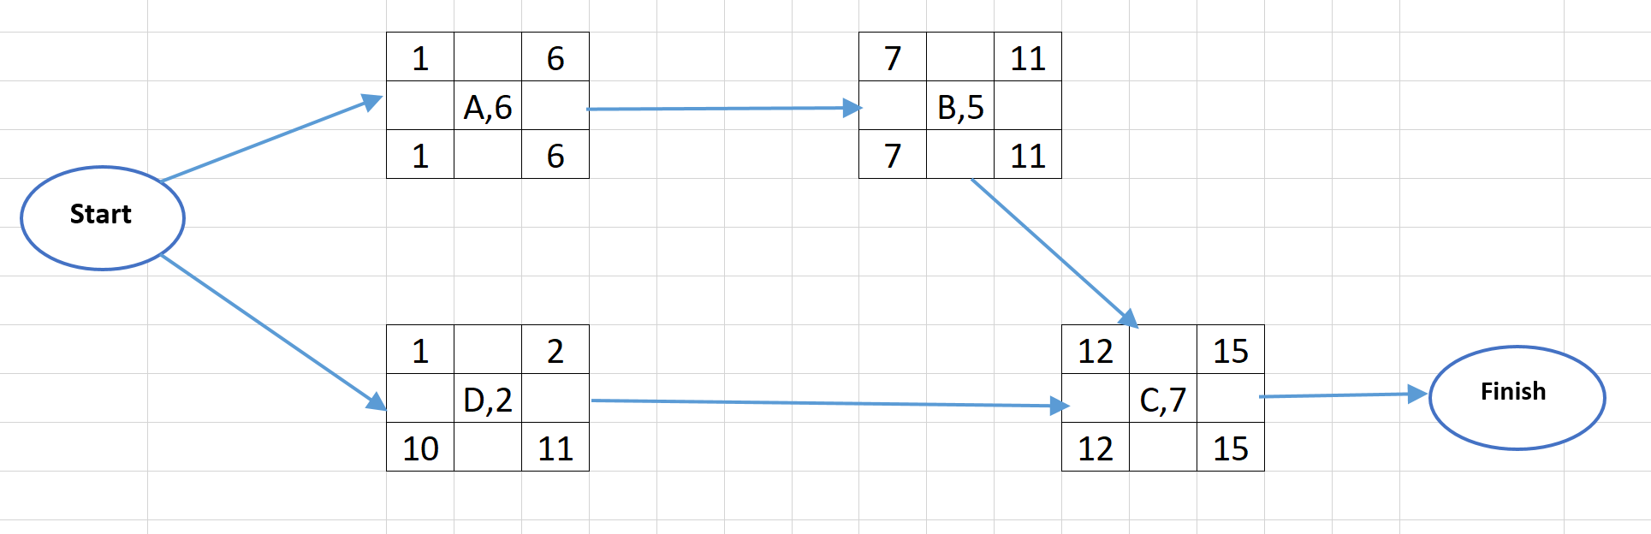

|  |  |  |  |  |  |  |  |  |
| --- | --- | --- | --- | --- | --- | --- | --- | --- |
| **Task** | **Duration** | **Pre** | **ES** | **EF** | **LS** | **LF** | **Total**  **Float**  **(LF – EF)** | **Float**  **(ESnext – EFactivity – 1)** |
| A | 6 | - | **1** | **6** | **1** | **6** | **0 (6 -6 =0)** | **0 (Thuộc CP)** |
| B | 5 | A | **7** | **11** | **7** | **11** | **0 (11- 11=0)** | **0 (Thuộc CP)** |
| C | 7 | B,D | **12** | **18** | **12** | **18** | **0 (18-18=0)** | **0 (Thuộc CP)** |
| D | 2 | - | **1** | **2** | **10** | **11** | **9 ( 11 – 2 = 9)** | **9 (12 – 2 -1 = 9)** |