MODULE 3: Working with Tasks

Exercise 3. Scheduling – Task dependencies

Create the list of tasks to model this processing (Start date: 1 Nov 2023)

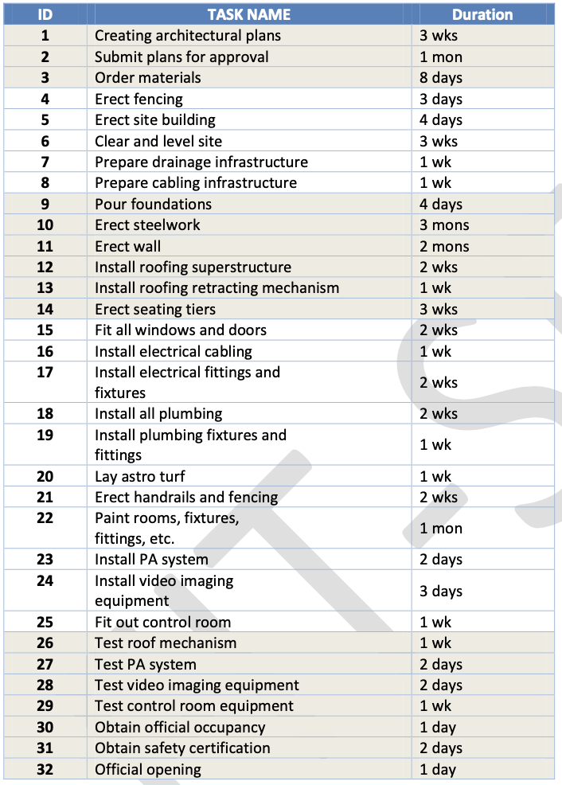

Create the summary tasks for series tasks below:

* Summary task name is Planning for tasks 1,2,3.
* Summary task name is Site Works form task 4 to task 8.
* Summary task name is Building Construction form task 9 to task 14.
* Summary task name is Fit Out form task 15 to task 25.
* Summary task name is Commissioning (5 days) form task 26 to the end task.

Create the milestones for this project below:

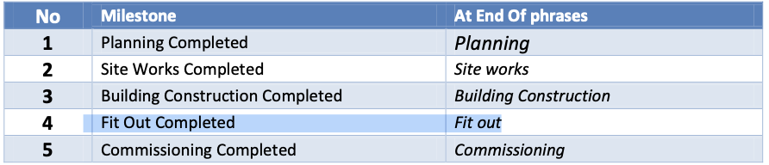

Creating Dependencies in Task Entry

