MODULE 3: Working with Tasks

Exercise 4.

•  Schedule it to start on 1 Nov 2023.

•  Create the new Time Work for your project. [NameTimeProject]

{Name: MSSV-HoTen - Ex: 123456_NguyenVanA }

•  NameTimeProject have Work Time form Monday to Friday as the following:

* Monday to Thurday: 09:00-12:00, 13:00-18:00
* Friday: 09:00-12:00, 13:00-17:00
* From 1/4/2024 -> 1/15/2024:
  + Monday to Thurday: 08:30-12:00, 13:00-17:30
  + Friday: 08:30-12:00, 13:00-16:30

•  NameTimeProject have two important religious holidays when they don't work (Exception)

* Calendar 1 - on the first day of every month (off 17:00-18:00)
* Holiday Day - on Jan 1st/2nd/3rd 2024

•  Assign the NameTimeProject to your Project and display the Project Information.

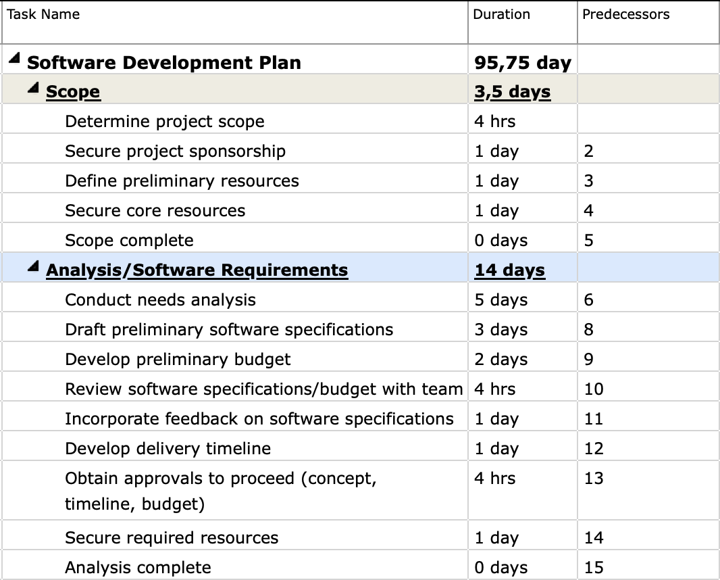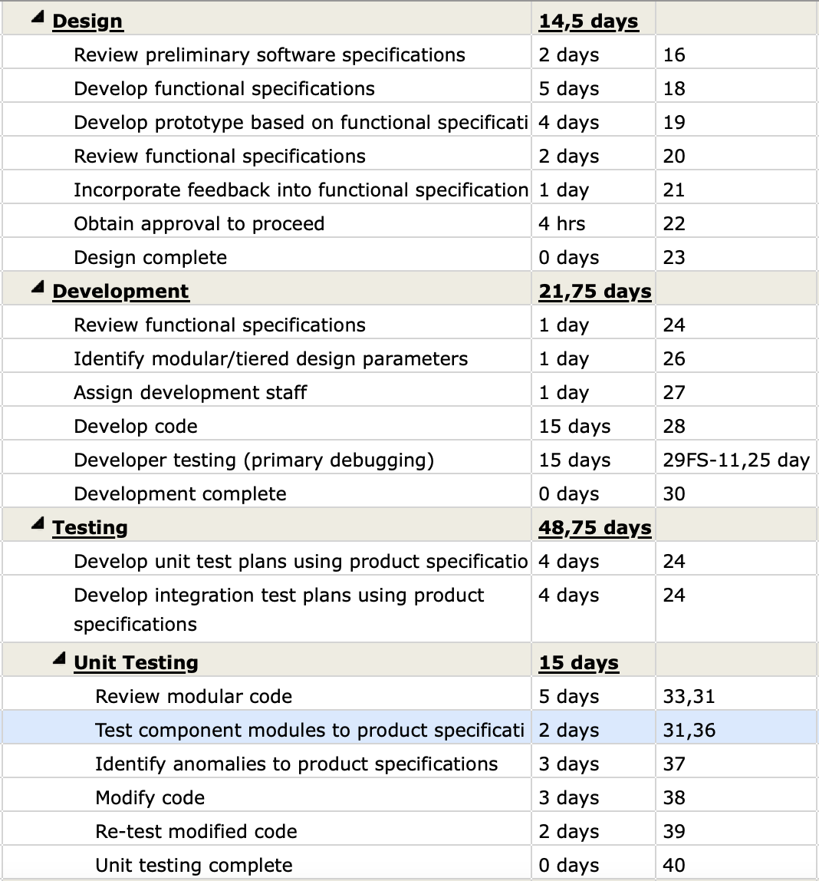

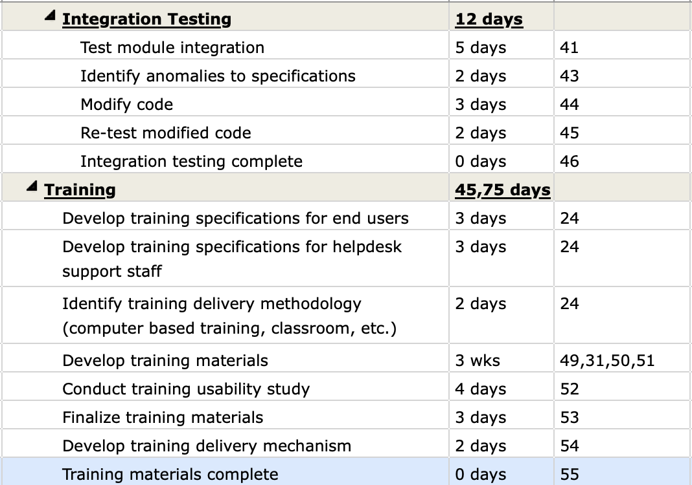

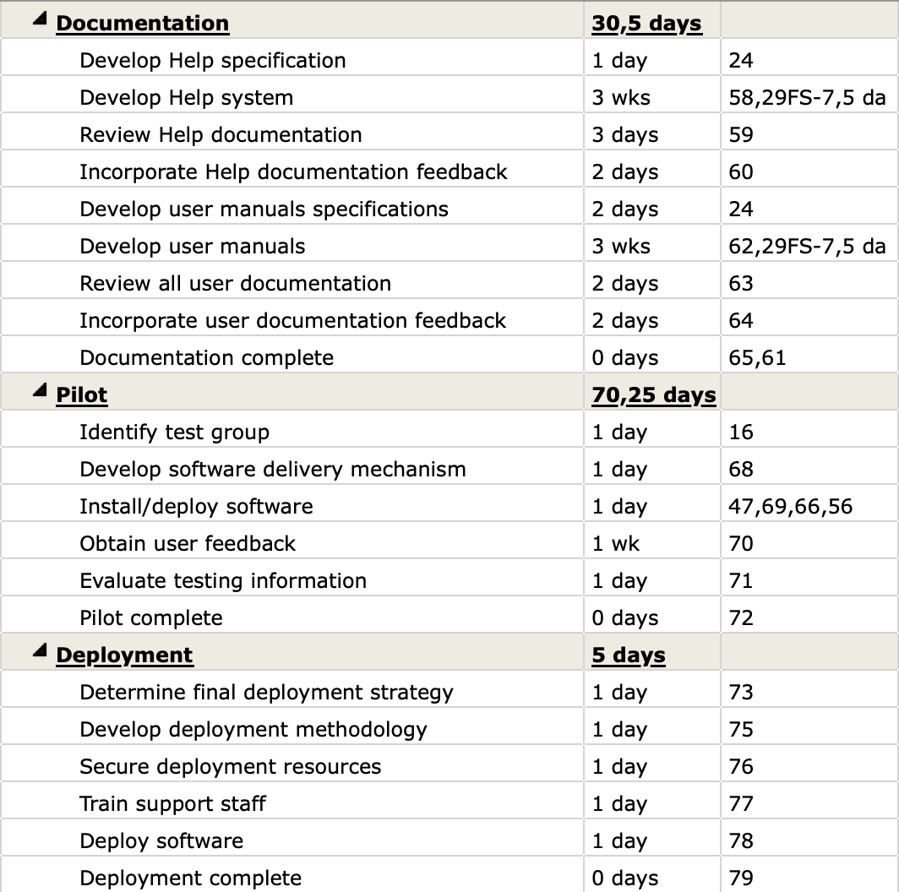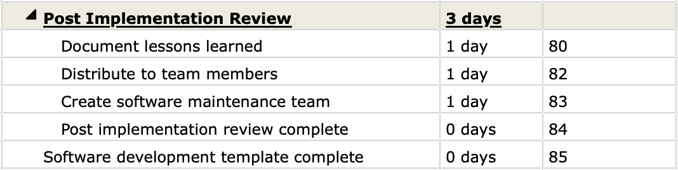

* Add task to Project Timeline
* Add Critical task
* Set baseline
* Add Early Start, Early Finish, Later Start, Later Finish, Free Slack, Total slack
* Display the Project Information
* View Project Timeline, Gant Chart, Network Diagram and capture the result of them.