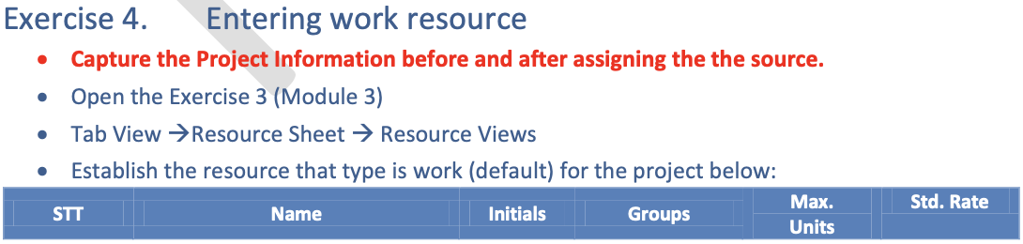

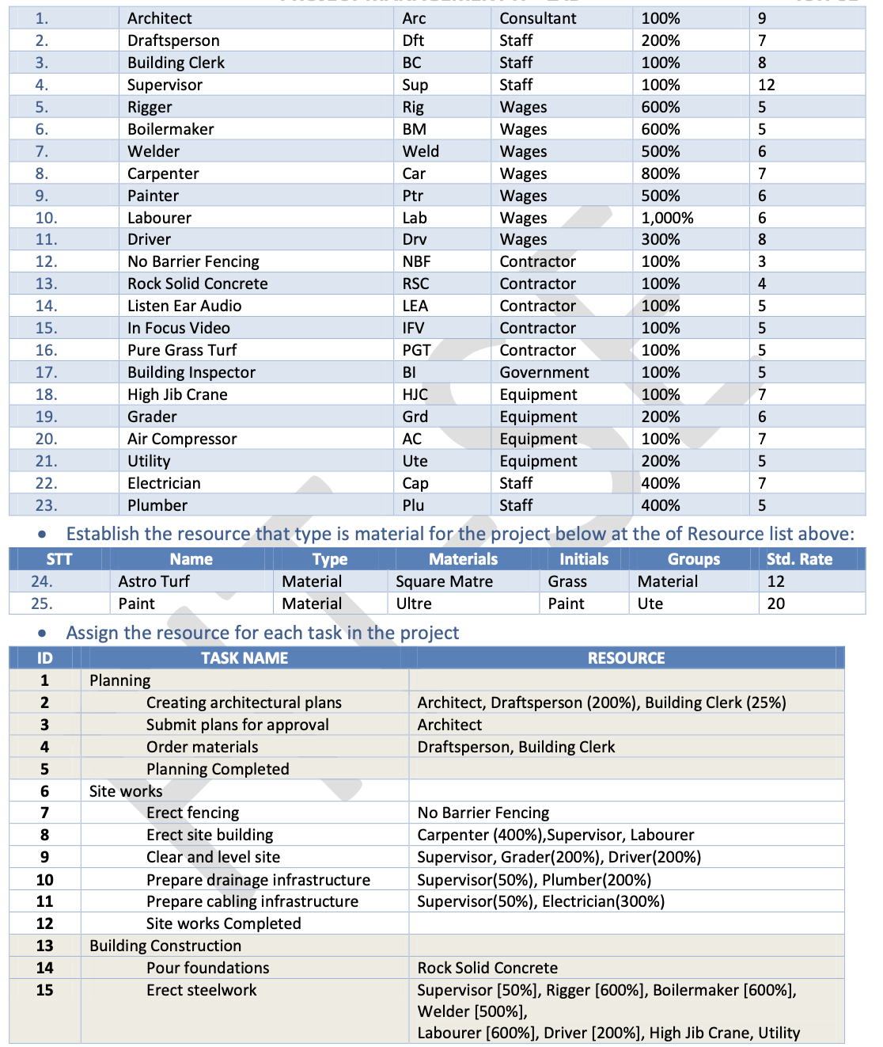

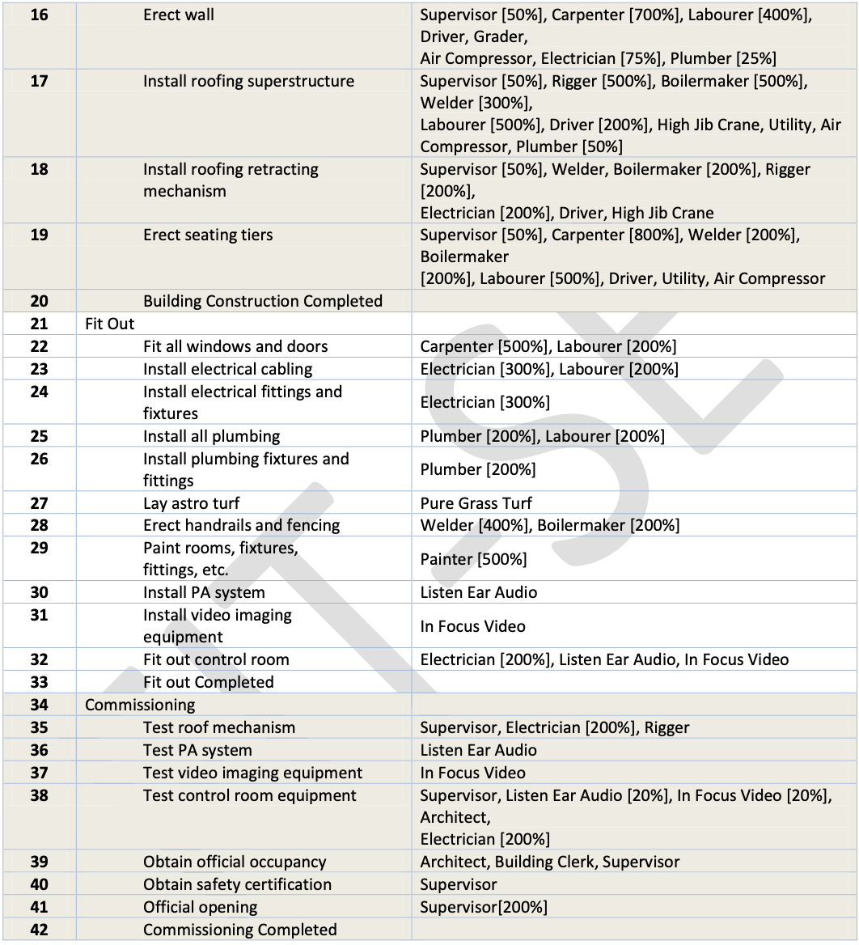

1. Set Baseline cho Project
2. Thêm column Baseline Start, Baseline Finish, Baseline Cost