Exercise 5.

Capture the Project Information before and after assigning the resource.

Creating the following tasks (Project Start Date 7/1/2023)

Establish working time: MSSV_Time

1. Working time: Mon – Fri: 8AM – 11AM, Sat: 11AM-9PM
2. Nonworking time: Sun
3. Exception: Nonworking time: 9/2/2023

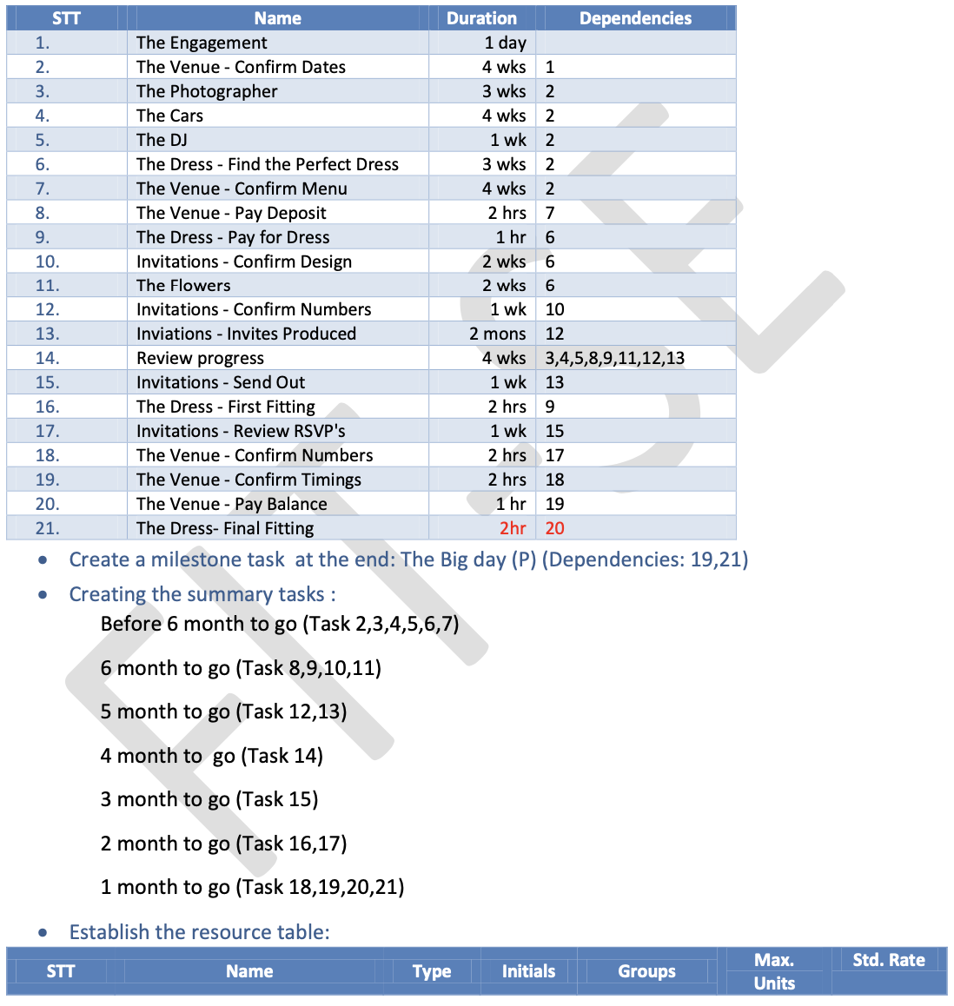

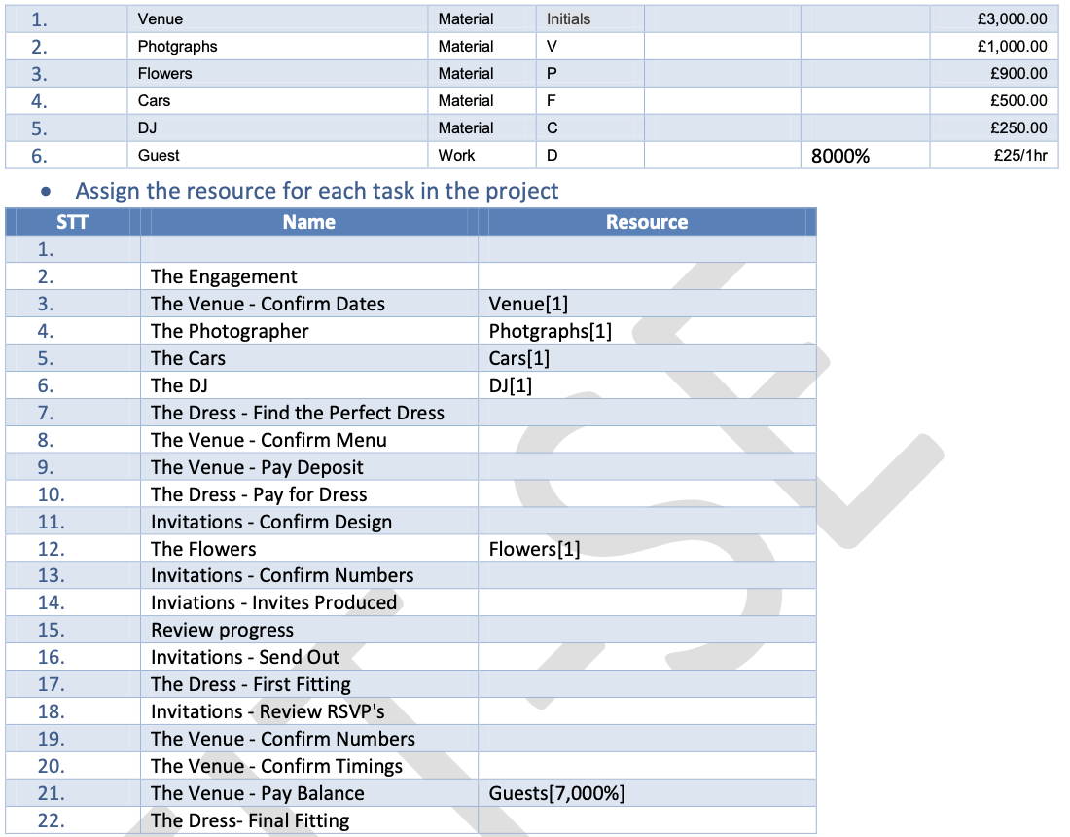

1. Set Baseline
2. Display Critical path
3. Add task to Timeline