Prerequisites:

1. Install Azure CLI tool: <https://docs.microsoft.com/en-us/azure/xplat-cli-install>
2. Login into your azure subscription by azure cli.

## Steps to resize or change number of virtual machines in a scale set.

1. Azure CLI command to resize a VM or increase/decrease capacity in a scale set require a json file which has values for the configuration properties that are applied when the command is executed.

Sample file: Name is used for machine size in scale set, capacity denotes the number of virtual machines in scale set.

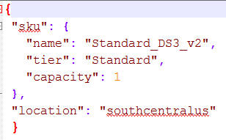

1. The shell script package has total 3 physical components:
   1. Parameters.csv
   2. json file
   3. Shell script: changesize.sh
2. Changesize.sh file takes name of resource group as argument. The shell script also uses the parameters.csv file and the json file.

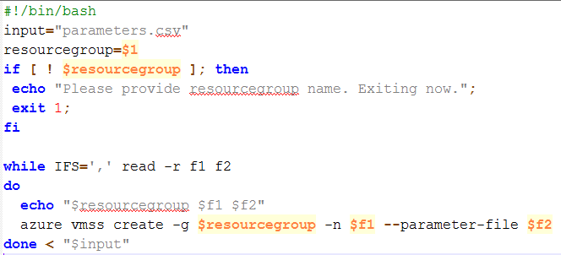

1. Execute changesize.sh by placing all 3 files in same folder.
2. Parameters.csv file contains comma separated values for “scale set name”,”json file name”.
3. There can be multiple comma separated values one value per line to change configuration in different scale sets. “**vmssmaster**” is name of scale set and “**vmss.json**” is file name that contains details about configuration.

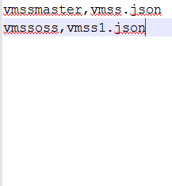

1. If required multiple json files can be used (one per scale set) to change configuration. This can increase the count of files in script folder.
2. Total artifacts:

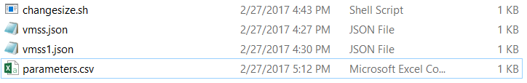

1. Sample execution:

