**Project 1**

**Team : Adventure**

**Team Members:**

* **Aroosa Sawati**
* **Mara**
* **Adeniyi**
* **Tony**
* **Nooshin**

**Project Overview**

* This project studies the employment statistics in Australia from Year 2012-2018.
* The data is collected from website “Australian bureau of statistics”. The URL is below: <https://www.abs.gov.au/statistics/labour/employment-and-unemployment/labour-force-australia/latest-release>
* Questions addressed- *How has Australia’s employment rate changed over the years 2012-2018 for the population aged 15-64.* *Furthermore, the correlation between participation rate, employment to population ratio*, and labor force is studied.
* *Additionally, the relationship between employment to population ratio and participation rate is studied , as it directly affects Australia’s economic growth potential. Three key factors that impact the economic growth, often referred to as the three P’s, are population, participation (or labour supply) and productivity .*

**Employment status**

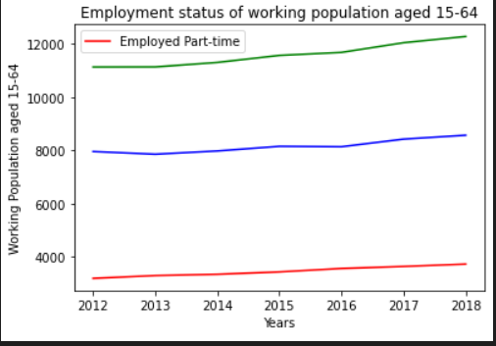

This line graph represents the number of persons employed part time and full-time, which we can see is increasing over the years. Full -time and Part time employment are both increasing over the span of time 2012-2018.

**Employment status /Gender**

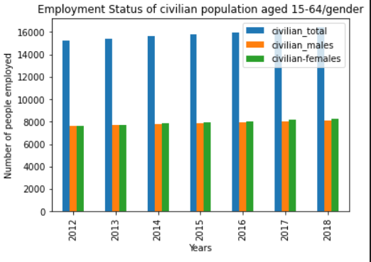

The bar graph shows the number of males and females for civilian population aged 15-64.

In 2012-2013 the employment status remain the same for both males and females. However, from 2014-2018 we can see a slight increase in the female employment.

**Participation rate**

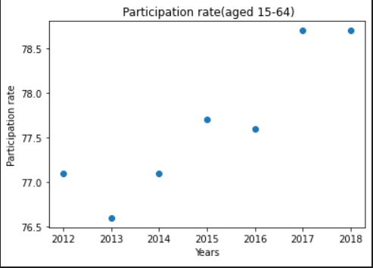

Three key factors that impact on economic growth, often referred to as the three P’s, are population, participation (or labour supply) and productivity .The Correlation between participation rate over the years is 0.91 which is a positive relationship.

Workforce participation refers to the share of the working age population who are either in a job or actively looking for one. It ‘matters’ because it affects Australia’s economic growth potential.

**Employment to population ratio**

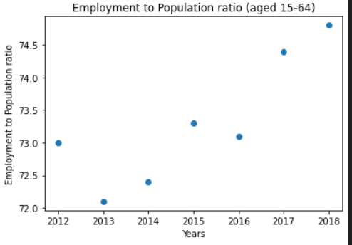

Employment to population ratio is the proportion of a country's population that is employed. Ages 15 and older are generally considered the working-age population.

**Why is employment to population ratio important?**

The ratio is used primarily as a measure of job holders and to track the pace of job creation, relative to the adult population, over time. The employment-population ratio has several properties that make it an attractive indicator for labour market analysis.

In general, a high ratio is considered to be above 70 percent of the working-age population whereas a ratio below 50 percent is considered to be low.

From the graph it clear that over the span of time from year 2012-2018 the employment to population ratio is above 70 which indicates a positivity towards the working age population.

**Labour force**

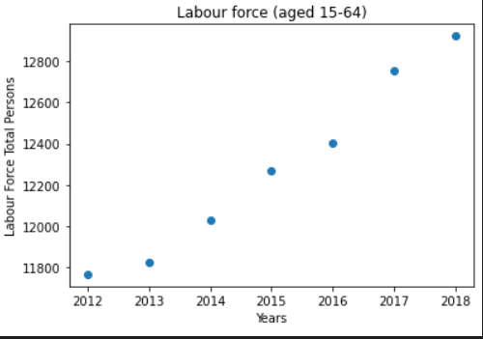

The labour force, or currently active population, comprises all persons who fulfil the requirements for inclusion among the employed (civilian employment plus the armed forces) or the unemployed. The unemployed are defined as people without work but actively seeking employment and currently available to start work.

Correlation is 0.99 indicating a positive relationship.

**Employment to population ratio vs Participation rate**

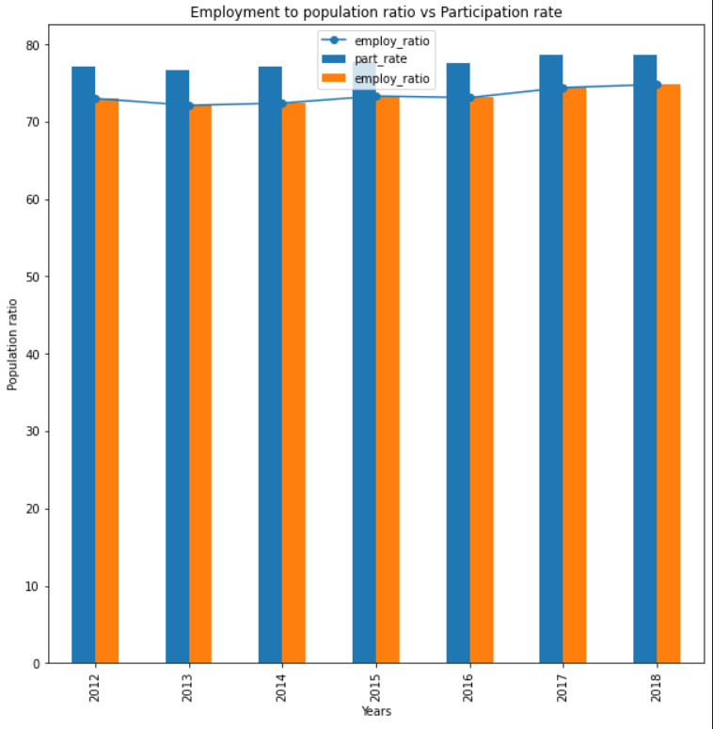

The r-squared value is 0.949269 .

This describes that a lot of variation in y is described by the variation in x which make sense because the line is a good fit .

the regression line represents the mean of y at every given point of x. That is to say: the central tendency of y depends on x.

