final report - project 1
ausTRALIAN Population Vs Employment/Underemployment (2012 – 2018)
ADVENTURE TEAM - JAN/FEB 2021

VERSION HISTORY
The development and distribution of this report was controlled and tracked as follow:
Version # | Implemented | Revision  Date | Approved  By | Approval  Date | Reason
1.0 | Team Adventure | 03-02-2021 | n/a | n/a | Draft doc. created and sent to team for review/add respective sections
1.1 | Team Adventure | 04/02/2021 | n/a | n/a | All sections added
1.2 | Team Adventure | 05/02/2021 | n/a | n/a | Final Draft sent to team for review/final amendments
TABLE OF CONTENTS
1 Introduction 4
1.1 Topic Selection, Project Objective and Assumptions 4
1.2 Scope Management/ Project Schedule /Respondabilities 1
1.3 Change Control Management 1
2 data selection overview 1
2.1 Australian and States Population Data 1
2.2 Other variables data 1
3 Questions Adressed 1
3.1 Australian population vs employment change rate over states/territories 1
3.2 Australian population vs employment over age groups 1
3.3 Australian population vs employment over hourly working time 1
3.4 Australian population vs Underemployment by industries 1
4 FINAL OBSERVATIONS AND CONCLUSIONS 2
4.1 Australian population vs employment over states/territories 2
4.2 Australian population vs employment over age groups 1
4.3 Australian population vs employment over gender 1
4.4 Australian population vs employment average hours worked annually 1
4.5 Australian population vs Underemployment by Industries 1
5 REFERENCES 1

Introduction

Topic Selection, Project Objective and Assumptions
The topic chosen for our project-1 is ‘Population growth and Employment/Underemployment rate in Australia during 2012 to 2018’.
Our main objective is to present the relationship between Australian Population Growth and labour market variables such as national/states employment, industries underemployment, age groups, gender, working hours, between 2012 and 2018 based on the concept of employment and underemployment presented by Australia Bureau of Statistics, 2018 ⁽¹⁾ ⁽²⁾:
- “People are defined as employed part-time in the LFS if they usually work less than 35 hours per week, and actually worked less than 35 hours in the survey reference week in all of their jobs. Full-time employed persons are defined as those who usually work 35 hours or more per week, regardless of how many hours they actually worked, and those who actually worked 35 hours or more in the reference week despite usually working less than 35 hours per week.”
- “The Australian Bureau of Statistics (ABS) identifies two distinct groups as underemployed: • part-time workers who wanted to work more hours and could start additional hours either in the reference week or in the subsequent four weeks; and • full-time workers who worked part-time hours in the reference week for economic reasons (such as being stood down or insufficient work being available). It is assumed these people wanted to work full-time and would have done so, had the work been available.”
We choose this topic because in December 2012, Australia Population had an increase of 1.8% on the previous year and was expected to continue to grow over the next years as per Australia’s changing population research done by Joanne Simon-Davies, Statistics and Mapping (3).
Based on this, we would expect in our analysis to find a level of correlation between the variables selected for the period of 2012 – 2018.
This final report contains, in addition to this introduction, two other sections as final endings. In the first section, we present an overview of the data and project workflow. Then, we analyse the variables from a perspective based on the concept of employment/underemployment formulated by ABS, highlighting the period from 2012 to 2018. In addition, this last section briefly presents a methodology used, conclusion and data source and relevant references.

Scope Management/ Project Schedule /Respondabilities
Project’s original scope, breakdown structure located at WAUS-PERTH-DATA-PT-12-2020-U. The project was divided in three sections:
- Topic research, data manipulation and final data analysis.
- Presentation.
- Final Report.
Name | Responsabilities
Adeniyi | Australian population vs employment over hourly working time
Aroosa | Australian population vs employment over age groups
Mara Venables | Australian Population vs Underemployment by Major Occupation/industries
Nooshin Kooshyar | Australian population vs employment over gender groups
Tony Zhao | Australian population vs Employment Analysis Over States/Territories
All | Presentation
All | Final Report

Change Control Management
All changes to the project were done via GitHub Adventure repository from each respective branch located at https://github.com/tonyzhao668/adventure.

data selection overview
From the several datasets available for the variables selected, Australia Bureau of Statistics row data was selected. To plot the relationship between Population Growth and Variables in Australia during 2012 to 2018, the following has been done:

Australian and States Population Data
- Uploaded original data from ABS and remove irrelevant information such as (years outside of the study period, update columns names, etc and save as csv files.

Other variables data
- Uploaded original data from ABS and remove irrelevant information such as (years outside of the study period, update columns names, etc and save as csv files.
- Make a python script to calculate the yearly change rate (base year 2012) and other relevant calculations.
- Save charts under inputs folder.
- Create word document for each section with the final analysis and observations for presentation/ final report.

Questions Adressed
The Project was divided in five subtopic and intended to address the following questions:

Australian population vs employment change rate over states/territories
- How the national/state 2012 -2018 population vs employment change rate developed?
- What is the yearly average change rate for population, employment, and its correlation coefficient over the whole country/states?

Australian population vs employment over age groups
- How has Australia’s employment rate changed over the years 2012-2018 for the population aged 15-64. Furthermore, the correlation between participation rate, employment to population ratio, and labor force is studied.
- Additionally, the relationship between employment to population ratio and participation rate is studied, as it directly affects Australia’s economic growth potential. Three key factors that impact the economic growth, often referred to as the three P’s, are population, participation (or labour supply) and productivity Australian population vs employment over gender.

Australian population vs employment over hourly working time
Looking at Average hours worked per annum, with 2012 as our base year:
- Are the hours worked by individuals employed changing with changes in the population or static?
- Are the average hours worked each year growing with population? Is it growing at the same rate as the population?

Australian population vs Underemployment by industries
- Is there any correlation between population growth and underemployment in Australia? If so, what is the disparity in terms of growth rate? Do population and underemployment change at a similar rate over time?
- In terms of gender, is the increase in underemployment rate similar for both males and females?

FINAL OBSERVATIONS AND CONCLUSIONS

Australian population vs employment over states/territories
- National and every state/territory population average positive increasing yearly from 2012 to 2018, with national level at 1.25%, max Vic at 1.74%, and min Tas at 0.27%. The population yearly average increase rate overpass that of employment in the whole country.
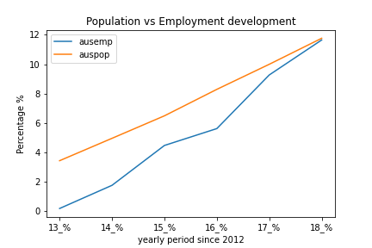

Notes: For all state/Territories charts, please refer in Result Folder under Adventure GitHub.

- Employment increasing every year in the whole country in the period of 2012 -2018, the national level at 0.9%, max Vic at about 1.4%, min SA at 0.04%.
- For both population and employment change rates point of view, VIC is the fastest developed state in Australia in the period of 2012 - 2018.
- From population vs employment correlation coefficient point of view, every state shown a very strong correlation effect with (coefficient value = 0.8 -0.99), except WA and NT with coefficient values at 0.55 and 0.65 respectively, means except WA and NT have weak correlation between population increase rate and employment increase rate, all other states including national rates shown very strong correlation.

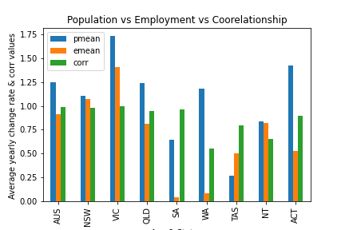

- Contrary to any other state, TAS’s yearly average employment change rate 50% higher than its population increase rate, means where the job market very active, needs to be further investigated.

Australian population vs employment over age groups
Employment status
- This line graph represents the number of persons employed part time and full-time, which we can see is increasing over the years. Full -time and Part time employment are both increasing over the span of time 2012-2018.

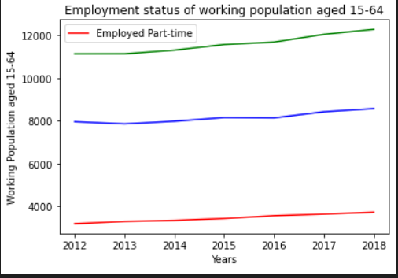
Employment Status /Gender
- The bar graph shows the number of males and females for civilian population aged 15-64. In 2012-2013 the employment status remains the same for both males and females. However, from 2014-2018 we can see a slight increase in the female employment.
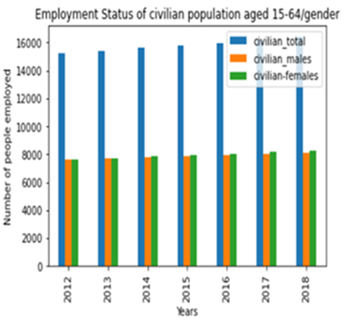
Participation rate
- Workforce participation refers to the share of the working age population who are either in a job or actively looking for one. It ‘matters’ because it affects Australia’s economic growth potential.

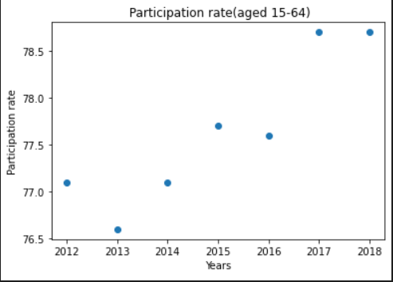
- Three key factors that impact on economic growth, often referred to as the three P’s, are population, participation (or labour supply) and productivity. The Correlation between participation rate over the years is 0.91 which is a positive relationship.

Employment to population ratio
- Employment to population ratio is the proportion of a country's population that is employed. Ages 15 and older are generally considered the working-age population. This ratio is used primarily as a measure of job holders and to track the pace of job creation, relative to the adult population, over time and has several properties that make it an attractive indicator for labour market analysis.
- In general, a high ratio is above 70 percent of the working-age population whereas a ratio below 50 percent is considered to be low. From the graph below it clear that over the span of time from year 2012-2018 the employment to population ratio is above 70 which indicates a positivity towards the working age population.

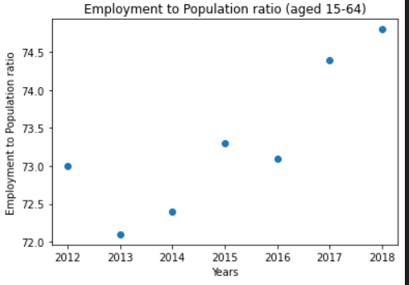
Labour Force
- The labour force, or currently active population, comprises all persons who fulfil the requirements for inclusion among the employed (civilian employment plus the armed forces) or the unemployed. The unemployed are defined as people without work but actively seeking employment and currently available to start work.
- Correlation is 0.99 indicating a positive relationship.

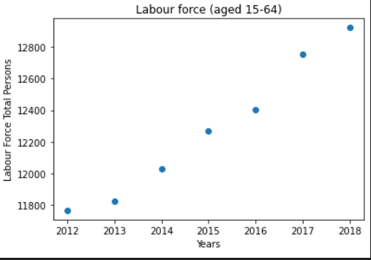
Employment to population ratio vs Participation rate
- The r-squared value is 0.949269. This describes that a lot of variation in y is described by the variation in x which make sense because the line is a good fit. The regression line represents the mean of y at every given point of x. That is to say: the central tendency of y depends on x.

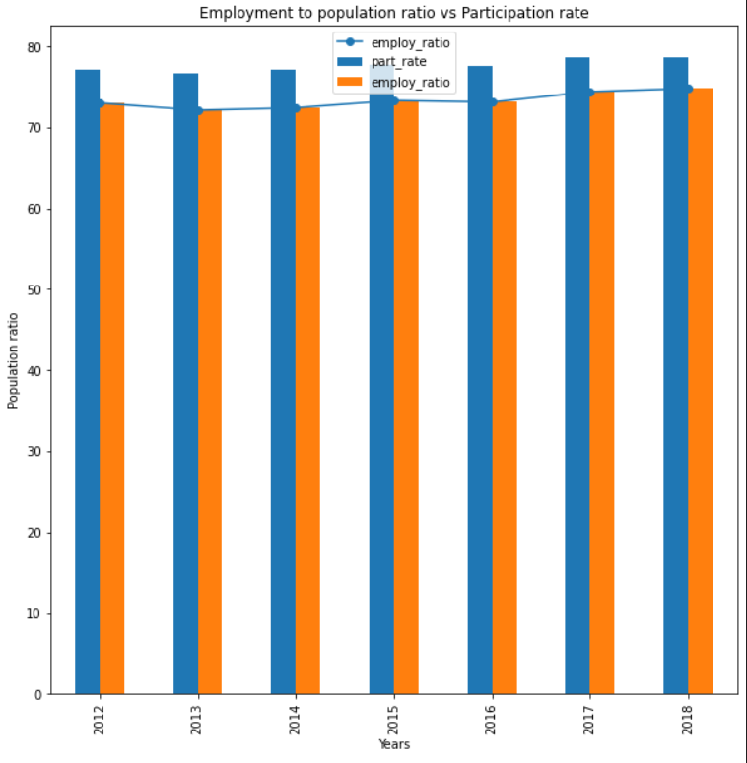

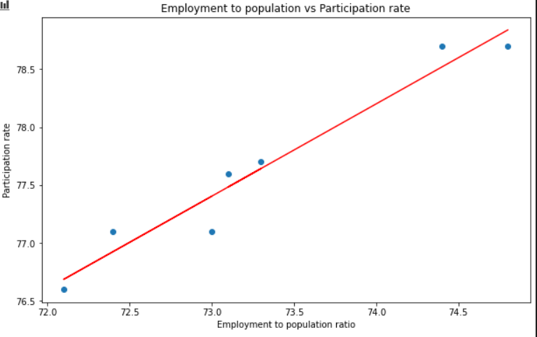

Australian population vs employment over gender
- Participation rate for the people from 2010 normally did not have too much change but at April 2020 it had a big drop which we all know the reason for that was Covid-19.
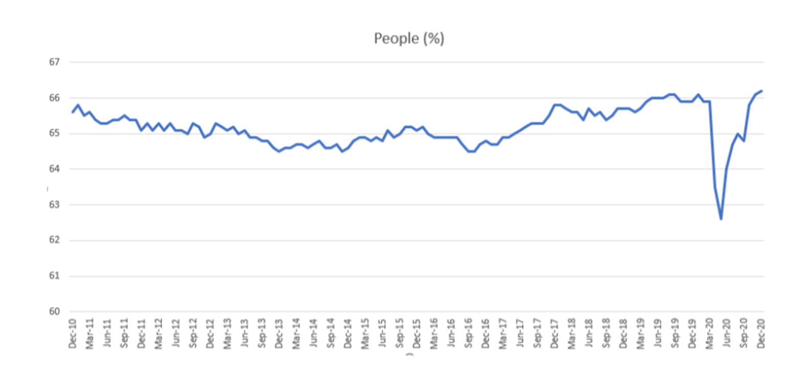
- I also compared participation rate based on gender, men participation was always higher than females, and again we can see the dramatic drop for both group on April 2020.

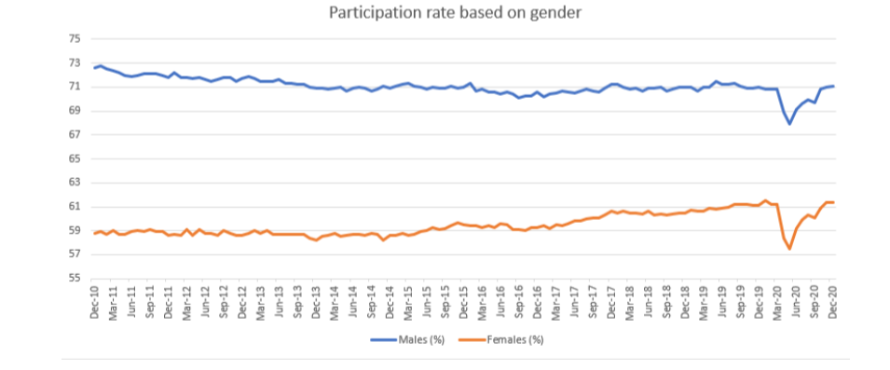

Australian population vs employment average hours worked annually
- There is a clear correlation (0.83) between growth in population from 2012 to 2018 and changes in the average annual hours worked.
- The rate of growth in the average annual hours worked trails the rate of change in the population, with exception of 2018 where the growth in average hours worked slightly exceeded the population growth.
- The average hours worked per individuals employed was constant for all the years considered.
- There is no correlation between the average hours worked per individuals employed with either the population or average number of hours worked.

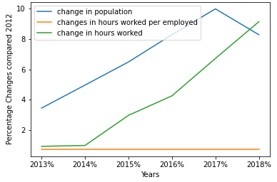

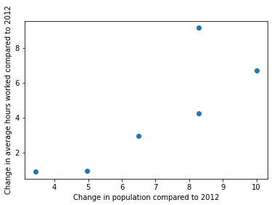

Australian population vs Underemployment by Industries
In terms of correlation, considering the data analysis 'Underemployment - Australian Social Trends' released in June 2010:
- “Although underemployed workers make up a small proportion of employed people, underemployment has been increasing over the last 30 years. Unlike the unemployment rate, which rises and falls with the business cycle, historically, the underemployment rate has tended to rise in economic downturns but not recover as quickly when the economy begins to improve.”
Based on the above, we would expect to find a level of correlation for the two variables for the period of 2012 - 2018.
From the above preliminary analysis, the following was observed:
- Pearson’s correlation is 0.812, showing positive correlation between population growth and Underemployment.
- Over the period of 2012 -2015, the underemployment showed a significant increase over population growth (4.96% and 25.36%) compared with 2012 -2014 (3.44% and 7.17%).

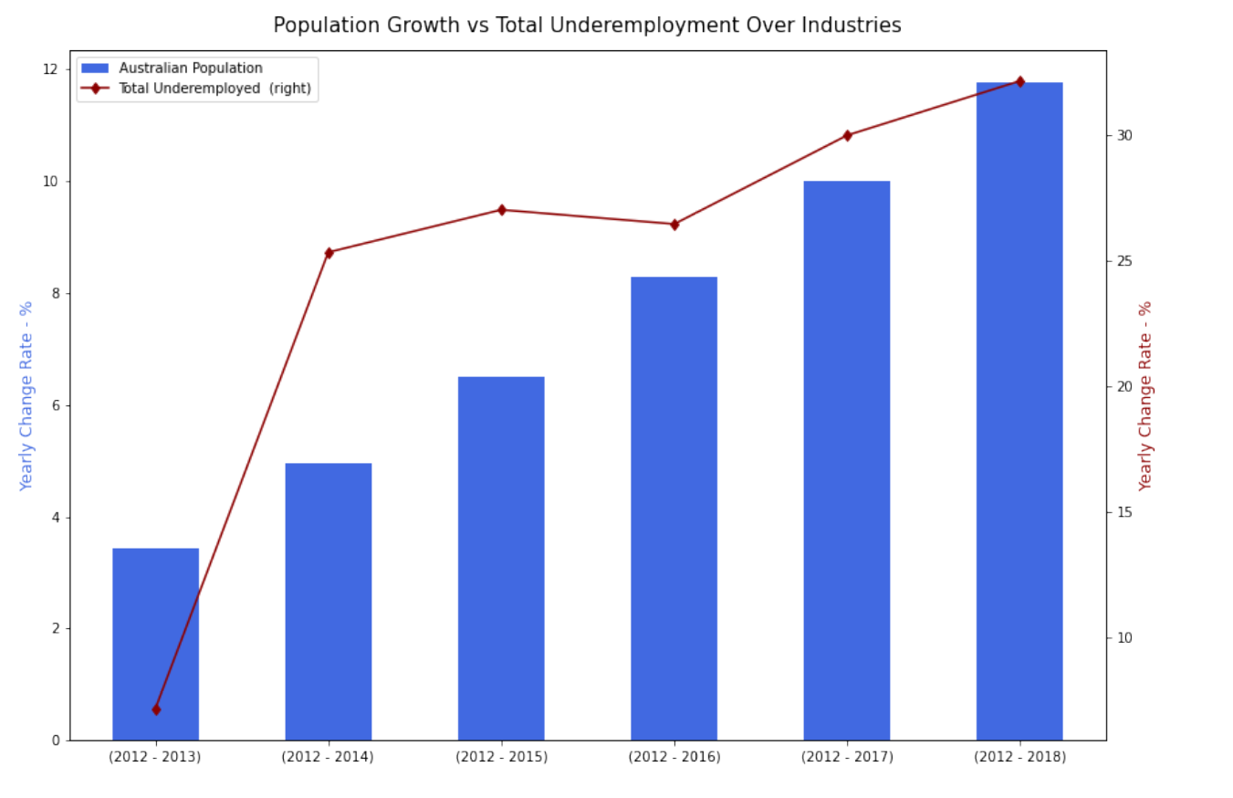

- Males have consistently represented the greater share of underemployed workers.
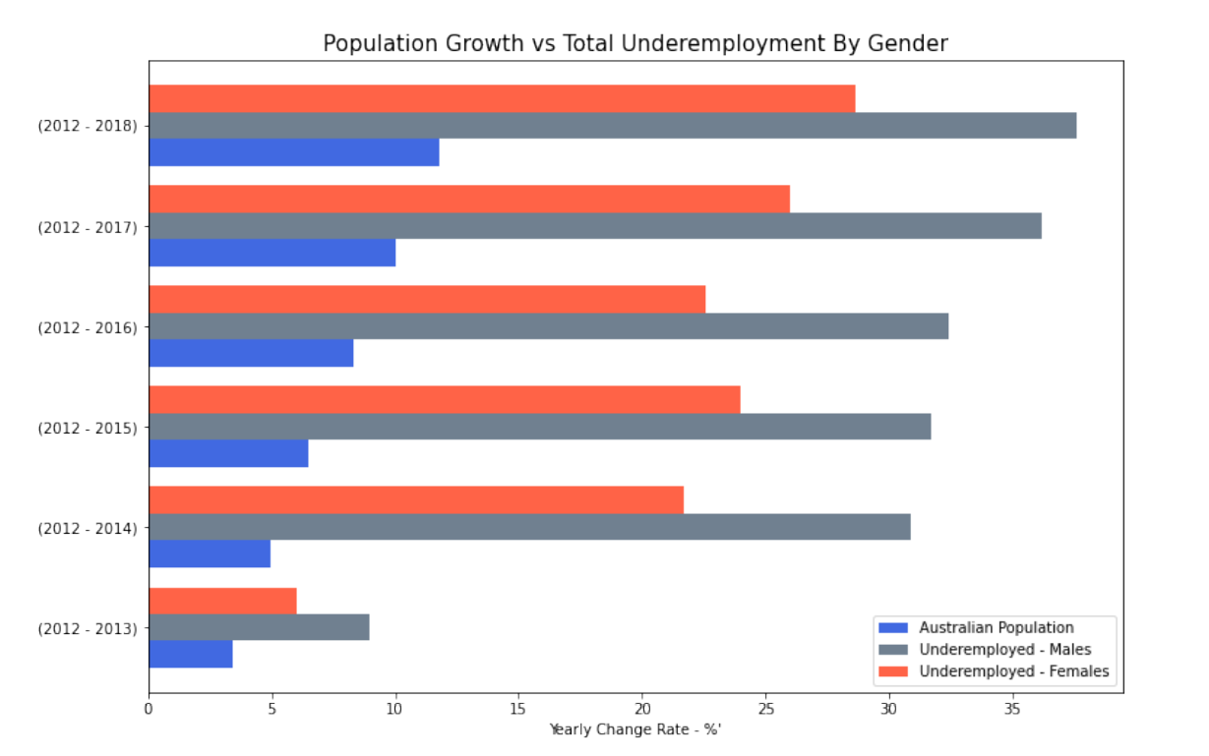
- In terms of underemployment over the total industry/ocupation listed, agriculture, mining and IT had the highest increase. From 2015 onwards mining had the highest increase overall.
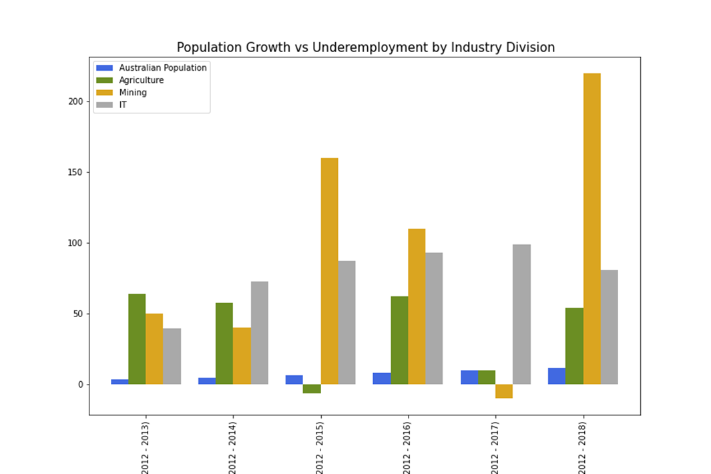

REFERENCES
- https://www.aph.gov.au/About_Parliament/Parliamentary_Departments/Parliamentary_Library/pubs/rp/rp1819/Quick_Guides/Underemployment.
- https://www.abs.gov.au/ausstats/abs@.nsf/lookup/4102.0main+features60jun+2010#:~:text=Factors%20contributing%20to%20income%2Drelated,of%20training%20or%20deficient%20infrastructure.
- https://www.abs.gov.au/statistics/labour/employment-and-unemployment/labour-force-australia-detailed/latest-release#underemployment-and-underutilisation
- https://www.abs.gov.au/statistics/people/population
- Astralia bureau of statistics, 31010do001_202006 national,state and territory population, jun 2020
- Astralia bureau of statistics, 310104
- https://www.abs.gov.au/statistics/labour/employment-and-unemployment
- Astralia bureau of statistics, 6202012, 6291019
- https://www.abs.gov.au/statistics/labour/employment-and-unemployment/labour-force-australia/latest-release

