final report - project 1
ausTRALIAN Population Vs Employment/Underemployment (2012 – 2018)
ADVENTURE TEAM - JAN/FEB 2021

VERSION HISTORY
The development and distribution of this report was controlled and tracked as follow:
Version # | Implemented | Revision  Date | Approved  By | Approval  Date | Reason
1.0 | Mara V. | 03-02-2021 | n/a | n/a | Draft created and sent to team for review/add respective sections
TABLE OF CONTENTS
1 Introduction 4
1.1 Topic Selection, Project Objective and Assumptions 4
1.2 Scope Management/ Project Schedule /Respondabilities 1
1.3 Change Control Management 1
2 data selection overview and hypotheses 1
2.1 Australian Population Data 1
2.2 Other variables data 1
2.3 Variables overview and hypotheses 1
2.3.1 Australian opulation vs employment over states/territories 1
2.3.2 Australian population vs employment over age groups 1
2.3.3 Australian population vs employment over gender 1
2.3.4 Australian population vs employment over hourly working time 1
2.3.5 Australian population vs Underemployment by industries 1
3 final observations and Conclusions 1
3.1.1 Australian opulation vs employment over states/territories 1
3.1.2 Australian population vs employment over age groups 1
3.1.3 Australian population vs employment over gender 1
3.1.4 Australian population vs employment over hourly working time 1
3.1.5 Australian population vs Underemployment by Industries 1
REFERENCES 2

Introduction

Topic Selection, Project Objective and Assumptions
The topic chosen for our project-1 is ‘Population growth and Employment/Underemployment rate in Australia during 2012 to 2018’.
Our main objective is to present the relationship between Australian Population Growth and labour market variables such as national/states employment, industries underemployment, age groups, gender, working hours, between 2012 and 2018 based on the concept of employment and underemployment presented by Australia Bureau of Statistics, 2018 ⁽¹⁾ ⁽²⁾ :
- “People are defined as employed part-time in the LFS if they usually work less than 35 hours per week, and actually worked less than 35 hours in the survey reference week in all of their jobs. Full-time employed persons are defined as those who usually work 35 hours or more per week, regardless of how many hours they actually worked, and those who actually worked 35 hours or more in the reference week despite usually working less than 35 hours per week.”
- “The Australian Bureau of Statistics (ABS) identifies two distinct groups as underemployed: • part-time workers who wanted to work more hours and could start additional hours either in the reference week or in the subsequent four weeks; and • full-time workers who worked part-time hours in the reference week for economic reasons (such as being stood down or insufficient work being available). It is assumed these people wanted to work full-time and would have done so, had the work been available.”

We choose this topic because in December 2012, Australia Population had an increase of 1.8% on the previous year and was expected to continue to grow over the next years as per Australia’s changing population research done by Joanne Simon-Davies, Statistics and Mapping (3).
Based on this, we would expect in our analysis to find a level of correlation between the variables selected for the period of 2012 – 2018.

This final report contains, in addition to this introduction, two other functions as final endings. In the first section, we present an overview of the data and project workflow. Then, we analyse the variables from a perspective based on the concept of employment/underemployment formulated by ABS, highlighting the period from 2012 to 2018. In addition, this last section briefly presents a methodology used, conclusion and data source and relevant references.

Scope Management/ Project Schedule /Respondabilities
Project’s original scope, breakdown structure located at WAUS-PERTH-DATA-PT-12-2020-U. The project was divided in three sections:
- Topic research, data manipulation and final data analysis.
- Presentation.
- Final Report.
Name | Responsabilities
Adeniyi | Australian population vs employment over hourly working time
Aroosa | Australian population vs employment over age groups
Mara Venables | Australian Population vs Underemployment by Major Occupation/industries
Nooshin Kooshyar | Australian population vs employment over gender groups
Tony Zhao | Australian population vs Employment Analysis Over States/Territories
All | Presentation
All | Final Report

Change Control Management
All changes to the project were done via GitHub Adventure repository from each respective branch.

data selection overview and hypotheses
From the several datasets available for the variables selected, Australia Bureau of Statistics row data was selected. To plot the relationship between Population Growth and Variables in Australia during 2012 to 2018, the following has been done:

Australian/States Population/EMPLOYMENT Data

Population Data Sources:

https://www.abs.gov.au/statistics/people/population

Astralia bureau of statistics, 31010do001_202006 national, state and territory population, jun 2020

Astralia bureau of statistics, 310104

Employment Data Sources:

https://www.abs.gov.au/statistics/labour/employment-and-unemployment

Employment/unemployment 2012 -2018 vs states:

Astralia bureau of statistics, 6202012, 6291019

Other variables data
- Uploaded original data from ABS and remove irrelevant information such as (years outside of the study period, update columns names, etc and save as csv files.
- Make a python script to calculate the yearly change rate (base year 2012) and other relevant calculations.
- Save charts under inputs folder.
- Create word document for each section with the final analysis and observations for presentation/ final report.

Variables overview and hypotheses

I suggest to use Target question to be answered: tony

Australian population vs employment change rate over states/territories

In this part, we try to answer the following questions:

a. How the national/state 2012 -2018 population vs employment change rate developed?

b. What is the yearly average change rate for population, employment and its correlation coefficient over the whole country/states?

Australian population vs employment over age groups

Australian population vs employment over gender

Australian population vs employment over hourly working time

Here we are looking at Average hours worked per annum, with 2012 as our base year,

Is the hours worked by individuals employed changing with changes in the population or static?

Is the average hours worked each year growing with population? Is it growing at the same rate as the population?

Australian population vs Underemployment by industries
For this section, a preliminary data analysis was undertaken for the years 2012 – 2018 to identify the relationship between Population growth and Underemployment rate by industries.
Only data for employed people was considered and analysed for the rate of underemployment, as per ABS⁽²⁾ definition.
In terms of correlation, taking into account the data analysis 'Underemployment - Australian Social Trends' released in June 2010:
- “Although underemployed workers make up a small proportion of employed people, underemployment has been increasing over the last 30 years. Unlike the unemployment rate, which rises and falls with the business cycle, historically, the underemployment rate has tended to rise in economic downturns but not recover as quickly when the economy begins to improve.”
Based on the above, we would expect in our preliminary analysis to find a level of correlation for the two variables for the period of 2012 - 2018.

final observations and Conclusions

Australian population vs employment over states/territories

1. National and every state/territory population average positive increasing yearly from 2012 to 2018, with national level at 1.25%, max Vic at 1.74%, and min Tas at 0.27%. The population yearly average increase rate overpass that of employment in the whole country.

2. Employment increasing every year in the whole country in the period of 2012 -2018, the national level at 0.9%, max Vic at about 1.4%, min SA at 0.04%.

3. For both population and employment change rates point of view, VIC is the fastest developed state in Australia in the period of 2012 - 2018.

4. From population vs employment correlation coefficient point of view, every state shown a very strong correlation effect with (coefficient value = 0.8 -0.99), except WA and NT with coefficient values at 0.55 and 0.65 respectively, means except WA and NT have weak correlation between population increase rate and employment increase rate, all other states including national rates shown very strong correlationship.

5. Contrary to any other state, TAS’s yearly average employment change rate 50% higher than its population increase rate, means where the job market very active, needs to be further investigated.

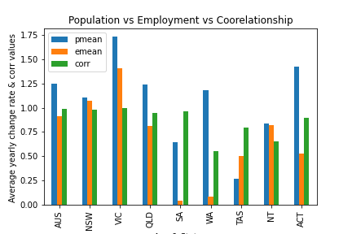

National Population and Employment change rate during 2012-2018

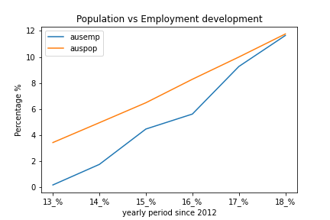

Remarks: All other charts for each state/Territories, please check in Result Folder.

Australian population vs employment over age groups

Australian population vs employment over gender

Australian population vs employment average hours worked annually

1, There is a clear correlation (0.83) between growth in population from 2012 to 2018 and changes in the average annual hours worked.
2, The rate of growth in the average annual hours worked trails the rate of change in the population, with exception of 2018 where the growth in average hours worked slightly exceeded the population growth.
3, The average hours worked per individuals employed was constant for all the years considered
4, There is no correlation between the average hours worked per individuals employed with either the population or average number of hours worked.

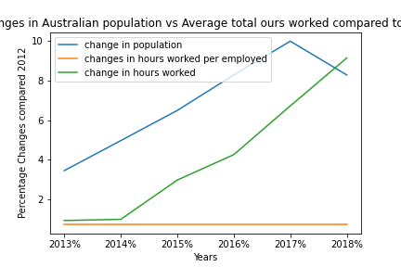

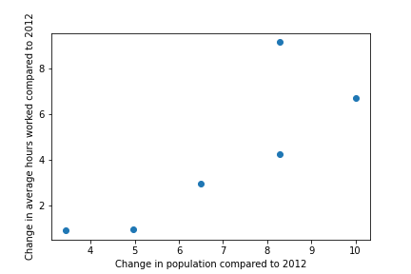

Australian population vs Underemployment by Industries
From the above preliminary analysis, the following was observed:
- Pearson’s correlation is 0.812, showing positive correlation between population growth and Underemployment.

- Over the period of 2012 -2014, the underemployment showed a significant increase over population growth (4.96% and 25.36%) compared with 2012 -2014 (3.44% and 7.17%).

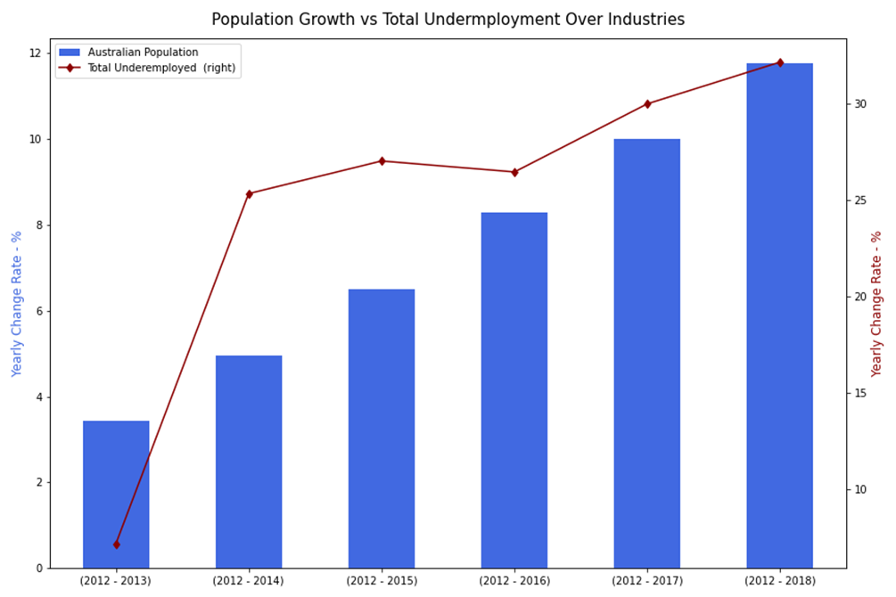

- Males have consistently represented the greater share of underemployed workers.
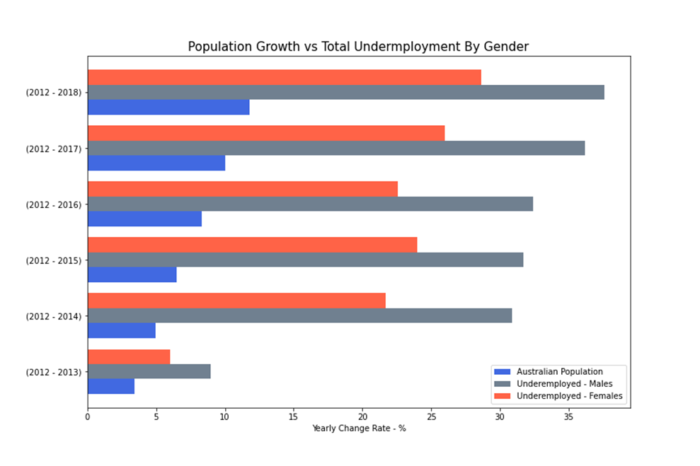
- In terms of underemployment over the total industry/ocupation listed, agriculture, mining and IT had the highest increase. From 2015 onwards mining had the highest increase overall.
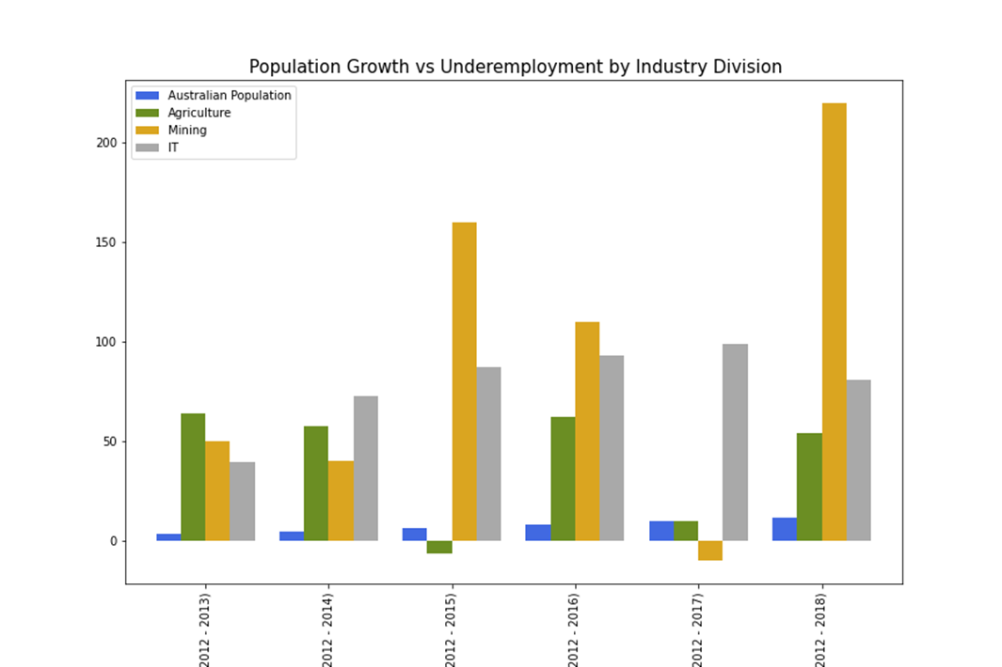

REFERENCES
(1)_https://www.aph.gov.au/About_Parliament/Parliamentary_Departments/Parliamentary_Library/pubs/rp/rp1819/Quick_Guides/Underemployment.

(2)_https://www.abs.gov.au/ausstats/abs@.nsf/lookup/4102.0main+features60jun+2010#:~:text=Factors%20contributing%20to%20income%2Drelated,of%20training%20or%20deficient%20infrastructure.

(3)_https://www.abs.gov.au/statistics/labour/employment-and-unemployment/labour-force-australia-detailed/latest-release#underemployment-and-underutilisation

