FINAL REPORT – ETL PROJECT
PERTH METROPOLITAN AREA ROADWORKS
Team Quokka - March 2021

- INTRODUCTION
This report presents a final summary of the ETL project for all the roadworks currently undertaken by Mainroads across the Perth Metropolitan Area, within the scope requested by the ‘Client’, whose main proposal aims to assess the disruption of roadworks on their commercial activities and community events in each suburb. The project’s guidelines are located at WAUS-PERTH-DATA-PT-12-2020-U master repository.
In our preliminary team discussion, the scope management/responsibilities were structured as following:

Name | Responsabilities
M. Venables/ T. Zhao | Data research and selection
T. Zhao | ETL – Dataset1– JSON format
M. Venables | ETL – Dataset2 – CSV format
M. Venables/ T. Zhao | Final Report

Our proposed workflow, in the section below, aimed to extend the current search options allowing our client to integrate both existing qualitative/quantitative datasets, and geographical search tools in their final analysis.

Regarding database selection, we decided the following for our Backend Architecture:
- MongoDB database used as a presenting area for the ETL process of JSON files due to its efficiency, support of unstructured data, and query capabilities. This was the preferred option as loading raw data into a SQL database requires the raw data to be error-free, and relationships between entities to be consistent, which was not achievable due to the timeline of this project.
- PostgreSQL database that contains operational data as our client has a highly structured data model.

  - Workflow
After establishing our data sources and dependences, the project workflow was defined as following:

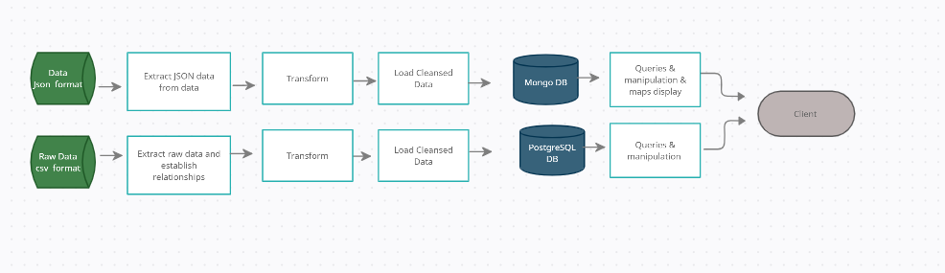

- ETL – Dataset 1
This section was implemented using pandas, xxxx.

  - Schema
tbc

  - Extract
The raw dataset_2 (“roadworks. geojson”, “packge_show.json was obtained from mrwa-roadworks website as a csv file and saved under Resources folder in our ETL project main GitHub repository. After download the data was extracted into DataFrames using pandas as following:
picture

  - Transform
- For the transformation step, the following was pursued:
- Create a filtered dataframe from specific columns and rename columns as per schema.
- Create a filtered dataframe from specific location that includes only roadworks current undertaken at Perth Metropolitan Area (‘Metro’).
- Add a new empty column map to the dataframe for future use.

  - Load
Clean data was successfully load to MongoDb database

  - Queries & Display
- Create the maps for the regions and projects location using the project id
- Individual position of project map
- ETL – Dataset 2
This section was implemented using pandas, SQLAlchemy and Postgresql.
  - Schema
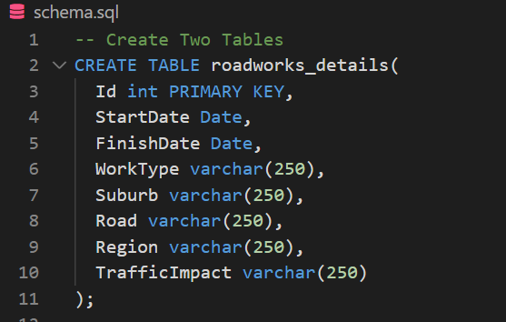

  - Extract
The raw dataset_2 (“roadworks.csv”) was obtained from mrwa-roadworks website as a csv file and saved under Resources folder in our ETL project main GitHub repository. After download the data was extracted into DataFrames using pandas as following:
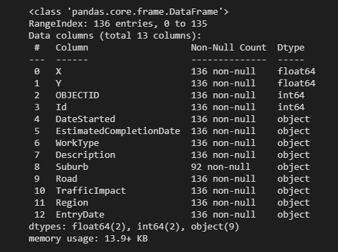

  - Transform
For the transformation step, the following was pursued:
- Create a filtered dataframe from specific columns and rename columns as per schema.
- Create a filtered dataframe from a specific location that includes only roadworks currently undertaken in the Perth Metropolitan Area (‘Metro’).

  - Load
We encountered a few issues to establish the initial connection, however after removing all the connection errors the clean data was successfully loaded to the PostgresSQL database as per below:

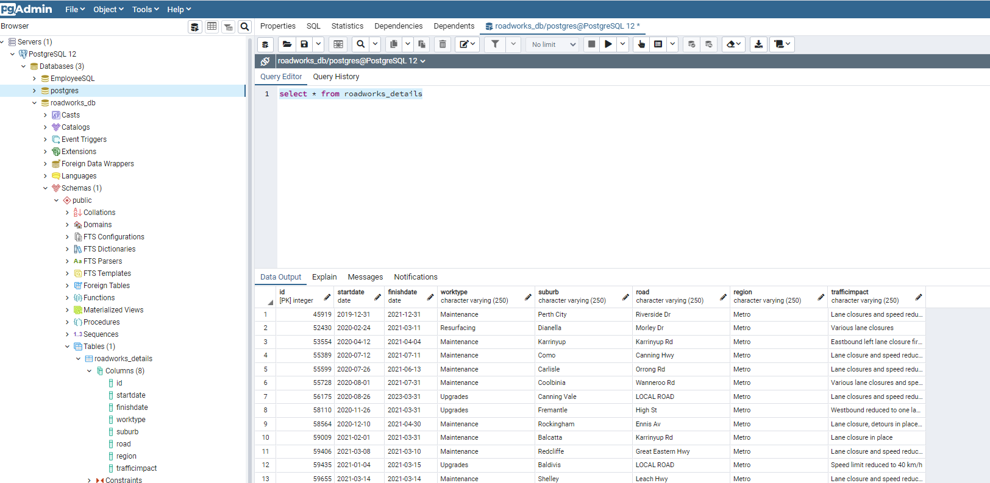

- Final Considerations
The outcome of this project and the steps necessary to obtain these results was straightforward given the timeframe as well as the simplicity of the raw data available for the chosen subject, however we are planning to implement a more integrated and complex architecture for our future projects.
More comments here

- References
- https://catalogue.data.wa.gov.au/dataset/mrwa-roadworks
- https://pandas.pydata.org/pandas-docs/version/0.25.3/
- Tony references

