FINAL REPORT – ETL PROJECT
ROADWORKS ACROSS PERTH METROPOLITAN AREA
Team Quokka - March 2021

- INTRODUCTION
This report presents a final summary of the ETL project for all the roadworks currently undertaken by Mainroads across the Perth Metropolitan Area, within the scope requested by the ‘Client’, whose main proposal aims to assess the disruption of roadworks on their commercial activities and community events in each suburb. The project’s guidelines are located at WAUS-PERTH-DATA-PT-12-2020-U master repository.
In our preliminary team discussion, the scope management/responsibilities were structured as following:

Name | Responsabilities
M. Venables/ T. Zhao | Data research and selection
T. Zhao | ETL – Dataset1– GEOJSON format
M. Venables | ETL – Dataset2 – CSV format
M. Venables/ T. Zhao | Final Report

Our proposed workflow, in the section below, aimed to extend the current search options allowing our client to integrate both existing qualitative/quantitative datasets, and geographical search tools in their final analysis.

Regarding database selection, we decided the following for our Backend Architecture:
- MongoDB database used as a presenting area for the ETL process of JSON files due to its efficiency, support of unstructured data, and query capabilities. This was the preferred option as loading raw data into a SQL database requires the raw data to be error-free, and relationships between entities to be consistent, which was not achievable due to the timeline of this project.
- PostgreSQL database that contains operational data as our client has a highly structured data model.

  - Workflow
After establishing our data sources and dependences, the project workflow was defined as following:

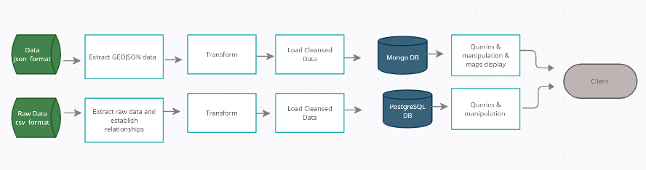

- ETL – Dataset 1
This section was implemented using pandas, sqlalchemy, geopandas, folium, pymongo, numpy.

  - Collection
General roadworks fields for the whole Metro and Regional areas projects:
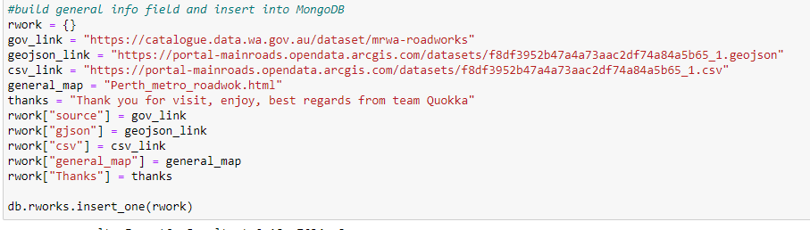
Detailed roadworks fields for Metro areas projects only:
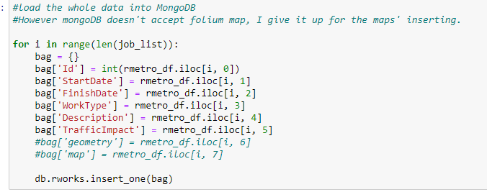

  - Extract
The raw dataset_2 (“roadworks. geoJson”) was obtained from mrwa-roadworks website as a csv file and saved under Resource’s folder in our ETL project main GitHub repository. After download, the data was extracted into DataFrames using pandas as following:
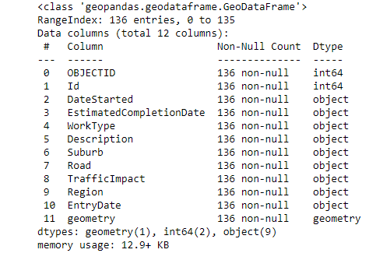

  - Transform
For the transformation step, the following was pursued:
- Create a filtered dataframe from specific columns and rename columns as per schema.
- Create a filtered dataframe from specific location that includes only roadworks current undertaken at Perth Metropolitan Area (‘Metro’).
- Add a new empty column map to the dataframe for future use.

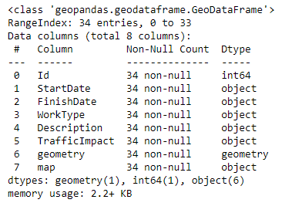
  - Load
The clean data was successfully loaded to the MongoDB database under collection ‘roadworks’ as per below:

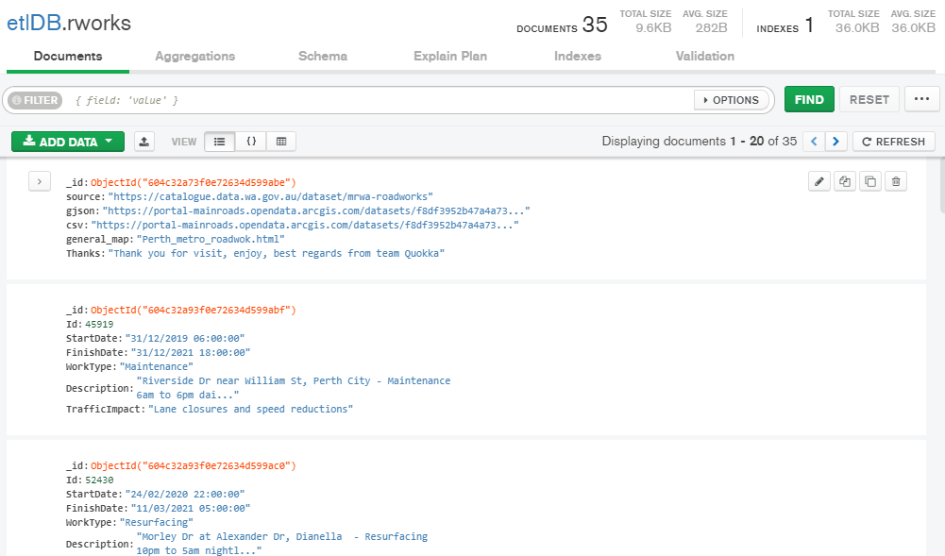
  - Queries & Display
The queries for the project’s location map as per below:

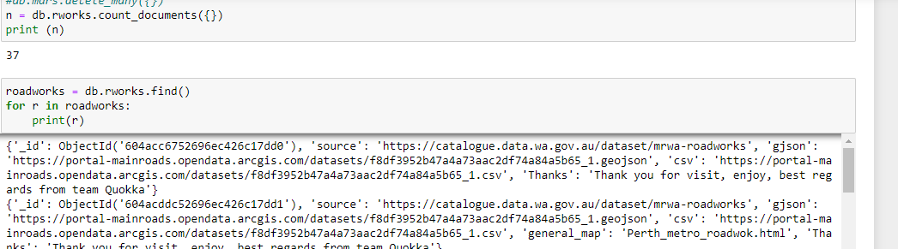

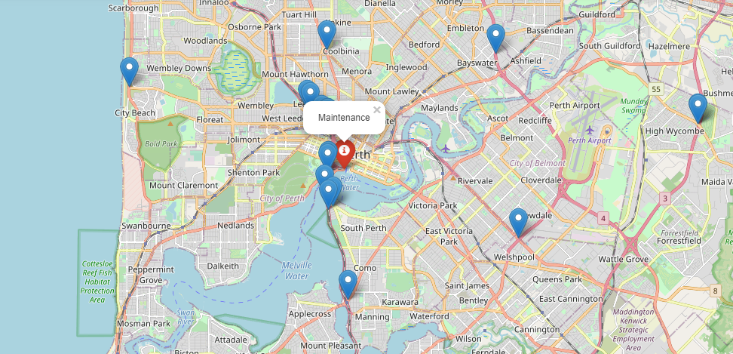
- ETL – Dataset 2
This section was implemented using pandas, SQLAlchemy and Postgresql.
  - Schema
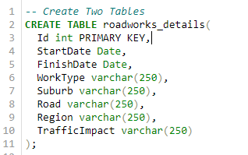

  - Extract
The raw dataset_2 (“roadworks.csv”) was obtained from mrwa-roadworks website as a csv file and saved under Resource’s folder in our ETL project main GitHub repository. After download, the data was extracted into DataFrames using pandas as following:
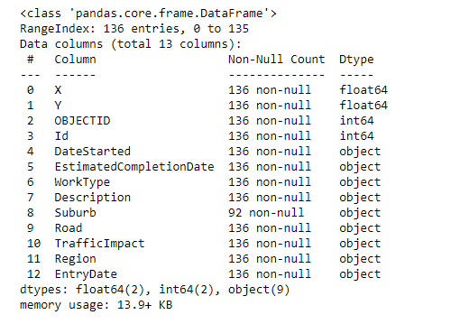

  - Transform
For the transformation step, the following was pursued:
- Create a filtered dataframe from specific columns and rename columns as per schema.
- Create a filtered dataframe from a specific location that includes only roadworks currently undertaken in the Perth Metropolitan Area (‘Metro’).
The data after transformation was displayed as following:

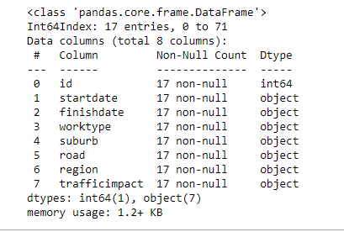

  - Load
We encountered a few issues to establish the initial connection with our database ‘roadworks_db’, however after removing all the connection errors the clean data was successfully loaded to the PostgresSQL database table ‘roadworks_details’ as per below:

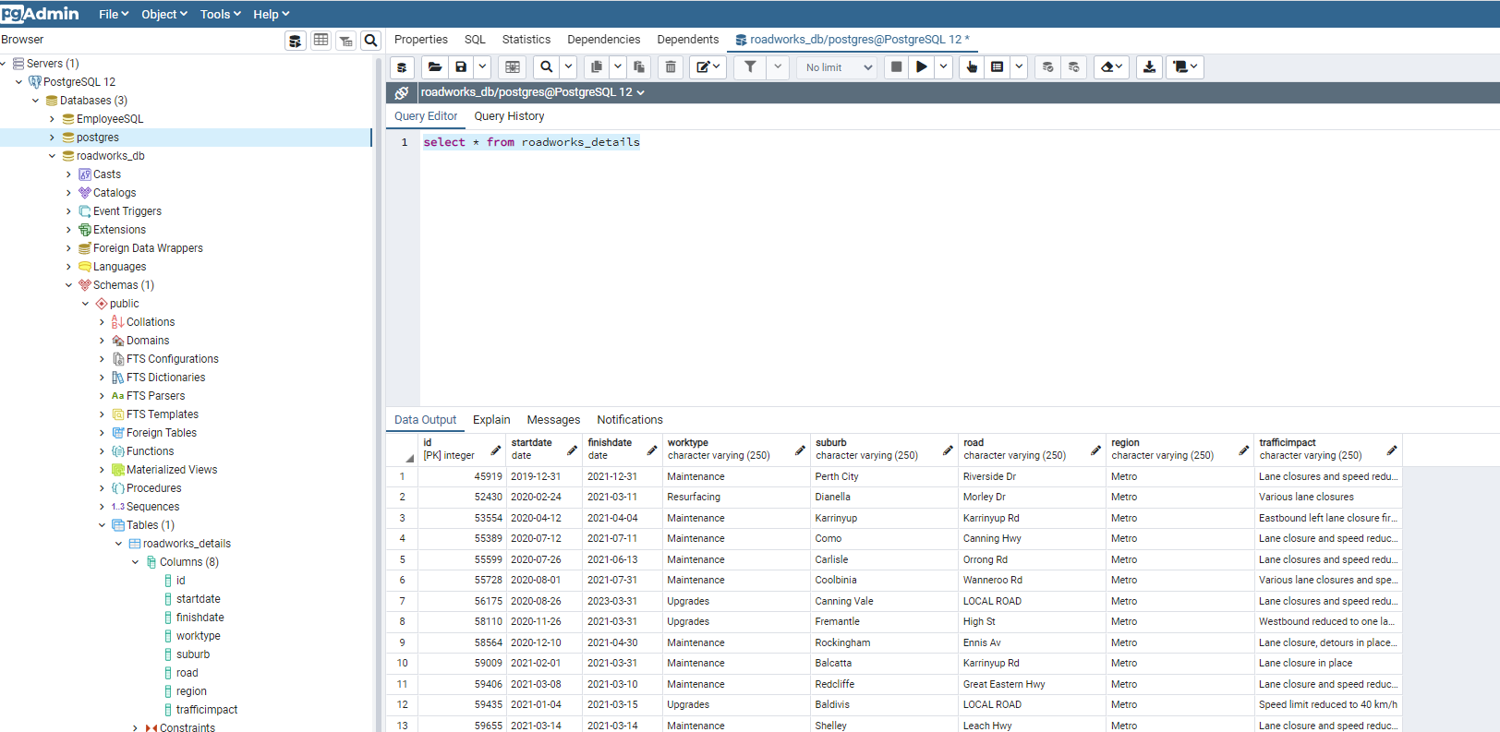

- Final Considerations
The outcome of this project ( Extract – Transform – Load ) and the steps necessary to obtain these results was straightforward given the timeframe and raw data available for the chosen subject, the clean data was successfully loaded to both , Postgresql and Mongodb, databases as per client’s request.

- References
- https://catalogue.data.wa.gov.au/dataset/mrwa-roadworks
- https://pandas.pydata.org/pandas-docs/version/0.25.3/

