**Report on Kickstarter Campaigns**

By Tony Zhao 05/12/2020

1. **Given the provided data, what are three conclusions we can draw about Kickstarter campaigns?**

* From Category vs State point of view, theatre, music and film & Video sectors have more players, and more than 57 - 77% chance to success.
* From the Bonus chart point of view, when the required value less than $5000 with 60% chance to success and 30% chance to fail. If you are bidding for $5000 to $45000 the chance is half to half. If one applies more than $45000 will have big chance to waste his time.
* From the sub-categories vs state point of view, the Plays sub-sector is much more active with highest number of players, and more than 65% successful rate. And Documentary, Hardware, Rock and Indian Rock sectors are promising, with no or quite less failing rate.
* From Months vs State point of view, the data paten from 2009 and 2017 looks abnormal, should be considered improve/neglect/delete, the remain data looks generally from Apr. to Jun. shown more chance to success.

1. **What are some limitations of this dataset?**

* It is unclear, who supplies the original data and their credibility/methodology deployed.
* The purpose of the Kickstarter and their capacity and principle of selecting is unclear. Is there serious bias involved, cause the data deviates from market reality picture?
* The definition of each category/sub-category is not clear.
* How to definite successful and live, and stuff-pick etc, is there any hiding influence?
* The goal/pledged amount is converted into single currency already? We just assume yes, at the moment.

1. **What are some other possible tables and/or graphs that we could create?**

* The Category vs Pledged, to show which sector get more money.
* The Countries vs state, to show the difference between countries.
* Date vs category.
* (Launched date -Deadline) vs Categories
* For the successful ones, (pledged-goal) vs Categories.
* For each sub-category’s vs state.
* Example of another table Categories vs Sum Pledged & Goal as attached, which shows:

The technology sector is the greatest winner and has grabbed about 50% of the total pledged money. And it seems people in Film & Video industry need much more money than backers could/like to pay, compare to that of other industries.

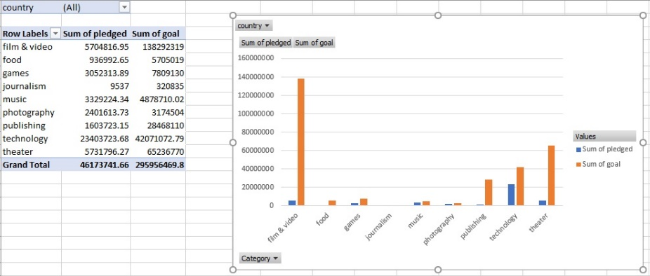

**Remarks:**

I have made all the job done in one spread book: StarterBook_Tony, with my created 6 column labels’ cells has been filled with light-blue, related spreadsheets have been renamed for easy finding.

End