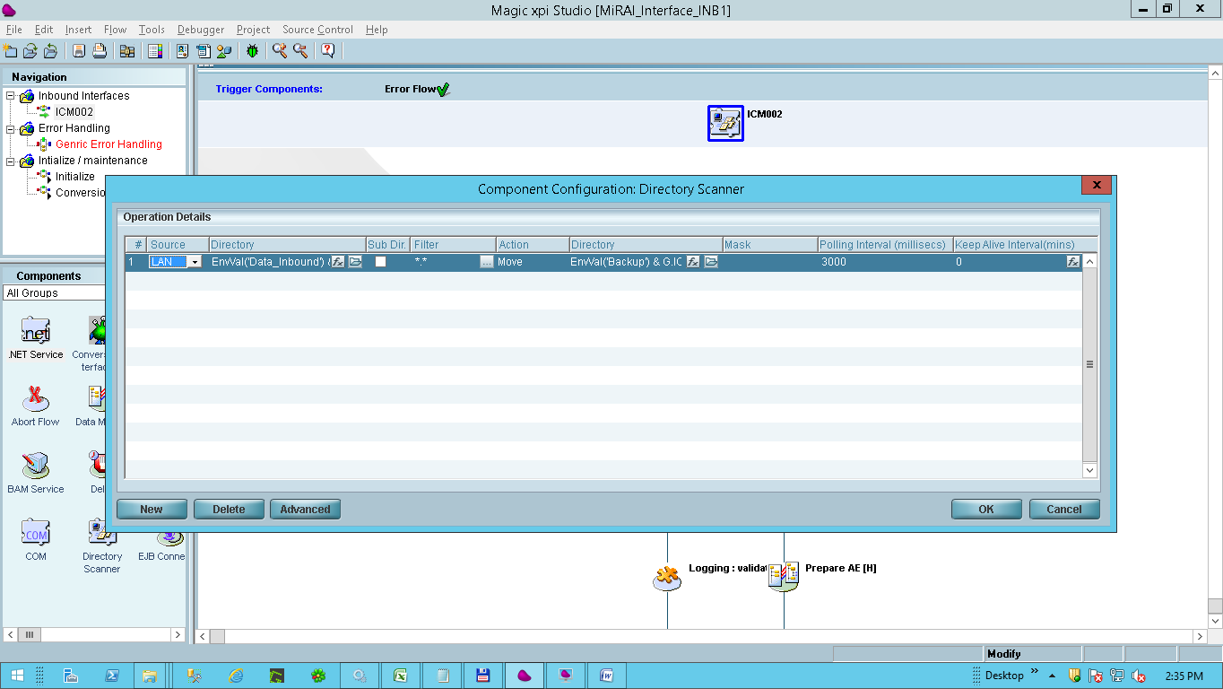

**Step 1** :- The ICM002 File is moved from Source to Destination

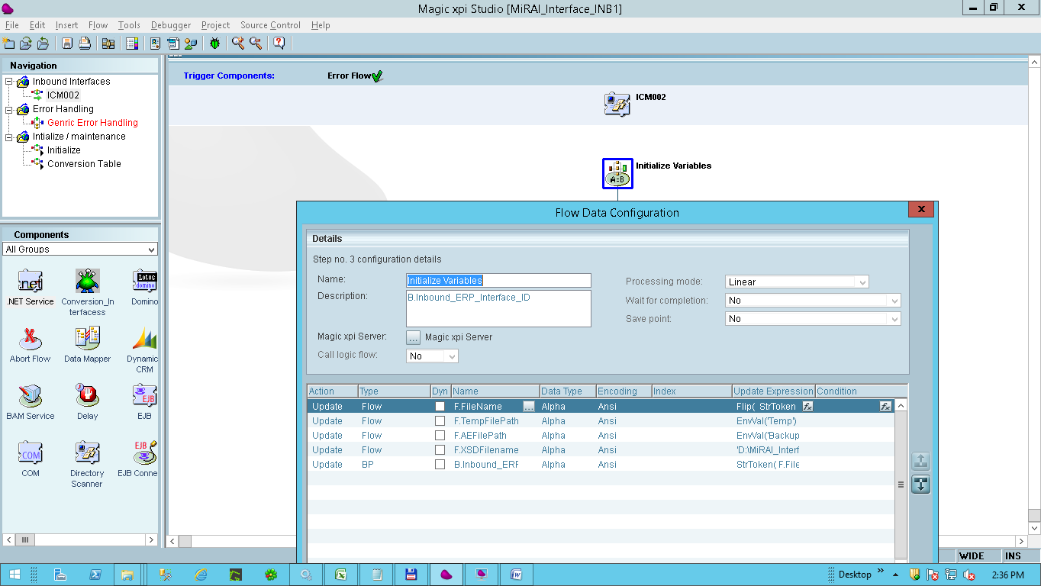

**Step 2** :- Required variables are initialized.

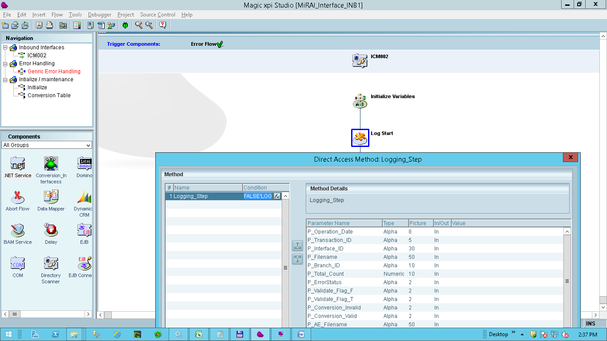

**Step 3 :** Logging initiated. Logging Component to be called from here .

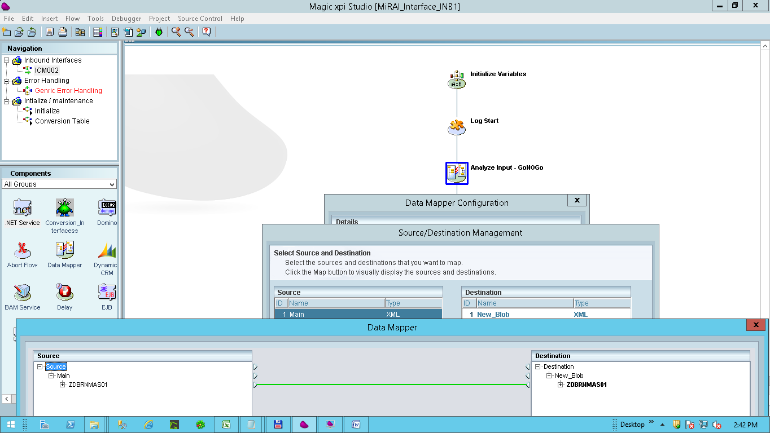

**Step 4 :** GoNOGo Stage : - Validate the XML and decide GONOGO.

IF GO

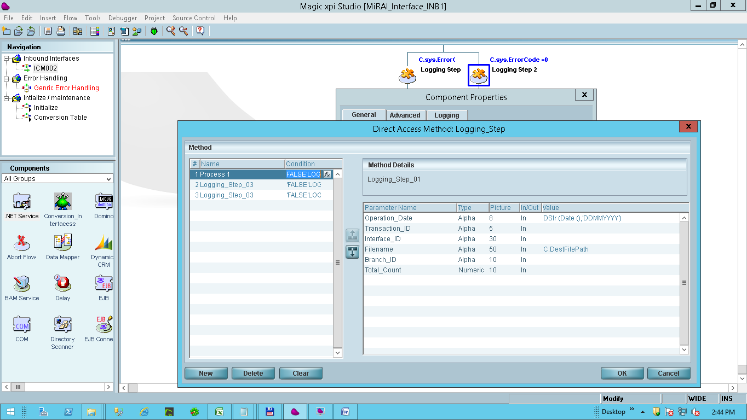

**Step 5 :**Loging using the Loging Component by MST

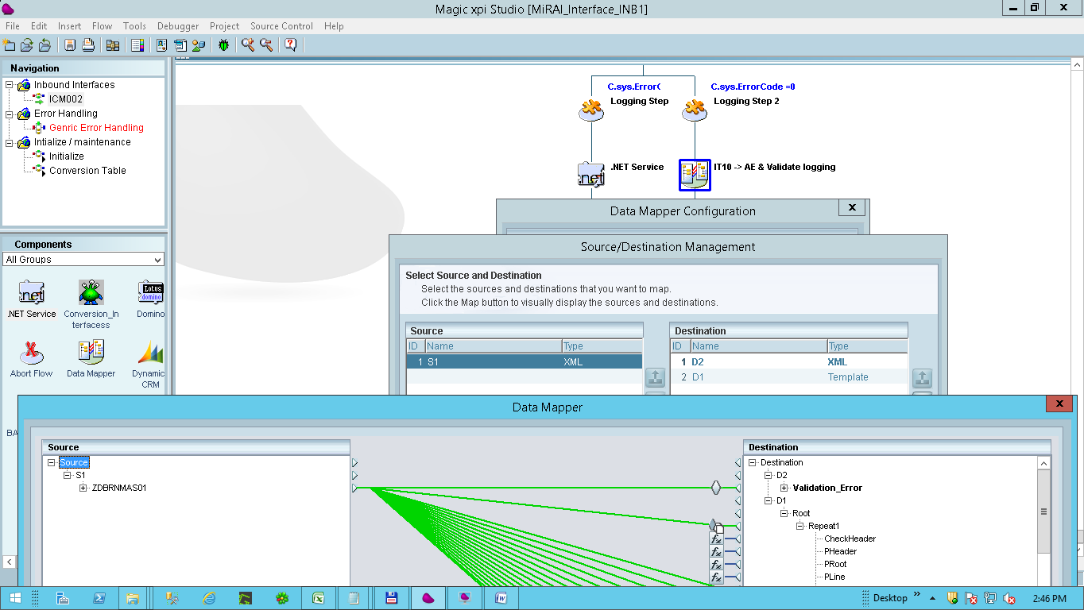

.

**Step 6 :**Validation in the conditions of Mapping ( Valdidation from Store porcedures incorporated here ) The AE file is written here in case of no Error. In case of error , Error Log written here. The AE file written here is in blob without the header line. The total number of records is retrieved in variable RunningSerialN in this mapper.

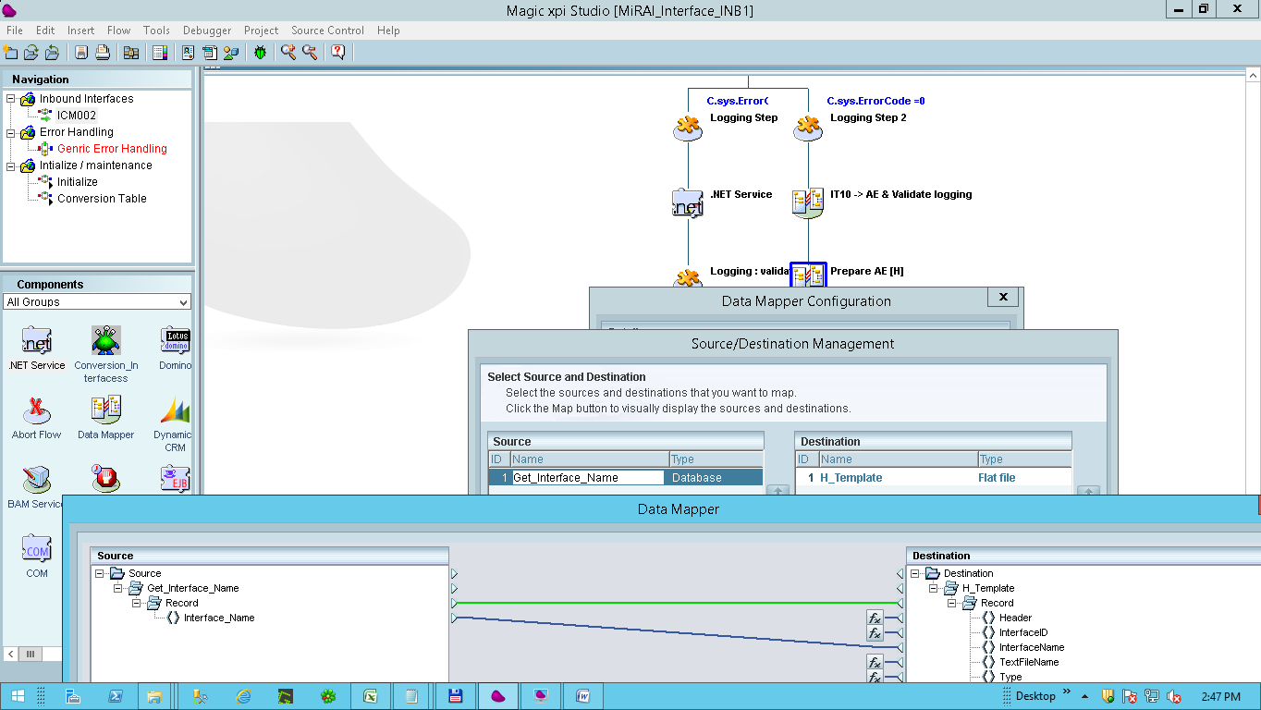

**Step 7 :** Create Header Line. The first line which of the file to be uploaded to AE. This line also contains total number of records in the file.

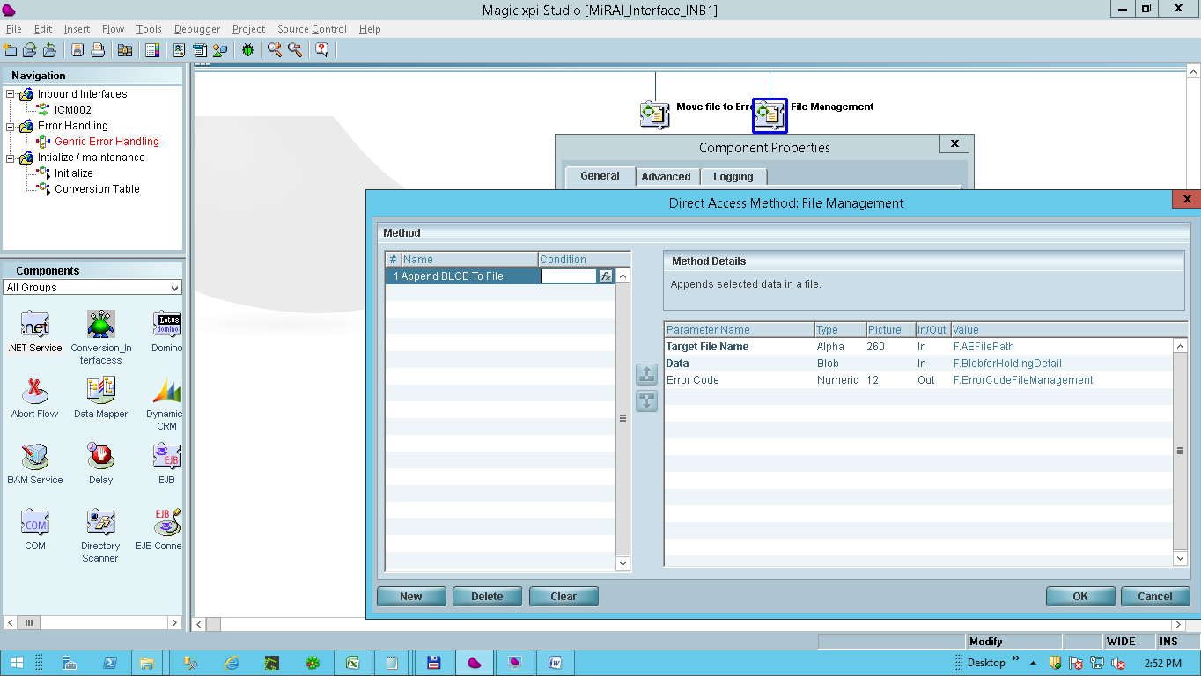

**Step 8 :** The Detail section of AE file created in Step 6 from the blob is merged into the header file created in Step 7

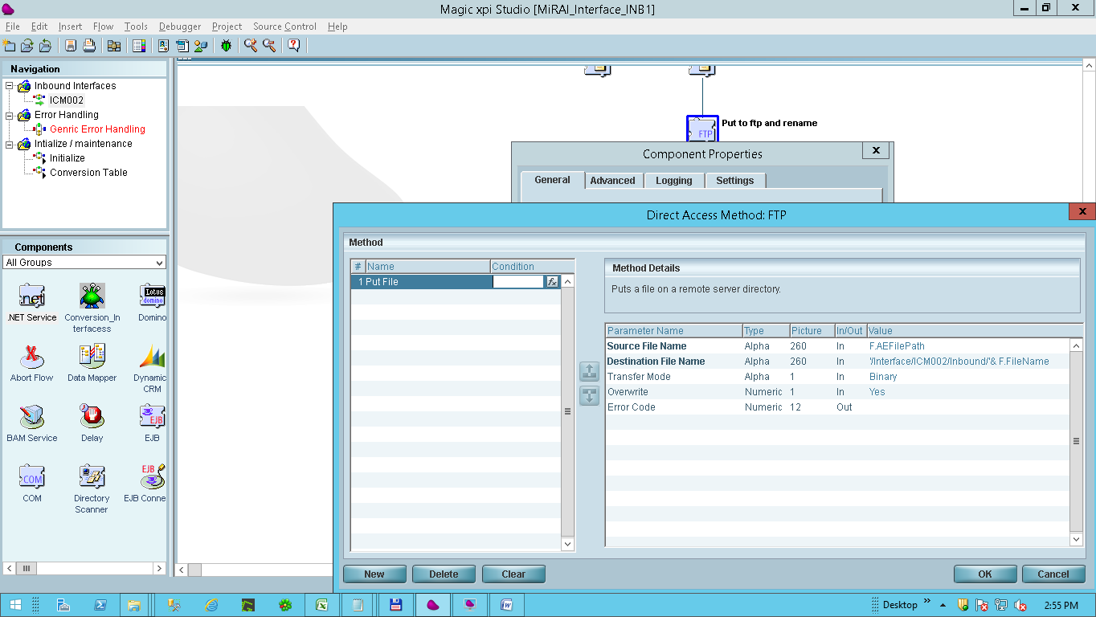

**Step 9 :** The file is put on ftp.

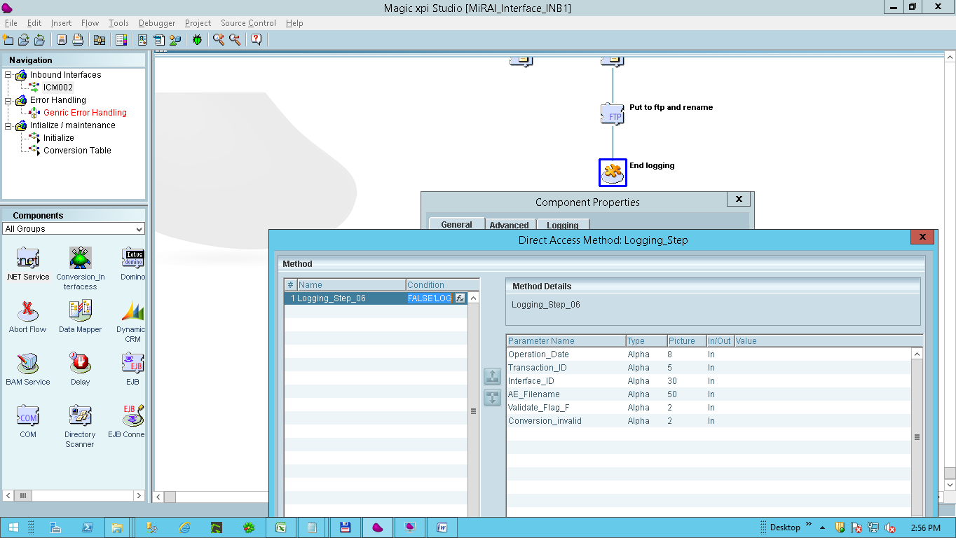

**Step 10 :** Logging by calling the Loging componet.