

ENERGY CONSUMPTION PREDICTION FOR SMART HOMES
Subject: Artifical Intelligence
Section: BSCS(B)
Instructor: Mam Aatka Ali
Submission Date: 26/12/2025
Group Members:
Roll.NO | Student Name:
233518 | Tooba Ghaffar
233520 | Komal Naz
233582 | Amna Sajjad
233550 | Ammar Yaqub

TABLE OF CONTENTS
Contents
1. Abstract 3
2. Introduction 3
3. Problem Statement 3
4. Objectives 4
5. Scope of the Project 4
6. Literature Review 4
7. Dataset Description 4
8. Methodology 4
9. System Architecture 5
10. Tools and Technologies 5
11. Implementation Details 5
12. Results and Discussion 5
13. Ethical Considerations 6
14. Limitations 6
15. Future Enhancements 6
16. Conclusion 6
17. References 6
Figures and Screenshots 7
Figure 1: Home Page / User Input Interface 7
Figure 2: User Input Form for Energy Parameters 9
Figure 3: Energy Consumption Prediction Result 12
Figure 4: Bar Chart – Predicted vs Target Energy 13
Figure 5: Pie Chart – Appliance-wise Energy Consumption 14
Figure 6: Dataset Structure View 15

ENERGY CONSUMPTION PREDICTION FOR SMART HOMES

1. Abstract
This project presents a Machine Learning–based web application for predicting electricity consumption in smart homes. The system allows users to manually input household conditions such as temperature, humidity, number of occupants, and detailed appliance usage information. Using these inputs, a trained regression model predicts the estimated monthly energy consumption. The application also visualizes the predicted and target energy values using graphs, helping users understand their energy usage behavior. This project demonstrates the practical application of Artificial Intelligence and Machine Learning for energy awareness and sustainable decision-making in smart home environments.

2. Introduction
Energy consumption in residential environments has increased due to the widespread use of electrical appliances and modern lifestyles. While smart meters provide usage data, users often lack tools to interpret this data effectively. Predictive systems can help households understand future energy usage and adopt energy-saving behaviors.
This project focuses on developing a web-based energy consumption prediction system using Machine Learning. Users provide appliance usage details through a web interface, and the system predicts energy consumption using a trained model. The application integrates data preprocessing, prediction, and visualization within a single platform.

3. Problem Statement
Despite the availability of energy data, most households do not have an intelligent system to estimate future electricity consumption based on their daily appliance usage. Energy consumption decisions are often made without predictive insight, resulting in higher electricity costs and inefficient usage. There is a need for a user-friendly system that can analyze appliance usage patterns and predict energy consumption using Machine Learning techniques.

4. Objectives
The main objectives of this project are:
- To predict household energy consumption using Machine Learning models
- To allow users to input appliance-level usage data through a web interface
- To visualize predicted and target energy values using graphs
- To promote awareness of efficient energy usage
- To demonstrate the integration of Machine Learning with a web application

5. Scope of the Project
The project is limited to predicting energy consumption based on user-provided inputs and historical dataset training. It does not include real-time IoT sensor integration. The system is developed for academic purposes and serves as a foundation for future enhancements such as real-time monitoring and mobile application deployment.

6. Literature Review
Previous research indicates that Machine Learning regression techniques are effective for energy consumption prediction. Models such as Linear Regression, Random Forest, and Support Vector Regression have been widely used for short-term forecasting. Unlike time-series–only approaches, regression models can incorporate appliance-level features, making them suitable for user-input-based prediction systems. These studies support the feasibility of predicting household energy consumption using structured appliance usage data.

7. Dataset Description
The dataset used in this project consists of energy-related attributes such as temperature, humidity, number of occupants, appliance usage duration, number of appliances, and total energy consumption. The dataset is either obtained from open-source platforms or generated through simulated appliance usage data. Data preprocessing steps include normalization using a standard scaler and feature alignment to match the trained model.
The dataset used in this project contains approximately 2,000 records.
Features:
- Temperature
- Humidity
- Number of Occupants
- Appliance Usage Duration
- Number of Appliances
Target Variable:
- Total Energy Consumption (kWh)
The dataset is sourced from open datasets and partially simulated data. Each feature is relevant as it directly affects household energy usage.

8. Methodology
The project follows these steps:
- Data Collection: Energy consumption dataset obtained from open-source or simulated sources.
- Data Preprocessing: Feature scaling and cleaning to prepare data for training.
- Model Training: A regression-based Machine Learning model is trained using Scikit-learn.
- User Input Handling: Users provide input values through a web form.
- Prediction: The trained model predicts energy consumption based on user input.
- Visualization: Bar and pie charts are generated to display prediction results.

9. System Architecture
The system architecture includes the following components:
- Web-based User Interface (Input Form)
- Data Processing and Feature Scaling Module
- Machine Learning Prediction Model
- Visualization Module (Graphs and Charts)
- Result Display Module
This modular architecture ensures clarity, scalability, and ease of maintenance.

10. Tools and Technologies
The tools and technologies used in this project are:
- Programming Language: Python
- Web Framework: Django
- Libraries: NumPy, Pandas, Scikit-learn, Matplotlib
- Database: SQLite (Django default)
- Development Platform: VS Code
- Dataset Source: Kaggle / Simulated Data

11. Implementation Details
The Machine Learning model is trained offline using Scikit-learn and saved as a serialized file (.pkl). A standard scaler is used to normalize input features. The Django web application loads the trained model and scaler to generate predictions based on user input. Visualization graphs are generated dynamically using Matplotlib and displayed on the result page.
Execution Steps:
1. Train and save the model
2. Run Django server
3. Input data and view predictions

12. Results and Discussion
The system successfully predicts energy consumption based on user-provided appliance usage data. The bar chart comparison between predicted and target energy values helps users evaluate their energy efficiency. Pie charts provide insight into appliance-wise energy contribution. The results demonstrate the effectiveness of Machine Learning models for energy usage prediction in smart homes.

13. Ethical Considerations
This project uses only open-source or simulated datasets and does not collect personal or sensitive user information. User inputs are used solely for prediction purposes and are not shared externally. The project complies with academic integrity and ethical guidelines.

14. Limitations
The accuracy of predictions depends on the quality and representativeness of the training dataset. Since the system relies on manual user input, inaccurate input values may affect prediction results. Real-world factors such as appliance power ratings and behavioral changes are simplified in the current model.

15. Future Enhancements
Possible future enhancements include:
- Integration with real-time IoT sensors
- Use of deep learning models for improved accuracy
- Automated energy-saving recommendations
- Mobile application development
- Continuous model retraining with new user data

16. Conclusion
This project demonstrates the successful integration of Machine Learning with a web-based application to predict smart home energy consumption. By allowing users to input appliance usage details and visualizing prediction results, the system enhances energy awareness and supports sustainable living. The project fulfills academic objectives and provides a strong foundation for future smart energy management systems.

17. References
- Kaggle Energy Consumption Datasets
- UCI Machine Learning Repository
- Scikit-learn Official Documentation
- Django Official Documentation
- Research articles on Machine Learning–based energy prediction

Figures and Screenshots

Figure 1: Home Page / User Input Interface
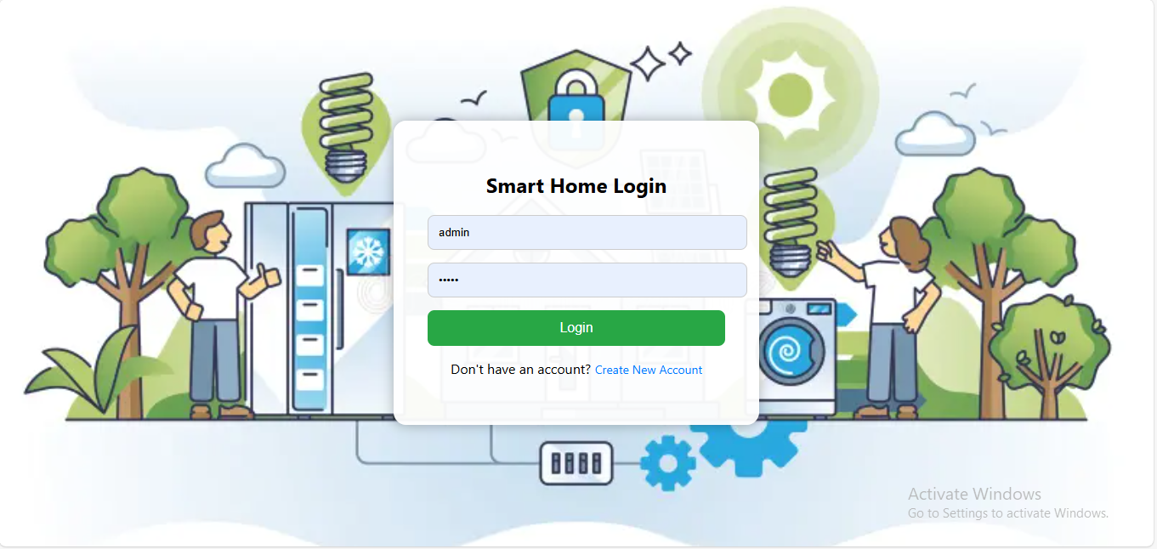
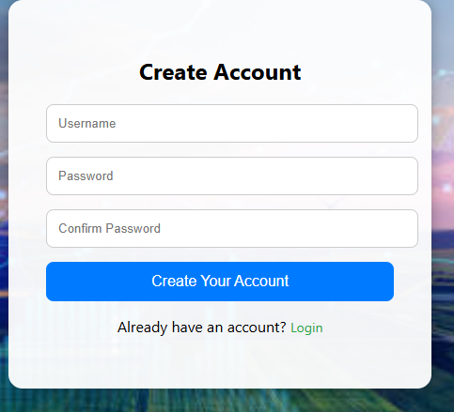

Figure 2: User Input Form for Energy Parameters
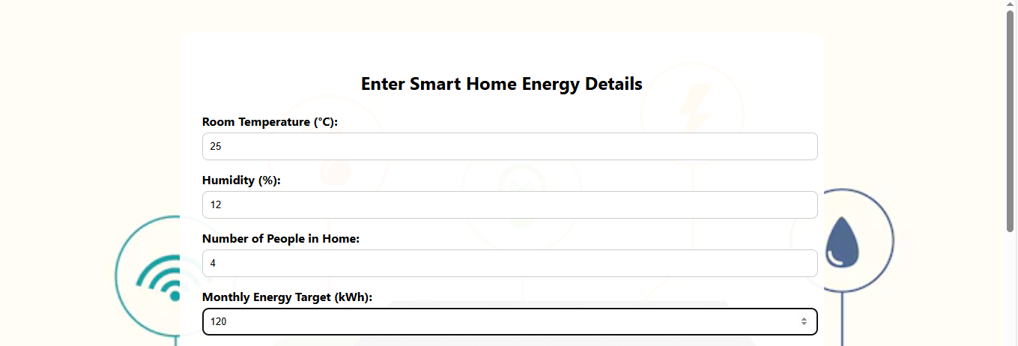
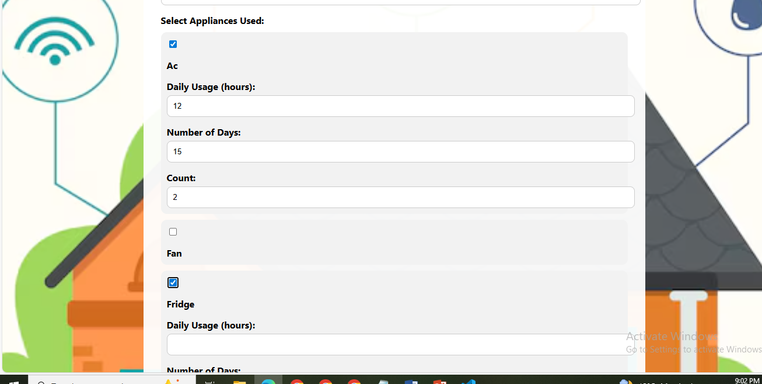

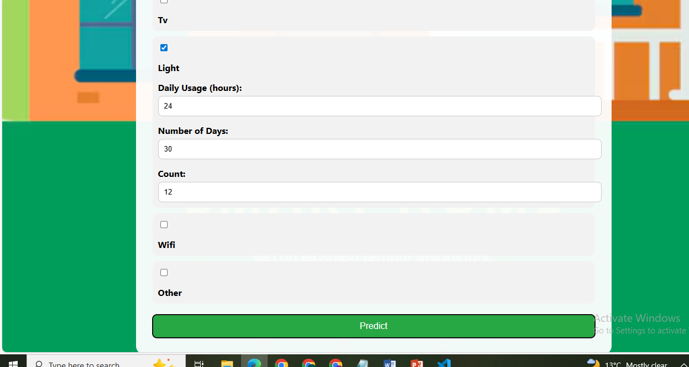
Figure 3: Energy Consumption Prediction Result
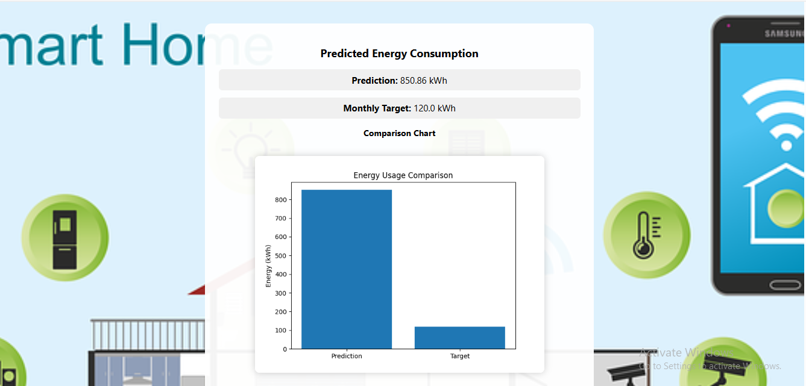

Figure 4: Bar Chart – Predicted vs Target Energy
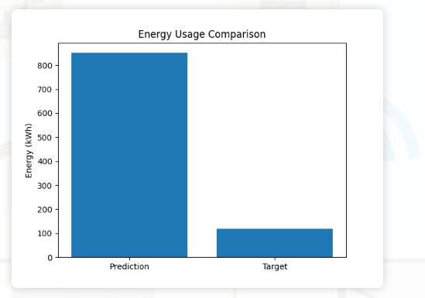
Figure 5: Pie Chart – Appliance-wise Energy Consumption
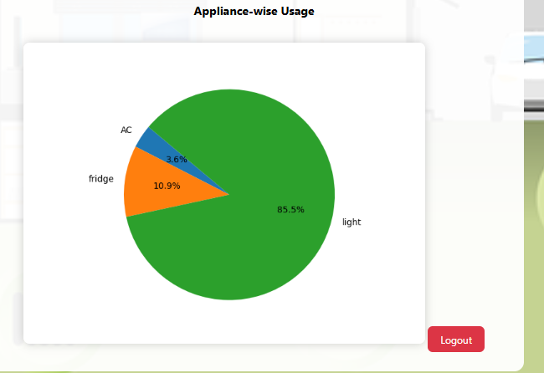

Figure 6: Dataset Structure View
