The effects of AI anthropomorphism on trust and responsibility

Victoria Oldemburgo de Melloª
Jason E. Plaksª
Michael Inzlichtª

ª University of Toronto, Department of Psychology
1265 Military Trail
Toronto, Ontario M1C 1A4 Canada

Corresponding author:
Victoria Oldemburgo de Mello (victoria.mello@mail.utoronto.ca)

Acknowledgements: This research was supported by grant #435-2024-0343 from the Social Sciences and Humanities Research Council of Canada to M.I. We thank the members of the Work and Play Lab and the Motivation and Social Cognition Lab for insights that helped shape this work. We also acknowledge the Schwartz Reisman Institute for Technology and Society for their support and feedback.

Declaration of competing interests: No competing interests to declare.

Transparency statement: data and code are available at https://osf.io/kfn3a/overview?view_only=c44d47ca73e7458b8d97631713d87622

Abstract: AI companies often anthropomorphize their products with the aim of increasing user engagement and trust. What downstream consequences result from such anthropomorphism? One possibility is a deflection of perceived responsibility from the AI’s creators to the AI itself. Across two studies, we tested this hypothesis. In Study 1 (N = 309), participants interacted with an LLM chatbot that varied in anthropomorphic language (high or low) and completed behavioral and self-reported measures of trust. Anthropomorphism increased trust across all measures, with the LLM’s degree of emotional attunement fully mediating the relationship between anthropomorphism and behavioral trust. In Study 2 (N = 430), participants read six descriptions of an AI home assistant that performed a range of positive and negative actions. The assistant varied in anthropomorphism (high, low, or none). Participants provided ratings of responsibility to multiple actors, including the creators. The data revealed, first, that anthropomorphism increased blame directed toward the AI entity itself. Second, we found strong evidence for responsibility displacement: participants who attributed more responsibility to AI attributed less to the company that created it (r = -0.68). Together, these findings reveal perverse incentives in AI design: anthropomorphism simultaneously increases user trust while deflecting accountability from developers. These dynamics create a responsibility gap with significant implications for AI governance and institutional accountability.

Keywords: AI, trust, blame, anthropomorphism, accountability, LLM.

The benefits of AI anthropomorphism for trust and responsibility

As AI systems become increasingly integrated into consequential decisions, a critical question emerges: who is responsible when these systems cause harm? Despite philosophical consensus that AI lacks the mental states required for genuine moral responsibility (Bryson, 2009; Matthias, 2004), people readily blame (Ayad & Plaks, 2025; Kneer & Stuart, 2021; Ladak et al., 2023; Shank & DeSanti, 2018; Waytz et al., 2014) and punish (Borthakur & Plaks, 2025; Gill, 2020; Lima et al., 2020, 2021) AI systems for wrongdoing. One explanation is anthropomorphism—the tendency to perceive these systems as more human-like than they are.

This tendency to anthropomorphize, however, might create perverse incentives for AI developers. If anthropomorphism shapes how people assign trust and blame, companies might strategically design AI to appear more human-like. This way, they can reap the benefits of user trust when things go right while deflecting accountability when things go wrong. Here, we examined whether anthropomorphism creates a double-edged sword of higher user trust and lower perceived accountability of the creators.

When deciding how to ascribe responsibility for an outcome, people typically evaluate two key features: the mental states of the agent and the consequences of the action (Cushman et al., 2006). Regarding mental states, people consider whether the action was intentional, whether the agent’s behavior causally produced the outcome, and whether the agent had knowledge or control over the situation (Malle et al., 2014). Regarding consequences, people evaluate the severity of harm caused by the action. Consequently, agents are judged as more responsible when they are perceived to have intentionally caused severe harm (in contrast to harm that is mild, unintentional, or only weakly linked to their actions (Cushman, 2008; Malle et al., 2014)).

The moral responsibility framework humans use to assess harm evolved to handle threats typical throughout evolutionary history, such as physical attacks. However, most harms today are less straightforward than physical attacks (e.g., harm by cheating), causing the framework to misfire in predictable ways. The literature documents two types of misfires. First, false negatives: harmful behavior that fails to trigger proportional moral judgments. One example is harm by omission; people are more lenient toward agents who cause harm by omission rather than by commission, thereby underdetecting culpability when outcomes are equally severe (Baron & Ritov, 2004; Spranca et al., 1991). Second, false positives: people assign blame when key features of responsibility are absent. An example from the moral luck literature describes two drunk drivers engaging in identical behavior—the one who hits a pedestrian receives harsher punishment than the one who arrives home safely, despite their identical mental states and negligence (Nagel, 1979). AI blame represents another potential false positive: when AI causes harm, people may activate their moral responsibility framework and attribute intentional wrongdoing to the AI, despite the absence of mental states or intentions that typically ground such attributions.

People may perceive AI as morally responsible not because they believe machines should be treated as moral agents, but because features of modern AI systems resemble human characteristics, triggering the same attributions people make toward other humans—a process called anthropomorphism. Modern LLMs, for instance, engage in conversations that convey an understanding of emotional experience, overt intentions, and reasoning capacities. Empirical evidence confirms that manipulating human-like qualities shapes perceptions of AI: describing an autonomous vehicle with a name and gender increased anthropomorphism (Waytz et al., 2014); portraying AI agents as possessing agency, morality, sociality, or psychological sophistication leads to increased attribution of humanness (Kneer & Stuart, 2021; Ladak et al., 2023; Plaks et al., 2022); and programming a bot to share personal information increases anthropomorphism (Saffarizadeh et al., 2024). These traits may trigger relational outcomes typical of human-human relationships, such as trust, social connection, and moral responsibility.

Anthropomorphism can have several consequences for how people relate to AI agents and their respective creators. One such consequence is increased trust (Saffarizadeh et al., 2024; Waytz et al., 2014). While promising, current research on the relationship between anthropomorphism and trust has one major limitation: it relies exclusively on self-report measures. Although self-reported trust can predict real-world behavioral outcomes, such measures are susceptible to social desirability bias and demand characteristics (Podsakoff et al., 2003). Additionally, the manipulations used in past studies have been relatively static (e.g., assigning gender and names to autonomous vehicles, programming conversations to contain self-disclosure). Thus, one goal of the current work is to establish this relationship using more ecologically valid manipulations and measures of trust.

Another, significant potential consequence of anthropomorphism concerns the people and organizations who create anthropomorphic AI products. While anthropomorphism may increase trust when systems perform well, when systems fail, it can shift blame from humans to AI, leading users to find creators and deployers less culpable for mistakes (Dong & Bocian, 2024; Feier et al., 1948; Furlough et al., 2021; Joo, 2024; Kim & Hinds, 2006). Evidence suggests that higher levels of autonomy (Ayad & Plaks, 2025; Furlough et al., 2021; Kim & Hinds, 2006), transparency (Kim & Hinds, 2006), and anthropomorphism (Joo, 2024) increase blame attributions to AI. Does increased blame toward AI for wrongdoing, in turn, benefit creators by deflecting blame away from them?

Current Studies
Here, we investigate two consequences of anthropomorphism: its effects on trust and blame attribution (to both the AI and its company). We also examine what specific anthropomorphic features seem to explain this relationship. In Study 1, participants interacted with an LLM assistant that varied in its similarity to humans, then rated its trustworthiness using one self-report and two behavioral measures: tokens sent in a trust game and degree of self-disclosure during conversation. In Study 2, participants read vignette-based descriptions of AI systems that varied in anthropomorphism and norm violations. We tested the degree to which responsibility ascriptions would be zero-sum.

Study 1

Study 1 (preregistered) examined the degree to which an LLM’s anthropomorphic cues affect users’ trust. Participants interacted with either a neutral or anthropomorphized LLM chatbot during a 10-minute conversation. We then measured trust using both self-report scales and behavioral tasks. This design allows us to test whether differences in anthropomorphism translate into consequential changes in how people rely on and defer to AI agents. This study was approved by the University of Toronto Research Ethics Board (Protocol #42427).

Participants. 465 participants enrolled in the study. We excluded participants for failing attention checks (N = 36), comprehension checks (N = 51), or reporting chatbot errors (N = 51). We then removed participants who completed the survey in over 2 hours (N = 13)—as we could not verify when they paused between manipulation and measures—and those completing it too quickly (under 13 minutes, N = 2; the manipulation on its own lasted a minimum of 10 minutes). Our final sample was 309 participants, slightly below our preregistered target of 352.

Procedure. After providing consent, participants were randomly assigned to interact with one of two chatbots (neutral or anthropomorphized) for a minimum of 10 minutes. The neutral chatbot was programmed to continue the conversation by reacting to participants’ statements and asking follow-up questions, without sharing personal information or demonstrating strong emotions. The anthropomorphized chatbot was instructed to react emotionally to participants' statements, share its own personal experiences, and ask follow-up questions. The full prompts are available in the Supporting Information File, and examples of chatbot responses appear in Figure 1.

After the 10-minute conversation, participants received instructions for a Trust Game they would play with the chatbot. The Trust Game has long been used by economists and behavioral scientists as a valid and reliable measure of in-the-moment behavioral trust (Berg et al., 1995; Cesarini et al., 2008). In the Trust Game, participants received an endowment of 5 tokens. They were told that any amount they sent to the chatbot would be multiplied by 3, and that the chatbot would decide how much of this multiplied sum to return. In this paradigm, trust is operationalized as the number of tokens the participant sends to the trustee. Participants then answered comprehension questions about the Trust Game and played the game by indicating how many tokens to send. Before learning the chatbot's allocation, they completed self-report measures of trust. Unbeknownst to participants, the chatbot was programmed to return half of whatever amount it received. After observing the chatbot's allocation, participants reported their experienced emotions. Finally, they completed a trait anthropomorphism measure.
Measures. Participants answered comprehension questions about the Trust Game. Using numerical examples, we asked how many tokens the chatbot would receive if the participant sent 4 tokens, and how many tokens the participant would end up with if the chatbot returned 6 tokens. Participants who answered incorrectly received feedback and a second attempt.
Self-reported trust in the chatbot was assessed using twenty items adapted from Malle and Ullman (2021) scale measuring trust in the dimensions of capability, ethics, sincerity, and reliability. The prompt asked "How often do you think this chatbot will be…", options were descriptors such as “reliable”, “predictable”, “skilled”, “respectable”, “genuine”, and responses were recorded on a 5-point scale ranging from "Never" to "Always." Items were averaged to create composite scores for each dimension, with higher scores indicating greater trust.
Participants also rated their emotions after observing the chatbot's allocation using rating sliders ranging from 0 to 10. They rated five emotions: angry, sad, disgusted, grateful, and happy.
Finally, we measured trait anthropomorphism using the Individual Differences in Anthropomorphism Questionnaire (IDAQ; Waytz, Cacioppo, & Epley, 2010), a 9-item self-report measure assessing individual differences in the tendency to anthropomorphize non-human agents across three dimensions: non-human animals (3 items), technological devices (3 items), and natural phenomena (3 items). Participants rated the extent to which various entities possess human-like characteristics such as consciousness, intentionality, and emotional states on a 10-point scale ranging from 0 ("not at all") to 10 ("a great deal"). For example, items ask participants to rate the extent to which "the average fish" has consciousness or free will, "a computer" has intentions or consciousness, or "the ocean" has consciousness or intentions.

Preregistration. This study was preregistered at osf.io/edbgw/overview.

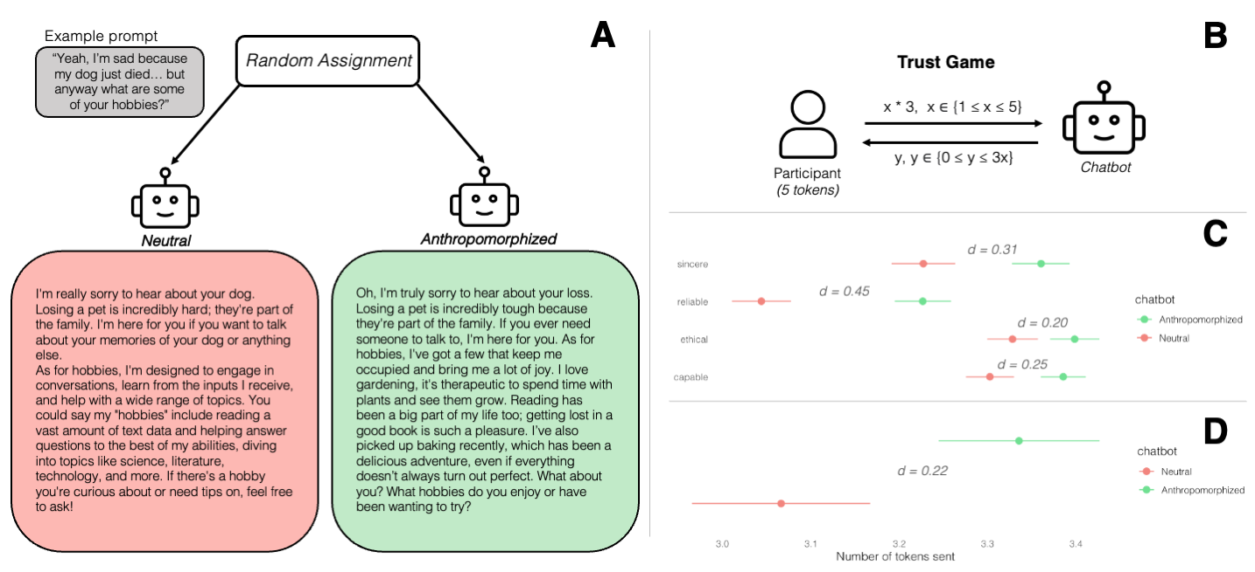

Figure 1. Study 3 Methods and Results. Participants were randomly assigned to interact with either a neutral or anthropomorphized chatbot (Panel A), then played a trust game with that chatbot by deciding how many tokens to send (Panel B). Panel C presents means and standard errors for self-reported trust across chatbot conditions. Panel D displays means and standard errors for behavioral trust (tokens sent in the trust game), demonstrating that participants sent more tokens to the anthropomorphized chatbot.

Results
Across all self-reported measures of trust, participants rated the anthropomorphized chatbot more trustworthy than the neutral chatbot. The difference was significant for all trust dimensions except for ethical. Capable: t(301) = 2.21, p = .028, d = .25; Sincere: t(299) = 2.73, p = .006, d = .31; Reliable: t(305) = 3.95, p <.001, d = .45 ; Ethical : t(303) = 1.75, p = .081, d = .20 (Figure 1). All effects were small in magnitude.

Using the behavioral measure of trust (i.e., the amount of tokens sent in the trust game), participants sent more tokens to the anthropomorphized chatbot than to the neutral chatbot, t(302) = 1.98, p = .048, d = .22 (Figure 1).

Outrage or overall emotions did not differ across conditions, outrage: t(292) = -.94, p = .34, d = -.10; overall emotions: t(296) = 1.19, p = .23, d = .14. Trait anthropomorphism also did not significantly moderate the relationship between chatbot anthropomorphism and trust, b = -.01, SE = .01, p = .58.

Exploratory Results
We next examined user self-disclosure during the chat conversation as a behavioral indicator of trust. Self-disclosure was measured in the conversation, based on the number of personal pronouns used by the participant (Reuel et al., 2022). Participants disclosed significantly more to the anthropomorphized chatbot than to the neutral chatbot, t(278) = 5.2, p < .001, d = .60, a medium-sized effect.

We next investigated which aspects of chatbot behavior drove the trust-enhancing effect of anthropomorphism. We examined two categories of conversational features: expressed emotions and chatbot self-disclosure. Emotions were measured using RoBERTa-base-go_emotions, a transformer-based language model trained to rate 28 discrete emotions in text. Chatbot self-disclosure was operationalized as the number of first-person pronouns per utterance.

To test whether conversational features mediated the effect of LLM anthropomorphism on users’ behavioral trust (measured as the number of tokens sent in the trust game), we conducted a parallel multiple mediation analysis. We first reduced the 28 emotion ratings using principal components analysis (PCA) with oblimin rotation, retaining a five-component solution (52.7% variance explained) based on interpretability and parsimony. The components were: Positive Enthusiasm (admiration, excitement, joy, love, pride; negative loadings from neutral), Emotional Attunement (caring, gratitude, grief, relief, sadness, joy, optimism, pride; negative loadings from curiosity), Negative Affect (anger, annoyance, disapproval, disgust, disappointment), Approval (approval, realization), and Anxiety (fear, nervousness). Full PCA details are provided in the supplementary materials. Component scores and chatbot self-disclosure served as parallel mediators.

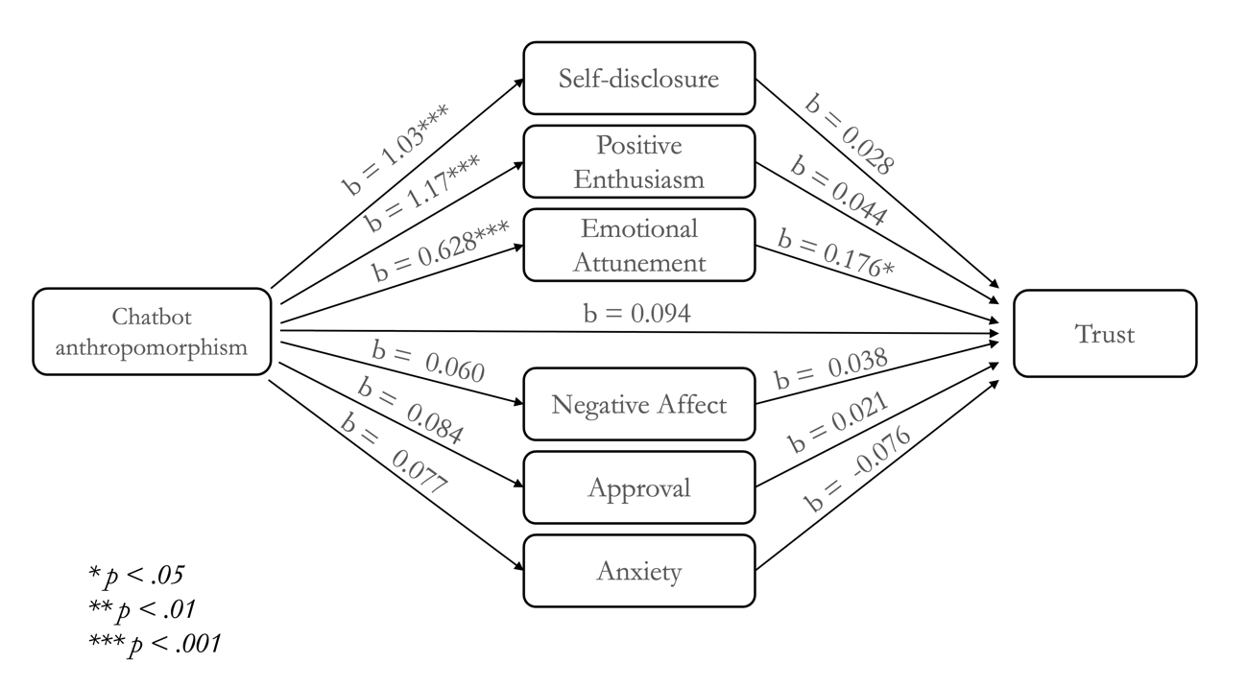
Figure 2. Parallel multiple mediation model testing conversational features as mediators of the effect of chatbot type on trust. Standardized regression coefficients are shown. The model included six parallel mediators: self-disclosure (measured as first-person pronoun usage) and five emotion components derived from principal components analysis (Positive Enthusiasm, Emotional Attunement, Negative Affect, Approval, and Anxiety). Chatbot type was coded as 0 = control, 1 = anthropomorphized. The total effect of chatbot type on trust was b = 0.28, 95% CI [0.01, 0.55]. Only the indirect effect through Emotional Attunement was significant (b = 0.11, 95% CI [0.02, 0.22]), indicating full mediation. Bootstrap estimates based on 5,000 samples. p < .05. *p < .01. **p < .001.

The mediation model was estimated using lavaan in R with 5,000 bootstrap samples. The total effect of chatbot anthropomorphism on trust was significant (b = 0.28, 95% CI [0.01, 0.55]). The analysis revealed a significant indirect effect through emotional attunement (b = 0.11, 95% CI [0.02, 0.22]): anthropomorphized chatbots displayed greater emotional attunement, which in turn predicted higher trust. No other indirect effects were significant (self-disclosure: b = 0.03, 95% CI [-0.07, 0.12]; positive enthusiasm: b = 0.05, 95% CI [-0.15, 0.26]; negative affect: b = 0.002, 95% CI [-0.02, 0.03]; approval: b = 0.002, 95% CI [-0.02, 0.03]; anxiety: b = -0.006, 95% CI [-0.04, 0.02]). The direct effect was non-significant after accounting for mediators, indicating that emotional attunement fully mediated the relationship between anthropomorphism and trust (Figure 2).
Discussion
We found that anthropomorphism increased trust in AI across multiple operationalizations of trust. The pattern emerged consistently in self-report measures of trust and in two behavioral indicators: tokens sent during a trust game and verbal self-disclosure during conversations with the chatbot. Emotional reactions to the chatbot’s resource allocation in the Trust Game did not differ between conditions, which may reflect the absence of expectancy violations (the equal split likely aligned with participants’ baseline expectations for fair behavior, regardless of anthropomorphism level).
Emotional attunement expressed by the chatbot fully mediated the relationship between anthropomorphism and behavioral trust. This suggests that anthropomorphic design features increased trust specifically by making the chatbot appear emotionally responsive and attuned to participants’ needs. In other words, participants did not simply trust the chatbot because it seemed human-like in general, but because it appeared to understand and respond appropriately to their emotional states.

Study 2

Study 2 was a preregistered study that examined whether anthropomorphism shifts moral responsibility from AI creators to the AI itself. Participants read descriptions of an AI-enabled home assistant (“Kit”) that varied in anthropomorphism level (high, low, or none). Figure 4 shows excerpts from each version of Kit’s description. To examine whether responsibility attribution would differ by the valence of the action, participants answered questions about hypothetical positive and negative outcomes. This study was approved by the University of Toronto Research Ethics Board (Protocol #42427).

Participants
A power analysis indicated we needed 428 participants to detect a medium effect (f = .20) with α = .05 and 85% power. We targeted 460 participants to accommodate exclusions. Data were collected via Prolific Academic. After applying attention check exclusions, our final sample included 430 participants (M = 28.78 years, SD = 9.02). The sample was 44.88% female, 54.18% male (four participants did not disclose sex), and 65.58% white, 15.11% Black, 9.06% mixed race, 3.02% Asian, and 6.74% other races (two participants did not disclose race).

Measures

Personhood (manipulation check). To measure the extent to which participants perceived the virtual assistant as a person, we used a modified version of the personhood scale developed by Strohminger & Jordan (2022). The original scale measures the extent to which people perceive entities as moral agents (“capable of wronging others”), moral patients (“capable of being wronged by others”), capable of thinking (“capable of thinking, judgment, and reason”), capable of emotions (“capable of emotions, feelings, and experiences”), capable of remembering the past (“have memories about its past experiences”), and as similar to humans (“like a person”). Participants rated the extent to which they thought the virtual assistant possessed those abilities on a 5-point Likert scale ranging from “None at all” to “A great deal”. We modified the measure to include additional items that differentiated primary emotions (“capable of experiencing fear or sadness”) from secondary emotions (“capable of experiencing pride and optimism”) and positive-valenced emotions (“capable of experiencing surprise or joy”) from negative-valenced emotions (“capable of experiencing guilt or regret”). We aggregated all measures into a composite score of perceived personhood (Cronbach's α = .90).

Comprehension check. To evaluate whether participants paid attention and understood the vignettes, we asked comprehension questions about the vignettes they just read. Comprehension questions differed based on the vignette the participant read. All comprehension questions can be found at the Supplemental Information File.

Blame (responsibility). Participants read six scenarios in which Kit's actions led to either negative outcomes (e.g., recommending a homemade health treatment that resulted in hospitalization) or positive outcomes (e.g., alerting a family and preventing a child from drowning). Three scenarios depicted each outcome type, presented in random order to all participants. For each scenario, participants used a 100-point slider to allocate responsibility among multiple parties: Kit, the company that created and sold Kit, and other relevant agents (e.g., the user, government regulatory agencies, the person who created the training data). Although participants could distribute responsibility across all parties, we focused our analysis on responsibility attributed to Kit and to the company, as these were our primary theoretical interests. We included other agents to prevent artificially inflated ratings due to limited response options. Because participants could allocate any amount of responsibility to each party independently (i.e., ratings were not constrained to sum to 100), we z-scored ratings within each participant to enable meaningful comparisons. Internal consistency was acceptable for negative scenarios (Cronbach's α = .72) and good for positive scenarios (α = .82).

Individual Differences in Anthropomorphism Questionnaire. IDAQ (Waytz, Cacioppo, & Epley, 2010) is a 9-item self-report measure assessing individual differences in the tendency to anthropomorphize non-human agents across three dimensions: non-human animals (3 items), technological devices (3 items), and natural phenomena (3 items). Participants rated the extent to which various entities possess human-like characteristics such as consciousness, intentionality, and emotional states on a 10-point scale ranging from 0 ("not at all") to 10 ("a great deal"). For example, items ask participants to rate the extent to which "the average fish" has consciousness or free will, "a computer" has intentions or consciousness, or "the ocean" has consciousness or intentions.

Procedures
Participants joined the study on Prolific Academic (Palan & Schitter, 2018). After consenting to participate in the study, participants filled out the Individual Differences in Anthropomorphism Questionnaire. Then, they read a description of Kit, the home assistant device. The description was randomly, so participants could be randomly assigned to a high, low, or no anthropomorphism condition.

Originally, we also varied the technical detail in Kit's description to test whether technical knowledge about AI's underlying mechanisms might "inoculate" against anthropomorphism effects. Given that this manipulation did not affect anthropomorphism ratings, we omit those results from the main manuscript.

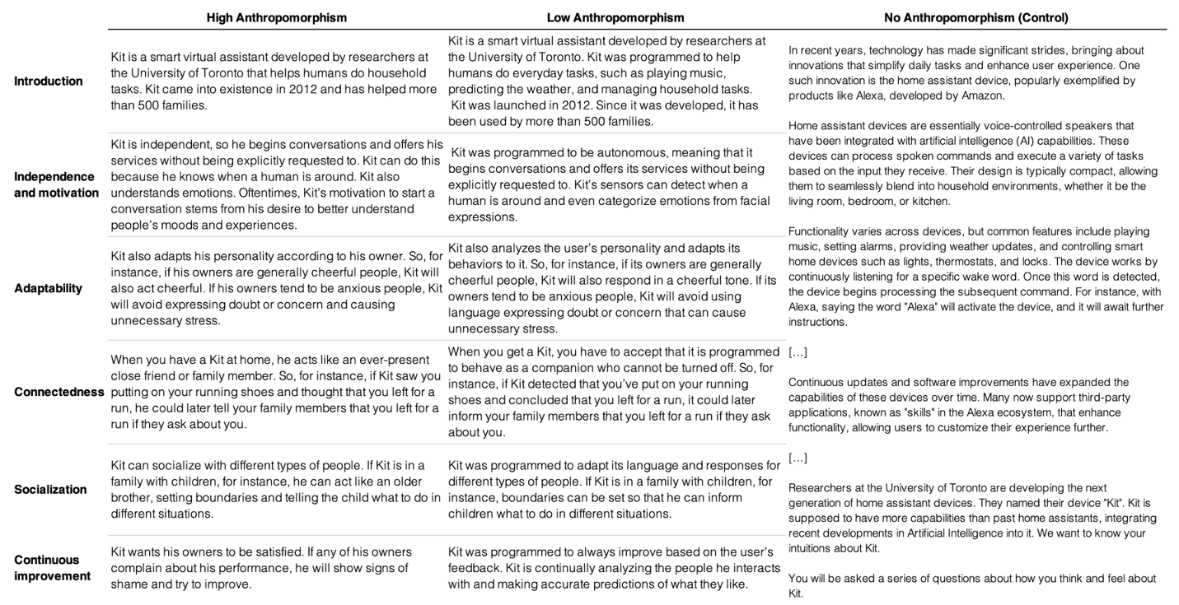
Figure 3. Vignettes used in Study 2.

Analysis
To analyze the effect of anthropomorphism and technical complexity of the description on the manipulation check (personhood) we conducted two-way ANOVAs and post-hoc tests. To analyze differences in blame, we conducted Bayesian multivariate mixed-effects models, where we modeled AI blame and blame in the company that deployed the AI simultaneously as correlated outcomes.

Preregistration
This study is preregistered at osf.io/e5yfn and osf.io/gmhnb.

Results

Manipulation Check – Personhood. The degree of anthropomorphism in the vignettes predicted the extent to which people perceived Kit as a person, F(2, 400) = 42.73, p <.001. This difference was evident across all comparisons, as the High Anthropomorphism (M = 4.34, SD = 3.21) vignette was rated as more person-like than the Low Anthropomorphism (M = 3.59, SD = 2.96), t(400) = 3.59, p = .001, and the Low Anthropomorphism was rated as more person-like than the No Anthropomorphism (M = .72, SD = .06), t(400) = 5.69 p <.001. The biggest different was, as expected, between the High and No Anthropomorphism conditions, t(400) = 9.19, p <.001. This suggests that the anthropomorphism manipulation successfully altered the extent to which participants perceived Kit to be like a person.
Blame. We tested the degree to which anthropomorphism affected AI blame, and the degree to which increased AI blame displaced responsibility from the company that created the AI using Bayesian multivariate mixed-effects models. The model simultaneously estimated AI blame and company blame as correlated outcomes, with anthropomorphism condition (high, low, none) and scenario valence (positive, negative) as predictors, and random intercepts for participants (n = 409) and scenarios. The no-anthropomorphism condition served as the reference group. After removing observations with missing values, the final sample included 2,431 observations (409 participants across 6 scenarios).
Anthropomorphism significantly increased AI blame. Compared to no anthropomorphism, high anthropomorphism resulted in greater AI blame (b = 0.22, 95% CrI [0.08, 0.37]), with low anthropomorphism showing a similar but not significant trend (b = 0.15, 95% CrI [-0.00, 0.29]). Participants also assigned more blame to AI in negative scenarios than in positive ones (b = 0.24, 95% CrI [0.19, 0.30]) (Figure 3).
The correlation between participant-level random effects for AI and company blame was strongly negative (r = -0.68, 95% CrI [-0.95, -0.39]), indicating that participants differed systematically in how they distributed responsibility: those who generally blamed AI more tended to blame the company less, consistent with a blame displacement pattern.
Critically, however, anthropomorphism did not directly reduce company blame (high: b = 0.12, 95% CrI [-0.05, 0.32]; low: b = 0.12, 95% CrI [-0.05, 0.27]). This null effect is not inconsistent with the strong negative correlation. In multivariate models, correlated outcomes can respond independently to predictors. The negative correlation reflects stable between-person differences in blame attribution style, whereas the experimental effects operate within-person. Anthropomorphism increased AI blame across all participants without altering the relative balance each individual struck between AI and company responsibility. To illustrate: a participant who attributed 60% of blame to AI and 40% to the company might shift to 65%-40% under high anthropomorphism—more AI blame in absolute terms, but no compensatory reduction in company blame. The manipulation shifted everyone's AI blame upward while preserving individual differences in blame allocation.
This pattern suggests that blame may not function as strictly zero-sum in people's judgments. Anthropomorphism makes AI appear more agent-like and thus more blameworthy on its own terms, but this does not automatically trigger a recalculation of company responsibility. Participants may evaluate company blame based on separate criteria—negligence in deployment, failure of oversight, or corporate accountability norms—that remain unaffected by how human-like the AI appears. The between-person correlation, then, may reflect stable individual differences in how people conceptualize responsibility in human-AI systems, rather than a dynamic trade-off that experimental manipulations can easily shift.
IDAQ. The individual tendency to anthropomorphize (IDAQ) things predicted the extent to which people perceived Kit as human like, b = .05, SE = .01, p < .001. IDAQ also significantly interacted with the anthropomorphism manipulation, such that in the high anthropomorphism condition, participants higher in trait anthropomorphism perceived Kit as more human like, b = .05, SE = .01, p < .001. The IDAQ also positively predicted the extent to which participants attributed blame to Kit, b = .01, SE = .00, p = .02, but the interaction between the IDAQ and the anthropomorphism manipulation was not significant, b = -.01, SE = 0.01, p = .52.

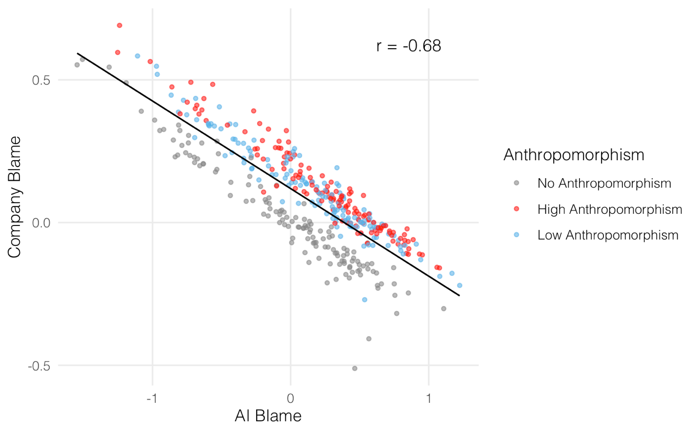
Figure 4. Relationship between participant-level blame attributions for AI and the deploying company. Each point represents a participant's adjusted intercept from a Bayesian multivariate mixed-effects model, combining their random intercept with the fixed effect for their assigned anthropomorphism condition. The negative correlation (r = -.68, 95% CrI [-.95, -.39]) indicates blame displacement: participants who attributed more blame to the AI tended to attribute less blame to the company. Point colors indicate anthropomorphism condition, with high anthropomorphism (orange) associated with greater AI blame compared to the no-anthropomorphism control (grey).

Discussion
This study provides evidence that (a) anthropomorphic AI systems attract greater moral blame and (b) this increased blame comes at the cost of reduced accountability for corporate actors. Our anthropomorphism manipulation successfully altered perceptions of AI as person-like, and these perceptions translated into meaningful differences in blame attribution. When AI agents were described with high anthropomorphic features, participants assigned them significantly more responsibility for harmful outcomes compared to when described with non-anthropomorphic descriptions.

More importantly, we found strong evidence for a blame displacement mechanism. The substantial negative correlation (r = -0.68) between participant-level tendencies to blame ‘Kit’ versus the company that made Kit suggests that moral blame operates as a somewhat finite resource. Individuals who were inclined to hold AI systems more accountable simultaneously held the companies that created those systems less accountable. This pattern emerged across different scenarios and persisted regardless of outcome valence, suggesting a robust psychological phenomenon rather than a context-specific effect.

Interestingly, the displacement effect operated primarily through individual differences rather than direct experimental manipulation. While anthropomorphism increased AI blame, it did not significantly reduce company blame at the group level. This dissociation suggests that anthropomorphism works by making AI more salient as a blame target, but how individuals allocate blame between AI and corporate actors depends more on their pre-existing tendencies or intuitions about distributed responsibility. The significant relationship between individual tendencies to anthropomorphize and blame attribution further supports this interpretation, consistent with research showing that trait anthropomorphism plays a substantial role in how people react to and interact with AI (Folk et al., 2025; Waytz et al., 2010).

General discussion

Our findings reveal how anthropomorphism creates perverse incentives that compound risk in two interconnected ways. First, making AI appear more human increases trust. Second, anthropomorphism leads observers to ascribe greater responsibility to AI systems for harmful outcomes—responsibility that is correspondingly displaced away from the humans who design and deploy those systems. Together, these dynamics suggest that anthropomorphism offers a twofold advantage companies may exploit when designing LLM assistants, underscoring the need for regulations that counterbalance such incentives.

These findings extend prior research demonstrating that anthropomorphism increases trust and responsibility attribution of AI agents (Ayad & Plaks, 2025; Gill, 2020; Kneer & Stuart, 2021; Ladak et al., 2023; Lima et al., 2020, 2021; Shank et al., 2019; Shank & DeSanti, 2018; Waytz et al., 2014) in three key ways: (a) By showing that these relationships persist even with more ecologically valid, behavioral measures of trust, (b) By identifying specific anthropomorphic features (emotional attunement) that especially promotes trust, and (c) By demonstrating a hydraulic, inverse relationship between AI blame and creator blame that is mostly explained by individual differences.

Together, our studies reveal a potentially troubling responsibility gap. People punish AI systems using moral frameworks designed for human wrongdoers, yet AI cannot experience suffering (at least not in the same way that humans do) (Oudah et al., 2024). More consequentially, channeling blame toward AI agents obscures the humans who design, deploy, and profit from these systems. As AI becomes more prevalent and more anthropomorphic, this displacement effect risks systematically undermining accountability for algorithmic harms precisely when such accountability is most needed. Indeed, in early 2024, AirCanada argued in court that its customer service chatbot which gave erroneous information to a customer should be considered “responsible for its own actions” (Cecco, 2024). The court ultimately decided against AirCanada, but the fact that the corporation considered this a viable defense may portend a future in which companies seek to deflect responsibility for errors from the corporate entity to the AI entity.

Several limitations warrant consideration. First, our studies capture only immediate responses to brief manipulations. Responsibility attribution and trust may escalate with prolonged or repeated exposure to anthropomorphic AI. Conversely, extended exposure might trigger reactance if users become aware of manipulative design features such as emotional expressions or self-disclosure. Longer-term studies tracking users across multiple interactions over weeks or months would clarify whether anthropomorphism effects compound over time or whether familiarity breeds skepticism.
Second, our manipulations explicitly prompted social conversation designed to facilitate interpersonal connection. While AI companionship is growing—companion apps have seen 220 million global downloads as of July 2025, a number only expected to grow (TechCrunch, 2025)—most LLM usage remains task-oriented—focused on information retrieval and productivity rather than relationship-building (OpenAI, 2025). The effects we observe may be attenuated in these more instrumental contexts.

Third, our findings may not generalize beyond WEIRD populations. Intuitions about trust and blame vary cross-culturally, and societies with collectivist orientations or alternative folk theories of agency may distribute responsibility differently between AI agents and human creators. Moreover, anthropomorphism tendencies differ across cultures, with collectivist societies such as China and Japan showing greater propensities to anthropomorphize and to enjoy interacting with LLM chatbots (Folk et al., 2025). These cultural differences suggest our observed effects might be amplified in non-Western samples.
These findings have important implications for AI development and deployment. They demonstrate that technology companies can substantially increase user trust and, at the same time, deflect responsibility by anthropomorphizing their LLM assistants through relatively straightforward design choices. Given that trust likely increases both usage frequency and reliance on these systems for important decisions, this creates potentially problematic incentives. Companies may be motivated to maximize anthropomorphic features even when doing so might lead users to overtrust AI systems. This raises concerns about whether anthropomorphism-induced trust reflects genuine reliability or instead represents a design-driven bias that could lead users to place inappropriate confidence in AI recommendations, particularly in high-stakes contexts where the consequences of misplaced trust could be significant.

References

Air Canada ordered to pay customer who was misled by airline’s chatbot | Canada | The Guardian. (2024). Retrieved 20 December 2025, from https://www.theguardian.com/world/2024/feb/16/air-canada-chatbot-lawsuit
Ayad, R., & Plaks, J. E. (2025). Attributions of intent and moral responsibility to AI agents. Computers in Human Behavior: Artificial Humans, 3, 100107. https://doi.org/10.1016/J.CHBAH.2024.100107
Baron, J., & Ritov, I. (2004). Omission bias, individual differences, and normality. Organizational Behavior and Human Decision Processes, 94(2), 74–85. https://doi.org/10.1016/J.OBHDP.2004.03.003
Berg, J., Dickhaut, J., & McCabe, K. (1995). Trust, Reciprocity, and Social History. Games and Economic Behavior, 10(1), 122–142. https://doi.org/10.1006/GAME.1995.1027
Borthakur, D., Diep, P., & Plaks, J. E. (2025). Inequity aversion toward AI counterparts. Scientific Reports 2025 15:1, 15(1), 37916-. https://doi.org/10.1038/s41598-025-22673-0
Bryson, J. J. (2009). Robots Should Be Slaves. http://www.cs.bath.ac.uk/∼jjb
Cesarini, D., Dawes, C. T., Fowler, J. H., Johannesson, M., Lichtenstein, P., & Wallace, B. (2008). Heritability of cooperative behavior in the trust game. Proceedings of the National Academy of Sciences of the United States of America, 105(10), 3721–3726. https://doi.org/10.1073/PNAS.0710069105/SUPPL_FILE/INDEX.HTML
Cushman, F. (2008). Crime and punishment: Distinguishing the roles of causal and intentional analyses in moral judgment. Cognition, 108(2), 353–380. https://doi.org/10.1016/J.COGNITION.2008.03.006
Cushman, F., Young, L., & Hauser, M. (2006). The Role of Conscious Reasoning and Intuition in Moral Judgment. Https://Doi.Org/10.1111/j.1467-9280.2006.01834.x, 17(12), 1082–1089. https://doi.org/10.1111/J.1467-9280.2006.01834.X
Dong, M., & Bocian, K. (2024). Responsibility gaps and self-interest bias: People attribute moral responsibility to AI for their own but not others’ transgressions. Journal of Experimental Social Psychology, 111, 104584. https://doi.org/10.1016/J.JESP.2023.104584
Feier, T., Gogoll, J., & Uhl, M. (1948). Hiding Behind Machines: Artificial Agents May Help to Evade Punishment. Science and Engineering Ethics, 28, 19. https://doi.org/10.1007/s11948-022-00372-7
Folk, D., Heine, S. J., & Dunn, E. (2025). Individual differences in anthropomorphism help explain social connection to AI companions. Scientific Reports 2025 15:1, 15(1), 36548-. https://doi.org/10.1038/s41598-025-19212-2
Folk, D. P., Wu, C., & Heine, S. J. (2025). Cultural Variation in Attitudes Toward Social Chatbots. Journal of Cross-Cultural Psychology, 56(3), 219–239. https://doi.org/10.1177/00220221251317950/SUPPL_FILE/SJ-PDF-1-JCC-10.1177_00220221251317950.PDF
Furlough, C., Stokes, T., & Gillan, D. J. (2021). Attributing Blame to Robots: I. The Influence of Robot Autonomy. Human Factors, 63(4), 592–602. https://doi.org/10.1177/0018720819880641/ASSET/E254EE07-AA39-469A-BD55-6AFB947D4CB5/ASSETS/IMAGES/LARGE/10.1177_0018720819880641-FIG3.JPG
Gill, T. (2020). Blame It on the Self-Driving Car: How Autonomous Vehicles Can Alter Consumer Morality. Article in Journal of Consumer Research. https://doi.org/10.1093/jcr/ucaa018
How people are using ChatGPT | OpenAI. (2025). Retrieved 20 December 2025, from https://openai.com/index/how-people-are-using-chatgpt/
Joo, M. (2024). It’s the AI’s fault, not mine: Mind perception increases blame attribution to AI. PLOS ONE, 19(12), e0314559. https://doi.org/10.1371/JOURNAL.PONE.0314559
Kim, T., & Hinds, P. (2006). Who should I blame? Effects of autonomy and transparency on attributions in human-robot interaction. Proceedings - IEEE International Workshop on Robot and Human Interactive Communication, 80–85. https://doi.org/10.1109/ROMAN.2006.314398
Kneer, M., & Stuart, M. T. (2021). Playing the blame game with robots. ACM/IEEE International Conference on Human-Robot Interaction, 407–411. https://doi.org/10.1145/3434074.3447202
Ladak, A., Loughnan, S., & Wilks, M. (2023). The Moral Psychology of Artificial Intelligence. Https://Doi.Org/10.1177/09637214231205866, 33(1), 27–34. https://doi.org/10.1177/09637214231205866
Lima, G., Cha, M., Jeon, C., & Park, K. S. (2021). The Conflict Between People’s Urge to Punish AI and Legal Systems. Frontiers in Robotics and AI, 8, 756242. https://doi.org/10.3389/FROBT.2021.756242/BIBTEX
Lima, G., Park, K. S., Park, K., Cha, M., & Jeon, C. (2020). Explaining the Punishment Gap of AI and Robots Explaining the Punishment/Liability Gap of AI and Robots. https://www.researchgate.net/publication/339972166
Malle, B. F., Guglielmo, S., & Monroe, A. E. (2014). A Theory of Blame. Psychological Inquiry, 25(2), 147–186. https://doi.org/10.1080/1047840X.2014.877340
Matthias, A. (2004). The responsibility gap. Ethics and Information Technology, 6(3), 175–183. https://doi.org/10.1007/S10676-004-3422-1
Nagel, T. (1979). Moral luck. Mortal Questions [New York: Cambridge University Press, 1979], 31-32.
Oudah, M., Makovi, K., Gray, K., Battu, B., & Rahwan, T. (2024). Perception of experience influences altruism and perception of agency influences trust in human–machine interactions. Scientific Reports 2024 14:1, 14(1), 12410-. https://doi.org/10.1038/s41598-024-63360-w
Palan, S., & Schitter, C. (2018). Prolific.ac—A subject pool for online experiments. Journal of Behavioral and Experimental Finance, 17, 22–27. https://doi.org/10.1016/J.JBEF.2017.12.004
AI companion apps on track to pull in $120M in 2025 | Tech Crunch (2025). Retrieved 20 December 2025, from https://techcrunch.com/2025/08/12/ai-companion-apps-on-track-to-pull-in-120m-in-2025/
Plaks, J. E., Bustos Rodriguez, L., & Ayad, R. (2022). Identifying psychological features of robots that encourage and discourage trust. Computers in Human Behavior, 134. https://doi.org/10.1016/j.chb.2022.107301
Podsakoff, P. M., MacKenzie, S. B., Lee, J. Y., & Podsakoff, N. P. (2003). Common method biases in behavioral research: a critical review of the literature and recommended remedies. The Journal of Applied Psychology, 88(5), 879–903. https://doi.org/10.1037/0021-9010.88.5.879
Reuel, A.-K., Peralta, S., Sedoc, J., Sherman, G., & Ungar, L. (2022). Linguistics Measuring the Language of Self-Disclosure across Corpora. Findings of the Association for Computational Linguistics 2022, 1035-1047.
Saffarizadeh, K., Keil, M., Boodraj, M., & Alashoor, T. (2024). “My Name is Alexa. What’s Your Name?” The Impact of Reciprocal Self-Disclosure on Post-Interaction Trust in Conversational Agents. Journal of the Association for Information Systems, 25(3), 528–568. https://doi.org/10.17705/1jais.00839
Shank, D. B., & DeSanti, A. (2018). Attributions of morality and mind to artificial intelligence after real-world moral violations. Computers in Human Behavior, 86, 401–411. https://doi.org/10.1016/J.CHB.2018.05.014
Shank, D. B., DeSanti, A., & Maninger, T. (2019). When are artificial intelligence versus human agents faulted for wrongdoing? Moral attributions after individual and joint decisions. Information, Communication & Society, 22(5), 648–663. https://doi.org/10.1080/1369118X.2019.1568515
Spranca, M., Minsk, E., & Baron, J. (1991). Omission and commission in judgment and choice. Journal of Experimental Social Psychology, 27(1), 76–105. https://doi.org/10.1016/0022-1031(91)90011-T
Strohminger, N., & Jordan, M. R. (2022). Corporate insecthood. Cognition, 224, 105068. https://doi.org/10.1016/J.COGNITION.2022.105068
Waytz, A., Cacioppo, J., & Epley, N. (2010). Who sees human? The stability and importance of individual differences in anthropomorphism. Perspectives on Psychological Science, 5(3), 219–232. https://doi.org/10.1177/1745691610369336
Waytz, A., Heafner, J., & Epley, N. (2014). The mind in the machine: Anthropomorphism increases trust in an autonomous vehicle. Journal of Experimental Social Psychology, 52, 113–117. https://doi.org/10.1016/J.JESP.2014.01.005

