***Project Title Page*** 

**Department of Computer Science**

**Muslim Youth University, Islamabad**

**Project No: 1**

**Course Code: CS- 102**

**Course Title: Programming Fundamentals**

**Name: Burhan Ahmed**

**Program: BSAI**

**Submitting to: Prof.Attiqa Hassnah**

**Project Title: Overview of C++ Compiler, Data types, Variables**

**Google Drive Link:**

**Best:**

**Average:**

**Worst:**

1

**Project # 1**

**Question#1:**

Write steps to install C++ Compiler.

Ans)

Step1: Search ‘Download C++ compiler’ on any internet browser.

Step2: Download Dev C++ compiler from browser.

Step3: Open the setup of Dev C++ compiler.

Step4: The language selection dialogue box will appear, select English and press “OK”.

Step5: Read the License agreement and click on “I Agree”.

Step6: Next, select all the features and components to install.

Step7: Select the destination folder where to install the Dev C++.

Step8: Click on install button.

Step9: After the installation click finish.

**Question#2:**

Write a program that print a text of 4 lines consisting of characters, integer values and floating-point values using Cout statement.

**Program:**

#include<iostream>

using namespace std;

int main()

{

int num1=10;

float num2=15.5;

char ch1='b';

char ch2='a';

cout<<"The integer value ="<<num1<<endl;

cout<<"The floating point value="<<num2<<endl;

cout<<"The Character type value="<<ch1<<endl;

cout<<"The character type value2="<<ch2;

return 0;

}

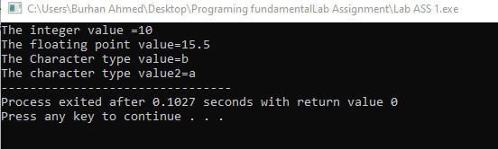

**Question#3:**

Write a program to print a number entered by user.

**Program:**

#include<iostream>

using namespace std;

int main()

{

int num;

cout<<"enter the number";

cin>>num;

cout<<"the number you entered ="<<num;

return 0;

}

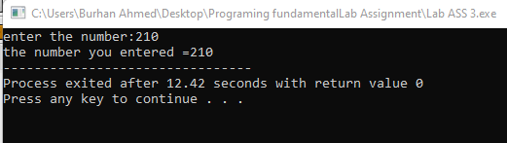

**Question#4:**

Write a program that inputs a number from user and displays its square and cube.

**Program:**

#include<iostream>

using namespace std;

int main()

{

int num,square,cube;

cout<<"Enter a number:";

cin>>num;

square=num*num;

cube=num*num*num;

cout<<"The square of "<<num<<"="<<square<<endl;

cout<<"The cube of "<<num<<"="<<cube<<endl;

return 0;

}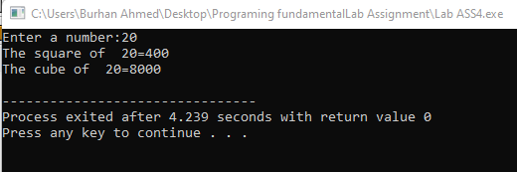

**Question#5:**

Write a program that inputs radius of sphere from user. It calculates its volume and surface area using the formula where π = 3.14.

Area = 4πr^2

Volume =4/3πr^3

**Program:**

#include<iostream>

using namespace std;

int main()

{

float r,vol,area;

cout<<"Enter the radius of sphere:";

cin>>r;

area=4*3.14*(r*r);

vol=4/(3*3.14*(r*r*r));

cout<<"The Volume of given radius ="<<vol<<endl;

cout<<"The area of given radius ="<<area<<endl;

return 0;

}

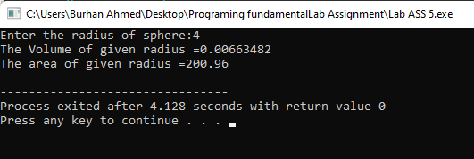**Question#6:**

Write a program that inputs total pages of a book, number of pages a person read in one day and number of days a person has read the book. It displays number of pages that have been read and number of pages remaining.

**Program:**

#include<iostream>

using namespace std;

int main()

{

int TP,pagesperday,noday,np;

cout<<"Write total no of pages of book:";

cin>>TP;

cout<<"write the no of pages a person read in a day:";

cin>>pagesperday;

cout<<"write the no of days a person has read the book:";

cin>>noday;

np=noday*pagesperday;

cout<<"The no of pages that have been read in "<<noday<<" days are "<<np<<endl;

cout<<"The no of pages remaining are "<<TP-np;

return 0;

}

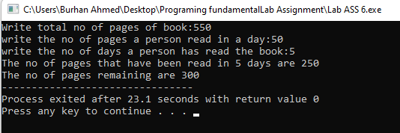

**THE END**