A Software Design Specification Template

by Brad Appleton <brad@bradapp.net>
http://www.bradapp.net

Adapted for LAFS by Elliott McCrory,

Copyright © 1994-1997 by Bradford D. Appleton

Permission is hereby granted to make and distribute verbatim copies of this document provided the copyright notice and this permission notice are preserved on all copies.

Table of Contents
1. Introduction 1
1.1. Document Outline 2
1.2. Document Description 4
1.2.1. Introduction 4
1.2.2. System Overview 5
2. Design Considerations 5
2.1. Assumptions and Dependencies 5
2.2. General Constraints 5
2.3. Goals and Guidelines 6
2.4. Development Methods 6
3. Architectural Strategies 6
4. System Architecture 7
6.1 Subsystem Architecture 8
5. Policies and Tactics 8
6. Detailed System Design 9
7. Glossary 11
8. Bibliography 11

Introduction

The following is an attempt to put together a complete, yet reasonably flexible template for the specification of software designs. Wherever possible, I have tried to provide guidelines (instead of prescribing requirements) for the contents of various sections and subsections of the document. Some may prefer to require more detailed subsections of a particular section, choosing one or more of the subsection topics from the list of guidelines provided. In this sense, this document is really a template for a template.

In devising this template, I have gleaned information from many sources, including various texts on Software Engineering (Pressman, Sommerville, and Van Vliet), Object-Oriented Development (Booch, Rumbaugh, Berard, and Wirfs-Brock), various SEI reports, DoD-Std and Mil-Std documentation requirements (2167/2167A), and IEEE documentation standards (particularly IEEE-1016 for software designs, and IEEE-830 for software requirements). I have made every effort not to assume or impose a particular software development methodology or paradigm, and to place more emphasis on content than on format.

It is my desire that a completed software design specification meet the following criteria:

- It should be able to adequately serve as training material for new project members, imparting to them enough information and understanding about the project implementation, so that they are able to understand what is being said in design meetings, and won't feel as if they are drowning when they are first asked to create or modify source code.

- It should serve as "objective evidence" that the designers and/or implementers are following through on their commitment to implement the functionality described in the requirements specification.

- It needs to be as detailed as possible, while at the same time not imposing too much of a burden on the designers and/or implementers that it becomes overly difficult to create or maintain.

Please note that there are no sections in this document for describing administrative or business duties, or for proposing plans or schedules for testing or development. The sections in this document are concerned solely with the design of the software. While there are places in this document where it is appropriate to discuss the effects of such plans on the software design, it is this author's opinion that most of the details concerning such plans belong in one or more separate documents.

Document Outline

Here is the outline of the proposed template for software design specifications. Please note that many parts of the document may be extracted automatically from other sources and/or may be contained in other, smaller documents. What follows is just one suggested outline format to use when attempting to present the architecture and design of the entire system as one single document. This by no means implies that it literally is a single document (that would not be my personal preference):

- Introduction
- System Overview
- Design Considerations
  - Assumptions and Dependencies
  - General Constraints
  - Goals and Guidelines
  - Development Methods
- Architectural Strategies
  - strategy-1 name or description
  - strategy-2 name or description
  - ...
- System Architecture
  - component-1 name or description
  - component-2 name or description
  - ...
- Policies and Tactics
  - policy/tactic-1 name or description
  - policy/tactic-2 name or description
  - ...
- Detailed System Design
  - module-1 name or description
  - module-2 name or description
  - ...
- Glossary
- Bibliography

The above outline is by no means exclusive. A particular numbering scheme is not necessarily required and you are more than welcome to add your own sections or subsections where you feel they are appropriate. In particular you may wish to move the bibliography and glossary to the beginning of the document instead of placing them at the end.

The same template is intended to be used for both high-level design and low-level design. The design document used for high-level design is a "living document" in that it gradually evolves to include low-level design details (although perhaps the "Detailed Design" section may not yet be appropriate at the high-level design phase).

The ordering of the sections in this document attempts to correspond to the order in which issues are addressed and in which decisions are made during the actual design process. Of course it is understood that software designs frequently (and often fortunately) don't always proceed in this order (or in any linear, or even predictable order). However, it is useful for the purpose of comprehending the design of the system to present them as if they did. Frequently, one of the best ways to document a project's design is to keep a detailed project journal, log, or diary of issues as they are mulled over and bandied about and to record the decisions made (and the reasons why) in the journal. Unfortunately, the journal format is not usually organized the way most people would like it for a formal review. In such cases, for the purpose of review, the journal can be condensed and/or portions of it extracted and reorganized according to this outline. However, if this is done then you need to choose whether to update and maintain the design document in the journal format, or the formal review format. It is not advisable to try and maintain the design document in both formats. (If you have an automated method of converting the journal into a formal document, then this problem is solved.)

Document Description

Here is the description of the contents (by section and subsection) of the proposed template for software design specifications:

System Overview
The main purpose of this system to digitize what are currently doing by manually such as patient assessments, care plans, maintain the record of patients, EHR provides a doctor early access to patient record, provide and maintain all kinds of tests for a patient, Billing and Report generation,

Design Considerations

This section describes many of the issues which need to be addressed or resolved before attempting to devise a complete design solution.

Assumptions and Dependencies

Describe any assumptions or dependencies EHR. These may concern such issues as:

2.1.1
Use of MSSQL depends upon a Microsoft Windows operating system. Database must be free from SQL injection and database backup must be available.
2.1.2
EHR application is a Web-based. EHR application will run on the desktop computers. EHR Application depend on the higher speed Internet connection.
2.1.3
The code should be reliable, reusable.
2.1.4
The product must have an interface which help end user to accomplish
Task.
2.1.5
The website should be responsive and interactive enough and must use bootstrap for responsive design.
2.1.3
- We are assuming that by working closely with domain expert of EHR we will be able to lower the chance of having large integration issues.

General Constraints

Describe any global limitations or constraints that have a significant impact on the design of the system's software (and describe the associated impact). Such constraints may be imposed by any of the following (the list is not exhaustive):

- EHR system requires mutual trust. For example, Patient security of life must be protected by code of ethics’ formulated by the Pakistan Medical and Dental Council – the national body that regulates those associated with the medical profession. . So, this is an important constraint for EHR system

Goals and Guidelines
The Goal of our system to provide the platform for the end user to perform their task with less time and in efficient way.

- The first goal of our system to provide such interface that help doctor to add notes in less time and in better way.

- The second goal of our system to provide such interface for patient to book appointment online quickly and in responsive way.
.

Development Methods

We are using Agile Method for developing EHR. By using Agile method, we get
- Customer satisfaction rapidly
- Reduce Project Risk
- Testing is integrated during the cycle, provided regular checkups to see that the product is working, and according to customer need or not during the development ...
- Provide Flexibility
As we know in EHR some information are not stable so agile method gives us benefit to make change easily.

Architectural Strategies

3.1 High level Component and Interface

EHR as a product:
This project will be implemented with JavaScript and PHP as scripting languages, LARAVEL as a Framework and CSS and bootstrap as style sheet language. In addition, Google Map API will be used to get location information.

User Interface Paradigm:

Screen Name | Description
Login | Log into the system as a Patient
Appointment | appointment button, add appointment, update/save appointment, cancel appointment,
Date | Display Date selection button , select date from calendar, modify date
Find a doctor | Display Input field for search the doctor, select specialty of a doctor according to your disease
Schedule | Display Time for doctor availability, save time for appointment, update time for appointment
Patient Profile | Display medical history, all appointments, all cancel appointment , display health tips , update record/profile
Approve/cancel appointment | Display notification of a appointment approve/cancel by doctor,
Medical Reports | Display reports , save, and delete reports, transfer report to doctor.

Screen Name | Description
Login | Log into the system as a doctor
Appointments | Display all appointments, , approve appointment, cancel appointment
Message | Display all messages , reply the messages, delete the messages , block messages
Medical Reports | Display reports , save, and delete reports, upload report and send to patient portal.
Schedule | Display schedule for routine work, update schedule ,
Doctor Profile | Display history of patient check by him, all appointments, cancel appointments , display health news ,display news about new technology invent in health sector, update record/profile

Error detection and recovery:

Detection Technique:
Ping/echo: asynchronous request/response message pair exchanged between nodes, used to determine reachability and the round-trip delay through the associated network path.
Self-test: procedure for a component to test itself for correct operation.

Recovery Technique:
Exception Handling:
dealing with the exception by reporting it or handling it, correcting the cause of the exception.
Rollback: revert to a previous known good state, referred to as the “rollback
line”.

Communication mechanisms:

It will use HTTPS protocols for communication.

MVC Architecture:

We chose MVC as architecture design pattern and object oriented design pattern because MVC architectural pattern separates an application into three main components: the model, the view, and the controller. We control our data which are in model, and views via controller. That makes easy to change information in tables.

System Architecture
Patient Component:
This is one of the key components of the EHR. This is where the Patient register themselves, book appointment, update their Profile. This also includes the Medical history preview.
This is the major sub system that is responsible for the security of the EHR.

Search by doctor specialty Component:
This Component is also a key component of the EHR. This is where the patient search doctor by their specialty and see their availability time.
Appointment Components:
Appointment Component is one of the key components of the EHR. This is where the, appointment implementation done, Patient use this component to book their appointment online. Patient have an authority to cancel and update their appointment, This also includes the all appointment history preview.

Bill Component:
Bill component is also a very important component .This component allow the patient to pay bill via credit card and on cash.
Doctor Component:

This one also the key components of the EHR. This is where the Doctor check
there appointments, update care plan for the patients, adding patient notes, see
patient reports.
- As we know Doctor are very busy in checking the patient they have no much time for training course so they start teaching themselves. So, Component design must be intuitive enough for them to do the basics like adding patient notes.
- Design the Component that provide easy way to add Structure Notes).
- Use their language. Don’t use terminology that’s unique for them.

Policies and Tactics

- Secure Database will be provided to the customer which will be able to store the data in the database. Database must have backup option and rollback option.
- No Source code provided to the customer.
- Only documentation provided to the customer.
- Maintenance provided for the first 6 month is free after that maintenance cost 30% of the whole system will be charged.
- Proper testing of each component should be done.
- System installation will be free of cost and training of 1 month will be given to the end user to teach them technical feature of the system.
- Interfaces should support usability, reliability, ease of use.Easy to done all task.

Detailed Design

6.1.1 USE CASE DIAGRAM

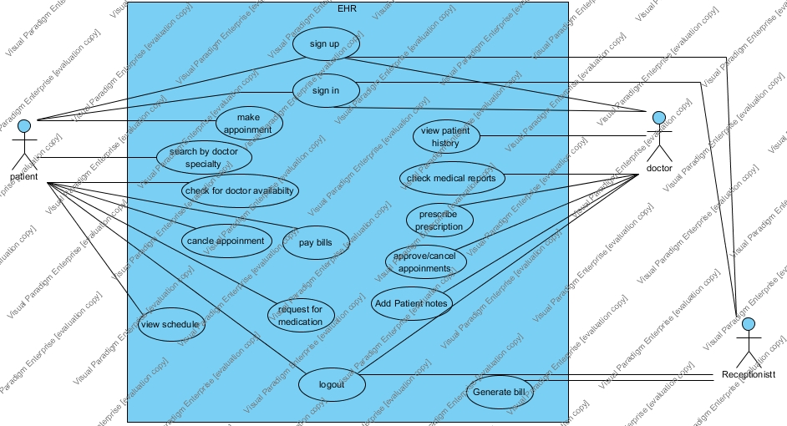

6.1.2 Class diagram

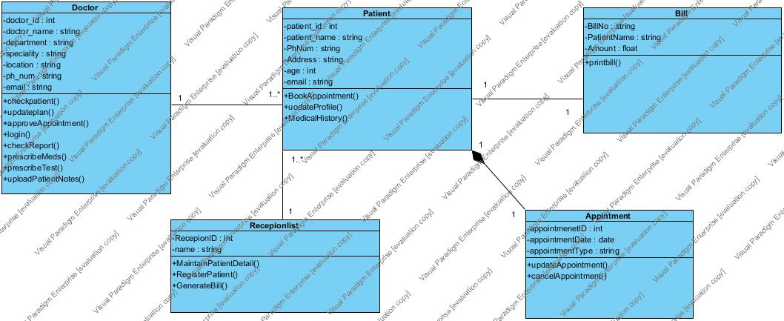

6.1.3 Component Diagram
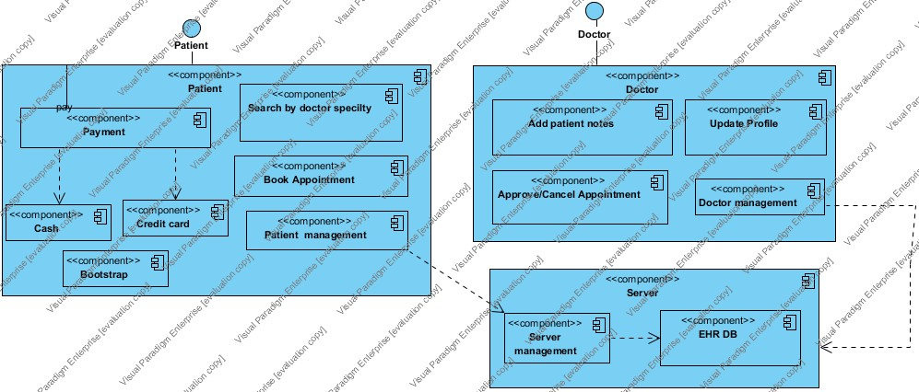

6.1.4 Entity Relation Diagram

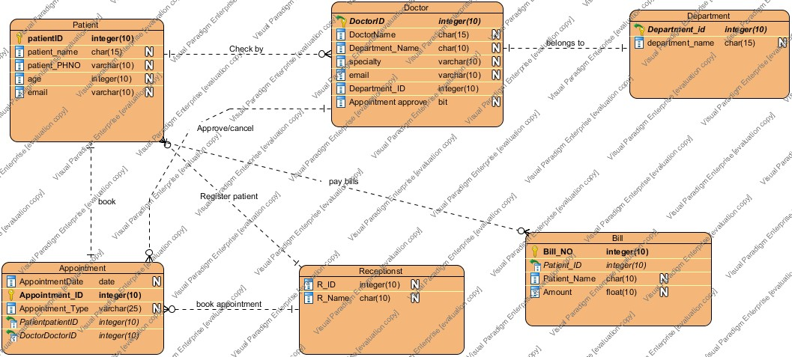

6.1.5 Sequence Diagram of patient appointment

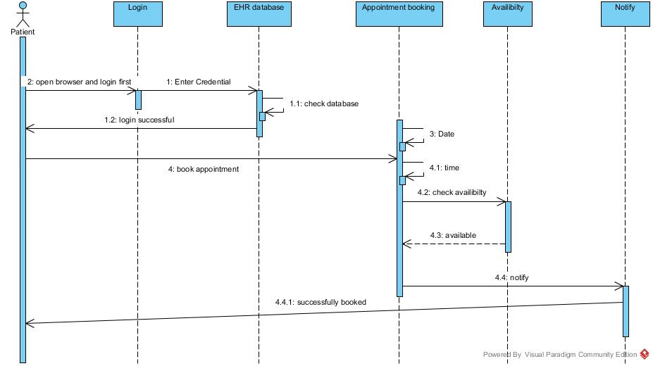
6.1.6 Sequence Diagram of Doctor approval appointment

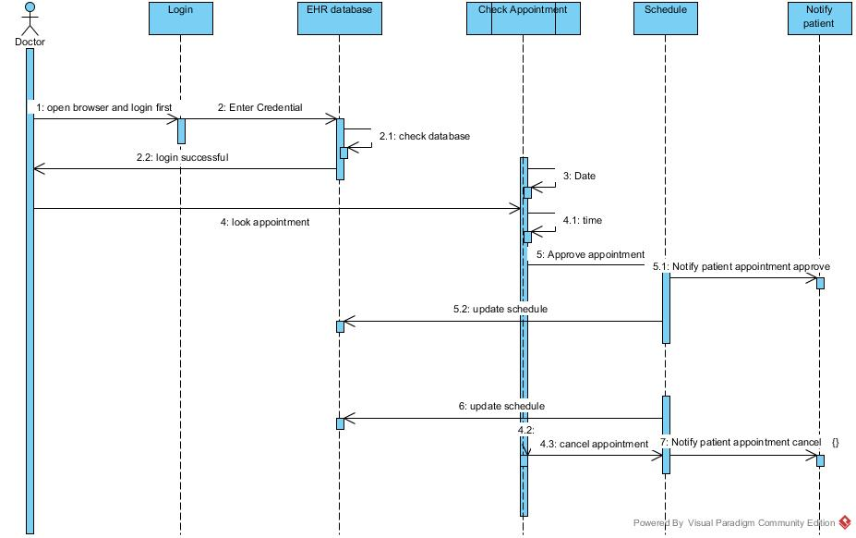

6.1.7 Sequence Add Patient Notes

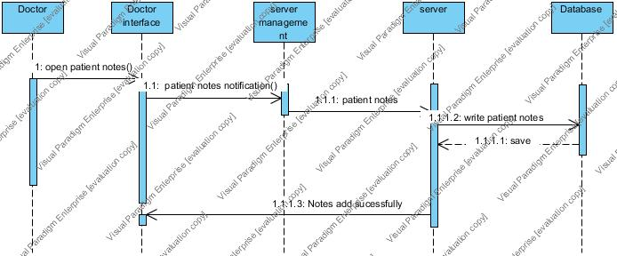

Sequence diagram of Search by Doctor Specialty:

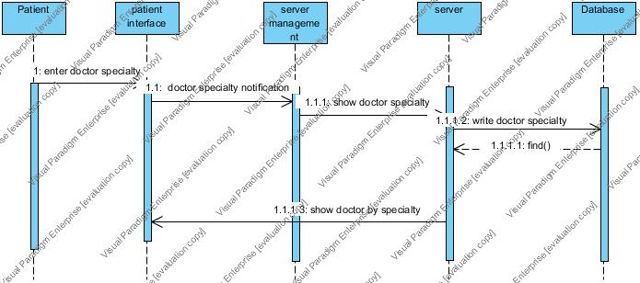

Sequence diagram of Cancel Appointment:

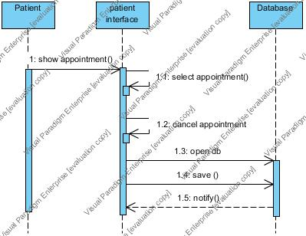

Sequence diagram of See Reports:

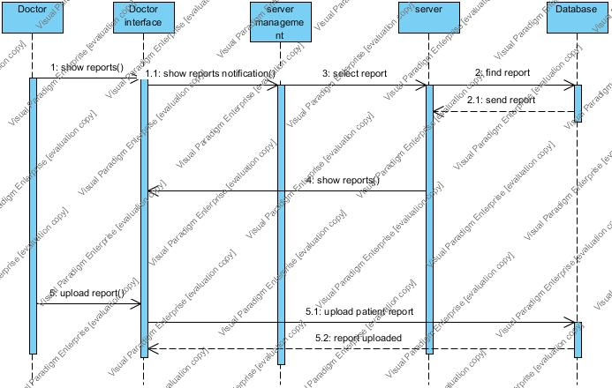

Sequence diagram of See Patient Record:
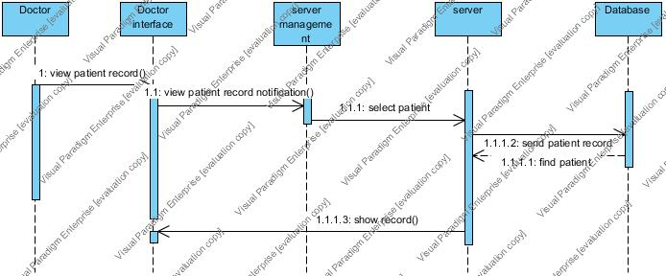

6.Glossary

An ordered list of defined terms and concepts used throughout the document.

7.Bibliography

A list of referenced and/or related publications.

Brad Appleton <brad@bradapp.net>
http://www.bradapp.net

