SUBMITTED BY

JUNAID IQBAL

BSSE02153032

SALEH ADNAN

BSSE02153035

HAMNA YAQOOB

BSSE02153117

TOOBA SHAFIQUE

BSSE02153146

SAIM AHMAD

BSSE02153232

SECTION

S

DEPARTMENT OF SOFTWARE ENGINEERING

**CLASS DIAGRAM**

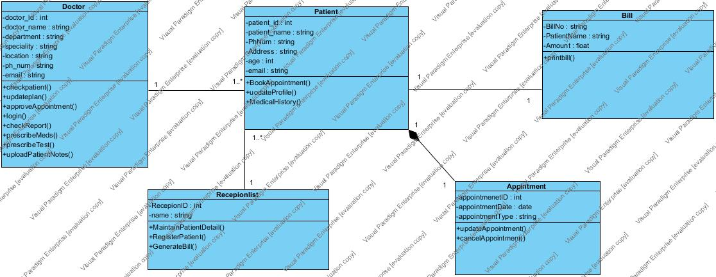

**Patient:**

public class Patient {

private int patient_id;

private string patient_name;

private string PhNum;

private string Address;

private int age;

private appointment ap;

public void BookAppointment() {

// TODO - implement Patient.BookAppointment

throw new UnsupportedOperationException();

}

public void updateProfile() {

// TODO - implement Patient.updateProfile

throw new UnsupportedOperationException();

}

public void MedicalHistory() {

// TODO - implement Patient.MedicalHistory

throw new UnsupportedOperationException();

}

}

**Appointment:**

public class Appointment {

private int appointmenetID;

private date appointmentDate;

private string appointmentType;

public void updateAppointment() {

// TODO - implement Appintment.updateAppointment

throw new UnsupportedOperationException();

}

public void cancelAppointment() {

// TODO - implement Appintment.cancelAppointment

throw new UnsupportedOperationException();

}

}

**Bill:**

public class Bill {

private string BillNo;

private string PatientName;

private float Amount;

void printBill() {

\]----=

}

}

**Doctor:**

public class Doctor {

private int doctor_id;

private string doctor_name;

private string department;

private string speciality;

private string location;

private string ph_num;

public void checkpatient() {

// TODO - implement Doctor.checkpatient

throw new UnsupportedOperationException();

}

public void updateplan() {

// TODO - implement Doctor.updateplan

throw new UnsupportedOperationException();

}

public void approveAppointment() {

// TODO - implement Doctor.approveAppointment

throw new UnsupportedOperationException();

}

public void login() {

// TODO - implement Doctor.login

throw new UnsupportedOperationException();

}

public void checkReport() {

// TODO - implement Doctor.checkReport

throw new UnsupportedOperationException();

}

public void prescribeMeds() {

// TODO - implement Doctor.prescribeMeds

throw new UnsupportedOperationException();

}

public void prescribeTest() {

// TODO - implement Doctor.prescribeTest

throw new UnsupportedOperationException();

}

public void uploadPatientNotes() {

// TODO - implement Doctor.uploadPatientNotes

throw new UnsupportedOperationException();

}

}

**Receptionist:**

public class Recepionlist {

private int RecepionID;

private string name;

public void MaintainPatientDetail() {

// TODO - implement Recepionlist.MaintainPatientDetail

throw new UnsupportedOperationException();

}

public void RegisterPatient() {

// TODO - implement Recepionlist.RegisterPatient

throw new UnsupportedOperationException();

}

public void GenerateBill() {

// TODO - implement Recepionlist.GenerateBill

throw new UnsupportedOperationException();

}

}