Cloud Computing (Lab 10)
Name : Tooba Shafique
Reg no : 2023-BSE-065

Task 1 — GitHub CLI Codespace Setup & Authentication
Goal: Install GH CLI (if not present), authenticate for Codespace use, and connect into the Codespace shell (all steps inside Codespace unless noted).
Install GitHub CLI: winget install --id GitHub.cli
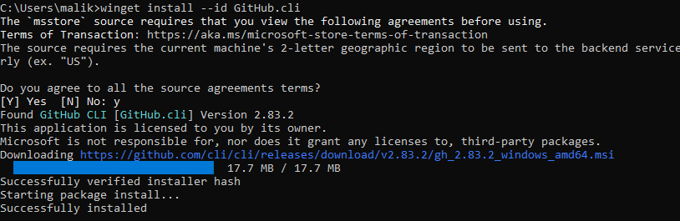
Authenticate GH CLI for Codespaces: gh auth login -s codespace
When prompted, generate a GitHub access token (classic). Set scopes to: admin:org, codespace, repo.
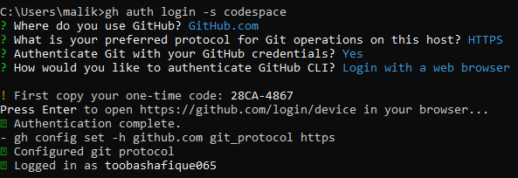
List available codespaces: gh codespace list Connect to a codespace via SSH: gh codespace ssh -c <name_of_codespace> gh codespace ssh -c potential-halibut-4jp7p65jqj963jgx4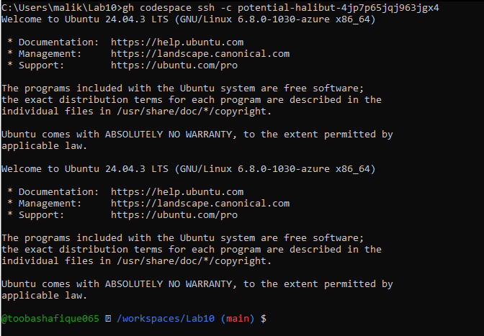

Task 2 — Install AWS CLI, Terraform CLI, Provider Setup
Goal: Install AWS CLI (if not present) & Terraform CLI inside Codespace; configure initial Terraform provider.
- Install AWS CLI (Skip if already installed)
In Codespace shell, install AWS CLI:
curl "https://awscli.amazonaws.com/awscli-exe-linux-x86_64.zip" -o "awscliv2.zip"
unzip awscliv2.zip sudo ./aws/install aws –version
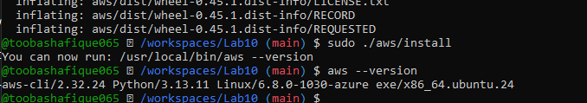
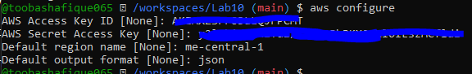
Then check config files: cat ~/.aws/credentials cat ~/.aws/config
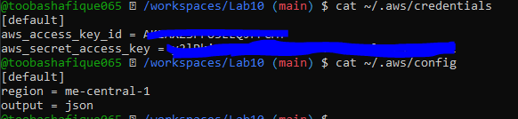

Verify AWS CLI connectivity: aws sts get-caller-identity
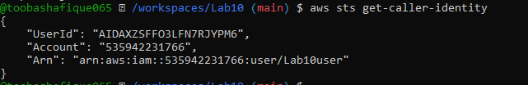
- Install Terraform CLI
Install Terraform CLI:
wget -O - https://apt.releases.hashicorp.com/gpg | sudo gpg --dearmor -o
/usr/share/keyrings/hashicorp-archive-keyring.gpg
echo "deb [arch=$(dpkg --print-architecture) signed-by=/usr/share/keyrings/hashicorp-archivekeyring.gpg] https://apt.releases.hashicorp.com $(grep -oP '(?<=UBUNTU_CODENAME=).*' /etc/osrelease || lsb_release -cs) main" | sudo tee /etc/apt/sources.list.d/hashicorp.list sudo apt update sudo apt install terraform which terraform terraform –version
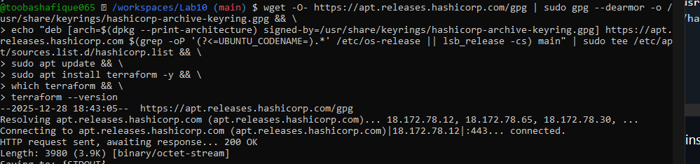
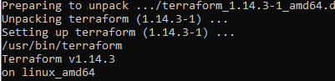

- Provider Configuration (main.tf)
Create main.tf using Vim: vim main.tf

Save screenshot as: task2_provider_file_creation.png — creation/editing of main.tf.
Inside main.tf, write: provider "aws" { shared_config_files = ["~/.aws/config"] shared_credentials_files = ["~/.aws/credentials"]
}
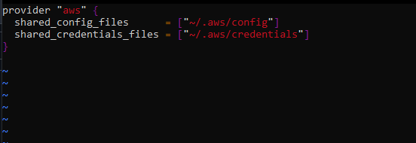
Save and quit: Press ESC then :wq
Initialize Terraform: terraform init
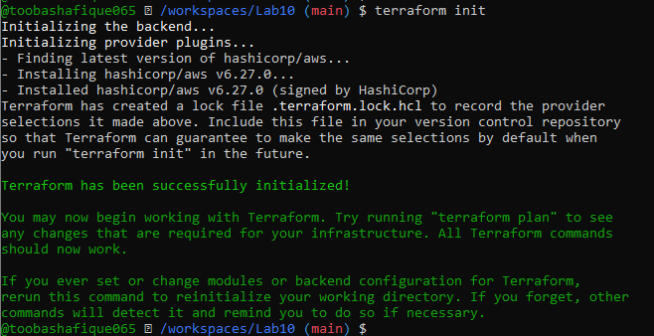

Show contents of .terraform.lock.hcl: cat .terraform.lock.hcl
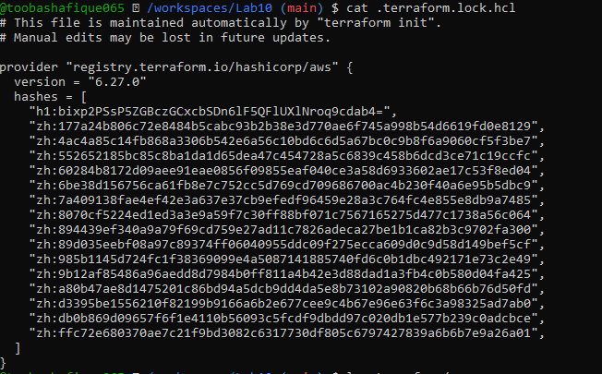
Show contents of .terraform/ directory: ls .terraform/

Task 3 — VPC/Subnet Creation, Initialization, Verification
Goal: Use Terraform to create VPC & Subnet resources, verify via CLI.
Edit main.tf to add:
resource "aws_vpc" "development_vpc" { cidr_block = "10.0.0.0/16"
}
resource "aws_subnet" "dev_subnet_1" { vpc_id = aws_vpc.development_vpc.id cidr_block = "10.0.10.0/24" availability_zone = "me-central-1a"
}
Use vim main.tf, edit and insert code.
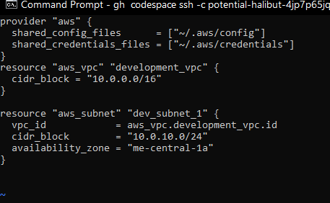
Run: terraform apply
Type yes when prompted.
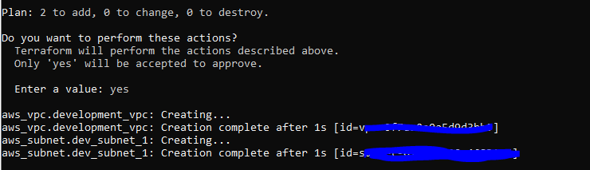
Save screenshot as: task3_terraform_apply_vpc_subnet.png — output showing successful apply and resources creation.
Verify resources using AWS CLI:
Prerequisites
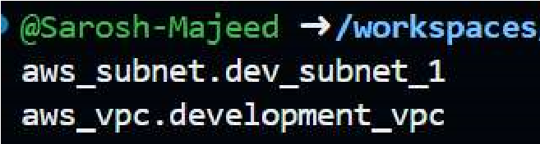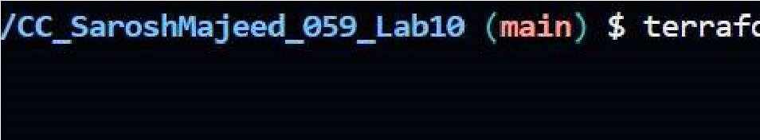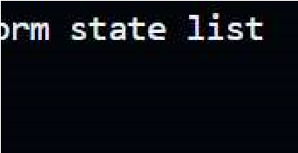

terraform state show aws_vpc.development_vpc look for id = "vpc-053de70bf83fd4e18" terraform state show aws_subnet.dev_subnet_1 look for id = "subnet-026072990904c35e4"
Run: aws ec2 describe-subnets --filter "Name=subnet-id,Values=<subnet-id>"

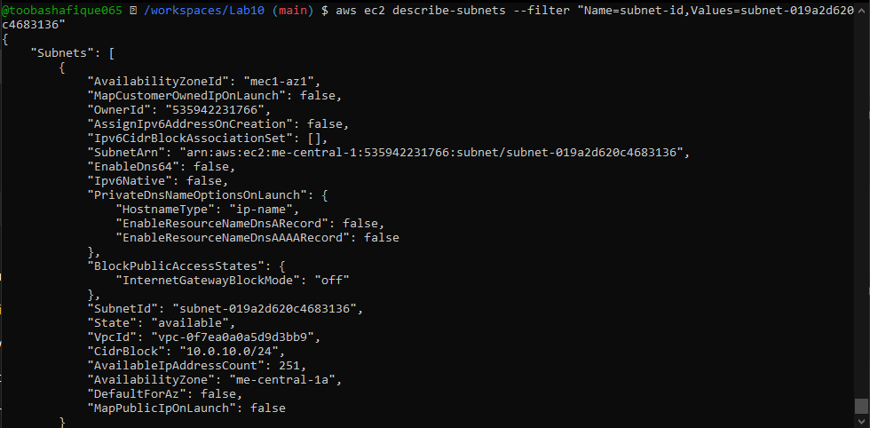
Run: aws ec2 describe-vpcs --filter "Name=vpc-id,Values=<vpc-id>"
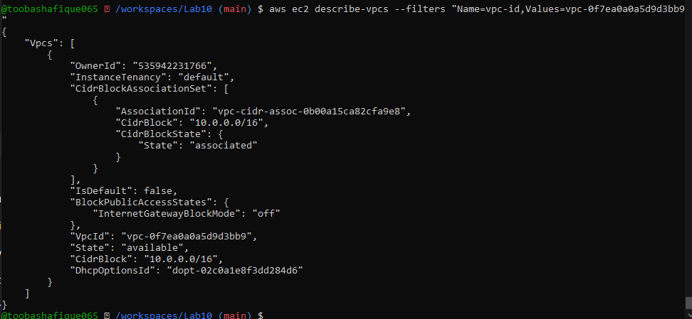

Task 4 — Data Source, Targeted Destroy, Tags

A. Data Source & Resource Creation
Add to main.tf: data "aws_vpc" "existing_vpc" { default = true
}
resource "aws_subnet" "dev_subnet_1_existing" { vpc_id = data.aws_vpc.existing_vpc.id cidr_block = "172.31.48.0/24" availability_zone = "me-central-1a"
}
Use vim to edit and insert code.
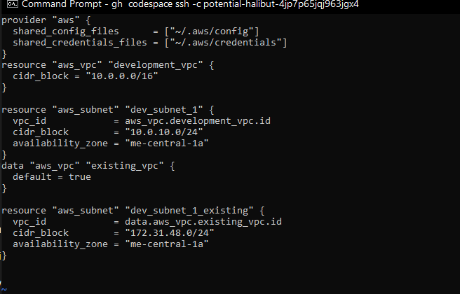
Apply configuration: terraform apply
Confirm only the new subnet is created.
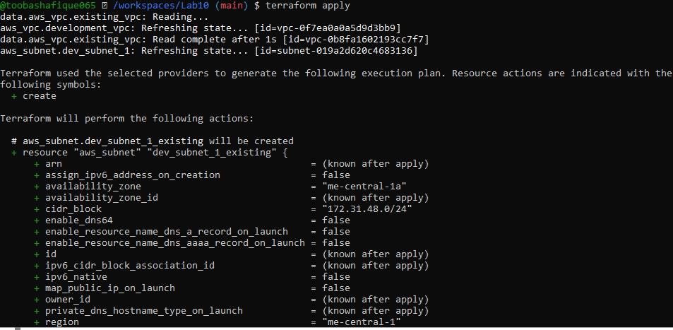

B. Targeted Destroy & Refresh
Destroy only one resource: terraform destroy -target=aws_subnet.dev_subnet_1_existing
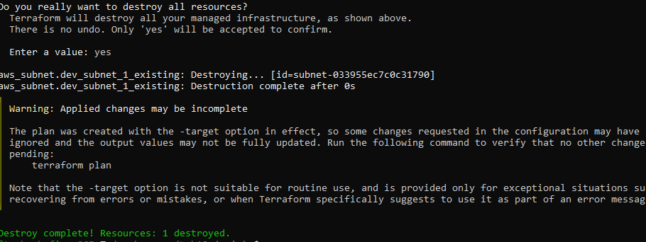
Refresh state: terraform refresh
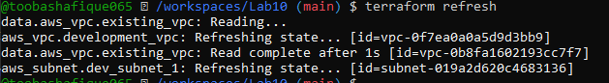
Re-apply configuration: terraform apply
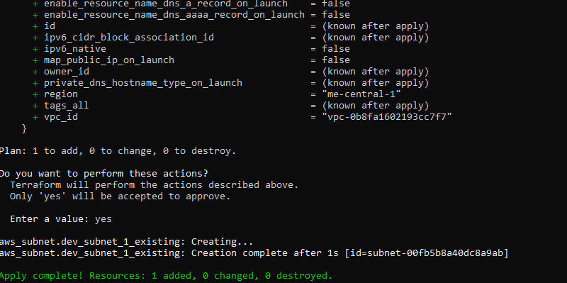
Destroy all resources: terraform destroy
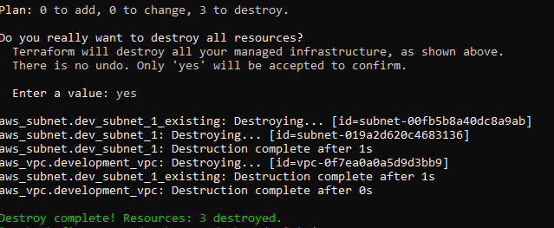
Plan configuration: terraform plan
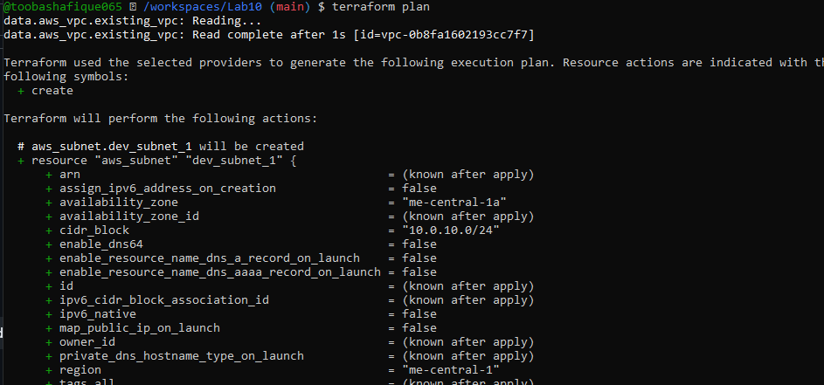
Apply again: terraform apply
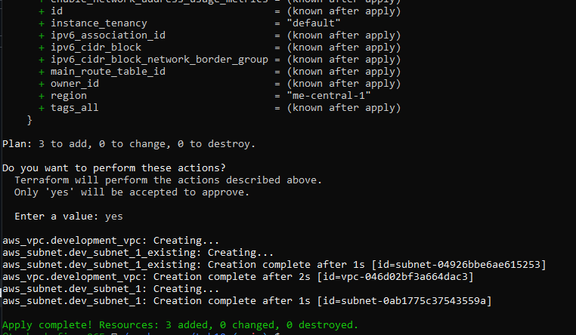

C. Tagging Resources
Modify main.tf to add tags: resource "aws_vpc" "development_vpc" { cidr_block = "10.0.0.0/16" tags = {
Name: "development" vpc_env = "dev"
}
}

resource "aws_subnet" "dev_subnet_1" { vpc_id = aws_vpc.development_vpc.id cidr_block = "10.0.10.0/24" availability_zone = "me-central-1a"
tags = {
Name: "subnet-1-dev"
}
}

resource "aws_subnet" "dev_subnet_1_existing" { vpc_id = data.aws_vpc.existing_vpc.id cidr_block = "172.31.48.0/24" availability_zone = "me-central-1a" tags = {
Name: "subnet-1-default"
}
}
Use vim to update tags.

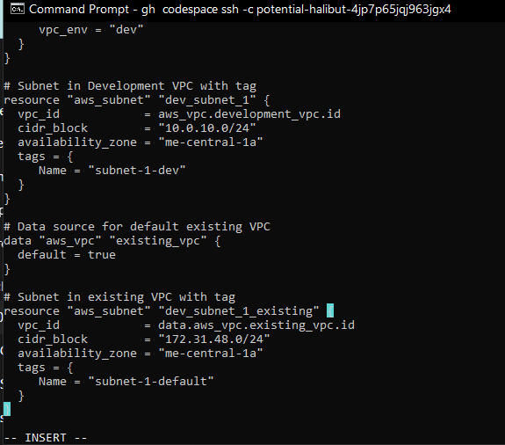
Run: terraform refresh terraform apply -auto-approve
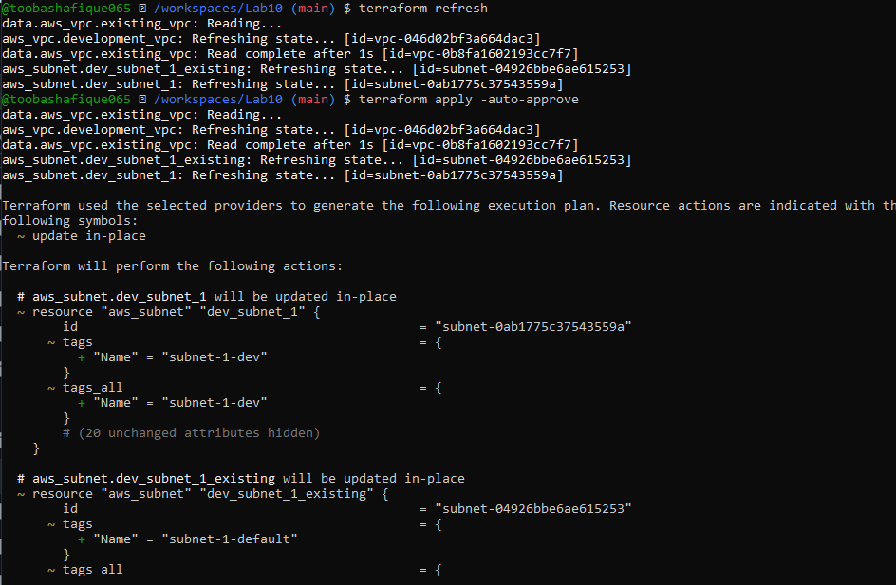
Remove vpc_env = "dev" tag from development_vpc resource, re-plan/apply:
vim main.tf
Prerequisites
Delete this line : vpc_env = "dev" From this block resource "aws_vpc" "development_vpc" { cidr_block = "10.0.0.0/16"

tags = {
Name = "development" vpc_env = "dev"
}
} ESC and :wq

Steps after editing:
- Save the file.
- Run: terraform plan
- Then run: terraform apply -auto-approve

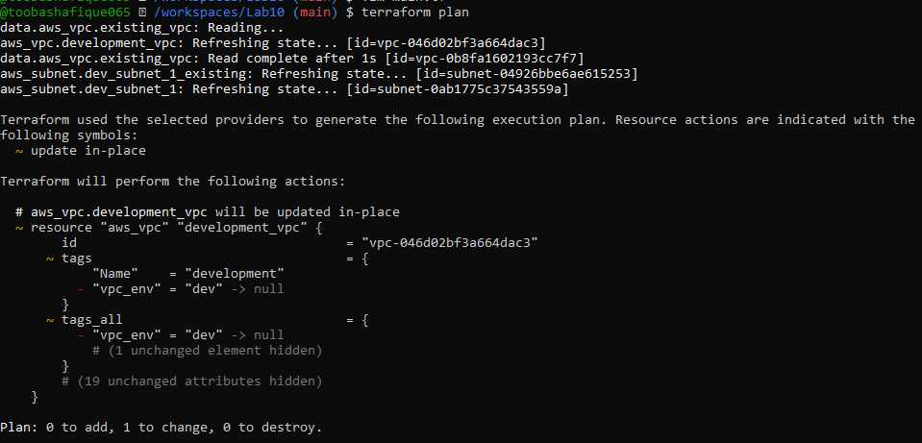
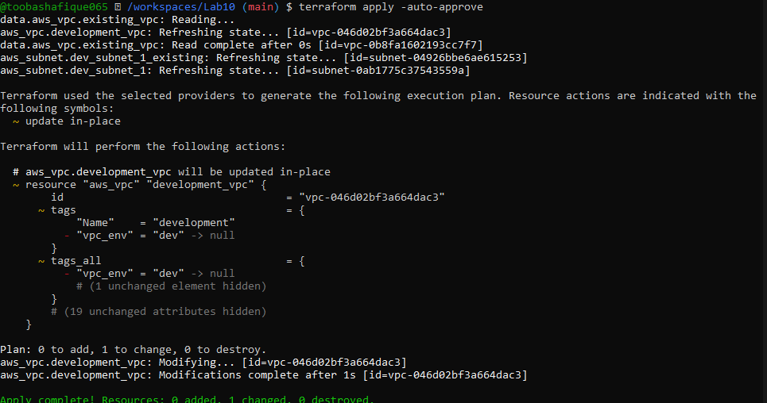

Task 5 — State File Inspection & Terraform State Commands
Destroy all resources: terraform destroy
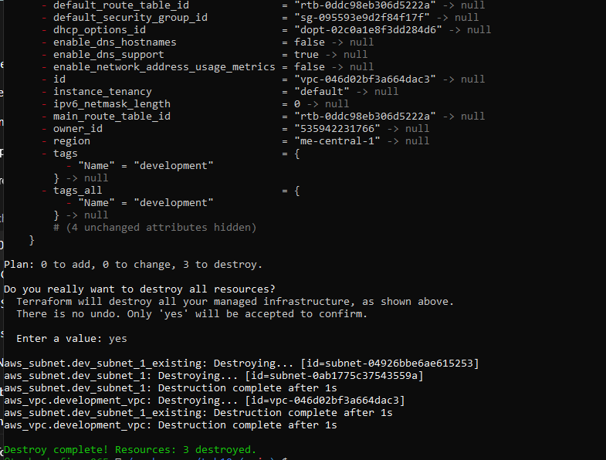
Inspect state files after destroy:
Run: cat terraform.tfstate
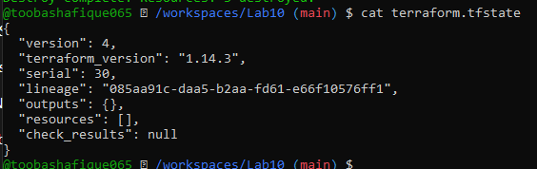

Run: cat terraform.tfstate.backup

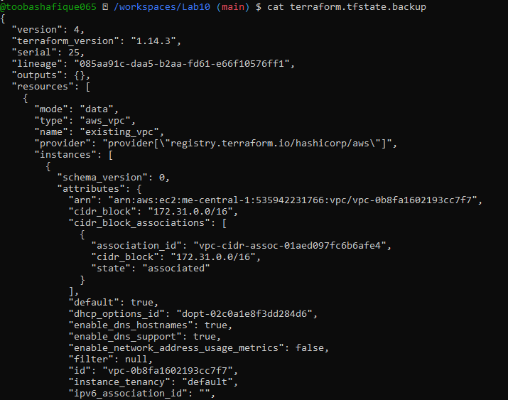
Recreate resources: terraform apply
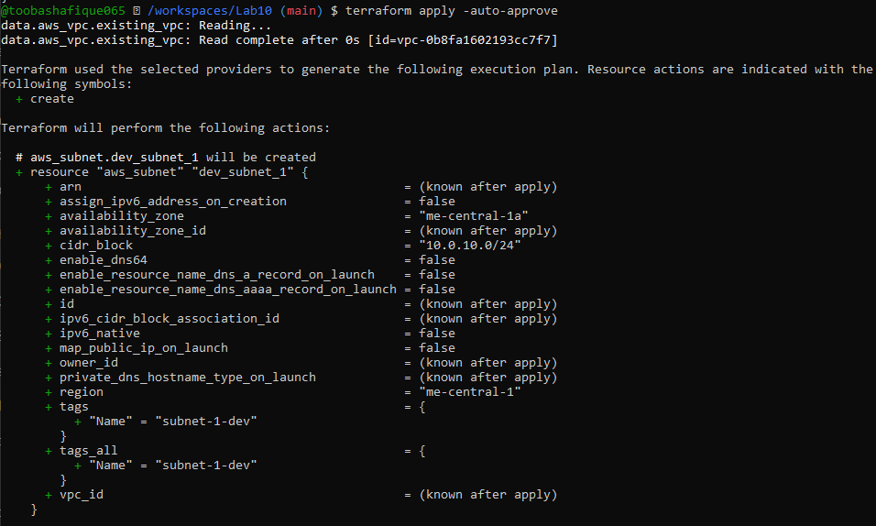
View state files: Run: cat terraform.tfstate
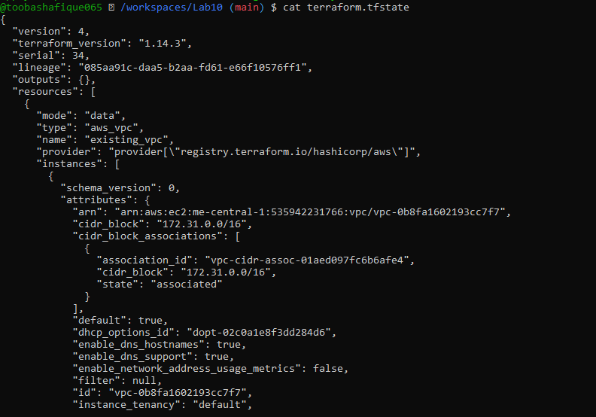
Run: cat terraform.tfstate.backup

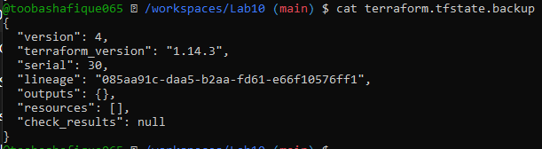

List resources: terraform state lis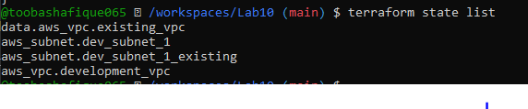
Show full attributes: terraform state show <resource-name>
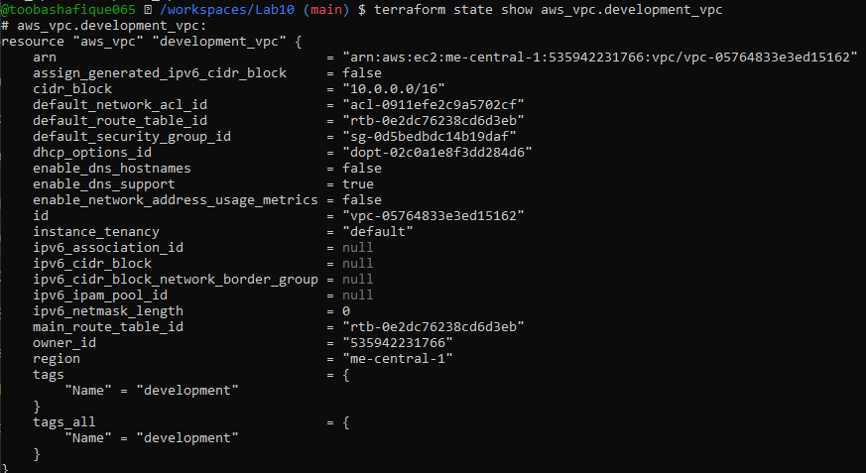
Note: Do NOT run the following (for information only): terraform state rm <resource-name>
Mentioned for knowledge — do not run.

Task 6 — Terraform Outputs & Attributes Reporting
Add outputs in main.tf: output "dev-vpc-id" { value = aws_vpc.development_vpc.id
}
output "dev-subnet-id" { value = aws_subnet.dev_subnet_1.id
}
output "dev-vpc-arn" { value = aws_vpc.development_vpc.arn }
output "dev-subnet-arn" { value = aws_subnet.dev_subnet_1.arn
}

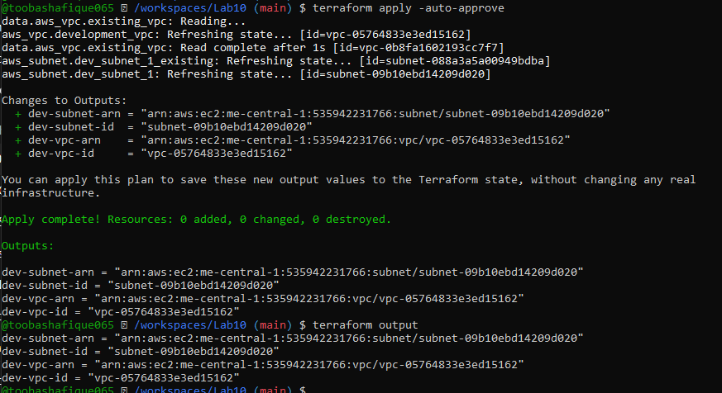
Return ALL of the following output attributes from your VPC and Subnet resources: a) cidr_block
- region
- tags.Name
- tags_all
Expand output section in main.tf accordingly: output "dev-vpc-cidr_block" { value = aws_vpc.development_vpc.cidr_block
}
output "dev-vpc-region" { value = aws_vpc.development_vpc.region }
output "dev-vpc-tags_name" { value = aws_vpc.development_vpc.tags["Name"]
}
output "dev-vpc-tags_all" { value = aws_vpc.development_vpc.tags_all
}
output "dev-subnet-cidr_block" { value = aws_subnet.dev_subnet_1.cidr_block
}
output "dev-subnet-region" { value = aws_subnet.dev_subnet_1.availability_zone
}
output "dev-subnet-tags_name" { value = aws_subnet.dev_subnet_1.tags["Name"]
}
output "dev-subnet-tags_all" { value = aws_subnet.dev_subnet_1.tags_all
}
Run terraform apply and record outputs.
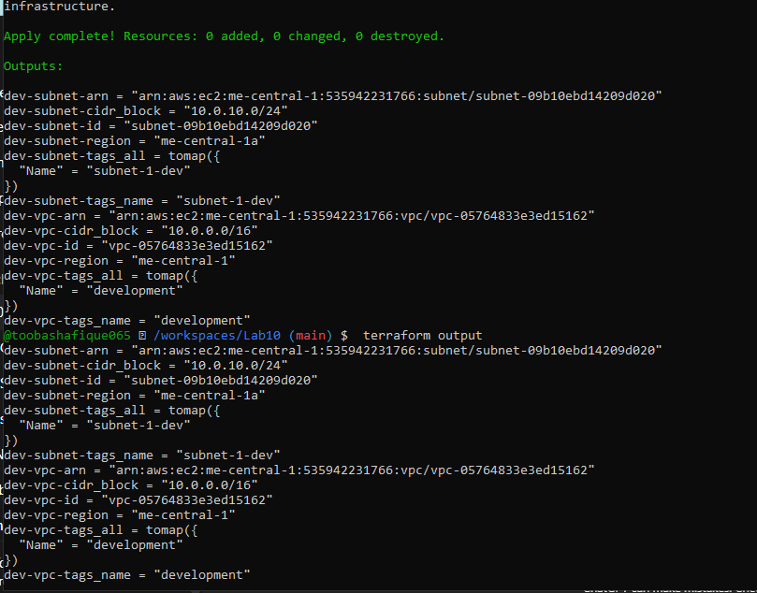

Cleanup — Delete Resources & State Verification
Destroy all resources: terraform destroy
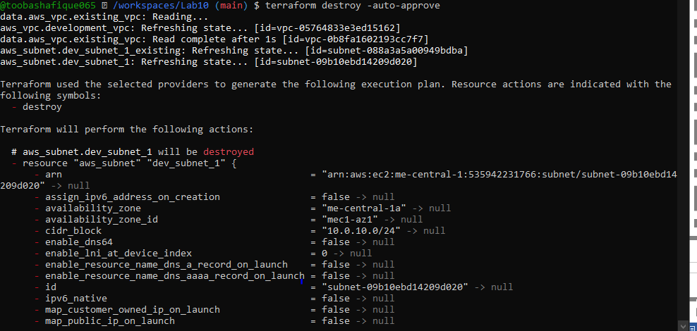
Inspect state files:
cat terraform.tfstate
cat terraform.tfstate.backup
