

Project Title:
Secure Multi-Tier Network Architecture on AWS
Cloud Computing BSE-VB
Submitted by:
Tooba Shafique (2023-BSE-065)
Seerat Fatima (2023-BSE-060)
Submitted to:
Sir Waqas
Submission Date:
27-01-2026

Contents
1. Repository Link 3
2. Executive Summary 3
3. Architecture Design 3
4. Terraform Implementation — Part 1 — Terraform Modules (Network, Security, Compute) 5
5. Part 2 — Terraform Execution & Outputs 8
6. Part 3 — Root Terraform & Environments 12
7. Part 4 — Ansible Implementation 15
8. Part 5 — Security Testing & Compliance Checklist 21
9. Part 6 — Challenges & Solutions 22
10. Part 7 — Conclusion & Future Improvements 24
11. Appendices 24

1. Repository Link
[GitHub Repository] (Repo link: https://github.com/toobashafique065/Project4-Secure-MultiTier)

2. Executive Summary
This project demonstrates the deployment of a secure three-tier architecture on AWS using Infrastructure as Code (IaC) and configuration management tools. The solution leverages Terraform for provisioning, Ansible for server configuration, Nginx for reverse proxying, and Git/GitHub for version control and collaboration.
The architecture addresses key security concerns:
- Prevents direct SSH access to internal servers
- Enforces least-privilege access via Security Groups
- Isolates the application tier in private subnets
- Implements SSH hardening and centralized log collection
The final outcome is a fully automated, secure cloud infrastructure with a bastion host, hardened SSH access, and verified compliance.

3. Architecture Design
3.1 High-Level Network Architecture
The infrastructure follows a secure three-tier architecture deployed within an AWS VPC:
- Web Tier (Public Subnet): Hosts an Nginx reverse proxy with a public IP. It receives HTTP traffic from Internet users on port 80 and forwards requests to the application tier.
- Application Tier (Private Subnet): Hosts Flask application servers running on port 8080. These instances have no public IPs and are only accessible from the web tier or bastion host.
- Management Tier (Management Subnet): Contains a bastion host with a public IP. It acts as the single SSH entry point for administrators, allowing secure access to web and app servers via private IPs.
Traffic Flow
- HTTP: Internet → Web Tier → Application Tier
- SSH: Admin → Bastion → Web/App (via private IPs)
Screenshot:
- project4_architecture_diagram.png
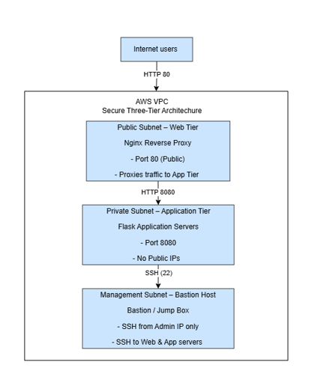
Figure1: architecture_diagram

3.2 Security Architecture Overview
The architecture enforces defense-in-depth security through subnet isolation and strict access controls:
- Network Segmentation:
  - Public subnet for web tier
  - Private subnet for application tier
  - Management subnet for bastion host
- Least-Privilege Security Groups:
  - Web tier allows HTTP (port 80) from the Internet and SSH only from the bastion
  - App tier allows HTTP (port 8080) from the web tier and SSH only from the bastion
  - Bastion allows SSH (port 22) only from a trusted admin IP
- Bastion Host as Single Entry Point: All SSH access is routed through the bastion, preventing direct access to internal servers.
- No Public IPs on Application Servers: App tier instances are fully isolated from the public Internet, reducing attack surface.
Screenshot:
- project4_security_architecture_diagram.png
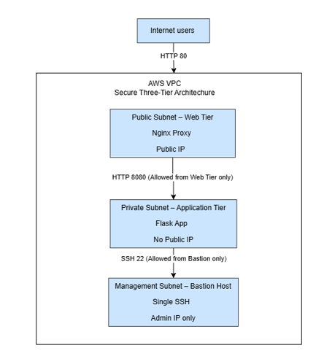
Figure2: security_architecture_diagram

4. Terraform Implementation — Part 1 — Terraform Modules (Network, Security, Compute)
4.1 Repository Structure
The repository is logically organized into separate directories for:
- Terraform modules (network, security, compute)
- Ansible roles and playbooks
- Application code
- Documentation and logs
This modular structure improves maintainability, supports reuse across environments, and ensures clarity for future audits and collaboration.
Screenshot:
- project4_part1_repository_structure.png
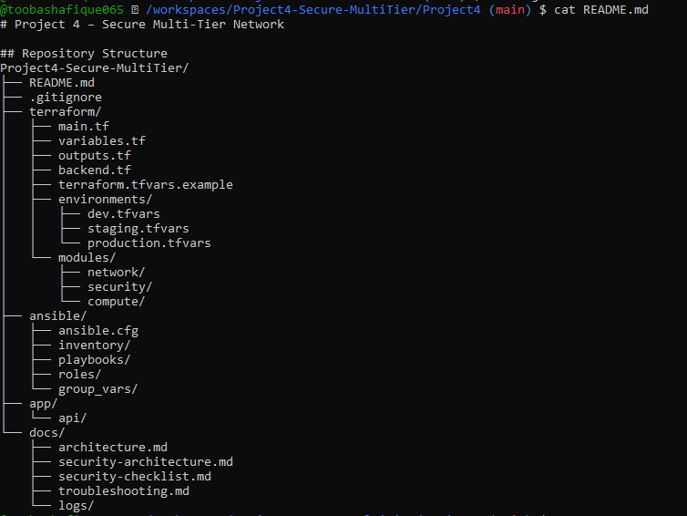
- project4_part1_initial_commit.png
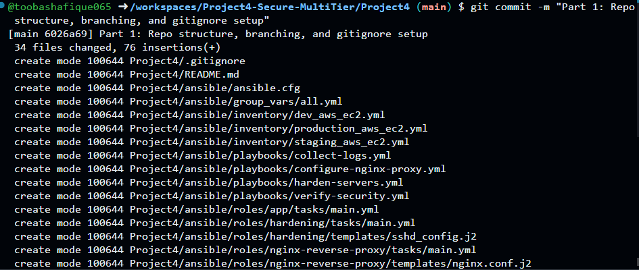

4.2 Git Ignore & Security
The .gitignore file is configured to exclude sensitive and auto-generated files such as:
- SSH keys
- Terraform state files (*.tfstate)
- AWS credentials
- Log files and temporary artifacts
This prevents accidental exposure of secrets and ensures a clean, secure version history.
Screenshots:
- project4_part1_gitignore.png
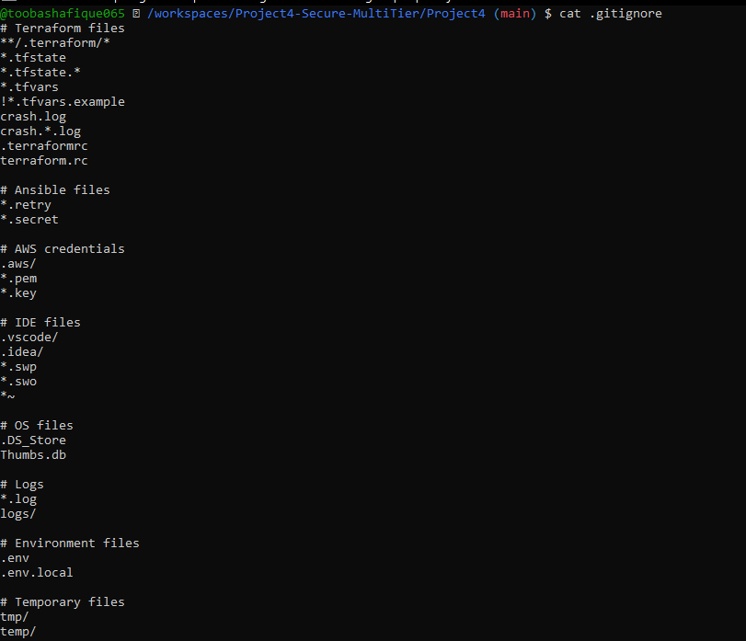
- project4_part1_git_status_clean.png
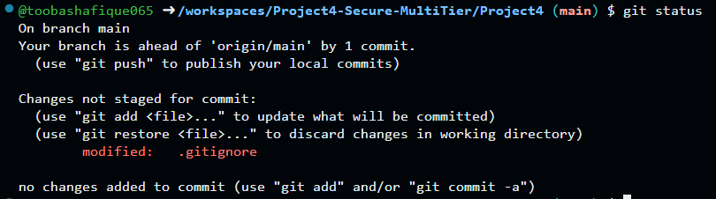

4.3 Git Branching Strategy
The project uses a structured Git branching model:
- main → stable production-ready code
- staging → pre-production testing
- dev → active development
- feature/* → isolated feature branches for modular changes
This strategy supports parallel development, safe testing, and controlled releases.
Screenshots:
- project4_part1_git_branches.png
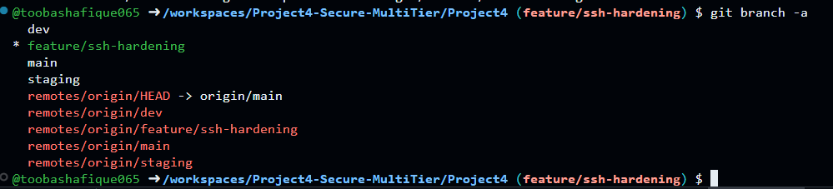
- project4_part1_branching_diagram.png
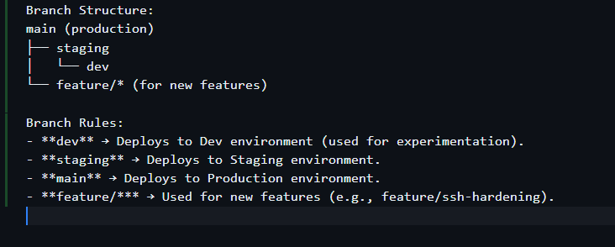

5. Part 2 — Terraform Execution & Outputs
5.1 VPC & Subnet Design
The VPC is defined with a CIDR block (e.g., 10.0.0.0/16) and segmented into:
- Public subnet for web tier
- Private subnet for application tier
- Management subnet for bastion host
An Internet Gateway is attached to the public subnet, and route tables are configured to control traffic flow.
Screenshots:
- project4_part2_network_main.png
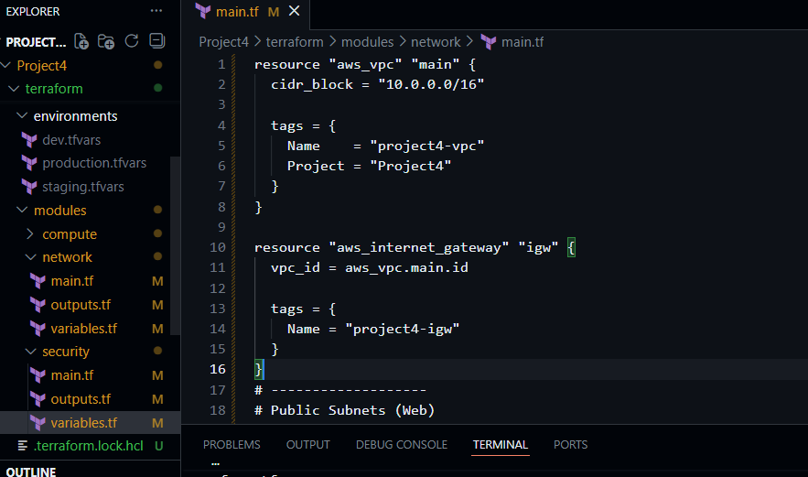
- project4_part2_network_outputs.png
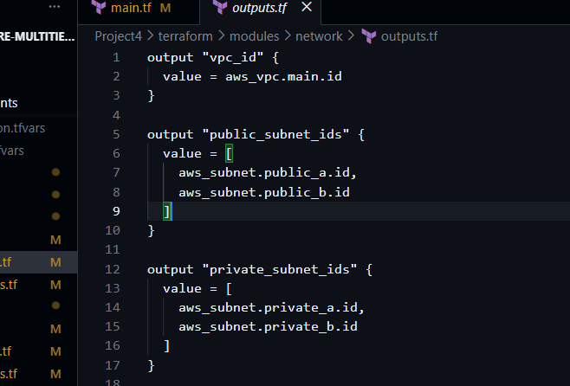

5.2 Security Groups (Least Privilege)
Security Groups enforce strict access rules:
- Web SG: Allows HTTP (80) from Internet, SSH only from bastion
- App SG: Allows HTTP (8080) from web tier, SSH only from bastion
- Bastion SG: Allows SSH (22) only from admin IP
Security Group-to-Group communication ensures internal access without exposing private servers.
Screenshots:
- project4_part2_security_main.png
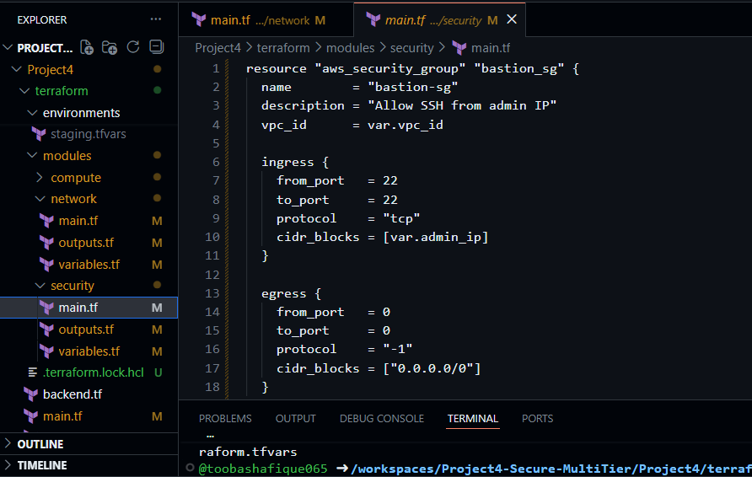
- project4_part2_security_rules_summary.png
Security Group | Direction | Protocol | Port(s) | Source/Destination
Bastion SG | Ingress | TCP | 22 (SSH) | Admin IP (4.240.18.227/32)
 | Egress | All | All | 0.0.0.0/0
Web SG | Ingress | TCP | 80 (HTTP) | 0.0.0.0/0 (anywhere)
 | Ingress | TCP | 22 (SSH) | Bastion SG
 | Egress | All | All | 0.0.0.0/0
App SG | Ingress | TCP | 8080 (App Port) | Web SG
 | Ingress | TCP | 22 (SSH) | Bastion SG
 | Egress | All | All | 0.0.0.0/0

5.3 Compute Resources
Terraform provisions:
- Web servers in public subnets
- App servers in private subnets
- Bastion host in management subnet
All resources are tagged with Project=Project4 and Tier=management/web/app for dynamic inventory and traceability.
Screenshots:
- project4_part2_compute_main.png
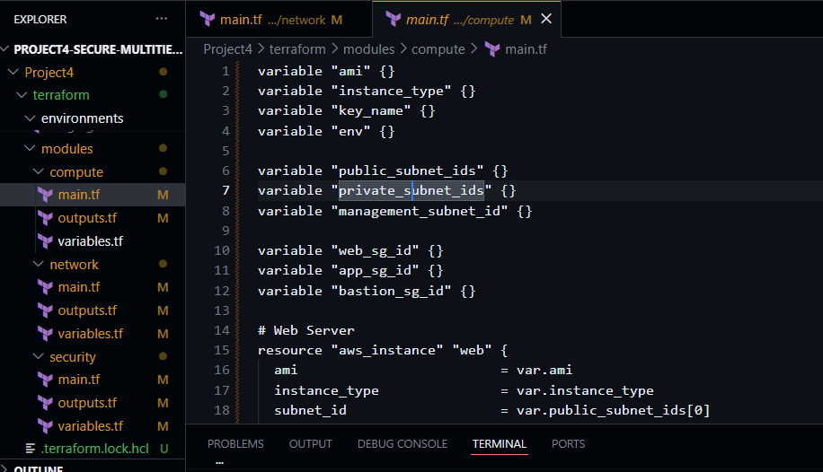
- project4_part2_compute_outputs.png
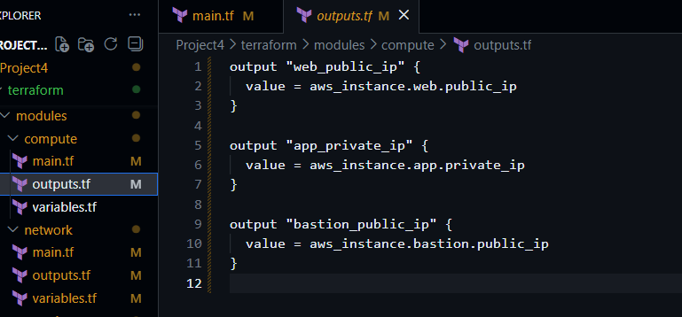
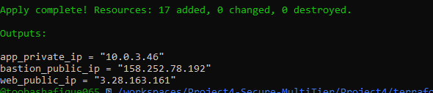
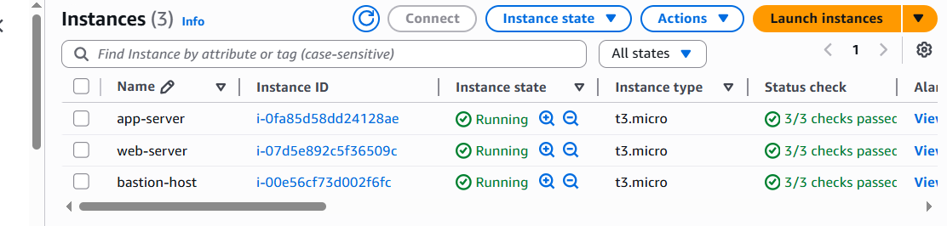

6. Part 3 — Root Terraform & Environments
6.1: The root module includes:
- main.tf → AWS provider and module instantiation
- variables.tf → input variables
- outputs.tf → public/private IPs
- backend.tf → remote state configuration
Modules are wired together: VPC → Subnets → Security Groups → EC2 instances.
Outputs include:
- Bastion public IP
- Web public endpoint
- App private IPs
Deliverables:
- Screenshot: project4_part3_main_tf.png
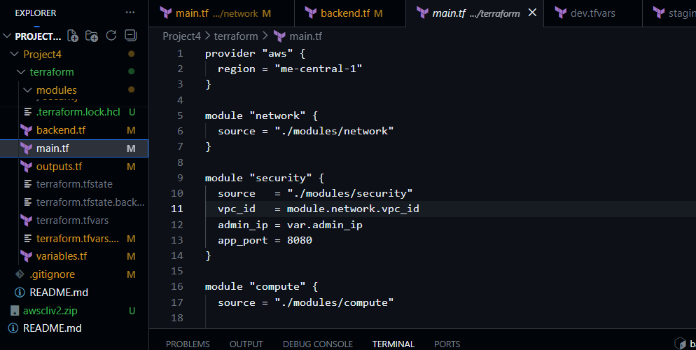
- Screenshot: project4_part3_outputs_tf.png
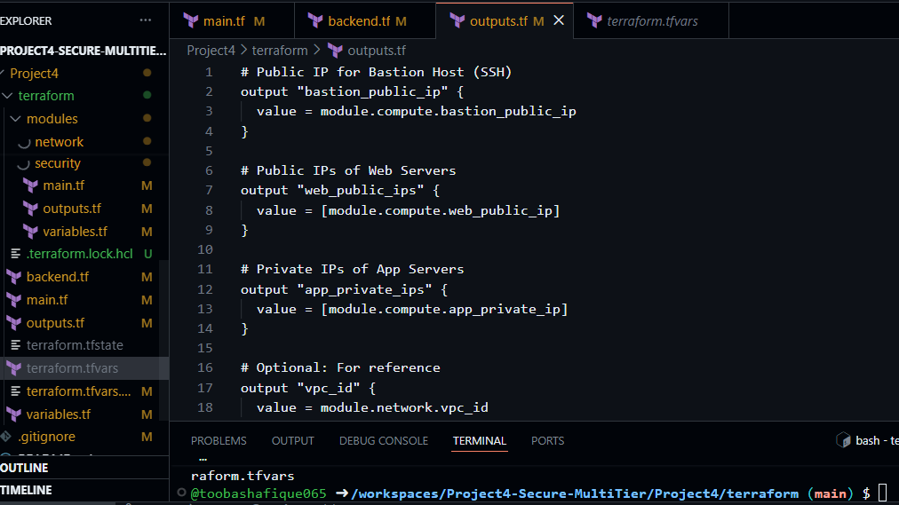
6.2 Environment-Specific Variables Files:
Environment files (dev.tfvars, staging.tfvars, production.tfvars) define:
- CIDR blocks
- Admin IPs
- Instance types and counts
- Consistent region: me-central-1
This enables flexible deployments across multiple environments.

Deliverables:
- Screenshot: project4_part3_dev_tfvars.png
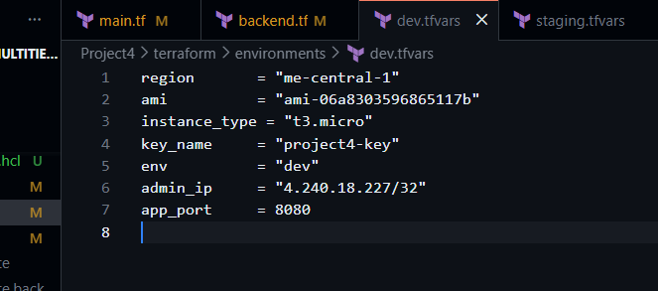
- Screenshot: project4_part3_staging_tfvars.png
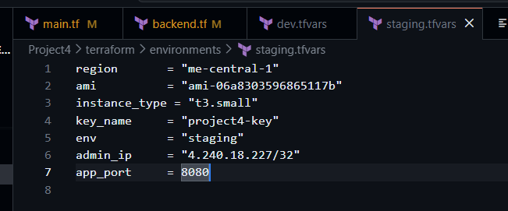
- Screenshot: project4_part3_production_tfvars.png
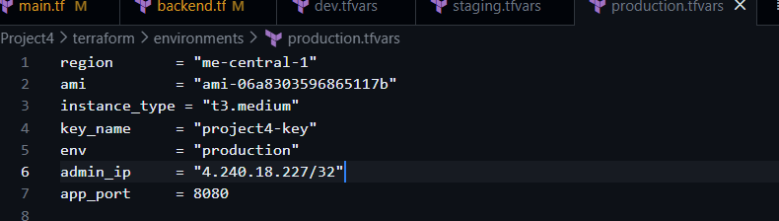
- Screenshot: project4_part3_tfvars_example.png
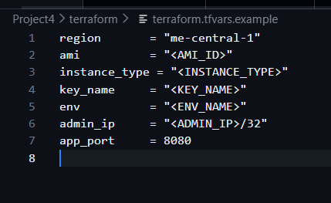
After running:
terraform init
terraform plan -var-file=environments/dev.tfvars
terraform apply -var-file=environments/dev.tfvars -auto-approve
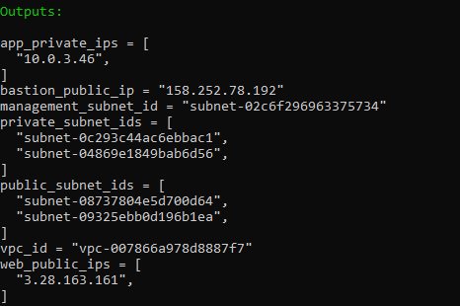

7. Part 4 — Ansible Implementation
7.1 Dynamic Inventory & Global Configuration
Ansible uses AWS EC2 dynamic inventory with tag-based grouping:
- Hosts are grouped by Tier tag
- ansible.cfg is configured for SSH key usage and inventory path
Deliverables:
- Screenshot: project4_part4_ansible_inventory_dev.png
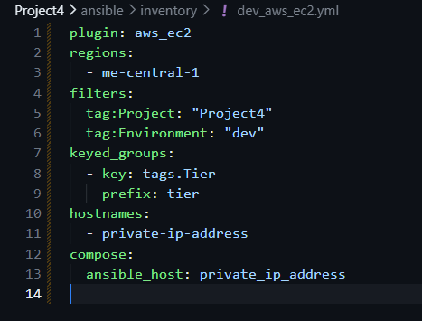
- Screenshot: project4_part4_ansible_cfg.png
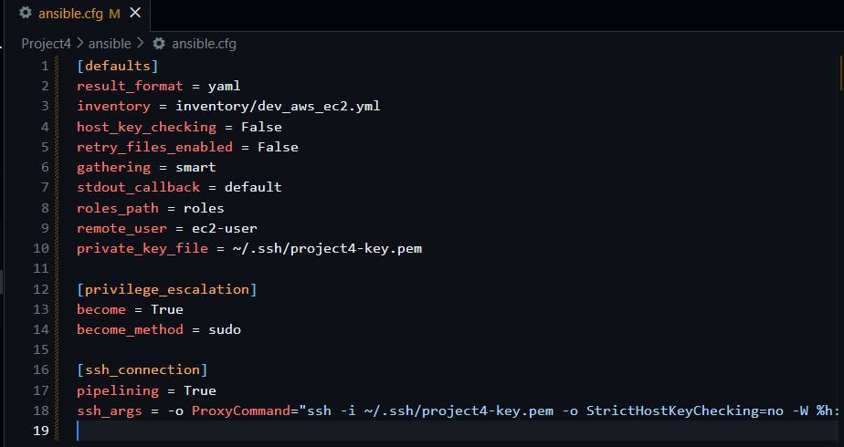
- Screenshot: project4_part4_group_vars_all.png
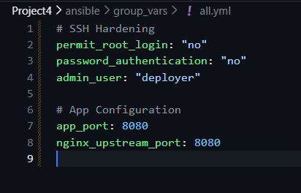
- Inventory graph
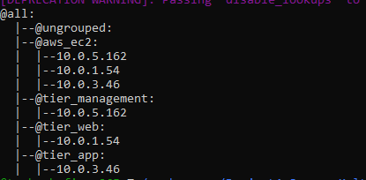
7.2 Server Hardening
The hardening role performs:
- Creation of non-root deployer user
- Disabling root login
- Enforcing SSH key-only access
- Fixing permissions on .ssh and sshd_config
Deliverables:
- Screenshot: project4_part4_hardening_role_main.png
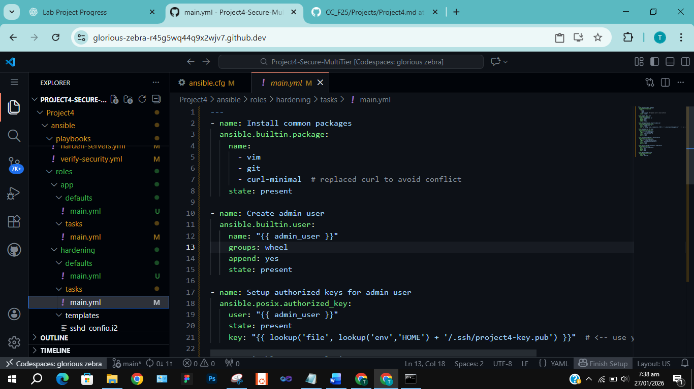
- Screenshot: project4_part4_harden_execution.png
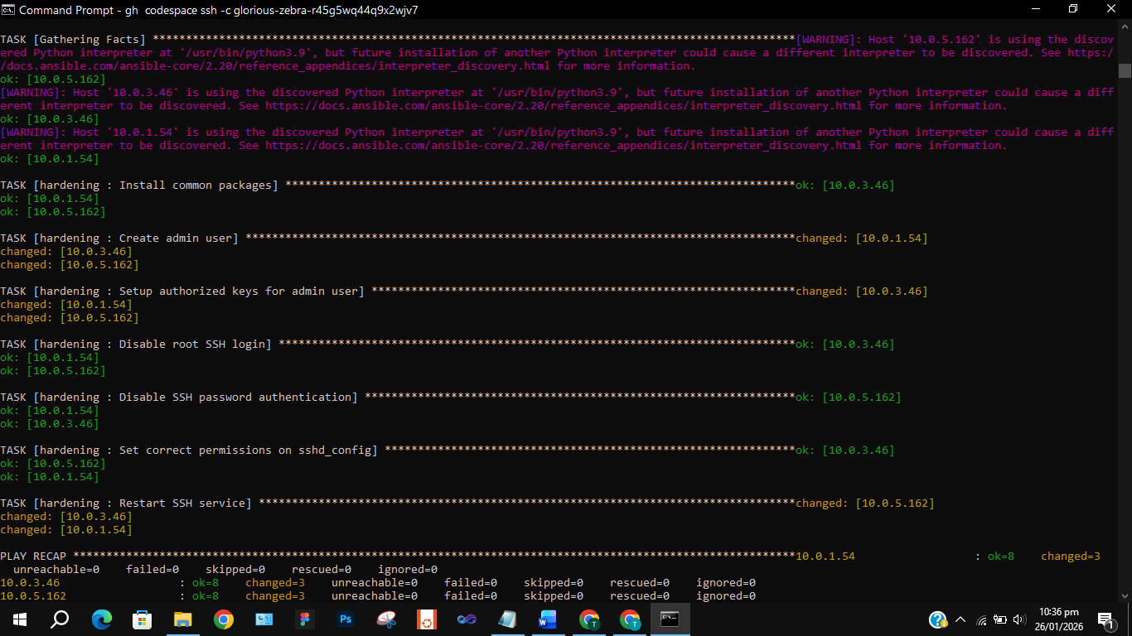
- project4_part5_sshd_config_evidence.png
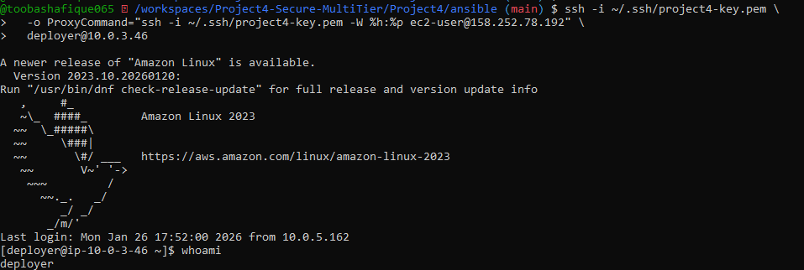
7.3 Nginx Reverse Proxy & Application Tier
The web tier runs Nginx configured to:
- Accept HTTP traffic on port 80
- Forward requests to app tier on port 8080
- Serve health check endpoints (/health)
Deliverables:
- Screenshot: project4_part4_nginx_conf_template.png
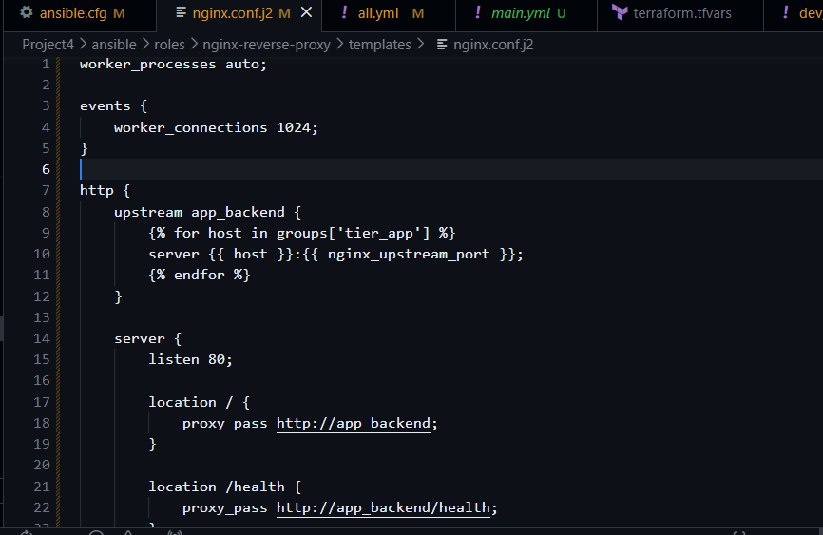
- Screenshot: project4_part4_configure_nginx_execution.png
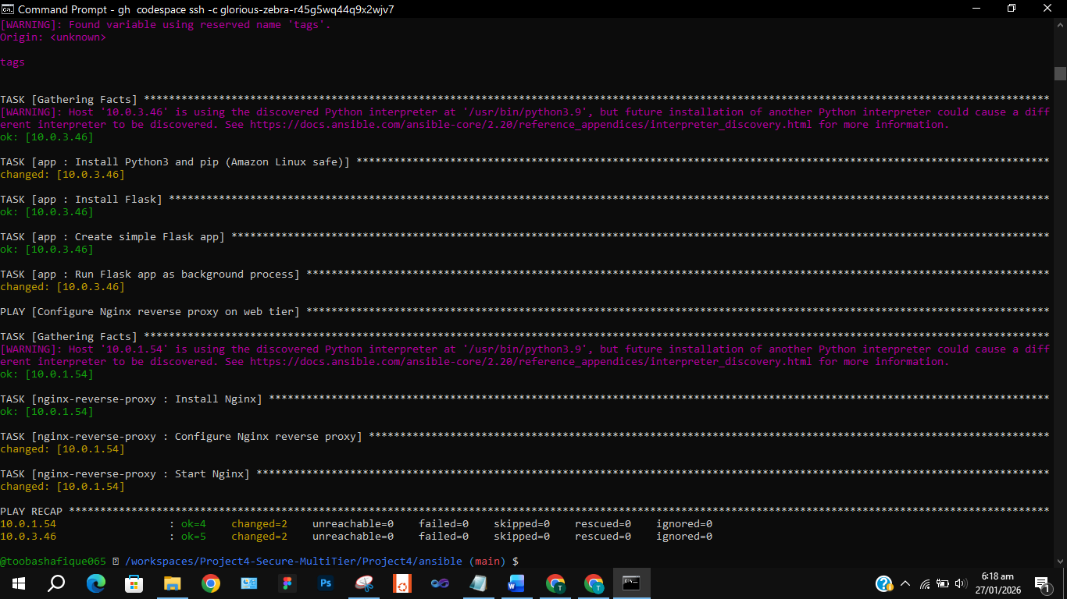
- project4_part4_nginx_proxy_test.png
- Verification was performed using both ec2-user and deployer accounts. Since services run system-wide, both accounts produced the same output.
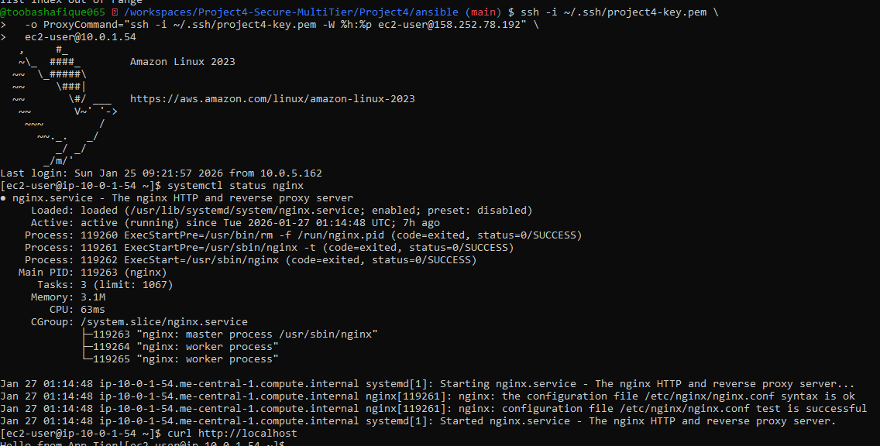
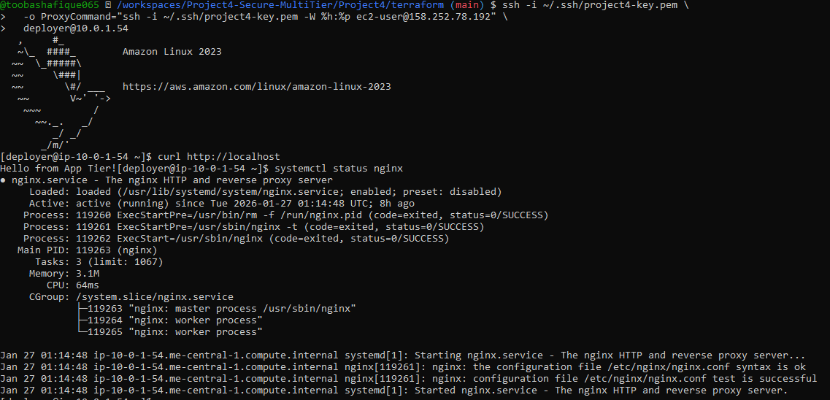
7.4 Log Collection for Evidence
Ansible collects:
- SSH logs
- Nginx access and error logs
Logs are stored in docs/logs/ for audit and compliance verification.
Deliverables:
- Screenshot: project4_part4_collect_logs_playbook.png
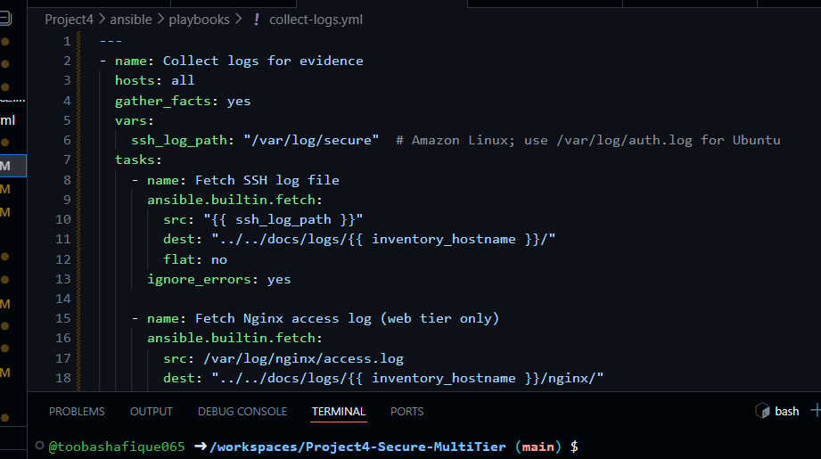
- Screenshot: project4_part4_logs_collected_tree.png
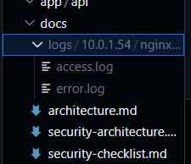

8. Part 5 — Security Testing & Compliance Checklist
8.1 Security Verification Tests
Tests confirm:
- Direct SSH to app tier fails
- SSH via bastion succeeds
- Nginx proxy correctly forwards traffic to app tier
Deliverables:
- Screenshot: project4_part5_bastion_ssh_flow.png

- Screenshot: project4_part5_nginx_proxy_working.png
- You can see when I ran curl http://localhost:8080 it gives : Hello from App tier!

- Screenshot: project4_part5_sshd_config_evidence.png
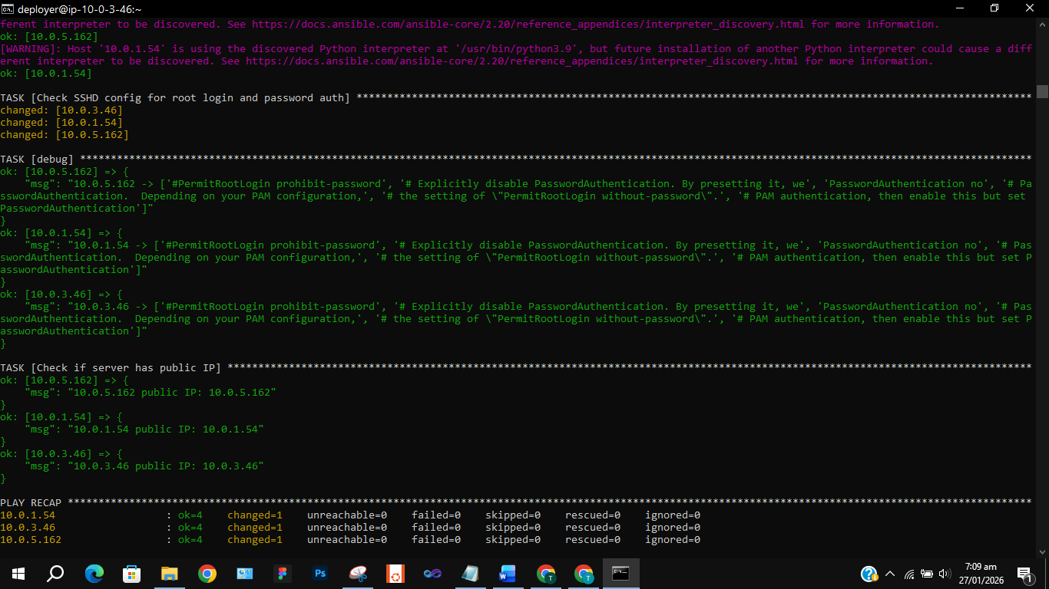
8.2 Security Compliance Checklist
Checklist confirms:
- Root login is disabled
- SSH key-only access is enforced
- App tier has no public IPs
- Logs are successfully collected
Deliverables:
- Screenshot: project4_part5_security_checklist_doc.png
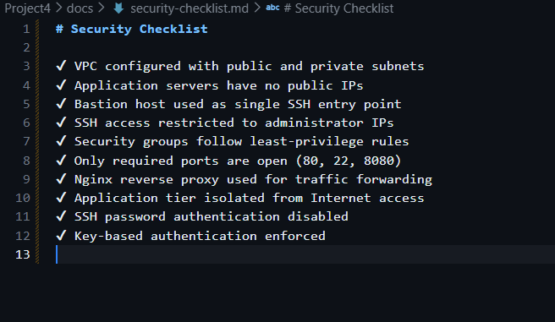

9. Part 6 — Challenges & Solutions
1. Terraform Deployment Issues
- Challenge: Initial Terraform runs failed due to AMI/region mismatches and unsupported instance types. Some resources didn’t provision correctly because of missing tags required for Ansible dynamic inventory.
- Solution: Verified AMI IDs and region compatibility, updated Terraform variables, and ensured all EC2 instances had consistent Project and Tier tags. Re-ran terraform apply until infrastructure deployed cleanly.
2. SSH Access & Hardening Challenges
- Challenge:
  - Direct SSH to app tier failed (no public IPs).
  - deployer user couldn’t read /etc/ssh/sshd_config without sudo.
  - Ansible hardening role initially misconfigured group membership (sudo vs wheel).
- Solution:
  - Used bastion host with ProxyCommand for secure SSH access.
  - Enabled become: true in Ansible playbooks to check SSHD config without needing a password.
  - Corrected group membership and variable scoping in Ansible roles to ensure deployer had sudo privileges.
3. Nginx Proxy / Networking Issues
- Challenge:
  - Nginx initially returned 502 Bad Gateway because the Flask app wasn’t running or listening on the correct port.
  - Health endpoint misconfigured in nginx.conf.
- Solution:
  - Verified Flask app with curl localhost:8080.
  - Updated Nginx upstream block to point to app tier private IPs on port 8080.
  - Added /health route in both Flask app and Nginx config.
  - Restarted services and confirmed proxy worked with curl http://<web-tier-public-ip>.
4. Log Collection Issues
- Challenge:
  - Ansible fetch task failed for /var/log/secure because Amazon Linux 2023 uses journalctl instead of flat log files.
  - Logs initially saved outside the project folder due to wrong dest path (../../ instead of ../).
- Solution:
  - Adjusted playbook to store logs under docs/logs/.
  - Documented the OS difference in README (SSH logs unavailable, but Nginx logs collected successfully).
  - Verified with tree docs/logs/ showing access.log and error.log.

10. Part 7 — Conclusion & Future Improvements
Final Outcome
- Successfully deployed a secure multi-tier architecture on AWS using Terraform and Ansible.
- Implemented hardening measures (non-root user, SSH key-only access, disabled root login).
- Configured Nginx reverse proxy to route traffic from web tier to app tier.
- Verified compliance with security checklist and collected logs for evidence.
Security Improvements Achieved
- Root login disabled → prevents unauthorized root access.
- Password authentication disabled → enforces key-only SSH.
- App tier isolated → no public IPs, accessible only via bastion.
- Centralized logging → Nginx logs collected for audit and evidence.
- Configuration automation → reproducible and consistent security setup via Ansible.
Future Enhancements
- Monitoring & Alerting → integrate CloudWatch or Prometheus/Grafana for real-time metrics and alerts.
- SSL/TLS Certificates → secure Nginx reverse proxy with HTTPS using Let’s Encrypt.
- Scaling & Load Balancing → add AWS ALB/ELB to distribute traffic across multiple app servers.
- CI/CD Integration → automate deployment pipelines for faster updates.
- Centralized Log Management → forward logs to ELK stack (Elasticsearch, Logstash, Kibana) for analysis.

11. Appendices
Appendix A — Code Snippets
A.1 Terraform Tagging Evidence
tags = {
Project = "Project4"
Environment = "dev"
Tier = "app"
}
1–2 lines explanation:
This Terraform snippet shows consistent resource tagging used for environment isolation, inventory discovery, and tier identification.

A.2 Ansible SSH Hardening Task
- name: Disable root login
lineinfile:
path: /etc/ssh/sshd_config
regexp: '^PermitRootLogin'
line: 'PermitRootLogin no'
- name: Disable password authentication
lineinfile:
path: /etc/ssh/sshd_config
regexp: '^PasswordAuthentication'
line: 'PasswordAuthentication no'
Explanation:
These Ansible tasks enforce SSH hardening by disabling root login and password-based authentication.

A.3 Nginx Reverse Proxy Upstream
upstream app_backend {
server 10.0.3.46:8080;
}
Explanation:
This configuration enables Nginx to forward traffic from the web tier to the private application tier.
Appendix B — Logs
Shows collected logs from my system:
- docs/logs/10.0.1.54/nginx/access.log.
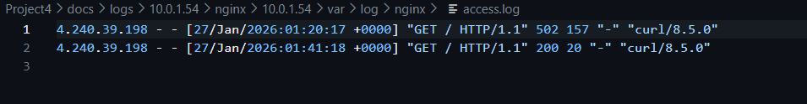
- docs/logs/10.0.1.54/nginx/error.log.
Appendix C — Screenshots
Insert all screenshots you’ve taken throughout the project:
- project4_part3_terraform_apply.png
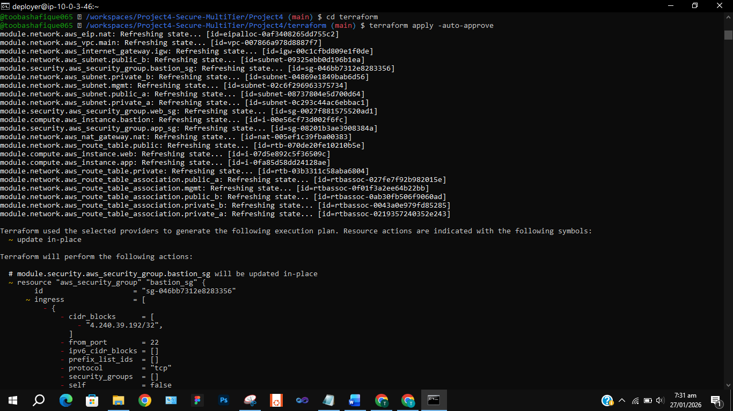
- project4_part3_terraform_output.png
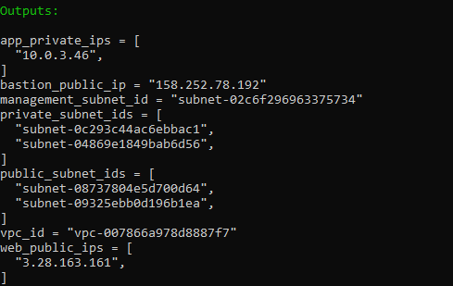
- project4_part4_collect_logs_playbook.png → playbook run for log collection.
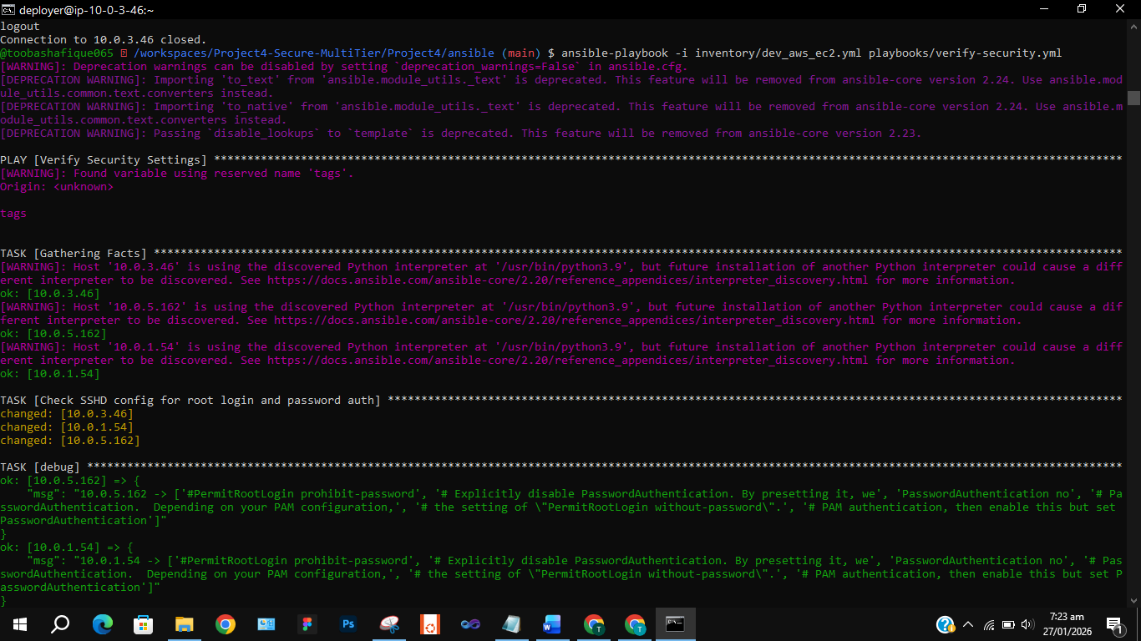
- project4_part4_logs_collected_tree.png → tree view of collected logs.
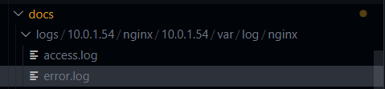

- project4_part5_bastion_ssh_flow.png → failed direct SSH, successful via bastion.
- project4_part4_flask_local_test.png
- Verification was performed using both ec2-user and deployer accounts. Since services run system-wide, both accounts produced the same output.
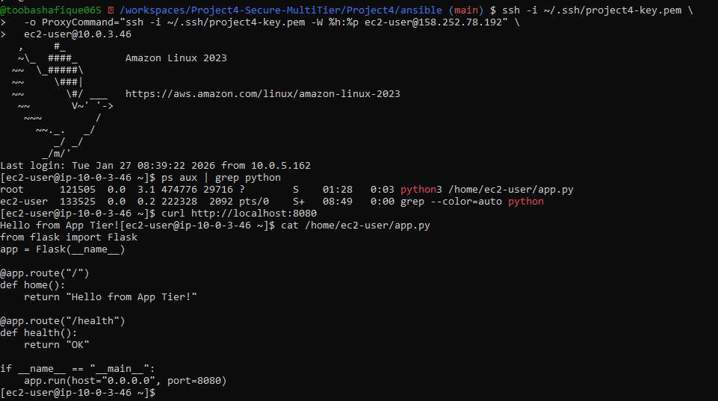
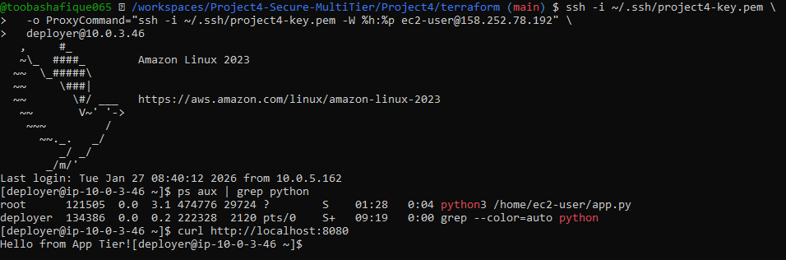
- project4_part5_nginx_proxy_working.png → curl showing proxy response.

- project4_part5_sshd_config_evidence.png → Ansible output proving root login disabled & password auth off.

- project4_part5_security_checklist_doc.png → compliance checklist ticked off.

Appendix D — Troubleshooting Notes
SSH Connectivity Issues
ssh -i ~/.ssh/project4-key.pem ec2-user@10.0.3.46
Failed as expected due to private subnet and no public IP.
ssh -i ~/.ssh/project4-key.pem \
-o ProxyCommand="ssh -i ~/.ssh/project4-key.pem -W %h:%p ec2-user@158.252.78.192" \
deployer@10.0.3.46
Successful SSH access via bastion host.

Reverse Proxy Verification
curl http://3.28.163.161/
Confirmed Nginx reverse proxy forwarded traffic to the application tier.

Security Verification
ansible-playbook -i inventory/dev_aws_ec2.yml playbooks/verify-security.yml
Verified SSH hardening and security configuration across all tiers.

