Peek/400
Version 4.0.8
User´s Manual

Produced by: Thomas Raddatz
e-mail: thomas.raddatz@tools400.de
Homepage: http://www.tools400.de
Release: 02.11.2026
© 1997-2026 Thomas Raddatz
Summary
1 Peek/400, Why? 6
2 Features And Restrictions 7
3 Download 9
4 License 10
4.1 Registration 10
4.2 Guarantee 10
5 New Features Of Version 4.0.8 11
6 Installation 12
6.1 Overview 12
6.2 Update Of A New Version 13
6.3 Roadmap 13
6.3.1 Preparing The Installation: 13
6.3.2 Finishing the Installation: 14
6.4 Change Command Language 14
7 Quick Start 15
8 Main Screen Of Peek/400 17
9 Functions Reference 19
9.1 What You Should Know 19
9.2 Subfile Options 19
9.2.1 Pin-Record 19
9.2.2 UnPin-Records 20
9.2.3 Change Record 20
9.2.4 Copy Record 20
9.2.5 Delete Record 21
9.2.6 Display Record 21
9.2.7 Copy Record Extern 21
9.2.8 Move Screen To The Left By One Field 23
9.2.9 Move Screen To The Right By One Field 23
9.2.10 Activation Of The SPLASH-Screen 23
9.2.11 Deactivation Of The SPLASH-Screen 24
9.2.12 Move Record to Top 24
9.2.13 Rebuild Program 24
9.2.14 Move Screen To The Next Marked Column 24
9.2.15 Move Screen To The Previous Marked Column 25
9.2.16 Select records access by key sequence 25
9.2.17 Select records access by record number sequence 26
9.2.18 „About“ 26
9.2.19 Hex Display Mode 26
9.2.20 Normal Display Mode 27
9.2.21 Colours 27
9.2.22 Save Environment 29
9.2.23 Load Environment 30
9.2.24 Delete Environment 31
9.3 Function Keys 31
9.3.1 SQL-SELECTION 31
9.3.2 Pin-Column 32
9.3.3 UnPin-Column 33
9.3.4 Exit 33
9.3.5 Prompt 33
9.3.6 Refresh 33
9.3.7 Insert Record 34
9.3.8 Toggle Headline 34
9.3.9 Mark Column 34
9.3.10 Release Mark Column 34
9.3.11 Display Database Relations 35
9.3.12 Position Cursor 36
9.3.13 Change Layout 36
9.3.14 Repeat Option 38
9.3.15 Enable Multi Colour Lines 38
9.3.16 Disable Multi Colour Lines 39
9.3.17 Extended column pin function 39
9.3.18 Search Engine 39
9.3.19 Top Of File 42
9.3.20 End Of File 42
9.3.21 Move Screen To The Left 42
9.3.22 Move Screen To The Right 43
9.3.23 Command Line 43
9.3.24 80/132 Display Mode 43
9.3.25 More Options 43
9.3.26 More Keys 43
9.4 Other Functions 44
9.4.1 Prompt 44
9.4.2 Short Command 44
10 Hex-Editor 46
10.1 Scrolling 47
10.2 Toggle Input Mode 47
10.3 Inserting Text 47
10.4 Deleting Text 47
11 Text-Editor 48
11.1 Scrolling 48
11.2 Inserting Text 49
11.3 Deleting Text 49
12 Keys and Options 50
12.1 Introduction 50
12.2 Example 50
12.2.1 Redefine of a key mapping 50
12.2.2 Redefine a key to an option 51
12.2.3 Define two choices for one function 51
12.3 Available functions of Peek/400 51
12.3.1 Main Program Of Peek/400, *PEEK05 51
12.3.2 Select Record Format, *PEEK12 53
12.3.3 Display Record, *PEEK14 53
12.3.4 Search Engine, *PEEK17 53
12.3.5 Colour, *PEEK24 54
12.3.6 Select Colour, *PEEK25 54
12.3.7 Target File, *PEEK26 54
12.3.8 Layout, *PEEK34 54
12.3.9 Prompt/Autoprompt: Fieldname, *PEEK37 55
12.3.10 Display Database Relations, *PEEK40 55
12.3.11 Hex-Editor, *PEEK45 56
12.3.12 Prompt: Select Member, *PEEK47 56
12.3.13 SQL Selection, *PEEK48 56
12.3.14 About, *PEEK49 57
12.3.15 Pin-Columns (Dialog), *PEEK50 57
12.3.16 Create Program, *PEEK52 57
12.3.17 Select Environment, *PEEK56 58
12.3.18 Delete Environment, *PEEK57 58
12.3.19 Message box, *PEEK59 58
12.3.20 Text-Editor, *PEEK64 58
12.3.21 Prompt: Select Subfile Option, *PEEK68 59
12.3.22 Prompt: Select File, *PEEK69 59
12.3.23 Update Programs, *Pxxxxxxxxx 60
12.3.24 Peek/400 Control Keys, *PGM 61
12.3.24.1 *ACCESSKEY (SET0003) 61
12.3.24.2 *CVTCHR (SET0006) 61
12.3.24.3 *CRTPGM (SET0012) 61
12.3.24.4 *DSPATR (SET0001) 62
12.3.24.5 *DFTDSPMDE (SET0011) 62
12.3.24.6 *ENVFILE (SET0015) 63
12.3.24.7 *FLOATKEYS (SET0009) 63
12.3.24.8 *LANGUAGE (SET0004) 63
12.3.24.9 *PROMPT (SET0008) 64
12.3.24.10 *PRVFILE (SET0014) 64
12.3.24.11 *SCROLL (SET0010) 64
12.3.24.12 *SEARCH (SET0002) 64
12.3.24.13 *SECATRDFT (SET0013) 65
12.3.24.14 *SPLASH (SET0005) 65
12.3.24.15 *VERSION (SET0007) 65
13 Tips & Tricks 66
13.1 Peek/400 and end-user!? 66
13.2 Create Your Own Default Keyboard Mapping 68
13.3 Your Own Language for Peek/400 68
14 EXIT-Programs 70
14.1 User´s Authority (EXIT01) 70
14.2 User Settings File (EXIT02) 70
14.3 Edit Codes Of The Update Programs (EXIT03) 70
14.4 Logging Of Changes (EXIT04) 71
14.5 Function Keys And Subfile Options (EXIT05) 71
14.6 Field Text And Column Headings (EXIT06) 72
15 Help me! 73
16 History 74

Peek/400, Why?
Peek/400 offers some special features that you will not find within other browsers and it is cheap.
Give it a go if you need one or more of the following features:
- Use Commit and Rollback
- Make use of the dedicated activation group for Peek/400
- Have a quick overlook due to the subfile representation of the records
- Use the 80/132-character mode representation
- Make use of the pin-function for columns
(„Pin“ your columns at the left edge of the screen)
- Make use of the pin-function for rows
(„Pin“ your rows at the top of the subfile)
- Use its powerful search engine
- Assign the commands of Peek/400 to your own keys
- Define your own language, German and English user interface
(Create your own language definition file)
- Have a look at records containing characters below x’40’ or equal x’FF’
(But be sure that you will not be able to edit them just with the hex-editor!)
- Hex-Editor for fields
(Edit fields with characters below x´40´ or equal x´FF´ with the hex-editor!)
- SQL selection and sorting of records by WHERE and ORDER BY
(In addition to the classic access methods: by key and by record sequence)

Features And Restrictions
The following field types are supported:
- alpha-numeric fields
- binary fields
- packed fields
- zoned fields
- date fields
- time fields
- timestamp fields
The following field type have not been tested yet:
- DBCS-Either
- DBCS-Only
- DBCS-Open
The following field type are not supported:
- floating-Point
- graphic data without CCSID
- hexadecimal
- unknown fields
To utilize the full range of features in Peek/400, an operating system version of V7R3M0 or higher and an ILE-RPG compiler are required.
The compiler is necessary because Peek/400 generates file-specific programs at runtime to facilitate the modification of data records.
This ensures maximum security when modifying your data sets.
Without an ILE-RPG compiler, the following functions are unavailable:
- Adding records
- Editing records
- Copying records within the same file

Download
Peek/400 is provided in as a single version that can be run in a CISC or RISC environment running OS/400 V7R3M0 or higher.
If you have a RISC environment Peek/400 will be converted to RISC by the operating system without any interaction from you.

License

Registration
Dies program is Freeware. There is no registration necessary.

Guarantee
Although we try to avoid any mistakes within Peek/400 it is not possible to develop a software without any mistakes. Therefore it may be that there will be an error left within Peek/400.
We can not guarantee that Peek/400 will do its work within any environment and on every AS/400.
Peek/400 is supplied as it is. We assumes no liability for damages, direct or consequential, which may result from use of Peek/400
We recommend to test Peek/400 with uncritical data before accessing critical data!
We appreciate any error reports but we can not guarantee that all errors will be fixed.

New Features Of Version 4.0.8
The following new features have been added or changed:
 | - | New headline type *COLHDG: F7 shows the column headings (COLHDG) of the fields in one line.
 | - | Empty field texts are replaced by the column headings, e.g. for SQL tables without LABEL ON ... TEXT IS.
 | - | New exit program EXIT06 to override the field text and the column headings (see chapter 14.6).
 | - | Fixed broken special characters, umlauts and accents.
 | - | Existing update programs show the column headings and the replaced field texts only after they have been rebuilt with option „RB“.

 | Updating Peek/400 will automatically add new keyboard settings.  Existing keyboard assoziations will not be changed!

Installation

Overview
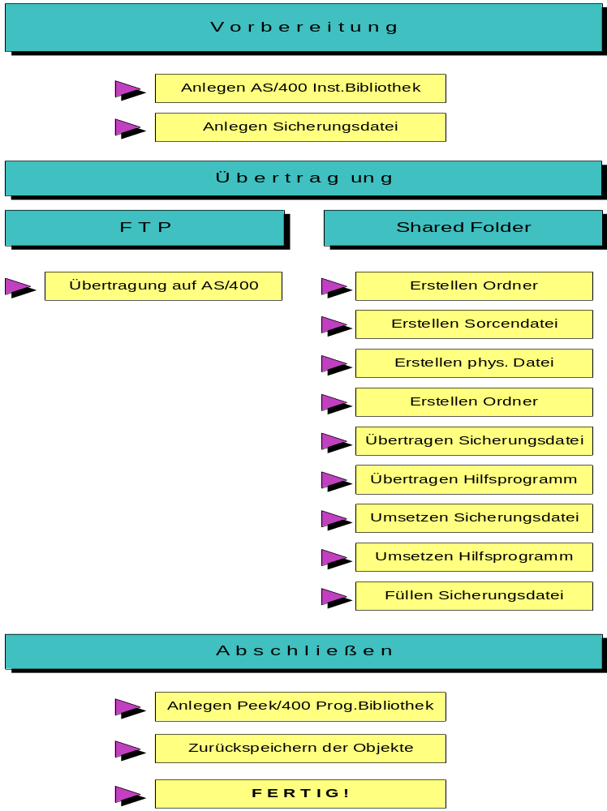
(Screen: Installation of Peek/400

Update Of A New Version
If you are going to restore an update of Peek/400 we recommend to rename the old program library of Peek/400 before restoring the new one. This will ensure that all of the update programs will be rebuild by Peek/400.

 | If you did any changes to the configuration files of Peek/400, e.g. PEEKSRC or PEEKUSR or EXIT01PF, these changes will be lost, then.  You should verify the new configuration files and add your changes again.

Roadmap
The installation of Peek/400 is not very complicated if you just follow the roadmap step by step. It is even much more easier if you have TPC/IP installed on your AS/400.
Follow the roadmap:

Preparing The Installation:
- Create a library PEEKINST on your AS/400 system.
CRTLIB LIB(PEEKINST)
- Create a save file PEEK placed into the library PEEKINST.
CRTSAVF FILE(PEEKINST/PEEK)
- Send the save file from your PC to your AS/400. Replace '###' with the current version number.
binary
put peek###.sav peekinst/peek (sending from the PC to the AS/400)
or
binary
get peek###.sav peekinst/peek (replace (receiving on the AS/400 from the PC)

Be sure to transfer the file having the binary mode enabled!

Finishing the Installation:
- Create a library PEEK on your AS/400.
CRTLIB LIB(PEEK)
- Restore all objects of Peek/400:
RSTOBJ OBJ(*ALL)
SAVLIB(PEEK)
DEV(*SAVF)
OBJTYPE(*ALL)
SAVF(PEEKINST/PEEK)
OUTPUT(*PRINT)
- Ready! Now you can safely delete library PEEKINST.
- We recommend to create a copy of the command PEEK into the library QGPL or QUSRSYS:
CRTDUPOBJ OBJ(PEEK)
FROMLIB(PEEK)
OBJTYPE(*CMD)
TOLIB(QGPL)
NEWOBJ(PEEK)

Change Command Language
You can recompile commands PEEK and TREE for a language that is supported by Peek. At the moment GER, ENG, SPA, ITA and FRA are the only supported languages.
You should consider recompiling the Peek/400 commands in case most of your users are non German speakers.
PEEKINIT LANGUAGE(GER | ENG | SPA | ITA | FRA)

Quick Start
Peek/400 will be started by entering PEEK at a command line.
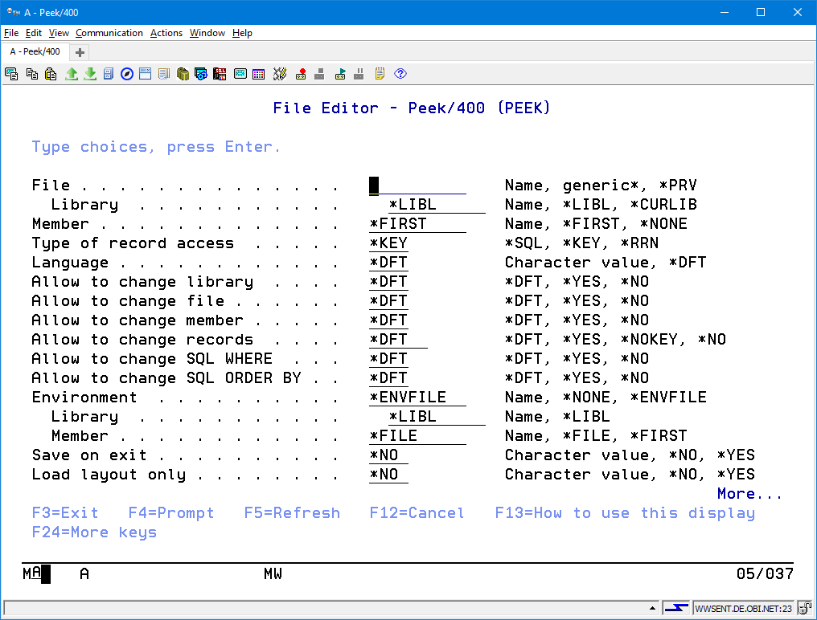
(Screen: How to start Peek/400)
There are the following key words available:
File: File name and library name of the file to be explored.
Member: Name of the file member
Type of record access:
Display by record sequence (= *RRN) or by key sequence (= *KEY)
Language: Language to be used for the user interface.
Enter the short cut of the language to be used.
Example: GER is the short cut for the German language and ENG is the short cut for the English language.
Allow to change library:
Allowed to change the library in the main screen of Peek/400.
Allow to change file:
Allowed to change the file in the main screen of Peek/400.
Allow to change member:
Allowed to change the member in the main screen of Peek/400.
Allow to change records:
Allowed to insert, change, delete or copy records.
Allow to change SQL WHERE
Specifies whether or not it is allowed to change the SQL WHERE clause used to select the records to be displayed.
Allow to change SQL ORDER BY
Specifies whether or not it is allowed to change the SQL ORDER BY clause that defines the sort sequence of the records.
Environment:
Environment that should be loaded immediately after program start.
Save on exit:
Specifies whether or not the current environment is saved to the specified environment file and member when the program ends.
Load layout only:
Specifies whether or not to load only the layout from the specified environment file and keep the specified file and member.
User settings:
Specifies which user settings are used. By default the user settings are stored in the Peek/400 product library. The name of the settings file is equal to the name of the user profile that is signed on to the system.
SQL WHERE clause:
Specifies a SQL WHERE clause to select the records that are displayed.
SQL ORDER BY clause:
Specifies a SQL ORDER BY clause to set the sort sequence of the records that are displayed.
The first invocation of Peek/400 will need a longer time than the next ones due to initialisation stuff that has to be done.

Main Screen Of Peek/400
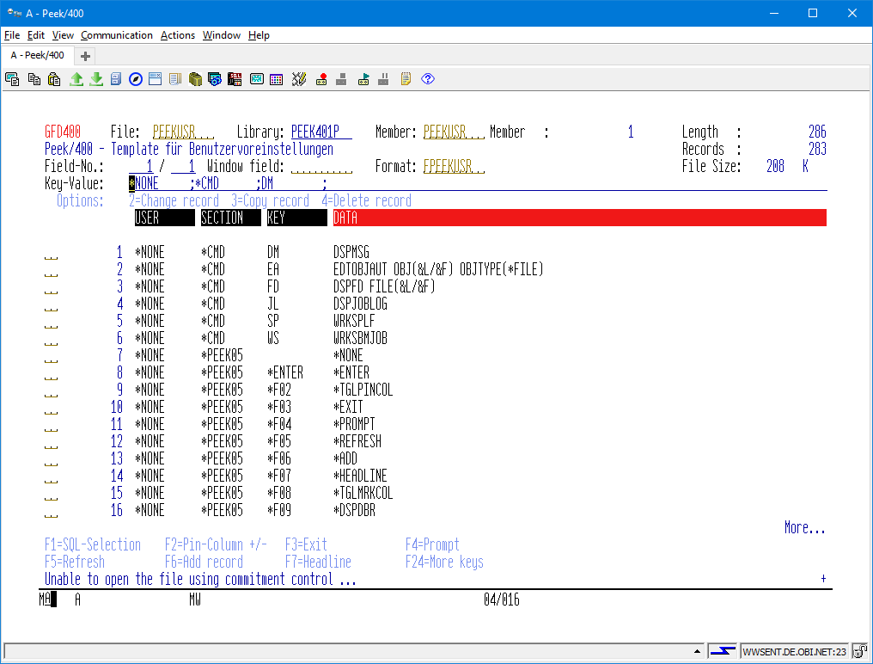
(Screen: Main screen of Peek/400)
There are the following information available listed from left to right:
- Name of the AS/400-Systems
- File name, library and member of the opened file
- Record length of the opened file
- Object description of the opened file
- Number of active records of the opened file
- Number of the first visible field
- Field where you may enter a name of a field to position the screen
- Name of the record format of the opened file
- Object size of the opened file
There are the following abilities for navigation available:
Enter the number of a field to scroll left and right.
Enter the name of a field to scroll left and right.
Enter the key or a part of the key to scroll up and down.
You have to separate the fields of the key by a blank or the negative sign if the is a need for negative values.
More options and function keys:
Simply have a look at the screen and use F23 and F24 to explore the options for the subfile and the function keys.

Functions Reference

What You Should Know
Due to the fact that you are able to assign the functions of Peek/400 to the keys and options of your choice we can not speak of keys and options within this handbook. You may have already changed it!
Therefore it is not possible to say “... by pressing F2 ...”.
Instead you will find expressions like that:
„... you are able to refresh the screen by the function „AKTUALISIEREN“ ...“
The default keyboard mapping will be shown as the following examples:
Function: „AKTUALISIEREN“
Default: Key „F5“
Program function: *REFRESH
The following phrase “*TGL” is a substitute for the English verb “to toggle”.
Functions including this prefix are able to switch a function on and off.
You may refer to the functions “ZEILEN PINNEN” (*PINROW) and “ZEILEN LÖSEN” (*UNPINROW). The first one pins a row and the second one unpins a row. But instead of them you may also use „UMSCHALTEN ZEILEN PINNEN“ (*TGLPINROW).

Subfile Options

Pin-Record
This function pins a record at the top of the subfile. Pinned records will not be affected by paging up and down. They stay at the top of the subfile until they are released by the user.
You have to use “ZEILEN LÖSEN” to release a pinned record.
If you refresh the screen your pinned records will be refreshed as well.
Function: „ZEILEN PINNEN“
Default: Option „P“
Program function: *PINROW
Function: „UMSCHALTEN ZEILEN PINNEN“
Default: *NONE
Program function: *TGLPINROW

UnPin-Records
This function will release pinned records.
Function: „ZEILEN LÖSEN“
Default: Option „U“
Program function: *UNPINROW*
Function: „UMSCHALTEN ZEILEN PINNEN“
Default: *NONE
Program function: *TGLPINROW
Function: „ALLE ZEILEN LÖSEN“
Default: *NONE
Program function: *CLRPINROW

Change Record
This function is to be used to change the contents of a record.
Peek/400 has to generate a program to perfume this request. The program will be build once after the file format has been changed (level check).
(The program will be used by the functions KOPIEREN and EINFÜGEN, too.)
Function: „ÄNDERN“
Default: Option „2“
Program function: *CHANGE

Copy Record
This function allows to copy a record within the same file.
Peek/400 has to generate a program to perfume this request. The program will be build once after the file format has been changed (level check).
(The program will be used by the functions ÄNDERN and EINFÜGEN, too.)
Function: „KOPIEREN“
Default: Option „3“
Program function: *COPY

Delete Record
This function deletes a record from the file.
There is no special program necessary.
Function: „LÖSCHEN“
Default: Option „4“
Program function: *DELETE

Display Record
This function displays a record within a window.
There is no special program necessary.
Function: „ANZEIGEN“
Default: Option „5“
Program function: *DISPLAY

Copy Record Extern
This function is to be used to copy a record to an external file.
There is no special program necessary.
Function: „EXT.KOPIEREN“
Default: Option „9“
Program function: *COPYEXT
Before the copy request can be performed you have to enter the target file, first:
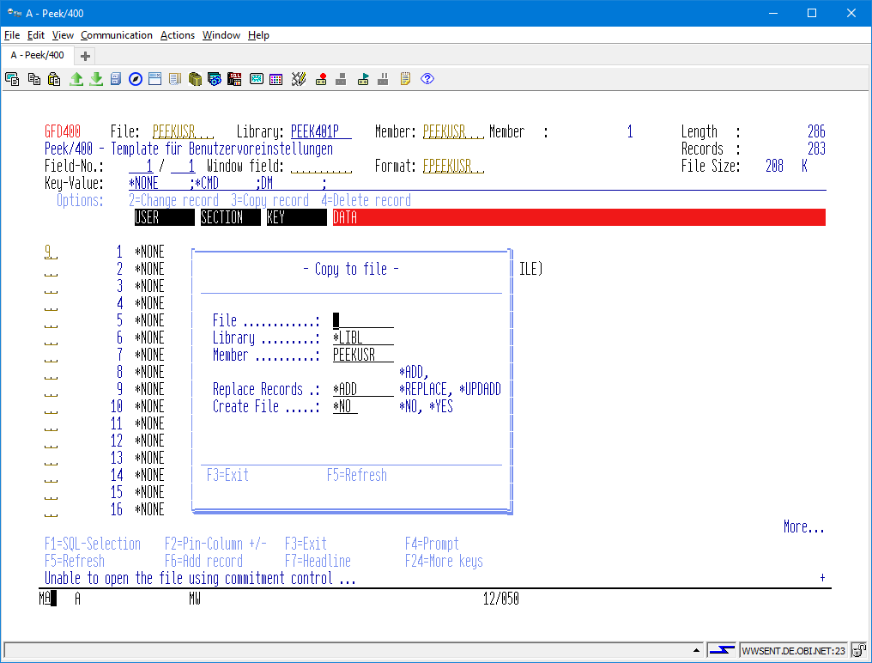
(Screen: Copy record extern Peek/400)
File:
Name of the target file.
Library:
Name of the library holding the target file.
You may specify *LIBL if the target file exists.
Member:
Name of the member of the target file.
Replace:
Whether or not the records within the target file are replaced by the new records.
Create file:
Whether or not the target file will be created if it does not yet exist.

Move Screen To The Left By One Field
This function moves the screen to the left by one single field.
Function: „LINKS“
Default: Option „L“
Program function: *LEFT

The default keyboard mapping has been changed from F19 to option “L”.

Move Screen To The Right By One Field
This function moves the screen to the right by one single field.
Function: „RECHTS“
Default: Option „R“
Program function: *RIGHT

The default keyboard mapping has been changed from F20 to option “R”.

Activation Of The SPLASH-Screen
This function enables the splash screen that is been shown at the start of Peek/400.
Function: „EINSCHALTEN SPLASH SCREEN“
Default: Option „S+“
Program function: *SPLASHON

(Screen: SPLASH-Screen of Peek/400)

Deactivation Of The SPLASH-Screen
This function disables the splash screen that is been shown at the start of Peek/400.
Function: „AUSSCHALTEN SPLASH SCREEN“
Default: Option „S-“
Program function: *SPLASHOFF

It is not possible to deactivate the splash screen with the shareware licence of Peek/400.

Move Record to Top
This function moves a record to the top of the subfile.
Records are moved by “Point & Shoot”. Point to the record by the cursor and execute the move record function.
Function: „NACH OBEN ZIEHEN“
Default: Key „T“
Program function: *MOVETOP

The default keyboard mapping of F9 has been changed. You will find the display relations by pressing F9 now.

Rebuild Program
This function rebuilds the program that is used for changing, deleting and copying of records.
Function: „PROGRAMM ERSTELLEN“
Default: Option „RB“
Program function: *REBUILD

Move Screen To The Next Marked Column
This function moves the screen to the next marked column. It will wrap after the end of the columns has been reached.
Function: „NÄCHSTE MARKIERTE SPALTE“
Default: Option „X“
Program function: *NEXTMARK

You are able to mark columns by using F8 within the default keyboard mapping.

Move Screen To The Previous Marked Column
This function moves the screen to the previous marked column. It will wrap after the first of the columns has been reached.
Function: „VORHERIGE MARKIERTE SPALTE“
Default: Option „Y“
Program function: *PREVMARK

You are able to mark columns by using F8 within the default keyboard mapping.

Select records access by key sequence
This function selects record access by key sequence.
The new position of the subfile depends on the position of the cursor of the screen at the moment the function was executed:
- If the cursor was placed above the old subfile the new subfile will show the first record of the file as the first record of the new subfile.
- If the cursor was placed below the old subfile the new subfile will show the last record of the file as the last record of the new subfile.
- If the cursor was placed within the pinned records of the old subfile the new subfile will show the first record below the pinned records of the old subfile as the first record of the new subfile below the pinned records.
- If the cursor was placed within the „normal“ records of the old subfile the new subfile will show the record pointed by the cursor as the first record of the new subfile.
Function: „SCHLÜSSELFOLGE“
Default: *NONE
Program function: *KEY
Function: „UMSCHALTEN SORTIERUNG“
Default: Option „S“
Program function: *TGLACCESS

Select records access by record number sequence
This function selects record access by record number sequence.
The new position of the subfile depends on the position of the cursor of the screen at the moment the function was executed:
- If the cursor was placed above the old subfile the new subfile will show the first record of the file as the first record of the new subfile.
- If the cursor was placed below the old subfile the new subfile will show the last record of the file as the last record of the new subfile.
- If the cursor was placed within the pinned records of the old subfile the new subfile will show the first record below the pinned records of the old subfile as the first record of the new subfile below the pinned records.
- If the cursor was placed within the „normal“ records of the old subfile the new subfile will show the record pointed by the cursor as the first record of the new subfile.
Function: „SATZFOLGE“
Default: *NONE
Program function: *RRN
Function: „UMSCHALTEN SORTIERUNG“
Default: Option „S“
Program function: *TGLACCESS

„About“
This function will show up the „About“ screen of Peek/400.
The „About“ screen will give you specific information about the version of Peek/400 and the actual address of the homepage of Peek/400 in the internet.
Function: „ABOUT“
Default: Option „A“
Program function: *ABOUT

Hex Display Mode
This function switches the main screen of Peek/400 into hex display mode.
Function: „HEX MODUS EIN“
Default: *NONE
Program function: *DSPHEX
Function: „UMSCHALTEN ANZEIGE MODUS“
Default: Option „H“
Program function: *TGLDSP

Normal Display Mode
This function switches the main screen of Peek/400 into normal display mode.
Function: „HEX MODUS AUS“
Default: *NONE
Program function: *DSPNRM
Function: „UMSCHALTEN ANZEIGE MODUS“
Default: Option „H“
Program function: *TGLDSP

Colours
This function allows to define your own colours for the main screen of Peek/400.
Have a look at the following dialog:
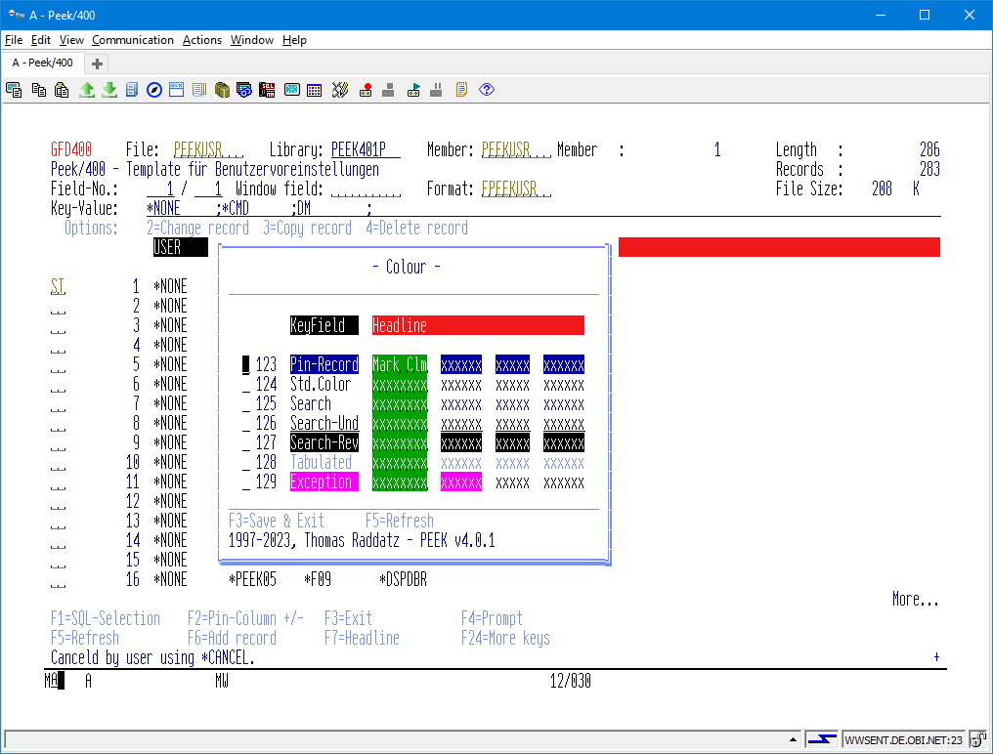
(Screen: Colours of Peek/400)
Function: „BENUTZEREINSTELLUNGEN“
Default: Option „ST“
Program function: *USERSETG

The default keyboard mapping has been changed from F15 to “ST”.
F15 has been mapped to the extended column pin function.
Colours are changed by “Point & Shoot”. Point to the colour to be changed by the cursor and press ENTER to execute your request.
The following screen will be displayed to select a new colour:
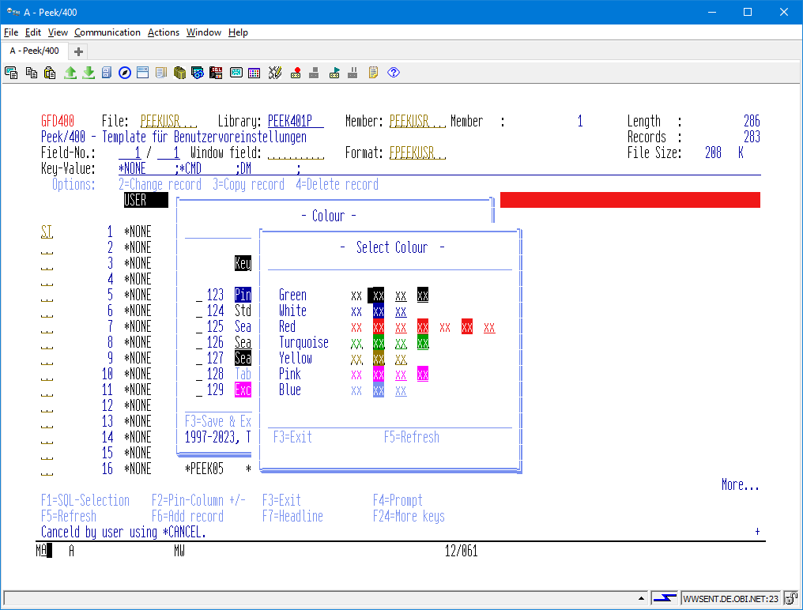
(Screen: Select a new colour for Peek/400)
Save the new settings by „SICHERN & BEENDEN“ or cancel by „ABBRECHEN“.
Function: „SICHERN & BEENDEN“
Default: Key „F3“
Program function: *SAVE_EXIT
Function: „ABBRECHEN“
Default: Key „F12“
Program function: *CANCEL

Save Environment
This function saves the actual envirnoment to a specified member of your choice.
The properties beeing saved are:
- Sort sequence
- SQL select/order by
- Pinned rows
- Pinned columns
- Layout of the file
Function: „SICHERN ARBEITSUMGEBUNG“
Default: SE
Program function: *SAVEENV
The environment settings are stored in individual members in file PEEKENV. The library where PEEKENV is stored is specified in the preferences record associated to key *ENVFILE.

Load Environment
This function loads an envirnoment from a specified member of your choice.
The properties beeing loaded are:
- Sort sequence
- SQL select/order by
- Pinned rows
- Pinned columns
- Layout of the file
If you are going to load an environment you must be aware of the following restrictions:
- Sort sequence will be restored without restrictions
- Pinned rows are only restored if the file actually open is the same one when the environment had been saved. (Same File, same library)
- In order to restore the remaining properties the filename must match only.
Function: „LADEN ARBEITSUMGEBUNG“
Default: LE
Program function: *LOADENV
The environment settings are automatically loaded on opening a file, if the name of the file matches the name of the environment settings.

Delete Environment
This function dedicated to delete an environment.
Function: „LÖSCHEN ARBEITSUMGEBUNG“
Default: DE
Program function: *DELETEENV

Function Keys

SQL-SELECTION
The function „SQL-AUSWAHL“ let you select and order records by SQL.

This function is only available in conjunction with physical files!

It is not possible to position the subfile by entering a key value or a record number. All other options and functions will work as before.
Function: „SQL-AUSWAHL“
Default: Funktionstaste „F1“
Program function: *SQL
The dialog looks like this:
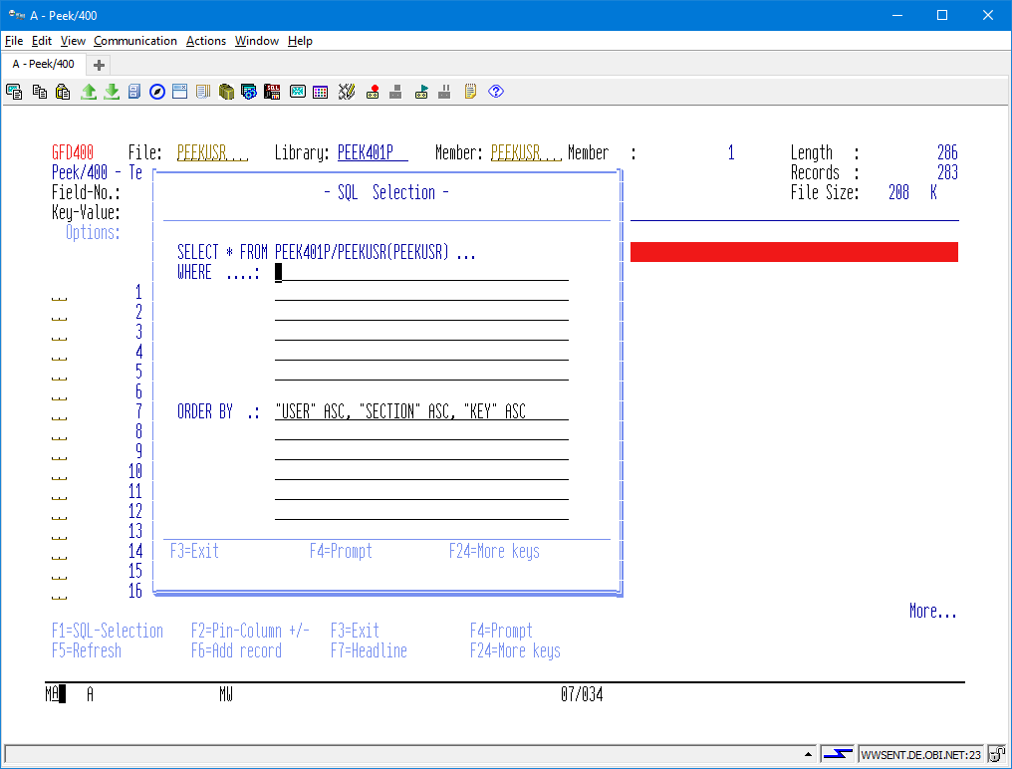
(Screen: SQL-Selection of Peek/400)
The fields of the current file can be viewed and inserted by „PROMPT“ (*PROMPT, F4). The selected field will be inserted at the current position of the cursor.
The key fields of the current file can be inserted by „EINFÜGEN SCHLÜSSELFELDER“ (*INSKEYFLD, F11). The fields will be inserted at the current position of the cursor.

Pin-Column
This function pins a column at the left edge of the subfile. The pinned columns will not be affected by scrolling left and right. They stay at the left edge of the subfile until they are released by the user.
Columns are pinned by “Point & Shoot”. Point to the column by the cursor and execute the pin function.
Function: „SPALTEN PINNEN“
Default: *NONE
Program function: *PINCOL
Function: „UMSCHALTEN SPALTEN PINNEN“
Default: Key „F2“
Program function: *TGLPINCOL

UnPin-Column
This function releases pinned columns.
Columns are unpinned by “Point & Shoot”. Point to the column by the cursor and execute the unpin function.
Function: „SPALTEN LÖSEN“
Default: *NONE
Program function: *UNPINCOL
Function: „UMSCHALTEN SPALTEN PINNEN“
Default: Key „F2“
Program function: *TGLPINCOL
Function: „ALLE SPALTEN LÖSEN“
Default: *NONE
Program function: *CLRPINCOL

Exit
This function exits Peek/400.
All user settings will be save.
Function: „BEENDEN“
Default: Key „F3“
Program function: *EXIT

Prompt
This function shows a field specific dialog in order to select an option.
Function: „PROMPT“
Default: Funktionstaste „F4“
Program function: *PROMPT

Refresh
This function refreshes the screen.
Function: „AKTUALISIEREN“
Default: Key „F5“
Program function: *REFRESH

Insert Record
This function inserts a record into the opened file.
Peek/400 has to generate a program to perform this request. The program will be build once after the file format has been changed (level check).
(The program will be used by the functions ÄNDERN and KOPIEREN, too.)
Function: „EINFÜGEN“
Default: Key „F6“
Program function: *ADD

Toggle Headline
This function toggles the headline to display the field names, the field texts, the column headings (COLHDG) or the field names with data type. Fields without field text show their column headings instead.
Function: „ÜBERSCHRIFT“
Default: Key „F7“
Program function: *HEADLINE

Mark Column
This function marks “important” columns by a different colour.
Columns are marked by “Point & Shoot”. Point to the column by the cursor and execute the mark column function.
Function: „SPALTEN MARKIEREN“
Default: *NONE
Program function: *MRKCOL
Function: „UMSCHALTEN SPALTE MARKIEREN“
Default: Key „F8“
Program function: *TGLMRKCOL

Release Mark Column
This function releases marked columns.
Marked Columns are released by “Point & Shoot”. Point to the column by the cursor and execute the release marked column function.
Function: „SPALTEN MARKIERUNG AUFHEBEN“
Default: *NONE
Program function: *UNMRKCOL
Function: „UMSCHALTEN SPALTE MARKIEREN“
Default: Key „F8“
Program function: *TGLMRKCOL

Display Database Relations
This function displays all database relations of a physical file.
Function: „RELATIONEN ANZEIGEN“
Default: Key „F9“
Program function: *DSPDBR

The default keyboard mapping of F9 has been changed. You will find “move to top” by entering option “T” now.
The dialog looks like:
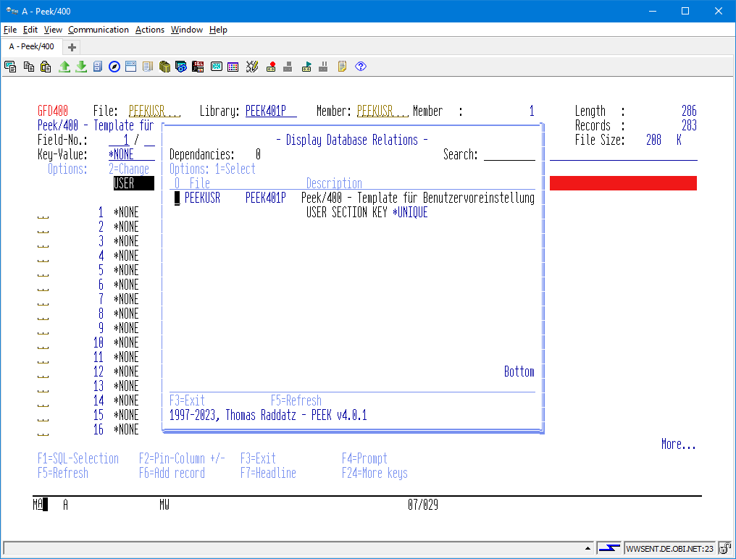
(Screen: Display Database Relations of Peek/400)

Position Cursor
This function places the cursor into the field to enter the relative record number or the key of the opened file.
Function: „CURSOR POSITIONIEREN“
Default: Key „F10“
Program function: *POSCSR

Change Layout
This function provides the ability to change the layout of the subfile. You are able to re-order the fields, to float key fields to top and to define a maximum width of the fields.
Function: „LAYOUT“
Default: Key „F11“
Program function: *LAYOUT
You are able to change the following attributes:
- Order of the fields
Define your own order of the fields.
- Hide a field if it is not of interest to you
Accepted values:
0 = hidden
1 = visible
- Editcode of a numeric field
Assign the editcode of your choice for the representation of a field within the subfile.
- Maximum width of a field
Define a maximum width of a field if its headline is to long.
- Colour of the marked columns
Change the colour of the marked columns function for a single field. You may also make use of the user settings dialog where you can define a global colour for marked columns.
The colour can be changed by entering a character of your choice into the field named “Colour” and pressing ENTER. After that you can select the colour of your choice by “Point & Shoot”, then.
- Mark/Release columns
Define a column a marked or not.
Accepted values are:
0 = column is displayed as marked
1 = column is not displayed as marked
Have a look at the layout screen:
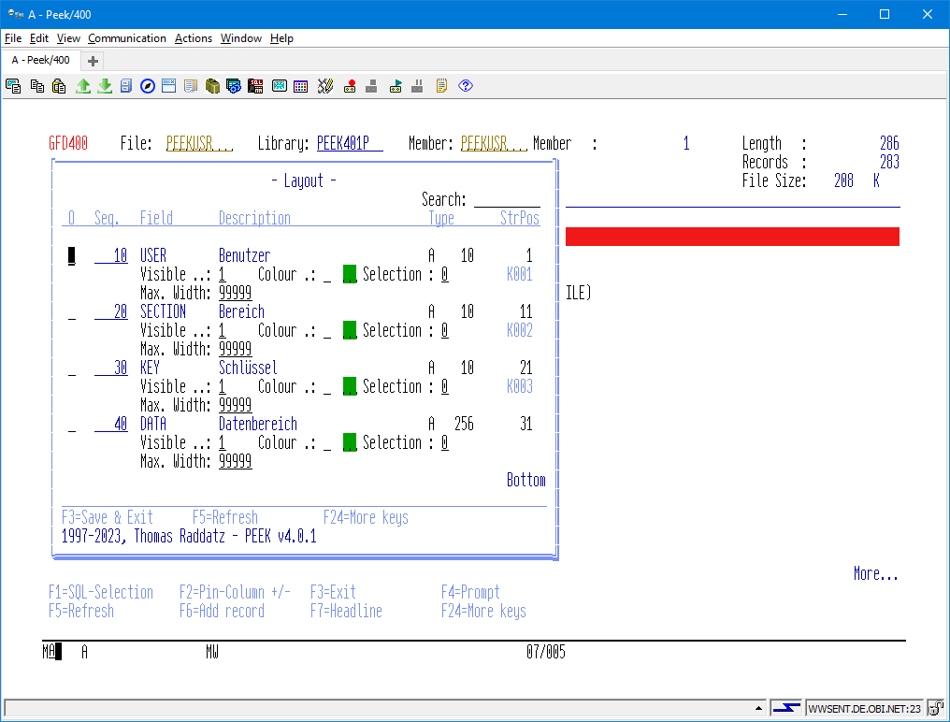
(Screen: Change layout of Peek/400)
You may float the key fields to top by the function „SCHLÜSSEL AN ANFANG SORTIEREN“.
Function: „SCHLÜSSEL AN ANFANG SORTIEREN“
Default: Key „F11“
Program function: *FLOATKEYS

Repeat Option
This function repeats the option of a subfile record like PDM does.
Function: „WIEDERHOLEN“
Default: Key „F13“
Program function: *REPEAT

Enable Multi Colour Lines
This function changes the subfile to display the records using alternating colours.
Function: „EINSCHALTEN TABELLIERPAPIER“
Default: *NONE
Program function: *TBLPAPON
Function: „UMSCHALTEN TABELLIERPAPIER“
Default: Key „F14“
Program function: *TGLTBLPAP

Disable Multi Colour Lines
This function changes the subfile to display the records using a single colour.
Function: „AUSSCHALTEN TABELLIERPAPIER“
Default: *NONE
Program function: *TBLPAPOFF
Function: „UMSCHALTEN TABELLIERPAPIER“
Default: Key „F14“
Program function: *TGLTBLPAP

Extended column pin function
With this function you can select columns to be pinned from a subfile screen.
Function: „SPATLEN PINNEN DIALOG“
Default: Key „F15“
Program function: *PINCOLDLG

The default keyboard mapping of F15 has been changed. You will find the user settings by option “ST” now.

Search Engine
This function allows sequential searching through the records of the opened file.
Have a look at the following screen:
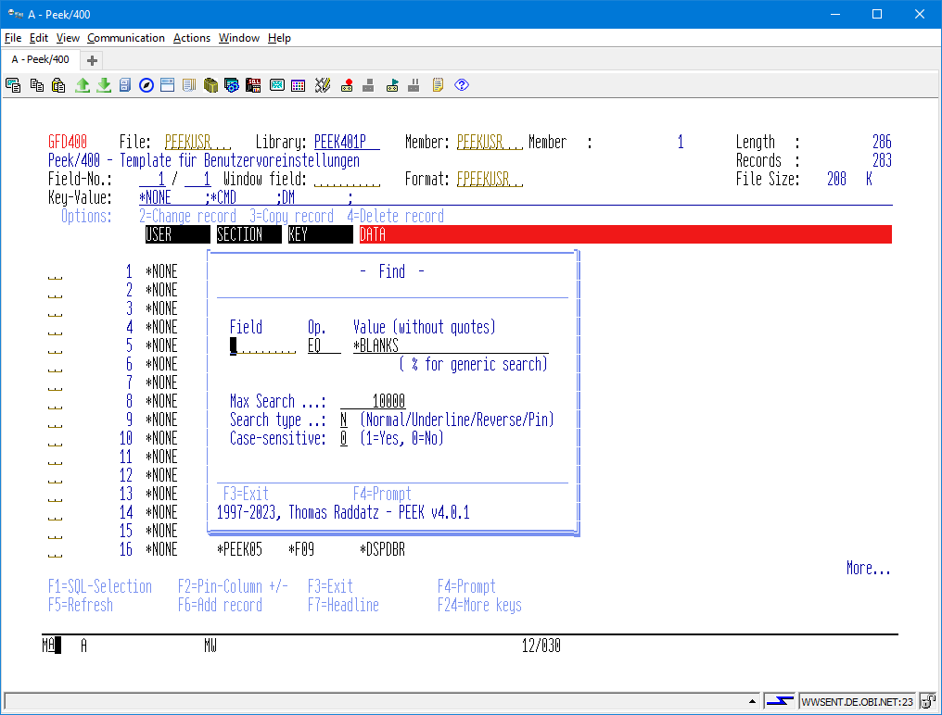
(Screen: Search engine of Peek/400)
Function: „SUCHEN“
Default: Key „F16“
Program function: *SEARCH
Field:
The name of the field which contents is to be searched for. Use the special value *RECORD if you want to search the whole record without the limitations of any fields.
Operand:
The type of the operand for the compare.
Use one of the following operands:
EQ - Equal
NE - Not equal
GT - Greater
LT - Lower
GE - Greater/Equal
LE - Lower/Equal
LIKE - like (for generic Search)
NLIKE - not like (for generic Search)
If you use *RECORD you have to use LIKE or NLIKE.
Value:
The argument that you are searching for.
There are the following special values available:
*BLANKS - Searching for blanks
*ZEROS - Searching for zeros
Max. Nbr. of records:
Due to the sequential search it is recommended to set a limit to the number of records to be scanned for the search argument.
After the maximum number of records have been processed you are able to restart the search by executing the function “SUCHEN” once again.
Type of search:
There are the following type of the search available:
N - Normal Search Mode
After the record has been found it will be placed at the top of the subfile. The next record will be found by executing “SUCHEN” once again.
U - Underlined Search Mode
After the record has been found it will be placed at the top of the subfile. The record and all other records within the window that matches the argument will be shown in underlined mode, too.
R - Reverse Mode
After the record has been found it will be placed at the top of the subfile. The record and all other records within the window that matches the argument will be shown in reversed mode, too.
P - Search & Pin
After the record has been found it will be pinned. The search will continue automatically and it stops after there is no more place for more records or the maximum number of records has been processed.

You are not able to re-define „N, U, R and P“!

Top Of File
This function moves the cursor to the top of the file.
Function: „DATEIANFANG“
Default: Key „F17“
Program function: *TOP

End Of File
This function moves the cursor to the end of the file.
Function: „DATEIENDE“
Default: Key „F18“
Program function: *BOT

Move Screen To The Left
This function moves the screen to the left.
Function: „SEITE LINKS“
Default: Key „F19“
Program function: *PAGELEFT

The default keyboard layout has been changed from *LEFT to *PAGELEFT.

Move Screen To The Right
This function moves the screen to the right.
Function: „SEITE RECHTS“
Default: Key „F20“
Program function: *PAGERIGHT

The default keyboard layout has been changed from *RIGHT to *PAGERIGHT.

Command Line
This function provides an OS/400 command line.
Function: „BEFEHLSZEILE“
Default: Key „F21“
Program function: *CMDLINE

80/132 Display Mode
This function toggles between 80 character and 132 character screen resolution.
Function: „ANZEIGEMODUS“
Default: Key „F22“
Program function: *132/80

More Options
This function displays more available option.
Function: „WEITERE AUSWAHLEN“
Default: Key „F23“
Program function: *MOREOPT

More Keys
This function displays more available keys.
Function: „WEITERE TASTEN“
Default: Key „F24“
Program function: *MOREKEYS

Other Functions

Prompt
Prompt let you select an option for a field by a subfile dialog if this function is been supported by the field.
Just key in “?” into the field for the fieldname and press ENTER to activate the prompt function.
The following fields supports the prompt function:
- Field name
(Main screen and search engine)
- Member
(Main screen)

Short Command
Like SEU you can define short commands within Peek/400. The short commands that you define can be executet within every subfile option within Peek/400.
The short commands are defined in the user´s configuration file of Peek/400 that is hold in the program library of Peek/400.
This is an example of a shipped short command that displays the file description of the currently opened file:

Benutzer | Bereich | Schlüssel | Datenbereich
user name | *CMD | FD | DSPFD FILE(&L/&F)
Benutzer: user name.
Bereich: constant „*CMD“
Schlüssel: option
Datenbereich: Command with or without replacement variables
You can make use of the following described replacement variables:

Variable | Replaced by
&L | the name of the library that holds the currently opened file
&F | the name of the currently opened file
&N | the name of the currently opened file member
&R | relative record number
% + field name | the value of a field of the current record
The names of the replacement variables are inspired by SEU.
Starting with v3.0 you can specify the data type of the ‘%’ field replacement variables. Example:
%FIELDNAME (P, 4, 2)
In the example above the value of %FIELDNAME is passed as a packed 4-digit value with two decimal positions to the called program. The following data types are supported:
'A' Alpha
'B' Binary
'I' Integer
'U' Unsigned Integer
'P' Packed
'S' Zoned

Hex-Editor
With „HEX-EDIT“ you are able to edit the content of a field in hex mode. This is very usefull if a field contains invalid numerical characters. Usually a field with invalid numerical characters can not be edited. With „HEX- can edit the field!
If you need to hex-edit a field, choose option 2 EDIT“ you in the subfile and press the enter key. This will invoke the „Record Change“ window. By default „HEX-EDIT“ can be activated by pressing F9, then. Point to the field to be edited with the cursor and press F9.
If you want to edit a field with invalid numerical characters you have to point to the string „Unprintable Char“ and press F9, then.
You can move the visible part of your field by entering a new start position into the field „Start position“.
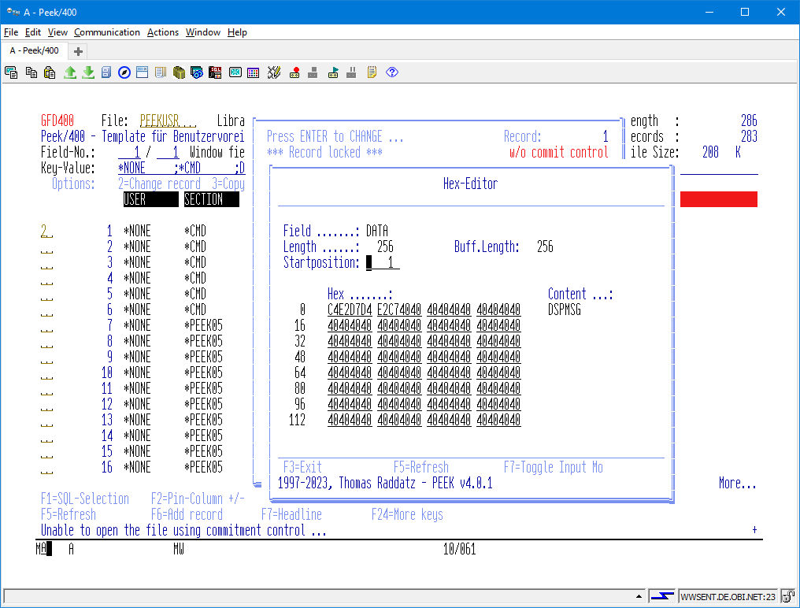
(Screen: Hex-Editor of Peek/400)
The edit window can be moved to any position within the data field via the "Start position" field.

Scrolling
The following function keys are available for scrolling through the data field:
- Page Up
- Page Down
- F17 – First Pos.
- F18 – Last Pos.
- F19 – Links (Towards the beginning of the text)
- F20 – Links (Towards the end of the text)

Toggle Input Mode
With the function key "F7" you can switch between "Hex Input" and "Text Input".

Inserting Text
This feature is not available at this time.

Deleting Text
This feature is not available at this time.

Text-Editor
With „TEXT-EDIT“ you are able to edit the content of a field up to a field length of 1024 byte.
If you need to text-edit a field, choose option 2 EDIT“ you in the subfile and press the enter key. This will invoke the „Record Change“ window. By default „TEXT-EDIT“ can be activated by pressing F10, then. Point to the field you want to edit with the cursor and press F10.
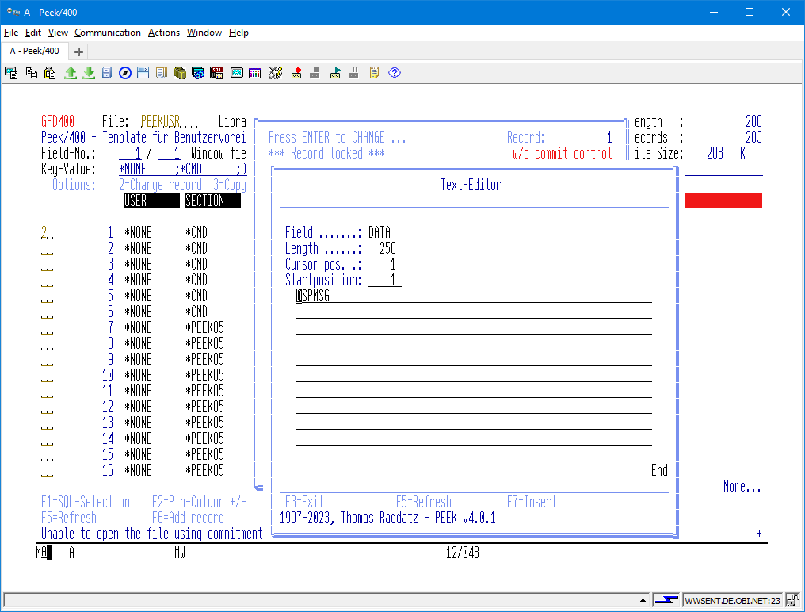
(Screen: Text-Editor of Peek/400)
The edit window can be moved to any position within the data field via the "Start position" field.
The Cursor Pos. field displays the position of the cursor within the data field.

Scrolling
The following function keys are available for scrolling through the data field:
- Page Up
- Page Down
- F17 – First Pos.
- F18 – Last Pos.
- F19 – Links (Towards the beginning of the text)
- F20 – Links (Towards the end of the text)

Inserting Text
The function key "F7" activates the insert mode. If the cursor is in the text field when activated, the current cursor position is copied to the "from" field.
Now you can enter the desired number of spaces to be inserted.
Pressing the "ENTER" button completes the process.
The F5 key refreshes the screen and cancels the insert mode. The process is also aborted when the cursor is in the text box and the F7 key is pressed without changing the position of the cursor.

Deleting Text
The function key "F8" activates the delete mode. If the cursor is in the text field when activated, the current cursor position is copied to the "from" field.
Now you can either enter the position of the last character to be deleted, which may have to be determined in a cumbersome way. It is easier to move the cursor to the last character to be deleted and press the function key "F8" one more time.
Pressing the "ENTER" button completes the process.
The "F5" key refreshes the screen and cancels the delete mode. The process is also aborted if the cursor is in the text box and the F8 key is pressed without changing the position of the cursor.

Keys and Options

Introduction
The keyboard mapping of the keys and the options can be configured by the user itself. If you do not like the default keyboard mapping just change it as you like, then!
The keyboard mapping is been stored within the Peek/400 configuration file. The name of the configuration file is like the name of your user profile and it is placed in the Peek/400 program library.
You may directly edit, insert or even delete these entries.
File format description:
Benutzer Name of the user
Section Section where the entry is been used
Key Key for the entry
Data Data part of the entry

Example
Assume that there are the following two entry defined for the use within PEEK05 which is the main program of Peek/400.
Old:
Benutzer Section Key Data Bemerkung
TESTUSER *PEEK05 *F02 *TGLPINCOL Pin-Column
TESTUSER *PEEK05 *F03 *EXIT End program

Redefine of a key mapping
Just change „*F02“ to „*F06“ and the pin-column function will be executed by pressing F6 instead of pressing F2.
New:
Benutzer Section Key Data Bemerkung
TESTUSER *PEEK05 *F06 *TGLPINCOL Pin-Column
TESTUSER *PEEK05 *F03 *EXIT End program

Redefine a key to an option
Simply change „*F03“ to „X“ and you will be able to exit Peek/400 by entering “X” instead of pressing F3.
New:
Benutzer Section Key Data Bemerkung
TESTUSER *PEEK05 *F02 *TGLPINCOL Pin-Column
TESTUSER *PEEK05 X *EXIT End program

Define two choices for one function
Of course you can define more than one way to execute a function of Peek/400. Have a look at the following example:
New:
Benutzer Section Key Data Bemerkung
TESTUSER *PEEK05 *F02 *TGLPINCOL Pin-Column
TESTUSER *PEEK05 X *EXIT End program
TESTUSER *PEEK05 *F03 *EXIT End program, too

Available functions of Peek/400

Main Program Of Peek/400, *PEEK05
Function Default Description
*NONE ' ' Keine Funktion ausführen
*ENTER ENTER enter
*SQL F1 select records by SQL
*TGLPINCOL F2 toggle pin-column
*EXIT F3 exit program
*PROMPT F4 Prompt
*REFRESH F5 refresh screen
*ADD F6 insert record
*HEADLINE F7 toggle headline
*TGLMRKCOL F8 toggle marked columns
*DSPDBR F9 display database relations
*POSCSR F10 position cursor
*LAYOUT F11 change layout
*CANCEL F12 cancel
*REPEAT F13 repeat option
*TGLTBLPAP F14 toggle multi colour lines
*PINCOLDLG F15 pin and unpin columns (dialog)
*SEARCH F16 search engine
*TOP F17 goto top of file
*BOT F18 goto bottom of file
*PAGELEFT F19 move screen to the left, whole screen
*PAGERIGHT F20 move screen to the right, whole screen
*CMDLINE F21 OS/400 command line
*132/80 F22 80-/132-character resolution
*MOREOPT F23 more options
*MOREKEYS F24 more keys
*PAGEUP PgUp scroll up
*PAGEDOWN PgDn scroll down
*ABOUT A "About Peek/400"
*DELETEENV DE Delete Environment
*TGLDSP H Toggle display mode hex to normal
*TGLKEYLUC K Toggle Key Mode ‘upper case’/’lower case’
*LEFT L move screen to the left, step one field
*LOADENV LE Load environment
*PINROW P pin row
*RIGHT R move screen to the right, step one field
*REBUILD RB rebuild update program
*TGLACCESS S Toggle order
*SPLASHON S+ enable SPLASH-Screen
*SPLASHOFF S- disable SPLASH-Screen
*SAVEENV SE Save environment
*USERSETG ST colour preferences
*MOVETOP T move record to top
*UNPINROW U release pinned row
*CLRPINCOL UC release all pinned columns
*CLRPINROW UR release all pinned rows
*NEXTMARK X scroll right to the next marked column
*PREVMARK Y scroll left to the previous marked column
*CHANGE 2 change record
*COPY 3 copy record
*DELETE 4 delete record
*DISPLAY 5 display record
*PRINT 6 print record
*COPYEXT 9 copy record to extern file
*CMD ... execute short command
*KEY -/- Select order by key sequence
*MRKCOL -/- mark column
*PINCOL -/- pin column
*RRN -/- Select order by record number sequence
*TBLPAPOFF -/- disable multi colour line representation
*TBLPAPON -/- enable multi colour line representation
*UNMRKCOL -/- unmark column
*UNPINCOL -/- release pinned column

Select Record Format, *PEEK12
Function Default Description
*ENTER ENTER enter
*EXIT F3 exit program
*REFRESH F5 refresh screen
*CANCEL F12 cancel
*MOREKEYS F24 more keys
*PAGEUP PgUp scroll up
(can not be changed by the user!)
*PAGEDOWN PgDn scroll down
(can not be changed by the user!)

Display Record, *PEEK14
Function Default Description
*ENTER ENTER enter
*EXIT F3 exit program
*REFRESH F5 refresh screen
*HEADLINE F7 toggle headline
*HEXEDIT F9 hex-editor (display mode)
*STREDIT F10 text-editor (display mode)
*CANCEL F12 cancel
*TOP F17 goto top of file
*BOT F18 goto botton of file
*PRINT F21 print record
*YESTOALL F22 yes to all selected records
(only available with some functions, e.g. „LÖSCHEN“)
*MOREKEYS F24 more keys
*PAGEUP PgUp scroll up
(can not be changed by the user!)
*PAGEDOWN PgDn scroll down
(can not be changed by the user!)

Search Engine, *PEEK17
Function Default Description
*ENTER ENTER enter
*EXIT F3 exit program
*PROMPT F4 prompt
*REFRESH F5 refresh screen
*CANCEL F12 cancel
*MOREKEYS F24 more keys

Colour, *PEEK24
Function Default Description
*ENTER ENTER enter
*SAVE_EXIT F3 Save & exit program
*REFRESH F5 refresh screen
*CANCEL F12 cancel
*MOREKEYS F24 more keys
*EXIT -/- exit program

Select Colour, *PEEK25
Function Default Description
*ENTER ENTER enter
*EXIT F3 exit program
*REFRESH F5 refresh screen
*CANCEL F12 cancel
*MOREKEYS F24 more keys

Target File, *PEEK26
Function Default Description
*ENTER ENTER enter
*EXIT F3 exit program
*REFRESH F5 refresh screen
*CANCEL F12 cancel
*MOREKEYS F24 more keys

Layout, *PEEK34
Function Default Description
*NONE ´ ´ no action
*ENTER ENTER enter
*SAVE_EXIT F3 Save & exit program
*REFRESH F5 refresh screen
*FLOATKEYS F11 float keys to top
*CANCEL F12 cancel
*SERACH F16 search
*TOP F17 goto top of file
*BOT F18 goto botton of file
*MOREKEYS F24 more keys
*PAGEUP PgUp scroll up
(can not be changed by the user!)
*PAGEDOWN PgDn scroll down
(can not be changed by the user!)
*EXIT -/- exit program

Prompt/Autoprompt: Fieldname, *PEEK37
Function Default Description
*NONE ´ ´ no action
*ENTER ENTER enter
*EXIT F3 exit program
*REFRESH F5 refresh screen
*CANCEL F12 cancel
*SERACH F16 search
*TOP F17 goto top of file
*BOT F18 goto botton of file
*MOREOPT F23 more options
*MOREKEYS F24 more keys
*PAGEUP PgUp scroll up
(can not be changed by the user!)
*PAGEDOWN PgDn scroll down
(can not be changed by the user!)
*SELECT 1 select subfile record

Display Database Relations, *PEEK40
Function Default Description
*ENTER ENTER enter
*EXIT F3 exit program
*REFRESH F5 refresh screen
*CANCEL F12 cancel
*SERACH F16 search
*TOP F17 goto top of file
*BOT F18 goto botton of file
*MOREOPT F23 more options
*MOREKEYS F24 more keys
*PAGEUP PgUp scroll up
(can not be changed by the user!)
*PAGEDOWN PgDn scroll down
(can not be changed by the user!)
*SELECT 1 select subfile record

Hex-Editor, *PEEK45
Function Default Description
*ENTER ENTER enter
*EXIT F3 exit program
*REFRESH F5 refresh screen
*TGLINPUT F7 toggle input mode
*CANCEL F12 cancel
*FIRSTPOS F17 goto first position
*LASTPOS F18 goto last position
*LEFT F19 move screen backward
*RIGHT F20 move screen forward
*MOREKEYS F24 more keys

Prompt: Select Member, *PEEK47
Function Default Description
*NONE ´ ´ no action
*ENTER ENTER enter
*EXIT F3 exit program
*REFRESH F5 refresh screen
*CANCEL F12 cancel
*SEARCH F16 search
*TOP F17 goto top of file
*BOT F18 goto botton of file
*MOREOPT F23 more options
*MOREKEYS F24 more keys
*PAGEUP PgUp scroll up
(can not be changed by the user!)
*PAGEDOWN PgDn scroll down
(can not be changed by the user!)
*SELECT 1 select subfile record

SQL Selection, *PEEK48
Function Default Description
*ENTER ENTER enter
*EXIT F3 exit program
*PROMPT F4 prompt
*REFRESH F5 refresh screen
*DSPDBR F9 display & select database relation (key)
*INSKEYFLD F11 insert key fields
*CANCEL F12 cancel
*MOREKEYS F24 more keys

About, *PEEK49
Function Default Description
*ENTER ENTER enter
*EXIT F3 exit program
*REFRESH F5 refresh screen
*CANCEL F12 cancel
*MOREKEYS F24 more keys

Pin-Columns (Dialog), *PEEK50
Programmfunktion Std.Blg. Bemerkung
*NONE ´ ´ no action
*ENTER ENTER enter
*SAVE_EXIT F3 Save & exit program
*REFRESH F5 refresh screen
*CANCEL F12 cancel
*SEARCH F16 search
*TOP F17 goto top of file
*BOT F18 goto botton of file
*CLRALL F22 clear all options
*MOREKEYS F24 more keys
*PAGEUP PgUp scroll up
(can not be changed by the user!)
*PAGEDOWN PgDn scroll down
(can not be changed by the user!)
*EXIT -/- exit program

Create Program, *PEEK52
Function Default Description
*ENTER ENTER enter
*EXIT F3 exit program
*REFRESH F5 refresh screen
*CANCEL F12 cancel
*MOREKEYS F24 more keys

Select Environment, *PEEK56
Function Default Description
*NONE ´ ´ no action
*ENTER ENTER enter
*EXIT F3 exit program
*REFRESH F5 refresh screen
*CANCEL F12 cancel
*SEARCH F16 search
*TOP F17 goto top of file
*BOT F18 goto botton of file
*MOREOPT F23 more options
*MOREKEYS F24 more keys
*PAGEUP PgUp scroll up
(can not be changed by the user!)
*PAGEDOWN PgDn scroll down
(can not be changed by the user!)
*SLCENV 1 select environment to load/save/delete (file & layout)
*SLCLAYOUT 2 select layout to load

Delete Environment, *PEEK57
Function Default Description
*EXIT F3 exit program
*DELETE F9 delete environment (confirmation)
*CANCEL F12 cancel
*MOREKEYS F24 more keys

Message box, *PEEK59
Function Default Description
*ENTER OK OK button
*F03 NO NO button
*F09 YES YES button
*F12 CANCEL CANCEL button

Text-Editor, *PEEK64
Function Default Description
*ENTER ENTER enter
*EXIT F3 exit program
*REFRESH F5 refresh screen
*CANCEL F12 cancel
*MOREKEYS F24 more keys

Prompt: Select Subfile Option, *PEEK68
Programmfunktion Std.Blg. Bemerkung
*NONE ´ ´ no action
*ENTER ENTER enter
*EXIT F3 exit program
*REFRESH F5 refresh screen
*CANCEL F12 cancel
*TOP F17 goto top of file
*BOT F18 goto botton of file
*MOREOPT F23 more options
*MOREKEYS F24 more keys
*PAGEUP PgUp scroll up
(can not be changed by the user!)
*PAGEDOWN PgDn scroll down
(can not be changed by the user!)
*SLCENV 1 select option

Prompt: Select File, *PEEK69
Function Default Description
*NONE ´ ´ no action
*ENTER ENTER enter
*EXIT F3 exit program
*REFRESH F5 refresh screen
*CANCEL F12 cancel
*SEARCH F16 search
*TOP F17 goto top of file
*BOT F18 goto botton of file
*MOREOPT F23 more options
*MOREKEYS F24 more keys
*PAGEUP PgUp scroll up
(can not be changed by the user!)
*PAGEDOWN PgDn scroll down
(can not be changed by the user!)
*SELECT 1 select subfile record

Update Programs, *Pxxxxxxxxx
Function Default Description
*ENTER ENTER enter
*EXIT F3 exit program
*REFRESH F5 refresh screen
*TGLLUCASE F6 toggle upper/lower case mode
*HEADLINE F7 toggle headline
*TGLNULL F8 toggle null indicator
*HEXEDIT F9 hex-editor
*STREDIT F10 text-editor
*CANCEL F12 cancel
*TGLRCDLCK F13 toggle record lock
*TOP F17 goto top of file
*BOT F18 goto bottom of file
*MOREKEYS F24 more keys
*PAGEUP PgUp scroll up
*PAGEDOWN PgDn scroll down
*LOWERCASE -/- lower case mode
*UPPERCASE -/- upper case mode

Peek/400 Control Keys, *PGM
The user settings files holds a lot of parameters that allow you to customize Peek/400 to meet your requirements. This chapter describes the values in section *PGM of the user settings file.
Every end of a record in this section must be marked with a "»" (x'8B').

*ACCESSKEY (SET0003)

Representation of the key of a file in the main screen of Peek/400
Position | Data type | Parameter | Description/Special Values
1 | 1A | Minus sign (-) | Sign to indicate a negative value
2 | 1A | Plus sign (+) | Sign to indicate a positive value
3 | 1A | Decimal point (,) | Sign to represent the decimal point
4 | 1A (bool) | Show minus/plus sign | 1=Yes; 0=No
5 | 1A | Delimeter (;) | Sign that is been placed between the fileds of the key

*CVTCHR (SET0006)

Replacement character for characters below x'40' and equal x'FF'
Position | Data type | Parameter | Description/Special Values
1 | 1A | Replacement character (÷) | Character that will be shown if there are non-displayable characters in the records (below x'40' and equal x'FF')

*CRTPGM (SET0012)

Defaults for the program generator
Position | Data type | Parameter | Description/Special Values
1 | 1A (bool) | Allowed to use lower case characters | 1=Yes; 0=No
2 | 1A (bool) | Default is lower case | 1=Yes; 0=No
3 | 1A (bool) | Lock record on read | 1=Yes; 0=No

*DSPATR (SET0001)

Settings for the representation of the subfile (main screen)
Position | Data type | Parameter | Description/Special Values
1 | 1A | Screen mode 80/132 characters | 1=80-characters; 0=132-characters
2 | 1A | Colour: normal colour | Hexadecimal colour attribute
3 | 1A | Colour: marked columns | Hexadecimal colour attribute
4 | 1A | Colour: pinned rows/columns | Hexadecimal colour attribute
5 | 1A | Colour: Headline | Hexadecimal colour attribute
6 | 1A | Colour: record found (search engine) | Hexadecimal colour attribute
7 | 1A | Colour: underlined (search engine) | Hexadecimal colour attribute
8 | 1A | Colour: reverse (search engine) | Hexadecimal colour attribute
9-18 | 10A | Type of headline | *FIELDNAME/*FIELDTEXT/  *COLHDG/*FIELDTYPE
19 | 1A | Colour: alternating line colour | Hexadecimal colour attribute
20 | 1A | Use alternating line colours | 1=Yes; 0=No
21 | 1A | Use editcode with sign instead of original editcode | 1=Yes; 0=No
22 | 1A | Colour: key fields | Hexadecimal colour attribute
23-32 | 10A | Aktive screen mode | *DSPNRM normal  *DSPHEX hexadecimal
33 | 1A | Display exceptions with column width | 1=Yes; 0=No
34 | 1A | Colour: exceptions column width | Hexadecimal colour attribute

*DFTDSPMDE (SET0011)

Default display mode
Position | Data type | Parameter | Description/Special Values
1-10 | 10A | Default screen mode | *DSPNRM normal  *DSPHEX hexadecimal

*ENVFILE (SET0015)

File to save environments
Position | Data type | Parameter | Description/Special Values
1-10 | 10A | File | *NONE Keine Datei
11-20 | 10A | Library | *NONE keine Bibliothek  *PRDLIB Peek/400 Prod.Bibl.
21 | 1A (bool) | Allowed to change the file | 1=Yes; 0=No
22 | 1A (bool) | Function activated | 1=Yes; 0=No

*FLOATKEYS (SET0009)

Automatically float key fields to top
Position | Data type | Parameter | Description/Special Values
1 | 1A (bool) | Float keys to top | 1=Yes; 0=No

*LANGUAGE (SET0004)

Current user language
Position | Data type | Parameter | Description/Special Values
1-3 | 3A | Language | GER German  ENG English

*PROMPT (SET0008)

Prompt function
Position | Data type | Parameter | Description/Special Values
1 | 1A | Character to invoke prompt function | Every character possible
2 | 1A (bool) | Display prompt fields with an other colour | 1=Yes; 0=No

*PRVFILE (SET0014)

Last specified file at Peek/400 command
Position | Data type | Parameter | Description/Special Values
1-10 | 10A | File
11-20 | 10A | Library
21-30 | 10A | Member

*SCROLL (SET0010)

Settings for horizontal field scroll mode
Position | Data type | Parameter | Description/Special Values
1-10 | 10A | Horizontal field scroll mode | *BOTH both directions  *LEFT left only  *RIGHT right only  *NONE do not scroll

*SEARCH (SET0002)

Settings for search engine
Position | Data type | Parameter | Description/Special Values
1 | 1A | Wildcard (%) | Every character possible
2-6 | 5S 0 | Number of records to search sequentially (10000)

*SECATRDFT (SET0013)

Default security attributes (may be overridden at command level or by EXIT01)
Position | Data type | Parameter | Description/Special Values
1 | 1A (bool) | Allowed to change the library  (main screen of Peek/400) | 1=Yes; 0=No
2 | 1A (bool) | Allowed to change the file  (main screen of Peek/400) | 1=Yes; 0=No
3 | 1A (bool) | Allowed to change the member  (main screen of Peek/400) | 1=Yes; 0=No
4 | 1A (bool) | Allowed to add/change/delete records  (main screen of Peek/400) | 1=Yes; 0=No
5 | 1A (bool) | Allowed to open a file Peek/400 | 1=Yes; 0=No

*SPLASH (SET0005)

Mode of splash screen
Position | Data type | Parameter | Description/Special Values
1 | 1A (bool) | Display splash screen at start | 1=Yes; 0=No

*VERSION (SET0007)

Version number
Position | Data type | Parameter | Description/Special Values
1-2 | 2A | Version
3-4 | 2A | Release
5-6 | 2A | Modification

Tips & Tricks

Peek/400 and end-user!?
„Never!“ – That will cause big trouble!
Keep calm and make use of the possibilities of Peek/400. Of course you can enable an end-user to work with Peek/400 but you may prevent him from:
- changing records
- copying records
- deleting records
Just open his configuration file and delete the following entries:
Function Default Description
*ADD F6 add record
*CHANGE 2 change record
*COPY 3 copy record
*COPYEXT 9 copy record to another file
*DELETE 4 delete record
*CMDLINE F21 command line
Now you have to ensure that your users do get the rights back by semself, for example with UPDDTA.
You may implement the following concept of security to achieve this goal:
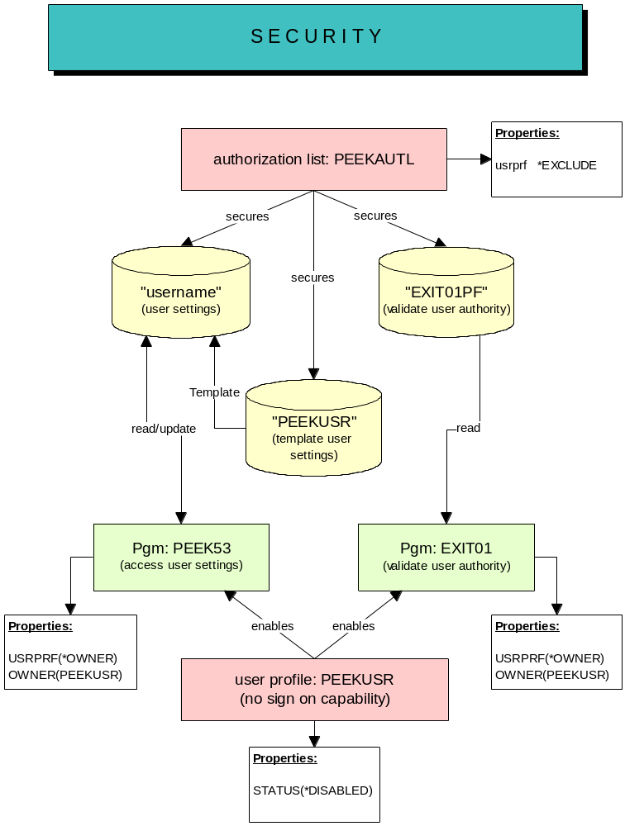
(Screen: Security Peek/400)
First you have to create an authorization list named „PEEKAUTL“ which is been used to secure that objects that are responsible for security. These objects are:
- all files with user settings
- PEEKUSR as the template file for the user settings
- all exit programs
All user that should not have access to that objects must be added to the authorization list with authority *EXCLUDE. Obviously these users should not have *ALLOBJ authority in their user profiles.
In order to allow Peek/400 to access and modify these objects you can create a user profile named "PEEKUSR“ with authority to access and modify the objects.
Last but not least you have to change the owner of all exit programs and of PEEK53 to „PEEKUSR“ and you must set the parameter USRPRF to *OWNER.
Now all security relevant objects just can be accessed and modified by the exit programs and by PEEK53 but not by your users.
That´s all!

Create Your Own Default Keyboard Mapping
Do you like to have your own default keyboard mapping of Peek/400?
Just open the file PEEKUSR placed in the program library of Peek/400 and change the entries.
PEEKUSR is the default configuration file for every new user of Peek/400.

Your Own Language for Peek/400
Create your own language definition file for Peek/400.
To do so you have to create a copy of the German or English language definition file and to translate the entries there.
Try the following way to create a Swedish language definition file:
CRTDUPOBJ OBJ(PEEKENG)
FROMLIB(PEEK)
OBJTYPE(*MSGF)
TOLIB(*FROMLIB)
NEWOBJ(PEEKSVE)
Translate the entries:
WRKMSGD MSGID(*FIRST)
MSGF(PEEK/PEEKSVE)
Ready!
Of course I appreciate any new language definition file!
Start Peek/400 with the new language:
PEEK FILE(FileName)
LANGUAGE(SVE)

EXIT-Programs

User´s Authority (EXIT01)
Since the exit program EXIT01 is been executed before any new file is been opened by Peek/400 you can verify if a particular user is allowed to open the file and if he is allowed to change records or to change the file, the library over the member in order to select another file or member.
The source code of EXIT01 has been shipped in source file QEXAMPLE and can be modified to meet your own requirements.
EXIT01 uses file EXIT01PF to verfy a user´s autority.
Further information about EXIT01 can be found in the source code. Unfortunately it is just available in German.

User Settings File (EXIT02)
The exit program EXIT02 is executed when Peek/400 is started, provided that it exists in the Peek/400 program library. It can determine the user and the user settings file that Peek/400 uses. Peek/400 passes the values of parameter SETTINGS of command PEEK. If EXIT02 returns a message ID, Peek/400 shows the message and ends.
The source code of EXIT02 has been shipped in source file QEXAMPLE and can be modified to meet your own requirements. Peek/400 calls EXIT02 only after the program has been created in the Peek/400 program library.
In its current form, EXIT02 only replaces the special values *DFT and *PRDLIB, like Peek/400 does without EXIT02: the user and the file get the name of the current user profile, the library is the Peek/400 program library. If you remove the RETURN statement described in the source code, EXIT02 uses the group profile of the user as user and as name of the user settings file.
Further information about EXIT02 can be found in the source code. Unfortunately it is just available in German.

Edit Codes Of The Update Programs (EXIT03)
The exit program EXIT03 is executed when Peek/400 creates the file specific program for changing, copying and adding records, provided that it exists in the Peek/400 program library. Peek/400 calls EXIT03 for each numeric field of the file and passes the file, the library, the user, the field name and the edit code of the field. It can override the edit code that the update program uses to display the field.
The source code of EXIT03 has been shipped in source file QEXAMPLE and can be modified to meet your own requirements. Peek/400 calls EXIT03 only after the program has been created in the Peek/400 program library. Existing update programs use the edit codes only after they have been rebuilt with option „RB“.
In its current form, EXIT03 replaces the edit codes by edit codes with minus sign and without thousands separator: „M“ for edit codes that suppress zero values, e.g. 2, 4, B, D and Z, and „L“ for edit codes that show zero values and for fields without edit code.
Further information about EXIT03 can be found in the source code. Unfortunately it is just available in German.

Logging Of Changes (EXIT04)
The exit program EXIT04 is executed after a record has been added, changed, copied or deleted, provided that it is found in the library list. Peek/400 passes the file, the library, the member, the event (*ADD, *CHANGE, *COPY or *DELETE), the user, the time stamp, the record number, the record length and pointers to the record before and after the change. It can log the changes of your data.
The source code of EXIT04 has been shipped in source file QEXAMPLE and can be modified to meet your own requirements. Unlike the other exit programs, Peek/400 does not look for EXIT04 in the Peek/400 program library, but in the library list.
In its current form, EXIT04 writes a record into table EXIT04LOG for each change, with the first 500 characters of both records. The SQL statement to create the table has been shipped in member EXIT04LOG of source file QEXAMPLE. If the table is not found in the library list, EXIT04 logs nothing.
Further information about EXIT04 can be found in the source code.

Function Keys And Subfile Options (EXIT05)
The exit program EXIT05 is executed for each input of the user, before and after Peek/400 translates a function key or a subfile option into a program function (see chapter 12), provided that it exists in the Peek/400 program library. It can filter or change function keys and subfile options.
Peek/400 passes the user settings file and its library, the user, the program (e.g. PEEK05), the type of the input and the value, which EXIT05 can change. The type tells what the value contains: *CMDKEY the function key pressed, *OPTION the subfile option entered, *EVENT the program function derived from it, e.g. *DISPLAY, and *USROPT an input without program function, before Peek/400 looks for a short command.
For example, for option „5“ in the main program PEEK05, Peek/400 calls EXIT05 four times: *CMDKEY with *ENTER, *EVENT with *ENTER, *OPTION with 5 and *EVENT with *DISPLAY.
The source code of EXIT05 has been shipped in source file QEXAMPLE and can be modified to meet your own requirements. Peek/400 calls EXIT05 only after the program has been created in the Peek/400 program library.
In its current form, EXIT05 removes leading zeros from subfile options, so that e.g. „05“ works like „5“.
Further information about EXIT05 can be found in the source code.

Field Text And Column Headings (EXIT06)
The exit program EXIT06 is executed for each field after Peek/400 has read the field list of a file, provided that it exists in the Peek/400 program library. It can override the field text and the column headings of the fields, e.g. with texts from a table of your own.
The source code of EXIT06 has been shipped in source file QEXAMPLE and can be modified to meet your own requirements. Peek/400 calls EXIT06 only after the program has been created in the Peek/400 program library.
In its current form, EXIT06 builds the column headings from the field text, if a field has no column headings of its own.
Further information about EXIT06 can be found in the source code. Unfortunately it is just available in German.

Help me!
Please let me know if you think that there is something missing! A good piece of software can not be produced by a lonely programmer hacking on his keyboard!

History
Datum |  | Beschreibung
29.09.1997 |  | Start development of Peek/400
07.11.1997 |  | Finished Version 1.0, Beta 1
11.11.1997 |  | Added option to switch between the input of uppercase letters and lowercase letters when changing alphanumeric fields.
13.11.1997 |  | Added dialog for entering the license key.  Added SPLASH-screen
26.11.1997 |  | Display of non-displayable characters in the subfile and in the frame via special character.
27.11.1997 |  | Editing of record with non-displayable characters. Fields with non-displayable characters are hidden so that they cannot be edited.
29.11.1997 |  | Release of Version 1.0
04.12.1997 |  | Cannot access files in the QTEMP library.  Correction of the command definition of the PEEK command.
Error in the process of deleting locked records.
Intercepted setlocks during the erasing process.
16.12.1997 |  | Function "Move whole page to the left" built in.  Program function: *PAGELEFT
Function "Move whole page to the right" built-in.
Program function: *PAGERIGHT
17.12.1997 |  | Fixed bug in the "SEARCH" function for "LIKE/NLIKE" in connection with "non-case-sensitive search".
18.12.1997 |  | Repeat function for subfile selections built in.  Program function: *REPEAT
19.12.1997 |  | Built-in automatic matching of user definition files when changing versions.
 |  | Editcodes without prefix (1, 2, 3, 4, Z) are converted to the corresponding prefixed editcodes.
Built-in function for program re-creation.
Program function: *REBUILD
Function to delete all pinned lines built in.
Program function: *CLRPINROW
Function to delete all pinned columns built in.
Program function: *CLRPINCOL
30.12.1997 |  | Built-in function to change the layout.
 |  | Program function: *LAYOUT
26.01.1998 |  | Color highlighting of key fields in the heading line
29.01.1998 |  | Enables entering negative values and values with decimal places within the search function.
16.02.1998 |  | Processing time, date and timestamp fields in the file key. Error checking when entering the override key for these field types.
27.02.1998 |  | Displaying files that cannot be updated, e.g.:  - JOIN-Files  - File with referencial integrity but without journaling.
06.03.1998 |  | Correction of an error in the generation function in relation to foreign code pages
15.03.1998 |  | Release of Version 1.1
18.03.1998 |  | Intercepted program abort after *REBUILD
21/22.03.1998 |  | Display of database relationships
04.04.1998 |  | Fixed an error when creating the update program.
14.04.1998 |  | In some cases the PEEKFLD file could not be found.
21.04.1998 |  | Function of shortcuts built-in.
 |  | Fixed a bug with the function *REFRESH in PEEK14. (Show, Ext. Copy, Delete)
 |  | *BOT and *TOP built into *PXXXXXXXXX programs
28.04.1998 |  | Fixed an error when converting non-presentable characters in the keyword
27.05.1998 |  | Renunciation of the OUTFILE when determining the key field information, now via API
28.05.1998 |  | Created command TREE
01.06.1998 |  | Release of Version 1.2
18.07.1998 |  | Fixed error in the display of Editcode X. Now treated as Editcode Z.
 |  | Fixed F11 in 80 character mode. F11 was not active in the display file.
17.08.1998 |  | Hex-Editor on field level in selection 2 (Change record) built-in.
27.09.1998 |  | Error generating the REFFLD line in the screen file.
06.10.1998 |  | Error in the Hex-Editor. Field changes in the "Change Record" screen were not applied to the Hex-Editor.
08.10.1998 |  | Error re-sorting the fields in the "Layout" function. The "Editcode" screen field was not initialized correctly.
11.10.1998 |  | Release of Version 1.3
11.12.1998 |  | Rename external file fields to internal field names in generated programs
14.12.1998 |  | F4 function for list of partial files
15.12.1998 |  | Correction of text display "with commit control"/"without commit control" in the generated programs
21.12.1998 |  | Display the number of partial files in the main screen
19.01.1998 |  | Hex display via F9 with the function "DISPLAY RECORD"
02.02.1999 |  | Release of Version 1.4
10.02.1999 |  | Improved support for date and time fields in the generated programs
11.02.1999 |  | In the event of an error in the generated programs (for example, "Double Key"), the screen field contents are no longer overwritten with the file field contents.
 |  | From now on, a new function "*PINCOLDLG" is available in the main screen (F15). Behind this function is a subfile dialog that makes it possible to pin fields (columns) by simple selection (enter sequence number).
 |  | The former function of F15 (*USERSETG) has been moved to the subfile selection "ST",
12.02.1999 |  | Display "About Peek/400" installed. Program function: "A"
 |  | The processing priority of screen input in the main screen has been changed. Data sharing with changes in the header of the screen (for example, changing the file) are processed before subfile input.
 |  | The *TOP and *BOT functions are now available in the display screen for the individual sentences.
 |  | The *TOP and *BOT functions are now available in the screen for selecting a field from the record (operator guide).
 |  | The *TOP and *BOT functions are now available in the layout display screen.
 |  | In the generated programs, as well as in the screen for displaying a single set, the keystrokes are marked with a ">".
16.02.1999 |  | In the "External Copy" screen, the "File, Library and Partial File" fields are no longer deleted unless the opened file has changed.
17.02.1999 |  | The values for "Replace records" and "Create file" are reset to the default values of "*ADD" and "*NO".
06.03.1999 |  | Release of Version 1.5
10.03.1999 |  | Fixed problems with positioning subfiles when entering subkeys in date, time and timestamp fields.
16.03.1999 |  | Selection of data sets via SQL. Program function: *SQL
18.03.1999 |  | Fixed display of key fields in generated programs.
19.03.1999 |  | Default information for the program generator built-in.
23.03.1999 |  | Display and selection database relationships built into SQL Selection to select a key.
02.04.1999 |  | Release of Version 2.0
27.04.1999 |  | Sharing/protecting the "File", "Library" and "Share File" fields via startup parameters (ALWCHGLIB, ALWCHGFILE, ALWCHGMBR)
28.04.1999 |  | Restricting the editing mode via startup parameters (UPDMOD(*YES/*NO)
 |  | Check user profile for parameter LMTCPB for action *CMDLINE
30.04.1999 |  | Bugfix for the generation data CASE and ALWLC. The corresponding values were interpreted incorrectly.
05.04.1999 |  | Special value *PRV in the PEEK command for KEYWORD FILE.
06.05.1999 |  | Displays the physical file in the database relations if no logical files exist.
 |  | Keep the pinned rows and columns when switching the sort order.
08.06.1999 |  | Release of Version 2.1
24.06.1999 |  | When reducing the column width using the *LAYOUT function, numeric values are now displayed right-adjusted.
24.06.1999 |  | Release of Version 2.1.1
21.07.1999 |  | Extension: Create service program for general functions. (Preparing for processing variable length fields.)
22.07.1999 |  | Extension: Added support for variable length fields.
22.07.1999 |  | Bugfix: Synchronization of the display between update and display program.
23.07.1999 |  | Bugfix: Executing shortcuts. Passing ShortCmd to PEEK42 Parameter length too short defined
29.07.1999 |  | Extension: Hex editor: move right/left with F19/F20 (PEEK45).
06.08.1999 |  | Extension: PEEK59, generic window for message retrieval (msgbox) created.
11.07.2000 |  | Bugfix: Update the fields "File", "Library" and "Member" when pressing the F5 key (PEEK05).
18.07.2000 |  | Bugfix: Deleting the fields: Attachment key and relative record number when changing the file. (PEEK05).
19.07.2000 |  | Extension: F17/F18 (begin/end) built into Hex editor. (PEEK45).
26.07.2000 |  | Bugfix: Part file list at function SE was incomplete. (PEEK56).
06.12.2000 |  | Extension:ALWCHGRCD(*NOKEY) built in
14.12.2000 |  | Bugfix: If a file could be opened for input only, then the following functions caused an error:  - Pin Record  - Copy record to external file  - Change sort sequence
25.02.2001 |  | Extension: Improved support for record format selection for logical files. Now only records of the respective record format are displayed.
11.03.2001 |  | PEEK12 has been adapted to use Msg variables.
09.04.2001 |  | Bugfix: Record lock for pinned records removed. Access via FILE00 to FILE04 changed in PEEK05.PBPinRcd
09.04.2001 |  | Bugfix: Case-sensitive search function; PEEK17 fixed.
09.04.2001 |  | Extension: Preassignment of the TOMBR() parameter in the program PEEK26 with the name of the "of partial file".
09.04.2001 |  | Extension: Display of records of multi-member files. (PEEK14)
26.04.2002 |  | Bugfix: Environments. PEEK54/PEEK55 Saving/loading pin tables in the environment file fixed.
26.04.2002 |  | Bugfix: Setup. PEEK05 Deleting the file PEEKFLD when a file is closed.
26.04.2002 |  | Extension: Environments. PEEK54/PEEK55 Save the opened file. Choice between *ENVIRONMENT or *LAYOUT_ONLY built-in.
27.04.2002 |  | Bugfix: Hex-Editor. For fields > 512 bytes only the first 512 bytes were written back into the record.
29.04.2002 |  | Change/Bugfix: Environments. PEEK54/PEEK55 Save environment data independently. Change of environment file library (PEEKENV) was not detected correctly.
04.05.2002 |  | Release of Version 2.2
23.05.2002 |  | Fixed bug in handling 2-byte binary values.
20.10.2003 |  | Allowed data types J, O, E.
20.10.2003 |  | Release of Version 2.2.1 (internes, nicht veröffentlichtes Release)
11.02.2004 |  | Fixed generation error for files with "input only" fields.
23.03.2004 |  | Built-in support for 1-byte and 8-byte integer fields.
01.04.2004 |  | Corrected error in PEEK05 with *HIVAL and *LOVAL values in date, time and timestamp fields.
01.04.2004 |  | Built-in support for time formats *HMS and *EUR, as well as date format *EUR.
28.04.2004 |  | Corrected break of PEEK05 for record lengths > 4096 characters.
28.04.2004 |  | Built-in support for record lengths up to 32766 bytes.
 |  | Release of Version 2.2.2
 |  | New substitute variable % + field name for shortcuts
 |  | Changing the licensing to freeware.
21.09.2004 |  | Release of Version 2.3.0
 |  | Fixed error in function f_basedPF().
 |  | Fixed an error when opening a SQL selection.
 |  | Output error message when pinning a set if the logical file is based on multiple physical subfiles.
 |  | Ignore empty subfile selections.
09.02.2006 |  | Release of Version 2.3.1 (internes, nicht veröffentlichtes Release)
 |  | Fixed problem when generating display files.
09.02.2006 |  | Release of Version 2.3.2
 |  | Install progress bars when creating update programs.
 |  | Corrected error message with incorrect input Yes/No.
 |  | Generate Display File with Edit Code 'P', if a numeric field has no Edit Code.
 |  | Field length DATA in PEEKUSR increased to 256 characters.
 |  | "Index out of range" error in PEEK15 corrected.
 |  | Release of Version 2.4.1 (internes, nicht veröffentlichtes Release)
 |  | Added support for 3I0 and 20I0 fields.
 |  | Improved positioning of the cursor after field selection (F4) in SQL selection.
 |  | Fixed program crash when entering 0 in "Field-Number": in program PEEK05.
 |  | Generated programs: Adjusted length of "ShortCmd".
 |  | Release of Version 2.4.2 (internes, nicht veröffentlichtes Release)
 |  | Corrected error when moving the display to the right with too long fields and pinned columns.
07.05.2008 |  | Release of Version 3.0.0
 |  | Store generated sources in QPEEKGEN instead of QCOPYLE and QRPGLE.
 |  | Built-in support for NULL-capable fields.
 |  | Improved hex editor.
 |  | Status message setting was not restored in case of conversion error in the RPG module.
 |  | New text editor for fields up to 1024 bytes.
 |  | Determination of the settings file based on the group profile in program EXIT02 disabled.
 |  | Maintain mode for input in lowercase/capital letters of the generated programs built in.
 |  | Generated programs: New selection: "Read locked sentence".
 |  | Generated programs: Changing the sentence lock.
 |  | Umschalten Eingabe der Schlüsselfelder in PEEK05 in Kleinbuchstaben mit Auswahl „K“.
 |  | Save/ Load mode of key fields (PEEK05) in the working environment.
 |  | Error loading the desktop environment, parameter ENVFILE() of the PEEK command fixed.
 |  | Generated programs: Query "Save anyway" when the record is changed by another job.
12.08.2008 |  | Release of Version 3.1.1
 |  | Template for update programs regarding sentence lock revised.
 |  | Built-in "Print record’ with selection "6’ or function key F21 (in the display program).
 |  | Expanded shortcuts so that the data format of the passed parameters can be specified.
 |  | Window to display and select the available subfile options in the main program PEEK05.
15.08.2008 |  | Release of Version 3.1.2
 |  | Fixed error when using SQL selection.
 |  | Improved output of error messages during SQL selection
22.08.2008 |  | Release of Version 3.1.3
 |  | Fixed another error when SQL selection is used.
04.09.2008 |  | Release of Version 3.1.4
 |  | Fixed field overflow in field $$Digt in program PEEK34 (Layout).
18.08.2009 |  | Release of Version 3.1.6
 |  | The SETGT and SETLL functions have been reworked. Fixed a bug that caused positioning at the end of the file when pressing F5 at the beginning of the file and then deleting the first record between SETLL and READ.
 |  | Fixed a bug in processing the shortcuts. The underline was not in the list of valid characters for field names.
 |  | Execute automatically from C_Enter in PEEK34 at F3 (SAVE).
 |  | Preassignment for JIS date and time field built in.
27.10.2009 |  | Release of Version 3.2.1
 |  | Changed the selection of the edit code for displaying numeric data in the subfile.
 |  | Generate internal key corrected for cases where the key is longer than the available input line.
27.10.2009 |  | Release of Version 3.2.3
 |  | Fixed an error when updating the subfile with F5. The subfile was placed at the end when the first record was deleted from another job in the meantime.
 |  | Fixed a bug in processing the shortcuts. The underline was not in the list of valid characters for field names.
 |  | Layout Editor (PEEK34): Automatically execute C_Enter on SAVE (F3).
 |  | Record display (PEEK16) and generated update programs: Preallocation for JIS date and time fields built in.
 |  | Built-in support for data type FLOAT.
Default editcode for processing numeric data changed to "L". Setting via „PEEKUSR“:
*DSPATTR, Position 21 (field SET_DspSgn):
0 = Do not change Edit Code
1 = Old behavior, 0=blanks
2 = New behavior, use the Edit Code defined at position 33
*DSPATTR, Position 33 (field SET_editCode):
Edit Code used, when SET_DspSgn equals 2.
 |  | Fixed an error when generating the internal overlay key if it is longer than the input line.
 |  | Changed order when opening files hFile00 – hFile03 to avoid problems with files with SHARE(*YES).
 |  | Release of Version 3.2.4 (internes, nicht veröffentlichtes Release)
 |  | Generic file selection at the command prompt.
 |  | Fixed bug in PEEK63.CIO_setllWithRRN().
 |  | Fixed bug in PEEK58.f_basedMbr(). Join files were not detected correctly.
 |  | F4 for file selection in the record display (PEEK05).
 |  | New: EXIT03 to determine the edit codes in the generated update programs.
 |  | Sort the entries by name in the overview of logical files.
 |  | Display of all key fields in the overview of logical files.
 |  | Release of Version 3.2.5 (internes, nicht veröffentlichtes Release)
 |  | Generic file selection in the Peek/400 main screen.
 |  | Fixed bug in the DDS generator with alternative field names longer than 30 characters.
 |  | Release of Version 3.2.6 (internes, nicht veröffentlichtes Release)
 |  | Spanish translation by Antón Vigo.
 |  | Extension of the PEEK and TREE commands by parameters WHERE and ORDERBY.
 |  | Correct display of the number of selected records with access type *SQL.
 |  | New command PEEKINIT to create the commands PEEK and TREE in the desired language (GER, ENG, SPA)
05.11.2010 |  | Release of Version 3.3.0
 |  | PEEK63 recreated to include the modified function value of the prototype of the function C_Rlslck in PEEK63C.
28.05.2011 |  | Release of Version 3.3.1
 |  | Parameter SETTINGS added.
 |  | EXIT02 extended.
 |  | Determining the user settings to be used has been revised.
28.06.2011 |  | Release of Version 3.3.2
 |  | Corrected preparation of the internal key for VARYING fields.
 |  | Corrected error when deleting records from a logical file if the logical file's record format is named differently from the physical file's record format.
 |  | From now on, the working environment entered at the command prompt is not only used for loading the first environment, but is maintained for the entire program runtime.
 |  | New parameter ENVSAVE to control whether the work environment should be saved automatically when exiting the program.
 |  | Display of GRAPHIC fields that have a CCSID and are used to store DBCS data.
 |  | Italian translation by Marco Alberici.
04.08.2012 |  | Release of Version 3.4.1
 |  | Bugfix when displaying the hex data (F9) starting from the record display (PEEK14).
 |  | New column header (F7), consisting of the field name and data type.
10.08.2012 |  | Release of Version 3.4.3
 |  | Bugfix PEK04: Missing call for event *DELETE built in.
 |  | Bugfix PEEK05/PEEK14: Disabled automatic character conversion depending on the job CSID when reading the data. Now converted manually.
 |  | Bugfix PEEK05: Fixed display of the record format ID.
 |  | Bugfix PEEK06: Delaying old display values fixed.
 |  | Bugfix PEEK06: Calculation of display length for GRAPHIC fields fixed.
 |  | Bugfix PEEK06: Fixing the headings regarding the CCSID.
 |  | Bugfix PEEK15: Fixed overwriting of alias names.
 |  | Bugfix PEEK15: Error in the hex editor for field types A and G.
 |  | (Field length 0 is passed to PEEK45.)
 |  | Bugfix PEEK18: RNX1000 in procedure cvtToJobCcsid().
 |  | New: EXIT05 to filter and change command keys and subfile selections.
 |  | New: parameter "Load layout only" (ENVLAYOUT).
27.08.2015 |  | Release of Version 3.5.0
 |  | Fixed incorrect processing of record fields in PEEK14 for logical files with different record structure to the physical file.
19.12.2015 |  | Release of Version 3.5.1 (internes Release)
 |  | Fixed infinite loop due to an incorrect return value in case of an IO error in the CIO_readp() function.
 |  | Command TREE: "Pointer not set" bug fixed.
04.04.2015 |  | Release of Version 3.5.2
 |  | Fixed a problem with changing the record format (Pmt_Fmt).
 |  | Program function *OK due to incorrectly delivered PEEKUSR equated to *ENTER. Likewise *NO for *EXIT.
 |  | Italian translation revised by Marco Riva.
06.03.2017 |  | Release of Version 3.5.3
 |  | Fixed an error when creating a new file for the user settings, so that the file now also contains the expected records.
10.04.2019 |  | Release of Version 3.5.4
Fixed problem when copying default values from PEEKUSR.
File PEEKUSR not opened correctly.
09.03.2021 |  | Release of Version 3.5.5
 |  | Fixed problems when displaying records from logical files with multiple record formats.
 |  | Now Float special values 'NaN' and 'Inf' are displayed.
 |  | Fixed RNX0100 (Length or start position is out of range) due to an odd number of signle quotes in the field description.
 |  | Fixed error message RNX0100 (Length or start position is out of range).
 |  | Disallowed zoned and packed fields with more than 30 digits.
 |  | Fixed problem of monitoring errors in CIO_read() and CIO_readp(). (Happend with logical files with multiple record formats.)
11.08.2022 |  | Release of Version 3.5.6
 |  | Fixed RNQ0103 (The target for a numeric operation is too small to hold the result) in PEEK05 when loading values to $$RECORDS.
13.06.2023 |  | Release of Version 3.5.7
 |  | Fixed problem with invalid special characters when overwriting alias name (keyword: ALIAS).
20.11.2023 |  | Release of Version 4.0.1
 |  | Fixed problem that fields larger than 1024 characters may lose data when using the text editor.
 |  | Added options "Insert" (F7) and "Delete" (F8) to the text editor.
 |  | Expanded the size of the start position field in the hex editor from 4 to 5.
 |  | Fields of data type "Graphic" are now supported in the text editor.
 |  | Source code fully converted to **free.
07.12.2023 |  | Release of Version 4.0.2
 |  | Fixed incorrect double quotation marks in the editor for the SQL ORDER BY clause.
 |  | Translated previous history items with online translator to English.
15.01.2024 |  | Release of Version 4.0.3
 |  | Fixed incorrect data types of field for SQL Order By and SQL Where.
02.02.2024 |  | Release of Version 4.0.4
 |  | Fixed RNQ0100 (Length or start position is out of range for the string operation) in PEEK03.
27.02.2024 |  | Release of Version 4.0.5
 |  | Added support for new SQL data type 'Boolean'.
11.04.2024 |  | Release of Version 4.0.6
 |  | Changed RRN from INTEGER to UNSIGNED INTEGER to fix error MCH1210 (Receiver value too small to hold result.).
04.10.2024 |  | Release of Version 4.0.7
 |  | Fixed PEEK02 to properly return the record format ID.
 |  | Fixed PEEK55 to properly load the layout on applying environment settings.
02.11.2026 |  | Release of Version 4.0.8
 |  | New headline type *COLHDG: F7 shows the column headings (COLHDG) of the fields in one line.
 |  | Empty field texts are replaced by the column headings, e.g. for SQL tables without LABEL ON ... TEXT IS.
 |  | New exit program EXIT06 to override the field text and the column headings.
 |  | Fixed broken special characters, umlauts and accents.

