1. **Unzip the Folder**
2. **Navigate to end-to-end-project directory**

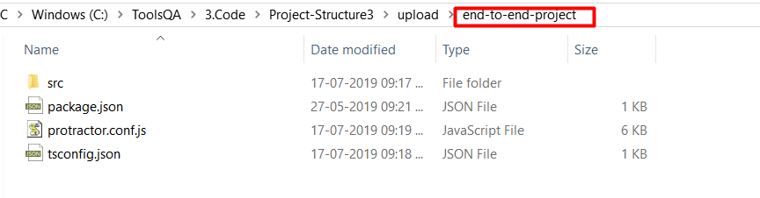

1. **Open command prompt here**

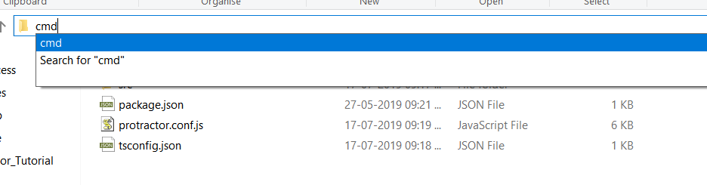

1. **Type command npm install**

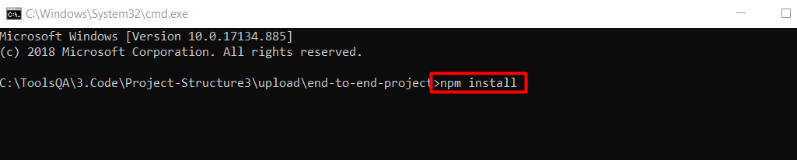

1. **Open folder in Visual studio Code**

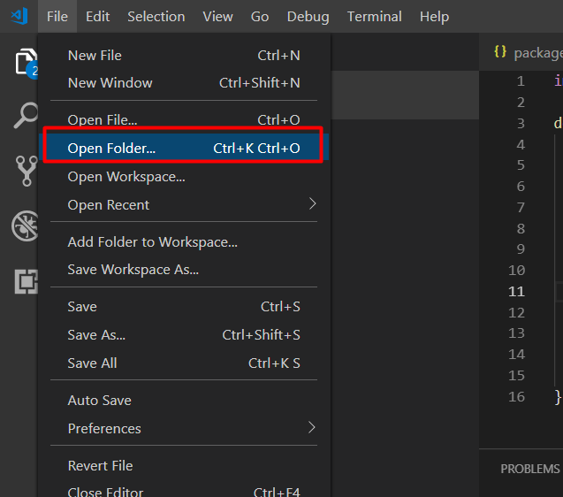

**7.Choose end-to-end-project folder**

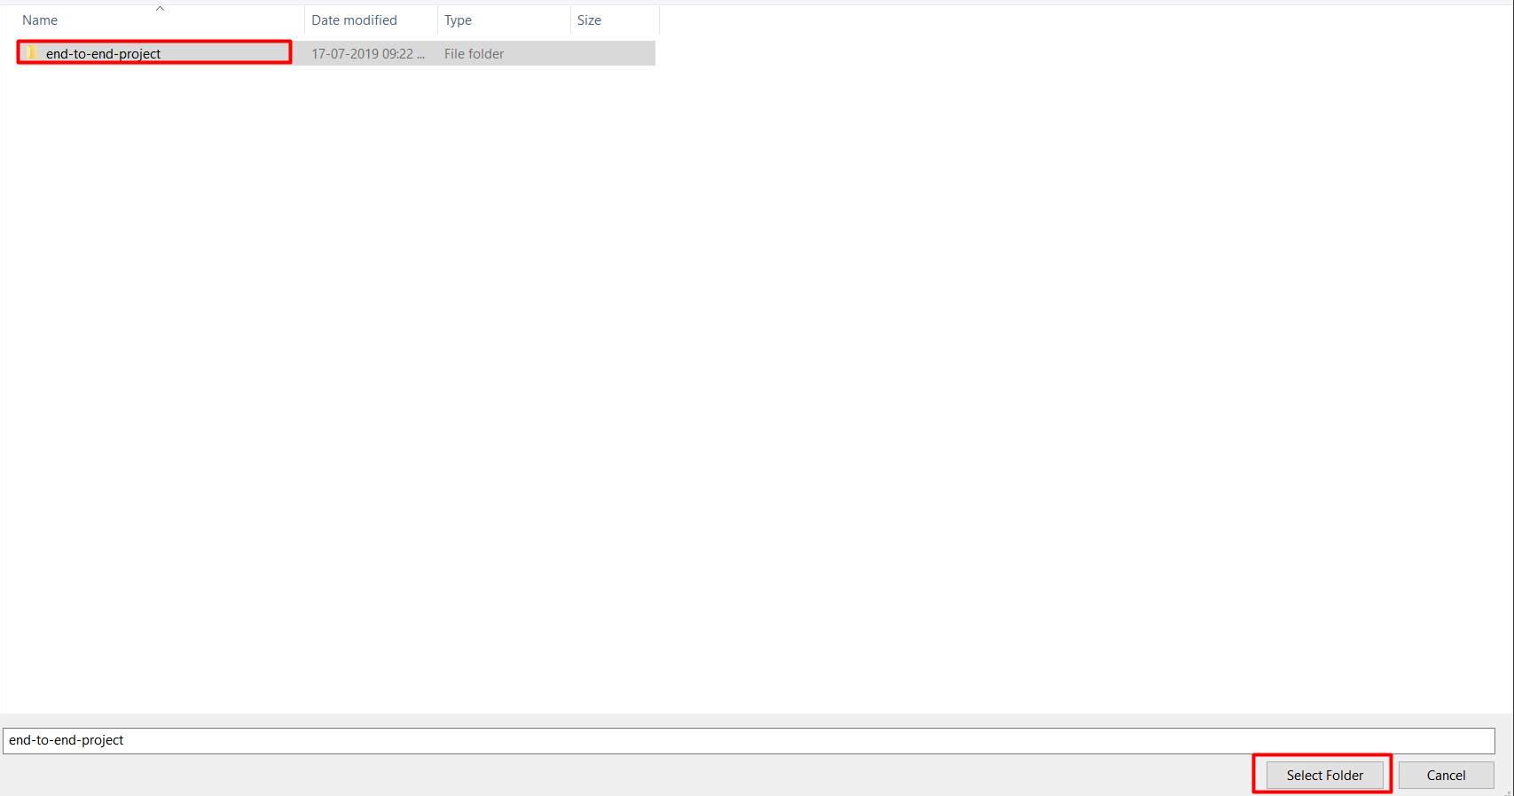

**8. Choose Folder and Project Open**

**It’s All yours protractor framework is ready**

References:

1. <https://www.toolsqa.com/protractor/install-visual-studio-code/>
2. <https://www.toolsqa.com/protractor/protractor-typescript/>
3. <https://www.toolsqa.com/protractor/what-is-protractor/>