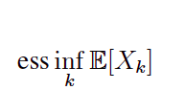

How you explain it in a simple words? We find the expectation of X, we will have a list, the best minumim of the x, the ess
What dose it do?

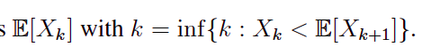

How you explain it in a simple words? We want The smallest time k in which the value of the random variable is less than the expected value of the random variable in the next time. And want the first time of that happens

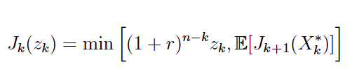
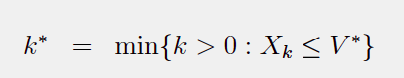
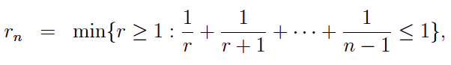

How you explain it in a simple words?
What dose it do?

How you explain it in a simple words? Find the first time such that the value of the random variable is less than V*

What dose it do?

How you explain it in a simple words?
What dose it do?

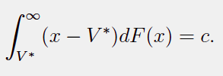

How you explain it in a simple words?
What dose it do?
